Women’s Knowledge, Attitude, and Practices about Breast Cancer and Breast Cancer Screening Programs among Iranian Women in Gonbade-Ghaboos, North-East of Iran: A Cross-Sectional Study

Ashkan Esmaeili
Master of Public Health
BIHE University
Biology Department
Fall SEMESTER 2020
A research as the final project
Supervised by Nathalie Auger, Professor of epidemiology, biostatistics and occupational health, faculty of medicine and health science, McGill, University of Montreal

Contents:
Introduction section
Non-communicable diseases………………………………………………………………………………………………………4
Breast cancer (Global term)………………………………………………………………………………………………………..4
Different types of breast cancer……………………………………………………………………………………………………7
Stages of breast cancer……………………………………………………………………………………………………………..8
Importance of early detection……………………………………………………………………………………………………...10
Consequences of breast cancer…………………………………………………………………………………………………….15
Breast cancer in Iran……………………………………………………………………………………………………………….17
Golestan province………………………………………………………………………………………………………………….22
Gonbade-ghaboos County………………………………………………………………………………………………................23
Literature review (Globally)……………………………………………………………………………………………………….24
Literature review (In Iran)………………………………………………………………………………………………................25
Importance of this study………………………………………………………………………………………………………...…27
Goals of the study……………………………………………………………………………………………………….................28

Research method section
Study design………………………………………………………………………………………………………………………29
Sampling method………………………………………………………………………………………………………………….29
Sample size………………………………………………………………………………………………………………………..30
Sample population and inclusion criteria………………………………………………………………………………………….32
Recruiting a facilitator…………………………………………………………………………………………………………….....33
Preparing consent form…………………………………………………………………………………………………………….34
Ethical considerations……………………………………………………………………………………………………………...34
Questionnaire………………………………………………………………………………………………………………………35
Data collection……………………………………………………………………………………………………………………..36
Data analysis………………………………………………………………………………………………………….....................36
Results section
Descriptive results…………………………………………………………………………………………………………………40
Analytical results………………………………………………………………………………………………………………......56
Discussion section
Discussion………………………………………………………………………………………………………………………….71
Contrasting findings in this study with existing literature…………………………………………………………………………75
Strength and limitations of the study……………………………………………………………………………………………….77
Recommendations for public health and prevention……………………………………………………………………………...77
Conclusion section
Conclusion………………………………………………………………………………………………………………………....81
Acknowledgements ……………………………………………………………………………………………….82
References………………………………………………………………...........................................................................83
Appendix…………………………………………………………………………………………………………………..89
This thesis is dedicated to the sacred soul of dear professor “ Parviz Javid” one of the founders of BIHE.
With Special thanks to my dearest supervisor, Nathalie Auger , Professor of epidemiology, biostatistics and occupational health, faculty of medicine and health science, McGill, University of Montreal
Many thanks to dear professor Roksana Mirkazemi for her pure and endless accompany at all stages of the project
Dedicated to the whole sacred instructors and teachers who sacrificed their life for us to educate
Hope for the days to come when we can apply what we have learned to serve our dearest country-mates in Iran and also to serve the whole people of the universe, since we have been taught that:
“The earth is but one country and all mankind its citizen”
Introduction:
Non-communicable diseases (NCDs): According to the World Health Organization (WHO), majority of global deaths (40.5 million, equivalent to 71%) were attributed to Non-Communicable Diseases (NCDs) in 2016. Among four NCDs (Cancers, diabetes, cardiovascular diseases and chronic lung diseases), cancers were the second leading cause of death (9 million, 22 of all NCD deaths), in 2016 (1).
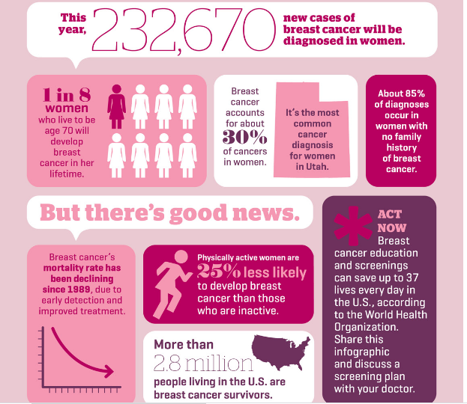
Breast cancer (BC)-Global term:

Figure1: Breast cancer facts(2)
Breast cancer (BC) is the most prevalent female cancer and the main leading cause of cancer death in females worldwide (3). It is also, the most frequently diagnosed female cancer in 140 of 184 countries in the world (4). BC is the second most common cancer overall (5).Comparing countries in the world, Belgium had the highest rate of BC, followed by Luxembourg and Netherland, with 113.2, 109.3 and 105.9 (age standardized rate per 100.000), respectively. Amazingly, nine out of top ten countries with BC in the world are developed countries (5). In spite of this, 50% of cases and 58% of deaths related to BC, occur in less developed countries, signifying the fact that BC is not merely the disease of advanced countries. The trend is ascending in less developed countries (6).
BC survival rate differs dramatically between countries, from 80% in North America, Japan and Sweden to 60% in middle-income countries (MICs) and less than 40% in low-income countries (LICs).This difference in survival rate of BC can be attributed to lack of screening programs for early detection and diagnosis of BC which is the most important determinant of survival rate (6).
There is a significant positive correlation between age and BC. Under 40-years of age, BC incidence is low (e.g., 4% in the US). The rate increases with increasing age and reaches to the peak in women with more than 70 years (7).For BC, the median age at the time of diagnosis is 62, showing that 50% of women have BC before this age which impose a great burden of disease on individuals, families, health care systems and communities. It is of great importance to note that the median age of diagnosing is different according to race and ethnicity (7).
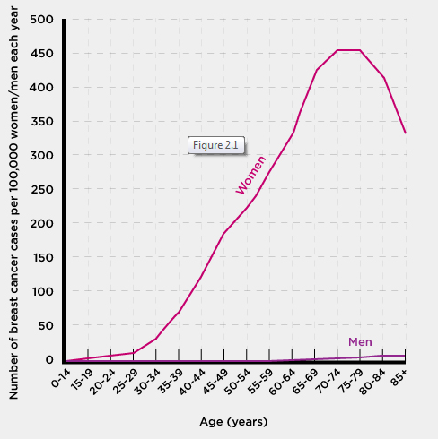
Figure 2: Age-Specific Rate of Breast Cancer in the US (7)

BC is not merely a disease of women. Although rare, it can be identified in men, too. According to the center for disease control and prevention (CDC), 1% of diagnosed breast cancers can be found in men in the US (8).

Different types of BC:
BC usually originates from the cells of lobules or ducts and based on the spread of cancerous cells, it is divided into two different types: The first type is non-invasive, in situ or BCs which stay at the same places where they are formed and do not invade normal tissues and the second type is invasive BC which does grow into healthy tissues. Most of BCs are invasive (9).
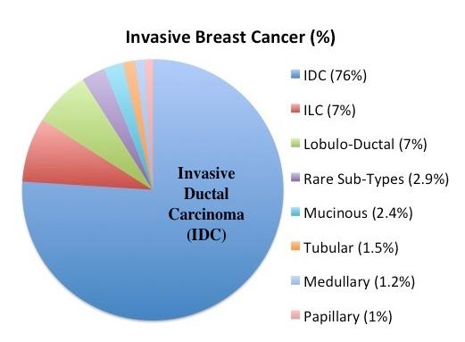
Figure3: Different types of breast cancer (10)
Stages of BC:
Classifying cancer according to how much the disease is present in the body and where it is located or how far it is from its origin is called “staging”. Tumor size, its location, the extent to which it spreads from the place of origin and where it is located at the present time, are information obtained from tests (such as clinical breast exam, mammography, or other tests) and are used to determine the stage of BC which is inevitable to appropriately plan treatment, approximate the outcomes and significantly affect survival rate (11). BC is clinically divided into 5 stages which has been illustrated in the below snapshots (figures 4 and 5).
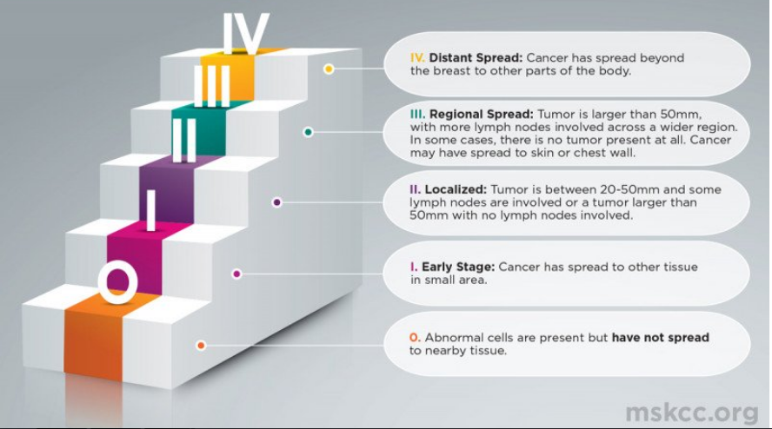
Figure 4: Stages of breast cancer(12)
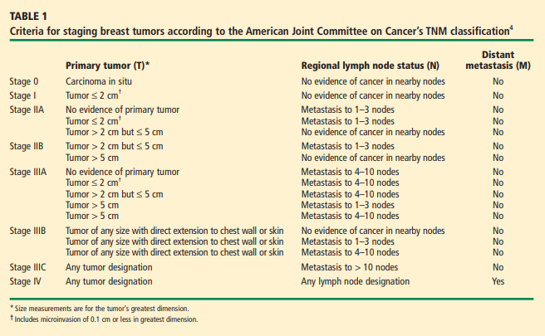
Figure 5: TNM classification system for breast cancer tumors(13)

Importance of early detection:
Mortality from BC, directly and dramatically is associated with early detection of disease. Statistics shows that 5-year survival rate is much greater (80%-99%) or even 100% when disease is identified at earlier stages than when it is diagnosed at later or end stages (22%-63% or even less than 22 %). Early diagnosis can have tremendous effect on decreasing the complications of disease (14). Early detection not only can significantly increase the rate of 5-year survival, but also can dramatically affect the costs of treatment as well. The difference in mean treatment costs is noticeable among different stages of diagnosis. Costs at stages 2, 3 and 4 are 32%, 95% and 109% higher than stage 1, respectively (15).
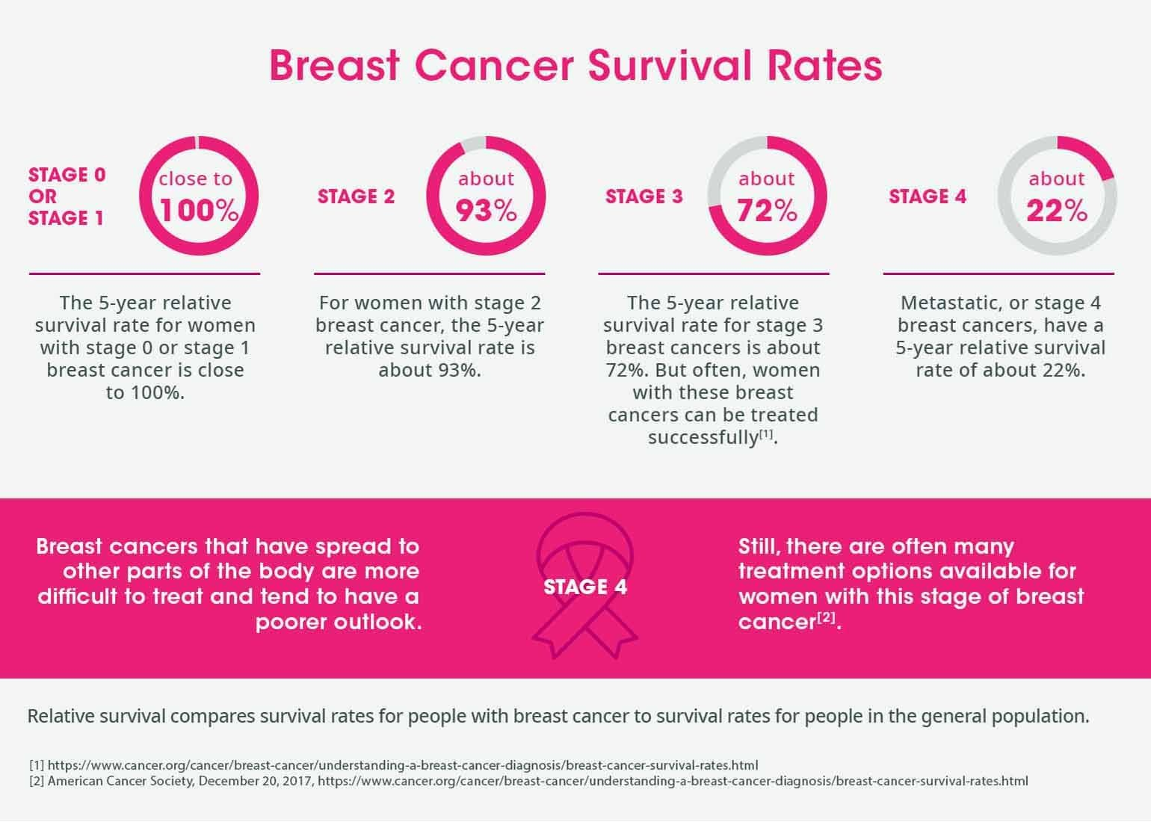
Figure6: Stages of BC and association with survival rate(16)
According to the World Health Organization, the first step to increase the rate of early detection of BC, is to improve awareness of females and their access to healthcare (17).
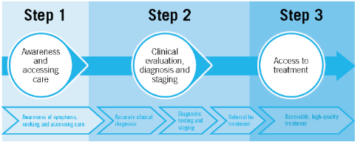
Figure7: Steps to BC early diagnosis (16)
Although breast self-exam (BSE) and clinical breast exam (CBE) are sometimes recommended, mammography is current BC standard technique and the most common breast cancer screening program (18). But in case of individuals less than 40-years of age ,dense breasts and tumors less than 1 mm- about 100.000 cells- mammography is less effective and other measures of diagnostic programs are recommended (19).
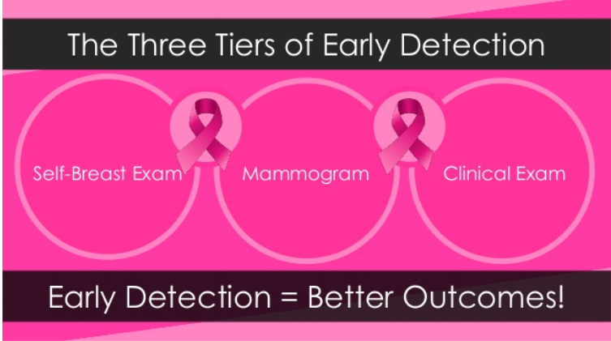
Figure8: The three most common tiers of early detection(20)

Other new methods for early diagnosis of BC are ultrasound (21), contrast-enhanced (CE) digital mammography which is more accurate than mammography and ultrasound in dense breasts (22), Magnetic resonance imaging (MRI) that is more powerful than mammography (23) and positron emission tomography (PET) which is the most accurate method. PET is expensive and may not be available for all (24). The most recent safe and low-cost alternative technique for mammography is microwave imaging (MI) technique (25). Biomarkers are among the most recent techniques, as well (26). Of course, most of these new techniques are not available or if available they are too expensive and not affordable in Iran.
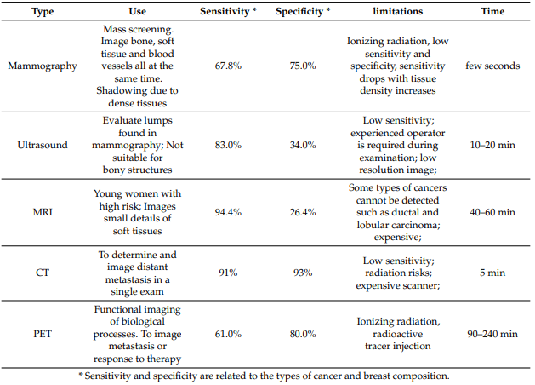
Figure 9: Conventional breast screening methods and their limitations(18)
Different organizations such as U.S. Preventive Services Task Force (UPSTF), American Cancer Society (ACS), American College of Obstetricians and Gynecologists (ACOG), International Agency for Research on Cancer (IARC), American College of Radiology (ACR), American College of Physicians (ACP), American Academy of Family Physicians (AAFP), recommend various guidelines for BC screening in women. So, there is no single accepted guideline for all (27). Below table illustrates ACS ‘s classification system which divides women into two different categories and suggests various recommendations for each group (28).
 | Women at average risk of BC | Women at high risk of BC
Characteristics | 1-NOT having a strong family history  2-NOT having gene mutation  3-NOT having personal BC history  4-NOT having chest radiation before 30 | 1-having strong family history  2-having a known gene mutation  3-Having a personal BC history  4-Having chest radiation before 30  5-Having extremely or heterogeneously  Dense breasts as seen on a mammogram  6-Having Li-Fraumeni syndrome, Cowden syndrome, or Bannayan-Riley-Ruvalcaba syndrome, or have first-degree relatives with one of these syndromes
Recommendations | - 40-44 years: mammography is an option; not necessary  - 45-56 years: should have mammography every year  - 55or older: Can continue to mammography every year or switch to every other year  - CBEs are not recommended at any age. | Should start screening with mammography and MRI at the age of 30 and continue.

Consequences of BC:
For a woman, being diagnosed with BC can be one of the most devastating events that she may confront with during her life span which can significantly affect the quality of her life (QOL).
Primary consequences of BC diagnosis include a wide range of psychological distress such as anxiety, depression, avoiding communication with others, being worried about future and family responsibilities, problems related to personal relationships, having problems in concentration, self-blaming, adverse effects of treatment, losing jobs, catastrophic financial burden and so many others which in turn can dramatically affect the QOL of patient, immediate-members of the family and also close friends.
Generally speaking, physical, social and financial problems are among the most important consequences (29).
Prevalence of depression in women with BC has a wide range from 1.5-50% (30).
More than one in ten women with BC develops severe depression (30).
Economic problems resulting from BC can affect the whole family since they are interlinked with patient (31).
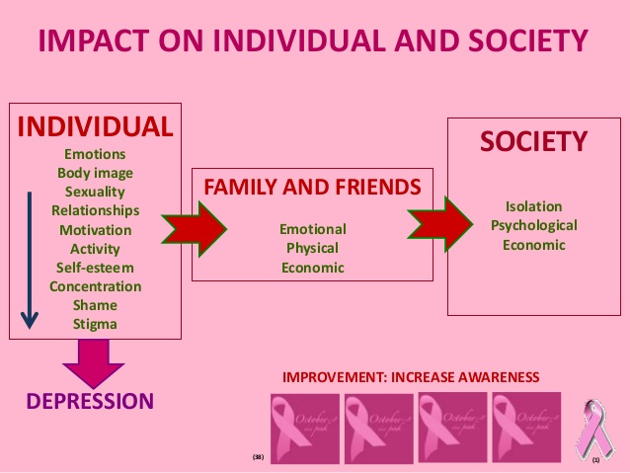
Figure10: Impacts of BC(32)
BC in Iran:
BC is the leading cause of death in women aged 35-55 in Iran (33). Comparing the most common cancers in Iranian females, it can be derived that BC is the most prevalent one, with Age Standard Rate (ASR) of 33.2 per 100,000. The mean age of occurrence of BC in Iran is 5 years earlier in comparison to mean age of affliction in developed countries (34). Another comparison between peak incidence age of BC in Iranian females with its peak at global level showed that the peak incidence of BC among Iranian females is in the fourth or fifth decades, whereas global peak incidence is a decade later (35). It is noteworthy to mention that owing to special socioeconomic status in Iran, women are considered as the main pillar of family as mothers and they have a key role in family life. So, when a mother is diagnosed with BC, this event can significantly affect not only the patient herself, but also psychological, social and financial aspects of family life (36).
Trend of BC incidence among Iranian women is ascending (37). By increasing life expectancy in recent decades and as a result of confronting with the procedure of ageing, it can naturally be anticipated that BC incidence accelerates in the near future much more than before (37). Ascending trend of BC incidence has been mentioned in some other researches, as well. Two age groups ( 45-65 and 80-85) had the highest BC incidence rate (38).
Different areas and provinces of Iran have various BC incidence rates. Lifestyle, individual behavior and age composition are among the factors that bring about these differences (39).
In addition, Iran has diverse classifications in geography, culture, climate, ethnicity, race, nutrition and socioeconomic status which cause individuals to be exposed to different risk factors conducive to BC (40). Comparing different provinces of Iran about BC, it has been found that the age standard rate of BC is higher in central and northern provinces of country (including Golestsan province) than in others (27).
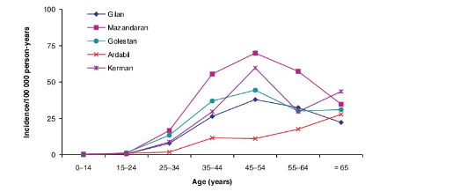
Figure 11: Age –specific incidence year per 100.000 person-years of breast cancer among women in 5 provinces in Iran (41).

In the snapshots below (figures 9 and10) BC deaths and disability-adjusted life years (DALYs) in women for all age groups in Iran in 2019 have been illustrated. BC deaths were 2.82% (2.62%-3.07%) of total deaths and BC DALYs were 1.76% (1.49%-2.07%) of total DALYs (42).
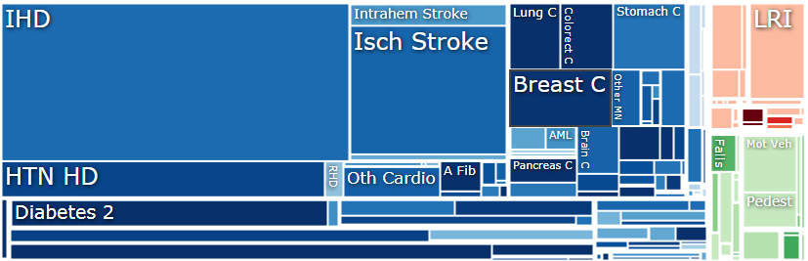
Figure 12: Iranian females - all age groups - deaths in due to BC in 2019(42)
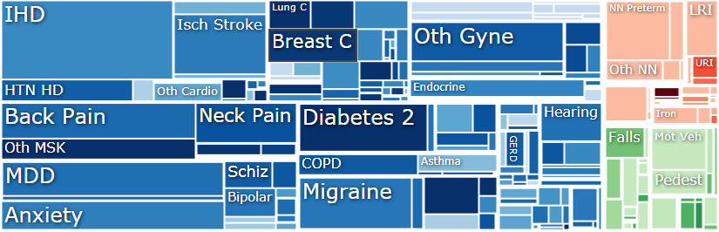
Figure 13: Iranian females, all age groups DALYs in due to BC in 2019(42)
In the next 4 snapshots, age –specific deaths and DALYs for two different age categories have been depicted and are divided into two categories according to age. The first one is for age group (15-49) and the next one is for age groups (50-69) (42).
Deaths
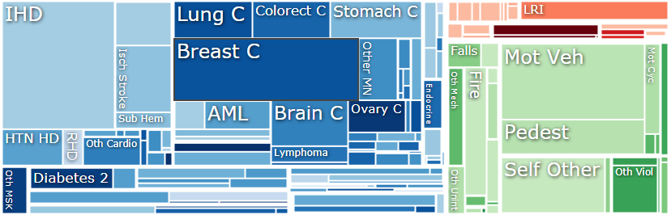
Figure 14: BC deaths in Iranian females aged 15-49 in 2019, 8.18% (7.56%- 8.84%) of total deaths-(42)
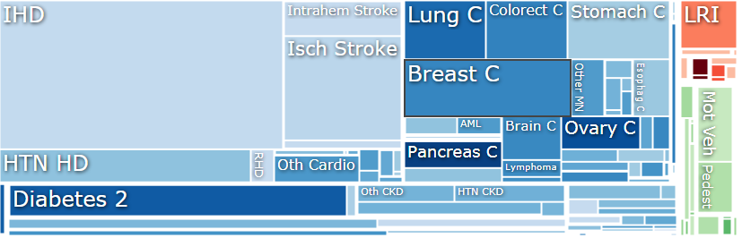
Figure 15: BC deaths in Iranian females aged 50-69 in 2019, 5.51% (5.11%-6.1%) of total deaths -(42)
Comparing figures 14 and 15 demonstrates that death rate among younger age group (15-49) is much higher than in older age group (50-69). It signifies the importance of improving knowledge, attitudes and practices of individuals in this age group about BC, to increase the rate of breast self-exam, clinical breast exam, mammography or other preventive measures so as to diagnose the disease in earlier stages in the natural history of the disease. Below figures depict DALYs.
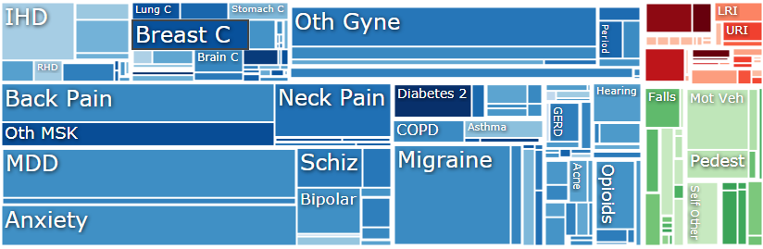
Figure 16: BC DALYs in Iranian females, aged 15-49 in 2019, 1.9% (1.515-2.36%) of total DALYs - (29)
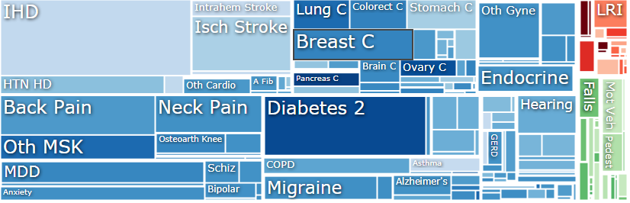
Figure 17: BC DALYs in Iranian females aged 50-69 in 2019, 2.93% (2.49%-3.42%) of total DALYs - (29)
Comparing figures 16 and 17 depicts that DALYs in older age group are roughly 50% higher than in younger age group (2.93% in older age group in comparison to 1.9%, in younger age group). It should be investigated that whether the witnessed difference is due to inappropriate time of diagnosis or the other probabilities such as comorbidities in elderly, lack of access to healthcare services, higher expenses or any other reasons.
Golestan Province:
Golestan province is located in north-east of Iran and south of Caspian Sea with a population of 1.8 million (in 2016) and an area of 20.380 km square. Its name comes from “Gol” which means “flower” and “estan” which means “land” in Persian language, so literary Golestan means “The land of flowers”. Golestan has 12 counties which are called “sharestan” in Persian language.
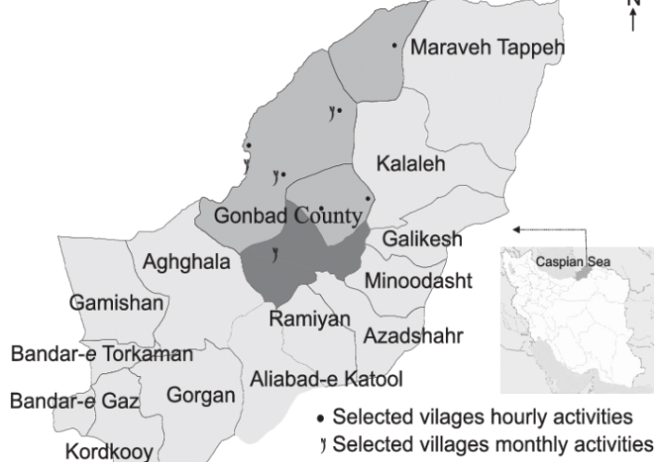
Figure 18: Map of Golestan province (43)
BC is the most prevalent female cancer in Golestan province and the trend is ascending (44).
Gonbade-ghaboos County:
Gonbade-ghaboos, with a population of 348744 in 97147 families, is the largest county in the province. Turkmen ethnicity is the most prominent and the most populated ethnicity in this county (45).
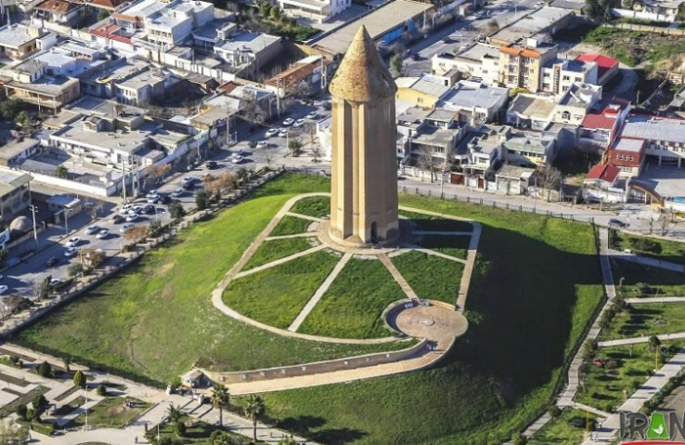
Figure 19: Symbol of the city. Tomb of Shams-ol-Mali Qaboos Ebne Voshmgir Ziyari, the ruler, in ancient times(46)
According to American Cancer Society (ACS) BC risk factors are divided into two groups. Modifiable (life-style related) and non-modifiable risk factors (47). Drinking alcohol, being overweight or obese, physical inactivity, null-parity, not breastfeeding, taking oral contraceptive pills (OCPs), hormone therapy after menopause and socioeconomic status are among the most important modifiable (life-style related) risk factors (34).
Being a female, inheriting certain genes, personal and also family history of BC, having early menstrual period, having dense breast tissues, age, race, ethnicity and geographic place of residence are among risk factors which can affect patterns of practicing BC screening programs, affect the rate of mortality and also have great impact on severity of complications .(34).
That is why, Gonbade-ghaboos (as the largest Turkmen city in Iran) has been considered and selected for this research to find out if there are any differences in knowledge, attitude and practices of Turkmen women (as the most prominent ethnicity in this county) with women from other ethnicities. This knowledge and attitude can affect participation in BC screening programs and early detection of disease, if it is definitely followed by taking action.
Literature review (globally):
Since BC incidence and related-deaths are important public health problems worldwide, there are a myriad number of studies performed in different parts of the world to assess knowledge, attitude and practices of women towards BC. From among all, we can name the studies performed in Saudi Arabia (48), Pakistan (49) , Iraq (50) , Nigeria (51), Tunisia (52), Saudi Arabia (53), India (54), Vietnam (55), India (56), Eritrea (57), Saudi Arabia (58), Vietnam (59), India (60) , Saudi Arabia (61). The goals of all these studies were to assess women’s knowledge, attitude and practices towards BC and BC screening programs in different geographic areas or in different countries so as to use the results to intervene, to improve the situation and to help early detection of BC, if necessary.
According to ACS, race, ethnicity and geographical region of residence can have great impact on socioeconomic, cultural, religious, environmental and so many other different factors involving in BC incidence and mortality. So, the study conducted in a special part of the world and in a special target population, although can provide a general overview of the problem for researchers, cannot introduce appropriate data for decision makers and health planners in other parts of the world or in a different population.
Actually, information about each target population is specific to that special community and can help policy-makers in that special area to make appropriate decisions, policies and plans according to the available data introduced at state, county or province or level.
Literature review in Iran:
There is no article related to study knowledge, attitude and practices of women towards BC in Gonbade-ghaboos, but there are some similar studies performed in different provinces or cities of Iran. In a study conducted by Parsa, et al in 2005 in Hamedan, 261 patients who referred to health and medical centers in Hamedan were interviewed with a structured questionnaire to explore their knowledge towards BC and their practices about breast self-examination (BSE). Two third of participants had never performed BSE, in 48% of these participants the reason for not practicing BSE was “lack of knowledge”. At the end of the study they reached this conclusion that most of the participants did not have appropriate and enough information about pertinent issues related to BC and had poor BSE practice. This article also mentioned that in western countries BC is a disease of postmenopausal period and usually cannot be seen in premenopausal females. But in Iran, premenopausal women (younger women) can be afflicted by disease, as well (62).
In another study conducted by Akhtari et al, in the same city (Hamedan), yeas later in 2014, to explore knowledge of BC and BSE practice among Iranian Women in Hamedan, 368 women were interviewed face-to-face based on a validated questionnaire. Only 26% of the participants had BSE practice and level of breast cancer knowledge was significantly associated with BSE practice. So, nine years after the first study (by Parsa in 2005) the researchers again reached the conclusion that the women had inadequate knowledge about BC and related issues, probably showing that no intervention had been implemented from the time that the first study had been performed (63).
A similar study conducted by Tazhibi et al, in Isfahan, published in 2014, to explore awareness level of BC risk factors, early warning signs, and screening and therapeutic approaches among Iranian adult women residing in Isfahan. In this cross-sectional study 2250 women in an institute of cancer research in Isfahan were investigated with a self-administered questionnaire. The rate of awareness about screening approaches, risk factors, early warning signs and therapeutic modalities of breast cancer was 33.2%, 31.9%, 26.7%, and 35.8%, respectively, and level of knowledge about BC was poor to moderate. The researchers reached this conclusion that awareness of study population about BC was low (64).
Fouladi et al, conducted a study in Ardebil, north-west of Iran, on 380 women 30 years- old or more, in 2013, to explore beliefs and behaviors of BC screening among women referring to health care centers in Ardebil , using a modified health belief model questionnaire. The result of the study showed that only 27% of women performed BSE, suggesting low level of awareness and knowledge among target population (65).
In a study conducted by Atashi et al, they used a standardized questionnaire to explore knowledge, attitudes, and practices toward breast cancer among 210 midwives, aged 20-62, participating in a breast cancer educational seminar in Tehran in 2020. The results showed that knowledge in 65.9% of the participants was excellent and 30.8% of them had regular BSE every month. So the researchers reached the conclusion that awareness and knowledge of BC is associated with educational level (66).
Importance of this study:
BC is the cause of a constellation of consequences, including death and disability adjusted life years (DALYs). Given that BC can dramatically affect quality of life, it can be considered as an important cause of devastating problems for the individuals, families and communities. BC can impose great burden on health care systems, as well. So, it is crucial for women to have enough basic knowledge about BC. This knowledge can have huge impact to participate in BC screening programs which can lead to early detection of the disease so as to avoid a great number of deaths and DALYs. In this case and as the first step, it is necessary to assess knowledge of target population and then try to intervene in order to improve the situation according to the results.
In this study we are going to evaluate knowledge, attitude and practices of Iranian women aged 20-70, residing in Gonbade-Ghaboos towards BC and BC screening programs. The data obtained from this study can be used by policy-makers at county or even province level to intervene, if necessary, in order to improve the situation and to decrease number of deaths or related consequences of BC.

Goals of the study:

Source: Clearvoice.com

General goal:
To study knowledge, attitude and practices about BC and BC screening programs among women aged 20-70, residing in Gonbade-ghaboos, referring to one of the main reference radiology and sonography centers in the county.

Specific goals:
- To determine level of knowledge, attitude and practices (KAP) about BC and BC screening programs among women aged 20-70, residing in Gonbade-ghaboos, referring to one of the main radiology and sonography centers in this city
- To identify practices of women aged 20-70, residing in Gonbad-ghaboos, referring to one of the main radiology and sonography centers in this city for screening BC behaviors
- To determine association between some of the most important demographic risk factors/exposures with probability of having BSE or mammography
- To study barriers to mammography
- Note: Knowledge and attitude about BC are factors that can lead to practices. So, knowledge and attitude were considered as “main exposures” and practices were considered as “main outcomes”.
Research method:
Study design: This was a cross-sectional study design.
Sampling method: Convenience sampling method was used to recruit the participants.

Sample size:
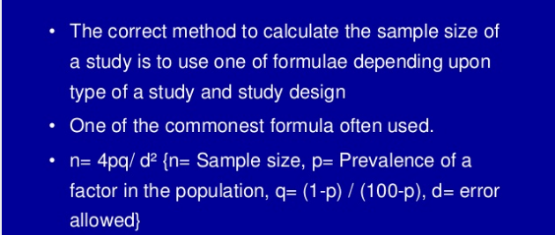
Figure 20: Sample size calculation(67)
- We used a special formula to calculate sample size in this cross-sectional study. Generally we need some factors to calculate sample size in a cross-sectional study design (68).
- We need P which is prevalence of condition/ health state and is obtained from previous studies. If there is no information from previous similar studies, the same as the case in this research (that no study has been conducted in county of interest up to the present time), then p should be considered P=0.5(or 50%). In this study, P is rate of knowledge, attitude and practices of Iranian women, residing in Gonbadeghaboos at the time of study, towards breast cancer.
- We also need q which is 100-p (when p is in percentage terms) and 1-p (when p is in decimal terms). In this study p=q=0.5.
- We need d, as well, which is allowable error (5-20% of P).It is also called the precision of the estimate. It can be called either relative precision, or the absolute precision. In this study d=5%=0.05.
- The last factor that we need is Za [Z alpha]. The value of z is obtained from probability tables. Considering this assumption that values are normally distributed, then 95% of values falls within 2 standard deviation of the mean. The value of z corresponding to this would be 1.96 (from standard normal variate tables).
The formula for estimating sample size (n) is:
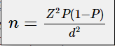 (68).
Substituting values of Za, we have n= (1.96) ^2[p*q]/d^2, where ^ is the symbol of “in power of”. We can round off value of Za (1.96) to 2, to obtain: n= (2) ^2[p*q], so n=4pq/d^2. Where * is the symbol of “multiplied by”.
In this study, p=q=0.5. So, n=4(0.5*0.5)/d^2= 4(0.5*0.5)/(0.05)^2= 4*0.25/0.0025=400
Using above-mentioned formula we recruited 400 individuals to participate in this study.

Sample population& Inclusion criteria:
Sample population of the study were all recruited from females, aged 20-70, residing in Gonbade-ghaboos at the time of study, referring to a reference radiology and sonography center for any reason as a patient within one month period from 22nd August to 22 September 2020. A total number of 400 participants were recruited to enter study according to calculations which computed appropriate number of sample size. There was no financial benefit for the radiology center during whole period of study. This center was the most famous, the best equipped and the most precise center in county and people usually refer to this center from different areas of county (not only the individuals who lived near this center). In this case, researcher not only could be sure about random selection of sample population, using convenience sampling method, but also could make sure that women participated in this study were representative of total population in this county. This could increase external validity of research and could make sure that results of this research can be generalizable to whole population of females residing in this county.
To avoid bias, participants were recruited from females who were totally alert and free from any aches at the time of referring to center to be able to fill in questionnaire and answer the questions carefully, completely and with maximum concentration, or they were excluded from study.
Manager of radiology center was present at all stages of data collection, supervising and evaluating whole procedure so as to make sure that the process of data collection be conducted accurately and correctly and also to solve probable problems, if there were any.
Recruiting a facilitator:
Following rules for active surveillance to achieve more accurate data, the author decided to specifically employ someone to interview candidates, assist them to fill in the structured questionnaire, if necessary and to explain them any probable misunderstanding to avoid dilemma in comprehending and answering questions.
Taking into consideration that all participants were female, knowing the local culture of women in this area (who were more convenient to talk to a female healthcare staff about their breast than to talk to a man) and also predicting that a large number of candidates will be recruited from among Turkmen ethnicity (major ethnicity in this county) who may not be able to communicate in Persian language correctly and properly, a Turkmen girl was recruited to work as a facilitator.
She was a university student of sports science, had excellent social communication abilities and was totally fluent in both Persian and Turkmen languages. The employee was trained for a week by researcher and manager of radiology center. She was trained to comprehend questions perfectly and to practice how to explain questions to sample population, if necessary. The facilitator was also trained so as to know how to behave with individuals, to encourage them to take part in study, to help them answer questions and to supervise the whole procedure so as to make sure that process of filling in the questionnaires being conducted appropriately and accurately. She was supervised by manager of radiology center at all stages of data collection.
The facilitator was paid for one month by researcher. She was asked to be present at radiology center from 8AM to 3PM during week days to recruit considered sample population and also she was asked to send a complete daily report (number of recruited individuals and any probable problems that she was confronted with during that day) to researcher through e-mail every night at 10 PM.
Informed consent:
A consent form was prepared. It contained a brief explanation of breast cancer and an overview about goals, risks and benefits of research project. It was clarified that they could withdraw and have their form destroyed at any point during the study.
Ethical considerations:
To regard ethical considerations, confidentiality, anonymity and voluntary nature of participation was explicitly mentioned in consent form. Also, it was being clarified that they were not obliged to answer all questions and they were free if they did not want to respond any question. Needless to say, the facilitator explained them that research team would appreciate if they answer as many questions as they can, so as to make the questionnaire more complete and assist investigator to reach more precise results. At the end of the day they were asked to sign consent form, hand it out to facilitator and receive the questionnaire.

Questionnaire:
The questionnaire consisted of 31 questions and was designed in 6 different parts as follow:
Questionnaire | Title of each part | Number of questions | Sub-questions
Part 1 | Sociodemographic | 11 | NA
Part 2 | General knowledge | 6 | NA
Part 3 | Knowledge on risk factors | 1 | Yes-9 question
Part 4 | Knowledge on signs & symptoms | 1 | Yes-6 question
Part 5 | Attitudes | 4 | NA
Part 6 | Practices | 8 | NA
Total |  | 31 | 15
*NA: Not available/applicable
Each questionnaire took about 20 minutes, on average, to be completed and filled in. It should be mentioned that original questionnaire, written in English, was translated into Persian language by author and then was re-translated into English by an American university student of nursing. Two English versions were compared by supervisor so as to be totally the same and to make sure that original questionnaire had been carefully and accurately translated into Persian language. Given that both translations were the same, researcher could make sure that translation of Persian version was exactly in accordance with original English questionnaire. Complete English version of questionnaire is enclosed (appendix section).
Data collection:
Data were collected via face-to-face conversation with participants to persuade them so as to take part in this study. After signing consent form, questionnaires were handed to volunteers. The facilitator was available during whole period to translate questions into Turkmen language or make any clarifications for those who were not sufficiently literate, if necessary. In the end, facilitator went through all questions to make sure that all questions have been answered, except for those that volunteers themselves did not want to answer.
Data analysis: IBM SPSS statistical software version 23 was used to analyze data.
We went through these steps to analyze data:
- Encoding questionnaires and entering data into statistical software
- Descriptive analysis
- Analytical analysis

Now, we go through each step-in detail.
- Encoding questionnaires and entering data into statistical software
First of all, we encoded all questionnaires and allocated a number to each, from 1 to 400, so as to have the possibility to return back to each question in every questionnaire and check it out again, to correct any probable mistakes in process of entering data into SPSS and to make corrections, if necessary. Then data for each questionnaire were entered into SPSS, separately.
- Descriptive Data and tables
Exposures, Outcomes and covariates: The most important sociodemographic risk factor (as exposure) was ethnicity in this study. Also, age, educational level of participants, their place of residence and marital status were other important demographic risk factors considered as exposure that could affect outcomes and were analyzed in the next section. Breast self- exam (BSE) and mammography were the final outcomes and age was considered as a covariate for all.
In this step, for the first part of the questionnaire, descriptive analysis was performed to introduce demographic characteristics of participants. Frequency and percentage of each factor as an exposure (age, marital status, age at marriage, number of children, educational level, ethnicity, place of residence, monthly family income, occupation and family history of BC) were calculated and related tables were designed (Table 1). Afterwards, the same analysis was performed for each of six different parts of questionnaire, separately and related tables were designed as well (Tables 2 to 6).
- Analysis→ Descriptive studies → Frequencies were the routes, used from” data view sheet” in SPSS to achieve the results for designing each table.

- Analytical analysis
Part A:
- To determine knowledge, attitude and practices (KAP) level of participants in quantitative terms, calculating KAP score for each and also for different categories.
In this part we went through these routes in SPSS:
Transform→ Recode into different variables→ Old and new values
We put forward 27 questions to define a parameter as total knowledge, attitude and practices score (KAPS) for participants. For each of these 27 questions we allocated below scoring system:
“1” if the answer was correct and” 0” if the answer was incorrect.
Afterwards this route was followed:
Transform→ Compute variable→ Define “target variable (As total KAP)
And we computed KAP score (KAPS) for each participant.
At the next step, these KAPSs were categorized and a new grouping system was introduced and defined as follow:
KAP score | 0-9 | 10-18 | 19-28
Category | Weak | Average | Good

Part B:
- To assess the association between risk factors (exposures) and odds of having BSE or mammography (as outcomes).
Following this route in SPSS we achieved the aforementioned goals:
Analyze→ Regression→ Binary logistic→ Define dependent variable and also independent variables (once the exposure alone and the second time we added age, ethnicity, education, Place of residence and marital status for adjustment.).
The results are being shown in the second part of analytical analysis in “result section (Table8 and Table9).
Results:
Descriptive results
Descriptive data for participants who took part in this study are being illustrated in 6 different tables.
Table 1: Sociodemographic Characteristics of participants
 |  | Frequency | Percent
Age |  | (n) | (%)
20-30 |  | 103 | 25.8
31-40 |  | 139 | 34.8
41-50 |  | 98 | 24.5
51-70 |  | 60 | 14.9
Marriage
Single |  | 53 | 13.2
Married |  | 327 | 81.8
Others |  | 20 | 5
Marital age
<20 |  | 192 | 48
20-25 |  | 115 | 28.7
>26 |  | 45 | 11.3
Missing |  | 48 | 12
Parity
None |  | 76 | 19
1 |  | 90 | 22.5
2 |  | 104 | 26
>2 |  | 86 | 21.5
Missing |  | 44 | 11
Education
No High school certificate |  | 150 | 37.5
High school certificate |  | 112 | 28
Higher education |  | 138 | 30.5
Ethnicity
Fars |  | 179 | 44.8
Turkmen |  | 125 | 31.3
Others |  | 96 | 23.9
Place of residence
Urban |  | 204 | 51
Rural |  | 196 | 49
Monthly family income
< 2 million Toman |  | 106 | 26.5
2-6 Million Toman |  | 190 | 47.5
Not stable |  | 91 | 22.7
Missing |  | 13 | 3.3
Occupation
Housewife |  | 290 | 72.5
Others |  | 110 | 27.5
Family history of breast cancer
Yes |  | 45 | 11.8
No |  | 355 | 88.2
Relatives with breast cancer
Mother |  | 11 | 2.8
Sister |  | 14 | 3.4
Others |  | 20 | 5
Missing/No |  | 355 | 88.8
Total(N) |  | 400 | 100
Table 1 describes sociodemographic characteristics of participants.
Descriptive statistics about age indicates that more than one-third (139 individuals) of participants were between 31-40 years of age which constitute the largest age group (34.8%). Remaining parts were categorized in other age groups, 21-30 (n=103), 41-50 (n=98) and 51-70 (n=60) equivalent to 25.8%, 24.5% and14.9% of all participants, respectively.
At initial category the researcher divided whole individuals into 5 age categories, but given that size of two last age groups were too small, they were aggregated.
Most of the participants were married (81.8%) and 13.2% were single. Only 5% of sample population had other different marital status (divorced, widowed or separated).
Age at marriage for nearly half of participants (48%) was under 20 and 28.7% of women in sample population were married at ages between 21- 25. Age at marriage was more than 26 years for 11.3% of females.
Considering parity, it could be found that 19% of women took part in this research had no child. 22.5% had one child, 26% had two children and 21.5% had more than two children.
More than one-third of females in this study (37%) had no high school certificate and 28% of them had high school certificate. 30.5% of the sample population had higher education (associated, bachelor, master degree or higher).
In regard to ethnicity, it could be found that just a little less than one-third of participants (31.3%) were from Turkmen ethnicity, the most prominent ethnicity in this county.
48% of the participants were from Fars ethnicity and 23.9% had other different ethnicities (Mazandarani, Turk, Balouch and others).
Frequency distribution of place of residence for women in this study was nearly the same between urban (51%) and rural areas (48.5%).
47.5% of candidates had monthly family income (MFI), more than2 and less than 6 million Toman (they were considered as families with an average MFI).
The figure for 26.5% of them was less than 2 million Toman (poor MFI) and in 22.7% of individuals MFI was not constant. And 3.3% of them didn’t tend to express their monthly family income.
Most of women participated in this study were housewife (72.5%) and the remaining 27.5% of them had various jobs (Private, civil servants, university-students or others).
There was no report on family history of BC among 88.2% of women and only 11.8% of them had family history of BC.
Considering the first-degree relatives, 3.4% of candidates reported a BC history for their sister and 2.8% for their mother.
Table 2: General knowledge of participants towards breast cancer
 | Frequency | Percent
 | (n) | (%)
Have you ever heard of breast cancer?
Yes | 377 | 94.5
No | 23 | 5.5
If heard, What is the source?
TV/Radio | 160 | 40
Health staff | 66 | 16.5
Other sources/Missing | 174 | 43.5
Have you ever heard of breast self-exam?
Yes | 307 | 76.8
No | 93 | 23.2
If heard, What is the source?
TV/Radio | 106 | 26.4
Health staff | 91 | 22.8
Other sources/Missing | 203 | 50.8
Why should BSE be done?
Helps BC prevention | 253 | 63.3
Health staff’s Advice | 46 | 11.5
I don’t know/ Missing | 73 | 18.2
Do you think BC is preventable?
Yes | 355 | 88.7
No | 45 | 11.3
Total (N/%) | 400 | 100
Table 2 signifies general knowledge of participants towards BC.
Nearly all of candidates (94.3%) had heard of BC and only 5.7% of them declared that they had never heard of BC. Evaluating sources of information in former group, we found that mass media including TV/Radio (40%) and health staffs (16.5%) were the most important sources, only second to other sources (43.5%), mainly internet (there were some missing data included in this figure). TV was the main source of information about BC (39.5%). Radio’s share was only 0.5%.
Roughly four-fifth of participants (76%) had heard of breast self-exam (BSE). Health staffs were the least important source of information in this group (22.8%), TV/Radio ranked the second (26.4% totally), 25.6% TV and 0.8% Radio, and the main source of information among this group was some sources other than the aforementioned ones (50.8%), mainly internet. There were some missing data included in this figure.
When individuals were asked “why BSE should be done”, more than three-fifth (63.3%) announced that it should be done given that health-care staffs advised to do so.
Less than one-fifth of them (18%) knew that BSE helps BC prevention, and 18.7% didn’t know the answer to the question or the question was missed.
Most of the sample population (88.7%) believed that BC is preventable and only 11.3% of them thought that BC cannot be prevented.
Table 3: Knowledge about risk factors(RFs) for BC
 |  | Frequency | Percent
 |  | (n) | (%)
Family history of BC is a risk factor
Agree |  | 248 | 62
Disagree |  | 17 | 4.2
I don't know/Missing |  | 135 | 33.8
Mother's BC is a risk factor
Agree |  | 271 | 67.8
Disagree |  | 18 | 4.5
I don't know/Missing |  | 111 | 27.7
Age is not a risk factor
Agree |  | 171 | 42.8
Disagree |  | 89 | 22.2
I don't know/Missing |  | 140 | 35
Giving birth after 35 is a risk factor
Agree |  | 64 | 16
Disagree |  | 76 | 19
I don't know/Missing |  | 260 | 65
Post-menopausal overweight is a risk factor
Agree |  | 84 | 21
Disagree |  | 52 | 13
I don't know/Missing |  | 264 | 66
Diet & Lifestyle are risk factors
Agree |  | 180 | 45
Disagree |  | 65 | 16.2
I don't know/Missing |  | 155 | 38.8
Using oral contraceptives>5 years is a risk factor
Agree |  | 90 | 22.5
Disagree |  | 48 | 12
I don't know/Missing |  | 262 | 65.5
>1 alcoholic drink per day is a risk factor
Agree |  | 91 | 22.8
Disagree |  | 34 | 8.4
I don't know/Missing |  | 275 | 68.8
No breastfeeding is a risk factor
Agree |  | 218 | 54.5
Disagree |  | 31 | 7.7
I don't know/Missing |  | 151 | 37.8
Total (N/%) |  | 400 | 100

Table 3 illustrates participants’ knowledge on BC risk factors. 10 risk factors have been evaluated in this part.
More than three-fifth of participants (62%) believed that family history of BC can be a risk factor for BC. 4.2% of participants didn’t believe the same as the former group and 33.8% didn’t know the answer or question was left unanswered.
Interestingly, when question became more specific and asked about mother’s BC as a risk factor,67.8% of candidates believed that mother’s BC is a risk factor for BC, whereas 4.5% did not believe so and 27.7% didn’t know the answer or the answer was missed.
42.8% believed that age is a risk factor and 22.2 % didn’t think so. In 35% of cases the answer was “I don’t know” or it was missed.
65% of the individuals didn’t know that giving birth to a child after 35 years of age can be a risk factor for BC or not (or answer was missed). Less than one-fifth of females (16%) believed that giving birth to a child after 35 is a risk factor and nearly one-fifth (19%) announced that it is not a risk factor.
21% of females believed that postmenopausal overweight is a risk factor and 13% believed it was not a risk factor for BC.
66% didn’t know whether being overweight after menopause can be a risk factor for BC or not (or question was missed).
When question asked about diet and lifestyle as a risk factor for BC, 45% of women believed that it was a risk factor whereas 16.2% didn’t think so and 38.8% didn’t know the answer (or the answer was missed).
22.5% of participants knew that using oral contraceptive pills (OCPs) for more than 5 years can be a risk factor for BC.12% believe that using OCPs> 5 years was not a risk factor and 65.5% of cases didn’t know the answer or the answer was missed.
Consuming more than one alcoholic drink per day was considered as a risk factor for BC by22.8% of candidates. 8.4% believed that it was not a risk factor and a large number (68.8%) didn’t know or missed the answer.
More than half of participants (54.5%) thought that no breastfeeding can be a risk factor for BC. On the contrary, 7.7% didn’t believe that it could be a risk factor and 37.8% didn’t have any idea about it (They whether didn’t know the answer or the answer was missed).
Table 4: Participants' knowledge towards BC signs and symptoms
 |  |  | Frequency | Percent
 |  |  | (n) | (%)
Breast paresthesia
Is a sign |  |  | 122 | 30.5
Is not a sign |  |  | 34 | 8.5
I don’t know |  |  | 244 | 61
Changing the skin form
Is a sign |  |  | 192 | 48
Is not a sign |  |  | 19 | 4.8
I don't know |  |  | 189 | 47.2
Bloody discharge from nipple
Is a sign |  |  | 228 | 57
Is not a sign |  |  | 21 | 5.2
I don't know |  |  | 151 | 37.8
Painful breast
Is a sign |  |  | 26 | 6.5
Is not a sign |  |  | 235 | 58.8
I don't know |  |  | 139 | 34.7
Wound on nipple
Is a sign |  |  | 167 | 41.8
Is not a sign |  |  | 55 | 13.8
I don't know |  |  | 178 | 44.4
Suspicious mass
Is a sign |  |  | 263 | 65.8
Is not a sign |  |  | 31 | 7.8
I don't know |  |  | 106 | 26.4
Total (N/%) |  |  | 400 | 100
Table 4 shows participant’s knowledge on BC signs and symptoms.
30.5% of women believed that breast paresthesia can be a sign of BC. 8.5% didn’t believe so and 61% didn’t know the answer. About half of the candidates (48%) knew that changing skin form can be a sign of BC. 4.8% didn’t think so and approximately the same percent of the first group (47.2%) didn’t know the answer.
More than half of the individuals (57%) believed that bloody discharge from nipple can be considered as a sign of BC and only 5.2% rejected this idea. 37.8%, didn’t know the answer.
Only 6.5% of females rejected the idea that painful breast near menopause can be considered as a sign of BC. 58.8% of them had the opposite idea and34.7% didn’t know the answer.
They were also asked about wound on nipple as a sign of BC. 41.8% considered this fact to be true and 13.8% believed that it cannot be a sign of BC. 44.4% didn’t know the answer.
More than three-fifth of the candidates (65.8%) believed that suspicious mass can be a sign of BC, whereas 7.8% thought vice versa. 26.4% didn’t know the answer to this question.

Table 5: Attitude of participants about breast cancer
 |  |  | Frequency | Percent
 |  |  | (n) | (%)
Patients should live freely in community
Agree |  |  | 352 | 88
Disagree/not sure |  |  | 48 | 12
BC is a punishment from God
Agree |  |  | 41 | 10.25
Disagree/not sure |  |  | 359 | 89.75
Community should provide support for patients
Agree |  |  | 352 | 88
Disagree/not sure |  |  | 48 | 12
BC patients should not breastfeed
Agree |  |  | 192 | 48
Disagree/not sure |  |  | 208 | 52
Total (N/%) |  |  | 400 | 100

Table 5 depicts attitude of participants towards BC and consisted of 4 questions. 88% of participants were agree with this opinion that patients with BC should live freely in the community and 12% were not agree or were not sure about the answer. 10.25% of sample population were agree that BC is a punishment from GOD but 89.75% disagreed or were not sure. Also, 88% agreed that community should provide support for BC patients and only 12 % were not agree or were not sure about it. 48% of individuals believed that women with BC should not breastfeed their babies whereas 52% of them disagreed or were not sure.
Table 6 : Participants' practices on breast cancer screening programs
 |  |  |  | Frequency | Percent
 |  |  |  | (n) | (%)
Have you ever done BSE?
Yes |  |  |  | 214 | 53.5
No/missing |  |  |  | 186 | 46.5
Why did you have BSE?
Health staffs' advice |  |  |  | 51 | 12.8
Noticing a lump in my breast |  |  |  | 31 | 7.7
One of family had BC/Warning |  |  |  | 14 | 3.5
Routine medical assessment |  |  |  | 110 | 27.5
Missing |  |  |  | 194 | 48.5
Why didn't you have BSE?
Didn't know about it |  |  |  | 99 | 24.8
Didn't know how to do it |  |  |  | 29 | 7.2
I was afraid of the result |  |  |  | 66 | 16.5
Missing |  |  |  | 206 | 51.5
Have you ever had mammography?
Yes |  |  |  | 84 | 21
No/missing |  |  |  | 316 | 79
How many times you had mammography?
Only once |  |  |  | 52 | 13
Every year |  |  |  | 7 | 1.8
Every 2 year |  |  |  | 9 | 2.2
Every 3 year |  |  |  | 3 | 0.8
Whenever necessary |  |  |  | 13 | 3.2
Missing |  |  |  | 316 | 79
When was your last mammography?
During last month |  |  |  | 12 | 3
During last year |  |  |  | 30 | 7.5
> A year ago |  |  |  | 42 | 10.5
Missing |  |  |  | 316 | 79
Why did you get a mammography?
A family member had BC |  |  |  | 10 | 2.5
A friend had BC/Warning |  |  |  | 1 | 0.2
Family member's suggestion |  |  |  | 3 | 0.8
A friend suggested |  |  |  | 1 | 0.2
A doctor suggested |  |  |  | 42 | 10.5
Routine check-up |  |  |  | 14 | 3.5
Because of my age |  |  |  | 8 | 2
Other reasons |  |  |  | 5 | 1.3
Missing |  |  |  | 316 | 79
Conditions leading to mammography
Husband agreement |  |  |  | 6 | 1.5
If results benefit |  |  |  | 125 | 31.2
Results kept secret |  |  |  | 5 | 1.4
If there is a treatment for BC |  |  |  | 17 | 4.3
If the center is near my home |  |  |  | 1 | 0.2
If it is affordable |  |  |  | 99 | 24.8
If it is totally free |  |  |  | 64 | 15
If the doctor is a woman |  |  |  | 82 | 2.4
Missing |  |  |  | 1 | 0.2
Total (N/%) |  |  |  | 400 | 100

Table 6 displays participant’s practices on breast cancer screening programs concerning BSE and mammography.
53.5% of sample population had done BSE and 46.5% hadn’t done. (The latter figure included missing data). Afterwards, they were asked about reasons for practicing BSE. Routine medical assessment ranked first among reasons for practicing BSE (27.5%).Among the other reasons, health staffs’ advice, noticing a lump in breast, BC family history as a warning, ranked second to forth by 12.8%, 7.7 and 3.5%, respectively. 48.5% were missing (including participants who hadn’t done BSE and the ones who didn’t answer).Then, reasons for not having BSE were asked. Nearly one fourth of candidates (24.8%) didn’t know anything about BSE. 16.5% had not performed BSE because they were afraid of the results and 7.2% didn’t know how to do it. 51.5% were missing, including the individuals who did BSE (and naturally didn’t need to answer the question) and those who missed the question. Just a little more than one-fifth of sample population (21%), had done mammography and 79% of them had not performed mammography, which included missing data.
Considering total sample size, 13% had performed mammography only once during their lifetime. The proportion of having mammography every year, every two year and every three year were 1.8%, 2.2% and 0.8%, respectively. 79% considered as missing including individuals who hadn’t done mammography and the ones who did not answer the question. From among all women took part in this study, top-three causes of having mammography were doctors’ suggestion, routine check-up and having positive BC family history with rates of 10.5%, 3.5% and 2.5%, respectively. 2% had performed mammography because of their age. Family member’s suggestion (0.8%), a friend’s suggestion (0.2%) and having a friend with BC as a warning (0.2%) were among the other reasons. 1.3% of females participated in the study performed mammography for reasons other than aforementioned reasons.
As the last and maybe the most important question in applied epidemiology related to BC, at the end of this part, women were asked about barriers to mammography and the situations under which they would accept to perform mammography.
This is one of the most considerable and the most crucial issues for policy-makers, health care systems and the ones who are in a position to take action. The results can be used to plan and implement some interventions so as to encourage females and to facilitate situation in order for females to increase their participation in BC screening programs and to perform mammography which in turn can significantly improve early detection of disease, decrease mortality and eliminate consequences of BC.
Among total sample population, the most important barrier to mammography was economic problem. Approximately one-fourth of the whole participants (24.8%) announced that they will have mammography if it is affordable and 15% declared that they will do so if it is totally free. To sum up, according to about 40 % of sample population, affordability and economic costs were the main barriers to mammography.
“If the results benefit”, was another major reason that had been put forward by 31.2% of women. If there is a treatment for BC (4.3%), if the doctor/ healthcare staff is a woman (2.4%), husband agreement (1.5%) , if the results will be kept secret (1.4%), and distance of healthcare center (0.2%) were the other reasons put forward by volunteers participated in this research.

Analytical results:
This section is divided into 3 parts.
- To measure knowledge, attitude and practices (KAP) score for women participated in this research towards BC and BC screening programs.
- To explore the association between the main demographic risk factors (age, ethnicity, education, place of residence and marital status) with odds of practicing BSE or performing mammography.
- To study barriers to mammography.
Part 1: To measure KAP score for women included in the sample population towards BC screening programs.
Table 7: Women's total KAP score category
 | Frequency | Percent | Valid percent | Cumulative percent
Weak | 57 | 14.2 | 14.2 | 14.2
Average | 187 | 46.8 | 46.8 | 61
Good | 156 | 39 | 39 | 100
Total | 400 | 100 | 100

As what can be seen in table 7, nearly one person out of six (14.2%) had weak KAPS and approximately half of the sample population (46.8%) had average KAPS. More than one-third of participants (39%) had good KAPS. Considering cumulative percent, it can be found that a little more than three-fifth of the sample population (61%) did not have appropriate or good KAPS towards BC and BC screening programs. (They had whether average or weak KAPS).
The results are being illustrated in figure 21, which shows frequency of the individuals in the sample population in Y-axis and total KAP score of participants in X-axis.
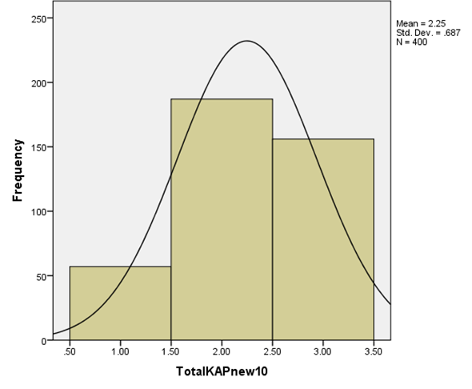
Figure 21: Women’s total KAP score category in this study
Since Turkmen ethnicity is the major ethnicity of the county, we compared KAP score between women from Turkmen ethnicity with others. So, cross-tabulation was performed for ethnicity and total KAP score and the results are as follow:
Table 8: Comparison of total KAP score between Turkmen women and others
 | Total KAP score
 | Weak (0-9) | Average (10-18) | Good (19-27) | Total
 | Frequency (%) | Frequency (%) | Frequency (%)
Turkmen women | 19 (15.2) | 62 (49.6) | 44(35.2) | 125
Other ethnicities | 38(13.82) | 125(45.46) | 112(40.72) | 275
Total | 57 | 187 | 156 | 400

Considering women from ethnicities other than Turkmen ethnicity, it can be seen that 38(13.82%), 125 (45.46%), 112 (40.72%) had weak, average and good KAP score, respectively.
We computed the same for Turkmen ethnicity and we found that 19 (15.2%), 62 (49.6%), 44 (35.2%) had very weak, average and good KAP score, respectively. Afterwards, we tried to find out if difference which can be seen between KAP scores of women from Turkmen ethnicity in comparison to others was significant or not.
Looking at Pearson Chi-square and level of significance (P-value=0.57) we reached this conclusion that the association between ethnicity and total KAP score of participants was not statistically significant.
To understand if there was any statistically significant association between place of residence and KAPS of participants we followed exactly the same procedure and the results showed that there was a statistically significant association between place of residence and KAPS (P-value=0.04). Accordingly, women living in urban areas had statistically significant higher KAPS than the ones living in rural areas.
The same procedure was performed for two other main exposures (Marital status and education). The results were as follow:
Considering total KAPS, we reached this conclusion that there was not any statistically significant association between marital status and total KAP score (P-value=0.222).
Considering educational level of participants and comparing total KAP score of women who had high school certificate or lower with those who had higher education, indicated that there was a positive association between educational level of individuals and total KAPS. The Association between educational level and total KAPS was statistically significant, suggesting that participants who had higher education had statistically significant higher KAPS than the ones who did not have higher education (P-value=0.000).
Part 2: To explore the association between main demographic risk factor and odds of practicing BSE/mammography.
In this part, researcher assessed the association between age, ethnicity, education, place of residence and marital status (as the most important demographic risk factors) with odds of practicing breast self-exam /mammography. The results are being illustrated and discussed in tables 9 and 10.
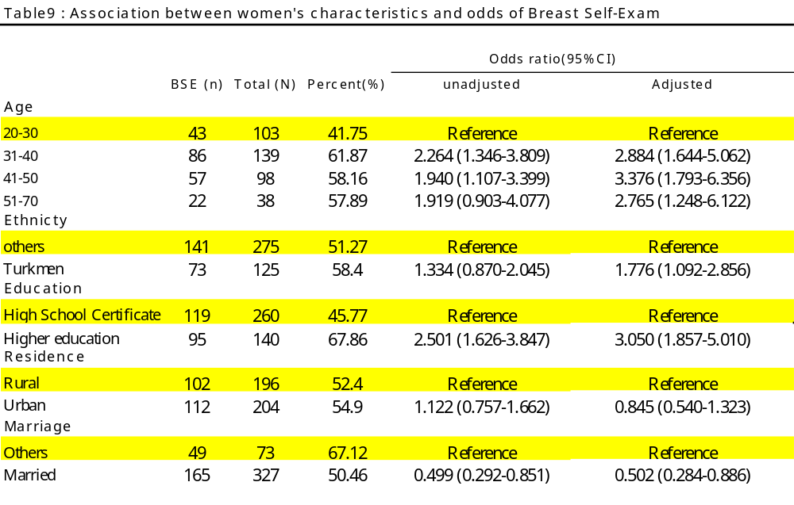
As table 9 depicts, unadjusted odds ratio for practicing BSE among different age groups (31-40, 41-50 and 51-70) in comparison to reference group, women aged 20-30) were 2.264, 1.940 and 1.919, respectively, suggesting that the odds of practicing BSE was the highest among the second age group (women aged 31-40) , in comparison to reference group.
After adjusting for all other covariates, the greatest adjusted odds ratio (3.376) could be seen in the third age group (women aged 41-50), in comparison to reference group, suggesting that the women aged 41-50 had the greatest probability to perform mammography, in adjusted case.
.Considering ethnicity, we found that unadjusted odds ratio of practicing BSE was 33.4% grater for Turkmen women than for women from other ethnicities. However, the difference was not statistically significant (P-value=0.186), indicating that there was no association between ethnicity and practicing BSE in unadjusted form.
After adjusting for age and all other covariates, odds ratio increased from 1.334 to 1.776 and this time the association was significant (P-value=0.021). This signified that although there was no statistically significant association between ethnicity and practicing BSE in unadjusted form, after adjusting for age and all other covariates, the association between ethnicity and BSE was statistically significant, suggesting that Turkmen women had a higher probability of practicing BSE than those from other ethnicities.
Considering education, we found out both unadjusted (2.501) and adjusted (3.050) odds ratio for practicing BSE were greater than “1” for women who had higher education than for those who did not have higher education (those with high school certificate or lower). The association between educational level of participants and probability of practicing BSE was statistically significant (P-value=0.000 for both unadjusted and adjusted groups), suggesting that having higher education was associated with increasing the probability of BSE practice.
Analyzing place of residence indicated that unadjusted odds of practicing BSE, was 12.2% greater in urban women than in rural women, although this difference was not statistically significant, before adjustment (P-value=0.566).
After adjusting for age and all other covariates the odds ratio decreased to 0.845 which still was not statistically significant (P-value=0.461). This suggested that there was not any statistically significant association between place of residence and practicing BSE both in unadjusted and adjusted forms.
Considering marital status, it can be found that there was a negative association between marital status and practicing BSE. Married women had lower odds ratio of BSE practice than the reference group (the ones who were single, divorced or separated), both in unadjusted and adjusted status. Negative association between marital status and practicing BSE was statistically significant in unadjusted form. (P-value=0.011), suggesting that married women had lower probability of practicing BSE than unmarried ones.
After adjusting for age and all other covariates, the odds ratio increased from 0.499 to 0.502. This figure, again, was less than “one”. Negative association between marital status and BSE practice was again statistically significant in adjusted form (P-value=0.014). So, it can be inferred that married women had lower probability of practicing BSE than those who were not married.
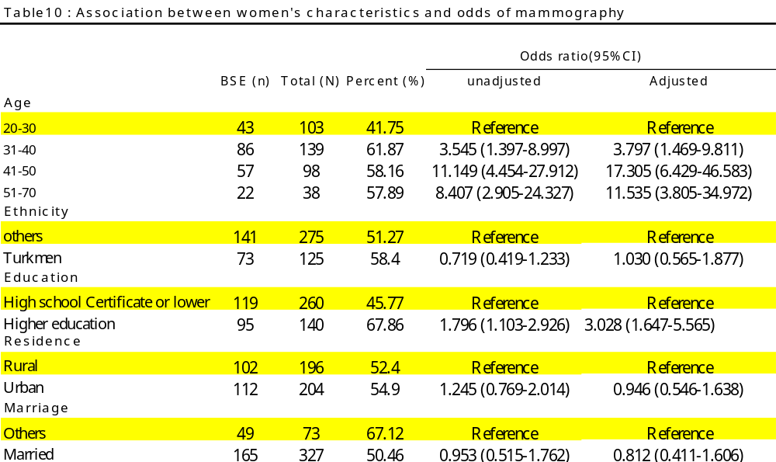
As table 10 depicts, unadjusted odds ratio for practicing mammography among different age groups (31-40, 41-50 and 51-70 in comparison to reference group, women aged 20-30) were 3.545, 11.149 and 8.407, respectively. So, age group 41-50 had the highest probability of performing mammography. After adjusting for age and all other covariates, the highest odds ratio of performing mammography, belonged to age group 41-50, the same as it was seen in unadjusted form.
.Considering ethnicity, it could be seen that unadjusted odds ratio for practicing mammography was 0.719 among Turkmen women in comparison to reference group, indicating that the probability of practicing mammography was 28.1% less in Turkmen women than in women from other ethnicities. In spite of this difference, the association between ethnicity and performing mammography was not statistically significant in unadjusted form (P-value=0.230).
After adjusting for age and all other covariates, it could be seen that the association between ethnicity and performing mammography was not statistically significant (P-value=0.924), suggesting that there was no difference between behavior of Turkmen women in comparison to the behaviors of women from other ethnicities in regard to performing mammography.
Considering education, we found out that both unadjusted (1.796) and adjusted (3.028) odds ratio for practicing mammography were greater than “1” for women who had higher education in comparison to those with no higher education (the ones with high school certificate or lower). The association between educational level of participants and performing mammography was statistically significant in unadjusted form (P-value=0.019).
After adjusting for age and all other covariates, the association between educational level of sample population and performing mammography was statistically significant, the same as unadjusted form (P-value=0.000), suggesting that women with higher education had statistically higher probability of performing mammography than those who didn’t have higher education.
Analyzing place of residence indicated that unadjusted odds of practicing mammography (1.245), was24.5 % greater in urban women than in rural women, although this difference was not statistically significant (P-value=0.373).
After adjusting for age and all other covariates the odds ratio decreased to 0.842 which was not statistically significant (P-value=0.461). This suggested that there was not any statistically significant association between place of residence and practicing mammography among women in the sample population, suggesting that behavior of urban and rural women in practicing mammography was the same.
Considering marital status, it can be found that there was a negative association between marital status and practicing mammography. Married women had lower odds ratio of mammography practice than the reference group (the ones who were single, divorced or separated), both in unadjusted and adjusted status. (4.7% less in unadjusted form and 18.8% less in adjusted form).This negative association was not statistically significant in unadjusted form (P-value=0.877).
After adjusting for age and all other covariates, the odds ratio decreased from 0.953 to 0.812. This reduction was not statistically significant (P-value=0.550), the same as unadjusted situation. So, there was no statistically significant association between marital status and performing mammography (in both unadjusted and adjusted cases).
Part 3: To study barriers to BC screening programs (BCSPs)
In this part of the study the participants were asked “under what condition they are ready to practice mammography?” in order to identify the barriers to mammography.
Having the result of this section, policy makers can intervene in the future to eliminate problem, if possible.
Considering the fact that early detection of BC is a crucial factor to determine the prognosis and to control or delay natural history of disease, the importance of identifying barriers to mammography would be much more justified and clear. Also, 5-year survival would be much greater if BC can be detected at earlier stages.
One of the most important reasons for high mortality rate from BC is that unfortunately patients do not follow BC screening programs (BSE, mammography or other preventive measures) and do not refer to health care centers on time or in time.
A large number of women usually seek care when disease is in its end stages and naturally not only the consequences are much more difficult to control, but also the probability of 5-year survival decreases significantly.
So, understanding barriers to BC screening programs and trying to intervene so as to diminish or eliminate these barriers can effectively increase early detection, decrease mortality rate and also diminish complications and consequences of BC.
Generally speaking, there are different barriers to BC screening programs and the barriers can be totally different in different target population given that age, race, ethnicity, place of residence, family income, culture, socioeconomic status, access to healthcare centers and a myriad number of other factors can affect the probability of participating in BC screening programs. Some of the barriers are being depicted in figure 22.
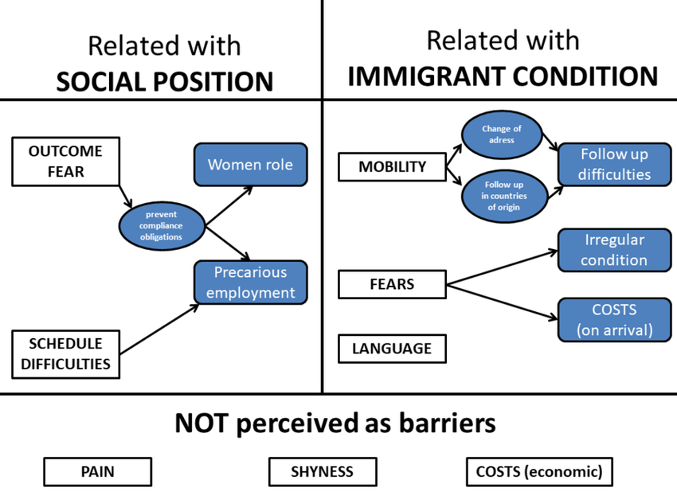
Figure 22: some barriers to BC screening programs (Source: reasearchgate.net)

The results of exploring barriers to mammography among sample population in this study can be seen in table 11.

Table 11: Conditions under which participants tend to perform mammography
 |  |  |  | Frequency | Percent
 |  |  |  | (n) | (%)
If my husband agrees |  |  |  | 6 | 1.5
If the results benefit me |  |  |  | 125 | 31.3
If the results will be kept confidential |  |  |  | 5 | 1.3
If there is a known cure for breast cancer |  |  |  | 17 | 4.4
If healthcare center is near my house |  |  |  | 1 | 0.2
If it is affordable for me |  |  |  | 99 | 24.8
If it is totally free |  |  |  | 64 | 16
If the health care stuff is a female |  |  |  | 82 | 20.5
Total |  |  |  | 399 | 99.8
Missing |  |  |  | 1 | 0.2
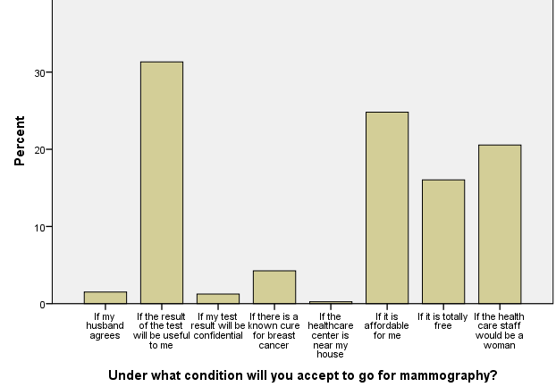

According to this study, three major barriers to BC screening programs (which contribute to 92.6% of total barriers) among women living in this county were as follow:
- Economic problems (40.8%). Being affordable (24.8%) or being totally free (16%).
- If the result of the test benefit the patient (31.3%)
- If the health care staff is a woman (20.5%)
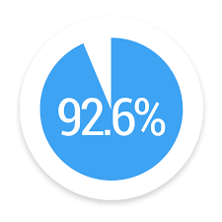
The results of our study showed that if we can intervene to overcome these three main barriers, we can significantly and effectively increase the probability of practicing mammography among females and help early detection of disease. As a result, we can decrease mortality rate, eliminate or delay complications and reduce huge burden of disease in this county.
Discussion:
General goal of this study was to assess knowledge, attitude and practices (KAP) of women (aged 20-70, residing in Gonbade-ghaboos, referring to one of the main reference radiology and sonography centers in this county about BC and BC screening programs.
The results suggested that 61% of sample population did not have good knowledge, attitude and practices score (KAPS) towards BC and BC screening programs. From among all participants in this study, 14.2% had weak KAPS, 46.8% had average KAPS and 39% had good KAPS. There was not any statistically significant association between ethnicity and total KAPS (P-value=0.576). Also, the association between marital status and total KAPS was not statistically significant (P-value=0.222). Considering place of residence, it was found that the association between participants’ place of residence and total KAPS was statistically significant suggesting that women from urban area had statistically significant higher total KAPS than women from rural area (P-value=0.040). The association between level of education and total KAPS was also statistically significant and it was witnessed that women with higher education had statistically higher total KAPS than those who had high school certificate or lower (P-value=0.000).
One of the specific goals of this study was to evaluate the practices of sample population towards BC, practicing BSE and mammography.
Before evaluating practices of women towards BSE and mammography, it is noteworthy to mention that the findings in this study indicated that 94.4% of sample population had heard of BC, 76.8% had heard of BSE and 63.3% of the participants knew that BSE can be effective in diagnosing BC. Also, 88.7% of candidates knew that BC is a preventable disease. In spite of having knowledge on BC and BC screening programs, (although 88.7% of women knew that BC is a preventable disease), only 53.5% practiced BSE and only 21% performed mammography. This emphasizes the fact that having appropriate and enough knowledge about something is not a guarantee to take action. So, having enough knowledge on BC is not a guarantee for practicing BSE or mammography (This should be considered by decision-makers and policy-makers if they want to implement any interventions).
Another specific goal of the study was to determine the association between ethnicity, education, place of residence and marital status with the probability of having BSE or mammography.
Comparing BSE practice in different age groups, it can be found that unadjusted odds ratio was the greatest (2.264) in the second age group (31-40) and it was statistically significant (P-value=0.002). After adjusting for all other covariates the highest odds ratio (3.376) could be seen in the third age group (41-50) and it was also statistically significant (P-value=0.000).
After adjusting for age and all other covariates it could be deduced that the associations between ethnicity, education and marital status (negative association) with practicing BSE were statistically significant (P-value= 0.021, 0.000 and 0.014, respectively), whereas the association between place of residence and practicing BSE not statistically significant (0.461).
Then, mammography was considered as the final outcome and it was found that interestingly odds ratio was the most for age group 41-50 in both unadjusted (odds=11.149) and adjusted (17.305) form. The association between age and performing mammography was statistically significant for age group 41-50 both in unadjusted and adjusted form (P-value=0.000 for both), suggesting that women between 41-50 years of age statistically had higher probability of practicing mammography than other age groups.
There was no association between ethnicity and performing mammography both in unadjusted (P-value=0.230) and adjusted (P-value=0.924) form, suggesting that Turkmen women had the same behavior as those from other ethnicities towards performing mammography.
The association between educational level of participants and practicing mammography was statistically significant both in unadjusted (P-value=0.019) and adjusted (P-value=0.000) form suggesting that women with higher education had higher probability of performing mammography.
Also, there was no statistically significant association between place of residence and performing mammography both in unadjusted (P-value=0.373) and adjusted (P-value=0.461) form.
There was no statistically significant association between marital status and performing mammography in both unadjusted and adjusted case (p-value=0.887 and 0.550, respectively).

The results of this part are being summarized in below table:
 | Association with practicing BSE | Association with Performing mammography
Ethnicity | Statistically significant association  Interpretation: The probability of practicing BSE was higher among Turkmen women than among those from other ethnicities. | No significant association  Interpretation: The probability of performing mammography was the same among Turkmen women and among those from other ethnicities.
Education | Statistically significant association  Interpretation: The probability of practicing BSE was higher among women who had higher education than in those who didn’t have higher education. | Statistically significant association  Interpretation: The probability of performing mammography was higher among women who had higher education than in those who didn’t have higher education.
Place of residence | No significant association  Interpretation: The probability of practicing BSE was the same among women living in Urban areas and those living in rural areas. | No significant association  Interpretation: The probability of performing mammography was the same among women living in urban areas and those living in rural areas.
Marital status | Statistically significant negative association  Interpretation: The probability of practicing BSE was lower in married women than in unmarried ones. | No significant association  Interpretation: The probability of performing mammography was the same between married women and unmarried ones.
The last specific goal of this study was to evaluate barriers to mammography in sample population.
Evaluation of barriers to mammography among participants in this county disclosed that economic problems Put forward by 40.8% of participants were the main barriers to mammography (24.8% of females declared that they would perform mammography if mammography was affordable and 16% said that they would perform mammography if it was totally free). Being sure that the results benefit the patient (31.3%) and also gender of health staff – to be a female- (20.5%) were second and third barriers to mammography in this county and collectively these three factors contribute to 92.6% of all barriers.
Contrasting finding in this study with existing literature:
Since Gonbade-ghaboos is located in the North-east of Iran and has common border with Turkmenistan (Turkmenia), many Turkmen people emigrated and settled down in this county from ancient times and nowadays a large proportion of the population in this county is composed of people from Turkmen ethnicity. According to American Cancer Society (as mentioned in introduction), race, ethnicity, education and place of residence can be risk factors for cancer and cancer screening programs. Unfortunately no study has been performed to evaluate women’s knowledge, attitude and practices towards BC in this city with this population composition up to now (Before this research). So, in fact there is no existing literature on this topic in this county to be compared with our study. But there are some studies performed in other provinces of Iran with different population composition.
In a study published in 2014, Behbahai, et al, performed a cross-sectional study and recruited 314 women from among those referred to public health centers in Sanandaj, in south- west of Iran (69). They found out that 47.2% had poor knowledge about risk factors of early detection 38% had average knowledge and only 15% had good knowledge on BC and BC screening programs. 52.6% of the participants had never examined their breast (BSE). Comparing this with our finding, we can conclude that generally Turkmen women had better KAPS (14.2% poor, 46.8% average and 39% good) than women participated in study in Sanandaj. (69)
In a cross-sectional study conducted in Mazandaran province, eastern neighbor of Golestan province, 304 women aged 20-65 were recruited in Hashemi healthcare center, affiliated to Babol University of medical science, within a 6 month period in 2017. Knowledge, attitude and practices of women towards BC and BC screening programs were assessed through a questionnaire and they found that 22.3% of sample population had good knowledge about BC and BC screening programs. (70) Comparing the result of this study with our study, it can be deduced that Turkmen women residing in Gonbade-ghaboos had much more good knowledge about BC and BC screening programs than their counterparts residing in Babol. Level of education in this study was significantly associated with women’s knowledge, attitude and practices on breast BC which is consistent with findings in our study result (70).
Our findings in this study were consistent with results from previous studies conducted by Parsa,et al, in 2005 in Hamedan(62), Akhtari,et al, in 2014 in Hamedan (63), Tabrizi,et al, in 2014 in Isfahan (64) and Fouladi, et al, in 2013 in Ardebil(65) which all suggested that interventions should be implemented for Iranian women to be more educated about BC and BC screening programs.

Strength and limitations of the study:
Strength:
To avoid selection bias, research team recruited sample population using convenience sampling method. Also, a facilitator was recruited to explain the participants about any probable misunderstanding in questions so as to avoid information bias. It is noteworthy to mention that the sample population referred to this center from different part of the city given that the center was a referent center. So, it could be declared with great certainty that females participated in this study were representative of total population which in turn guaranteed external validity of this study and as a result, findings in this study can be generalizable to total population.
Limitations:
There were some limitations for this study.
First issue: Psychological conditions of the participants might have affected their responses.
Second issue: Although facilitator was trained to try her best so as to perform her duty accurately and appropriately, lack of cooperation or weakness of connection between facilitator and participants might also have affected the answers to the questions.
Third issue: Some of participants might have some questions and they might have been ashamed to ask facilitator for more clarification because they were not convenient to talk about their breast (as a private body organ) to someone else.
Fourth issue: Some of participants might have come to this center with their friends or one of their family members and this accompany might have affected answering some questions, since they might have discussed with each other about how to respond the questions. For the same reason, if two or more friends had come to the center simultaneously and had taken part in study at the same time, they might have discussed with each other and might have answered questions the same as each other.
Recommendations for public health and prevention:
Early detection of BC is a major public health concern. Tackling this problem is not confined to only one part of society and there should be some efficient and comprehensive interventions implemented, involving different levels of community.
At personal level:
According to our findings 88.7% of sample population knew that BC is a preventable disease. In spite of this knowledge, it was unfortunate that only a little more than half of them (53.5%) practiced BSE and only 21% performed mammography. Among those who had not practiced BSE,” Not knowing how to do BSE “was the main reason. So, first of all, there should be some interventions implemented at personal level to encourage females to take action if they have enough knowledge about the ways of prevention and early detection of disease. Also, the females should be taught how to do BSE correctly.
At county or community level:
Since most of the participants did not have good total KAPS, it seems that interventions should be implemented to improve the situation and educate them about BC. It can be done through public health centers or centers called “Hygiene / health house” or any other sources..
Given that there was statistically significant association between place of residence and total KAPS, and women living in urban areas had statistically higher KAPS than those living in rural areas, it seems that there should be some interventions implemented in rural areas to improve general knowledge about BC. This is a very important issue because this county has a huge number of villages and rural areas with a high composition of rural population. Increasing knowledge about BC and BC screening programs is inevitable to improve early detection of BC in these areas. Considering the fact that usually women living in rural areas have less monthly family income than those living in urban areas and recalling the fact that there was a statistically significant association between monthly family income and KAPS about BC in our findings, the importance of implementing some comprehensive interventions in rural areas of this county would be much more justifiable, suggesting that rural areas should be the first priority for decision-makers or policy-makers.
Any intervention which will be implemented in the future should describe women the importance of early detection of BC and should define them different types of screening programs. Recommendations put forward by the WHO should also be explained to females precisely in order to make them more aware and more sensitive to preventive measures so as to take action and participate in BC screening programs. By screening and early detection, BC mortality rate and its consequences will surely be diminished in the future.
In evaluating barriers to mammography it was found that the main barrier was economic. So, taking action to make mammography free or more affordable would be one of the most important steps to encourage women to perform mammography. Maybe non-governmental organizations and charities can help improve the situation at county level, if it is impossible to tackle the problem at national level. It also should be explained to females that BC is a preventable disease (and if occurs, it can be treated at earlier stages), so the results of BC screening programs will surely benefit them.
Since religiously and culturally women in this county are more convenient to be examined by a female healthcare staff, recruiting female healthcare staffs at mammography wards of hospitals or at private sections, can effectively and significantly increase females’ tendency (and may be an encouraging factor) to perform mammography.
At province and country level:
Since TV was the most important source of information reported by study participants, it seems that including educational programs about BC and BC screening programs in TV programs can markedly increase awareness and knowledge of females about this disease.

Since economic problems have been identified as the main barriers to mammography in this study and performing mammography can have a great impact on social health of community, it may be possible to try as much as we can so as to convince insurance companies to pay for expenses pertinent to mammography and make it free or at least more affordable.
Nowadays, Internet and social media are among the main and the most comprehensive sources of information for a huge number of people, especially new generations. That is why these sources can be of great importance and should be considered as one of the best ways to educate people and to improve their knowledge by policy makers and those who want to implement interventions.
Conclusion:
Considering the findings in this research, it is strongly recommended that some comprehensive and multilevel interventions should be implemented to improve females’ knowledge on BC and BC screening and prevention methods. By increasing females’ awareness and knowledge on BC, raising their sensitivity towards regular and accurate performance of BSE/ mammography and other preventive measures, also by diminishing the barriers to mammography, early detection can be increased. The result will be a reduction in mortality rate and decreasing the complications of BC.

Acknowledgments:
Special thanks to my dearest friend, Dr. Keivan Yadegari for his accompany at all stages of this project.
We appreciate Dr. Negahdari radiology and sonography center in Gonbade-ghaboos for providing support and giving research team the opportunity to recruit sample population.
With great thanks to dear Hale Roohi for her pure, endless and sincere accompany at all moments of this MPH course from the beginning to the end.
We also appreciate sincere efforts and assistance of dear Ehsan Shiraz and dear Niloufar Agah who helped in different steps of the project.
Great Thanks to BIHE which taught me these sentences:
“Winners are not people who never fail but people who never quit”
“It always seems impossible until it’s done”

References:
1. WHO | NCD mortality and morbidity [Internet].WHO. World Health Organization; [cited 2020 Oct 23]. Available from: http://www.who.int/gho/ncd/mortality_morbidity/en/
2. Breast Cancer Stats and Facts [Internet].[cited 2020 Nov 1]. Available from: https://healthcare.utah.edu/healthfeed/postings/2015/10/100515_infographic-breast-cancer-stats.php
3. Akram M, Iqbal M, Daniyal M, Khan AU.Awareness and current knowledge of breast cancer. Biol Res [Internet].2017 Oct 2 [cited 2020 Oct 24]; 50. Available from: https://www.ncbi.nlm.nih.gov/pmc/articles/PMC5625777/
4. Breast Cancer Statistics And Resources [Internet].Breast Cancer Research Foundation. 2016 [cited 2020 Oct 24]. Available from: https://www.bcrf.org/breast-cancer-statistics-and-resources
5. Breast cancer statistics [Internet].World Cancer Research Fund. 2018 [cited 2020 Oct 24]. Available from: https://www.wcrf.org/dietandcancer/cancer-trends/breast-cancer-statistics
6. WHO | Breast cancer: prevention and control [Internet]. WHO. World Health Organization; [cited 2020 Oct 24]. Available from: http://www.who.int/cancer/detection/breastcancer/en/
7. Age and Breast Cancer Risk [Internet] [cited2020 Oct 24]. Available from: http://ww5.komen.org/BreastCancer/GettingOlder.html
8. CDC BreastCancer.Breast Cancer in Men [Internet].Centers for Disease Control and Prevention. 2020 [cited 2020 Oct 24]. Available from: https://www.cdc.gov/cancer/breast/men/index.htm
9. Non-Invasive or Invasive Breast Cancer [Internet]. Breastcancer.org. 2020 [cited 2020 Oct 24]. Available from: https://www.breastcancer.org/symptoms/diagnosis/invasive
10. Invasive Ductal Breast Cancer and other Types - Moose and Doc [Internet]. [cited 2020 Oct 24]. Available from: https://breast-cancer.ca/5a-types/
11. Stages of breast cancer - Canadian Cancer Society [Internet]. www.cancer.ca. [cited 2020 Oct 24]. Available from: https://www.cancer.ca:443/en/cancer-information/cancer-type/breast/staging/?region=on
12. Stages of Breast Cancer | Memorial Sloan Kettering Cancer Center [Internet]. [cited 2020 Oct 24]. Available from: https://www.mskcc.org/cancer-care/types/breast/diagnosis/stages-breast
13. Hammer C, Fanning A, Crowe J. Overview of breast cancer staging and surgical treatment options. Cleve Clin J Med. 2008 Mar 1;75(Suppl_1):S10–S10.
14. Safizadeh H, Hafezpour S, Shahrbabaki PM. Health Damaged Context: Barriers to Breast Cancer Screening from Viewpoint of Iranian Health Volunteers. Asian Pac J Cancer Prev APJCP.2018; 19 (7):1941–9.
15. Sun L, Legood R, dos-Santos-Silva I, Gaiha SM, Sadique Z. Global treatment costs of breast cancer by stage: A systematic review.PLOS ONE. 2018 Nov 26;13(11):e0207993.
16. Breakthroughs in Breast Cancer Research - Oct 23, 2018 [Internet]. [cited 2020 Oct 25]. Available from: http://www.news.sanofi.us/2018-10-23-Breakthroughs-in-Breast-Cancer-Research
17. WHO | Early Diagnosis and Screening [Internet]. WHO. World Health Organization; [cited 2020 Oct 30]. Available from: http://www.who.int/cancer/prevention/diagnosis-screening/en/
18. Wang L.Early Diagnosis of Breast Cancer.Sensors. 2017 Jul 5;17(7).
19. Onega T, Goldman LE, Walker RL, Miglioretti DL, Buist DS, Taplin S, et al. Facility Mammography Volume in Relation to Breast Cancer Screening Outcomes. J Med Screen. 2016 Mar;23(1):31–7.
20. https://uhapo.com/collateral/blogdetail/breast-cancer---diagnosis-and-screening[Internet]. [cited 2020 Oct 30]. Available from: https://uhapo.com/collateral/blogdetail/breast-cancer---diagnosis-and-screening
21. Ozmen N, Dapp R, Zapf M, Gemmeke H, Ruiter NV, van Dongen KWA. Comparing different ultrasound imaging methods for breast cancer detection.IEEE Trans Ultrason Ferroelectr Freq Control. 2015 Apr;62(4):637–46.
22. Lewis TC, Pizzitola VJ, Giurescu ME, Eversman WG, Lorans R, Robinson KA, et al. Contrast-enhanced Digital Mammography: A Single-Institution Experience of the First 208 Cases. Breast J. 2017 Jan;23(1):67–76.
23. Roganovic D, Djilas D, Vujnovic S, Pavic D, Stojanov D. Breast MRI, digital mammography and breast tomosynthesis: comparison of three methods for early detection of breast cancer. Bosn J Basic Med Sci. 2015 Nov 16;15(4):64–8.
24. SU‐E‐I‐81: Targeting of HER2‐Expressing Tumors with Dual PET‐MR Imaging Probes - Xu - 2015 - Medical Physics - Wiley Online Library [Internet]. [cited 2020 Oct 31]. Available from: https://aapm.onlinelibrary.wiley.com/doi/abs/10.1118/1.4924078
25. Wenli Chen, Dubuc D, Grenier K. Microwave dielectric spectroscopy of a single biological cell with improved sensitivity up to 40 GHz. In: 2015 IEEE MTT-S International Microwave Symposium [Internet]. Phoenix, AZ, USA: IEEE; 2015 [cited 2020 Oct 31]. p. 1–3. Available from: http://ieeexplore.ieee.org/document/7166974/
26. Chatterjee SK, Zetter BR. Cancer biomarkers: knowing the present and predicting the future. Future Oncol Lond Engl. 2005 Feb;1(1):37–50.
27. Breast Cancer Screening Guidelines for Women. :3.
28. ACS Breast CancerEarly Detection Recommendations[Internet]. [cited 2020 Oct 31]. Available from: https://www.cancer.org/cancer/breast-cancer/screening-tests-and-early-detection/american-cancer-society-recommendations-for-the-early-detection-of-breast-cancer.html
29. Al-Azri M, Al-Awaisi H, Al-Rasbi S, Al-Moundhri M. Coping with a diagnosis of breast cancer among Omani women. J Health Psychol. 2013 Mar 21;19.
30. Isfahani P, Arefy M, Shamsaii M. Prevalence of Severe Depression in Iranian Women with Breast Cancer: A Meta-Analysis [Internet].Vol. 2020, Depression Research and Treatment. Hindawi; 2020 [cited 2020 Oct 28].p. e5871402. Available from: https://www.hindawi.com/journals/drt/2020/5871402/
31. Alexander A, Kaluve R, Prabhu JS, Korlimarla A, Srinath B, Manjunath S, et al.The Impact of Breast Cancer on the Patient and the Family in Indian Perspective.Indian J Palliat Care. 2019; 25(1):66–72.
32. Breast Cancer - Lessons - Tes Teach [Internet]. Tes Teach with Blendspace. [cited 2020 Oct 25]. Available from: https://www.tes.com/lessons/qfnhiA6nKTUXWw/breast-cancer
33. Khalili AF, Shahnazi M. Breast cancer screening (breast self-examination, clinical breast exam, and mammography) in women referred to health centers in Tabriz, Iran. Indian J Med Sci. 2010 Apr;64(4):149–62.
34. Nafissi N, Khayamzadeh M, Zeinali Z, Pazooki D, Hosseini M, Akbari ME. Epidemiology and Histopathology of Breast Cancer in Iran versus Other Middle Eastern Countries. Middle East J Cancer. 2018 Jul 1; 9(3):243–51.
35. Akbari ME, Sayad S, Sayad S, Khayamzadeh M, Shojaee L, Shormeji Z, et al. Breast Cancer Status in Iran: Statistical Analysis of 3010 Cases between 1998 and 2014 [Internet].Vol. 2017, International Journal of Breast Cancer. Hindawi; 2017 [cited 2020 Oct 25]. p. e2481021. Available from: https://www.hindawi.com/journals/ijbc/2017/2481021/
36. Mousavi SM, Montazeri A, Mohagheghi MA, Jarrahi AM, Harirchi I, Najafi M, et al. Breast Cancer in Iran: An Epidemiological Review. Breast J. 2007 Jul;13(4):383–91.
37. Mousavi SM, Gouya MM, Ramazani R, Davanlou M, Hajsadeghi N, Seddighi Z. Cancer incidence and mortality in Iran. Ann Oncol. 2009 Mar 1;20(3):556–63.
38. Rafiemanesh H, Salehiniya H, Lotfi Z. Breast Cancer in Iranian Woman: Incidence by Age Group, Morphology and Trends.Asian Pac J Cancer Prev APJCP. 2016;17(3):1393–7.
39. FARHOOD B, GERAILY G, ALIZADEH A. Incidence and Mortality of Various Cancers in Iran and Compare to Other Countries: A Review Article.Iran J Public Health. 2018 Mar;47(3):309–16.
40. Shadmani FK, Mansori K, Khazaei S, Hanis SM, Khazaei S, Sani M, et al. Geographic distribution of breast cancer incidence in Iran.Biomed Res Ther. 2017 May 21;4(05):1295–304.
41. WHO EMRO | Epidemiology of breast cancer in the Islamic Republic of Iran: first results from a population-based cancer registry | Volume 15, issue 6 | EMHJ volume 15, 2009 [Internet]. [cited 2020 Oct 28]. Available from: http://www.emro.who.int/emhj-volume-15-2009/volume-15-issue-6/epidemiology-of-breast-cancer-in-the-islamic-republic-of-iran-first-results-from-a-population-based-cancer-registry.html
42. GBD Compare | IHME Viz Hub [Internet]. [cited 2020 Oct 28]. Available from: http://vizhub.healthdata.org/gbd-compare
43. Fig. 1: Districts map of Golestan province, Iran showing the study... [Internet]. ResearchGate. [cited 2020 Oct 29]. Available from: https://www.researchgate.net/figure/Districts-map-of-Golestan-province-Iran-showing-the-study-villages-in-Gonbad-e-Kavus_fig1_309529193
44. Roshandel G, Sadjadi A, Aarabi M, Keshtkar A, Sedaghat SM, Nouraie SM, et al. Cancer incidence in Golestan Province: report of an ongoing population-based cancer registry in Iran between 2004 and 2008. Arch Iran Med. 2012 Apr;15(4):196–200.
45. Gonbad-e Kavus County. In: Wikipedia [Internet]. 2020 [cited 2020 Oct 29]. Available from: https://en.wikipedia.org/w/index.php?title=Gonbad-e_Kavus_County&oldid=969641503
46. www.sirang.com SR. Gonbad Qaboos Tower 2020 Tourist Attraction in Gonbad Kavoos, travel to iran, Visit Iran [Internet].itto.org | Iran Tourism & Touring. [cited 2020 Oct 29]. Available from: https://www.itto.org/iran/attraction/gonbad-e-qabus-tower/
47. Breast Cancer Risk Factors and Prevention Methods [Internet]. [cited 2020 Oct 30]. Available from: https://www.cancer.org/cancer/breast-cancer/risk-and-prevention.html
48. Jahan S, Al-Saigul AM, Abdelgadir MH.Breast cancer.Knowledge, attitudes and practices of breast self- examination among women in Qassim region of Saudi Arabia. Saudi Med J. 2006 Nov;27(11):1737–41.
49. Khokher S, Qureshi W, Mahmood S, Saleem A, Mahmud S. Knowledge, attitude and preventive practices of women for breast cancer in the educational institutions of Lahore, Pakistan.Asian Pac J Cancer Prev APJCP. 2011;12(9):2419–24.
50. Alwan N a. S, Al-Attar WM, Eliessa RA, Madfaie ZA, Tawfeeq FN. Knowledge, attitude and practice regarding breast cancer and breast self-examination among a sample of the educated population in Iraq.East Mediterr Health J Rev Sante Mediterr Orient Al-Majallah Al-Sihhiyah Li-Sharq Al-Mutawassit. 2012 Apr;18(4):337–45.
51. Azubuike S, Okwuokei S. Knowledge, Attitude and Practices of Women Towards Breast Cancer in Benin City, Nigeria. Ann Med Health Sci Res. 2013;3(2):155–60.
52. El Mhamdi S, Bouanene I, Mhirsi A, Sriha A, Ben Salem K, Soltani MS. Women’s knowledge, attitudes and practice about breast cancer screening in the region of Monastir (Tunisia). Aust J Prim Health. 2013;19(1):68–73.
53. Latif R. Knowledge and attitude of Saudi female students towards breast cancer: A cross-sectional study. J Taibah Univ Med Sci. 2014 Dec 1;9(4):328–34.
54. Gangane N, Ng N, San Sebastian M. Women’s Knowledge, Attitudes, and Practices about Breast Cancer in a Rural District of Central India. Asian Pac J Cancer Prev. 2015 Nov 4; 16:6863–70.
55. Kotepui M, Piwkham D, Chupeerach C, Duangmano S. Knowledge, attitudes and practice of breast cancer screening among female personnel of Walailak University. Health Expect Int J Public Particip Health Care Health Policy. 2015 Dec;18(6):3069–78.
56. Paunikar AP, Khadilkar HA, Doibale MK, Kuril BM. Knowledge, attitude and practices of women towards breast cancer in the field practice area of urban health training centre, Aurangabad, Maharashtra. Int J Community Med Public Health. 2017 Sep 22;4(10):3659–63.
57. Andegiorgish AK, Kidane EA, Gebrezgi MT. Knowledge, attitude, and practice of breast Cancer among nurses in hospitals in Asmara, Eritrea. BMC Nurs[Internet]. 2018 Jul 31 [cited 2020 Oct 30];17. Available from: https://www.ncbi.nlm.nih.gov/pmc/articles/PMC6069844/
58. Thoubaity FA. Assessment of knowledge, attitudes and practices of women on breast cancer detection, screening and breast self-examination: A public awareness study.Biomed Res [Internet]. 2019 [cited 2020 Oct 30];30(6). Available from: https://www.alliedacademies.org/abstract/assessment-of-knowledge-attitudes-and-practices-of-women-on-breast-cancerrndetection-screening-and-breast-selfexamination-a-public-11599.html
59. Toan DTT, Son DT, Hung LX, Minh LN, Mai DL, Hoat LN.Knowledge, Attitude, and Practice Regarding Breast Cancer Early Detection Among Women in a Mountainous Area in Northern Vietnam. Cancer Control J Moffitt Cancer Cent. 2019 Dec;26(1):1073274819863777.
60. Kalliguddi S, Sharma S, Gore CA. Knowledge, attitude, and practice of breast self-examination amongst female IT professionals in Silicon Valley of India. J Fam Med Prim Care. 2019 Feb;8(2):568–72.
61. Heena H, Durrani S, Riaz M, AlFayyad I, Tabasim R, Parvez G, et al. Knowledge, attitudes, and practices related to breast cancer screening among female health care professionals: a cross sectional study. BMC Womens Health.2019 Oct 22;19(1):122.
62. Parsa P, Kandiah M. Breast cancer knowledge, perception and breast self-examination practices among Iranian women. Int Med J. 2005 Jan 1;4.
63. Asian Pacific Journal of Cancer Prevention [Internet]. [cited 2020 Oct 30]. Available from: http://journal.waocp.org/?sid=Entrez:PubMed&id=pmid:25169482&key=2014.15.16.6531
64. Tazhibi M, Feizi A. Awareness levels about breast cancer risk factors, early warning signs, and screening and therapeutic approaches among Iranian adult women: a large population based study using latent class analysis. BioMed Res Int. 2014;2014: 306352.
65. Fouladi N, Pourfarzi F, Mazaheri E, Asl HA, Rezaie M, Amani F, et al. Beliefs and behaviors of breast cancer screening in women referring to health care centers in northwest Iran according to the champion health belief model scale. Asian Pac J Cancer Prev APJCP. 2013;14(11):6857–62.
66. Atashi HA, Vaghar ME, Olya M, Mirzamohammadi P, Arani HZ, Hadizadeh M, et al. Knowledge, Attitudes, and Practices toward Breast Cancer: among Midwives in a Breast Cancer Educational Seminar in Tehran. Arch Breast Cancer. 2020 Feb 29;29–36.
67. Md Yunus. Me thesis[Internet]. Education presented at; 12:40:31 UTC [cited 2020 Oct 31]. Available from: https://www.slideshare.net/drmdyunus/me-thesis-38068397
68. Pourhoseingholi MA, Vahedi M, Rahimzadeh M. Sample size calculation in medical studies.Gastroenterol Hepatol Bed Bench. 2013;6(1):14–7.
69. Morshed Behbahani, Dadkhah Tehrani, F.Gharibi. Knowledge, attitude and practices of Iranian women towards breast cancer, European Journal of breast cancer.2014; volume50, supplement4, page e73
70. Mehdi Safapour, Amir Tyuri, Masumeh Mohamadzadeh. Knowledge, attitude and practices of women towarda breast cancer and its screening: Babol city, Iran. Iran J Health Sci.2018, volume 6, issue 4, pages 1-9


English version of the questionnaire used in this study is enclosed.
Part 1: General questions
1-How old are you?
A- Between 20-30 years
B- Between31-40 years
C- Between41-50 years
D- Between51-60 years
E- Between61-70 years
2- What is your marital status?
- Single
- Married
- Divorced
- Widowed
- Separated
- Others
If you are single you do not need to answer questions 3 and 4.Otherwise, please answer questions 3 and 4.
3- How old were you at the time of marriage?
- Between20-30
- Between 31-40
- Between 41-50
- Between 51-60
- Between 61-70

4- How many children do you have?
A- I have no children
B- One child
C- Two children
D- Three children
E- More than 3 children
5- What is your education level?
A- Under high school certificate (Diploma)
B- Diploma
C- Associated degree
D- BA
E- MA
F- Higher than MA
6- What ethnicity are you from?
A- Fars
B- Torkmen
C- Turk
D- Sistani (Balouch)
E- Mazandarani
F- None of the above
7- Where do you live?
A- I live in Gonbade-ghaboos (Urban area)
B- I live in a village near the city (Rural area)

8- What is your monthly family income?
A- Under 2 million Toman
B- More than 2 million Toman and less than 4 million Toman
C- More than 4 million Toman and less than 6 million Toman
D- More than 6 million Toman
E- It is different in different months and is not stable
9- What is your occupation?
A- Unemployed
B- Housewife
C- University student
D- Governmental job (Civil servant)
E- Private job
F- None of above
10- Have you ever had a family history of breast cancer?
A- Yes
B- No
If your answer to question 10 is negative (No), you do not need to answer question 11. But if your answer to question 10 is positive (Yes) then please answer question 11.
11- Which of your family members has contracted breast cancer?
A- Mother
B- Sister
C- Maternal aunt
D- Paternal aunt

Part 2: Questions on knowledge
Part2-A: General knowledge
12-Have you ever heard of breast cancer?
A- Yes
B- No
If the answer to question 12 is negative (No) you do not need to answer question 13. But if the answer to question 10 is positive (yes), please answer question13.
13- What is/are your source(S) of information?
A- TV
B- Radio
C- Friends
D- Health workers
E- Newspaper
F- Magazine
G- Other sources
14- Have you ever heard of breast self-examination (BSE)?
A- Yes
B- No
If the answer to question 14 is negative (No), you do not need to answer question 15 and 16. But if the answer to question 14 is positive (Yes) then please answer question 15 and 16.
15- What is/are your source(s) of information?
A- TV
B- Radio
C- Friends
D- Health workers
E- Newspaper
F- Magazine
G- Other sources
16- Why breast self –examination should be done?
A- I do not know
B- Because health workers advise to do so
C- Because it can be effective to diagnose breast cancer
17- Do you think breast cancer is preventable?
A- Yes
B- No
C- I do not know
Part 2-B: Knowledge on risk factors
Question 18 evaluates the knowledge on risk factors for breast cancer. Please choose the best answer for each statement.
18-1- Having family history of breast diseases increase the risk of contracting breast cancer
A- True
B- False
C- I do not know
18-2-If your mother has had breast cancer, your risk of contracting breast cancer will increase
A- True
B- False
C- I do not know

18-3- The risk of contracting breast cancer is not related to age
A- True
B- False
C- I do not know
18-4- Giving birth to the first child after 35years of age increases the risk of breast cancer
A- True
B- False
C- I do not know
18-5- Being overweight after menopause, increases the risk of breast cancer
A- True
B- False
C- I do not know
18-6- Diet and lifestyle are not the risk factor for breast cancer
A- True
B- False
C- I do not know
18-7-Taking birth control pill for 5 years or longer, is not a risk factor of breast cancer
A- True
B- False
C- I do not know
18-8- Having more than one alcoholic drink per day, increases the risk of breast cancer
A- True
B- False
C- I do not know
18-9- No breastfeeding is a risk factor for breast cancer
A- True
B- False
C- I do not know
Part 2-C: Knowledge on signs and symptoms
Question 19 evaluates the knowledge on and symptom of breast cancer. Please choose the best answer for each statement.
19-1- Breast Paresthesia can be a sign of breast cancer
A- Yes
B- No
C- I do not know
19-2-Changing the skin form can be a sign of breast cancer
A- Yes
B- No
C- I do not know
19-3- Purulent discharge can be a sign of breast cancer
A- Yes
B- No
C- I do not know
19-4- Breast enlargement can be a sign of breast cancer
A- Yes
B- No
C- I do not know
19-5- Painful breast near menstruation can be a sign of breast cancer
A- Yes
B- No
C- I do not know
19-6-Wound on the nipple can be a sign of breast cancer
A- Yes
B- No
C- I do not know
19-7- Suspicious mass can be a sign of breast cancer
A- Yes
B- No
C- I do not know
Questions on Attitude
20- People with breast cancer should be allowed to live freely in the community
A- I am agree
B- I am disagree
C- I am not sure
21- Cancer of the breast is a punishment from God?
A- I am agree
B- I am disagree
C- I am not sure
22- Members of the community should provide support and home care for breast cancer patients?
A- I am agree
B- I am disagree
C- I am not sure
23-Women with breast cancer should not breast feed their babies?
A- I am agree
B- I am disagree
C- I am not sure

Questions on Practice
24- Have you ever done breast self-examination?
A- Yes
B- No
If the answer to question 23 is “Yes” then please answer question 24 (and you do not need to answer question 25).
If the answer to question 23 is “No” please answer question 25 (and you do not need to answer question 24)
25- Why did you have breast self-examination?
A- Because of an advice by a health worker
B- Because I noticed a lump in my breast
C- Because one of my family members had cancer and it was a warning for me
D- As part of the routine medical assessment
26- Why you did not have breast self-examination?
A- Because I do not know about it.
B- Because I know that it is effective but I do not know how to perform it
C- I am afraid of knowing the result
28-Have you ever had a mammography?
A- Yes
B- No
If the answer to question 26 is “NO” you do not need to answer questions 28-29 and 30.
If the answer to question 26 is “Yes” then please answer questions 28-29 and 30.
28-How many times did you have mammography in your lifetime?
A- Only once
B- I usually have mammography every year
C- I usually have mammography every two years
D- I usually have mammography every three years
E- I usually have mammography whenever I think is necessary
29- When was your last mammography?
A- During last month
B- During last year
C- More than a year ago
30- Why did you get a mammography?
A- Because one of the family members had breast cancer and it was a warning for me
B- Because one of my friends had breast cancer and it was a warning for me
C- One of my family members suggested to have mammography
D- Because one of my friends suggested to have mammography
E- Because my doctor suggested to have mammography
F- As routing screening/ parts of medical check up
G- Because of my age I thought it is better to have mammography
H- Some other reasons
32- Under what condition will you accept to go for breast cancer screening or mammography?
A- If my husband agrees
B- If the result of the test will be of benefit to me
C- If my result will be confidential
D- If there is a known cure breast cancer
E- If the healthcare center is near my house
F- If breast cancer screening or mammography is affordable for me
G- If breast cancer screening or mammography is totally free
H- If the doctor or health worker is a woman

