Identification of genes with potential novel involvement in in the etiology of
Parkinson’s Disease

CONTENTS
- INTRODUCTION 3 - 5
- PARKING DISEASE (PD)
- DOPAMINERGIC NEURONAL DEGENERATION
- PATHOLOGY OF PD
- MITOCHONDRIAL DYSFUNCTION & PD
- GENETIC OF PD 6 - 12
- SNA
- LRRK2
- PARKIN (PARK2)
- PINK1
- TAU
- DJ1 (PARK1)
- ATP13A2 (PARK9)
- PLA2G6 & PINK2
- GLUCOCEREROSIDASE (GBA)
- PARIS
- PHYOGENETIC PROFIING 13
- HYPOTHESIS 14
- METHODS 15 - 16
- RESULT 17 - 21
- DISCUSSION 22 - 24
- REFERENCE 25 - 29
1
Introduction
Parkinson's disease (PD)
Parkinson's disease is the second most common neurodegenerative disorder with a heterogeneous pathology (5), and a prevalence of 1 to 2 percent among the population aged over 65 years (1, 3). Motor symptoms are associated with the profound neuronal loss in the substantia nigra pars compacta (SNpc), (20). Striatal dopaminergic innervation and nigral neurons are progressively lost with associated Lewy pathology readily apparent on autopsy. The condition also has prominent autonomic, cognitive, psychiatric, sensory and sleep components. It is estimated that within the world`s ten most populated countries alone, more than 4 million individuals are affected by PD. Within the next 20 years, the number of PD patients is predicted to reach 10 million (2). Approximately 90% of PD cases are idiopathic and are characterized by late-onset Parkinsonism. The causes of idiopathic PD are unknown but are considered to result from a combination of environmental factors and genetic predisposition. For example, living in a rural environment appears to confer an increased risk of PD perhaps due to increased exposure to pesticides, consuming coffee and smoking cigarette are inversely associated with risk of developing PD (2). Five to ten percent of PD cases are associated with mutations in a range of genes inherited in an autosomal dominant, autosomal recessive or apparently sporadic pattern (1). Several PD genes such as Parkin, DJ-1, Pink 1 and ATP13A2 contribute to an early-onset autosomal recessive form of Parkinsonism. Other genes like alpha-synuclein are linked to Parkinsonism in an autosomal dominant fashion and are responsible for early-onset forms of PD (5, 6) as well as the more common late-onset forms of PD (tau, LRRK2, VPS35) (5). In early-onset and more atypical PD, deficits in mitophagy pathways and lysosomal function, as well as cellular bioenergetics appear to be prominent. By contrast, in more typical late-onset PD, chronic, albeit subtle, dysfunction in synaptic transmission, early endosomal trafficking and receptor recycling and chaperone-mediated autophagy, provide a unifying hypothesis of the molecular pathways involved (20).
As per statistics, 30% of patients develop mild cognitive impairment within 5 years of motor symptoms and may develop dementia (5). PD is clinically or pathologically distinct from other forms of Parkinsonism. A definitive diagnosis of PD requires the presence of Lewy bodies and Lewy neurites (proteinaceous intracellular inclusions) in the brain stem (midbrain), although these lesions are often more widespread (6, 7).
Clinically, the disease presents with classic motor symptoms such as resting tremor, rigidity, muscle tone rigidity, bradykinesia, postural instability, and slowness of movement that develop over time and becomes debilitating (3, 2, 4). These motor symptoms are often accompanied by non-motor symptoms, including cognitive impairment, sleep disturbance, olfactory dysfunction, obsessive-compulsive behavior, depression, constipation and urinary difficulty (2). PD, but not parkinsonism, is often associated with a variety of autonomic problems (constipation, bowel, bladder incontinence and drooling), cognitive dysfunctions (from mild impairments in executive function to dementia), motor problems (from dystonia to dyskinesia), neuropsychiatric symptoms (mood disorders, such as depression to impulse control), sensory problems (from unexplained pain syndromes to hyposmia or anosmia) and sleep disorders (daytime sleepiness to REM sleep behavior disorder). Several of these problems, including dyskinesia, mood disorders, and daytime sleepiness, may be associated with levodopa therapy or the use of dopamine agonists (20).
Dopaminergic Neuronal Degeneration
The main pathological hallmark of PD is the progressive degeneration of dopaminergic neurons in the SNpc which leads to a severe dopamine depletion in the striatum and the motor symptoms observed in the disease. In particular, SNpc is subdivided into ventral and dorsal tiers and neuronal death in PD mainly occur in the ventral tier, in this regard, studies on post-mortem PD brains reported that the degeneration affecting the ventral tier accounts for 80-95% of the neuronal loss. The pattern of cell loss and the selective vulnerability of DA neuron seen in PD don't occur in other neurodegenerative diseases or in normal aging, suggesting that these neurons possess distinct features that render them more susceptible to degeneration (3).
Pathology of PD
PD is a complex multifactorial disorder marked by extensive system-wide pathology including a substantial loss of nigrostriatal dopaminergic neurons. Motor dysfunction is due to the loss of dopamine-producing neurons within the SNpc. The loss of SNpc dopaminergic neurons results in a concomitant depletion of dopamine in the striatum impairing the nigrostriatal system in such a way that the execution of coordinated movement is prevented. The cellular pathology also includes the formation of fibrillary cytoplasmic inclusions, known as Lewy bodies, which contain ubiquitin and alpha-synuclein (3, 2). The etiology of PD remains elusive but there is considerable evidence that in addition to well-defined genetic mechanisms, environmental factors play a crucial role in disease pathogenesis (2). MiRNA profile of PD brains revealed the early downregulation of miR-34b/c, which is known to modulate mitochondrial function. IN particular, the downregulation of miR-34b/c was detected in promoter stages (stages 1-3) of the disease. Additionally, it`s downregulation was coupled to a decrease in the expression of mitochondria-associated and familial PD-linked proteins, DJ-1 and Parkin (2). Among various epigenetic mechanisms, histone modification appears to be the most prominent epigenetic change observed due to environmental toxins such as pesticides. Histone acetylation may represent a key epigenetic modification in dopaminergic neuronal cells due to neurotoxic insults. Alteration in miRNA profiles is also reported following exposure to environmental toxins. Dopamine (DA) neurodegeneration in PD is directly associated with expression levels of alpha-synuclein. Collectively it suggests that the effects of the epigenome caused by chronic exposure to environmental toxins may lead to alteration in gene regulation (2). It is generally accepted that the loss of midbrain dopaminergic neurons occurs and is largely responsible for the major motor symptoms. This is not the only region showing pathological hallmarks in PD pathogens. Lewy bodies and cell loss occur in other non-dopaminergic areas of the brain including brainstem cells, nuclei, olfactory bulb, limbic system and neocortex suggesting a mechanism involving propagation and progression of the pathology similar to the one observed in prion disease. This model of pathological propagation has recently gained particular attention with regard to neurodegenerative disease linked to misfolded and aggregated proteins (3).
Mitochondria are vitally important organelles involved in an array of functions. The most notable is their prominent role in energy metabolism, where they generate over 90% of cellular energy in the form of ATP through oxidative phosphorylation. Mitochondria are involved in various other processes including the regulation of calcium homeostasis and stress response. Mitochondrial complex I impairment and subsequent oxidative stress have been identiﬁed as modulators of cell death in experimental models of PD (36). Studies on PINK1, Parkin and DJ-1 mutants also have shown that the mitochondrial dysfunction and PD are closely related (34). In particular, pink1 and parkin mutation in Drosophila show similar phenotypes and pink1 acts upstream of parkin in a common genetic pathway to regulate mitochondrial function. DJ-1 has a role in oxidative stress protection, but a direct role of DJ-1 in mitochondrial function has not been fully established. Importantly, defects in mitochondrial function have also been identified in patients who carry both PINK1 and PARKIN mutations (43). Pink1 localizes to mitochondria, and mitochondrial cristae are fragmented in pink1 mutants. Expression of human PINK1 in the Drosophila testes restores male fertility and normal mitochondrial morphology in a portion of pink1 mutants, demonstrating functional conservation between human and Drosophila Pink1. Loss of Drosophila Parkin shows phenotypes similar to the loss of pink1 function (44). Mitochondrial impairment is also thought to be central to the development of sporadic PD, triggered by environmental factors in combination with certain susceptibility gene variants and normal age-related loss of mitochondrial function (22).

2
Genetics of PD
There are 18 PARK loci. The symptomatic carriers of these genes usually present with Parkinsonism, although additional clinical features can be seen during the course of the disease. Carriers of non-PARK loci/genes frequently present with a mixed phenotype that includes Parkinsonism and additional clinical features. Carriers of the eIF4G1 and VPS35 genes present with a parkinsonian phenotype. Although PD was long considered a non-genetic disorder of ‘sporadic' origin, 5 to 10% of patients are now known to have monogenic forms of the disease. At least, 13 loci and 9 genes are associated with both autosomal dominant (PARK1 and PARK4/α-Synuclein; PARK5/UCHL1; PARK8/LRRK2; PARK11/GIGYF2; PARK13/Omi/Htra2) and autosomal recessive (PARK2/Parkin; PARK6/PINK1; PARK7/DJ-1; PARK9/ATP13A2) PD. Mutation of SNCA gene, which encodes alpha-synuclein, causes early onset autosomal dominant PD (1). Duplications and triplications of the locus containing SNCA initially PARK4 suggest that over-expression of SNCA is toxic (45), and Inhibition of GBA activity is associated with elevated alpha-synuclein accumulation (18). In sporadic PD between 5-30% of cases have a heterozygous GBA mutation while 8.4% of European autosomal dominant PD families have GBA mutation (18). The asymmetric loss of dopaminergic neurons observed in PD with GBA mutation may thus reflect stochastic element whereby there is a focal loss of glucocerebrosidase activity below a critical level eventually resulting in an initially focal accumulation of alpha-synuclein and Lewy body formation. There is evidence from human brain and cell models that alpha-synuclein accumulation results in inhibition of glucocerebrosidase, thus causing a feed-forward mechanism which could contribute to the spread of pathology and neurodegeneration (18, 19).
PINK1 mutations are the second most common cause of early-onset PD, present in 2-4% of the cases. Clinical reports of PINK1-associated PD emphasize a slow disease progression, prominent gait impairment and marked neuropsychiatric symptoms compared to sporadic PD. Mutations in DJ-1 are rare accounting for just 1 % of early-onset PD, while the allelic mutation in PINK1, PARKIN, and DJ-1 are highly penetrant for PD (1). Recent studies indicate that Parkin operates together with Pink1 in a common genetic pathway and loss of either of them causes an alteration in mitochondrial dynamics and impaired mitochondrial function (4). Both Pink1 and parkin proteins are proposed to play a role in clearing damaged mitochondria, and there is evidence that loss of function of these proteins is associated with mitochondrial dysfunction (14, 15). The diffuse and symmetrical loss of dopaminergic neurons may reflect widespread dysfunction and degeneration of striatal dopaminergic projections due to a general predisposition to neuronal mitochondrial dysfunction in PINK1 and Parkin mutations (7, 16, and 17). A serious malfunction of mitochondria which may lead to the development of neurodegenerative process was shown in a mouse model of ALS. By introducing the mutant gene hsoD1 probably the change in the mRNA level of PINK1 was associated with changes in mitochondrial function or may have led to their disruption which in turn may have caused neurodegeneration (2).
Mostly, PD is considered a sporadic disorder with onset later in life, and its etiology is incompletely understood. For most of the 20th century, genetic involvement was thought to play a negligible role in the disease but over the past 15 years, the identification of distinct genetic loci responsible for both dominant and recessive inherited forms of PD has provided us with tremendous insight into its molecular causes. To date, approximately 17 PD-related genetic loci have been described and Among them five are studied well: alpha-synuclein(SNCA), Parkin, PINK1, DJ-1 and leucine-rich repeat kinase 2(LRRK2) (1). biallelic mutations in PINK1, Parkin, and DJ1 are highly penetrant for PD, suggesting that interactions with additional genetic or environmental factors are not required for neurodegeneration to occur in these genetic subtypes (7). Many genetic components have been connected to this function which now appears to contribute to the pathogenesis of PD. One of these functions is the synaptic transmission, which signaling molecules called neurotransmitters are released by a neuron and bind to and activate another neuron. Alpha-synuclein is found abundantly at the presynaptic terminals of neurons and is involved in synaptic release (23). It`s monomeric form, contributing in facilitating both synaptic and vesicle exocytosis and endocytosis (25). The conformation of alpha-synuclein to multimeric forms has previously revealed the physiologic interaction with mitochondria (20). The other function is called lysosomal autophagy. Lysosome has an essential function in maintaining protein and organelle integrity within cells and impaired lysosomal function which may play an important role in the pathogenesis of PD. Aggregated alpha-synuclein in the form of Lewy body inclusions that fail to be degraded by the proteasomal or lysosomal system is a pathologic hallmark of PD (24). Loss of GBA (glucocerebrosidase gene) activity increase intracellular glucosylceramide accumulation resulting in decreased lysosomal degradation and subsequent accumulation of alpha-synuclein (20). The deficit of mitochondrial complex I have been noted in idiopathic Parkinsonism as well (27). Most highlighted is the role of Parkin in regulating degradation of depolarized mitochondria in concert with Park2 and FBXO7 which are also genes implicated in early-onset recessive Parkinsonism. DJ-1 mutations, which result in early-onset Parkinsonism, may also regulate PINK1-dependent Parkin translocation to depolarized mitochondria. DJ1 deficiency leads to altered mitochondrial morphology and increased the level of reactive oxygen species (20). MPTP is specifically transported into dopamine neurons via dopamine transporter and is then oxidized into toxic MPP+, a noncompetitive complex inhibitor of the electron transport chain (20). Below we survey the role of each of genes which have been discovered to date.
SNCA
α-synuclein is a small (140 kDa) and natively unfolded protein encoded by the α-synuclein (SNCA) gene (the non-A4 component of amyloid precursor). SNCA is expressed at high levels within the vertebrate brain, localized principally to synaptic terminals where it associates with vesicles and the plasma membrane (20, 26). Specifically, recent in vivo evidence demonstrates that α-synuclein binds to and promotes assembly of SNARE complexes that are required for fusion of vesicles to the pre-synaptic membrane (26). SNCA plays a role in synaptic vesicle biogenesis and modulation of synaptic transmission (5).
SNCA is also a major component of LBs (5, 6). The onset of disease and co-occurrence of severe dementia and psychiatric problems appear to be associated with the number of copies of SNCA (21, 23, and 24). In terms of neuropathology, there is a nigral neuronal loss, as well as widespread Lewy bodies in both the brainstem and cerebral cortex. In general α-synuclein mutation has significant Lewy body neuropathology usually with brainstem and cerebral lesions (5). This is accompanied by hallucinations and fluctuations in consciousness reminiscent of dementia with Lewy bodies (25). In the PD brain, α-synuclein is usually detected in Lewy bodies and Lewy neurites in neurons of the brainstem and cortex, and α-synuclein is the major protein component of these structures (26).‏
Mutations and single nucleotide polymorphisms render alpha-synuclein protein more prone to misfolding and accelerate the aggregation which has been linked to an autosomal dominant form of PD and increased susceptibility to sporadic PD (3, 6). Fibrils of α-synuclein do play a role in toxicity as the formation of α-synuclein fibrils is required for significant neurodegeneration (30). Aging may contribute to α-synuclein toxicity via the age-related accumulation of oxidative and nitrative α-synuclein modifications, which promote aggregation. The mechanism underlying this association is not known but may be due to alterations in lipid metabolism or autophagy and lysosomal function (22). Alpha-synuclein has intimately linked to the heritable and aggressive form of PD by being multiplications of SNCA. Increases cellular concentration of Alpha-synuclein and favor the formation of aggregates (3). SNCA duplication and triplication, as well as missense point mutation is known to cause an autosomal dominant form of PD and Lewy body pathology (2, 5). SNCA naturally exists as a soluble natively unfolded monomer and/or a folded alpha helix tetramer. In vitro, it can convert into soluble oligomeric form and a beta sheet fibrillary form that serves as a template for the formation of larger aggregates. Misfolding of α-synuclein inhibits complex I in the electron transport chain activity, increases ROS level and potentiates its own mitochondrial translocation, resulting in an increased protein tyrosine nitration and disrupted ETC function (23, 36). Hence, under certain conditions, transmissible α-synuclein aggregates may self-propagate from neuron to neuron and from one brain region to the next. One puzzling aspect of this theory is how, in transmitting from one neuron to its neighbor, α-synuclein aggregates the pass through two cell membrane barriers. It is possible that cell-cell transfer of small transmissible aggregates may occur via exocytosis/endocytosis, cell injury, exosomes or tunneling nanotubes (22).
Moreover, single nucleotide polymorphism within SNCA promoter region or 3'UTR cause PD. Irrespective of the differences between missense mutation and gene multiplication, both variants of SNCA are known to cause accumulation of the alpha-synuclein protein into cytoplasmic aggregates which serve as the structural components of LBs, the signature pathological hallmarks of PD. Methylation of the SNCA gene may be involved in pathology via structural changes or the overexpression of the protein leading to protein aggregates or via impaired gene expression. Methylation of SNCA intron 1 has been demonstrated to be associated with decreased SNCA transcription, whereas reduced methylation at this site, causing increased expression of SNCA, was found to be decreased in several brain regions including the substantia nigra of sporadic patients. These results raise the possibility that the increased alpha-synuclein production that is associated with PD may be the consequence of a decreased methylation state of the SNCA gene (2).
Investigating the phosphorylation of SNCA in diseased and aged brains has shown that SNCA can be phosphorylated at serine as well at several tyrosine residues including, Y125, Y133, and Y136. Y125 phosphorylation has been reported to be inversely correlated with PD-related pathology. Indeed, Y125 phosphorylation appears to protect brains against SNCA-mediated toxicity, as this modification is reduced in aged human brain tissue and is absent in brain tissue affected by Lewy body dementia (5). Clinically, a patient with ASCN missense mutations presents with severe early-onset Parkinsonism. This is accompanied by fluctuations in consciousness reminiscent of dementia with Lewy bodies (6).
LRRK2
LRRK2 is a large multi-domain protein with GTP-regulated serine/threonine kinase activity (29). LRRK2 is a complex protein of 2527 amino acids containing several predicted functional domains (5, 21). The LRRK2 mutation affects individuals with quite discordant clinical features including ALS and dementia. The typical age at onset for LRRK2-linked PD is in the sixth decade of life (21). LRRK2 is associated with intestinal inflammatory disorders, immune response, and kidney homeostasis function (20). This gene is responsible for the most common familial form of PD with autosomal dominant inheritance (7). The ability of LRRK2 to antagonize miRNA is dependent on its kinase activity, a finding that further substantiates their (miRNA) relevance to PD. The common PD, causing LRRK2 mutants induce increased kinase activity which is an important factor in neurodegeneration. LRRK2 mediated miRNA regulation is exacerbated by these Kinase mutations whereas a kinase-dead LRRK2 mutant does not affect gene expression (2). Several lines of evidence support a role for LRRK2 in mitochondria. LRRK2 regulates UCPs (uncoupling protein) to maintain MMP (matrix metalloprotease) and ATP production and its mutations cause decreased MMP and total intracellular ATP level (15). The presence of the G2019S LRRK2 mutation does not influence LRRK2 expression in fibroblasts. This results in reduction of cellular ATP levels consistent with compromised cellular function. This uncoupling of mitochondrial oxidative phosphorylation was associated with a cell-specific increase in uncoupling protein (UCP) 2 and 4 expressions (46). The MMP and total intracellular ATP levels are reduced both in cells derived from skin biopsies of patients with LRRK2 mutations as well as in human cell lines expressing mutant LRRK2. Furthermore, LRRK2's kinase activity regulates UCPs to maintain MMP and ATP production when examining metrics of severity of disease such as occurrence of falls, rate of progression, and dyskinesia, LRRK2-linked disease appears to be less rapidly progressing than idiopathic PD, but compared to idiopathic PD, LRRK2 patients appear to suffer more from dystonia and tremor (6). A novel twist in the potential function of LRRK2 comes from recent evidence that it may interact with the microRNA pathway to regulate translation (31). Also, there is a genetic interaction between alpha-synuclein and LRRK2 that, Reducing of LRRK2 decreases accumulation and aggregation of alpha-synuclein (22). LRRK2 protein levels also diminish with aging (21).
LRRK2 directly impacts the secretory and endocytic machinery, it has been demonstrated that LRRK2 interacts with Rab5b, a regulator of endocytic vesicle trafficking. In addition, LRRK2 has been observed to modulate synaptic vesicle trafficking through interaction with pre-synaptic proteins such as NSF, actin, syntaxin, and SV2A (3). However, additional and sometimes discordant pathological features have been described, including fulminant plaque and tangle inclusions reminiscent of MSA, which is a rapidly progressive neurodegenerative disease arising from the misfolding and accumulation of the protein α-synuclein in oligodendrocytes (6).
PARKIN (PARK2)
PARKIN (PARK2) is associated with the development of early-onset autosomal recessive PD. Parkin encodes cytosolic ubiquitin E3 ligase and its main function is regulation of mitophagy; this function of Parkin becomes inactivated In PD patients (20, 22). Parkin is also a neurodegenerative agent which has a key role in the survival of dopaminergic neurons upon exposure to various neurotoxins (20). Mutation in Parkin gene is the most common cause of autosomal recessive PD. To date, more than 100 pathogenic parkin mutations have been found to disrupt the protein's E3 ligase activity, either directly or by altering the solubility or stability of the protein, leading to dopaminergic cell death (4). Loss of function by the mutation in Parkin is associated with an autosomal juvenile form of PD and loss of heterozygosity and, cancers of Parkin has been observed in several types of malignant tumors (1). Parkin is a gene that is frequently targeted by hemizygous deletion and inactivation in both malignant tumors and tumor-derived cell lines representing a wide range of cancers including breast and ovarian (47). Parkin regulates apoptosis, mitophagy and, cytochrome C which releases from mitochondria (20). Parkin mutations cause the misfolding and dysfunctional protein to accumulate and finally leading to cell death (36). Accumulation of Parkin substrate causes its inactivation and so Dopamine neurodegeneration (22). The number of methylated sites in DNA increases with aging. These changes may aid the process of aging which is a major risk factor for PD (2). Heterozygous Parkin mutations have frequently been identified and speculated to be associated with PD. Its mutation displays a small decrease in striatal F-DOPA uptake which causes nigral dysfunction maybe by the presence of other genetic factors (6). A number of mutations and structural changes have been identified in Parkin that accounts for up to 10% of the early onset PD cases. Atypical and later onset cases are described with prominent dystonia, hyperreflexia and early complications (6).
PINK 1
PINK1 is a mitochondrial-associated protein kinase and loss of kinase domain is actively required for PD pathogenesis (22). PINK1 gene was first connected to PD by linkage analysis of consanguineous families with early-onset autosomal recessive PD (4, 6, and 12). The gene encodes a mitochondrial targeted Serin/Threonine kinase and loss of this kinase`s function is associated with the development of PD (4). Clinically, atypical features are often observed including prominent dystonia, sleep disturbance, and pyramidal signs. Mutation in the PINK 1 revealed neuronal loss in the substantia nigra pars compacta, Lewy bodies and aberrant neuritis in the reticular nuclei of the brainstem (6). Complete loss of PINK1 or Parkin in animals causes locomotion impairment, apoptotic muscle degeneration, reduced lifespan, dysfunctional mitochondria and loss of DA neurons. PINK1 and parkin seem to regulate mitophagy, which is a normal physiological process of destroying dysfunctional mitochondria. It maintains normal functioning by protein degradation and turnover of the destroyed cell organelles for new cell formation. Parkin overexpression causes damage to the mitochondria and increased autophagy in a PINK1-dependent manner (22).
PINK1 and Parkin support ATP production and affect the activity of different complexes within ETC. Mutations in the two genes, reduce Complex I assembly, increase sensitivity to oxidative stress and downregulate mitochondrial uncoupling protein (36). insight into a putative relationship between PINK1 and Parkin in regulating mitochondrial elimination or mitophagy and the regulation of the major transcriptional regulator of mitochondrial biogenesis, PGC-1α, through the Parkin substrate, PARIS, further emphasizes the importance of mitochondrial dysfunction in PD etiology (33).
TAU
Tau is a microtubule associating protein which is involved in several neurodegenerative diseases (21). The mechanisms by which tau mutations cause neurodegeneration vary and are unclear to some degree, but evidence supports changes in alternative splicing, phosphorylation state, interaction with tubulin, and self-association into filaments as important contributing factors (54). Tau phosphorylation is important for tau function/dysfunction as hyperphosphorylation of tau is generally correlated with the formation of tau protein aggregates which are major components of neurofibrillary tangles, one of the main neuropathological hallmarks of Alzheimer disease. Phosphorylated tau also more specifically influences its affinity for microtubules and high phosphorylation levels of tau have been reported to negatively influence cytoskeleton-related synaptic functions as well as cell viability. The phosphorylation changes are the result of a balance between the activity of kinases and phosphatases (21).
DJ1 (PARK7)
PARK7 mutations are rare and the age of onset is in the 20s or 30s, with levodopa-responsive PD (10, 13). There are atypical features that occur in reported families such as additional psychiatric and dystonia features and functional imagining of the brain, showed significant evidence for a presynaptic dopamine deficit (6). DJ1 protects neurons against oxidative stress and cell death (22). DJ1 also has a role in maintaining respiratory complex stability and so its mutation cause increasing levels of mitochondrial fragmentation (23).
ATP 13 A2 (PARK9)
Mutation in this gene is likely to have a role in lysosome degradation based on the putative gene function and sural nerve pathology (6). There were atypical features of hyperreflexia, Babinski's sign, slowed saccades, supranuclear gaze palsy, optokinetic nystagmus, visual hallucinations, mini-myoclonus and oculogyric dystonic spasms.
PLA2G6 & PINK2
Mutations in PLA2G6 and PANK2 usually cause early-onset recessive degeneration with spasticity, ataxia, and dystonia, however, later adult-onset forms of the disease can present with a dystonia predominant parkinsonism. imaging has shown neuronal brain iron accumulation (NBIA) and these diseases are mainly classified where the 2 major types of NBIA associated degeneration caused by the mutation in PANK2 and NBIA type 2 or infantile neuroaxonal dystrophy (INAD) due to the mutation in PLA2G6. The clinical phenotype of NBIA accumulation in most cases presents before the age of 5 years with developmental delay, dystonia, rigidity, dysarthria, and ataxia. Optic nerve polar, spasticity and seizures are also frequently seen (6). The patients with PLA2G6 homozygous mutation presented in their 20s with slowly progressive gait problems, clumsiness, imbalance, hand tremor, cognitive decline, and dysarthria. On examination, there was facial hypomania, eyelid opening apraxia, supranuclear vertical gaze palsy, generalized rigidity, dystonia in all limbs, left pill rolling resting tremor, mild postural arm tremor and bilateral bradykinesia (6). Patients with homozygous PANK2 mutation, usually present in the first decade of life with severe extrapyramidal signs, rigidity, ataxia, and dysarthria. The disease progresses rapidly with loss of ambulation and death in early teenage years (6).
Glucocerebrosidase (GBA)
The most common genetic risk factor for PD is the mutation of the GBA gene which encodes a lysosomal enzyme. Deficient in the lysosomal storage cause more gauche disease (GD). Parkinson's disease (PD) patients have a five-fold greater risk of carrying genetic mutations in the -glucocerebrosidase gene (GBA), which are commonly associated with Gaucher disease (GD). Patients with both PD and GD tend to experience the earlier onset of PD and more serious cognitive changes than PD patients without the mutations. A new study suggests that GD or the presence of GBA mutations may actually shield patients from deficiency in visual color discrimination, which is a hallmark of PD. in sporadic PD between 5-30% of cases have a high frequency of GBA mutation while in Ashkenazi Jews disease as well, 8.4% of European autosomal dominant PD families have GBA mutation (7). The clinical symptoms associated with possession of GBA risk allele by a PD patient are quite similar to those observed in typical PD, although there are data that supported a greater rate of cognitive changes, bradykinesia, resting tremor and rigidity in patients harboring GBA mutation (6).
PARIS
Paris is a transcriptional repressor of PGC1-alpha and transcriptional coactivator of a receptor which is involved in the activation of mitochondrial biogenesis. Paris undergoes ubiquitination by parkin. PARIS degradation by Parkin triggers the expression of PGC-1alpha and the subsequent activation of mitochondrial biogenesis. So, high levels of PARIS inhibit mitochondrial biogenesis via the repression of PGC1-alpha, leading to neurodegeneration (20). Parkin regulates the level of PARIS via the ubiquitin-proteasome system. Paris upregulation is necessary and sufficient to cause DA neuron degeneration in models of parkin inactivation (22).

3
Phylogenetic Profiling
Phylogenetic profiling is a method based on the assumption of proteins that function together in a pathway or structural complex, are likely to evolve in a correlated fashion. The idea is that genes that are functionally related are gained and lost at the same time during evolutionary process (41). All such functionally linked proteins tend to be either preserved or eliminated in a new species. Phylogenetic profiles are strings, representing presence or absence of genes or proteins in a number of genomes or proteomes. Proteins with similar profiles tend to be functionally linked. This method allows us to predict the function of uncharacterized proteins as per the similarity of their phylogenetic profiles with well-known characterized proteins (38). A comparison of profiles on a local or global scale reveal proteins that follow the same distribution in phylogenetic profile as the query protein, indicating functional linkages that capture parts of known interaction networks and hint at unknown ones, and assist in assigning putative function to proteins based on their associations with characterized entities (40). This suggests that the diversity, speciﬁcity and correlation structure of environmental factors, active on a branch of phylogeny, will determine the value of coordinated gene gains and losses on this branch for phylogenetic proﬁling and by increasing the resolution of the phylogenetic tree, the resolution in terms of selective factors are increased (41).

4
Hypothesis
PD genes are involved in regulation of common, evolutionarily conserved, biochemical pathways that are ultimately related to the same pathologic phenotype, PD. The hypothesis of this article is, surveying the correlations among the phylogenetic profiles of PD genes and novel (unrelated to PD) genes, would reveal novel pathways, fundamental to the etiology of PD.
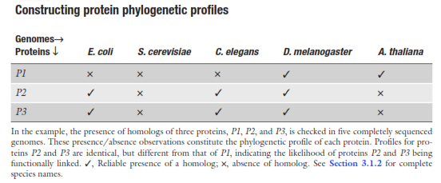
FIG 1. Constructing protein phylogenetic profiles. The presence of homologs of three proteins, P1, P2, and p3, is checked in five completely sequenced genomes. These presence/absence observations constitute the phylogenetic profile of each protein. Profile for protein P2 and P3 are identical, but different from that of P1, indicating the likelihood of proteins p2 and p3 being functionally linked (figure adopted from (40)).
Assigning a function to a previously uncharacterized protein family by phylogenetic profiling
The phylogenetic profile of a protein describes the presence or absence of homologs in organisms. Proteins that make up multimeric structural complexes are likely to have similar profiles. Also, proteins that are known to participate in a given biochemical pathway are likely to be neighbors in the space of phylogenetic profiles (38). It is also possible to use this approach to assign a function to a previously uncharacterized protein family. That is, if nothing is known about the function of protein family A, but using phylogenetic proﬁling one identiﬁes that it is coevolving with functionally characterized protein family B, then it is likely that the function of A is similar to that of B. A recent review demonstrates that over the years a variety of examples of this "guilt by association" technique have been used to predict and then verify the functions of previously uncharacterized protein families (3).

5
Methods
PrePhyloPro (PPP) is software for constructing and comparing phylogenetic profiles. PPP is able to handle vectors as input, and measure the similarity (or distance) between them. The program is able to perform a mathematical/statistical operation on the profile set and measure the distance between a pair of vectors. The degree of similarity between phylogenetic profiles is indicative of the likelihood of a functional linkage between proteins. PPP measures the similarity between vectors in a pairwise manner and the functional linkages which will be determined between all profile vectors (40). Phylogenetic profiling is a diagram that can show us the genes or proteins which have appeared or disappeared in particular taxonomy at the particular time so we use this privilege to introduce novel genes; those had a function at the same time with other known genes, so the probability of functioning in the same pathway is much higher. Incompletely or partially sequenced genomes have not been included in this database, to avoid a false representation of the query proteins (40). This software allows us to group the proteins that act within the same biological process together. Examples of biological processes are the cell cycle, speciﬁc metabolic pathways or large protein complexes, such as the ﬂagella. In order to demonstrate that coevolving pairs of protein are functionally related, we simply demonstrate that these pairs are more often members of the same biological process than random pairs (38). For example, ubiquinone oxidoreductase (NADH, Complex I), an energy-transducing multi-protein complex located in the mitochondrial inner membrane. Several of its members have paralogues that are members of Complex I itself or of other mitochondrial complexes. Noted that Complex I member, N7BM (B17.2) and its paralogue B17.2L have similar occurrence proﬁles and were lost together from multiple independent lineages. Unfortunately, the function of N7BM within the complex was unknown and thus the co-occurrence- and homology-based link to this protein and to Complex I did not provide information on the speciﬁc function of B17.2L. It was an experimental study of Complex I assembly that showed, B17.2L is an assembly factor involved in this process and its mutation can lead to the Complex I deﬁciency associated with a progressive encephalopathy in human patients (41).
To find new genes which might be involved in the etiology of Parkinson’s disease and have similar occurrence profile with previously known genes, first of all, we have studies some articles through PUBMED to find out the genes were already proved to be part of PD. Then, we prepared a list of those genes to find out the novel genes which can be functionally linked to PD by phylogenetic profiling software (http://prephylopro.org/phyloprofile/#doc). The website's profile is constructed from 972 different species containing 276 eukaryotic, 614 bacterial, and 82 archaea species and mitochondrial and chloroplast proteins were also included. Linkage number and blast value are variable in number as per our requirements. Linkage number can be selected between 100 to 500 and the smaller value will give us less predicted linkage but mostly with higher accuracy. As we increase the number we will be getting more predicted linkage in quantity, and Blast value is the other option which the smaller values of it result in less homolog in profile. The organism can be selected from, Homo sapiens (human) or Arabidopsis thaliana according to the subject which we are studying (FIG 2).
To identify phylogenetic profiles similar to the PD genes within the human proteome, we generated a list consisting of significantly correlated protein pairs. We have chosen the top 9 proteins which had been proved to have a role on PD at the BLASTP threshold of E< 0.001 and linkage number of 100 (FIG 4). Output result is visualized online and could be easily downloaded and restored on local computers to find out novel genes which are in a close evolutionary relationship with known PD genes by understanding the number of repetition of new genes with those are already known and trying to select among them the ones with higher likelihood of connection to PD. The appearance of a protein in the similarity/correlation lists of multiple PD factors would indicate a higher likelihood of acting in the same function. To find out those genes we have sorted the repetition numbers from largest to smallest to separate those genes were repeated 3 times as it was the highest number of repetition, then we passed it into another sheet. Over all, we sorted the Jaccord column from largest to smallest to delete those have had less than 0.05 percent as must be having very less percent of probability to be involved in PD. (FIG 3). We repeat the same procedure for 3 times to find out their correlations with each other and novel genes which may are functioning in PD.


FIG 2. Linkage number and blast value. Linkage number is selectable between 100 to 500 and the smaller value will give us less predicted linkage but mostly with higher accuracy. As we increase the number we will be getting more predicted linkage in quantity. The smaller values of blast result into less homolog in profile.
FIG 3. Phylogenetic profiling list. The list of genes related to inputted list of genes, from whole human proteome. The genes are ordered as per their repetition number.
6
Results
Phylogenetic profiles of the PD genes

As per FIG4, our inputting data involves 9 known PD genes, (PINK1, DJ1, PARKIN, SNCA, LRRK2, MAPT, UCHL1, ATP13A2, and DDX50) which has come out of previous studies. We uploaded the list into the PPP. The output includes the phylogenetic profiles with 2120 entries in human whole-proteome proteins, phylogenetic profiling of predicted linkage and correlation matrix (5, 6). The correlation matrix was color coded from -1 to 1, with 1 representing the highest positive correlation. The correlation matrix revealed clustering of the PD genes into two distinct evolutionary groups. The highest correlation was observed between UCHL1 and Parkin with 0.97 and the lowest was between Pink1 and SNCA and Pink1 and MAPT with 0.2. The two distinct evolutionary groups were sub-divided into 4 distinct pathways, respectively Parkin & UCHL1 with 1.00 %/ SNCA & MAPT with 0.75 %/ PINK1, UCHL1 & MAPT with 0.50 % correlation with each other and DDX50, ATP13A2 &SNCA and MAPT are having the lowest percentage of correlation in evolutionary view. As per figure 5, PD genes are most expressed among animals and then bacteria and so less percentage were expressed in other species. As per phylogenetic profiling, we have 4 particular groups of genes, Pink 1& LRRK2 (group 1), DDX50 & ATP13A2& DJ1 (group 2), MAPT& SNCA (group 3), and UCHL1 &Parkin (group 4). The division of genes in different groups is as per their presence or absence in different taxonomies because this method believes the proteins which have been found or lost in particular taxonomies are most probably functioning in the same pathway. The first group, PINK1 & LRRK2 are not observed in Archaea and bacteria’s. The second groups, DDX50 & ATP13A2 are expressed in all the species except some of the bacteria’s. DJ1 is also part of the second group and not any other group because it has the most similarity of expression with DDX50 and ATP13A2 but not expressed in fungi and bacteria’s group. In the third group, MAPT & SNCA are expressed in the animal taxonomy. The last group, UCHL1 & PARKIN appears in animal and plant only and some of fungi taxonomy.
FIG 4. List of PD genes
List of known PD genes (inputting data) to find out those which are in a higher correlation with them from whole human proteome.
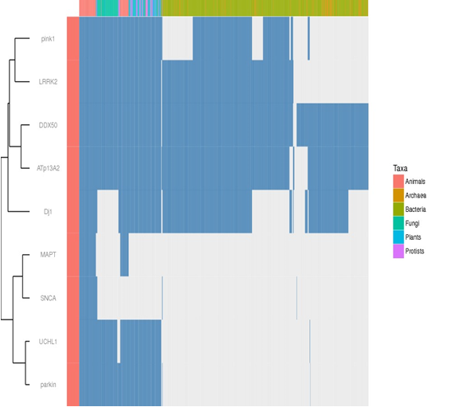
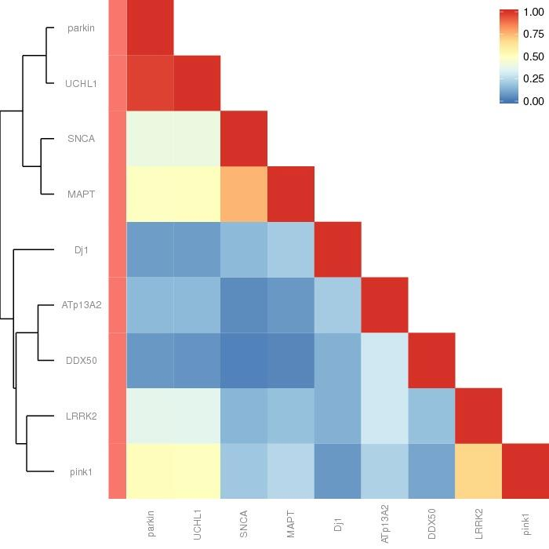
FIG 5. Phylogenetic profiling. The phylogenetic profiles of 9 PD genes among different taxa. Blue bars represent presence and gray bars are absence. Four particular groups of genes are observed. Those genes which are having the same bar color are most probably functioning in the same pathway.

FIG 6. Correlation matrix among the phylogenetic profiling of PD genes
The number 1 which is red color indicates the highest correlation between two genes and 0 which is blue color indicates the lowest correlation during evolutionary pathway. Correlation matrix indicating at least two distinct evolutionary groups of development factors in 4 distinct pathways, respectively Parkin & UCHL1 with 1.00 %/ SNCA & MAPT with 0.75 %/ PINK1, UCHL1 & MAPT with 0.50 % are having the highest correlation with each other and DDX50, ATP13A2 &SNCA and MAPT are having the lowest percentage of correlation.
To narrow down the results, we studied each group separately with different linkage numbers from 100 to 500. We then determined the maximum number of times a protein appeared in the predicted linkages list of groups belongs to group 4 with 81 entries and 2 times repetition. The higher number of repetition indicates higher correlation among the PD genes and new genes. To find out whether any of these genes were studied before, we studied their function individually to see whether they have been linked to PD and neuronal pathology or no. Among 81 genes, one gene (ArfGAP1) was correlated with both UCHL1 and LRRK2. ArfGAP1 is a regulator of LRRK2 GTPase and kinase activity as well as neuronal toxicity induced by LRRK2. ArfGAP1 also serves as a novel substrate for phosphorylation mediated by LRRK2 kinase activity. ArfGAP1 may, therefore, represent a promising molecular target for interfering with neurodegeneration due to LRRK2 mutations in familial and sporadic forms of PD (43).
We then added EIF4G1, VPS35, FBX07, PIA2G6, HTRA2, and GIGYF2, which were in a higher number of correlations with known PD genes, in the previous list. The correlation matrix showing a high degree of correlation between GIGYF2, EIF4G1, vps35, Parkin and UCHL1 and around a correlation coefficient of 0.50 between this group and MAPT, SNCA and FBXO7. This suggests a functional linkage between GIGYF2, PARKIN and UCHL1. The phylogenetic profiling chart showing four distinct groups of genes. The first group (HTRA2, ATP13A2, and DJ1) is mostly expressed in all species, except archaea and some bacteria. The second group (UCHL1, Parkin & GIGYF2) are mostly expressed in animals and plants and prosthesis and some bacteria’s species. The third group (MAPT, FBXO7 and SNCA) are expressed only in the animal group and so rare in fungi and the last group (GIGYF2, EIF4G1, vps35, Parkin and UCHL1) are expressed in animals and some bacterias (Figure7, 8).
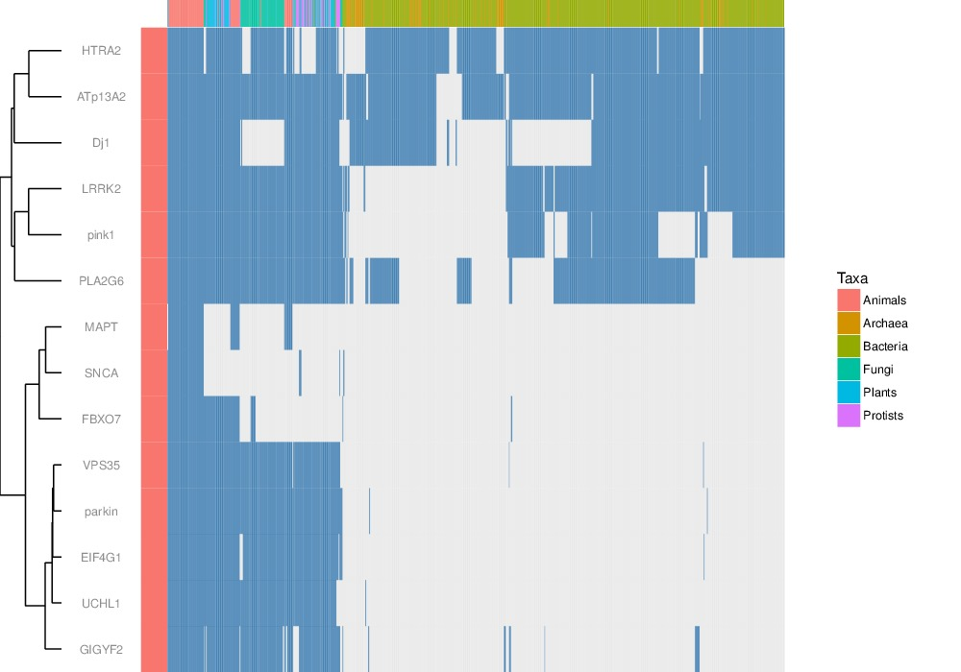
FIG 7. Phylogenetic profiling
Four distinct groups are there. The last group is mostly expressed in animals and other genes are also divided to different groups according to their expression in different taxonomies in different times of evolution. But still we can see that genes in the last group are the most similar to each other as per their expression.
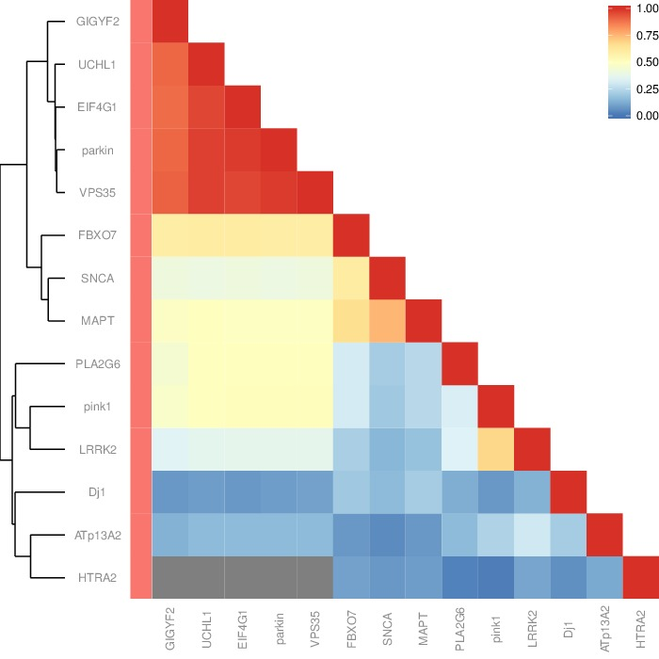
FIG 8. Correlation matrix among the phylogenetic profiling PD genes.
There are four main groups. The first group which is shown by red and orange colors is indicating number one and 0.75 which is the highest correlation among all inputted genes. The second, third and fourth groups are indicating 0.5 and below that correlation which are shown by yellowish and blueish colors.
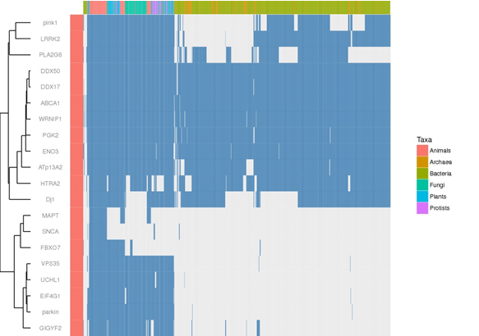
For the third time, we repeated the same procedure to select more proteins with the highest number of correlation with the known PD genes. This time, we couldn’t achieve any useful new data as the new genes which were added to the previous list are not showing a good correlation with other genes and all had come in blue color with almost 0.00 percentage of correlation in the matrix. The phylogenetic profiling showing four distinct groups of genes. PINK1, LRRK2, PLA2G5, did not appear in archaea's and some bacterial species. The second group involves DDX50, DDX17, ABCA1, ARNIP1, PGK2, ENO3, ATP13A2, HTRA2, DJ1, which did not appear just in some archaeal species. MAPT, SNCA, FBXO7, made up the other group, which was the only group has been expressed in animals and rarely in bacteria and prosthesis. VPS35, UCHL1, EIF4G1, PARKIN, GIGYF2 are involved to the other group as they didn't get expressed in most of the bacterial species and archaea. So we postulated that GIGYF2 and EIF4G and VPS35 must be working in the same pathway as Parkin or UCHL1 and PLA2G6 might be linked to the function of LRRK2 or PINK1.(Figure 9,10)
FIG 9. Phylogenetic profiling
It is showing four distinct groups of genes which appear in a different area of taxonomy. PINK1, LRRK2, PLA2G5, have not appeared in archaea's and some of bacterial. The second group involves DDX50, DDX17, ABCA1, ARNIP1, PGK2, ENO3, ATP13A2, HTRA2, DJ1, have not appeared just in some of the archaeal taxonomy. MAPT, SNCA, FBXO7, is the other group which is the only group has been expressed in animals and rarely in bacteria and prosthesis. VPS35, UCHL1, EIF4G1, PARKIN, GIGYF2 are involved to the other group as they didn't get expressed in most of the bacterial species and archaea.
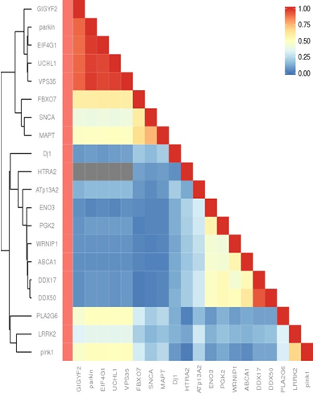FIG 10. Correlation matrix among the phylogenetic profiling PD genes.
It is classified to two main groups and each group is divided to two smaller groups. The highest correlation is related to EIF4G1, PARKIN, UCHL1 and VPS35 which is shown in dark red color. Then SNCA with MAPT, LRRK2 with PINK1, and ABCA1 with DDX50 are shown with orange color. MAPT and FBXO7 with first group are shown in darker yellow and PLA2G6 and PINK1 with lighter color in relation with first group. The correlation among other genes is very less, between 0 to 0.25.
7
Discussion
PD is a multifactorial neurodegenerative disease of unknown causes. Several genes have been identified as PD genes. Mutations in these genes are known to cause familial Parkinson's disease. The central hypothesis of this work is that these genes are part of an interlinked pathway that might be the underlying cause of the vulnerability and degeneration of midbrain dopaminergic neurons during the course of the disease. Identifying new players in this process might help with a better understanding of the molecular etiology of the disease and development of novel therapeutic targets. We used the well-established phylogenetic profiling method to identify the interacting partners of the PD genes. Phylogenetic profiling is used to identify novel protein partners, based on their co-evolution, as the genes that evolve in a correlated manner are more likely to interact or function together. Using the PPP tool, we built the phylogenetic profiles of the PD genes and identified, from the entire human genome, other genes that have the similar profile to the PD genes. This study revealed a close correlation between a subset of the known PD genes. The new sets of proteins clustered, along with the known PD genes, into three groups: 1) GIGYF2 & Parkin & EIF4G & UCHL1 &VPS35 2) Pink 1 &LRRK2 &PLA2G6 and 3) FBXO7 & SNCA & MAPT. Some of these proteins have been studied extensively in connection with the cellular and animal models of PD and their connection with the PD genes has been established, confirming the validity of this approach.
EIF4G & Vps35.
EIF4G is a scaffold component in the mRNA translation initiation complex performing a key role in both cap-dependent and cap-independent translation initiation. Together with PABP and EIF4E, EIF4G circularizes the mRNA to stabilize it and to also promote initiation in conventional cap-dependent translation initiation. EIF4G binds with EIF4A to form a subcomplex thereby initiate translation by recruiting 43S complex onto internal ribosome entry site without the cap binding EIF4G complex (50).
This gene belongs to a group of vacuolar proteins and it’s a component of a large multimeric complex termed the retromer complex involved in retrograde which does the transport of proteins from endosomes to the trans-Golgi network. VPS35 mutations cause mitochondrial fragmentation and cell death in cultured neurons in vitro. VPS35-induced mitochondrial deficits and neuronal dysfunction which could be prevented by inhibition of mitochondrial fission. VPS35 mutants showed increased interaction with dynamin-like protein (DLP) 1, which enhanced turnover of the mitochondrial (DLP)1 complexes via the mitochondria-derived vesicle–dependent trafficking of the complexes to lysosomes for degradation (49).in one of research they showed experimentally that VPS35 is able to protect against α–synuclein-induced neurodegeneration in a mouse model. Together, these results reveal robust genetic and functional interactions between two known PD genes and illuminate novel connections to α–synuclein pathobiology. VPS35 and EIF4G1, are able to interact in a powerful way and, in a broader sense, retromer deficiency sensitizes cells to effects of altering translation initiation factor function. These results demonstrate a synthetic effect between the vps-35 mutation and overexpression of EIF4G1 in neurons and indicate that the VPS35-EIF4G1 genetic interaction that they discovered in yeast is conserved and functional in the nervous system. The unexpected link between translation initiation factor eIF4G1 and Vps35, including the role of protein misfolding and activation of the unfolded protein response, illuminates translation regulation and protein quality control pathways as well. Protein misfolding and impairments in protein degradation lie at the heart of neurodegenerative diseases, including PD (54).
PLA2G6
This gene contains CAG trinucleotide repeats and encodes a protein containing several stretches of polyglutamine residues. The encoded protein may be involved in the regulation of tyrosine kinase receptor signaling. Mutation in PLA2G6 cause neurodegenerative disorder characterized by bradykinesia, resting tremor, muscular rigidity and postural instability, as well as by a clinically significant response to treatment with levodopa. The pathology involves the loss of dopaminergic neurons in the substantia nigra and the presence of Lewy bodies (intraneuronal accumulations of aggregated proteins), in surviving neurons in various areas of the brain (51). Misfolded proteins and protein oligomers accumulate because of increased production or reduced removal. The amount of misfolded protein and oligomer is thought to depend primarily on the initial amount of starting protein and its natural propensity to aggregate. The accumulating misfolded proteins and oligomers lead to the uncoordinated assembly of higher order oligomers, amyloids and eventually large fibrils, which harm the cell and precipitate neurodegeneration (54).
FBXO7
This gene encodes a member of the F-box protein family which is characterized by an approximately 40 amino acid motif, the F-box. The F-box proteins constitute one of the four subunits of the ubiquitin protein ligase complex called SCFs (SKP1-cullin-F-box), which function in phosphorylation-dependent ubiquitination. The protein encoded by this gene belongs to the Fbxs class and it may play a role in the regulation of hematopoiesis (52).
GIGYF2
GIGYF2 is potentially involved in the pathogenesis of PD due to the effect of IGF-1 on the insulin signaling in the central nervous system. An analysis was performed among 7,246 cases and 7,544 controls to evaluate the association between seven polymorphisms of GIGYF2 and PD. only seven polymorphisms of GIGYF2 were investigated, which may not fully reflect the function of GIGYF2 in PD while there are 9571 variants in the GIGYF2 according to the NCBI dbSNP database. The earlier onset and severe clinical course in the index patient suggest additive effects of the GIGYF2 and LRRK2 mutations. These data strongly support GIGYF2 as a PARK11 gene with a causal role in familial PD (56). GIGYF1 (or PERQ1) and GIGYF2, interacting through their GYF domain with the Grb10 adaptor protein. Grb10 and the GIGYF proteins are of interest for their potential involvement in insulin-like growth factor (IGF) and insulin signaling. Because the IGFs and insulin have important effects on the central nervous system and are potentially associated with PD, investigated the involvement of the GIGYF2 (TNRC15) gene in PD (55). Primary cultured embryo fibroblasts from Gigyf2 null mice exhibit decreased IGF-I-stimulated IGF-I receptor tyrosine phosphorylation and augmented ERK1/2 phosphorylation. These data provide further evidence for an important role of GIGYF2 in age-related neurodegeneration and IGF pathway signaling (53).
An interesting point of this research is the correlation of LRRK2 and PINK1 with PLA2G6. These three proteins are known to cause mitochondrial dysfunction by enhancing each other’s function or functioning individually (54). Overexpression of Parkin causes damage to mitochondria and increasing autophagy in PINK 1 dependent manner. Parkin support ATP production and affect the activity of different complexes within electron transport chain (ETC), so its mutation can cause reducing the CI assembly and increase sensitivity to oxidative stress and slowing down-regulation of mitochondrial uncoupling protein (36). LRRK2 regulates UCPs to maintain MMP and ATP production so its mutation cause decreasing the level of MMP and total intracellular ATP level. In particular, the mitochondrial kinase PINK1 and the cytosolic E3 ubiquitin ligase parkin act in a common pathway to regulate mitochondrial function. PINK1/parkin pathway also plays a critical role in the autophagic removal of damaged mitochondria–mitophagy. It is not known how mutations in PLA2G6 cause neuropathology. However, it has been suggested that the loss of normal PLA2G6 activity in neurodegenerative disease involves structural abnormalities of cell or mitochondrial membranes and disturbances in lipid homeostasis and lipid metabolism. Indeed, a study in a mouse Pla2g6 knockout model demonstrates ultrastructural abnormalities in mitochondrial and synaptic membranes. As well as possible mitochondrial defects, it is thought that changes in the composition of the plasma membrane and other intracellular membranes may in turn affect the normal processes responsible for the movement of membranes within axons and dendrites, subsequently leading to accumulation of membranes as so-called spheroids (57).
The novelty this approach relies on the predictive value of the phylogenetic profiling in identifying proteins that might play a role in the etiology of PD. The results of this study might also be utilized in identifying new therapeutic targets for treatment of Parkinson’s disease.

8
References
1) McNeill AW, u RM, Tzen KY, Aguiar PC, Arbelo JM, Barone P, Bhatia K, Barsottini O, Bonifati V, Bostantjopoulou S, Bressan R, Cossu G, Cortelli P, Felicio A, Ferraz HB, Herrera J, Houlden H, Hoexter M, Isla C, Lees A, Lorenzo-Betancor O, Mencacci NE, Pastor P, Pappata S, Pellecchia MT, Silveria-Moriyama L, Varrone A, Foltynie T, Schapira AH (2013) Dopaminergic neuronal imaging in genetic Parkinson's disease: insights into pathogenesis. journal.pone 10.1371.0069190.
2) Navneet Ammal Kaidery, Shaista Tarannum, and Bobby Thomas (2013) epigenetic landscape pf Parkinson`s disease:emerging role in disease mechanism and therapeutic modalities. Neurotherapeutics 10:698-708.
3) Isabella Russo, Luigi Bubacco, and Elisa Greggio (2012) exosome associated neurodegeneration and progression of Parkinson`s disease. Am J Neurodegener 1:217–225.
4) Leslie A. Scarffe, Daniel A, StevensValina L, Dawson Ted M, Dawson (2014) Parkinand PINK1: much more than mitophagy. Trends Neurosci 37:315–324.
5) Jean-Marc Taymans and Veerle Baekelandt (2014) phpsphatase of alpha-synuclein, LRRK2, and tau: important players in the phosphorylation-dependent pathology of Parkinsonism. Front Genet 5:382.
6) Henry Houlden Andrew B, Singleton (2012) the genetic and neuropathology of Parkinson`s disease. Acta Neuropathol 124:325–338.
7) ) Payal N. Gandhi, Shu G. Chen and Amy L. Wilson-Delfosse (2014) Leucine-Rich Repeat Kinase 2 (LRRK2): A Key Player in the Pathogenesis of Parkinson’s Disease. J Neurosci Res 87:1283–1295.
8) McNeill A, Duran R, Mehta A, Hughes D, Schapira AH (2012) A clinical and family history study of Parkinson's disease in heterozygous glucocerebrosidase mutation carriers. J Neurol Neurosurg Psychiatry 83:853-4.
9) Healy DG, Falchi M, O'Sullivan SS, Bonifati V, Durr A, et al (2008) Phenotype, genotype and worldwide penetrance of LRRK2 -associated Parkinson's disease.
10) Lees AJ, Hardy J, Resvez T (2009) Parkinson's disease. Lancet 13;373:2055-66.
11) Warner TT, Schapira A (1998) The role of the alpha-synuclein gene mutation in patients with sporadic Parkinson's disease in the United Kingdom. J Neurol Neurosurg Psychiatry. 65: 378–379.
12) Samaranch L, Lorenzo-Betancor O, Arbelo J, Ferrer I, Lorenzo E, et al (2010) PINK1-linked parkinsonism is associated with Lewy body pathology. Brain 133:1128-42.
13) Kitada T, Tomlinson JJ, Ao HS, Grimes DA, Schlossmacher MG (2012) Considerations regarding the etiology and future treatment of autosomal recessive versus idiopathic Parkinson's disease. Curr Treat Options Neurol 14:230-40.

14) Gegg ME, Schapira AH (2011) PINK1-parkin-dependent mitophagy involves ubiquitination of mitofusins 1 and 2: Implications for Parkinson's disease pathogenesis. Autophagy 7:243-245.
15) Abramov AY, Gegg M, Grunewald A, Wood NW, Klein C, et al (2011) Bioenergetic consequences of PINK1 mutations in Parkinson's disease. journal.pone 10.1371.
16) Pavese N, Khan NL, Scherfler C, Cohen L, Brooks DJ, et al (2009) Nigrostriatal dysfunction in homozygous and heterozygous parkin gene carriers: an 18F-dopa PET progression study. Mov Disord 24: 2260–2266.
17) Kessler KR, Hamscho N, Morales B, Menzel C, Barrero F, et al (2005) Dopaminergic function in a family with the PARK6 form of autosomal recessive parkinson's syndrome. J Neural Transm 112: 1345–1353.
18) Gegg ME, Burke D, Heales SJ, Cooper JM, Hardy J, et al (2012) Glucocerebrosidase activity in substantia nigra of Parkinson's disease brains. Ann Neurol 72: 455–463.
19) Mazzulli JR, Xu YH, Sun Y, Knight AL, McLean PJ, et al (2011) Gaucher disease glucocerebrosidase and alpha-synuclein form a bidirectional pathogenic loop in synucleinopathies. Cell 146: 37–52.
20) Michelle K Lin and Matthew J Farrer (2014) Genetics and genomics of Parkinson's disease. Genome Medicine 20146:48.

21) Herzig MC, Kolly C, Persohn E, Theil D, Schweizer T, Hafner T, Stemmelen C,Troxler TJ, Schmid P, Danner S, Schnell CR, Mueller M, Kinzel B, Grevot A,Bolognani F, Stirn M, Kuhn RR, Kaupmann K, van der Putten PH, Rovelli G, Shimshek DR (2011) LRRK2 protein levels are determined by kinase function and are crucial for kidney and lung homeostasis in mice. Hum Mol Genet 20:4209–4223.
22) Ian Martin, Valina L. Dawson, and Ted M. Dawson (2014). Recent Advances in the Genetics of Parkinson's Disease. Annu Rev Genomics Hum Genet 12:301–325.
23 ) Burré J, Sharma M, Tsetsenis T, Buchman V, Etherton MR, Südhof TC (2010) Alpha-synuclein promotes SNARE-complex assembly in vivo and in vitro. Science 24; 329:1663–1667.
‏ 24) Fraldi A, Medina DL, Ballabio(2013) A.Signals from the lysosome: a control centre for cellular clearance and energy metabolism. Nat Rev Mol Cell Biol 14:283-96.
25) J Biol Chem, Westphal CH1, Chandra SS (2013) Monomeric synucleins generate membrane curvature. J Biol Chem 18;288:1829-1840.
26) Lee VM, Trojanowski JQ (2006) Mechanisms of Parkinson's disease linked to pathological alphasynuclein: new targets for drug discovery. Neuron 52:33–38.
27) Keeney PM, Xie J, Capaldi RA, Bennett JP (2006) Parkinson's disease brain mitochondrial complex I has oxidatively damaged subunits and is functionally impaired and misassembled. J Neurosci 10;26:5256-5264.
28) Nemani VM1, Lu W, Berge V, Nakamura K, Onoa B, Lee MK, Chaudhry FA, Nicoll RA, Edwards RH (2010) Increased expression of alphasynuclein reduces neurotransmitter release by inhibiting synaptic vesiclereclustering after endocytosis. Neuron 65:66-79
29) West AB, Moore DJ, Biskup S, Bugayenko A, Smith WW, et al (2005) Parkinson's disease-associated mutations in leucine-rich repeat kinase 2 augment kinase activity. Proc Natl Acad Sci U S A 102:16842–16847.
30) Dawson TM, Ko HS, Dawson VL (2010) Genetic animal models of Parkinson's disease. Neuron 66:646–61.
31) Gehrke S, Imai Y, Sokol N, Lu B (2010) Pathogenic LRRK2 negatively regulates microRNA-mediated translational repression. Nature 466:637–641.
32) Velayati A, Yu WH, Sidransky E (2010) The role of glucocerebrosidase mutations in Parkinson's disease and Lewy body disorders. Curr Neurol Neurosci Rep 10:190–198.
33) Javitch JA, D'Amato RJ, Strittmatter SM, Snyder SH (1985) Parkinsonism-inducing neurotoxin, Nmethyl-4-phenyl-1,2,3,6 -tetrahydropyridine: uptake of the metabolite N-methyl-4-phenylpyridine by dopamine neurons explains selective toxicity. Proc Natl Acad Sci U S A 82:2173–2177.
34) Schapira AH (2008) Mitochondria in the aetiology and pathogenesis of Parkinson's disease. Lancet Neurol 7:97–109.
35) F.SchulerandJ, E.Casida (2001) Functionalcoupling of PSSTand ND1 subunits in NADH:ubiquinone oxidoreductase established by photoaﬃnity labeling," Biochimica et Biophysica Acta—Bioenergetics 1:p 79–87.
36) RossB,Mounsey and PeterTeismann (2010) Review Article Mitochondrial Dysfunction in Parkinson's Disease: Pathogenesis and Neuroprotection Biochimica et Biophysica Acta 1506:79-87.
37) C. Perier, K. Tieu, C. Gu ´ egan et al. (2005)"Complex I deﬁciency primes Bax-dependent neuronal apoptosis through mitochondrial oxidative damage," Proceedings of the National Academy of Sciences of the United States of America, vol. 102, Proc Natl Acad Sci U S A 102: 19126–19131.
38) Assigning protein functions by comparative genome analysis: Protein phylogenetic profiles‏.PNAS 96: 4285-4288
39) Kensche PR, van Noort V, Dutilh BE, Huynen MA (2008) Practical and theoretical advances in predicting the function of a protein by its phylogenetic distribution. J R Soc Interface 5:151–170
40) V. Date and José M. Peregrín-Alvarez (2008) Phylogenetic Profiling Shailesh. Bioinformatics Volume II: Structure, Function and Applications 453:201-216.
41) Philip R. Kensche ,Vera van Noort , Martijn A. Huynen ,Bas E. Dutilh (2008) Practical and theoretical advances in predicting the function of a protein by its phylogenetic distribution. J R Soc Interface 6;5:151-170.
42) MATTEO PELLEGRINI, EDWARD M. MARCOTTE, MICHAEL J. THOMPSON, DAVID EISENBERG, AND TODD O. YEATES (1999) Assigning protein functions by comparative genome analysis: Protein phylogenetic profiles. Molecular Biosciences 8:4285-4288.
43)mark w dodson (2007) Pink1, Parkin, DJ-1 and mitochondrial dysfunction in Parkinson's disease. Curr Opin Neurobiol 17:331-337.
44) Ira E. Clark, Mark W. Dodson, Changan Jiang, Joseph H. Cao, Jun R. Huh, Jae Hong Seol, Soon Ji Yoo, Bruce A. Hay and Ming Guo (2006) Drosophila pink1 is required for mitochondrial function and interacts genetically with parkin. Nature 441:1162–1166.
45) Fujioka,S,. wszolek, Z.K (2012) update on genetic of parkinsonism Neurodegener Dis 10:257-260.
46) Tatiana D. Papkovskaia, Kai-Yin Chau, Francisco Inesta-VaqueraDmitri B. Papkovsky, Daniel G. Healy, Koji Nishio, James Staddon, Michael R. Duchen, John Hardy, Anthony H.V. Schapira and J. Mark cooper (2012) G2019S leucine-rich repeat kinase 2 causes uncoupling protein-mediated mitochondrial depolarizationHum. Mol Genet 21:4201-13.
47) Amanda L, Woerman, Joel C, Watts, Atsushi Aoyagi , Kurt Giles , Lefkos Middleton and Stanley B. Prusiner1 (2017) α-Synuclein: Multiple System Atrophy. Prions 10.1101
48)Shiam-Peng Tay, Calvin W.S.Yeo,Chou Chai, Pei-Jou, Hua-Mei Tan, Alex X.Y.Ang,Jian-xiong Sung, Puay HoonTan, Boon-Huat Bay, Siew- Heng, Daniel L. H. Yip, Carol Tang, Jeanne M.M.Tan and Kah-Leong Lim (2012) Parkin Enhances the Expression of Cyclin-dependent Kinase 6 and Negatively Regulates the Proliferation of Breast Cancer Cells. J Biol Chem 285:29231-29238.
49) Wenzhang Wang, Xinglong Wang, Hisashi Fujioka, Charles Hoppel, Alan L Whone, Maeve A Caldwell, Peter J Cullen, Jun Liu and Xiongwei Zhu (2015) Parkinson's disease–associated mutant VPS35 causes mitochondrial dysfunction by recycling DLP1 complexes. Nat Med 22:54-63.
50) Hiroaki Imataka, Alessandra Gradi, Nahum Sonenberg (1998) A newly identified N‐terminal amino acid sequence of human eIF4G binds poly(A)‐binding protein and functions in poly(A)‐dependent translation. EMBO J 17:7480–7489.
51) Laura A. Engel,Zheng Jing,Daniel E. O'Brien,Mengyang Sun,Paul T(2008) Kotzbauer Catalytic Function of PLA2G6 Is Impaired by Mutations Associated with Infantile Neuroaxonal Dystrophy but Not Dystonia-Parkinsonism. PLoS One 5:12897.
52) Suzanne J. Randle, Heike Laman (2017) Structure and Function of Fbxo7/PARK15 in Parkinson's Disease. Current Protein & Peptide Science 10.2174
53) Barbara Giovannone William G. Tsiaras Suzanne de la Monte Jan KlysikCorinne Lautier Galina Karashchuk Stefano Goldwurm Robert J. Smith (2009) GIGYF2 gene disruption in mice results in neurodegeneration and altered insulin-like growth factor signaling. Hum Mol Genet 18:4629-39
54) Nripesh Dhungel, Simona Eleuteri, Ling-bo Li, Nicholas J. Kramer, Justin Chartron, Brian Spencer, Kori Kosberg, Jerel Adam Fields, Stafa Klodjan, Anthony Adame, Hilal Lashuel, Judith Frydman, Kang Shen, Eliezer Masliah and Aaron D. Gitler (2014) Parkinson’s disease genes VPS35 and EIF4G1 interact genetically and converge on α–synuclein. Neuron 85:76–87.

55) Dai D, Wang Y, Zhou X, Tao J, Jiang D, Zhou H, Jiang Y, Pan G, Ru P, Ji H, Li J, Zhang Y, Yin H, Xu M, Duan S (2014) Meta-analyses of seven GIGYF2 polymorphisms with Parkinson's disease. Biomed Rep 2:886-892.

56) CorinneLautier, Stefano Goldwurm, AlexandraDürr, Barbara Giovannone, William G.Tsiaras, Gianni Pezzoli, Alexis Brice, Robert J.Smith (2008) Mutations in the GIGYF2 (TNRC15) Gene at the PARK11 Locus in Familial Parkinson Disease. Am J Hum Genet 82: 822–833.

57) Kinghorn, K.J, Castillo-Quan, J.I, Bartolome, F, Angelova, P.R, Li, L., Pope, S, Cochemé, H.M, Khan, S, Asghari, S, Bhatia, K.P, Hardy, J, Abramov, A.Y and Partridge, (2015) Loss of PLA2G6 leads to elevated mitochondrial lipid peroxidation and mitochondrial dysfunction. Brain 138: 1801-1816

