Importance of Synaptic vesicle trafficking dysfunction in Parkinson's disease

By: Boshra Afaghi
Supervisor: Dr. Kambiz Nassirpour Alavian

This thesis is submitted to the Department of Biology as partial fulfilment of the MSc
program in Neuroscience

January 2021
Department of Biology
Faculty of Science
Baha'i Institute for Higher Education (BIHE)

Summary
Parkinson's disease (PD) is the most common neurodegenerative movement disorder disease. PD's main pathological characteristic is the extensive and progressive degeneration of dopaminergic neurons in the substantia nigra pars compacta and neuronal loss in different brain regions. Recent studies have shown that genetic and environmental factors have a role in the etiology of Parkinson's disease, but the exact mechanism is yet to be determined. In this work, I examined the evolutionary correlation of the genes associated with the genetics of PD to identify novel molecular pathways for Parkinson's disease. Phylogenetic profiling of 15 PD genes revealed a high degree of correlation among five genes, indicating potential participation in a common pathway. A literature review showed that all five genes have a role in synaptic vesicle trafficking, which could be a crucial pathological pathway in Parkinson's disease. To further investigate the connections between the genetics of PD and synaptic vesicle trafficking, I chose six genes that displayed the highest degree of correlation with the highest number of PD genes, based on the predicted linkages. Gene ontology analysis of these candidate proteins confirmed their involvement in synaptic vesicle trafficking. These results suggested a strong connection between the proteins involved in the regulation of synaptic vesicle trafficking and the etiology of Parkinson's disease.

Table of Contents
Introduction 1
Parkinson's disease 1
Neurodegeneration 1
Clinical features 3
Therapeutic interventions 6
Etiology and pathogenesis 7
Basal ganglia 10
Normal 10
PD 14
Genetics of Parkinson’s disease 15
Alpha-synuclein 15
LRRK2 15
PRKN (Parkin, PARK2) 16
PTEN-INDUCED KINASE 1 (PINK1, PARK6) 16
DJ1 (PARK7) 16
ATP13A2 (PARK9), PLA2G6 (PARK14), and FBXO7 (PARK15) 17
Novel genes 17
Vesicle trafficking 20
Main pathways of neuronal vesicle trafficking 20
Vesicle trafficking in Parkinson’s disease 21
Phylogenetic profiling 22
Hypothesis 24
Material and Method 25
PD genes 25
Phylogenetic profiling 26
Testing new genes 27
Results 27
Phylogenetic profiling of the 15 genes 27
Correlation between five genes 27
Co-evolution, co-function of the five genes 29
PD genes with a role in synaptic vesicle trafficking 31
Testing the new hypothesis 32
Discussion and conclusions 45
References 48

List of figures

Figure 1. Neuropathology of Parkinson's disease. 3
Figure 2. Suggested physiological pathways related to PD. 8
Figure 3. Mechanisms of Neurodegeneration 10
Figure 4. Basal ganglia nuclei. 11
Figure 5. Schematic figure of the direct/indirect pathway classical model in the physiological condition and Parkinson’s disease. 13
Figure 6. Lewy bodies in dopaminergic neurons from the substantia nigra pars compacta 14
Figure 7. synaptic vesicle trafficking at DA synapses in normal conditions and PD 22
Figure 8. Schematic image for phylogenetic profiling method. 23
Figure 9. Phylogenetic profiles of input genes: 28
Figure 10. Correlation matrix of input genes: 29
Figure 11. Correlation matrix of the new group of genes (15+6). 33
Figure 12. Result of biological process in the "Generic Go Term Finder" 37

List of tables
Table 1. Symptoms of PD 6
Table 2. genes of Parkinson's disease selected for phylogenetic profiling 25
Table 3. the six new-found genes by the phylogenetic method related to PD genes 32
Table 4. Terms from the Process Ontology of gene_association.goa_human with p-value <= 0.01 36
Table 5. GO Terms from the biological_process Ontology 45

List of abbreviation
AD Autosomal dominant
ADPD Autosomal dominant Parkinson's disease
AMPA α-amino-3-hydroxy-5-methyl-4-isoxazolepropionic acid receptor
AR Autosomal recessive
ARFGAP1 ADP-ribosylation factor GTPase-activating protein 1
ARFGAP2 ADP-ribosylation factor GTPase-activating protein 2
ARFGAP3 ADP-ribosylation factor GTPase-activating protein 3
ARPD Autosomal recessive Parkinson's disease
ATP Adenosine triphosphate
ATP13A2 ATPase Cation Transporting 13A2 , PARK9
ATP6AP2 ATPase, H+ Transporting, Lysosomal Interacting Protein 2
BG Basal ganglia
BLAST Basic local alignment search tool
CDCre-1 Septin GTPase
CME Clathrin-Mediated Endocytosis
CN Caudate nucleus
CNS Central nervous system
COQ2 Coenzyme Q2, Polyprenyltransferase
D1DA Dopamine receptor 1
D2DA Dopamine receptor 2
DA Dopamine
DBS Deep brain stimulation
DJ1 PARK7, Parkinsonism Associated Deglycase
DNAJC13 DnaJ Heat Shock Protein Family (Hsp40) Member C13
DNAJC6 DnaJ Heat Shock Protein Family (Hsp40) Member C6
L-DOPA 3,4-dihydroxy-L-phenylalanine
EIF4F Eukaryotic initiation factor 4F
EIF4G1 Eukaryotic Translation Initiation Factor 4 Gamma 1
ER Endoplasmic reticulum
ES Embryonic stem
FBXO7 F-Box Protein 7, PARK15
GDP Guanosine diphosphate
GP Globus pallidus
GTP Guanosine triphosphate
GWL Genome-wide linkage
HSP40 Heat shock protein 40 kD
HSPA8 Molecular chaperone heat shock cognate 70
eIF3 The eukaryotic initiation factor 3
IPS Induced Pluripotent Stem
KIF1C Kinesin family member 1C
KRS Kufor-Rakeb syndrome
LB Lewy body
LRKK2 Leucine-rich repeat kinase 2
LTXS1 Kinesin family member 1C, KIF1C
MPS Massive parallel sequencing
MPTP 1-methyl4-phenyl-1,2,3,6-tetrahydropyridine
MSC mesenchymal stem cells
MYB v-myb avian myeloblastosis viral oncogene homolog
NBLA10535 ARFGAP2, ADP-ribosylation factor GTPase activating protein 2
NSC neuronal stem cells
PABP Poly(A)-binding protein
PARK14 PLA2G6
PARK15 FBXO7, F-box protein 7
PARK17 Vacuolar protein sorting 35 (VPS35)
PARK18 EIF4G1
PARK2 Parkin RBR E3 Ubiquitin Protein Ligase
PARK6 PTEN-INDUCED KINASE 1, PINK1
PARK7 DJ1
PARK9 ATP13A2
PD Parkinson's disease
PINK1 PTEN-induced putative kinase 1
PKA Protein kinase A
PLA2G6 Phospholipase A2 group 6
PPP PrePhyloPro
PRKN Parkin RBR E3 ubiquitin-protein ligase
mRNA Messenger RNA
ROS Reactive oxygen species
RP Reserve pool
SCFD1 Sec1 family domain containing 1
SMAP2 Stromal membrane-associated protein, SMAP1L
SN Substantia nigra
SNAP25 Synaptosome Associated Protein 25
SNARE SNAP receptor
SNCA α-synuclein
STN Subthalamic nucleus
SV Synaptic vesicle
SYNJ1 Synaptojanin 1
TGN Trans-Golgi network
UCB Umbilical cord blood stem cells
VPS35 Vacuolar protein sorting 35
VTA Ventral tegmental area

Acknowledgments
I want to express my sincere gratitude to my supervisor Dr. Kambiz Nassirpour Alavian, for his guidance and support when writing my thesis. Also, I should thank my family for their encouragement and patience.

Introduction

Parkinson's disease

Neurodegeneration
Neurodegenerative disorders have the common property of the progressive loss of a specific group of neurons. The difference is that during the aging process, a diverse group of neurons in different brain regions is lost, and this is correlated with distinct clinical features. For example, neuronal loss in the hippocampus and cerebral cortex is related to memory problems associated with Alzheimer's disease. In contrast, loss of neurons that project from the substantia nigra (SN) pars compacta to the striatum and produce neurotransmitter dopamine cause significant problems in movement such as tremor, slowness of movement, and difficulties with postures that all seen in Parkinson's disease [1].
Other pathological conditions are seen in most neurodegenerative diseases, such as the accumulation of specific proteins in the survived neurons. These are mostly aggregated, and insoluble proteins, and often their encoding genes act as inherited genes of disease or risk factors [1]. Parkinson's disease, as the most common neurodegenerative movement disorder, conforms general description of neurodegeneration [1, 2]. It is characterized by extensive and progressive degeneration of dopaminergic neurons in the substantia nigra pars compacta and neuronal loss in different brain regions. Loss of pigmented dopaminergic neurons leading to the pale of the SN in PD. The second pathological characteristic of PD is the accumulation of Lewy bodies (LBs) in the brain [1, 3]. LBs are spherical eosinophilic cytoplasmic protein aggregations that include different proteins such as α-synuclein, Parkin, ubiquitin, and neurofilaments [4].
As described above, the degeneration of nigrostriatal dopaminergic neurons is the pathological hallmark of PD that causes the reduction of dopamine (DA) level in the brain. Generally, in mammals, dopaminergic pathways in the central nervous system are classified into ascending and descending. In PD appears that all ascending dopaminergic pathways such as nigrostriatal, mesolimbic, mesocortical, and hypothalamus are affected in various degrees, whereas descending projections remain intact [5]. Among ascending dopaminergic pathways, nigrostriatal degenerated the most. This pathway includes melanized dopaminergic neurons that cell bodies located into the SNpc and project to the striatum (caudate and putamen). Dopaminergic neurons that project to putamen degenerate more than neurons that project to caudate, so DA reduction is more in dorsolateral putamen (figure1) [4, 5]. Although degeneration in mesolimbic, mesocortical, and hypothalamus pathways is less than the nigrostriatal pathway, DA level is reduced in these pathways too. Mesolimbic and mesocortical, also called mesocorticolimbic pathway, including dopaminergic neurons that cell bodies located into the ventral tegmental area (VTA) and project to many limbic structures such as the nucleus accumbens, cingulate and entorhinal cortex, hippocampus, olfactory tubercles, and neocortical regions such as frontal, temporal and occipital cortex. In PD, DA level reduced in various degrees in these areas while it is much smaller than nigrostriatal pathways. Besides, dopaminergic innervation of the hypothalamus is damaged and causes DA reduction [4, 5].
Neurodegeneration isn't limited to dopaminergic neurons in Parkinson's disease. Degeneration is also seen in noradrenergic (locus ceruleus), serotonergic (raphe, striatum, neocortex), and cholinergic (nucleus basalis of Meynert, the dorsal motor nucleus of the vagus, neocortex, hippocampus) systems, cerebral cortex (cingulate and entorhinal cortices), olfactory bulb, and autonomic nervous system. Degeneration in these pathways is milder than dopaminergic ones [4, 5].
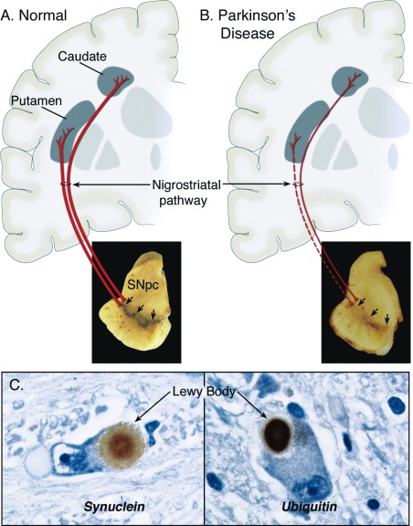
Figure 1. Neuropathology of Parkinson's disease.
A: normal nigrostriatal pathway in red. Cell bodies of dopaminergic neurons are located in substantia nigra pars compacta, and they project to basal ganglia and synapse in the striatum (putamen and caudate nucleus).
B: the nigrostriatal pathway that is degenerated in PD. The dashed line shows the loss of dopaminergic neurons that project to the putamen, the thin red solid line shows lesser loss of projections to the caudate. Depigmentation because the loss of dopaminergic neurons in the SNpc is also shown.
C: Immunohistochemical labeling of Lewy bodies in SNpc with an antibody against α-synuclein (left photograph) and antibody against ubiquitin (right photograph)[4]. http://www.sciencedirect.com/science/article/pii/S0896627303005683#gr1

Clinical features
In 1817 for the first time, James Parkinson, in the "Essay on the Shaking Palsy" described core clinical features of Parkinson's disease as the second age-related neurodegenerative disease after Alzheimer's disease. The overall prevalence of Parkinson's disease is 0.3% in industrial countries. The mean age of onset is 55 years old, and the incidence increases with age, from more than 1% in 60 to 4% in age 80. PD is classified as sporadic and familial clusters. About 90% of cases are sporadic, which means no apparent genetic linkage exists, while in familial cases, the disease is inherited [3, 4].
Recent studies show that Parkinson's disease is a multisystem neurodegenerative disease with motor and nonmotor features (table1). Motor symptoms include rest tremor, rigidity (stiffness), bradykinesia (slowness of movement), hypokinesia (reduction in movement amplitude), akinesia (absence of normal unconscious movements), hypomimia (reduction in face expression), hypophonia (reduction in voice volume), drooling (failure to swallow without thinking about it), micrographia (decreased size of handwriting) and postural inability. Nonmotor symptoms include psychological (depression, passivity, hallucinations), autonomic (constipation, orthostatic hypotension, dysfunction of urinary and genital), cognitive impairment (visuospatial skills to dementia, executive functions, memory), sleep disorders, olfactory dysfunction, and pain [4, 6]. Among motor symptoms, cardinal ones (tremor, rigidity, and bradykinesia) are related to loss of dopaminergic neurons, while those related to gait, posture, and the balance primarily result from loss of nondopaminergic neurons. Multiple neurotransmitter deficiencies such as Acetylcholine, norepinephrine, and serotonin in the central and peripheral nervous system have a role in nonmotor symptoms [6, 7].

Symptom or sign | Description
Cardinal motor symptoms and signs
Bradykinesia | The slowness of voluntary movement and/or a movement that is ongoing. For the companion terms akinesia and hypokinesia, see below
Rest tremor | Asymmetric 4–6 Hz moderate amplitude tremor, which usually involves the thumb (pill-rolling tremor). It may involve other body parts, such as the forearm pronation/supination, the leg adduction/abduction, and the jaw. Head tremor is rarely seen in PD.
Rigidity | Increased muscle tone felt during examination by passive movement of the affected segment, involving both flexor and extensor muscles and not increased with higher mobilization speed (in contrast with spasticity)
Postural instability | Impaired postural adjustment due to decrease or loss of postural reflexes
Other motor symptoms and signs (early and advanced disease stages)
Akinesia | Reduction, delay, or absence of either voluntary, spontaneous, or associated movement
Hypokinesia | Reduced movement amplitude, particularly with repetitive movements
Hypomimia | Reduced facial expression
Hypophonia | Reduced voice volume
Micrographia | Small handwriting that becomes progressively smaller and less readable
Festination | Involuntary gait acceleration with step shortening
Tachyphemia | Acceleration of speech segments
Sialorrhea | Drooling of saliva
Dysarthria | Slurred speech
Dysphagia | Difficulty in swallowing
On phase | A phase characterized by a beneficial effect of levodopa with release from the parkinsonian symptoms and signs
Off phase | A phase, in which the parkinsonian symptoms and signs take over, sometimes in the form of a crisis with severe bradykinesia, rigidity, and tremor. Nonmotor off features include pain, paresthesia, sweating, thoracic oppression, and anxiety symptoms
Freezing of gait | Difficulty in gait initiation (start hesitation) and paroxysmal unintentional episodes of motor block during walking
Postural instability | Impaired postural adjustment due to decrease or loss of postural reflexes
Akathisia | Feeling of inner restlessness and strong need to be in constant motion associated with the inability to sit or stay still
Camptocormia | Abnormal involuntary flexion of the trunk that appears when standing or walking and disappears in the supine position
Anterocollis | Marked neck flexion (>45%), disproportionate to trunk flexion
Pisa syndrome | Tonic lateral flexion of the trunk associated with slight rotation along the sagittal plane
Selected nonmotor symptoms and signs
Hyposmia/anosmia | Reduction/loss of the sense of smell
Constipation | Infrequent and frequently incomplete bowel movements
Orthostatic hypotension | A decrease in systolic blood pressure of at least 20 mm Hg or a decrease in diastolic blood pressure of at least 10 mm Hg within three minutes of standing when compared with blood pressure from the sitting or supine position
Fatigue | Overwhelming sense of tiredness and feeling of exhaustion with difficulties in initiating and sustaining mental and physical tasks
Apathy | Lack of motivation characterized by diminished goal-oriented behavior and cognition and reduced emotional expression
Restless legs syndrome | Movement disorder characterized by compelling urge to move the legs, particularly when in bed and trying to sleep
Table 1. Symptoms of PD
This table is the glossary of the main motor and nonmotor symptoms and signs in Parkinson’s disease [6].
https://www.hindawi.com/journals/pd/2016/9832839/tab1/

Therapeutic interventions
Most of the current therapies for PD are symptomatic and based on neuropathological characteristics of the disorder. Neurodegeneration of dopaminergic neurons of SN causes dopamine deficit in the striatum, so pharmacologic replacement of dopamine is the primary source of treatment. 3,4-dihydroxy-L-phenylalanine (L-DOPA), carbidopa, and monoamine oxidase-B inhibitors are examples of pharmacological dopamine replacement. L-DOPA is used for more than 50 years, and it is effective for reducing motor symptoms in the early stage of the disease. Still, long-term usage minimizes the effectiveness of the drug and causes involuntary motor complications. Surgical procedures such as pallidotomies and thalamotomies are used to treat refractory symptoms, but this method has severe side effects. Deep brain stimulation (DBS) of the subthalamic nucleus or globus pallidus is another treatment method. DBS has minor tissue damage while reducing annoying symptoms and medicines' daily dosage [3, 12].
A novel therapy for PD is implanting stem cells in caudate and putamen of PD patients to restore, replace, or repair the striatum's degenerated neurons. Animal models and human models showed that successful grafts could improve the function of dopaminergic neurons. Although this method seems effective, it has many limitations. For example, most grafted cells die in the best condition, and grafted neurons may undergo PD like destinated. In addition to each PD patient, six fetuses are needed to extract sufficient stem cells, and it is not clinically effectual. Stem cells include embryonic stem (ES) cells, neuronal stem cells(NSCs), mesenchymal stem cells(MSCs), Induced Pluripotent Stem (IPS) Cells, Umbilical cord blood stem cells(UCB), human UCB stem cells [3].

Etiology and pathogenesis
Recent studies show that both genetic and environmental factors have a role in Parkinson's disease. The environmental toxin hypothesis improved by the discovery of MPTP-induced Parkinsonism. 1-methyl4-phenyl-1,2,3,6-tetrahydropyridine (MPTP) is a neurotoxin that causes dopaminergic neurodegeneration, and it is used as a neurotoxin in animal models. Various environmental factors that range from industrialization, rural environment, plant-derived toxins, viral and bacterial infections, exposure to carbon monoxide, organic solvents, carbon disulfide, and pesticides may cause PD or increase the risk of disease. Besides, over the last two decades, by studying the familial form of PD and the use of advanced genetic methods, many genes and risk loci are described as related to PD. Nevertheless, the exact cause of PD is unknown yet. The genes and the environment both have a role [4, 8, 9]. One other important factor related to the onset of the disease is the aging process. Still, its mechanism is unknown because, in the aging process, patterns of dopaminergic neuronal death are different from those in PD. In PD, neuronal death occurs mainly in the ventrolateral and caudal portion of SNpc, while during normal aging, the dorsomedial region of SNpc is affected [4, 8].
The molecular mechanism involved in dopaminergic neuronal death is unknown, but there are two major hypotheses regarding PD's pathogenesis based on genetic studies and toxic PD models. One hypothesis explains misfolding and aggregation of proteins are the cause of dopaminergic neuronal death in SNpc. The other hypothesis proposes that mitochondrial dysfunction and, consequently, oxidative stress causes cell death PD [4]. Besides other pathological events such as deficits in synaptic transmission, endosomal receptor sorting and recycling, and lysosome-mediated autophagy increase PD susceptibility [10].
Postmortem tissue studying shows the association of oxidative stress with the death of dopaminergic neurons [8]. Reactive oxygen species (ROS) are produced continuously in all body tissues. Oxidative stress occurs when there is an imbalance between ROS production and cellular antioxidant activity. ROS is produced as a product of oxidative phosphorylation in mitochondria as the leading site of ROS production. In pathological conditions, leakage of ROS to the cytoplasm happens. Although the exact mechanism of ROS production in PD is unknown, three primary sources of oxidative stress generation in DA neurons include DA metabolism, mitochondrial dysfunction, and neuroinflammation (figure2)[11].
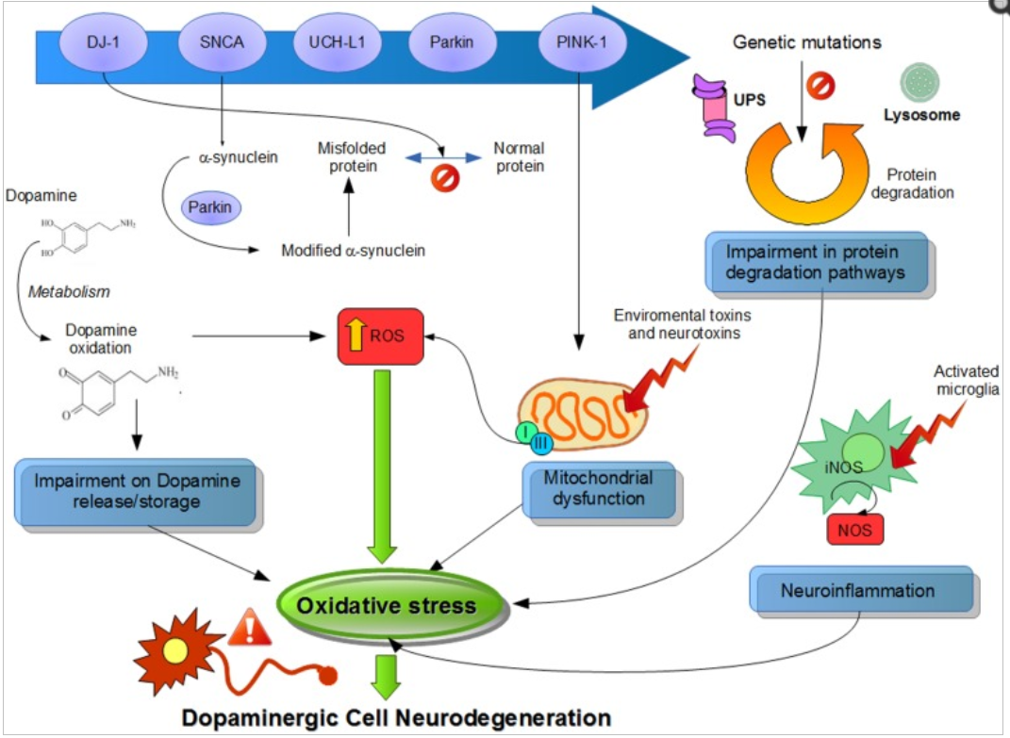
Figure 2. Suggested physiological pathways related to PD.
This schematic figure shows different pathways and their dysfunction because of genetic modification in PD genes that lead to increased oxidative stress. Mutation or altered expression of these proteins leads to mitochondrial impairment, oxidative stress, and protein misfolding. Also, oxidation of dopamine metabolism produces reactive dopamine quinones that increase the level of reactive oxygen species. Modification of α-synuclein results in more aggregations. Increased oxidative stress cause dysfunction of UPS that degrades misfold or damaged proteins, so affect cell survival. Environmental toxins destroy mitochondrial function and lead to free radicals that increase protein aggregates such as α-synuclein. Inhibition of Complex 1 of mitochondria leads to increased oxidative stress, a decrease of ATP production, and finally damage to intracellular components and cell death. Neuroinflammatory mechanisms may also provoke a cascade of mechanisms to lead to cell death. In summary, all these cellular pathways increase oxidative stress, implicated in the selective degeneration of dopaminergic neurons [11]. https://www.ncbi.nlm.nih.gov/pmc/articles/PMC4495335/figure/F1/

In PD, Lewy bodies (LBs) have oxidatively modified α-synuclein that produces greater aggregation than normal ones. Several herbicides and pesticides cause misfolding and aggregation of α-synuclein. Besides, the ability of the cell to handle misfolded proteins decreases by age. In normal conditions, cells, by inducing chaperons, try to refold misfolded proteins. If not correctly refold, they are targeted for degeneration by the ubiquitin-proteasome system. by aging, both mechanisms are impaired. Aggregations or soluble misfolded proteins could be neurotoxic in PD, but it is unknown that misfolded proteins directly damage the cell or formation of LBs cause neurotoxicity [4].
These two pathways, protein aggregation and oxidative stress have several points of interaction. For example, oxidative stress causes damage to α-synuclein, and modified α-synuclein has a greater ability to misfold and aggregate. Potential points of interaction are shown in figure3 [4].
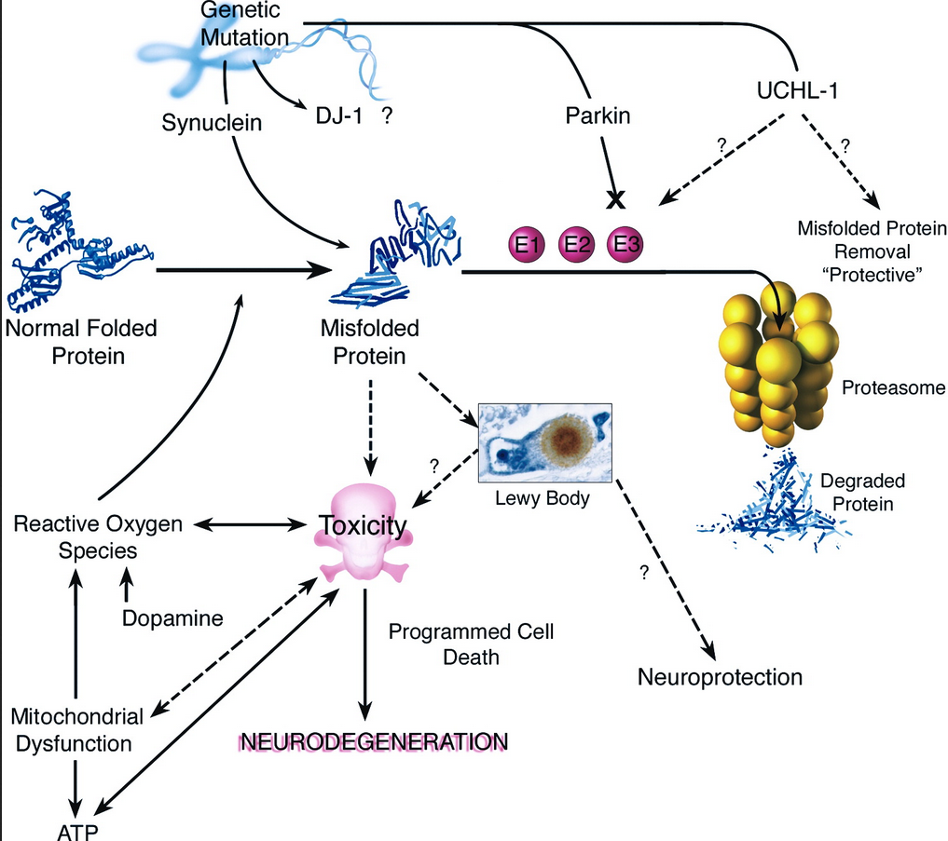
Figure 3. Mechanisms of Neurodegeneration
It seems that the accumulation of misfolded proteins is one of the key events in PD Neurodegeneration. Pathogenic mutations cause directly build-up of abnormal proteins such as α-synuclein or indirectly by destroying the ability of cell machinery to detect and degrade misfold proteins such as Parkin, UCHL1. Although the role of some mutant genes is unknown such as DJ1. Oxidative damage leads to mitochondrial dysfunction and abnormal dopamine metabolism that may cause of construction of misfolded proteins. It is unknown yet that misfolded proteins directly result in toxicity or formation of protein aggregates called Lewy bodies to promote toxicity. Oxidative stress, energy crisis such as decrease of ATP and activation of programmed cell death machinery are mechanisms of neurodegeneration of dopaminergic neurons in PD [4]. http://www.cell.com/cms/attachment/562274/4054841/gr2_lrg.jpg

Basal ganglia
As Basal ganglia (BG) is the main region of dopaminergic neuronal death in PD, we focus on it a little more.

Normal
Basal ganglia is a complex structure located in the deep brain composed of multiple subcortical nuclei: the striatum, the globus pallidus (GP), the subthalamic nucleus (STN), and the substantia nigra [15]. In a strict definition, basal ganglia and related nuclei are divided into nuclei in the deep brain hemisphere (striatum or caudate-putamen and globus pallidus) as basal ganglia and structures located in the diencephalon (subthalamic nucleus), mesencephalon (substantia nigra), and pons (pedunculopontine nucleus) as related nuclei (figure4) [13].
Generally, basal ganglia and related nuclei can be divided into input nuclei, output nuclei, and intrinsic nuclei. Input nuclei consist of the caudate nucleus (CN), the putamen (Put), and the accumbens nucleus (Acb) that receive incoming information from various sources include cortical, thalamus, and nigral in origin. Output nuclei include the internal segment of the globus pallidus (GPi), and the substantia nigra pars reticulata (SNr), which send information from the basal ganglia to the thalamus. Intrinsic nuclei consist of the external segment of the globus pallidus (GPe), the subthalamic nucleus (STN) and the substantia nigra pars compacta (SNc). These structures are located between input and output nuclei and relay information between them [13].
Efferent information from the cortex and thalamus reach the striatum (CN, Put, and Acb) for processing in the basal ganglia. Then output nuclei( GPi and SNr) send processed information mainly to the thalamus( ventral nuclei), and it sends back information to the cerebral cortex (mainly frontal lobe). Basal ganglia influence cortical activity via the thalamus. In this way, BG has a significant role in motor tasks, movement initiation, learning, memory, arousal, reward reinforcement, sensory processing, executive functions and behaviors, cognitive and emotions [13, 14]. The basal ganglia system for appropriate function needs dopamine to be released at the input nuclei [13].

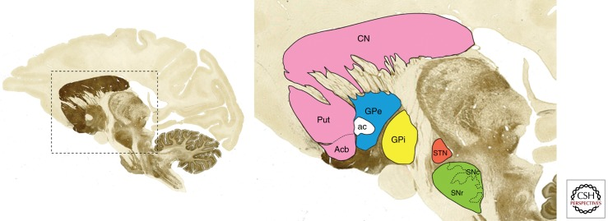
Figure 4. Basal ganglia nuclei.
The parasagittal section of the monkey brain stained with the acetylcholinesterase method shows all major components of the basal ganglia system [13]. https://www.ncbi.nlm.nih.gov/core/lw/2.0/html/tileshop_pmc/tileshop_pmc_inline.html?title=Click%20on%20image%20to%20zoom&p=PMC3&id=3543080_cshperspectmed-PKD-009621_F1.jpg

One model which explains basal ganglia functions is based on direct and indirect pathways. Different striatal medium spiny neurons (MSNs) project to different output nuclei and produce two separate circuits with two opposite effects on movements in this model. However, recent findings show that these two pathways are functionally and structurally intertwined. In the direct pathway, cortical activation causes glutamate release that activates MSNs, which project to the SNr and GPi (striatonigral output neurons). MSNs are GABAergic, so they have an inhibitory effect on SNr. SNr neurons are GABAergic, so inhibition of them finally causes disinhibition of thalamic glutamatergic neurons that receive inputs from SNr and send output information to the cortex. Therefore the final result of this pathway is locomotor activation. The indirect pathway is based on the activation of striatopallidal MSNs, which indirectly project to SNr by GPe and STN. MSNs inhibits GPe GABAergic neurons that cause disinhibition of STN glutamatergic. So excitatory neurons of STN activate GABAergic neurons of SNr, which send output to the thalamus. Finally, this pathway reduces the activation of locomotor activity and movement (figure5a) [16].
MSNs of these two pathways, besides distinct projections, have different dopamine (DA) receptors. Direct pathway MSNs have D1DA receptors, and indirect pathway MSNs express D2 receptors. D1 and D2 are associated with different G proteins, and activation of them causes activation of various intracellular signaling pathways and produces different biochemical responses[16].

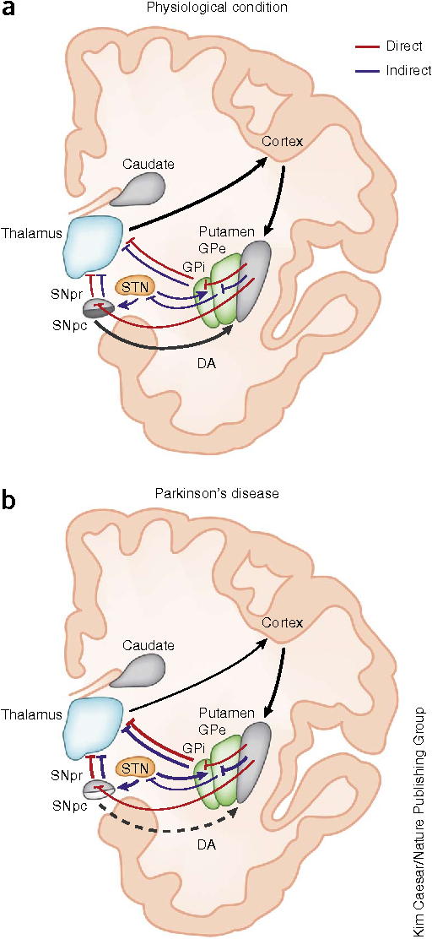
Figure 5. Schematic figure of the direct/indirect pathway classical model in the physiological condition and Parkinson’s disease.
(a) In the physiological condition, presumably, dopamine (DA) from the SNpc activates D1-expressing striatal MSNs of the direct pathway (red lines) and inhibits D2-expressing striatal neurons of the indirect pathway (blue lines). GPi and SNpr (output nuclei) project to the thalamus, which in turn sends efferents to the cortex and completes the cortico-basal ganglia-thalamo-cortical loop. (b) In Parkinson’s disease, the degeneration of nigral neurons reduces DA receptor stimulation in striatal MSNs. The imbalance between direct and indirect pathways results in abnormal activation of output nuclei and over inhibition of thalamic neurons projecting to the cortex [16].
https://www.semanticscholar.org/paper/Direct-and-indirect-pathways-of-basal-ganglia-a-cr-Calabresi-Picconi/234d3fb8960a4afb13c642adad3c6588e174d5ec/figure/0

PD
The progressive degeneration of dopaminergic neurons in substantia nigra pars compacta and depletion of dopamine levels in the striatum are pathological PD characteristics [17]. In humans, dopaminergic neurons of SNc have a pigment that causes the black color of SNc in freshly extracted brains. This pigment is a dopamine precursor neuromelanin [13]. In Parkinson's disease, SNc appears pale [18]. In PD, alive neurons often have intracellular aggregates of misfolded proteins that α-synuclein is the most important. These aggregates often produce circular shapes called Lewy bodies, histopathological PD features (figure6)[13].

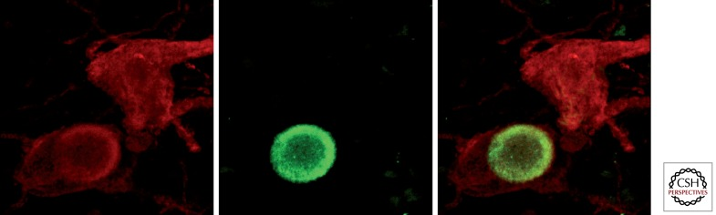
Figure 6. Lewy bodies in dopaminergic neurons from the substantia nigra pars compacta
Dual immunofluorescent detection of tyrosine hydroxylase (red channel) and α-synuclein (green channel), identifying two dopaminergic neurons from a PD patient, one of them showing a typical intracytoplasmic Lewy body [13].
https://www.ncbi.nlm.nih.gov/pmc/articles/PMC3543080/figure/A009621F4/

Evidence from experimental models and patients with Parkinson's disease show that depletion of dopamine levels changes the balance in basal ganglia activities and leads it toward the indirect pathway. It means the subthalamic nucleus (STN) activated excessively and overstimulates GPi/SNr. The output from GPi and SNr increased and over inhibits thalamocortical projections that reduce neurocortical activities related to movement initiation. Besides, in the PD response of basal ganglia to external inputs is also distorted. The response of Putamen, STN, and GPi to peripheral stimulations increased [13]. Overlay in PD dopaminergic depletion leads to the imbalance of corticostriatal circuits. It causes increased activity of the indirect pathways and reduced activity of direct circuits. Therefore in PD internal balance of BG is disrupted, and it causes hyperactivity in STN and striatum (two entry points of BG) and increases inhibitory output from the GPi ( figure5b) [19].

Genetics of Parkinson’s disease

Parkinson's disease generally is sporadic, while familial PD rarely exists. Familial PD is inherited in an autosomal dominant (AD) or autosomal recessive (AR) manner. Eight genes are associated with Mendelian forms of PD. ADPD: α-Synuclein (SNCA) and leucine-rich repeat kinase 2 (LRRK2) and ARPD: Parkin, phosphatase and tensin homolog (PTEN)-induced kinase 1 (PINK1), DJ-1, and ATPase type 13A2 (ATP13A2), PLA2G6 (PARK14), and FBXO7 (PARK15)[3].

Alpha-synuclein
The SNCA encodes α-synuclein, which is expressed mainly in the brain, heart, pancreas, skeletal muscles, and blood cells. The α-synuclein has a role in neuronal plasticity, development, cell adhesion, learning, phosphorylation, differentiation, and uptake of dopamine regulation. Mutation in the α-synuclein's gene can be point mutation or duplication and triplication, although duplication is more common and may be related to ADPD. Aggregates of α-synuclein are seen in Lewy body inclusions that are the hallmark of PD. Aggregates of α-synuclein may be toxic and cause the death of dopaminergic neurons [3, 10].

LRRK2
Leucine­rich repeat kinase 2 (LRRK2) gene has 51 exons that encode a large protein called lrrk2 or dardarin. It has two predicted enzymatic domain, kinase and GTPase, and several protein-protein interaction domains. Mutations in LRRK2 are the most common known cause of ADPD. Many different variants of the LRRK2 gene are identified, and their frequencies are variable in diverse populations. Among these mutations, Gly2019Ser is the most common point mutation. This mutation can be seen in both familial and sporadic PD, and dopaminergic neuronal loss, gliosis in the SN and LB inclusions are common features of PD patients with this kind of LRKK2 mutation [3, 20].

PRKN (Parkin, PARK2)
The Parkin gene has 12 exons, and it is related to the autosomal recessive form of PD. Mutation in the parkin gene is the cause of about 45% of ARPD cases with the age of onset before 45 and 77% of isolated cases with disease onset before 20 years. It is the most common cause of ARPD in early-onset. The Parkin gene encodes E3 ubiquitin ligase Parkin that is very important in mitochondrial quality control and turns over. Under stress conditions, Parkin may be localized to the mitochondrial outer membrane or ER. Parkin with a ubiquitin-conjugating enzyme (E2) form complex and ubiquitinate cellular proteins for degeneration. Parkin with PINK1 and DJ1 are AR cause of PD. Parkin and PINK1 are involved reciprocally in the mitophagic pathway that removes damaged mitochondria, while DJ1 is a redox sensor of oxidative stress [3, 21-23].

PTEN-INDUCED KINASE 1 (PINK1, PARK6)
As mentioned before, the mutation in PINK1 is seen in ARPD. PINK1 encodes a 581 amino acid protein with a kinase domain in C-terminal and a mitochondrial targeting motif in the N-terminal domain. Cell biology studies show that PINK1 accumulates on the outer membrane of dysfunctional mitochondria and phosphorylate ubiquitin and Parkin there and activate Parkin's E3 ligase activity. So PINK1 detects dysfunctional mitochondria and sends the signal to Parkin to start the mitophagic process to remove dysfunctional mitochondria [24].

DJ1 (PARK7)
DJ1 gene codes a 189 amino acid protein conserved during evolution and expressed in all cells and tissues such as the brain. In the brain, it is expressed both in neurons and glial cells. DJ1 is overexpressed in oxidative stress conditions and work as a redox sensor. DJ1, such as Parkin and PINK1, is the cause of ARPD. It seems that the function of DJ1 in oxidative stress is related to the pathogenesis of PD. Studies show that DJ1 is also involved in sporadic PD, Alzheimer's disease, and acts as an oncogene [3, 25].

ATP13A2 (PARK9), PLA2G6 (PARK14), and FBXO7 (PARK15)
Mutation in these three genes also causes autosomal recessive Parkinson's disease with early age of onset, although this form of PD is rare and has atypical clinical features[20].
ATP13A2 gene encodes a large lysosomal transmembrane protein that belongs to the group 5 P-type ATPase family and highly expressed in the brain, particularly in SN. P-type ATPases use the energy of ATP hydrolysis to generate a gradient of ions across the membrane. Mutation in ATP13A2 is seen in Kufor-Rakeb syndrome (KRS) patients and may cause ARPD [3, 26].
PLA2G6 gene encodes Ca2+-independent phospholipase A2 group 6. Distinct mutations in this gene discovered are related to familial PD, although recent studies show the association of PLA2G6 mutation to idiopathic Parkinson’s disease, too [27].
FBXO7 belongs to the F-box protein family that have a role in protein degradation relating to the ubiquitin-proteasome system. Mutation in the FBXO7 gene cause early-onset ARPD, which exact mechanism is unknown [3, 28].

Novel genes
New technologies and techniques have resulted in the discovery of new genes related to PD, including:
VPS35 (PARK17)
Vacuolar protein sorting 35 (VPS35) gene encodes a central component of the retromer cargo-recognition complex that forms a luminal structure to transport special membrane-associated proteins. This structure's formation is crucial for transporting specific proteins from endosomes to plasma and trans-Golgi network and from mitochondria to peroxisomes. Also, it has a role in the recycling of membrane-associated proteins. The exact role of VPS35 in neurons is unknown yet, but its mutation in ADPD is seen [20, 22].

EIF4G1 (PARK18)
EIF4G1 is the central component of the EIF4F complex that regulates the translation of mRNAs. EIF4G1 gene encodes eukaryotic translation initiation factor G1, and its mutation is related to ADPD with late-onset. 4G1 operates as a scaffold portion that interacts with many initiation factors such as e4, PABP, two eIF4Fcomponents, 40S ribosome, and methionyl tRNA. Mutation in EIF4G1 influences mRNA translation initiation in PD and may have a role along with other PD genes in other pathways [20, 22].

DNAJC6
DNAJC6 gene encodes Auxilin that belongs to the DNAJ/HSP40 family of proteins. This family regulates molecular chaperone functions by activating ATPase activity. Auxilin acts explicitly in the Clathrin-Mediated Endocytosis (CME) pathway. Auxilin selectively expressed in neurons and functions with its partner Hcs70 in clathrin uncoating. Mutation in the DNAJC6 gene is reported in familial and sporadic PD in rare cases. It may be related to the role of Auxilin in synaptic vesicle recycling, so it emphasizes the importance of the endocytic/lysosomal pathway in PD [22, 29].

DNAJC13
DNAJC13 is a DNAJ-domain-bearing protein that is localized to the membrane of the lysosomal system. There it binds to Hsc70, the molecular chaperone heat shock cognate 70 (HSPA8) via its DNAJ domain. HSPA8 is a clathrin uncoating ATPase that one of its prominent roles is the dissociation of clathrin from clathrin-coated vesicles. DNAJC13 also interacts with retromer component sorting nexin 1. So the function of DNAJC13 in endosomal trafficking may be related to its pathological mechanism in PD [30].

ATP6AP2
ATP6AP2 is a lysosomal-associated protein-like ATP13A2. ATP6AP2 gene (ATPase, H+ transporting, lysosomal accessory protein 2) encodes a transmembrane protein that involves many processes such as intracellular pH homeostasis, renin-angiotensin system, and WNT signaling. ATP6AP2 is an essential accessory component of vacuolar ATPase which has a role in lysosomal degradation and autophagy, and this role may be related to Parkinson's disease. Human ATP6AP2 has spliced alternatively in different tissue, and its mRNA splice isoforms are complex in humans. One isoform of ATP6AP2 is reported to be increased in X-linked Parkinsonism [31].

SYNJ1
SYNJ1 (synaptojanin 1) is a polyphosphoinositide phosphatase highly expressed in the brain and involved in synaptic vesicle recycling. SYNJ1 includes two inositol phosphatase domains, the N‐terminal Sac1 inositol phosphatase domain and the central inositol 5‐phosphatase domain. These domains are followed by a COOH‐terminal proline‐rich region that interacts with many various protein factors and has a role in endocytosis, signaling, and actin nucleation. Recent studies show that mutation of SYNJ1 is related to Parkinson's disease. It may be related to its role as a lipid metabolizing enzyme that regulates phosphoinositide metabolism in the nervous system and regulates critical synaptic processes, including recycling synaptic vesicles, internalizing AMPA receptors, and actin dynamics [32].

COQ2
COQ2 gene encodes the enzyme parahydroxybenzoate-polyprenyl transferase. This enzyme is essential for the biosynthesis of Q10, which is located in the inner mitochondrial membrane. Q10 acts as an electron acceptor and antioxidant. Studies have shown that the mutation in the COQ2 gene increased the risk of PD, maybe because of its role in oxidative stress [33].
This list of genes is increasing by recent studies and the use of new technics.

Vesicle trafficking
Synaptic vesicle trafficking is affected in several neurodegenerative conditions such as Alzheimer's disease, Huntington's, and PD. Although the exact molecular mechanism in synaptic dysfunction is yet to be determined in PD, functional analysis of genes related to PD showed intriguing links with synaptic vesicle trafficking mechanisms. Therefore in this part, I assessed neuronal vesicle trafficking pathways in normal and PD conditions {Esposito, 2012 #42}.

Main pathways of neuronal vesicle trafficking
Many lipids and proteins are involved in synaptic vesicle (SV) trafficking that is a multiple-step process. SVs based on their functions and response to different stimulations can be divided into separate pools. Most SVs in nerve terminals are stored in the reserve pool (RP). Such SVs released only in response to intense stimulations. They mobilize to fuse quickly and act as neurotransmitters in synapses. Other SVs reside in the releasable pool. These vesicles respond to mild stimulation. We don't explain other functional pool here because their relation to neurodegenerative disease is less or unknown. Vesicles should mobilize and anchor to the active zone of the plasma membrane. Then they undergo a priming process and ready for fusion. Membrane depolarization by the influx of calcium causes the fusion of the vesicle membrane with the presynaptic membrane and neurotransmitters to leak to the synaptic cleft to activate postsynaptic receptors. Recycling vesicles is another process that is regulated in the plasma membrane with many proteins to keep the amount of vesicles stable in nerve terminals.
In nerve terminals, most vesicles are in reserve pools and mobilize just by intense stimulation. Tethering of vesicles in RP and regulation of their mobilization depends on multiple processes, including PKA signaling, calcium level, and ATP. Synapsin is a protein that is important in tethering RP vesicles to the cytoskeleton. It binds to the vesicles and anchors them to the actin filaments. Synapsin binding to SVs is phosphorylation-dependent, and its phosphorylation is calcium-dependent. Besides, mobilization of SVs is depended on ATP produced by mitochondria in nerve terminals.
The fusion of SVs to the plasma membrane is another process that is controlled by the influx of calcium in response to membrane depolarization. Vesicles captured and docked in active-zone one of the plasma membranes then undergo numerous priming steps that cause the formation of SNARE complex and ready for membrane fusion. SNARE complex includes vesicle-associated Synaptobrevin, the plasma membrane-associated Syntaxin, SNAP25, bridges plasma membrane and SVs. Synaptotagmin is another protein that can associate the SNARE complex, binding of calcium to it can cause conformational changes to force membrane fusion. Besides, other proteins such as Complexin, control SNARE functions.
After fusion, Clathrin-mediated endocytosis causes retrieval of the SV membrane. Several regulatory proteins are involved in this complicated process. Adaptors recognize SV cargo and lipids and begin clathrin cage formation. Endophilin, which causes membrane curvature, dynamin that pinch newly formed vesicles from the membrane, Synaptojanin and its binding partner Endophilin modify SV membrane lipids and cause adaptors dissociation. Many other proteins are involved in this process. Now new vesicles may mobilize to store in RPs. Intra synaptic trafficking is regulated by Rab GTPases and their regulators GTPase activating proteins and GDP/GTP exchange factors [34].

Vesicle trafficking in Parkinson’s disease
The study of genes related to Parkinson's disease shows disruption in various cellular processes, including oxidative stress, mitochondrial dysfunction, and protein aggregation. However, the particular molecular mechanism that connects mutations to neuronal degradation is unknown yet. In recent years alternation in SV trafficking is seen in many PD models and suggests that defects in SV trafficking are an essential factor in Parkinson's disease. The below figure (figure7) shows synaptic vesicle trafficking at DA synapses in normal conditions and PD [34]. In this picture, only a few proteins are mentioned that have a role in synaptic vesicle trafficking, but studies have shown that the synaptic vesicle trafficking cycle is a multi-step pathway that coordinated action of perhaps 50 -100 proteins is required {Augustine, 1999 #62}.
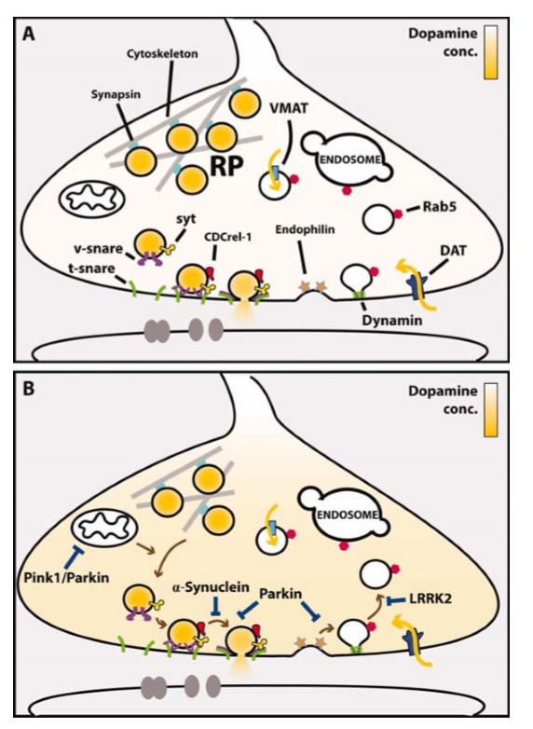
Figure 7. synaptic vesicle trafficking at DA synapses in normal conditions and PD
A: vesicle trafﬁcking at a DA synapse. Synaptic vesicles filled with dopamine are anchored to the cytoskeleton and kept in the reserve pools. They mobilized to the plasma membrane, then after docking and priming, they fuse with the plasma membrane and release neurotransmitters. By endocytosis, the SVs are retrieved. B: show the synaptic vesicle cycle in PD.

Phylogenetic profiling
In evolutionary processes, proteins that are linked together in a pathway or structural complex tend to be either preserved or eliminated in a new species. Based on this hypothesis, functionally linked proteins evolved in a correlated fashion [39]. Phylogenetic profiling is a method based on patterns of evolutionary co-occurrence of genes among many organisms that assess functional associations between them and predict gene functions. Based on this method, genes with similar co-occurrence patterns or similar profiles probably exist in the same protein complexes or metabolic pathways [38, 40].
A binary vector is usually used to represent the phylogenetic profile of a gene. This vector represents the presence (1) or absence (0) of the gene homologous across a set of organisms [38, 40]. Phylogenetic profiling is based on this evolutionary scenario that when a group of genes is functionally coupled, loss of one of them leads directly or indirectly to others' loss. It means that during evolution, functionally linked proteins in a structural complex or metabolic pathway tend to be preserved or eliminated together. This method is used for the first time by Pellegrini for Escherichia coli genes. After that phylogenetic profiling method, is used for eukaryotes successfully, and now it is used for human genomes. Figure 8 shows phylogenetic profiling in a simplified schematic way. [39, 41]

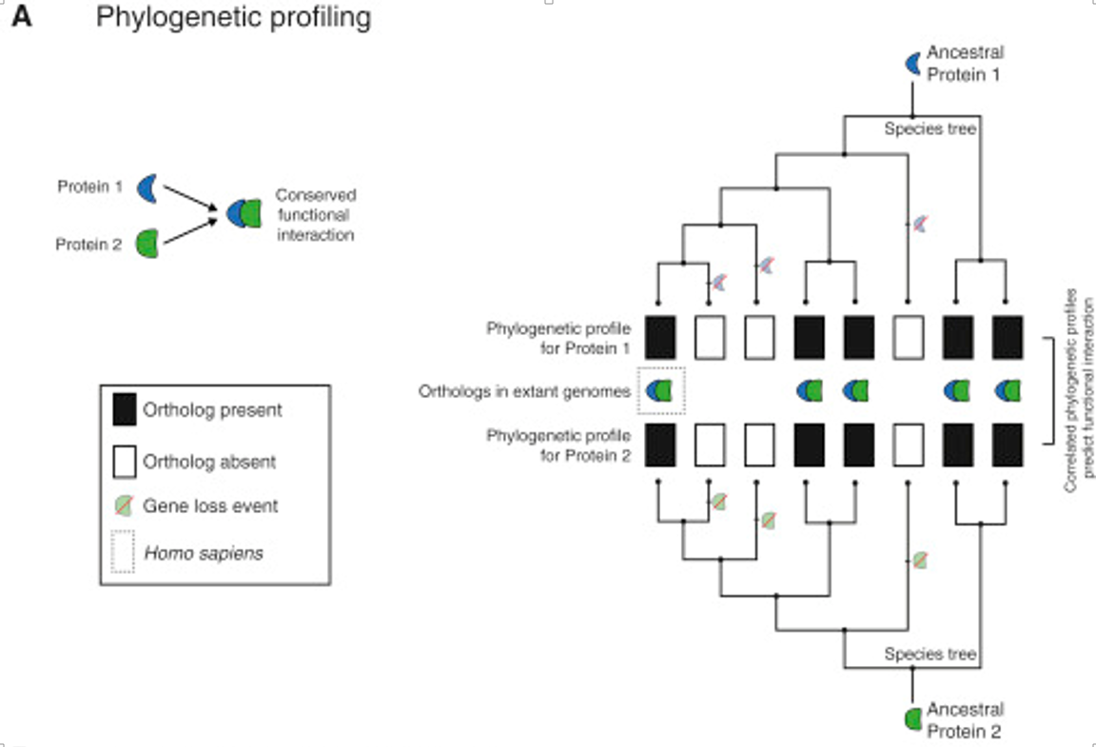
Figure 8. Schematic image for phylogenetic profiling method.
In this figure, phylogenetic profiling of homologs (orthologs) of eight species that are related through the accompanying species, a tree, is done. The presence of an ortholog in the phylogenetic profile is shown with1 (black), and the absence is shown with 0 (white). The correlated phylogenetic profiles for Proteins 1 and 2 can be used to predict the conserved functional interaction [41].
https://els-jbs-prod-cdn.literatumonline.com/cms/attachment/f537408c-03ae-4c7a-a3cb-8961fcec7186/gr1.jpg

The presence or absence of homologous can be determined by orthology databases such as COG or raw sequence similarity such as BLAST E-value. The Orthology database is very limited because of low coverage and infrequent update, so sequence similarity is the best way to construct profiles automatically. Several methods exist to constrict phylogenetic profiles by BLAST E-value and bit score [38]. Besides the method of constructing profiles, the set of organisms that are used is important too. Experiments show that using a more diverse set of organisms that are maximally distant from each other improves the result's accuracy [38].
In this article, we chose 15 PD genes and assessed their evolutionary correlation. All of these genes were related to Parkinson's disease, but their relationship was unknown. If we could find an evolutionary correlation between them, we could find a functional or structural relationship between them. The best method for doing this was the phylogenetic profiling method, as described before.

Hypothesis

Many genes are investigated for Parkinson's disease, but the exact mechanism of Parkinson's disease is unknown yet. Besides, there isn't a particular therapy for this neurodegenerative disease. In this article, I tried to find the correlation between PD genes. Maybe it could lead us to a new pathway for Parkinson's disease or help us to investigate new genes related to PD. For this purpose, I chose 15 PD genes and then assessed their evolutionary background.
My hypothesis was based on the fact that genes with co-evolutionary patterns likely to have structural or functional correlations. So I predicted that these 15 genes related to PD, as they are the vulnerability factor of Parkinson's disease, probably revealed evolutionary correlations. For testing this prediction, I used the phylogenetic profiling method that was the best way to the assessment of evolutionary correlations.
The result would provide much useful information about PD genes and their structural or functional correlations. It could help us find the relationship between PD genes or a new pathway for Parkinson's disease based on PD genes' correlation. This pathway could provide a new suggestion for the treatment of PD. Besides, we could find new genes related to PD based on phylogenetic profiling results.

Material and Method

PD genes
In the first step, 15 genes selected for phylogenetic profiling. These genes were more common genetic factors of PD. Genome-wide linkage (GWL) analysis or homozygosity mapping and comparable family-based studies showed mutations in SNCA and LRRK2 cause the autosomal dominant form of PD, and mutations in PRKN, PINK1, DJ-1 and ATP13A2, PLA2G6, FBXO7 cause an autosomal recessive form of PD [20, 42]. Mutations in other genes such as VPS35, EIF4G1, DNAJC6, ATP6AP2, COQ2, SYNJ1, DNAJC13 were discovered by other techniques such as massive parallel sequencing (MPS) that combined with GWL and homozygosity mapping [10, 42]. These 15 genes were shown in table2.

PD genes
Gene name | Gene ID
a-synuclein | SNCA hsa:6622
leucine-rich repeat kinase 2 | LRRK2 hsa:120892
parkin RBR E3 ubiquitin-protein ligase | PRKN (Parkin, PARK2) hsa:5071
PTEN-induced putative kinase 1 | PINK1 (PARK6) hsa:65018
Parkinson protein 7 | DJ-1 (PARK7) hsa:11315
ATPase type 13A2 | ATP13A2 (PARK9) hsa:23400
phospholipase A2 group 6 | PLA2G6 (PARK14) hsa:8398
F-box protein 7 | FBXO7 (PARK15) hsa:25793
vacuolar protein sorting 35 homolog | VPS35 hsa:55737
eukaryotic translation initiation factor 4 gamma 1 | EIF4G1 hsa:1981
dnaJ homolog subfamily C member 6 | DNAJC6 hsa:9829
ATPase H+ transporting lysosomal accessory protein 2 | ATP6AP2 hsa:10159
coenzyme Q2 4-hydroxybenzoate polyprenyltransferase | COQ2 hsa:27235
synaptojanin 1 | SYNJ1 hsa:8867
dnaJ homolog subfamily C member 13 | DNAJC13 hsa:23317
Table 2. genes of Parkinson's disease selected for phylogenetic profiling

Phylogenetic profiling
I used the online tool called PrePhyloPro (PPP) to phylogenetic profiling of the Parkinson's genes. The method is built on the basis that functionally linked proteins are likely to evolve in a correlated manner. PPP directly compare the phylogenetic profiles of paired proteins by combining multiple co-occurrency measures such as the Pearson correlation coefficient and Jaccard similarity. As the PPP uses co-occurrence as the main criterion for detecting linkages, it is suitable for predicting protein interactions when they have common homologous distributions. It could be used to detect new protein-protein interaction (physical), predict novel components of biological complexes, and suggest new linkages in metabolic processes or signaling pathways. The PPP tool works in 3 steps. First is choosing algorithm parameters that include top rank threshold (linkage number), BLAST Evalue threshold, reference Organism. The second step is selecting the size of protein names for output plots. The third step is uploading a table of query proteins in "txt" or "csv" format onto the website for linkage prediction{Niu, 2017 #63}.
The output of PPP includes figures and tables. Two of them are phylogenetic profile plot and correlation matrix of input proteins. In the phylogenetic profile plot, the top panel represents the 972 surveyed species, and the left panel represents the input proteins. The blue bars correspond to the presence, and the gray bars correspond to the absence of homologies in this plot. The correlation matrix shows the Pearson correlation coefficient of paired input proteins by two colors. Blue shows no correlation between any given profile pairs, and red indicates a high correlation between them. These two figures not only show the homologous distribution of input proteins among a list of eukaryotic and prokaryotic organisms but also demonstrate the evolutionary relationship within input proteins. The PPP output also includes the visualization of predicted linkage by the interactive Circus plot and the network. In addition, the predicted linkage is summarized in a table as the output of PPP. In this table, "from" and "to" columns are included standard protein IDs of input proteins, and the predicted interacting proteins, respectively. The last two columns show Jaccard similarity and Pearson correlation coefficient values, in a decreasing order {Niu, 2017 #63}.

Selected groups of PD genes (15 gens from table 2) uploaded in the PrePhyloPro Software "http://prephylopro.org/phyloprofile/ ". To upload the genes on the website, I saved them in a csv file based on their gene id and one color assigned to each gene. The software parameters for them are set according to this: linkage number 100, BLAST E value 0.0010. Then the result was interpreted for finding any similarity between phylogenetic profiles of the genes.

In the next step, I used phylogenetic results and analyzed more repeated genes in the "predicted linkage" file. I found six new genes that were repeated four times. Then I added these six genes to the previous 15 PD genes and again uploaded the csv file to the PrePhyloPro Software "http://prephylopro.org/phyloprofile/ ". Also, the result was interpreted.

Testing new genes
Finally, to test the role of these six newly found genes, I used this website: "https://go.princeton.edu/".
I choose two web tools on this website: Generic GO Term Finder and Generic GO Term Mapper. Then the results were assessed to find the potential role of these six genes in synaptic vesicle pathways.

Results

Phylogenetic profiling of the 15 genes

Correlation between five genes
Phylogenetic profiling of the 15 genes, including SNCA, LRRK2, PRKN, PINK1, DJ-1, ATP13A2, PLA2G6, FBXO7, VPS35, EIF4G1, DNAJC6, ATP6AP2, COQ2, SYNJ1, and DNAJC13, revealed an approximately high correlation between these five genes: VPS35, Parkin, DNAJC6, SYNJ1, and EIF4G1. Phylogenetic profiles and correlation matrix of input genes are shown in the below figures (figure9 and 10).
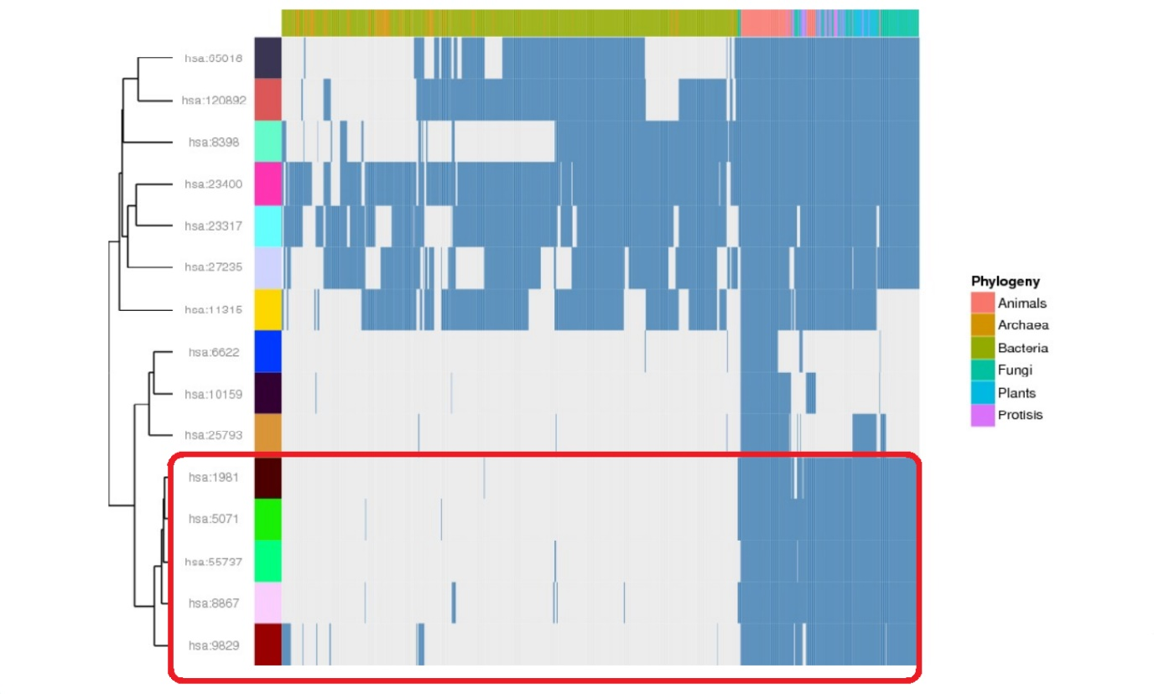
Figure 9. Phylogenetic profiles of input genes:
In the red box, the similarity between hsa:1981 (EIF4G1), hsa:5071 (Parkin), hsa:55737 (VPS35), hsa:8867 (SYNJ1), hsa:9829 (DNAJC6) is seen.
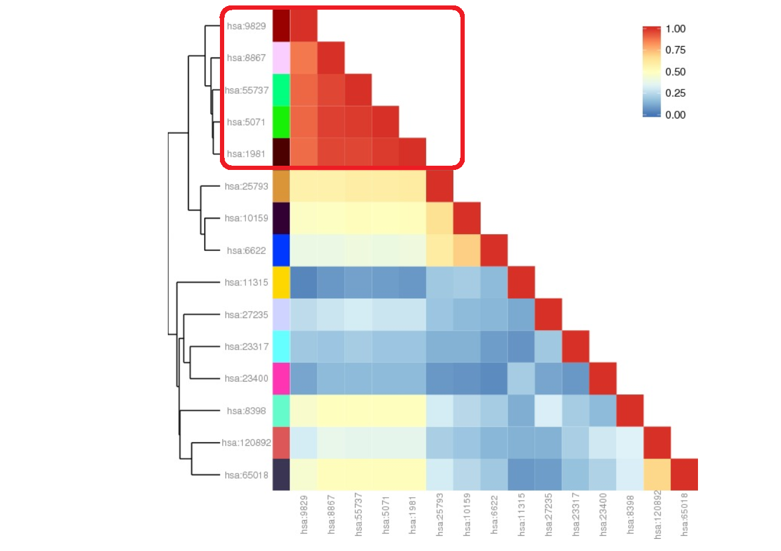
Figure 10. Correlation matrix of input genes:
Correlation between 5 genes is revealed more obviously in this figure. The correlation between these five genes is more than 0.75 that is determined in the red box.

Co-evolution, co-function of the five genes
Phylogenetic profiling of the 15 PD genes (figure 9) revealed similar profiles for five genes (VPS35, Parkin, DNAJC6, SYNJ1, and EIF4G1). These 15 genes were familial genes of Parkinson's disease with approximately well-known functions. The high correlation between these five genes' profiles assumed that they participated in the same biological pathway or the same protein complex to co-evolved [43]. After assessing these five genes' function, I found that all of them somehow have a role in synaptic vesicle trafficking. As all of them were genes of Parkinson's disease, and all participated in synaptic vesicular trafficking, I predicted that this molecular pathway is crucial in PD pathology. So it seemed that more concentration in the pathophysiology of synaptic vesicular trafficking in PD is principal.
Below role of these five genes in SV trafficking reviewed:
VPS35
Vacuolar protein sorting 35 (VPS35) is a core component of the retromer complex that is important for intracellular trafficking and endosomal protein sorting. Recently find a mutation in VPS35 D620N is seen rarely in familial PD.
Parkin
Parkin has a ubiquitylation role in neurons, and it affects synaptic function by the ubiquitin-proteasome system. Interaction of Parkin with CDCrel-1, a septin GTPase, is seen in a yeast two-hybrid experiment. CDCrel-1 interact with SNARE component syntaxin. This interaction seems to inhibit SV exocytosis. In the absence of Parkin, CDCre-1 didn't ubiquitylate normally and degraded. In Parkin knock-out mice, DA release decreased, and CDCre-1 accumulated. These could approve the role of Parkin in SV trafficking via ubiquitylation in PD.
Also, other interactions between Parkin and synaptic components are reported. For example, Parkin ubiquitylates Synphilin1 that is an SV-associated protein that promotes aggregation of α-Syn. Another substrate of Parkin is Synaptotagmin XI (SytXI), a vesicle-associated protein and seems to down-regulate transmitter release.
Besides its role in exocytosis, Parkin seems to have a role in SV endocytosis by controlling the turnover of EndophilinA. Endophilin is a membrane deforming protein and has a role in the uncoating of newly formed SVs. Parkin ubiquitylates it and controls its abundance so in this way controls endocytic efficiency[34].
DNAJC6
DNAJC6, as mentioned before, encodes Auxilin that selectively expresses in neurons. This protein has a role in clathrin-mediated Golgi-lysosome trafficking and synaptic vesicle endocytosis [35].
SYNJ1
Synaptojanin 1, as explained before, is a polyphosphoinositide phosphatase that has a role in clathrin uncoating and vesicle recycling. When Endophilin, a binding partner of Synj1, is knocked out, clathrin uncoating endocytosis is blocked, so SVs cannot be recycled and reduced [36].
EIF4G1
EIF4G1 is a large scaffold protein that has a role in the assembly of the translation initiation factor complex. Studies show that EIF4G1 and VPS35 have functional interaction in PD. VPS35 is a component of the retromer complex and has a role in sorting vesicles in endocytosis [37].
As the role of these five genes in SV trafficking is mentioned above, their interaction in PD may be related to vesicular trafficking pathways.
VPS35 is a core component of the retromer complex that its exact role in CNS isn't wholly understood. Still, it's commonly responsible for transport and recycling transmembrane protein cargo from the endosome to the trans-Golgi network (TGN) and plasma membrane[44]. Parkin encodes E3 ubiquitin ligase and has a role in numerous biological functions. Reports show that mutation of parkin results in synaptic dysfunction [45]. DNAJC6 and SYNJ1 mutations are seen in the case of juvenile Parkinsonism. DNAJC6 encodes auxilin that is selectively expressed in neurons. This protein allows clathrin-mediated Golgi–lysosome trafficking and synaptic vesicle endocytosis. SYNJ1 encodes synaptojanin-1 that is a phosphoinositide phosphatase protein. This protein has a role in synaptic vesicle endocytosis [35]. EIF4G1 is a scaffold protein that has a role in the assembly of translation initiation factor complex and its exact role in PD is unknown yet. There is a hypothesis that its mutation causes dysfunction in translation and leading to the accumulation of misfolded and unfolded proteins. Also an experiment identified interaction between EIF4G1 and VPS35 [37].

PD genes with a role in synaptic vesicle trafficking
Using the Phylogenetic profiling method, I found five PD genes with a high correlation that interestingly all participated in the synaptic vesicle trafficking pathway. Based on this finding, my hypothesis was confirmed because I found a high correlation between some PD genes. Also, I predicted that if I found some high correlation genes, they would probably participate in a common structural complex or pathway. This prediction was confirmed because all of these five genes had a role in synaptic vesicle trafficking. Based on these findings, a new complementary hypothesis raised that synaptic vesicle trafficking was one of the most important pathways of Parkinson's disease, and this pathway could be the junction of PD genes. According to this new hypothesis, maybe we can explain the pathophysiology of Parkinson's disease and find new therapeutic approaches to PD in the future.

Testing the new hypothesis
To test the new hypothesis, I used the phylogenetic method again. In Phylogenetic profiling results, the "predicted linkages" indicated the first 100 genes with the closest correlation with our 15 PD genes. I used this list to find new genes related to Parkinson's disease. Therefore I chose the most repeated genes in this list. I found six new genes that each one repeated four times. The below table showed these six new genes:
hsa:10749 | KIF1C, LTXS1; kinesin family member 1C; K10392 kinesin family member 1
hsa:23256 | SCFD1, C14orf163, RA410, SLY1, SLY1P, STXBP1L2; sec1 family domain containing 1
hsa:26286 | ARFGAP3, ARFGAP1; ADP-ribosylation factor GTPase activating protein 3; K12493 ADP-ribosylation factor GTPase-activating protein 2/3
hsa:4602 | MYB, Cmyb, c-myb, c-myb_CDS, efg; v-myb avian myeloblastosis viral oncogene homolog; K09420 myb proto-oncogene protein
hsa:64744 | SMAP2, RP1-228H13.3, SMAP1L; small ArfGAP2; K12486 stromal membrane-associated protein
hsa:84364 | ARFGAP2, IRZ, NBLA10535, ZFP289, ZNF289; ADP-ribosylation factor GTPase activating protein 2; K12493 ADP-ribosylation factor GTPase-activating protein 2/3
Table 3. the six new-found genes by the phylogenetic method related to PD genes

To test these new genes' correlation with the 15 genes of PD, I uploaded all of them as one file again in the PrePhyloPro Softwarehttp://prephylopro.org/phyloprofile/. The result was shown below:
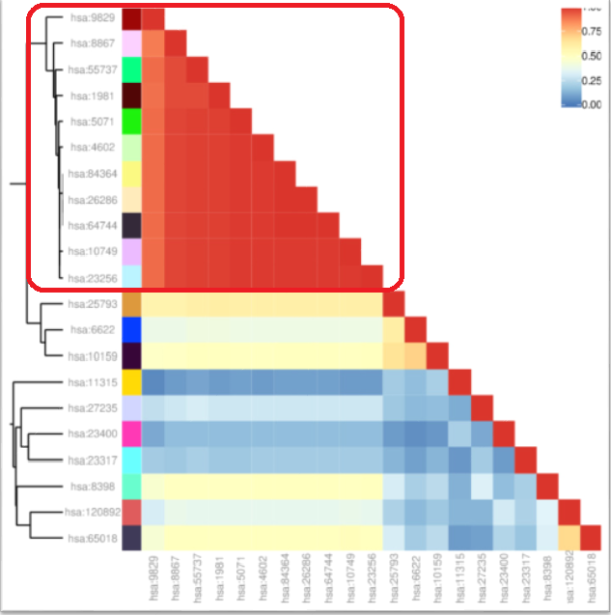
Figure 11. Correlation matrix of the new group of genes (15+6).
After uploading a new list of genes to the PPP, the correlation matrix shows a high correlation between the previous five genes: hsa:9829(DNAJC6), hsa:8867(SYNJ1), hsa:55737(VPS35), hsa:1981(EIF4G1), hsa:5071(Parkin), and new six genes: hsa:4602(MYB), hsa:84364(ARFGAP2), hsa:26286(ARFGAP3), hsa:64744(SMAP2), hsa:10749(KIF1C), hsa:23256(SCFD1). The correlation between these 11 genes is more than 0.75, and it is highlighted in the red box.

The result showed that these six new genes had a high correlation with the previous five genes. Therefore I predicted that these six new genes had a role in the synaptic vesicle trafficking pathway too.
To test the function of these new genes, I used this website: "https://go.princeton.edu/". I choose two web tools on this website: Generic GO Term Finder and Generic GO Term Mapper.
The results of uploading the six new genes to "Generic GO Term Finder": were divided into three parts based on ontology aspects: Process, Function, and component. The process result was shown in table 4 and figure 12:

Gene Ontology term | Cluster frequency | Genome frequency | Corrected  P-value | FDR | False  Positives | Genes annotated to the term
retrograde vesicle-mediated transport, Golgi to ER | 4 of 6 genes, 66.7% | 86 of 19775 genes, 0.4% | 3.57e-07 | 0.00% | 0.00 | SCFD1, ARFGAP2, KIF1C, ARFGAP3
establishment of vesicle localization | 4 of 6 genes, 66.7% | 290 of 19775 genes, 1.5% | 4.78e-05 | 0.00% | 0.00 | SCFD1, ARFGAP2, KIF1C, ARFGAP3
vesicle coating | 3 of 6 genes, 50.0% | 69 of 19775 genes, 0.3% | 5.81e-05 | 0.00% | 0.00 | SCFD1, ARFGAP2, ARFGAP3
vesicle localization | 4 of 6 genes, 66.7% | 306 of 19775 genes, 1.5% | 5.92e-05 | 0.00% | 0.00 | SCFD1, ARFGAP2, KIF1C, ARFGAP3
vesicle targeting, to, from or within Golgi | 3 of 6 genes, 50.0% | 73 of 19775 genes, 0.4% | 6.89e-05 | 0.00% | 0.00 | SCFD1, ARFGAP2, ARFGAP3
COPI-coated vesicle budding | 2 of 6 genes, 33.3% | 6 of 19775 genes, 0.0% | 8.28e-05 | 0.00% | 0.00 | ARFGAP2, ARFGAP3
Golgi transport vesicle coating | 2 of 6 genes, 33.3% | 6 of 19775 genes, 0.0% | 8.28e-05 | 0.00% | 0.00 | ARFGAP2, ARFGAP3
COPI coating of Golgi vesicle | 2 of 6 genes, 33.3% | 6 of 19775 genes, 0.0% | 8.28e-05 | 0.00% | 0.00 | ARFGAP2, ARFGAP3
Golgi vesicle budding | 3 of 6 genes, 50.0% | 79 of 19775 genes, 0.4% | 8.76e-05 | 0.00% | 0.00 | SCFD1, ARFGAP2, ARFGAP3
vesicle targeting | 3 of 6 genes, 50.0% | 92 of 19775 genes, 0.5% | 0.00013 | 0.40% | 0.04 | SCFD1, ARFGAP2, ARFGAP3
Golgi vesicle transport | 4 of 6 genes, 66.7% | 380 of 19775 genes, 1.9% | 0.00014 | 0.36% | 0.04 | SCFD1, ARFGAP2, KIF1C, ARFGAP3
vesicle budding from membrane | 3 of 6 genes, 50.0% | 101 of 19775 genes, 0.5% | 0.00018 | 0.33% | 0.04 | SCFD1, ARFGAP2, ARFGAP3
establishment of organelle localization | 4 of 6 genes, 66.7% | 507 of 19775 genes, 2.6% | 0.00044 | 0.31% | 0.04 | SCFD1, ARFGAP2, KIF1C, ARFGAP3
organelle localization | 4 of 6 genes, 66.7% | 705 of 19775 genes, 3.6% | 0.00163 | 1.57% | 0.22 | SCFD1, ARFGAP2, KIF1C, ARFGAP3
ER to Golgi vesicle-mediated transport | 3 of 6 genes, 50.0% | 218 of 19775 genes, 1.1% | 0.00185 | 1.47% | 0.22 | SCFD1, ARFGAP2, ARFGAP3
vesicle organization | 3 of 6 genes, 50.0% | 328 of 19775 genes, 1.7% | 0.00627 | 2.50% | 0.40 | SCFD1, ARFGAP2, ARFGAP3
Table 4. Terms from the Process Ontology of gene_association.goa_human with p-value <= 0.01
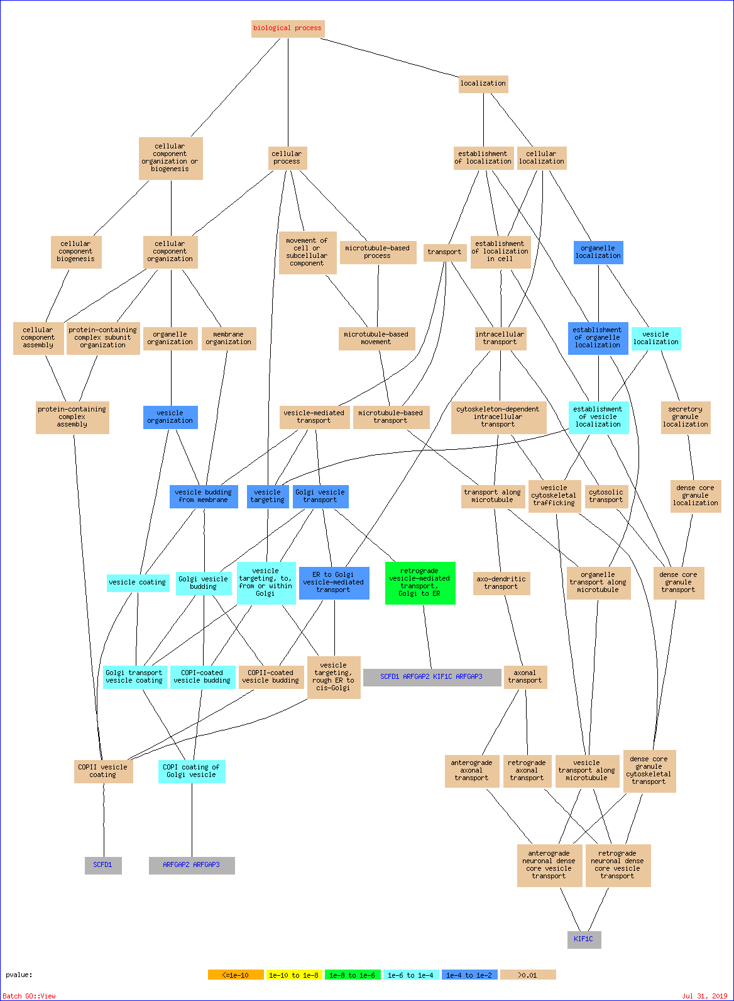
Figure 12. Result of biological process in the "Generic Go Term Finder."
This figure, such as the previous table, shows the result of uploading six new genes to the "Generic GO Term Finder" based on the Biological process.

The biological process interestingly showed that these genes were related to vesicle transport. As it was shown in the table: vesicle localization, vesicle coating, vesicle targeting, and vesicle organization were some biological processes that were related to most of these genes.

The result for uploading the six new genes to the "Generic GO Term mapper", choosing "process" as the ontology criteria, was shown in table 5:
GO Term (GO ID) | Genes Annotated to the GO Term | GO Term Usage in Gene List | Genome Frequency of Use
transport ( GO:0006810 ) | ARFGAP2, ARFGAP3, KIF1C, MYB, SCFD1 | 5 of 6 genes, 83.33% | 4956 of 19497 annotated genes, 25.42%
vesicle-mediated transport ( GO:0016192 ) | ARFGAP2, ARFGAP3, KIF1C, SCFD1 | 4 of 6 genes, 66.67% | 2000 of 19497 annotated genes, 10.26%
response to stress ( GO:0006950 ) | MYB, SCFD1 | 2 of 6 genes, 33.33% | 3830 of 19497 annotated genes, 19.64%
anatomical structure development ( GO:0048856 ) | MYB, SCFD1 | 2 of 6 genes, 33.33% | 5588 of 19497 annotated genes, 28.66%
mitotic cell cycle ( GO:0000278 ) | MYB | 1 of 6 genes, 16.67% | 976 of 19497 annotated genes, 5.01%
cell proliferation ( GO:0008283 ) | MYB | 1 of 6 genes, 16.67% | 1973 of 19497 annotated genes, 10.12%
immune system process ( GO:0002376 ) | MYB | 1 of 6 genes, 16.67% | 2974 of 19497 annotated genes, 15.25%
biosynthetic process ( GO:0009058 ) | MYB | 1 of 6 genes, 16.67% | 6416 of 19497 annotated genes, 32.91%
autophagy ( GO:0006914 ) | SCFD1 | 1 of 6 genes, 16.67% | 476 of 19497 annotated genes, 2.44%
cytoskeleton-dependent intracellular transport ( GO:0030705 ) | KIF1C | 1 of 6 genes, 16.67% | 157 of 19497 annotated genes, 0.81%
cell morphogenesis ( GO:0000902 ) | SCFD1 | 1 of 6 genes, 16.67% | 932 of 19497 annotated genes, 4.78%
cell differentiation ( GO:0030154 ) | MYB | 1 of 6 genes, 16.67% | 3981 of 19497 annotated genes, 20.42%
chromosome organization ( GO:0051276 ) | MYB | 1 of 6 genes, 16.67% | 1174 of 19497 annotated genes, 6.02%
cell-cell signaling ( GO:0007267 ) | MYB | 1 of 6 genes, 16.67% | 1593 of 19497 annotated genes, 8.17%
cell death ( GO:0008219 ) | MYB | 1 of 6 genes, 16.67% | 2130 of 19497 annotated genes, 10.92%
cellular component assembly ( GO:0022607 ) | SCFD1 | 1 of 6 genes, 16.67% | 2713 of 19497 annotated genes, 13.91%
protein-containing complex assembly ( GO:0065003 ) | SCFD1 | 1 of 6 genes, 16.67% | 1686 of 19497 annotated genes, 8.65%
membrane organization ( GO:0061024 ) | SCFD1 | 1 of 6 genes, 16.67% | 905 of 19497 annotated genes, 4.64%
cell adhesion ( GO:0007155 ) | MYB | 1 of 6 genes, 16.67% | 1328 of 19497 annotated genes, 6.81%
cellular nitrogen compound metabolic process ( GO:0034641 ) | MYB | 1 of 6 genes, 16.67% | 6622 of 19497 annotated genes, 33.96%
cellular protein modification process ( GO:0006464 ) | MYB | 1 of 6 genes, 16.67% | 4113 of 19497 annotated genes, 21.10%
catabolic process ( GO:0009056 ) | SCFD1 | 1 of 6 genes, 16.67% | 2443 of 19497 annotated genes, 12.53%
cell cycle ( GO:0007049 ) | MYB | 1 of 6 genes, 16.67% | 1793 of 19497 annotated genes, 9.20%
developmental maturation ( GO:0021700 ) | none | 0 of 6 genes, 0% | 253 of 19497 annotated genes, 1.30%
ribonucleoprotein complex assembly ( GO:0022618 ) | none | 0 of 6 genes, 0% | 211 of 19497 annotated genes, 1.08%
nervous system process ( GO:0050877 ) | none | 0 of 6 genes, 0% | 1364 of 19497 annotated genes, 7.00%
cell wall organization or biogenesis ( GO:0071554 ) | none | 0 of 6 genes, 0% | 15 of 19497 annotated genes, 0.08%
protein folding ( GO:0006457 ) | none | 0 of 6 genes, 0% | 236 of 19497 annotated genes, 1.21%
protein targeting ( GO:0006605 ) | none | 0 of 6 genes, 0% | 397 of 19497 annotated genes, 2.04%
nitrogen cycle metabolic process ( GO:0071941 ) | none | 0 of 6 genes, 0% | 15 of 19497 annotated genes, 0.08%
signal transduction ( GO:0007165 ) | none | 0 of 6 genes, 0% | 6030 of 19497 annotated genes, 30.93%
cellular amino acid metabolic process ( GO:0006520 ) | none | 0 of 6 genes, 0% | 367 of 19497 annotated genes, 1.88%
generation of precursor metabolites and energy ( GO:0006091 ) | none | 0 of 6 genes, 0% | 506 of 19497 annotated genes, 2.60%
mitochondrion organization ( GO:0007005 ) | none | 0 of 6 genes, 0% | 570 of 19497 annotated genes, 2.92%
extracellular matrix organization ( GO:0030198 ) | none | 0 of 6 genes, 0% | 335 of 19497 annotated genes, 1.72%
embryo development ( GO:0009790 ) | none | 0 of 6 genes, 0% | 945 of 19497 annotated genes, 4.85%
translation ( GO:0006412 ) | none | 0 of 6 genes, 0% | 604 of 19497 annotated genes, 3.10%
transposition ( GO:0032196 ) | none | 0 of 6 genes, 0% | 25 of 19497 annotated genes, 0.13%
secondary metabolic process ( GO:0019748 ) | none | 0 of 6 genes, 0% | 61 of 19497 annotated genes, 0.31%
photosynthesis ( GO:0015979 ) | none | 0 of 6 genes, 0% | 0 of 19497 annotated genes, 0.00%
lipid metabolic process ( GO:0006629 ) | none | 0 of 6 genes, 0% | 1419 of 19497 annotated genes, 7.28%
sulfur compound metabolic process ( GO:0006790 ) | none | 0 of 6 genes, 0% | 361 of 19497 annotated genes, 1.85%
chromosome segregation ( GO:0007059 ) | none | 0 of 6 genes, 0% | 348 of 19497 annotated genes, 1.78%
small molecule metabolic process ( GO:0044281 ) | none | 0 of 6 genes, 0% | 2081 of 19497 annotated genes, 10.67%
ribosome biogenesis ( GO:0042254 ) | none | 0 of 6 genes, 0% | 334 of 19497 annotated genes, 1.71%
symbiont process ( GO:0044403 ) | none | 0 of 6 genes, 0% | 841 of 19497 annotated genes, 4.31%
cell motility ( GO:0048870 ) | none | 0 of 6 genes, 0% | 1488 of 19497 annotated genes, 7.63%
plasma membrane organization ( GO:0007009 ) | none | 0 of 6 genes, 0% | 76 of 19497 annotated genes, 0.39%
carbohydrate metabolic process ( GO:0005975 ) | none | 0 of 6 genes, 0% | 600 of 19497 annotated genes, 3.08%
cofactor metabolic process ( GO:0051186 ) | none | 0 of 6 genes, 0% | 558 of 19497 annotated genes, 2.86%
mRNA processing ( GO:0006397 ) | none | 0 of 6 genes, 0% | 499 of 19497 annotated genes, 2.56%
aging ( GO:0007568 ) | none | 0 of 6 genes, 0% | 284 of 19497 annotated genes, 1.46%
nucleocytoplasmic transport ( GO:0006913 ) | none | 0 of 6 genes, 0% | 339 of 19497 annotated genes, 1.74%
cell division ( GO:0051301 ) | none | 0 of 6 genes, 0% | 581 of 19497 annotated genes, 2.98%
locomotion ( GO:0040011 ) | none | 0 of 6 genes, 0% | 1721 of 19497 annotated genes, 8.83%
circulatory system process ( GO:0003013 ) | none | 0 of 6 genes, 0% | 507 of 19497 annotated genes, 2.60%
reproduction ( GO:0000003 ) | none | 0 of 6 genes, 0% | 1391 of 19497 annotated genes, 7.13%
DNA metabolic process ( GO:0006259 ) | none | 0 of 6 genes, 0% | 982 of 19497 annotated genes, 5.04%
mitotic nuclear division ( GO:0140014 ) | none | 0 of 6 genes, 0% | 257 of 19497 annotated genes, 1.32%
homeostatic process ( GO:0042592 ) | none | 0 of 6 genes, 0% | 1641 of 19497 annotated genes, 8.42%
nucleobase-containing compound catabolic process ( GO:0034655 ) | none | 0 of 6 genes, 0% | 606 of 19497 annotated genes, 3.11%
cytoskeleton organization ( GO:0007010 ) | none | 0 of 6 genes, 0% | 1212 of 19497 annotated genes, 6.22%
anatomical structure formation involved in morphogenesis ( GO:0048646 ) | none | 0 of 6 genes, 0% | 1020 of 19497 annotated genes, 5.23%
transmembrane transport ( GO:0055085 ) | none | 0 of 6 genes, 0% | 1534 of 19497 annotated genes, 7.87%
tRNA metabolic process ( GO:0006399 ) | none | 0 of 6 genes, 0% | 188 of 19497 annotated genes, 0.96%
cell junction organization ( GO:0034330 ) | none | 0 of 6 genes, 0% | 266 of 19497 annotated genes, 1.36%
vacuolar transport ( GO:0007034 ) | none | 0 of 6 genes, 0% | 121 of 19497 annotated genes, 0.62%
pigmentation ( GO:0043473 ) | none | 0 of 6 genes, 0% | 98 of 19497 annotated genes, 0.50%
protein maturation ( GO:0051604 ) | none | 0 of 6 genes, 0% | 372 of 19497 annotated genes, 1.91%
growth ( GO:0040007 ) | none | 0 of 6 genes, 0% | 922 of 19497 annotated genes, 4.73%
Table 5. GO Terms from the biological_process Ontology

It also confirmed my hypothesis as most of the genes related to the terms: transport, vesicle-mediated transport, response to stress. It revealed that these genes could be related to synaptic vesicle trafficking of Parkinson's disease too.
The Princeton website results were divided into two groups based on web tools that were used: Generic GO Term Finder and Generic GO Term Mapper. I choose the "process" results of these tools because my hypothesis was related to a biological process. Generic GO Term Finder process result showed that most of these new genes were related to the terms: vesicle coating, vesicle localization, vesicle organization, and vesicle targeting. It revealed that these genes are probably associated with synaptic vesicle trafficking too. The generic Go Map Finder process result was interesting as well. It showed that most of the genes related to the terms: transport, vesicle-mediated transport, response to stress. Therefore it was probable that they had a role in synaptic vesicle trafficking too.

Discussion and conclusions
Parkinson's disease (PD) is an age-related neurodegenerative disorder whose exact etiology is unknown yet. The potential risk factors of PD include environmental toxins, pesticides, drugs, focal cerebrovascular damage, brain microtrauma, and genomic defects. The disease's neuropathology is mainly loss of dopaminergic neurons in substantia nigra pars compacta, although other parts in the central nervous system and peripheral tissues are involved too[46]. In recent years most pathogenic mechanisms that are explained include dysfunction of the ubiquitin-proteasome system, dysregulation of mitochondrial function, and oxidative stress [46, 47]. These pathogenic pathways are due to genomic, epigenetic, and environmental factors and cause conformational change and deposit of key proteins [46]. Another molecular mechanism that more studied recently and seems related to Neurodegeneration in PD is synaptic vesicular trafficking [48, 49].
In this research, I used the phylogenetic profiling results of PD genes to find novel functional or structural interactions in PD genes. The results represented interesting facts regarding PD genes and synaptic vesicle trafficking and revealed further research is needed in this field. I found 5 PD genes with a high correlation. These genes included VPS35, Parkin, DNAJC6, SYNJ1, and EIF4G1. This finding suggested the participation of these five genes in a common pathway or structural complex. After a quick review of these genes' well-known functions, I found synaptic vesicle trafficking as a common pathway that all of them had a role in it. VPS35 is a core component of the retromer complex that is important for intracellular trafficking. EIF4G1 is a large scaffold protein, and previous studies show its functional interaction with VPS35. We know that in synaptic vesicle trafficking, synaptic vesicles that are kept in reserve pools should mobilize to the plasma membrane. It seems that more studies could prove the role of EIF4G1 and VPS35 in this mobilization process. Mutation in Parkin causes synaptic dysfunction. Also, DNAJC6 and SYNJ1 both have a role in synaptic vesicle endocytosis. Based on phylogenetic profiling, these five genes could interact in synaptic vesicle trafficking in PD, but more studies are needed to determine the exact interaction among them.
To further examine my findings, I assessed the first 100 genes with the closest correlation with our 15 PD genes and found six genes. These six new genes were then added to the previous 15 genes and uploaded to the "PPP". The result shows those six genes had a high correlation with the last five genes. Then I used the Princeton website to provide more information about the function of six new genes. Based on their high correlation with those five genes, I predicted they would have a role in synaptic vesicle trafficking too. The Princeton website's result revealed these six new genes probably are related to synaptic vesicle trafficking and interestingly approved my hypothesis.
The results confirmed that the five Parkinson's genes have a role in synaptic vesicle trafficking, suggesting a connection between dysfunction in this pathway and the etiology of PD. Also, I found six new genes related to the PD genes that have a role in synaptic vesicle trafficking. Future investigations could reveal a novel role for these genes in the imbalance of synaptic vesicle trafficking during the course of Parkinson's disease.

References

1. Cookson, M.R., Evolution of neurodegeneration. Curr Biol, 2012. 22(17): p. R753-61.
2. Eriksen, J.L., Z. Wszolek, and L. Petrucelli, Molecular pathogenesis of Parkinson disease. Arch Neurol, 2005. 62(3): p. 353-7.
3. Fan, H.-C., et al., Parkinson's disease: from genetics to treatments. Cell transplantation, 2013. 22(4): p. 639-652.
4. Dauer, W. and S. Przedborski, Parkinson's disease: mechanisms and models. Neuron, 2003. 39(6): p. 889-909.
5. Sidhu, A., M. Laruelle, and P. Vernier, Dopamine Receptors and Transporters: Function, Imaging and Clinical Implication, Second Edition. 2003: CRC Press.
6. Magrinelli, F., et al., Pathophysiology of Motor Dysfunction in Parkinson&#x2019;s Disease as the Rationale for Drug Treatment and Rehabilitation. Parkinson&#x2019;s Disease, 2016. 2016: p. 18.
7. Prakash, K.G., et al., Neuroanatomical changes in Parkinson's disease in relation to cognition: An update. J Adv Pharm Technol Res, 2016. 7(4): p. 123-126.
8. Schapira, A.H. and P. Jenner, Etiology and pathogenesis of Parkinson's disease. Mov Disord, 2011. 26(6): p. 1049-55.
9. Ferreira, M. and J. Massano, An updated review of Parkinson's disease genetics and clinicopathological correlations. Acta Neurologica Scandinavica, 2016: p. n/a-n/a.
10. Trinh, J. and M. Farrer, Advances in the genetics of Parkinson disease. Nat Rev Neurol, 2013. 9(8): p. 445-54.
11. Blesa, J., et al., Oxidative stress and Parkinson's disease. Front Neuroanat, 2015. 9: p. 91.
12. Oertel, W.H., Recent advances in treating Parkinson's disease. F1000Res, 2017. 6: p. 260.
13. Lanciego, J.L., N. Luquin, and J.A. Obeso, Functional neuroanatomy of the basal ganglia. Cold Spring Harb Perspect Med, 2012. 2(12): p. a009621.
14. Antal, M., B.M. Beneduce, and W.G. Regehr, The substantia nigra conveys target-dependent excitatory and inhibitory outputs from the basal ganglia to the thalamus. J Neurosci, 2014. 34(23): p. 8032-42.
15. Kim, T., et al., Reward Based Motor Adaptation Mediated by Basal Ganglia. Front Comput Neurosci, 2017. 11: p. 19.
16. Calabresi, P., et al., Direct and indirect pathways of basal ganglia: a critical reappraisal. Nature Neuroscience, 2014. 17: p. 1022.
17. Maiti, P., J. Manna, and G.L. Dunbar, Current understanding of the molecular mechanisms in Parkinson's disease: Targets for potential treatments. Transl Neurodegener, 2017. 6: p. 28.
18. Daroff, R.B., et al., Neurology in Clinical Practice. 2012: Elsevier Health Sciences.
19. Obeso, J.A., et al., Functional organization of the basal ganglia: therapeutic implications for Parkinson's disease. Mov Disord, 2008. 23 Suppl 3: p. S548-59.
20. Singleton, A.B., M.J. Farrer, and V. Bonifati, The genetics of Parkinson's disease: progress and therapeutic implications. Mov Disord, 2013. 28(1): p. 14-23.
21. Schirinzi, T., et al., Early synaptic dysfunction in Parkinson's disease: Insights from animal models. Movement Disorders, 2016. 31(6): p. 802-813.
22. Ferreira, M. and J. Massano, An updated review of Parkinson's disease genetics and clinicopathological correlations. Acta Neurol Scand, 2016.
23. Arkinson, C. and H. Walden, Parkin function in Parkinson's disease. Science, 2018. 360(6386): p. 267-268.
24. Pickrell, A.M. and R.J. Youle, The roles of PINK1, Parkin, and mitochondrial fidelity in Parkinson's disease. Neuron, 2015. 85(2): p. 257-73.
25. Ariga, H., et al., Neuroprotective function of DJ-1 in Parkinson's disease. Oxid Med Cell Longev, 2013. 2013: p. 683920.
26. Santoro, L., et al., Novel ATP13A2 (PARK9) homozygous mutation in a family with marked phenotype variability. Neurogenetics, 2011. 12(1): p. 33-9.
27. Zhou, Q., et al., Impairment of PARK14-dependent Ca(2+) signalling is a novel determinant of Parkinson's disease. Nat Commun, 2016. 7: p. 10332.
28. Burchell, V.S., et al., The Parkinson's disease-linked proteins Fbxo7 and Parkin interact to mediate mitophagy. Nat Neurosci, 2013. 16(9): p. 1257-65.
29. Edvardson, S., et al., A deleterious mutation in DNAJC6 encoding the neuronal-specific clathrin-uncoating co-chaperone auxilin, is associated with juvenile parkinsonism. PLoS One, 2012. 7(5): p. e36458.
30. Vilarino-Guell, C., et al., DNAJC13 mutations in Parkinson disease. Hum Mol Genet, 2014. 23(7): p. 1794-801.
31. Korvatska, O., et al., Altered splicing of ATP6AP2 causes X-linked parkinsonism with spasticity (XPDS). Hum Mol Genet, 2013. 22(16): p. 3259-68.
32. Krebs, C.E., et al., The Sac1 domain of SYNJ1 identified mutated in a family with early-onset progressive Parkinsonism with generalized seizures. Hum Mutat, 2013. 34(9): p. 1200-7.
33. Yang, X., et al., Association of the COQ2 V393A Variant with Parkinson's Disease: A Case-Control Study and Meta-Analysis. PLoS One, 2015. 10(6): p. e0130970.
34. Esposito, G., F. Ana Clara, and P. Verstreken, Synaptic vesicle trafficking and Parkinson's disease. Dev Neurobiol, 2012. 72(1): p. 134-44.
35. Hunn, B.H., et al., Impaired intracellular trafficking defines early Parkinson's disease. Trends Neurosci, 2015. 38(3): p. 178-88.
36. Verstreken, P., et al., Synaptojanin is recruited by Endophilin to promote synaptic vesicle uncoating. Neuron, 2003. 40(4): p. 733-48.
37. Dhungel, N., et al., Parkinson's disease genes VPS35 and EIF4G1 interact genetically and converge on alpha-synuclein. Neuron, 2015. 85(1): p. 76-87.
38. Snitkin, E.S., et al., Comparative assessment of performance and genome dependence among phylogenetic profiling methods. BMC Bioinformatics, 2006. 7: p. 420.
39. Pellegrini, M., et al., Assigning protein functions by comparative genome analysis: protein phylogenetic profiles. Proc Natl Acad Sci U S A, 1999. 96(8): p. 4285-8.
40. Cokus, S., S. Mizutani, and M. Pellegrini, An improved method for identifying functionally linked proteins using phylogenetic profiles. BMC Bioinformatics, 2007. 8 Suppl 4: p. S7.
41. Dey, G. and T. Meyer, Phylogenetic Profiling for Probing the Modular Architecture of the Human Genome. Cell Syst, 2015. 1(2): p. 106-15.
42. Verstraeten, A., J. Theuns, and C. Van Broeckhoven, Progress in unraveling the genetic etiology of Parkinson disease in a genomic era. Trends Genet, 2015. 31(3): p. 140-9.
43. Sferra, G., et al., Phylo_dCor: distance correlation as a novel metric for phylogenetic profiling. BMC Bioinformatics, 2017. 18(1): p. 396.
44. Williams, E.T., X. Chen, and D.J. Moore, VPS35, the Retromer Complex and Parkinson's Disease. J Parkinsons Dis, 2017. 7(2): p. 219-233.
45. Lee, W., et al., Presynaptic Dysfunction by Familial Factors in Parkinson Disease. Int Neurourol J, 2018. 22(Suppl 3): p. S115-121.
46. Cacabelos, R., Parkinson's Disease: From Pathogenesis to Pharmacogenomics. Int J Mol Sci, 2017. 18(3).
47. Moore, D.J., et al., Molecular pathophysiology of Parkinson's disease. Annu Rev Neurosci, 2005. 28: p. 57-87.
48. Inoshita, T. and Y. Imai, Regulation of vesicular trafficking by Parkinson's disease-associated genes. Vol. 2. 2015. 461-475.
49. Pan, P.Y., et al., Crosstalk between presynaptic trafficking and autophagy in Parkinson's disease. Neurobiol Dis, 2018.

Appendix:
Terms from the Function Ontology of gene_association.goa_human with p-value <= 0.01
Gene Ontology term | Cluster frequency | Genome frequency | Corrected  P-value | FDR | False  Positives | Genes annotated to the term
GTPase activator activity | 3 of 6 genes, 50.0% | 274 of 19775 genes, 1.4% | 0.00071 | 0.00% | 0.00 | SMAP2, ARFGAP2, ARFGAP3
GTPase regulator activity | 3 of 6 genes, 50.0% | 305 of 19775 genes, 1.5% | 0.00098 | 0.00% | 0.00 | SMAP2, ARFGAP2, ARFGAP3
nucleoside-triphosphatase regulator activity | 3 of 6 genes, 50.0% | 345 of 19775 genes, 1.7% | 0.00141 | 0.00% | 0.00 | SMAP2, ARFGAP2, ARFGAP3
enzyme activator activity | 3 of 6 genes, 50.0% | 521 of 19775 genes, 2.6% | 0.00479 | 0.00% | 0.00 | SMAP2, ARFGAP2, ARFGAP3

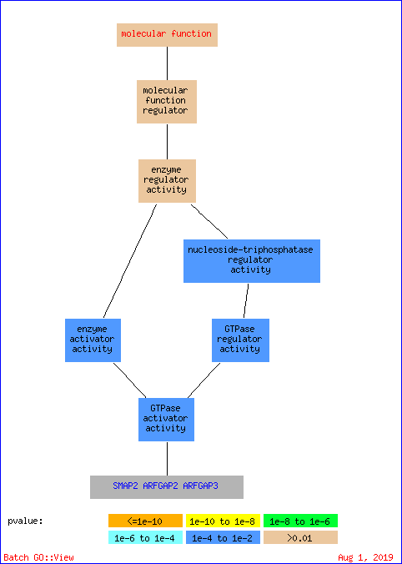
Terms from the Component Ontology of gene_association.goa_human with p-value <= 0.01

Gene Ontology term | Cluster frequency | Genome frequency | Corrected  P-value | FDR | False  Positives | Genes annotated to the term
COPI vesicle coat | 2 of 6 genes, 33.3% | 15 of 19775 genes, 0.1% | 0.00036 | 0.00% | 0.00 | ARFGAP2, ARFGAP3
COPI-coated vesicle membrane | 2 of 6 genes, 33.3% | 20 of 19775 genes, 0.1% | 0.00066 | 0.00% | 0.00 | ARFGAP2, ARFGAP3
Golgi-associated vesicle | 3 of 6 genes, 50.0% | 182 of 19775 genes, 0.9% | 0.00069 | 0.00% | 0.00 | SCFD1, ARFGAP2, ARFGAP3
COPI-coated vesicle | 2 of 6 genes, 33.3% | 27 of 19775 genes, 0.1% | 0.00123 | 0.50% | 0.02 | ARFGAP2, ARFGAP3
vesicle coat | 2 of 6 genes, 33.3% | 58 of 19775 genes, 0.3% | 0.00578 | 0.40% | 0.02 | ARFGAP2, ARFGAP3

