PARP inhibitors in Treatment Breast and Ovarian cancer

By: Negar Safarian
Supervisor: Dr. Nima Mosammaparast

April 2018
Department of Biology
Faculty of science
Bahá’í Institute for Higher Education (BIHE)

© Negar Safarian, Babolsar, Iran, 2018
Index
- Abstract
- Acknowledgment
- Introduction
- Chapter 1: BRCA1 and BRCA2 genes
-Role of BRCA1 in cells
- Role of BRCA2 in cells
-Homologous recombination
- BRCA1/BRCA2 mutations in breast and ovarian cancers
- BRCA1/2 mutations in other cancers
- Chapter 2: PARP (Poly-ADP-Ribose Polymerase) inhibitors
- PARP
- Role of PARP in the BER pathway
- PARP inhibitors and synthetic lethality
- Pre-clinical studies of PARP Inhibitors
- Clinical development of PARP inhibitors
- PARP inhibitors in combination with cytotoxic therapy
- PARP inhibitors with combination with ionizing radiation
- PARP inhibitors and chemotherapy
- Resistance to PARP Inhibitors
- Chapter 3: PARP inhibitors in treatment of prostate cancer
- Conclusion and future prospects

Abstract
Discovering the concept of synthetic lethality has provided new background for the development of targeted therapies. Synthetic lethality is a condition which two genetic aberration create positive result in therapies. In cancer cells with BRCA1 and BRCA2 loss of function that have deficiency in DNA repair pathway by homologous recombination, inhibition of PARP1 enzymatic activity leads to converted single strand breaks to double strand breaks but cannot be repaired by homologous recombination. Inhibition of PARP by PARP inhibitors shows new targeted therapy for cancers with BRCA1/2 mutations. However loss of function of various proteins that have role in double strand break repair other than BRCA1 and BRCA2 has been suggested to be synthetically lethal with PARP inhibition. Inactivation of these genes reported in many human cancers, the most important genes in breast and ovarian cancers was BRCA1/2. Loss of function of these genes are biomarker for using PARP inhibitors to treatment. In this review we discuss about the effect of PARP inhibitors in treatment process of breast and ovarian cancer and prostate cancer that harbor BRCA1 and BRCA2 genetic deficiency.

Key words: Synthetic lethality, Homologous recombination, BRCA1, BRCA2, PARP, PARP inhibitors.

Acknowledgment
I am grateful to my supervisor Dr. Nima Mosammaparast for guidance, support and helping me improve. Also Thank Mr. Shayan Moghimy for his pursue and all of my family members, friends, teachers who encourage me.

Introduction
Breast cancer is one of the most prevalent cancers among women with risk of 8-10% (1). About 15-20% of breast and ovarian cancers are familial, such that genetic factors interact with environmental influences to increase risk of cancer. 5-10% of breast and ovarian cancers are hereditary caused by mutations in Breast Cancer Susceptibility gene 1 (BRCA1) and Breast Cancer Susceptibility gene 2 (BRCA2). The risk of breast cancer in a person who has a BRCA1 mutation is 20% until 40 years old, 82% until 80 years old, and 17% for ovarian cancer (2). For people with BRCA2 mutations the risk of breast cancer is 45% until 80 years old and 11% for ovarian cancer (3). Recent studies shown that existence of BRCA1 and BRCA2 mutations are associated with other cancers, such as prostate cancer in men, melanoma, and pancreatic cancer.
Previous work showed that BRCA1 and BRCA2 genes act as tumor suppressors. BRCA proteins have important role in repair of DNA breaks through homologous recombination mechanism. Breaks in DNA come from natural process as well as radiation or other environmental exposures, and they sometimes occur when chromosomes exchange during cell division. BRCA1/2 maintain the stability of chromosomes and activate damage DNA response as well as regulation of the cell cycle. Without BRCA1/2 the cells face genetic instability and form tumors. When DNA encounters a single stranded break, Poly (ADP-ribose) polymerase (PARP1) is activated and repairs the site of damage. PARPs are family of enzymes that respond to DNA damage. Eighteen PARP family members have been discovered, and PARP-1 to PARP-3 are dependent on DNA damage for their activities. Upon damage to DNA two PARPs (PARP1 and PARP2) are activated in the nucleus of mammalian cells. To test which of these have an important role in repair, either PARP1 or PARP2 and BRCA2 were depleted with siRNA. Small interfering RNA (siRNA) are small pieces of double strand RNA bind to messenger RNA at specific sequences to promoting mRNA degradation (4). So siRNA prevent the production of specific proteins based on the nucleotide sequences of their mRNA. In this experiment scientist depleted BRCA2, PARP1 and PARP2 by siRNA. Results showed that when PARP1 and BRCA2 are depleted together, the clonogenic survival become significantly reduced (Figure 1). On the other hand depleting PARP2 with BRCA2 did not have an effect on clonogenic survival. Thus, PARP1 appears to have more important role in the repair of DNA damage.
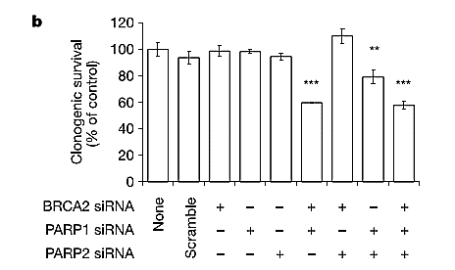
Figure 1: "Clonogenic survival after 48 h depletion of BRCA2, PARP1 and PARP2. The means and standard deviation of at least three experiments are shown."
In absence of PARP activity, the single strand breaks (SSBs) become double strand breaks (DSBs) because the separation of the replication fork leading to DSBs (Figure 2). Cells have two pathways for repair of DSBs: 1) Homologous Recombination (HR) pathway that uses sister chromatids to repair breaks by several factors such as BRCA1; 2) Non-Homologous End Joining (NHEJ) that joins two ends of break site of DNA together by 53BP1 and DNA Ligase IV4 which are prone to errors. Homologous recombination, repairs DNA before the cell enters mitosis (M phase). It occurs during and shortly after DNA replication during, the S and G₂ phases of the cell cycle, when sister chromatids are available (5). Sister chromatids are templates for homologous recombination because they have an identical copy of a given chromosome.
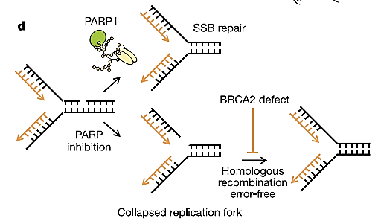
Figure 2:"Model: in the absence of PARP1, unrepaired SSBs collapse replication forks into DSBs, which are repaired by BRCA2-dependent homologous recombination"
Familial breast cancer is caused by inherited defect in one alleles of BRCA1 or BRCA2; alternatively, spontaneous mutations in BRCA1 or BRCA2 may occur. In absence of BRCA1 other factors like Rad51, HR pathway is impaired. As a result cells use NHEJ pathway for repair that do not use a template like HR and produce complex chromosome rearrangements resulting in genomic instability. The HR defect with BRCA1/BRCA2 deficient cells have sensitivity to PARP inhibitors through mechanism described below. This property of PARP inhibitor can be used to kill HR-defective cells in treatment of breast and ovaries cancer.
PARP inhibitors are agents that can be used for treatment of BRCA-deficient breast and ovarian cancer. PARP inhibitors, inhibit the BER pathway so the single strand breaks are not repaired and cells attempt to use the HR pathway. In BRCA1 and BRCA2 deficient cells, the HR pathway is defective, leading to PARP inhibitors sensitivities. PARP inhibitors, when used on BRCA1/2 deficient cells, have a synthetic lethality effect, which is when a combination of two conditions leads to cell death (as shown in figure 1). One of the advantages for synthetic lethality is that only the tumor tissue will be targeted and the amount of toxicity will be reduced. Another mechanism of action of PARP inhibitors is called “PARP trapping”, which may be more important in determining PARPi cytotoxicity (6). In this process PARPi prevents dissociation of PARPs from the DNA damage site. These stabilize PARP/DNA complexes and block the replication fork during DNA replication and as a consequence cause double strand breaks formation.
All PARP inhibitors discovered to date can inhibit both PARP1 and PARP2. Scientist tested the effect of PARP inhibitors on BRCA1 or BRCA2- deficient cells. PARP inhibitors under clinical development targeted PARP 1 and PARP2 proteins. Such PARP inhibitors include Pfizer’s PF 01367338 (AG014699), AstraZeneca’s Olaparib (AZD2281, KU-0059436), sanofi-aventis’ iniparib (BSI 201), Abbott Laboratories’ veliparib (ABT 888), Merck’s MK 4827, and Cephalon’s CEP 9722. Biomarin’s BMN673 (LT-673) and BiPar Science’s BSI 401 are in preclinical development (7).
In this type of therapy with PARP inhibitors, scientist have observed that some cells show resistance to this drug. This drug resistance can occur by HR restoration in BRCA1-deficient cells. They have shown that proteins which regulate NHEJ have an effect on HR pathway. If 53BP1 is lost in BRCA1 mutant cells, the HR pathway is restored by inducing ATM that attach to broken end of DNA and produce recombogenic single-stranded DNA that can repair with HR. But DNA Ligase IV deficient cells can't reverse HR defective in BRCA1 mutant cells. The balance between HR and NHEJ can kill or protect BRCA1 mutant cells that are the major reason for breast and ovarian cancer. The ways to overcome to these resistance for treatment is important issue that will be the focus of this thesis.
The multiple areas of exploration of PARP inhibitors include the biology of the PARP inhibitors, DNA repair mechanisms, genetic defects of DNA repair, and the toxicity effect of PARP inhibitors. This article will have three chapters; chapter 1 include introduction of BRCA1 and BRCA2 genes, their roles in homologous recombination, and BRCA1/BRCA2 mutations. Chapter 2 will discuss the role of PARP in cells, clinical development of PARP inhibitors, and possibility of inducing tumors to be more sensitive to PARP inhibitors, and resistance of cells to PARP inhibitors. Chapter 3 will focus treatment other cancers by PARP inhibitors. This review article will discuss these areas with focus on PARP inhibitors in the treatment of BRCA1 and BRCA2 cancer cells.

Chapter 1 BRCA1 and BRCA2 genes
BRCA1 and BRCA2 genes are identified as gene mutations in hereditary familial breast and ovarian cancer. These genes are tumor suppressors that control the cell growth so inactivation of these genes leads to loss of growth control. Existence of one allele mutation of these genes is enough to increase predisposition to cancer but it is not enough for tumor formation. However, inactivation of both alleles of these genes leading cells to formed tumor. These genes have important role in the repair of DNA breaks through homologues recombination mechanism that maintains the stability of chromosomes and activates DNA damage responses. These genes contain high densities of repetitive elements. This feature in BRCA genomic region increase the chromosomal instability of these genes. Scientist approve somatic alternation of BRCA and BRCA2 are common and driven by rearrangement between these repetitive elements (9). Analysis of Breast Cancer Linkage Consortium (BCLC) families, by age 70 years showed that BRCA1 mutations for breast cancer risk is 71% and for ovarian cancer risk is 47-63%. BRCA2 mutations for breast cancer risk is 84% and an ovarian cancer risk is 27% (Ford et al, 1998) (8). Scientists hope that identification of the properties of BRCA1 and BRCA2 will provide an important key to cancer prevention and new cancer treatments.
-Role of BRCA1 in cells
BRCA1 is a large protein with multiple functional domains that interacts with several proteins with important roles in biological pathways. Mounting evidence indicates that BRCA1 has role in all phases of cell cycle and regulates events in cell cycle progression. The deficiencies of BRCA1 cause abnormalities in S-phase checkpoint, the G₂/M checkpoint, the spindle checkpoint and centrosome duplication. Deficiency of BRCA1 results in genomic instability affecting cellular responses to DNA damage and induces apoptosis. The roles of BRCA1 in cell cycle checkpoints, genome integrity, DNA damage response (DDR) and tumor evolution will help us to understand cancer cells with BRCA1 mutations and find therapeutic approaches for this disease.
BRCA1 gene was mapped in 1990 and was cloned in 1994 (10). Germline mutations in BRCA1 have been found in approximately half of familial breast cancer and most cases of combined familial breast and ovarian cancers. The location of BRCA1 is on q arm of chromosome 17 at position 21 (Figure 3). It has 24 exons and encodes the BRCA1 protein that has 1863 amino acids and also encodes at least two smaller proteins via alternative splicing (11-14). One form of BRCA1 is one that does not have exon 11 designated BRCA1-Δ11 (14). Full length BRCA1 has multiple functional domains such as conserved N-terminal RING finger, two nuclear localization signals that exist in exon 11, an ‘SQ’ cluster between amino acids 1280–1524 and C-terminal BRCT domains (15). BRCA1 interacts directly or indirectly with several tumor suppressors, oncogenes, DNA damage repair proteins, cell cycle regulators and transcriptional activators. Therefore BRCA1 mutations have multiple effect on cell including growth retardation, defect in repair of DNA damage, increased apoptosis, abnormal centrosome duplication, defective G₂/M checkpoint, impaired spindle checkpoint and chromosome damage (16,17). Oncologists suggest that mutations in BRCA1 don’t directly result in tumor formation but it causes genetic instability and leading cells to transform to malignancy (18,19).
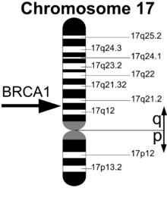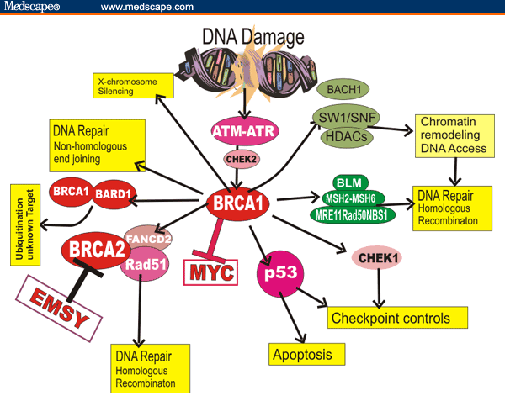
Figure3: Location of BRCA1 gene on chromosome 17. Figure 4: Multiple functions of BRCA1 in the cell.
An important role of BRCA1 is to participate in DNA repair pathways such as homologous recombination. The first step of this pathway is establishing BRCA1 at DNA damage site and then repairing of DNA. BRCA1 has BRCT domains that can recognize phosphorylated serine-proline-x-phenylalanine (pSPxF) motif including Abraxas, Bach1/FancJ and CtlP. Ionizing radiation that causes damage on DNA strands induces ATM dependent phosphorylation of serine 404. Phosphorylated S404 that motifs like promotes BRCA1-BRCT domain to attach to Abraxas and make BRCA1-BRCT/Abraxas heterodimer. This complex can bring BRCA1 to DNA damage sites (20). Mutation of S404 leads to deficiency in BRCA1 to attach at DNA damage sites and cells become sensitive to IR. Two germline mutations of BRCA1 are found to disrupt the dimer interface and complex formation. The phosphopeptide-binding ability of BRCA1-BRCT is essential for BRCA1 tumor suppression function (Shakya et al., 2011), where many breast and ovarian cancer related mutations occur (Clapperton et al., 2004; Couch and Weber, 1996; Friedman et al., 1994; Shattuck-Eidens et al., 1995; Shiozaki et al., 2004; Williams et al., 2004).
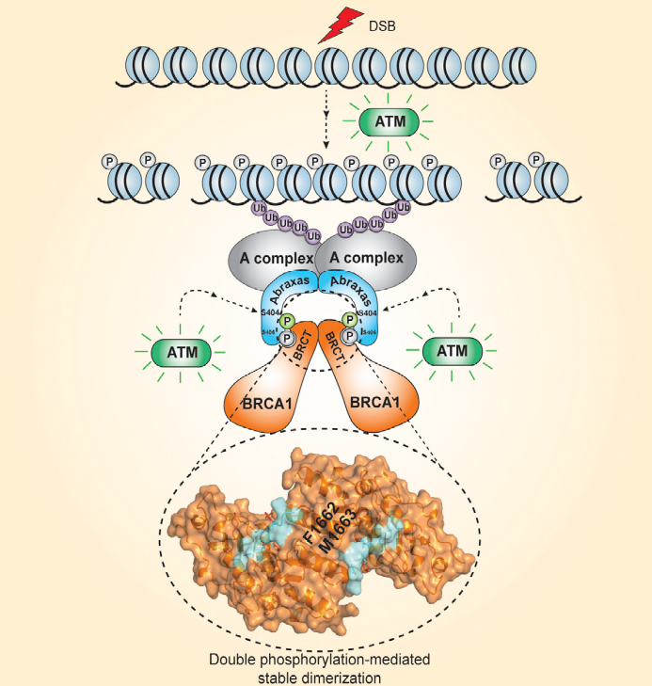
Figure 5: Mechanism of BRCA1 recruitment to sites of DNA damage.
- Role of BRCA2 in cells
In 1995 the BRCA2 gene was isolated from q arm of chromosome 13 at position 12.3. It has 26 coding exons that includes approximately 84.2 kb of genomic DNA and encode a protein with 3418 amino acids (28). BRCA2 is a nuclear protein that contains an N-terminus that has transcriptional activation domain and C-terminal domain that has DNA binding domain. Two nuclear localization signals (NLS) have been identified in BRCA2 C-terminal domain. BRCA2 exon 11 encodes eight conserved motifs called BRC repeats and each of these repeats is composed of 30 residues. BRCA2 expression depends on the rate of cell proliferation and expression of BRCA2 was observed in actively dividing tissues such as epithelium of breast during puberty and pregnancy but not in non-dividing cells. The BRCA2 expression is regulated during the cell cycle and the highest expression of BRCA2 is in S-phase.
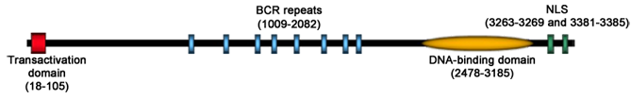
Figure 6: structure of BRCA2. BRCA2 is a 3418 aa protein. BRC repeats: BRCA C-terminal repeats; NLS: Nuclear localization signals.
BRCA2 has several functions in cells including: maintenance of genomic integrity and cellular response to DNA damage through homologous recombination, DNA replication stress, telomere maintenance, R loop metabolism, G2/M checkpoint, mitosis and cytokinesis and transcriptional control.
-Homologous recombination
DNA break repair pathway is generally divided into two pathways; one of them repairs damage affecting one strand of DNA, and the other repairs damages affecting both strands of DNA. Homologous recombination (HR) and non-homologous end joining (NHEJ) are repair mechanisms that fix damages on double strand (DSBs). Nucleotide excision repair, base excision repair (BER) and mismatch repair (MMR) are repair mechanism for single strand breaks (SSBs).
DSBs are the most important DNA lesion in cells that can cause genome rearrangement and genomic instability. DSBs are induced by ionizing radiation and by endogenous sources during recombination and meiosis (Keeney and Neale 2006; Nishana and Raghavan 2012). DSB also occurs during DNA replication when forks are blocked by lesions such as single strand breaks and other types of base damage (Allen et al. 2011; Budzowska and Kanaar 2009). Cells sense the DSBs damage and phosphorylate H2AX (γ-H2AX) that act as a marker for DSBs and have important role in DNA damage signaling and DSB repair. Cells have two pathways to repair DSBs; one of them is non-homologous end joining (NHEJ) and the other is homologous recombination (HR). When two DSBs occur on different chromosomes, NHEJ can mediate translocations (Lieber et al.2006; Nickoloff et al. 2008; Weinstock et al. 2006), but most of the time repair through NHEJ occurs with small error such as short deletions or insertion mutations (Deriano and Roth 2013). This mechanism leads to genome instability. HR can occur between two homologous sequences such as sister chromatids and repair through this mechanism is generally error free.
HR is divided in two pathways for repairing DSBs; a conservative and accurate pathway that use RAD51 to mediate stand invasion (DSBR) and non-conservative pathway that is RAD51 independent that termed synthesis-dependent strand annealing (SDSA). They are two models for how HR repairs two ended DSBs, and the choice between these two ways is regulated by proteins that control resection including 53BP1 and, BRCA1. BRCA1 and BRCA2 interact with other proteins in HR pathway to repair the damage site of DNA. After DNA damage occurs, the histone H2A family member H2AX becomes phosphorylated and forms foci at break sites. The Mre11/Rad50/Nbs1 (MRN) complex then attaches to break sites of DNA. Mre11 has endonuclease activity that caused nucleolytic processing of DSBs to produce ssDNA overhangs that is necessary for HR; this process is called resection. During resection RPA (replication protein A) attaches to ssDNA overhangs, becomes phosphorylated, and is replaced by RAD51 with the help of BRCA1 to form RAD51 ssDNA nucleofilament. The formed RAD51 nucleoprotein filament facilitates DNA strand invasion and exchange steps which leads to formation of a Holliday junction (HJ). From this point, the DSBR (double-strand break repair) pathway and the SDSA (synthesis-dependent strand annealing) pathway are defined. For the DSBR model the nucleoprotein filament search for DNA sequences similar to 3' overhang; in fact the second 3’ overhang forms a holiday junction with the homologous chromosome that is the sister chromatid. After finding the proper sequence, the single stranded nucleoprotein filament moves into the similar recipient DNA (that is the sister chromatid) by a process called strand invasion. After searching for homology strand a displacement loop (D-loop) is formed during strand invasion between the 3' overhang strand and homologous chromosome. Then DNA polymerase synthesizes new DNA at the end of the invading 3' strand (Figure 7c). Through SDSA pathway, the first invading 3' strand is extended along the recipient DNA by a DNA polymerase and did not form holiday junction and resolve by branch migration (figure 7b).
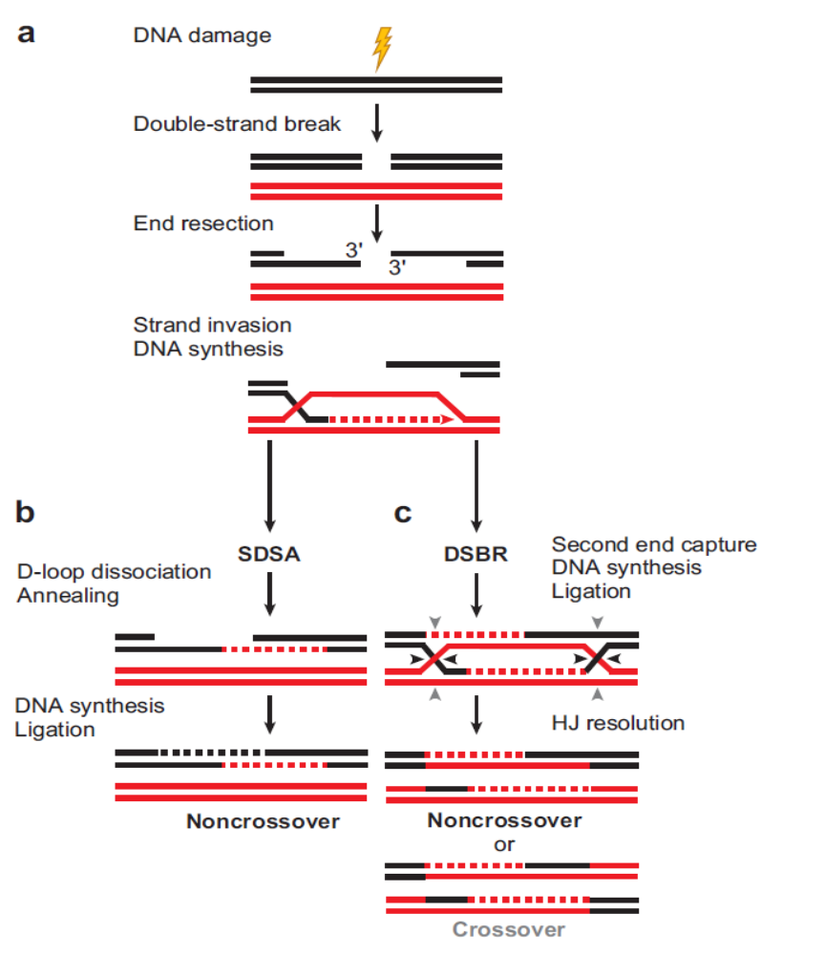
Figure 7: "Homologous recombination pathway to repair double strands breaks. a) After DSB formation, the DNA ends create 3’ single strand DNA (ssDNA) overhangs. These overhangs are substrates for HR proteins to invade the strand through partner chromosome. After homology search, strand invasion occur to form a nascent D-loop structure. DNA synthesis then continued. b) In SDSA pathway, the D-loop is unwound and ssDNA strand anneals with the complementary ssDNA strand that is associated with the other DSB end. Process completed by gap filling DNA synthesis and ligation. In this process only noncrossover products are formed. c) The second DSB end can be captured to form an intermediate that harbors two Holliday junctions (HJ), accompanied by gap-filling DNA synthesis and ligation. The resolution of HJs by a specialized endonuclease can result in either non-crossover or crossover products."
BRCA1 has high affinity to bind other proteins that participate in HR pathway. One of the first interacting proteins discovered was RAD51 (42,43), which functions in homologous recombination and DNA damage repair. It was demonstrated that in BRCA1 deficient cells the RAD51 foci formation in cultured MEFs after γ-irradiation are decreased (44). RAD51 also interacts with BRCA2 and it is suggested that BRCA1-BRCA2-RAD51 form a stable complex during DNA damage repair. A group of proteins associated with BRCA1 to form a large complex called BASC (BRCA1-associated genome surveillance complex) (45). This complex includes tumor suppressors and DNA damage repair proteins, MSH2, MSH6, MLH1, ATM, BLM and the RAD50-MRE11-NBS1 protein complex. Members of this complex recognize abnormal DNA structure or damage DNA such as DSB, mismatched DNA, stalled replication forks, Holliday junctions and telomere repeats. This finding suggested that BRCA1 functions as a basic element to start multiple activities required for maintaining genome integrity. After DNA damage the histone H2AX become phosphorylated and formed foci at break site. BRCA1 is recruited to this foci before other factors RAD51. This suggests that H2AX and BRCA1 initiate repair and allow DNA repair proteins to accesses the damage site. Analysis of DNA damage repair in absence of H2AX demonstrated that DNA damage repair fails because of diminished BRCA1 foci formation in H2AX^{−/−} cells after irradiation (46).
BRCA2 was first identified protein as DNA repair protein that has physical interaction with recombination protein RAD51 (47,48). During HR, RAD51 and BRCA2 with other factors promote a reaction and use damaged chromatid pairs for exchange of genetic information from the latter to the former. This process needs the resection of DSB to generate a 3′-ssDNA overhang that used for recombination machinery to find homology. At the end displacement loop (D-loop) is formed between resected DNA and template chromatid to promote DNA synthesis.
In humans, RAD51 binding site of BRCA2 is located in the BRC repeats. RAD51 interaction site is on C-terminal region. Through the BRC repeats, BRCA2 enforces RAD51 to bind single stranded DNA (ssDNA) and promotes its HR function (49,50). BRCA2 binds DNA through DNA binding domain in the C-terminal region that contains 3 oligonucleotide/oligosaccharide binding folds (OB folds), a helical domain, and a tower domain (51). The DNA binding domain and RAD51 interacting site allow BRCA2 to promote the assembly of RAD51 onto ssDNA and ssDNA/dsDNA junctions (52). BRCA2 is able to displace replication-protein A (RPA) from ssDNA to form RAD51 nucleoprotein filament that promotes DNA strand exchange (Figure 8). This finding shows that the role of BRCA2 as a mediator of HR in somatic cells. Another factor that binding to BRCA2 and promotes HR is PALB2 (partner and localizer of BRCA2). PALB2 is attached to BRCA2 through N-terminus of BRCA2. Both proteins cooperate in stimulating RAD51-mediated D-loop formation (53). The depletion of PALB2 leads to a decrease in HR efficiency. PALB2 forms a complex with BRCA1 and BRCA2 and provide an indirect link between the two BRCA proteins (54). Like BRCA1 and BRCA2, PALB2 is also a breast cancer predisposition gene (55).
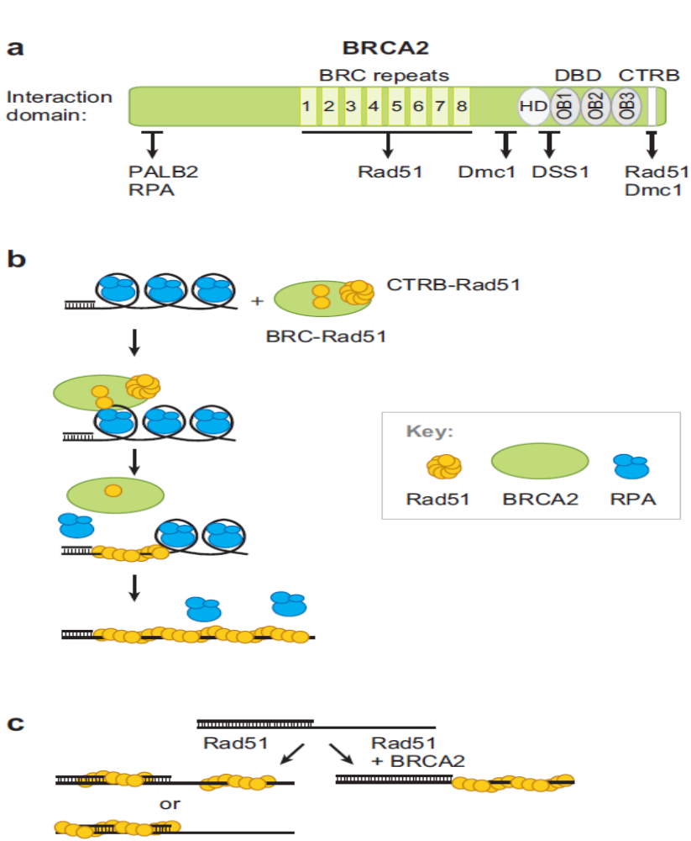
Figure 8: Role of BRCA2 in homologous recombination. a) Functional domains in human BRCA2. b) BRCA2 binds to Rad51 through BRC repeats and C-terminal Rad51-binding domain (CTRB) charged by an intact Rad51 heptamer. One of the BRC repeats and the CTRB then cooperate to assemble a nascent Rad51 filament, followed by the further displacement of RPA by the growing Rad51 filament. c) Function of BRCA2 in assembling Rad51 to the ssDNA region of a resected DSB.

The ends of chromosomes have the potential for DNA damage repair. Homologous recombination prevents chromosomal ends from degradation, fusion and maintain telomere integrity. BRCA2 facilitates telomere replication and protection by loading RAD51 onto telomeric DNA. But in BRCA2 deficient cells the telomeres become fragile telomeres and telomere sister chromatid exchange is increased (32). So BRCA2 deficient tumors show telomere shortening and telomere fragility that can promote tumorigenesis (33). BRCA2 also has potential binding sites to attach to both ssDNA and dsDNA. Scientists used electrophoretic mobility shift assays (EMSA) for testing the ability of BRCA2 to bind ssDNA (3' tail and 5' tail) and dsDNA. Illustration below shows that Brca2 can bind to all of them but it prefers ssDNA for attachment (figure 9).
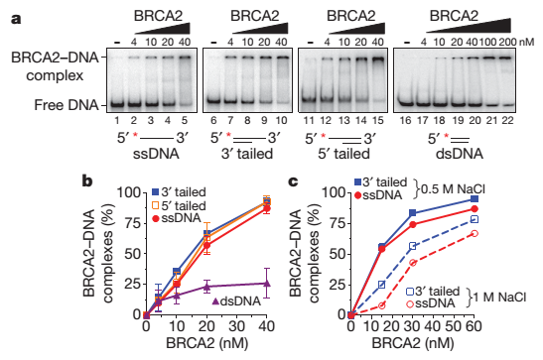
Figure 9: "BRCA2 displays a strong preference for binding tailed and ssDNA substrates over dsDNA."
BRCA2 stimulates DNA strands to exchange by RAD51. The function of RAD51 in homologous recombination is due to its capacity to create homologous repair for exchanging DNA strands. RAD51 can bind to both ssDNA and dsDNA and compete with RPA for binding ssDNA (34,35). The attachment of RAD51 to dsDNA can blocks DNA strand exchange (35,36). In this way scientist used a mixture of 3' tailed DNA and dsDNA and introduced RAD51 to this mixture. Analysis showed that RAD51 can bind to both ssDNA and dsDNA so DNA strand exchange is reduced to background levels (figure 10b). When BRCA2 was added to this mixture before RAD51 bind to DNA, BRCA2 inhibited the attachment of RAD51 to dsDNA and directed RAD51 to ssDNA and DNA strand exchange increased.
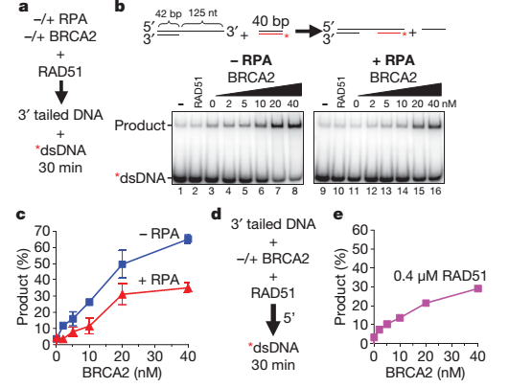
Figure 10: "BRCA2 stimulates DNA strand exchange promoted by RAD51. a) DNA strand exchange reaction protocol for b and c. b) Reaction in the absence (left) or presence (right) of RPA. d) DNA strand exchange protocol for e in the absence of RPA."
Another experiment showed amount of DNA strand exchange by RPA and RAD51 in absence or present of BRCA2. They used the optimal amount of RAD51 and naked ssDNA. At first ssDNA was coated with RPA (figure 11a) and then RAD51 introduced. The amount of DNA strand exchange was measured by RPA and RAD51 in the absence or present of BRCA2. The increased amounts of RPA before addition of RAD51 caused impaired of DNA strand exchange. But the increase of BRCA2 increased the amount of DNA strand exchange. This is because BRCA2 help RAD51 formed nucleoprotein filament at the presynaptic stage of recombination (Figure 11).
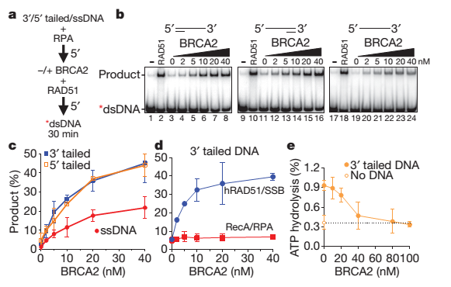
Figure 11: "BRCA2 stimulates RAD51-mediated DNA strand exchange by promoting stable RAD51–ssDNA filament formation, overcoming inhibition by RPA. a) DNA strand exchange reaction protocol for b and c. b) Autoradiograms of 3’ tailed, 5’ tailed and ssDNA substrates. c) Quantification of b. d) Assays as in a, except RecA replaced RAD51 and SSB replaced RPA. e) Inhibition of RAD51 ssDNA-dependent ATP hydrolysis by BRCA2."
In some species that lack BRCA2, like V.Maydis and E.coli, analogous protiens exist which function like BRCA2. In these cases. These proteins can only attach to 3' ssDNA overhang but the human BRCA2 can act at both 3' and 5' tailed DNA and the DNA strand exchange in both position. BRCA2 have this ability to stimulate RAD51 bind to 3' to 5' ssDNA tails.
BRCA2 has four effects: 1) It forces binding of Rad51 to ssDNA 2) It increases the rate of RPA replacement to Rad51 in ss-DNA 3) Inhibits ATPase activity of Rad51 4) limits Rad51 attachment to dsDNA. BRCA2 produces the active and most stable form of RAD51, the ATP-RAD51-ssDNA complex (37,38). RAD51 have self-inactivation by ATPase activity so BRCA2 inhibits RAD51 self-inactivation. BRCA2 facilitate assembling of RAD51 in both 5'$→$ 3' and 3'$→$5' directions. The loss of BRCA2 in each cell stops the homologous recombination pathway and therefore the cell uses the error-prone repair that increase chromosomal instability.
Another function of BRCA2 is transcriptional activation. The third exon of BRCA2 has been involved in transcriptional activation (39). This function is regulated by multiple factors like EMSY that attach to N-terminal region of BRCA2 and represses its transactivation activity. Because EMSY is amplified in sporadic breast and high grade ovarian cancer, this interaction may link BRCA2 to sporadic breast cancer (40). BRCA2 associates with the tumor suppressor and transcription regulation protein p53 through the DBD. Overexpression of BRCA2 inhibits the transcriptional activity of p53 and the level expression of target genes are reduced such as p21 and Bax. P53 transactivation deficiency leads to HR inhibition so association of BRCA2 and p53 can play an important role in regulation of HR (41).
-BRCA1 and BRCA2 mutations in Breast and Ovarian cancers:
Mutations in BRCA1 and BRCA2 are responsible for 80-90% of all hereditary breast cancers (56). Germline mutations in BRCA1 and BRCA2 are responsible for 5%-10% of epithelial breast and ovarian cancer (57). Mutations of these genes have been found throughout the entire coding region and splicing sites. The majority of mutations in both genes are small insertion or deletions resulting in a frame shift, nonsense mutations or splice site alternations. The Breast Cancer Information Core (BIC) has published the specific mutations in BRCA1 and BRCA2. Currently they have collected $\sim$12,000 carriers of BRCA1 mutation and $\sim$11,000 BRCA2 carriers on record. The BIC reports that the most common BRCA1 mutations identified are 185delAG (16.5%), 5382insC (8.8%) and the missense alteration C61G (1.8%). The most commonly reported BRCA2 mutations are 6174delT (9.6%), K3326X (2.6%), 3036del4 (0.9%), and 6503delTT (0.8%) (58). 70%-75% of breast and ovarian cancers are sporadic and it has been suggested that BRCA1 and BRCA2 deficiency have a role in this type of cancers as well. The risk of breast and ovarian cancer among patient with BRCA1 and BRCA2 mutations are different, which may result from differences in exposure to environmental risk factors in different populations or within families. Also genetic backgrounds may influence disease risk.
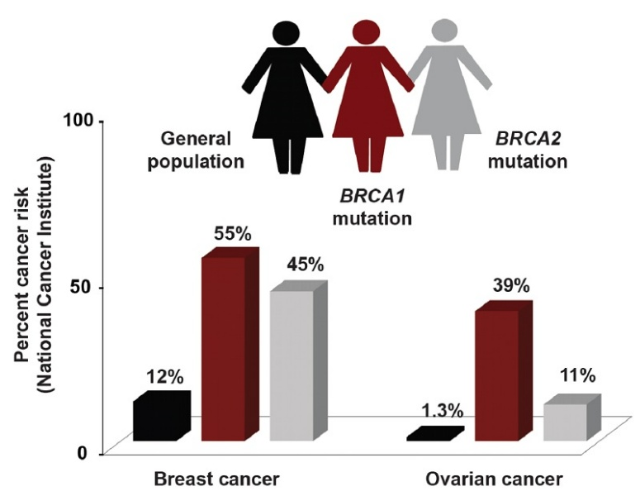
Figure12: Present Breast and Ovarian cancer risk in BRCA1, BRCA2 mutation genes and general population

BRCA mutation testing can predict the amount of cancer risk. Data shows that breast and ovarian cancer risk vary by different type and site of mutations in BRCA genes. It is suggested that BRCA1 mutations in the central part of the gene (nt 2401-4190) are related to lower breast cancer risk and the mutations in the 3’ end (beyond nt 4119) could be related with lower ovarian cancer risk (Thompson and Easton, 2002). Scientists identified the regions of the gene related to increased risk of breast and ovarian cancer. The regions that increase the breast cancer risk compared with ovarian cancer are called breast cancer cluster regions (or BCCRs), and regions associated with a higher risk of ovarian cancer compared to breast cancer are called ovarian cancer cluster regions (or OCCRs). For BRCA1, an initial study suggested that mutations located in the5’ end of the gene were associated with higher risks of ovarian cancer compared to mutations in the 3’ end (Gayther et al., 1995) (figure 13& 14). Scientist identified 3 BCCRs and 1 OCCR region in BRCA1gene but in BRCA2 gene they found multiple BCCRs and 3 OCCRs region. Thus with distinct mutations, it is possible to predict the type of cancer with greater accuracy. Scientists have hope to design an algorithm that can calculate risk of developing breast and ovarian cancer according to data from cluster regions in BRCA1 and BRCA2 sequences. This prediction allows doctors and patients to access more data for earlier treatment.

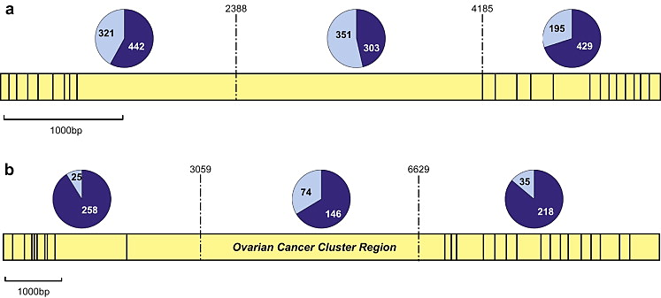
Figure 13: “Proportion of breast and ovarian cancer cases in families with mutations in the 50, central and 30 regions of each gene. Yellow part is exon structure of each gene and dark blue are breast cancer cases and light blue are ovarian cancer cases. Data from Thompson et al. (2001, 2002a) and Ramus et al. (2007) (excluding overlapping families). (a) BRCA1; the ratio of breast to ovarian cancer in each region is 1.4, 0.9 and 2.2 respectively showing increased risk of ovarian cancer for mutations in the central region bounded by 2388–4185 bp. (b) BRCA2 gene mutations in the central OCCR, bounded by 3059-6629bp showing more risk of ovarian cancer to compare with ratio of breast cancer in other region.”

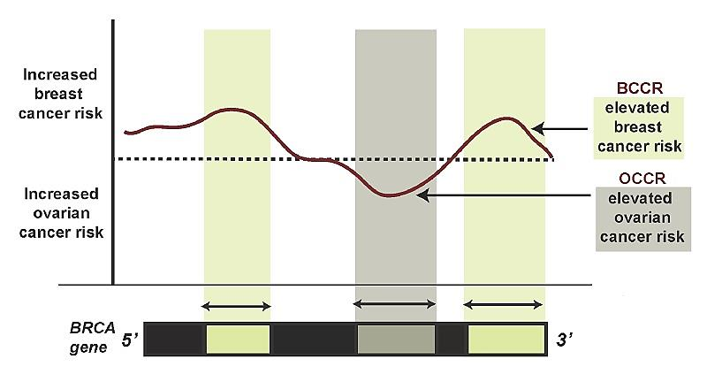
Figure 14: The correlation between BRCA gene mutation region and the risk of breast and ovarian cancer.
Studies have demonstrated that the loss of one allele of BRCA1 by mutation leads to haplo-insufficiency, which results in genomic instability. This genetic instability may promote another genetic changes in BRCA1 heterozygous cells. Heterozygous BRCA1 inactivation is likely to be insufficient for complete breast carcinogenesis because most of BRCA1 tumors showed loss of second wild-type BRCA1 allele. So scientists have suggested BRCA1 haplo-insufficiency leads to genomic alternations but is not sufficient for BRCA1-mediated breast tumors. So the hallmark of somatic inactivation in tumor suppressor genes is loss of one copy of gene when another copy of gene have a mutation; this process called loss of heterozygosity (LOH). LOH is the most common type of somatic alternation found in human breast tumors. The BRCA1 region also displays LOH in 30 to 70% of sporadic breast and ovarian cancer. It shows that BRCA1 is a tumor suppressor gene and has a role in both inherited and sporadic breast and ovarian cancer (59). Previous studied on BRCA1 gene demonstrate that the mutation of a single allele of BRCA1 leads to genomic instability in human breast epithelial cells. The women who carry heterozygous BRCA1 mutations have 85% risk for breast cancer, and the wild-type allele of BRCA1 are lost in all these tumors (60).
Somatic mutations that occur in repetitive elements of BRCA genes are frequent events. In a woman who has germline mutation in BRCA1 or BRCA2, somatic inactivation of remaining allele causes cells to lose their ability to repair damage of DNA. This cell will be arrested by cell cycle checkpoint and will die. In a women without germline mutation that have sporadic BRCA tumorigenesis, somatic alternation of one allele of BRCA1 or BRCA2 in breast epithelial cells occurs in repetitive elements of these genes during estrogen-mediated proliferation. Inactivation of second allele may occur through four mechanisms: somatic genomic alternation or transcriptional splicing, loss of BRCA function related to haplo-insufficiency or failure of post-translational modification. Inactivation of second BRCA allele results in cell death.
The rare BRCA deficient cells escape from cell death. For this event scientists suggest that tumor may acquire second alteration including mutation of critical checkpoint genes that result tumor formation. For BRCA1-mediated tumorigenesis, one of the checkpoint genes is p53. Evidences shows that loss of BRCA1 in mammary cells of mice leads to incomplete proliferation, apoptosis and tumor at a low frequency (38). In these mice heterozygous mutation of p53 leads to more mammary tumors and most of them have lost their remaining p53 allele. In this model p53 mutation would inactivate cell cycle checkpoint and lead to uncontrolled growth (Figure 15). P53 alteration can rescue cellular lethality caused by BRCA1 deficiency. The identification of similar genetic alternations that activate other genetic changes could be potentially exploited to develop targeted therapies for BRCA1-related cancers and will be explained in the second chapter.
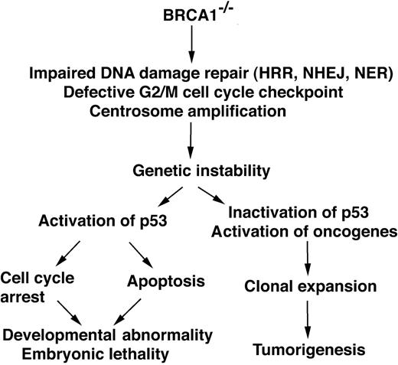
Figure 15: BRCA1 mutated cells lose their ability repair damage of DNA and cause genetic instability. If cell cycle checkpoint is activated these cell arrests and will die but in absence of cell cycle checkpoint, like p53, this cell growth is uncontrolled and produces tumor.
BRCA1 and BRCA2 germline mutations are the fundamental defect in hereditary breast and ovarian cancer when the normal allele is inactivated in cancer cells (61, 62). The first estimated breast cancer risk related to BRCA1 patogenic varients was based on 33 families with linkage to BRCA1 with an estimated risk of 87% by age of 70 years (Ford et al 1994). For BRCA2 early cumulative breast cancer risk are estimated to be 84% by age 70 years (Ford et al 1998). Another studied 676 Ashkenazi families and 1272 families of other ethnicities. Here, the breast cancer risk in these groups of women with germline BRCA1 reached 46% by age 70 years (Chen et al 2006). Studies on groups of individuals from United kingdom included 978 individuals with a BRCA1 pathogenic variant and 909 individulas with BRCA2 variant, and estimated the breast cancer risk in BRCA1 heterozygotes to be 60% and 55% risk for BRCA2 heterozygotes by age 70 years (Mavaddat et al 2013). For estimating BRCA1/2 defeciency in male breast cancer scientists collected data from 1939 families with 97 males with breast cancer and evaluated the risk of developing breast cancer in males with BRCA1 or BRCA2 pathogenic variants. The risk was higher for men in 30 and 40 years and decreased by increasing age.
Ovarian cancer includes fallopian tube and primary peritoneal cancers. BRCA germline mutations increase risk for ovarian cancer, ranging from 16.5% to 63%. The estimated risk for BRCA1 pathogenic variants were 63% by age 70 years (Easton et al 1995) and for BRCA2 pathogenic variants were 27% by age 70 years (Ford et al 1998). In the US population study included 676 Ashkenazi families and 1272 families of other ethnicities, ovarian cancer at age 70 years in individual with germline BRCA1 mutation was 39% (Chen et al 2006). In another study estimated risk of ovarian cancer among BRCA1 heterozygotes was 37% and 21% among BRCA2 heterozygotes (Satagopan et al 2002). Recently analyzes of the molecular pathways of ovarian cancer, calculated that most cases of high grade cancers arise from the fallopian tubes rather than the ovaries (Daly et al 2015). Studied on ovarian cancer in women with a germline BRCA1/2 mutations showed higher survival rate compared to individuals without BRCA1/2 deficiency. Additionally epithelial ovarian tumors that were platinum- sensitive were more likely to have germline BRCA1/2 mutant cancer than individuals with platinum resistant tumors (Dann et al 2012). Recently, studies in a large group of unselected individuals with ovarian cancer illustrated the short-term survival in ovarian cancer with germline BRCA1/2 mutations was better than individuals without BRCA1/2 mutations. This survival advantage was short lived and did not have long-term survival benefit (McLaughlin et al 2013). Scientists selected 360 patients with ovarian cancer from the USA to determine BRCA1/2 mutations among these individuals. This group was not selected for family history or age at diagnosis. Genetic testing estimate 63 patients (18%) had BRCA mutations and the percentage of other deficiencies in other HR molecules. Figure 17 shows the percentages of each mutation for BRCA1, BRCA2 and other molecules.
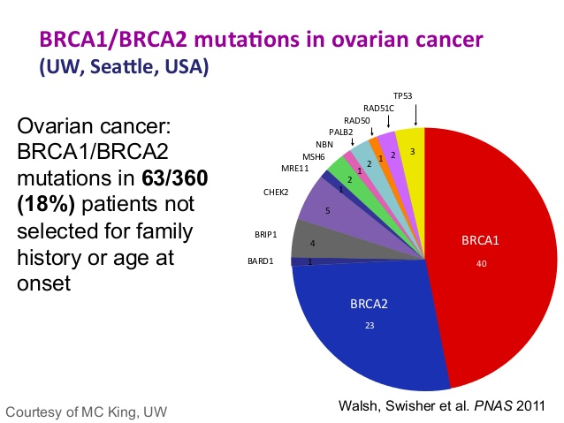
Figure 16: BRCA1/2 mutations in 63/360 (18%) patients with ovarian cancer and the rate of HRR protein mutations.
In the sporadic form of breast and ovarian cancers the BRCA1/2 somatic mutations are not common but significantly lack BRCA1/2 function. According to the Cancer Genome Atlas Research Network, genetic or somatic mutations of BRCA1 and BRCA2 are found in 20% of all ovarian tumors (63). Alternations of BRCA1/2 have been reported in up to 82% of all tumors (64). Another epigenetic mechanism targeting BRCA1/2 is transcriptional silencing that inactive tumor suppressor genes. In as many as 90% patient that do not have germline BRCA1 mutations or family history of BRCA deficiency, decrease level of BRCA1 protein and mRNA can be observed (65). Scientists showed that BRCA1 gene methylation is frequent in primary sporadic breast and ovarian tumors and most of these cells have reduced BRCA1 expression. This deletion of BRCA1 gene require another alternation known as Knudsen’s two hits in sporadic breast tumors. Scientists observed phenotypic similarities between familial BRCA1 and BRCA1 methylated tumors based on BRCA1 deletion and p53 mutations. Gene silencing by hypermethylation occurs at CpG-island promoters. Methylation may be passed to daughter cells during DNA replication by activity of DNA methyltransferases. Hypermethylation of BRCA1 promoter is observed in sporadic breast and ovarian tumors and may occur with allelic imbalance at the BRCA1 locus to reduce BRCA1 expression (50,51). BRCA1 promotor methylation has been demonstrated up to 14% of sporadic breast cancers and up to 30% of sporadic ovarian cancers (66,67,68).
Triple negative breast cancers (TNBC) account for 20% of all breast cancers and are defined as tumors that are estrogen receptor-negative, progesterone receptor-negative and HER2-negative. Over 80% of hereditary BRCA1 mutated tumors are TNBC. Scientists have done experiments to investigate the amount of germline and somatic BRCA1/2 mutations in unselected patient with triple negative breast cancer. DNA from 77 TNBC and DNA from normal tissues were analyzed. BRCA1/2 exons regions were sequenced from patients to determine if they are mutated or wild type. In this unselected patient cohort with TNBC, they found 19.5% of BRCA mutations (Liderau et al). They examined 70 patients with ER-negative and high grade breast cancer diagnosed before age 35 and found a 28.6% BRCA1 germline mutation rate. Another study focused on germline BRCA1/2 mutations in selected patients with TNBC. In this study 54 women with high grade TNBC at age 40 were selected. Patients in this study did not have family history of breast or ovarian cancer. All coding exons of BRCA1 and two large exons of BRCA2 were screened. Five deleterious germline BRCA1 mutations and one deleterious BRCA2 mutation (11% total) were identified (69). Individuals with triple negative breast cancer may thus have BRCA mutations and genetic testing so important to identify treatment strategy.
However high frequencies of loss of heterozygosity (LOH) have been found on sites of BRCA1 and BRCA2 genes. Down-regulation of BRCA1 mRNA levels is seen in sporadic breast tumors compare with normal breast epithelial cells. To obtain a molecular characterization of BRCA2 expression in sporadic breast cancer, BRCA2 mRNA was measured by RT-PCR in primary breast tumors. Scientists analyzed 127 breast tumor RNA samples and showed that 39 (31%) had altered BRCA2 mRNA expression. 14 tumors (11%) showed reduced expression of BRCA2 mRNA and 25 (20%) tumors showed overexpression. Genetic instability caused by decreased expression of BRCA2 could form mutations that lead to uncontrolled proliferation and invasive growth. Studied have shown decreased level of BRCA2 expression in the patient with breast cancer and more invasive cancer.
Scientists made a mutation BRCA2 vector and inserted a ${PGK-neo}^{r}$ position of the mouse gene that in a same orientation of BRCA2 transcription. The BRCA2 fragments used as probe A and probe B to the site of BRCA2 alleles. Hybridization analysis showed amount of wild type (+/+), heterozygous (+/-) and homozygous (-/-) of BRCA2. The ${B{RCA}_{2}}^{-/-}$ mice showed early embryonic lethality (80,81). But in some genetic background some ${B{RCA}_{2}}^{-/-}$mice may live. Male and female ${B{RCA}_{2}}^{-/-}$showed some abnormality such as the presence of kink in the tail and abnormal developmental structure in ribs and sternum (Figure 17).
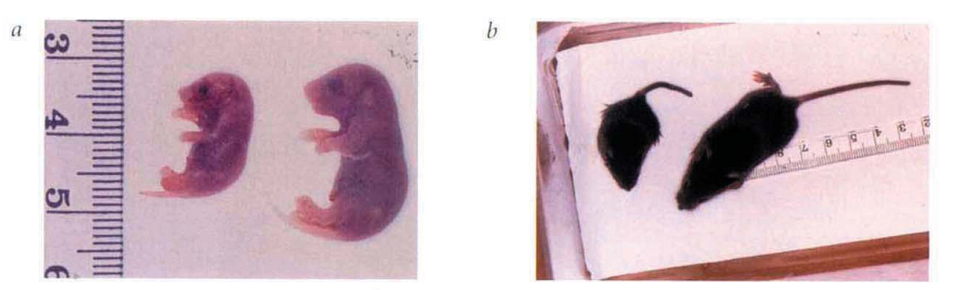
Figure 17: “Viability but growth impairment of some ${B{RCA}_{2}}^{-/-}$ mice. a) E17.5 embryos from a cross of heterozygous mice. Left ${B{RCA}_{2}}^{-/-}$ embryo, right control mouse. b) Nineteen day mice from a cross of heterozygous mice. Left ${B{RCA}_{2}}^{-/-}$ mouse, right control mouse”.
Testing of adult males with ${B{RCA}_{2}}^{-/-}$ mutation alive showed that they could not breed and had reproductive problems. The reproductive organs of these animals are normal but the testes were smaller than wild type. In ${B{RCA}_{2}}^{-/-}$ testes the sertoli cells that do not have germ cells so the gonads do not form duing embryogenesis. The ovaries of ${B{RCA}_{2}}^{-/-}$ females are reduced in size and do not have follicles. The ${B{RCA}_{2}}^{-/-}$mice are smaller in size during both embryonic and adult stages, because of a defect in cell proliferation. So scientists compared the growth of mouse embryionic fibroblasts (MEFs) in wild type, hetrozygous and homozygouse mice. ${B{RCA}_{2}}^{+/-}$and ${B{RCA}_{2}}^{+/+}$showed that MEFs proliferate well but ${B{RCA}_{2}}^{-/-}$ MEF prolifrate poorly. This seems likely to be caused by over-expression of p53 and p21. p53 is a dependandt cell cycle arrest in response to DNA damage and p21 is an important target gene for tumor supressor p53 that is linking DNA damage to cell cycle arrest. In ${B{RCA}_{2}}^{-/-}$MEF that have wild-type p53, the over-expression of p53 and p21 observed in result the cell go to cell cycle arrest and defect in cell proliferation occur. In this way the mice that strongly expressing p53 die very early in embryogenesis, but under one-third survive the perinatal period and reach adulthood. In these mice seems p53 mutation were occur before loss of the wild-type allele, growth arrest would not occur and the cell would still ${B{RCA}_{2}}^{+/-}$. After loss of heterozygosity of ${B{RCA}_{2}}^{+/-}$ that driven by centrosome defect caused by loss of p53 function. As a result defective DNA repair pathway leads to activation of oncogenes. Defects in DNA repair can lead to development of thymic lymphomas in ${B{RCA}_{2}}^{-/-}$ mice. Lymphocytes mature through a DNA rearengment of V(D)J genes through double strand breaks. Thymic lymphomas might form from deficiency of this DNA break being properly repaired during V(D)J.
- BRCA 1/2 mutations in other cancers:
Contralateral breast cancer (CBC): Contralateral breast cancer is a tumor in opposite breast and independent from primary breast cancer and diagnosed more than 6 month after detection of the first cancer. Several studies have reported higher rates of CBC among women (van den Broek et al 2015). Oncologist check some factors to predict CBC; these predictors are age at first breast cancer, family history of early breast cancer and the affected BRCA gene (Graeser et al 2009, Malone et al 2010, Metcalfe et al 2011a, van den Broek et al 2015). Researchers have shown that in unselected individuals with breast cancer, for those had BRCA1 mutation the risk of CBC was 21.1% and for BRCA2 mutations the risk of CBC were found 10.8%. Mavaddat et al estimated the risk of CBC among group of 978 BRCA and 909 BRCA2 heterozygous from United Kingdom. The risk of CBC in BRCA1 heterozygous carriers was 83% and for BRCA2 heterozygous carriers was 62% by age 70 years. (Mavaddat et al 2013).
Prostate cancer: Genetic studies on individuals with prostate cancer showed the presence of malfunctioning BRCA genes. To study germline BRCA1 mutations in males with prostate cancer, scientists selected 913 males with prostate cancer in age from 36 to 86 years. Germline BRCA1 mutations were found in three of individuals at or before age 65 years. It was estimated that in a person who has BRCA1 deficiency the risk of prostate cancer is 8.6% risk by age 65 years (Leongamornlert et al 2012). In males with BRCA2 mutations the risk of prostate cancer has been estimated at 20% (Breast Cancer Linkage Consortium 1999). Kote-Jarai et al screened 1864 males with prostate cancer between age 36 and 88 years for BRCA2 pathogenic variants. Nineteen protein-truncating variants were identified, all of which occurred in individuals who were diagnosed with prostate cancer at or before age 65 years. They found 20% risk of prostate cancer for BRCA2 mutations and it showed BRCA2 mutations increase risk of prostate cancer in compared with BRCA1 mutations (Kote-Jaraie et al 2011).
Pancreatic cancer: Pathogenic variants of BRCA1 and BRCA2 genes increased risk of pancreatic cancer. Thompson et al reported increases risk for pancreatic cancer in individuals with germline BRCA1 mutations and in those with BRCA2 mutations. Risch et al (2006) studied on 1171 unselected females that have ovarian cancer showed the risk for pancreatic was 3.1 in BRCA1 pathogenic variants and 6.6% for BRCA2 pathogenic variants. So BRCA1/2 mutations increase the risk of pancreatic cancer in compare with individuals without BRCA1/2 mutations.
Melanoma: Melanoma is the most deadly skin cancer. Studies on BRCA2 mutation carriers showed that BRCA2 mutation can double or triple the risk of melanoma (90). An analysis of 490 families with BRCA1/2 pathogenic variants showed an increased risk for ocular melanoma in individuals with germline BRCA2 pathogenic variants.
The most promising recent development in systemic therapy for BRCA mutation-associated breast and ovarian cancer is PARP inhibitors. BRCA genetic testing lets us know which cancers have BRCA mutations allowing to use of agents with less side effects. Scientists found PARP inhibitors as theraputic agents for treatment of BRCA deficient cancers. Will introduce PARP, PARP inhibitors and the trials to treat BRCA deficient cancers, especially breast and ovarian cancer.

Chapter 2 PARP inhibitors
PARP:
Increasing our knowledge about the function of poly-[adenosine diphosphate (ADP)] ribose polymerase (PARP) enzymes in DNA repair, among other pathways, has led to understand therapeutic properties of PARP inhibitors for treatment of cancer.
The PARP family of enzymes has 17 protein members. The human PARP proteins have $≃$1,00044 amino acids and include three main sequences: N-terminal DNA binding domain (DBD) that has two zinc fingers that act as molecular sensors. Central domain includes auto-poly-(ADP-ribosyl) site and regulates PARP-DNA interactions. C-terminal catalytic domain performs nick-binding-dependent poly-ADP ribose synthesis (Murcia and Menissier-de Murcia 1994). The PARP enzymes have several functions in cellular pathways, including; DNA repair, replication fork arrest, transcription, metabolism, chromatin dynamics, apoptosis and protein degradation.
PARP1 enzyme was first characterized in 1963 (91). This enzyme is the most catalytically active member of this family; it can modify histones, other proteins, or PARP itself in response to signals, especially DNA damage. PARP1 with enzymatic activity can polymerize ADP-ribose monomers from donor NAD⁺ molecules into poly (ADP-ribose) chains on target proteins (92, 93). PARP1 is an enzyme responsible for at least 80% of ADP-ribosyl transfrase activity (PARylation) in both non-transformed and malignant human cells (94).
PARP1 and PARP2 are enzymes that participate in a DNA repair pathway for single strand break that called base excision repair (BER). Single stranded damage occurs by several factors like oxygen species, radiation, alkylating agents, and other DNA damage agents, which activate BER pathway for repair of DNA damage. PARP catalytic function is activated by sensing DNA breaks and then PARylation of specific proteins. Varieties of PARP substrates have been identified in vitro and in vivo, including histones and PARP itself (95). Some downstream proteins recognize PARylated PARP1 and are attached to site of DNA break. Some of these proteins are amplified in liver cancer 1 (ALC1), aprataxin (APTX) and polynucleotide kinase 3’-phosphatase (PNKP) (96-97). These proteins remodel chromatin or recruit other proteins that facilitate DNA repair. PARP1 can add PAR to histones that cause chromatin structure to become relaxed and help access of repair proteins to fix the damage. PARP1 has also a role in binding and restoring stalled replication forks (98). PARP1 also has transcriptional regulation activity in cancer and non-cancer cells.
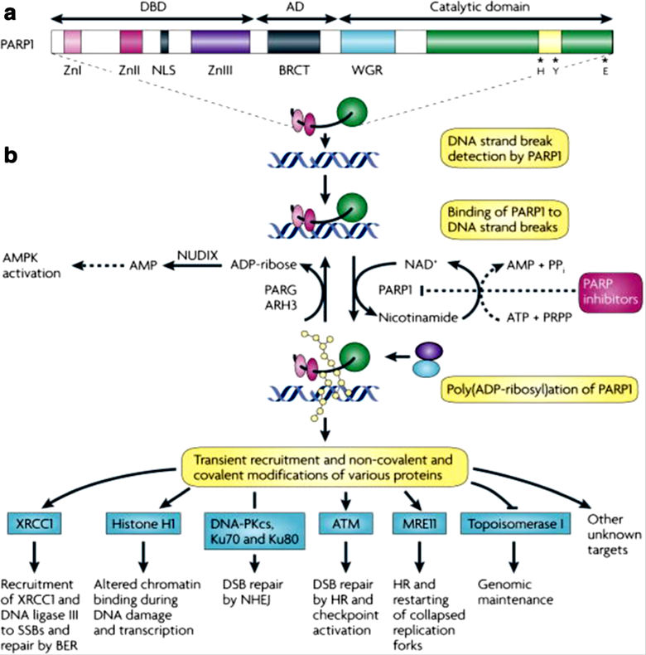
Figure 18: a) "Structure of PARP1 with its DNA binding domain, automodification domain and catalytic domains. Residues for nicotinamide adenine dinucleotide (NAD+) binding is located in catalytic domain (histidine; H and tyrosine; Y) and for polymerase activity (glutamic acid; E). b) PARP1 finde DNA damage through its DNA binding domain. This activates PARP1 to synthesize poly (ADP) ribose (yellow beads) on acceptor proteins such as histones and PARP1. The negative charge of poly (ADP) polymerase chains cause PARP1 to lose affinity for DNA and allows repair proteins by pADPr attach to damaged DNA (blue and purple circles). Poly (ADP-ribose) glycohydrolase (PARG) and possibly ADP-ribose hydrolase 3 (ARH3) hydrolyze pADPr into ADP-ribose molecules and free pADPr. PARP inhibitors prevent the synthesis of pADPr and hinder subsequent downstream repair processes, lengthening the lifetime of DNA lesions".
Role of PARP in BER pathway:
The mostly accepted function of PRP1 is produces PARP chains and then uses these proteins in base excision repair (BER). Experimental approaches have shown that PARP interacts with protein in the BER pathway. PARP1 can physically interact with single-stranded break repair (SSBR) factor XRCC1 which plays a major role in SSBR signaling pathway. Both proteins interact with each other by their BRCT domains. XRCC1 interact with DNA ligase III via their carboxyl terminal that filing the gap. These interactions suggest that PARP is a part of multi protein complex of BER pathway proteins that include nick sensors (PARP and DNA ligase III), an adaptor factor (XRCC1) and direct mediators of DNA repair (DNA ligase III). Studies on PARP1 demonstrated PARP1 is able to interact with other BER/SSBR factors including oxoguanine glycolylase1 (OGG1), DNA polymerase B, and aprataxin. Many of these factors can be PARylated by PARP1, although PARP2 has also been shown to interact with XRCC1, DNA Pol B and DNA III (100).
To analyze the ability of PARP1 deficient cell to promote DNA repair, scientist use PARP deficient cells and by method of single cell electrophoresis and comet assay, monitored the level of broken DNA in such cells. They treated cells with genotoxins and saw that PARP deficient cell didn’t have ability to rejoin break sites of DNA compared with WT cells (Trucco et al, 1998). All cell extracts from PARP deficient cell line had deficient BER pathway in polymerization step (Oantzer et al, 1999). This experiment suggested that PARP interacts functionally with BER factors.
PARP inhibitor and synthetic lethality:
PARP1 knockout mice are viable but very sensitive to DNA alkylating agents or $γ$-radiation (107). In these cells unrepaired SSBs are converted to DSBs at replication forks and the HR pathway is require to repair DSBs.
Understanding function of PARP1 and PARP2 and their role in DNA repair pathway has led to finding PARP inhibitor molecules. PARP inhibitors are a group of pharmacological inhibitors of PARP. The important concept of using PARP inhibitors in treatment of cancers comes from the term synthetic lethality. Synthetic lethality was first described by Dobzhansky in 1946. This occurs when two conditions independently would not cause cell death, but the combination of them lead to cell death. In cancers with BRCA1/2 deficiency, using PARP inhibitors causes single strand breaks and leads to stalling of replication forks. The inhibition of the BER pathway causes double strand breaks to form. In the absence of functioning HR, this leads to activation of the more error prone NHEJ. The errors and rearrangement that occurred in NHEJ pathway cause genomic instability that cause cell death. Disabling certain NHEJ factors rescues the lethality of PARP inhibition in cell lines with BRCA1 and BRCA2 deficiency (figure 19). Thus, tumors that have defect in HR seem to be sensitive to the effects of PARP inhibitors. MacCabe et al demonstrated via in vitro studies that deficiencies of many proteins in the HR DNA repair pathway cause PARP inhibitor sensitivity. This concept is known as “BRCAness” that describe the phenotype of sporadic cancers that have normal BRCA1/2 but share features like BRCA1/2 mutated tumors (108). One of these proteins is Phosphatase and tensin homolog (PTEN), a common tumor suppressor gene involved in expression of RAD51 and important to HR function. So PTEN deficiency can also lead to cell death in response to PARP inhibitors. Other HR proteins are ATM (ataxia telangiectasia mutated) and ATR (ataxia telagectasia and RAD3-related protein) whose loss leads to HR reduction and PARPi sensitivity (109). Uses of PARP inhibitors in the treatment of cancer has two advantages. The first is that this treatment is targeted therapy so that only the tumor tissue is affected. Secondly toxicity to the patient is reduced. Most people with BRCA mutations have heterozygous abnormality; the tumor is homozygous for BRCA1/2. So PARP inhibitors would provide synthetic lethality selective for the tumor cells. Inhibiting PARP alone may be sufficient for tumor cell death and avoid toxic side effects of chemotherapy and radiation.
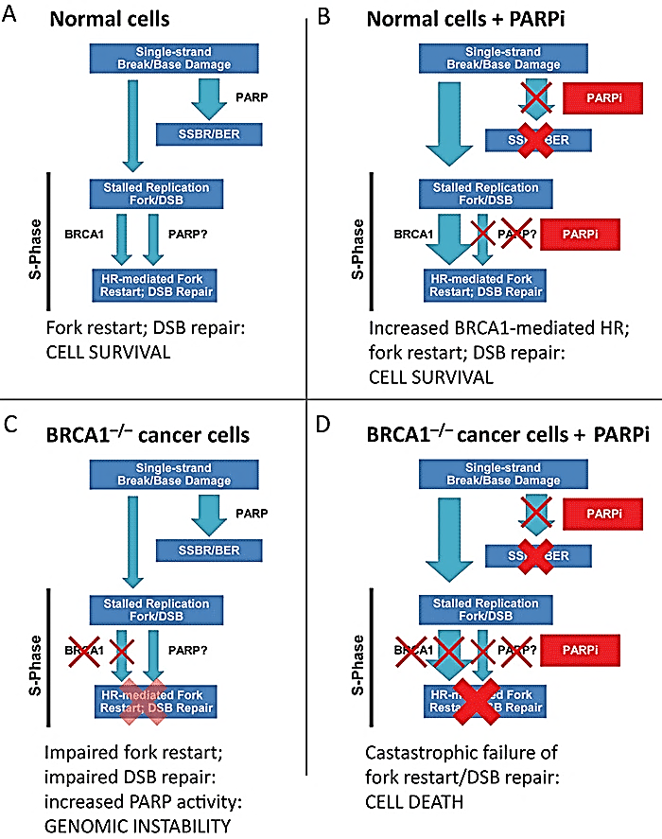
Figure 19: "Synthetic lethality of PARPi with BRCA1−/− cells. A) In normal cells single strand breaks are repaired by PARP. The few unrepaired breaks that lead replication fork arrest and create double strand breaks (DSBs) are repaired by BRCA1 dependent repair. B) In the presence of PARPi, SSBR not be repaired and change to double strand breaks in this time cells repaired double strand breaks by BRCA1 dependent pathway. C) In BRCA1−/− cells homologous recombination mediated repair of stalled replication forks and DSB is impaired. These maybe increase PARP dependent mechanism and increased PARP activity. D) In BRCA1−/− cells treated with PARPi, increased of unrepaired single strand breaks enter S phase. The lesions cannot be repaired because DSB related repair is disable and leading failure of replication fork restart and cell arrest or death"
For test this hypothesis that homologous recombination-deficient cells are sensitive to PARP inhibitors, scientist tested two recombination-deficient cell lines and exposed them to PARP inhibitors like 3-aminobenzamide, 1,5 dihydroxyisoquinoline, and 8-hydroxy-2 methylquinazolinone (NU1025) (110). The result show that both recombination-deficient cells are sensitive to all PARP inhibitors. PARP inhibitors have a cytotoxicity effect on cells lacking BRCA2. Scientists discovered two specific PARP inhibitors (NU1025 and AG14361) that have this effect at low concentration. To test cytotoxicity effect of these two inhibitors on relevant breast cancer cells, they tested them on "MCF7 (wild-type p53) and MDA-MB-231 (mutated p53) human breast cancer cell lines". Results show that after depletion of BRCA2 with siRNA, NU1025 decreased the survival of MCF7 and MDA-MB-231 cells. As a result we can say that BRCA2-depleted breast cancer cells are sensitive to PARP inhibitors.
"About ${10}^{4}$spontaneous SSBs occur in each cell every day". In the absence of PARP1, SSBs convert to DSBs that trigger the formation of $γ$-H2AX and RAD51 that these normally form in response to DSBs in mammalian cells. Scientist treated V-C8 (deficient BRCA2) and V-C8+B2 (BRCA2 complimented) with NU1025 and saw both of them induce $γ$-H2AX (Figure 20b). RAD51 formation were induced in V-C8+B2 cells after treatment with NU1025. This indicates that recombinogenic lesions trigger homologous recombination to repair these cells and allowing them to survive (Figure 20c). BRCA2 deficient V-C8 cells were unable to form RAD51 foci after treated with NU1025 (Figure 20c). As a result the homologous recombination defect, which results in unrepaired recombinogenic lesions cause cell death.
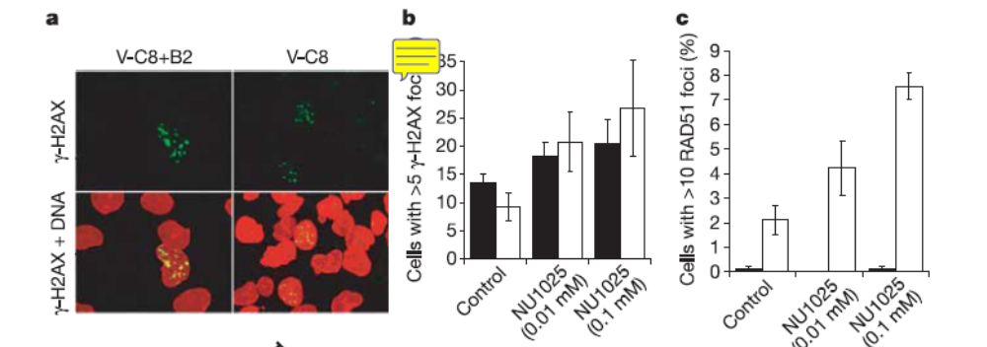
Figure 20: "a) Visualization of g-H2AX foci in untreated V-C8 þB2 and V-C8 cells. b) Number of cells containing RAD51 foci (c) visualized in V-C8þB2 (open columns) and V-C8 (filled columns) cells after a 24-h treatment with NU1025 (10 mM)."
To test the hypopthesis that PARP inhibitors may be useful for specific treatment of BRCA2-deficient tumors, they implanted BRCA2-deficient V-C8 and BRCA2-complimented V-C8+B2 cells in the thigh of 40 CD-1 nude mice (111). They inject two doses of AG14361 in saline for 5 days and measure the amount of tumors. As a result they saw AG14361 had no effect on V-C8+B2 cells in contrast three out of five VC8 cells showed responded to AG14361 treatment and one mouse had no sing of tumor. At the end not all V-C8 cells have same respond to AG14361 but these experiments show that BRCA2-deficient tumors in a xenograft are capacity to treatment with PARP inhibitor AG14361 alone.

Pre-clinical of PARP Inhibitors:
PARP enzymes catalyze transfer of ADP-ribose to donor proteins. This ADP-ribose monomer comes from cellular NAD+ which led the first inhibitors to be analogous structure of NAD+ that cause blocking of NAD+ binding. New research show that some inhibitors especially Rucaparib, Oliparib, Niraparib and talazoparib can trap PARP1 on DNA and preventing auto-PARylation. So PARP1 is not released from the site of damage, interfering with the catalytic cycle of PARP1 (112-113). This mechanism of PARPi to trap PARP1 is analogous to mechanism of action of cancer drugs that inhibit topoisomerase II that also trap DNA repair protein on the DNA. It seems that PARP1 deficient cells resistant to PARPi (112,114). Each PARP inhibitors have differ potential to trap PARP1; talazoparib is 100 times more potent than niraparib in trap PARP1 and niraparib traps PARP1 more potently than olaparib and rucaparib (113). Veliparib has limited ability to trap PARP1 but have ability to inhibit PARylation. This ability of trapping PARP1 rather than their ability to inhibit PARylation is a powerful tool to determine its role in the cytotoxicity of BRCA mutant cells in vitro. It is possible that the ability to trap PARP1 produces toxicity when PARPi is combined with doses of cytotoxic chemotherapies. This feature of PARPi of trapping PARP1 needs to be a consideration when designing combination therapies involving PARPi (115).
Clinical development of PARP inhibitors:
PARP inhibitors have studied as single agents in BRCA1/2 deficient cancers and cancers with reduced “BRCAness” and in combination therapy with other DNA damaging agents like ionizing radiation. In total 9 PARP inhibitors are in various stages of drug development and are in various trials including phase 0 to III trials: Rucaparib, Olaparib, iniparib, Veliparib, Talazoparib, MK4827, CEP 9722, BMN-673, E7016 (Table 1).
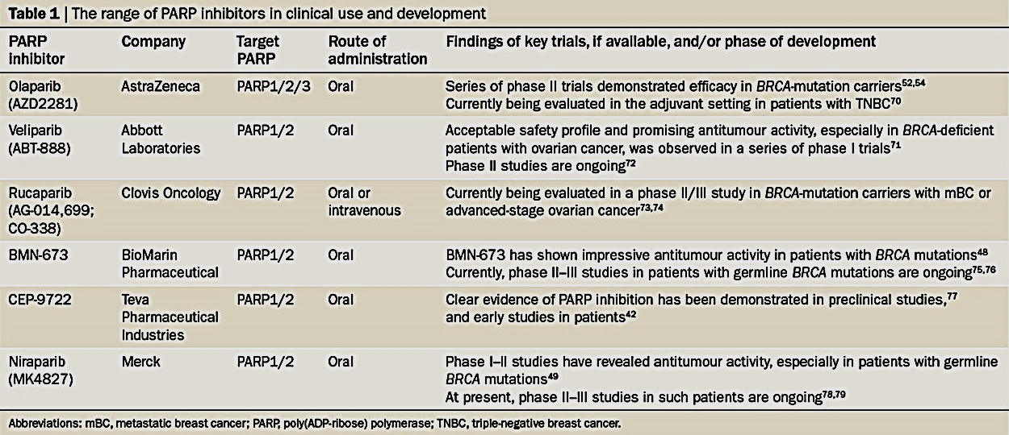Table1: Sonnenblick, A. et al. (2014) An update on PARP inhibitors—moving to the adjuvant setting Nat. Rev. Clin. Oncol. doi:10.1038/nrclinonc.2014.163
The first clinical study of PARP inhibitors began in 2003. They used PARP inhibitors without tumor selection for deficient in DNA repair and used them as chemosensitizers in combination with other cytotoxic agents in variety of pre-clinical models. They found PARP inhibition increased the clinical effect of alkylating agents (Temozolamide), Topoisomerase inhibitors and ionizing radiation (125). In 2005 second clinical study began when the term of “synthetic lethality” was identified as PARP inhibition have negative affect in cells with BRCA mutation background. Bryant et al and farmer et al demonstrated the BRCA deficient cells had more sensitivity to PARP inhibition and restoration of BRCA2 cause resistance to PARP inhibitors. This observation provides strong confirmation for use of PARP inhibitors in patient with BRCA1/2 mutation cancers. Then scientist illustrated that some cancers occurred in result of HR proteins mutations or somatic mutations but share the same phenotype of BRCA1/2 tumors that they called “BRCAness”. For example somatically mutation of BRCA1 or BRCA2 as a result of hyper-methylation of BRCA1 or mutation in other genes that involved in DSB repair and stability of replication forks such as AD51, RAD51, DSS1, RPA1, ATM, CHK2 and PTEN bring cells to be more sensitive to DNA damaging agents and agents inhibits BER mechanism and show sensitivity to PARPi (126,127). Large-scale cancer genome sequencing projects also revealed that somatic mutations in genes involved in HRR occur in a wide variety of tumors (128). Some cancers that show such somatic mutations are high-grade serous ovarian cancer (HGS-OVCa), advanced prostate cancer, pancreatic cancer and triple-negative breast cancer (TNB). These and other cancers with HRR mutations are candidates for testing PARPi efficacy. For identified BRCAness and PARPi sensitive tumors, scientist used molecular approaches that was mutational signature (found the number and type of mutation in a tumor). This approaches identified the genomes of tumor cancer in patients with germline BRCA gene mutations. This pattern of mutations called "scar" and include large scale genomic rearrangements that reflects the defect in DNA repair in absence of HRR over the lifetime of the disease. Similar mutational scars are identified in tumors that did not have BRCA gene mutations that such "BRCAness scars" could be used to predict clinical responses to PARPi or platinum based drugs in patient without germline BRCA mutations (128). Another way to find the HR defective in a tumor cell is measure HRR functionally in tumor such as localization and activity of key DNA repair proteins that are involve in DNA repair process such as RAD51. Use of functional HRR biomarkers has not been tested but this approach is the most effective way for identify BRCAness.
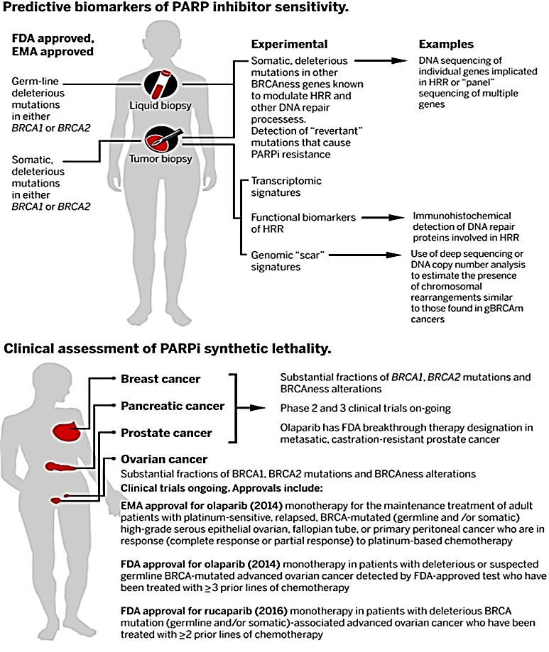
Figure 21: A) Predictive biomarkers of PARP inhibitor sensitivity: FDA and EMA Company approved tests that selected germline or somatic BRCA1 or BRCA2 mutations to identify patients to respond to PARPi therapy. These approaches are estimate the presence or absence of an HRR defect and identification of DNA mutations in BRCAness gens that control tumor cell responses to PARPi. In this approaches they identifying the extent and type of chromosomal alternations in BRCA mutant and BRCAness tumors and also found functional biomarkers that are key proteins involved in HRR and predict the ability to repair of DNA when PARPi induced DNA lesions. B) Clinical assessment of PARPi synthetic lethality: these trials focused on types of tumors which are germline BRCA1 or BRCA2 mutations or either other BRCAness defect. FDA and EMA have recently approved PARPi to be used in ovarian cancer patients with BRCA1 or BRCA2 mutations.
Phase I clinical trial of Olaparib was initiated with patients with BRCA1 or BRCA2 mutations. Olaparib is an oral inhibitor of PARP1, PARP2 and PARP3. It is the first PARP inhibitor that shows activity in BRCA related breast and ovarian cancers. The phase I trial of Olaparib as single agent for treatment BRCA mutation carriers has been published in 2009 that reported by Fong. This trial enrolled 60 patients with solid tumors that 22 of them had BRCA mutation. This study supported synthetic lethality concept. This trial began to distinguish the best dose of Olaparib for treatment. The maximum tolerated dose was established at 400 mg twice a day. Patients with BRCA1and BRCA2 mutation treated with 200 mg Olaparib twice daily and showed positive tolerability with an objective antitumor activity (131). In continues of study they confirmed that PARP inhibitor anti-tumor activity is effective in platinum- resistance disease but sensitivity to PARP inhibitors decrease by raising resistance to platinum (132). In other word resistance to platinum decreases sensitivity to this PARP inhibitor. We can understand the relationship between tumor responses that show resistance to multiple therapies. This observation approved the hypothesis that platinum based drugs and PARPi are target similar molecules.
In 2010 phase II study was done by Fong to compare the effect of Olaparib at the dose 400 mg twice a day to Olaparib at 100 mg twice a day in BRCA1 or BRCA2 ovarian cancer patient. Olaparib was given daily in 28 day cycle to 33 patients at 400 mg BID and 24 patients at 100mg BID. Both groups of patient showed significant antitumor effect with an objective response rate (ORR) of 33% with response duration of 9.5 month at the dose of 400 mg twice a day, an ORR of 13% with response duration of 8.8 month at the dose of 100 mg twice a day. The tolerability and side effect were similar in two these groups. The side effect of nausea, fatigue and anaemia were observed in patients (133). The response rate of germline BRCA mutation ovarian cancer patients was sufficient for the U.S Food and Drug Administration (FDA) to approve Olaparib as treatment for patient with advanced ovarian cancer that received three lines of therapies (134) (figure 21B).
A number of studies were focused on the effect of Olaparib on patients with BRCAness tumors that include Triple Negative Brest cancer (TNBC), High-Grade Serous Ovarian cancer (HGSOvCa) and advanced prostate cancer. In HGSOvCa patient that previously treated with platinum-based chemotherapy, saw the positive effect of Olaparib that reduce the rate of disease recurrence and extend progression free survival (135). These observation led European Medicines Agency (EMA) approved Olaparib as maintenance treatment for BRCA mutant patients with platinum sensitive cancers (high grade serous epithelial ovarian, fallopian tube). In the phase 2 clinical trial 30% of patients showed clinical response to olaparib that half of them had BRCA2 or ATM defects in their tumor (136). TNBC clinical responses to olaparib were multiple, patients with BRCA1/2 mutation tumors showed some disease stabilization but other tumor without BRCA1/2 mutation showed no sustained response. Suggested that BRCAness might be less frequent in TNBC than in diseases such as HGSOvCa (137)
Recently rucaparib has been shown to extend PFS in a maintenance therapy (139). In phase 2 trial they categorized patients into three groups according to their genomic features of their tumors that calculating the chromosomal loss of heterozygosity (LOH) across the genome: 1) BRCA mutation patients with germline or somatic BRCA mutations 2) BRCA wild type with high genomic LOH 3) BRCA wild type with low LOH. BRCA mutant group and high LOH group showed greatest PFS when treatment them by rucaparib (139). The responses of wild type BRCA patients was still below that expected with standard platinum based combination therapy. This clinical result with data of phase II in HGSOvCa have led FDA approval for rucaparib to use in patients with germline or somatic advanced ovarian cancer that treated with two or more chemotherapies (figure 21B). In a recent study, oncologist examined the effect of Talazoparib on breast cancer patients. They collected 13 early stage breast patients with germline mutations in BRCA1 or BRCA2 and treated them with talazoparib for two months before chemotherapy or surgery as a first line of therapy. All patients showed a reduction in tumor volume after two months (140).
Until now oncologist could not say the conclusions of which PARPi are most effective in treatment of particular cancer in each patients. For this decision they need different trial designs and multiple population of patients used to asses different PARPi for direct comparison. But according to biochemical and cellular effect of different PARPi oncologist are beginning to give ideas on how different PARPi might be used clinically. for example talazoparib can kill BRCA mutant cells in vitro at a dose lower than 200 mg that need for olaparib and rucaparib that is because of the power of talazoparib in trapping PARP1 (141). In vitro the therapeutic ratio in BRCA1/2 defective cells in compare to wild type cells for all three PARPi are similar and it is unclear the enhanced trapping ability of talazoparib compared with rucaparib and olaparib will improved therapeutic ratio or not (142). Understanding of which PARPi is the best agent in clinical situation will be informed by future comparison of mature phase 3 clinical outcome data.
PARP inhibitors in combination with cytotoxic therapy:
PARP inhibitors can enhance the effect of chemotherapies. DNA methylating agents such as dacarbazine and temozolomide were discovered to activate PARP1. These agents caused SSB and required BER pathway to for repair it. In this situation PARP1 have resistance to methylayting agents. If PARP inhibitors inhibit the function of PARP1 and PARP 2 and disable BER, the SSBs could not be repaired and turned to DSBs. If HR pathway be turned off cell death occurs. Mismatch repair (MMR) deficient cells do not respond to the DNA methylating agent temozolomide (TMZ). In wild type cells MMR would correct errors in replication or cause replication arrest and cell death. MMR deficient cells can escape from cell arrest and survive. 3aminobenzamide increase the efficiency of TMZ regardless of MMR situation (143). AG14361 a PARP inhibitor enhanced the effect of TMZ in MMR deficient cells (144). Veliparib in combination with TMZ showed slowed tumor progression in rat but telozomide as single agent didn’t show sufficient effect (144). PARP inhibitors can increase the cytotoxicity effect of topoisomerase I inhibitor. Topoisomerase I inhibitors promote DNA breakage because it can cleaves, unwinds and decreases torsional strain of DNA. Studied on ovary cells showed added AG14361 to topoisomerase inhibitors, decreased the lethal concentration (LC50) and the resistance and PARP inhibitors overcome the resistance to topoisomerase inhibition in BER competent cells (146). Resistance to topoisomers inhibitors can develop from overexpression of XRCC1 which is in roll of DNA SSB repair mechanism. PARP inhibition overcomes to this resistance mechanism by interfering with XRCC1 to the DNA break site. In mouse xenograph model, veliparib enhanced the activity of cisplatin and carboplatin in a BRCA deficient cells (144). Preclinical evidence suggests that tumors damaged by alkylating or methylating agents may be more sensitive to the chemotherapy in presence of PARP inhibition.
PARP inhibitors with combination with ionizing radiation:
PARP inhibitors potentiate ionizing radiation by inhibition of BER. Combining ionizing radiation with PARPi, the SSB induced by radiation go unrepaired by PARP of BER mechanism and leading cell death and delay in tumor growth. In BER deficient cells in presence of PARP inhibitors the DSB formed after ionizing radiation. Such cells that have resistance to radiation are treated with radiotherapy (XRT) after exposure with AG14361, this experience showed 73% increase in tumor growth inhibition compare to treatment with radiotherapy alone (148). Another experience on a mouse colon cancer showed that addition veliparib to irradiation increase the life time of mouse from 23 to 36 days. In addition role of PARP inhibitors to inhibiting SSB, it can inhibit DSBs too. PAR requires two zing finger for attached SSBs but only one Zn finger are require for PARP to attached DSBs. Nu 1025 inhibited the repair of DSBs after radiation, by inhibiting NHEJ. DNA-PK is a protein that activates in NHEJ pathway and can stimulate by PARP1 because PARP inhibition decrease the activity of DNA-PK. When the NHEJ pathway is defective, PARP1 is recruited for DSB repair. NHEJ deficient cells that are exposed to radiation have highest chance for cell killing with PARP inhibitors.
PARPi and chemotherapy:
Preclinical studies have been improved that PARPi increase the cytotoxic effects of chemotherapy. PARP is express in all cells, it expression and activity is increased in proliferating cells. Some solid tumors have been found with high level of PARP expression compared with normal cells so PARPi could selective target tumor cells. Preclinical studies have shown that PARP inhibitors can enhance the cytotoxic effect of agents that cause SSBs in DNA such as alkylating agents and topoisomerase inhibitors. Combination trials of PARPi and cytotoxic in vivo showed the great result on patient with BRCA mutation suggesting that this combination therapy have the greater effect on patient with inherent DNA repair defect (149).
Resistance to PARP Inhibitors:
As described above, PARP inhibitors have a selective effect on BRCA1/2 deficient cells and can kill these tumors. Sometimes, however, tumors show resistance to PARP inhibitors. Several factors have a role in such resistance. It is believed that this happens because of HR restoration either dependent or independent of BRCA1. It is possible that this resistance could happen independent of HR restoration.
- Loss of 53BP1 in resistance tumors:
Other factors that can reverse the HR defect in BRCA1-deficient cells are certain NHEJ proteins. For example, if 53BP1 is loss in BRCA1 mutant cells, the HR pathway is reactivated by inducing ATM to attach to broken ends of DNA and produce recombinogenic single-stranded DNA that can repair with HR. However, DNA Ligase 4 deficient cells cannot reverse HR defect in BRCA1 mutant cells. Thus the balance between HR and NHEJ can kill or protect BRCA1 mutant cells.
Evidences showed that BRCA1-deficient mice that don’t have 53BP1 did not develop breast tumors. In this experiment scientist used mice that were deficient for BRCA1-exon11 (${{BRCA}_{1}}^{∆11/∆11})$ (Xu et al., 2001) and compared the result with mice that also lacked 53BP1 (${{BRCA}_{1}}^{∆11/∆11}/{53BP1}^{-/-})$ and in context of ${p53}^{+/-}$ (${{BRCA}_{1}}^{∆11/∆11}/{P53}^{+/-})$. As a result the chromatid exchange rates in (${{BRCA}_{1}}^{∆11/∆11}/{P53}^{+/-})$ cells was 10.7% (Venkitaraman, 2004) and the chromatid exchange in ${{BRCA}_{1}}^{∆11/∆11}/{53BP1}^{-/-}$ cells was 1.0%. Thus the loss of 53BP1 can effect on the ability of Brca1-deficient cells to repair DNA damage.
In another experiment scientists tested on the effect of PARP inhibitors on BRCA1 deficient cells that with or without. The $({{BRCA}_{1}}^{∆11/∆11}/{P53}^{+/-})$ and $({{BRCA}_{1}}^{∆11/∆11}/{P53}^{-/-})$ cells showed more death cells (Farmer et al., 2005) because of the effect of PARPi but in contrast the $({{BRCA}_{1}}^{∆11/∆11}/{53BP1}^{-/-})$ cells showed more survival Brca1 mutant cells in compare to Brca1 mutant cells that had P53. In presence of 53BP1 the amount of DNA broken in Brca1-deficient cells are lower so the effect of PARPi to kill these cells become weaker and they were insensitive to PARPi and continued to their divided. So 53BP1 in Brca1-deficient cells are toxic effect on PARP inhibitors.
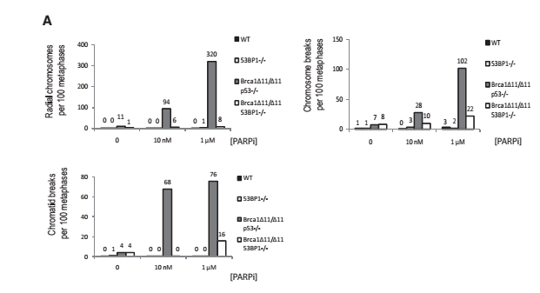
Figure 22: "Analysis of genomic instability in metaphases from B cells treated with 0, 10nM and 1$μM$ PARP inhibitor. Charts show the number of radial chromosomes, chromatid breaks and chromosome breaks per 100 metaphases. Genomic instability in (${{BRCA}_{1}}^{∆11/∆11})$ cells that independent of P53 are equivalent results were seen in $({{BRCA}_{1}}^{∆11/∆11}/{P53}^{+/-})$ and $({{BRCA}_{1}}^{∆11/∆11}/{P53}^{-/-})$ cells."
PARPi increase the genomic instability and increase DSB in s phase of BRCA1-deficient cells in a presence of 53BP1. According to experimented in a ${{BRCA}_{1}}^{∆11/∆11}/{P53}^{-/-}$ cells, the PARPi increased the amount of DSB from 0.1 to 1.8 per cell and the effect of PARPi on this cells caused 20 fold increase in aberrations. In other hand treated ${{BRCA}_{1}}^{∆11/∆11}/{53BP1}^{-/-}$ cells with PARPi showed less genomic instability. The amount of DSB was 0.5 per cells which is 10 fold lower than PARPi treated with ${{BRCA}_{1}}^{∆11/∆11}/{P53}^{-/-}$ cells.
In BRCA1 mutant cells the loss of 53BP1 was restored the HR pathway (Moynahan et al., 1999). For test this hypothesis focused on formation of Rad51 foci that a key molecule for HR pathway and it's impaired in BRCA1 mutant cells (Bhattacharyya et al., 2000; Scully et al., 1997). The result of experiments showed that in ${{BRCA}_{1}}^{∆11/∆11}/{P53}^{+/-}$ cells, 6.8% Rad51 formed although in ${{BRCA}_{1}}^{∆11/∆11}/{53BP1}^{-/-}$ cells the formation of Rad51 was 30% more than that cells and similar to normal cells. In another test scientist focused on the measure of sister chromatid exchange (SCEs) which is depend on Rad51 foci formation. The effect of PARPi on ${{BRCA}_{1}}^{∆11/∆11}/{P53}^{+/-}$ cells was increased radial chromosome formation that is cause HR deficiency. But the effect of PARPi on ${{BRCA}_{1}}^{∆11/∆11}/{53BP1}^{-/-}$ cells was increased of sister chromatid exchange that is lead cells to repair with HR pathway.
Loss of 53BP1 revers the HR pathway in a BRCA1 mutation cells but not rescues the XRCC2-defitiont cells. Because 53BP1 rescue the early stage of HR pathway and XRCC2 is downstream in this pathway (Nagaraju et al., 2009).
Ligase 4 is another NHEJ protein that have important role in this pathway. Scientist search about the effect of loss of Ligase 4 on HR pathway. The result showed that the loss of Ligase 4 could not rescue HR defective pathway like loss of 53BP1. Irradiation induced Rad51 foci formation and in BRCA1-deficent cells that loss 53BP1 and in normal cells was 25% but in BRCA1-deficient cells that loss Ligase 4, the Rad51 foci formed at lower frequency (8%-11%). So 53BP1 and Ligase 4 deficiency can inhibit or remove PARPi-induced radial fusions in BRCA1 mutant cells. Only 53BP1 deficiency could rescue from PARPi induced cell death, chromosomal instability and defect of IR to produce Rad51-foci formation (153).
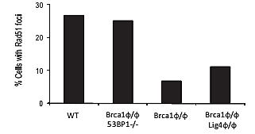
Figure 23:"This Chart showing the percentage of cells with Rad51 foci after ionizing radiation as measured by immunofluorescence."
In HR pathway the MRN complex attach to break sides of DNA and move along them. MRN complex have Mre11/Rad50/Nbs1. MRe11 have endonuclease activity that cause the nucleolytic processing of DSBs to produce ssDNA overhangs that is necessary for HR this process called resection. During resection RPA (replication protein A) attaches to ssDNA overhangs and then RPA phosphorylated and Rad51 by help of Brca1 replace to RPA and form Rad-51 ssDNA nucleofilament.
Loss of 53BP1 has effect on resection process. Scientist done tested on WT, ${53BP1}^{-/-}$Bcells and showed that the level of RPA phosphorylation was higher in ${53BP1}^{-/-}$Bcells. Another test was on the effect of 53BP1 and Lig4 to inhibit RPA phosphorylation in Brca1 mutant cells. They compared the level of phosphorylation in WT,${{BRCA}_{1}}^{∆11/∆11}$,${{BRCA}_{1}}^{∆11/∆11}/{53BP1}^{-/-}$, ${{BRCA}_{1}}^{∆11/∆11}/{Lig}^{-/-}$ cells. The level of phosphorylation decrease in ${{BRCA}_{1}}^{∆11/∆11}$ and ${{BRCA}_{1}}^{∆11/∆11}/{Lig}^{-/-}$ cells to compared with WT. But the phosphorylation of RPA in${{BRCA}_{1}}^{∆11/∆11}/{53BP1}^{-/-}$ cells was near to WT cells. So loss of 53BP1 is able cells to formation ssDNA for RPA phosphorylation and rescue HR process in BRCA1 mutant cells and loss of Lig4 didn't have this effect. The nocleolytic process of DSB that leading RPA coated ssDNA occur by ATM kinase activity. The ATM phosphorylated CtlP and together they mediated the resection and have direct influence on RPA phosphorylation. In absence of 53BP1 in BRCA1 mutant cells, the loss of ATM showed the lower level of RPA phosphorylation. The ${{BRCA}_{1}}^{∆11/∆11}/{53BP1}^{-/-}$ cells that treated with ATMi show the lower level of RPA phosphorylation and the ${{BRCA}_{1}}^{∆11/∆11}/{53BP1}^{-/-}$ cells that had CtlP with short RNA showed impairment of RPA phosphorylation. ATMi reduce the formation of Rad51foci so the loss of 53BP1 could rescue the HR pathway in depend of ATM activity.
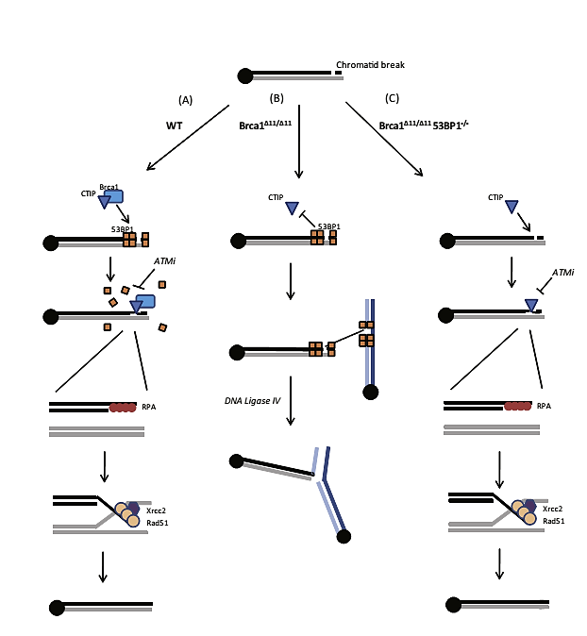
Figure 24: "The chromatid Break in S phase cells; (A) In WT cells, Brca1 displaces 53BP1 from DSBs, enabling resection at the break site by factors such as CtlP, which promotes RPA loading onto single-stranded regions of DNA. RPA is displaced by Rad51, which enables strand invasion at the homologous region of the sister chromatid. Rad51 acts in complex with several effectors of HR, including Xrcc2. leading to error-free, template-directed repair of the double-strand breaks. (B) In${{BRCA}_{1}}^{∆11/∆11}$ cells, 53BP1 is not displaced and inhibits resection. In the absence of resection, the break persists, and if more than one chromatid break is present, these breaks can be joined by a Lig4 dependent NHEJ pathway. Joining of the chromatid breaks produces radial chromosome structures. (C) In ${{BRCA}_{1}}^{∆11/∆11}/{53BP1}^{-/-}$cells, 53BP1 is not present at the double-strand break site, enabling resection even in Brca1-deficient cells. RPA and downstream effectors of homologous recombination are able to load normally at the break site, permitting error-free DNA repair. "
- Rev7 loss in resistance tumors:
Rev7 or (MAD2L2) have major role in BRCA1-independent restoration of HR. Loss of Rev7 in mouse and human cells re-establishes CtlP on DSB and leads to HR-restoration and PARP inhibitor resistance. Rev7 blocks HR and promotes non-homologous end-joining. Rev7 attaches to DSB in a way that depends on H2AX-MDC1-RNF82-RNF168-53BP1.
For analysis role of Rev7 in resistance tumors, scientist used two cell lines KB1P-B11 and KB1P-G3that derived from ${{BRCA}_{1}}^{-/-}{P53}^{-/-}$ mouse mammary tumors. They used two PARP inhibitors, Olaparib and AZD2461. The cells that were treated with Olaparib continuously and eventually showed high concentration of resistant cells but in control dishes the cells were killed. Sequencing of resistant colonies illustrated that their expression of Rev7 was reduced. Scientists tagged Rev7 by green florescent protein (GFP), then they observed after DNA damage occurred Rev7 co-localized with 53BP1. When Rev7 was knocked down, Rad51 foci was reduced. But Rev7 re-expression inhibited Rad51 foci formation (Fig 25) In turn tumors that have resistance to PARP inhibitors showed low Rev7 gene expression.
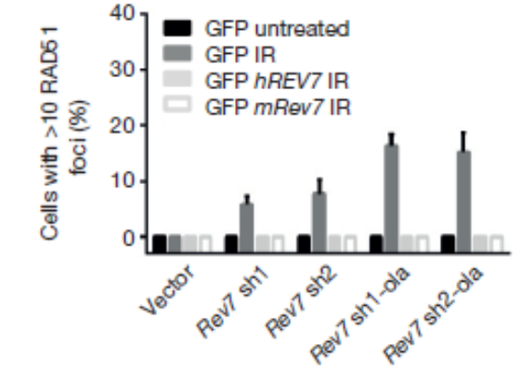
Figure25: "Quantification of RAD51 foci in KB1P-G3 cells (with or without REV7 depletion) transfected with an empty vector (GFP) or vectors containing mouse or human Rev7 or REV7".

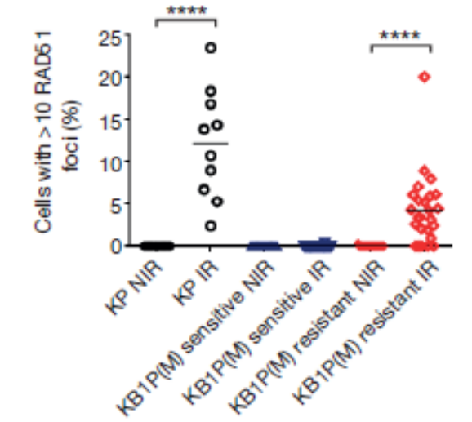
Figure 26: "In situ analysis of RAD51 foci in PARPi-resistant KB1P(M) tumors with low Rev7 gene expression. KP (KP3.33) denotes mouse mammary tumor cell line (p532/2); IR denotes 2 h after 15 Gy ionizing radiation".

Scientists tested the role of ATM in Rev7-depleated cells after DNA damage. They showed that inhibition of ATM can suppress DNA-damage-induced Rad51 foci and increases Olaparib sensitivity. Therefore formation of Rad51 foci after DNA damage in cells that loss Rev7 is depends on ATM activity. In BRCA1 deficient cells, depletion of Rev7 cause cells to show resistance to PARP inhibitors, but in BRCA2 deficient cells this was not seen.
DNA end resection is altered in the absence of Rev7 in BRCA1 deficient cells. RPA is a single strand binding particle that is a marker for generation of single stranded DNA. BRCA1 deficient cells exposed to $α$ particles showed decrease in RPA recruitment compared with BRCA1 proficient cells. Rev7 loss can restore end resection in BRCA1 deficient cells and its depletion can restore HR. Therefore, scientists tested embryonic stem cells with BRCA1 knockout allele (150). Rev7 loss in mES cells with BRCA1 deletion can lead to formation of Rad51 foci upon DNA damage.
Rev7 like 53BP1 promotes repair mechanism to NHEJ of DSBs and causes PARPi resistance. This is because of the inhibitory effect of Rev7 on DNA ends resection.

- Protection of Replication fork in resistance tumors:
Another pathway that causes PARPi resistance in BRCA1/2 deficient cells is the protection of replication fork from degradation, independent from restoration of HR.
The first factor is MLL3/4 protein complex and PTIP. Their deficiency does not restore homologues recombination at double strand breaks; instead the loss of PTIP protects replication fork from MRE11 nuclease to attach to nascent DNA. MRE11 is a key of component of MRN (Mre11-Rad50-Nbs1) complex that plays a role in the restart of stalled replication fork and increases resection at stalled replication fork in BRCA2 deficient cells. The protections of replication fork from degradation can induce resistance of BRCA1/2 deficient cells from DNA damaging agent like PARP inhibitors and cisplatin.
BRCA1/2 deficient cells show degradation of nascent replication tracks. For testing this scientist inactivated BRCA2 in B-lymphocytes and then labeled with Cldu (red) and when active RF were stalled with hydroxyurea (HU) change to Idu (green). The measure of shortening Idu track after treatment with HU showed the RF degradation. After HU treatment wild type cells showed an equal ratio of Idu/Cldu track. But BRCA1/2 deficient B cells showed 30-45% reduction length of Idu track. This RF degradation in B lymphocytes was depending on MRE11 exonuclease activity.
Some factors can regulate MRE11 necessary for regulating DNA end resection during damage (154,155). In other words these factors can function in RF stability and protect RF. To test the role of each of these factors scientists inactivate RIF1, PTIP and 53BP1 in B-lymphocytes. Absence of 53BP1 did not protect BRCA1 deficient B-cells from degradation of RF (figure 27b). Analysis showed that absence of 53BP1 effector Rif1 in BRC1 deficient cells increased genomic instability when treated by HU. Loss of PTIP protected RF from degradation after treated with HU in both BRCA1 and BRCA2 deficient cells. (Figure 27c) BRCA1/PTIP doubly deficient cells showed 2.4 fold fewer chromosomal aberration and increase genomic stability compared with ${{BRCA}_{1}}^{-/-}$ cells (figure 27f). Also the loss of PTIP in BRCA2 deficient cells decreased the amount of chromosomal aberrations upon exposure with HU.
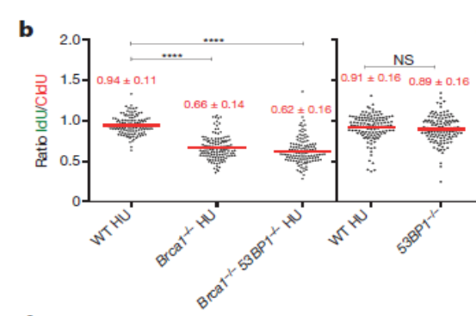
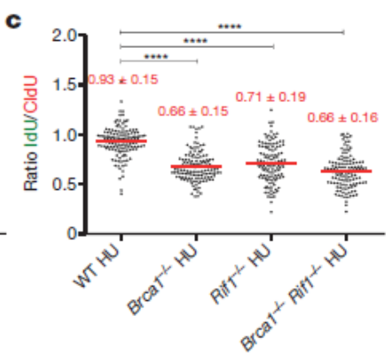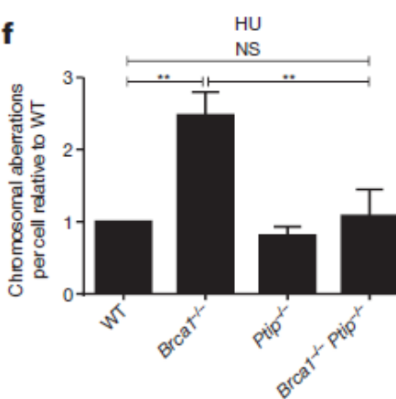
"Figure 27: B,c: Ratio of IdU versus CldU upon HU treatment. One hundred and twenty-five replication forks were analysed for each genotype. f: Genomic instability (top) and viability upon HU treatment (bottom) relative to WT upon 6 h of 10 mM HU treatment. Fifty metaphases were analysed."

In another tested scientists observed the length of Idu track length by exposure to HU across all phenotypes. ${{BRCA}_{2}}^{-/-}$ ${Ptip}^{-/-}$Cells had longer replication track after treatment by HU
(Figure 28). ${{BRCA}_{2}}^{-/-}$ ${Ptip}^{-/-}$ doubly deficient cells restarted normally so loss of PTIP cause RF progression and in BRCA2 deficient cells, restart RF and decrease the RF degradation.
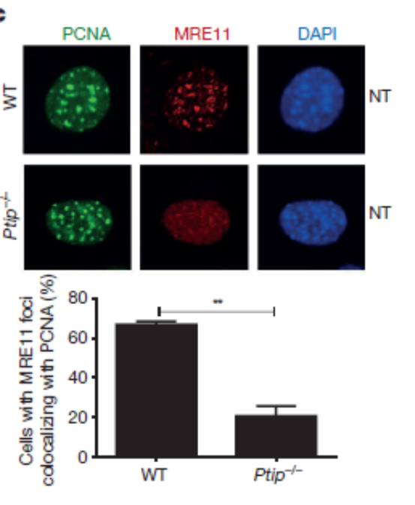
Figure 28: "Co-localization of PCNA (green) and MRE11 (red). Quantification in lower panel (n = 150 cells examined)".
One element that could protect RFs from degradation is stabilization and level of Rad51 filament (156,157). Experiments showed that the Rad51 level were similar in WT,${{BRCA}_{2}}^{-/-}$, ${Ptip}^{-/-}$ and ${{BRCA}_{2}}^{-/-}$ ${Ptip}^{-/-}$ cells. But in ${{BRCA}_{2}}^{-/-}$ ${Ptip}^{-/-}$ cells the ability of Rad51 to localize to site of DNA was impaired. So ${{BRCA}_{2}}^{-/-}$ ${Ptip}^{-/-}$ B cells have defective in formation Rad51 foci but they didn’t see in ${{BRCA}_{2}}^{-/-}$ ${Ptip}^{-/-}$ resistance colonies indicative of defective HR. so loss of Ptip protects RF from degradation and rescue the lethality of BRCA2 deficiency without restoring HR.
Loss of PTIP could decrease of Mre11 association with PCNA foci. Introduction of full length of PTIP into${Ptip}^{-/-}$ cells restored Mre11 co-localized with PCNA in late S-phase (figure 29). When irradiation occur the localization of Mre11 to site of DNA replication is dependent on PTIP.
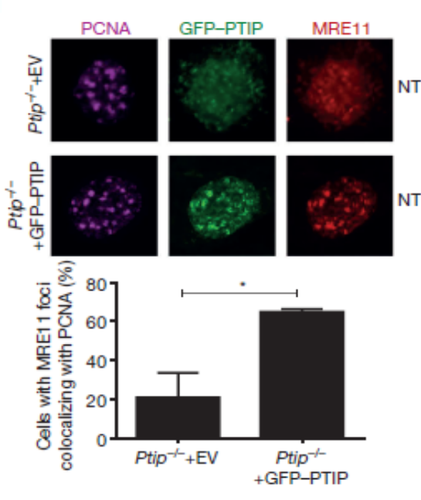
Figure 29:" Ptip−/− MEFs infected with either empty vector (EV, containing IRES–GFP) or full-length PTIP (GFP–PTIP) and probed for GFP (green), MRE11 (red) and PCNA (magenta). Quantification in lower panel (n = 150 cells examined)."
The amount of Mre11 and Rad51 in active and stalled RF measured with iPOND analysis. WT cells showed increase level of Mre11 and Rad51 on stalled RF. PTIP deficiency cells showed an increase in Rad51 at RF but decrease amount of Mre11 upon HU treatment. So localization of Mre11 on newly synthesized DNA is dependent on PTIP (158).
PTIP associated with PA1 and with MLL3/MLL4 histone methyltranferase that catalyze methylation of histone H3 at lysine 4 (159, 160). The establishment of Mre11 at stalled fork is depending on MLL3/4. Mll4 is responsible for degradation of stalled forks in BRCA deficient cells. They observed the fork degradation was not occurred in ${{BRCA}_{2}}^{-/-}$ ${MLL4}^{-/-}$SET cells in presence of PARPi or cisplatin. So methyltransferase activity is important for promoting fork degradation
Different level of PTLP expression could be effect on patient responses to platinum chemotherapy. Analyzes survival resistance colonies showed that Brca2 mutant cells with high PTIP expression in response to platinum have longer survival time. But lower expression of PTIP also protects shorter survival life for Brca2 mutant ovarian cancer cells. So PTIP levels are a biomarker for resistance to platinum chemotherapy in BRCA1/2 mutant ovarian cancer.
Reduce level of CHD4 factor that is nucleus remodeling in BRCA2 mutant cells increase tolerance to DNA damage agents without restoration Rad51-dependant HR (161) and Patient that show poor responses to chemotherapy. For tested this resistance mechanism they knocked down CDH4 in the BRCA4 ovarian cancer cell. CDH4 depletion in these cells didn’t restore HR (161) in contrast it protection to nascent replication tracks from degradation upon HU treatment
(figure 30). Depletion of CHD4 resulted in decreases of MRE11 when treated by HU in BRCA2 mutant cells.
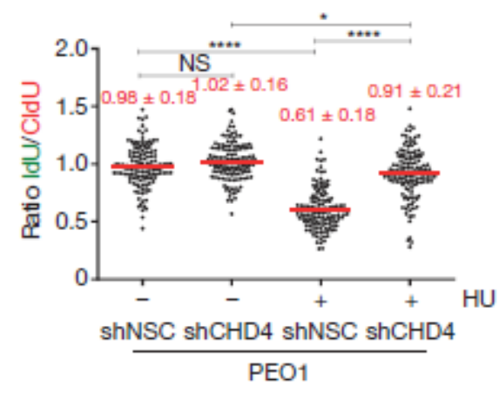
Figure 30: "Ratio of IdU versus CldU in BRCA2-mutated PEO1 cells either mock (shNSC) infected or infected with shRNA against CHD4 (shCHD4) (*P ≤ 0.05, ****P ≤ 0.0001, Mann–Whitney test). One hundred and twenty-five replication forks were analysed".

When Mre11 nuclease activity was inhibited resulted showed the partly of BRCA2 deficient cells protected from cisplatin that induced DNA damage. So MRE11 nuclease promotes genomic instability in BRCA deficient cells.
Mre11 need PARP1 for localization to stalled replication fork and its loss rescues the lethality effect of BRCA2 null ESC (162). Loss of PARP1 protected BRCA1 deficient RF from degradation. The treatment with PARP inhibitors increase the level of DNA damage in BRCA deficient cells but loss of PARP1 before BRCA1 loss protects against genomic instability (163, 164). So we can understand the RF protection is main mechanism for showing resistance in BRCA deficient tumors than restoration of HR.
Evidences showed that reduction in PTLP or PARP1 levels rescues the lethality of BRCA deficiency. Loss of PTLP, PARP1 and CDH4 lead to resistance to a variety of DNA damage agents in BRCA deficient cells and lead drug resistance in such cells. This resistance occurred because of RF protection from degradation by inhibiting access of MRE11 to single strand DNA at stalled replication for. 53BP1 disruption rescues the BRCA deficient mice by restoration HR but the loss of 53BP1 in BRCA1 deficient mice cell showed increase level of RF degradation and genomic instability.
BRCA1/2 is essential genes in all cells so how BRCA1/2-deficient tumors survive and tolerate the lack of BRCA1/2? To answer this question scientist predict that only breast and ovary can tolerate the loss of BRCA1/2 that have second mutations and promote to survival of these cells. For example loss of p53 is essential for BRCA1-deficient cells survived (Holstege et al., 2009; Xu et al., 1999). But in tumors that have deficient in both p53 and BRCA1, they have defective HR and sensitive to PARP inhibitor. Another mutation that cause the survival of BRCA1 deficient tumors is the loss of 53BPP1 that enhance the DSB resection and rescue HR pathway and cell resistant to PARPi. Illustrate showed that the loss of 53BP1 can rescue HR pathway by promoting ATM-dependent resection. In this way ATM inhibitor is a second chemotherapy agent to kill these tumors that have tolerance to PARPi. Another way is independent from HR restoration; it is protection of replication fork that loss of PTLP, PARP1 and CDH4 are the elements of this tolerance.

Chapter 3:
PARP inhibitors in treatment of prostate cancer
Prostate cancer is the most common cancer in men and is the sixth leading cause of death in men. In the United Stated more than 217,000 cases were diagnosed and more than 32,000 deaths occurred in 2010 (165). Recognition of the genetic factors that cause this cancer is a way to identify essential biomarkers in order to improve treatment. Metastatic and Castration-resistant prostate cancer may have genetic mutations in DNA repair pathways. When prostate tumors spread to other parts of the body beyond the prostate by lymphatic system or blood this type of tumor called metastatic. Many men with metastatic prostate cancer have castration-resistant prostate cancer. Many early stage prostate tumor need normal level of testosterone for growth, so scientists have used androgen depletion therapy for treatment of these tumors. However castration resistant prostate cancer does not need testosterone for growth. This advanced tumor shows resistance to testosterone suppression therapy (173). In such type of tumors, oncologists need more potential options for treatment; studies about genetic abnormalities may find new treatments.
Rearrangements or gene fusions of the ETS family of transcription factors are common events in prostate cancer. This discovery by Tomlins et al in 2005 changed the field of solid tumor biology. ETS transcription factors are expressed in a diverse array of cancers including prostate, breast, melanoma and Ewing's sarcoma. The ETS family consist of 28 unique genes that include ERG, FLI1, and ETV1. ETS gene fusions result in altered expression of the ETS proteins. ERG is an oncogene and the predominant ETS gene involved in prostate cancer. The fusion of ERG and TMPRSS2 is the most common genomic alternation in prostate cancer. Other ETS transcription factors have less frequency in prostate cancer. TMPRSS2 is an androgen-regulated gene that is expressed in prostate cancer. In 2005 the overexpression of ERG in prostate cancer was observed (Petrovics et al. 2005). The mechanism of this overexpression is based on rearrangement between the first exon of TMPRSS2 and ERG oncogenes (figure 31; Tomlins et al., 2005). Now scientists believe that half of prostate cancers have TMPRSS2-ERG gene fusion as the most genomic alternation (Kumar-Sinha et al., 2008). TMPRSS2 is located on chromosomal at 21q22 and ERG is in the same orientation on 21q22 at a distance of 3Mb (Figure 31). The fusion of the first exon(s) of TMPRSS2 to the coding sequence of ERG causes the androgen-regulated overexpression of ERG. ETS proteins have a DNA binding domain that can regulate transcriptional initiation from a variety of cellular and viral gene promoters to increase cell invasion. The overexpression of ETS transcriptional proteins such as ETV1, ETV4, ETV5, and ERG can lead cell to cancer through different mechanisms. Scientists observed the overexpression of ERG lead to prostate cancer in mouse with deletion of tumor suppressor PTEN (Corver et al., 2002; King et al., 2009). In other experiments they forced overexpression of ERG and androgen receptor gene in mouse prostate epithelium cells and observed these cells to change to invasive prostate epithelium (Zong et al., 2009). This evidence showed that ERG rearrangement can function to promote prostate cancer.
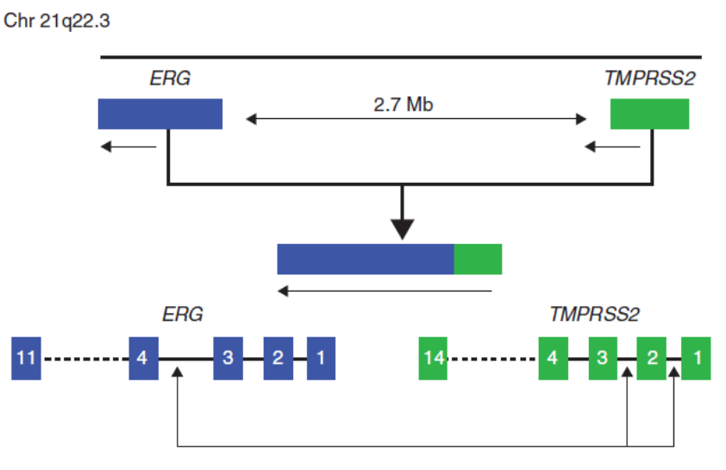
Figure 31: Position of TMPRSS2-ERG fusion on chromosome 21q22.
Scientists identified the protein-protein interactions that may act as therapeutic targets. They used mass spectrometric (MS) to analysis proteins that interact with most ETS gene fusion product, ERG. They used V-CaP prostate cancer cells that harbor a TMPRSS2:ERG rearrangement and human kidney (HEK) 293 cells that infected with adenoviral V5-tagged ERG expression vectors. IP was completed in eight biological replicated to isolate protein- protein interactions. The interaction peptide coverage showed ERG is top scoring protein with 64.4% coverage with 17 tryptic peptides and the next interacting protein is DNA-dependent protein kinase complex that include the large catalytic subunit of a Phosphatidyl inositol 3/4 kinase (PI3/4 kinase), with 10% coverage. Two proteins are attached to DNA-dependent protein kinase through catalytic subunit, KU70 (26% coverage) and KU80 (34% coverage) (figure 32). Another protein to interact with ERG is PARP1. Two peptides of PARP1 were identified: VVSEDFLQDVSAST and QQVPSGESAILDR. PARP1 endogenously associated with ERG in V-cap prostate cancer cells. V-cap cells are a prostate cancer cell line that established from prostate cancer tissue and harvested from a metastatic lesion to a lumber vertebral body of patient with prostate cancer. This cell line is used as a model system of human prostate cancer (Korenchuk et al., 2001).
DNA-PKcs only binds to DNA via Ku80 and Ku70 in the presence of DNA (spagnolo et al., 2006). Scientist tested the dependence of the ERG:PARP1 and ERG:DNA-PKcs interactions in presence of DNA by added 100mM ethidium bromide. This exposure disrupted the intraction between ERG, Ku70 and Ku80 but not the interactions between ERG and PARP1 or DNA-PKcs. As evidences showed the interactions between ERG:PARP1 and ERG:DNA-PKcs are DNA independent. ETS gene mediated transcription and cell invasion require PARP1 and DNA-PKcs expression and activity. ERG-PARP1 and ERG:DNA-PKCs interactions occur in human prostate cancer tissue. This result came from the ERG-IP that showed enrichment of DNA-PKCs, KU70, KU80 and PARP1 in ERG gene fusion positive prostate cancer but not in ETS- fusion negative cells.

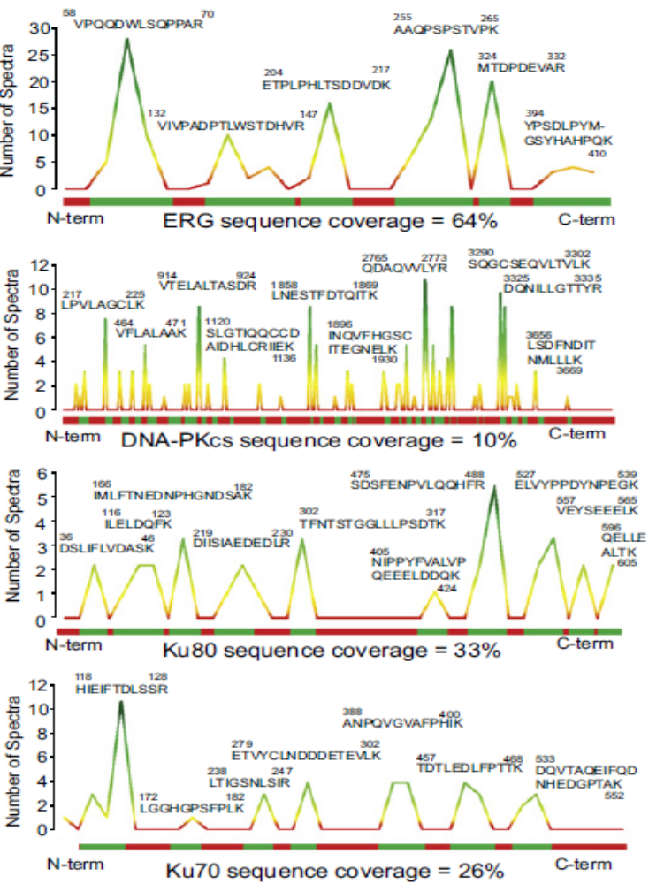
Figure 32: MS analysis of protein interacting with ERG. Peptide coverage of ERG, DNA-PCKs, KU80 and KU70
Inhibition of PARP1 and DNA-PKcs led to decrease of ERG mediated transcription. Inhibition of PARP1 led to decrease xenograft growth of ETS positive cancer but did not affect ETS negative cancer xenograft growth. In such prostate cancer cells the over-expression of TMPRSS2-ERG fusion induces DNA damage, causing PARP1 activation. For testing the effect of inhibiting PARP1 and DNA-PKcs on the ERG transcription, they analyzed two cell lines of ETS-positive (LNcap) and ETS-negative (PC3) treatment them by Olaparib; Olaparib blocked the formation of liver metastases from LNcap but not PC3 cell line. Additionally they realized over the treatment period the ETS-positive tumors are become smaller than ETS-negative tumors. This experiment suggested that PARP1 may have a role in the long-term maintenance of ETS-positive cancer cell survival. The long-term ETS over-expression decreased by treatment Olaparib. Scientists compared the effect of Olaparib on ETS positive cells with BRCA1 mutation and ETS positive cells without BRCA1/2 mutations. Two cell lines were taken and both of them had ETS positive cells; HCC1937 (BRCA1 mutant) and MDA-MB-231 (BRCA1/2 WT) cell lines. They noticed the effect of Olaparib on HCC1937 cell line was equivalent to effect of Olaparib on ETS positive prostate cancer xenograft growth but Olaparib not have measurable effect on the MDA-MB-231 cell line (Figure33).
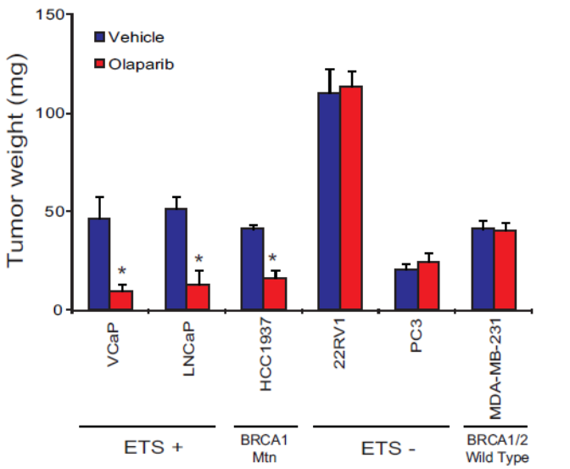
Figure 33: ETS-positive (VCap, LNCap) and ETS-negative (PC3, 22RV1) prostate cancer cells and BRCA mutation (HCC1937) and BRCA1/2-WT (MDA-MB-231) breast cancer cells. These cell lines were treated by 40 mg/Kg Olaparib for 8 days. Average tumor weight for each cell line calculated and shown.
Oncologists could further the hypothesis that Olaparib specifically alters the growth of ETS-overexpressing or BRCA1/2 deficient cell lines. They extended the treatment to identified combination therapy without causing toxicity, alkylating agent called Temozolomide (TMZ) that it had potency with other PARP inhibitors in several cancer xenograft models (Donawho et al., 2007; Liu et al., 2008; Palma et al., 2009). The result of combination treatment was reduction growth of Vcap tumors that was maintained over 6 weeks (Figure 34). In this combination therapy at this dosage they did not observe overt toxicity such as weight loss and this suggested that addition PARP inhibitors to chemotherapy will help enhance the overall effect on ETS-positive tumors.
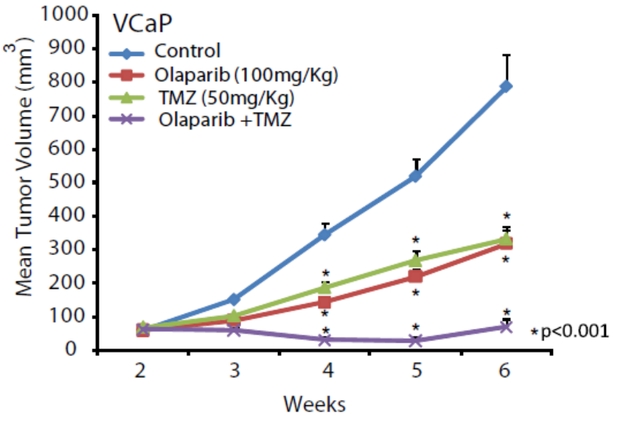
Figure 34: Mice xenografted with Vcap cells that treated with 100mg/Kg Olaparib and 50mg/Kg TMZ and combination of both of them. The volumes of tumor were shown after 6 week treatment.
Scientists hypothesized that overexpression of ERG may cause increased level of DNA damage. At first they evaluated the levels of histone mark of DNA double strand breaks that called
γ-H2AX in Olaparib treated cells compared to untreated VCap cells. The untreated cells had a high level of γ-H2AX foci (figure 35A). In addition they tested if the overexpression of ETS genes can induces DNA double strand breaks. Over-expression of ETS genes in primary prostate cancer cells induced γ-H2AX foci in more than 75% of analyzed cells, but the control genes LACZ (ETS-negative) and HZH2 did not have this effect (figure 35A & B). On the other hand other ETS genes were also capable of inducing γ-H2AX foci in different prostate cell lines. For confirm that ERG induces γ-H2AX foci, they depleted ERG by RNA interference and found measurable decreases in the average number of γ-H2AX foci. γ-H2AX is one element that represents in early DNA damage recognition, and 53BP1 is present in later stages of repair. As DNA damage occur the level of 53BP1 foci increases so ETS genes also induced 53BP1 foci formation (figure 35A-B). Analysis confirmed the overexpression of ERG or ETV1 was sufficient to induce γ-H2AX and 53BP1 levels. They hypothesized that the ETS positive cancer cells can be eliminated by inhibition of the DNA repair enzyme, PARP1. For tested this hypothesis they used VCap cells treated with Olaparib for 48hr. After treatment Vcap cells showed very high level of γ-H2AX foci. A similar increase in foci was observed in PC3-ERG cells and PC3 cells with BRCA2 deficiency but not in control cells. This demonstrated that PARP inhibitors such as Olaparib lead ETS-positive cells to create more double strand breaks, and like BRCA 1/2 deficient tumors, ETS-positive prostate cancer models are sensitive to PARP inhibition (Figure 35c). To test the mechanism of how ERG induces DNA damage, they exposed cells to Olaparib after 0.5, 1, 24, 48 hours and used COMET assays to show that the amount of DNA damage observed in PC3-ERG cells equal to PC3-LACZ as early as 30 min after exposed. They suggested the ERG induced DNA damage is independent of the genes regulated by PARP1 mediated transcriptional activation. The expression of genes involved in DNA damage repair pathway did not show any significant changes; therefore DNA damage is independent of changes to ERG-regulated gene expression. To analyze the role of repair pathways they tested proteins that act in NHEJ pathway like XRCC4. Down regulation of XRCC4 can induce DNA damage in HR deficient cells, so they treated HR deficient HCC1937 with XRCC4 siRNA, resulting in increased DNA damage. In contrast induction of DNA damage in PC3-ERG cells with knockdown of XRCC4 or XRCC3 was not observed as compared with PC3-LACZ cells. They suggested that ERG overexpression cannot block double strand break repair pathway completely and HR deficiency assays confirmed that HR is not completely altered by ERG overexpression.
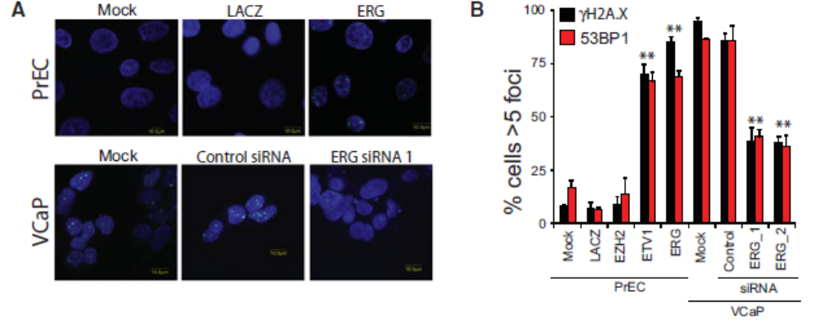
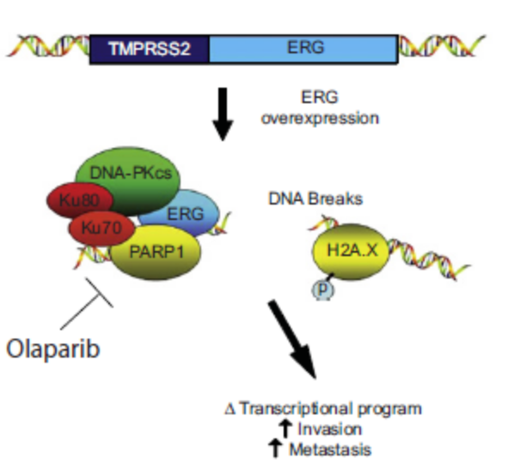
Figure 35: A) g-H2A.X immunofluorescence staining shows that ERG induces the formation of g-H2A.X foci. Top row shows benign PrECs were infected with lentiviruses expressing LACZ or ERG. Bottom row illustrates VCaP cells treated with control siRNA or ERG siRNA. (B) Quantification of g-H2A.X and 53BP1 immunofluorescence staining in PrEC or VCaP cells. (C) Proposed model to therapeutically target ETS gene fusions via their interacting enzyme, PARP1.
Evidence showed that men with metastatic prostate cancer that have DNA repair gene mutations and thus are responsive to PARP inhibitors and platinum-based chemotherapy (169,170). The amount of germline DNA repair gene mutations among men was low. Recently, scientists analyzed the somatic mutations that occur in metastatic prostate cancer with whole-exome sequencing of metastatic tumors (171). Sequenced germline DNA exomes from these men showed 8% carried pathogenic germline mutation in DNA repair genes, so men with metastatic prostate cancer can have heritable defects in DNA repairs. Oncologists analyzed 692 men with whole exome sequencing or targeted next generation sequencing assays and showed 82 (11.8%) had at least one pathogenic germline mutation in a DNA repair genes. The 84 men that have germline mutation included 79 truncating mutations and 5 missense mutations. These mutations identified in 16 different genes including BRCA2 (44%), ATM (13%), CHEK2 (12%), BRCA1 (7%), RAD51D (4%), and PALB2 (4%) (Figure 36). Scientists did not find a relationship between germline DNA- repair gene mutations and age of diagnosis or race. Mutations of these genes can affect sensitivity to PARP inhibitors, thus recognition of mutations in other DNA repair or transcription factor genes could expand the patient population that could benefit from therapy.
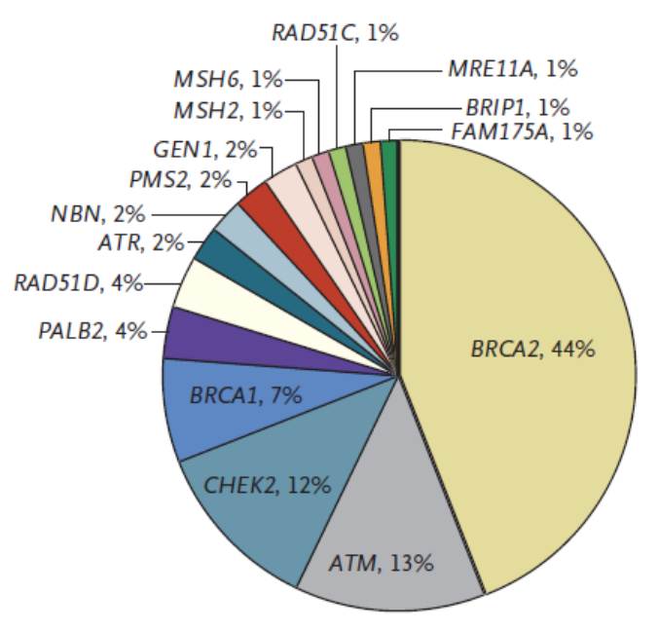
Figure 36: mutations in DNA repair proteins in prostate cancer in selected population.
Previous work on PARP inhibitors proved that PARP inhibitors can induce cell death in BRCA deficient tumors that harbor DNA-repair defects. Scientists now demonstrate that PARP inhibitors can also inhibit ETS gene fusion protein activity by preventing ETS transcriptional activity thus inhibiting ETS-mediated-invasion and enhancing ETS-mediated DNA damage. The ability of ETS fusion to induce DNA damage by PARP inhibition is similar to lethality of PARP inhibition in BRCA1/2 deficient tumors, which is of clinical interest. Studies on prostate cancer have shown that 15-35% of metastatic castration-resistant prostate cancers contain DNA repair defects including BRCA gene mutations. This information suggests that these patients may be sensitive to PARP inhibitors such as Olaparib. Olaparib responses specifically to patients with tumors that have DNA damage repair gene alternations. Oalaprib therapy is also well-tolerated. The phase III clinical trials of Olaparib are being planned, and if previous results are confirmed the FDA could approve Olaparib for treatment of prostate cancer. The phase I of Niraparib published in 2013 that focused on the relationship between PTEN loss in prostate cancer and tumor response. Niraparib showed good tolerability and clinical responses in both BRCA mutation patients and sporadic cancers. Trials for studying PARP inhibitors in treatment of prostate cancer are ongoing this year, comparing olaparib alone or olaparib with abiraterone (hormone therapy drug) in metastatic CRPC.
The observation that gene fusions cause overexpression of ETS genes and induce DNA double strand break formation inform how ETS gene fusions drive cancer progression. PARP inhibitors are promising approaches to be used to treat prostate cancer and other solid tumors with specific molecular features. Use of PARP targeted therapy before, after, with or in place of standard hormonal therapies and chemotherapies will need to be defined that give us information about maximized antitumor effect and patient survival.

Conclusion and future prospect:
PARP inhibitors have showing promising activity in both monotherapy and in combination with chemotherapy in BRCA1/2 mutated cancers. Recently this concept has been experienced in sporadic high grade serous ovarian cancers and TNBCs. According to research about the effect of PARP inhibitors on breast and ovarian cancer, we can appreciate that PARP inhibition may be feasible, but only in patients with the proper biomarker status. This biomarker can be deficiency of HR proteins. Some of the possible HR deficiencies include PTEN defects, ATM abnormalities, RAD51 inactivation, EMSY defects and TNKS abnormalities. Researcher tries to find more biomarkers in tumors that are more responsive to PARP inhibitors for example the abnormalities in HR dysfunction and gene profiling that we identify as BRCAness. Also observation of resistance to PARP inhibitors by genome analysis might select the best candidate with more susceptibility to PARP inhibitor treatment. For this area more investigation is needed to overcoming resistance. The approval of Olaparib in Europe and metastatic setting in the US for patients with BRCA mutations in ovarian cancer open the way for more trials. Trials in progress for identify additional population that may have deficiency in HR pathway and will give benefit from PARP inhibitors. Another area of PARP inhibitors is combination them with chemotherapy, radiation and cytotoxic agents that rise up the effective of PARP inhibitors in patients and overcome to resistance. Trials are undergoing to recognize agents that impair the DNA damage repair pathway like Veliparib and dinaciclib that creating synthetic lethality without need of selection of patients (172). The synthetic lethality concept of BRCA and PARPi discovered more than 10 years. Now according on preclinical studies and trials, PARPi is a very powerful area for research in oncology. With multiple trials underway, oncologist optimism PARPi will be approval for multiple cancers. Some areas of PARP inhibitors need more investigation in future, one of them is which PARP inhibitors kill or inhibit tumor cells in each patient that this information can give by biomarkers that characterize each patient. Another area is overcome to resistance that can be achieved by identifying the mechanisms that cause PARPi resistance and biomarkers that shows it. Understanding of combination therapy that which drug combination has antitumor effects and identifying biomarkers for PARPi combination therapy responses. PARPi is a new class of agent that has many possibilities for developments and its important tool in fight against cancer.

Refrences:
1- Ripperger T, Gadzicki D, Meindi A, Schlegelberger D. Breast cancer susceptibility: Current knowledge and implications for genetic counseling. Eur J Hum Genet. 2009; 17: 722-731.
2- Fackenthal JD, Olopade OI. Breast cancer risk associated with BRCA1 and BRCA2 in diverse populations. Nat Rev Cancer. 2007; 7: 937-948.
3- King MC, Marks JH, Mandell JB; New York Breast Cancer Study Group. Breast and ovarian cancer risks due to inherited mutations in BRCA1 and BRCA2. Science. 2003; 302: 643-646.
4- John C Schmitz and Edward Chu (Jan 2011). Effects of small interfering RNA 3’-end overhangs on chemosensitivity to thymidylate synthase inhibitors. PMCID: PMC3035029
5- Alberts B, Johnson A, Lewis J, Raff M, Roberts K, Walter P (2008). Molecular Biology of the Cell (5th ed.). Garland Science. p. 303. ISBN 978-0-8153-4105-5
6- Marcie K. Weil, M.D. and Alice Chen, M.D. PARP Inhibitor Treatment in Ovarian and Breast Cancer. Introduction. Paragraph 3. (2011) PMC3063418
7-Murai J, Huang SY, Das BB, Renaud A, Zhang Y, Doroshow JH, et al. Trapping of PARP1 and PARP2 by clinical PARP inhibitors. Cancer Res. 2012;72:5588–99. doi:10.1158/0008-5472.CAN-12-2753.
8. E Levy-Lahad and E Friedman. Cancer risks among BRCA1 and BRCA2 mutation carriers; Brest and Ovarian Cancer Risk in Women, British Journal of Cancer (2007) 96, 11 – 15
9. Piri L. Welcsh Mary-Claire King. BRCA1 and BRCA2 and the genetics of breast and ovarian cancer. Human Molecular Genetics, Volume 10, Issue 7, 1 April 2001, Pages 705–713.
10. Miki T., Bottaro D.P., Fleming T.P., Smith C.L., Burgess W.H., Chan A.M., Aaronson S.A. Determination of ligand-binding specificity by alternative splicing: two distinct growth factor receptors encoded by a single gene. Proc. Natl Acad. Sci. USA. 1992;89:246–250.
11. ElShamy W.M., Livingston D.M. Identification of BRCA1-IRIS, a BRCA1 locus product. Nature Cell Biol. 2004;6:954–967. [PubMed]
12. Wilson C.A., Payton M.N., Elliott G.S., Buaas F.W., Cajulis E.E., Grosshans D., Ramos L., Reese D.M., Slamon D.J., Calzone F.J. Differential subcellular localization, expression and biological toxicity of BRCA1 and the splice variant BRCA1-delta11b. Oncogene. 1997;14:1–1 [PubMed]
13. Thakur S., Zhang H.B., Peng Y., Le H., Carroll B., Ward T., Yao J., Farid L.M., Couch F.J., Wilson R.B., et al. Localization of BRCA1 and a splice variant identifies the nuclear localization signal. Mol. Cell Biol. 1997;17:444–452. [PMC free article] [PubMed]
14. Xu X., Weaver Z., Linke S.P., Li C., Gotay J., Wang X.W., Harris C.C., Ried T., Deng C.X. Centrosome amplification and a defective G₂-M cell cycle checkpoint induce genetic instability in BRCA1 exon 11 isoform-deficient cells. Mol. Cell. 1999;3:389–395. [PubMed]
15. Paterson J.W. BRCA1: a review of structure and putative functions. Dis. Markers. 1998;13:261–274.
16. Venkitaraman A.R. Cancer susceptibility and the functions of BRCA1 and BRCA2. Cell. 2002;108:171–182.
17. Brodie S.G., Deng C.X. BRCA1-associated tumorigenesis: what have we learned from knockout mice? Trends Genet. 2001;17:S18–S22.
18. Deng C.X. Tumorigenesis as a consequence of genetic instability in Brca1 mutant mice. Mutat. Res. 2001;477:183–189.
19. KinzlerK. W., VogelsteinB. Cancer-susceptibilitygenes. Gatekeepers and caretakers. Nature. 1997;386:761–763.
20. Qian Wu, Atanu Paul, Dan Su, Shahid Mehmood, Tzeh Keong Foo, Takashi Ochi, Emma L. Bunting, Bing Xia, Carol V. Robinson, Bin Wang, and Tom L. Blundell. Structure of BRCA1-BRCT/Abraxas complex Reveals Phosphorylation-Dependent BRCT Dimerization at DNA Damage Sites. 2016: Molecular Cell 61, 434–448

21. Hollander, M.C., Sheikh, M.S., Bulavin, D.V., Lundgren, K., Augeri-Henmueller, L., Shehee, R., Molinaro, T.A., Kim, K.E., Tolosa, E.,
Ashwell, J.D. et al. (1999) Genomic instability in Gadd45a-deficient mice. Nat. Genet., 23, 176–184.
22. Harkin, D.P., Bean, J.M., Miklos, D., Song, Y.H., Truong, V.B., Englert, C., Christians, F.C., Ellisen, L.W., Maheswaran, S., Oliner, J.D. and Haber, D.A. (1999) Induction of GADD45 and JNK/SAPK-dependent apoptosis following inducible expression of BRCA1. Cell, 97, 575–586.
23. Smith, M.L., Ford, J.M., Hollander, M.C., Bortnick, R.A., Amundson, S.A., Seo, Y.R., Deng, C.X., Hanawalt, P.C. and Fornace, A.J. Jr (2000) p53-mediated DNA repair responses to UV radiation: studies of mouse cells lacking p53, p21, and/or gadd45 genes. Mol. Cell Biol., 20, 3705–3714.
24. Hartman, A.R. and Ford, J.M. (2002) BRCA1 induces DNA damage recognition factors and enhances nucleotide excision repair. Nat. Genet., 32, 180–184
25. Takimoto, R., MacLachlan, T.K., Dicker, D.T., Niitsu, Y., Mori, T. and el-Deiry, W.S. (2002) BRCA1 transcriptionally regulates damaged DNA binding protein (DDB2) in the DNA repair response following UVirradiation. Cancer Biol. Ther., 1, 177–186; discussion 187–178.
26. Hwang, B.J., Ford, J.M., Hanawalt, P.C. and Chu, G. (1999) Expression of the p48 xeroderma pigmentosum gene is p53-dependent and is involved in global genomic repair. Proc. Natl Acad. Sci. USA, 96, 424–428.
27. Adimoolam, S. and Ford, J.M. (2002) p53 and DNA damage-inducible expression of the xeroderma pigmentosum group C gene. Proc. Natl Acad. Sci. USA, 99, 12985–12990.
28. Simon A. Gayther and Bruce A.J. Ponder. Clues to the Function of the Tumour Susceptibility Gene BRCA2, Human Cancer Genetics Research Group (1998) 1–8
28. Lomonosov M, Anand S, Sangrithi M, Davies R, Venkitaraman AR.. Stabilization of stalled DNA replication forks by the BRCA2 breast cancer susceptibility protein. Genes Dev 2003; 17:3017-22; PMID:14681210
29. chlacher K, Christ N, Siaud N, Egashira A, Wu H, Jasin M.. Double-Strand Break Repair-Independent Role for BRCA2 in Blocking Stalled Replication Fork Degradation by MRE11. Cell2011; 145:529-42; PMID:21565612
30. Schlacher K, Wu H, Jasin M.. A Distinct Replication Fork Protection Pathway Connects Fanconi Anemia Tumor Suppressors to RAD51-BRCA1/2. Cancer Cell 2012; 22:106-16; PMID:22789542

31. Buisson R, Niraj J, Pauty J, Maity R, Zhao W, Coulombe Y, Sung P, Masson J-Y. Breast cancer proteins PALB2 and BRCA2 stimulate polymerase η in recombination-associated DNA synthesis at blocked replication forks. CellReports 2014; 6:553-64
32. Min J, Choi ES, Hwang K, Kim J, Sampath S, Venkitaraman AR, Lee H.. The breast cancer susceptibility gene BRCA2 is required for the maintenance of telomere homeostasis. J Biol Chem 2012; 287:5091-101; PMID:22187435; http://dx.doi.org/10.1074/jbc.M111.278994
33. Badie S, Escandell JM, Bouwman P, Carlos AR, Thanasoula M, Gallardo MM, Suram A, Jaco I, Benítez J, Herbig U, et al. BRCA2 acts as a RAD51 loader to facilitate telomere replication and capping. Nat Struct Mol Biol 2010; 17:1461-9; PMID
34. Sugiyama, T., Zaitseva, E. M. & Kowalczykowski, S. C. A single-stranded DNAbinding protein is needed for efficient presynaptic complex formation by the Saccharomyces cerevisiae Rad51 protein. J. Biol. Chem. 272, 7940–7945 (1997).
35. Sigurdsson, S., Trujillo, K., Song, B., Stratton, S. & Sung, P. Basis for avid
homologous DNA strand exchange by human Rad51 and RPA. J. Biol. Chem. 276,
8798–8806 (2001).
36. Baumann, P., Benson, F. E. & West, S. C. Human Rad51 protein promotes ATPdependent homologous pairing and strand transfer reactions in vitro. Cell 87,
757–766 (1996).
37. . Carreira, A. et al. The BRC repeats of BRCA2 modulate the DNA-binding selectivity of RAD51. Cell 136, 1032–1043 (2009).
38. Carreira, A. & Kowalczykowski, S. C. BRCA2: shining light on the regulation of DNAbinding selectivity by RAD51. Cell Cycle 8, 3445–3447 (2009).
39. Milner J, Ponder B, Hughes-Davies L, Seltmann M, Kouzarides T.. Transcriptional activation functions in BRCA2. Nature 1997; 386:772-3; PMID:9126734
40. Hughes-Davies L, Huntsman D, Ruas M, Fuks F, Bye J, Chin S-F, Milner J, Brown LA, Hsu F, Gilks B, et al. EMSY links the BRCA2 pathway to sporadic breast and ovarian cancer. Cell 2003; 115:523-35; PMID:14651845
41. Rajagopalan S, Andreeva A, Rutherford TJ, Fersht AR.. Mapping the physical and functional interactions between the tumor suppressors p53 and BRCA2. Proc Natl Acad Sci USA 2010; 107:8587-92; PMID:20421506; http://dx.doi.org/10.1073/pnas.1003689107
42. Scully, R., Chen, J., Plug, A., Xiao, Y., Weaver, D., Feunteun, J., Ashley, T. and Livingston, D.M. (1997) Association of BRCA1 with Rad51 in mitotic and meiotic cells. Cell , 88, 265–275.
43. Scully, R., Chen, J., Ochs, R.L., Keegan, K., Hoekstra, M., Feunteun, J. and Livingston, D.M. (1997) Dynamic changes of BRCA1 subnuclear location and phosphorylation state are initiated by DNA damage. Cell , 90, 425–435.
44. Huber, L.J., Yang, T.W., Sarkisian, C.J., Master, S.R., Deng, C.X. and Chodosh, L.A. (2001) Impaired DNA damage response in cells expressing an exon 11-deleted murine Brca1 variant that localizes to nuclear foci. Mol. Cell Biol., 21, 4005–4015.
45. Wang, Y., Cortez, D., Yazdi, P., Neff, N., Elledge, S.J. and Qin, J. (2000) BASC, a super complex of BRCA1-associated proteins involved in the recognition and repair of aberrant DNA structures. Genes Dev., 14, 927–939.
46. Celeste, A., Petersen, S., Romanienko, P.J., Fernandez-Capetillo, O., Chen, H.T., Sedelnikova, O.A., Reina-San-Martin, B., Coppola, V., Meffre, E., Difilippantonio, M.J. et al. (2002) Genomic instability in mice lacking histone H2AX. Science, 296, 922–927.
47. Wong AK, Pero R, Ormonde PA, Tavtigian SV, Bartel PL.. RAD51 interacts with the evolutionarily conserved BRC motifs in the human breast cancer susceptibility gene brca2. J Biol Chem 1997; 272:31941-4
48. Mizuta R, LaSalle JM, Cheng HL, Shinohara A, Ogawa H, Copeland N, Jenkins NA, Lalande M, Alt FW.. RAB22 and RAB163/mouse BRCA2: proteins that specifically interact with the RAD51 protein. Proc Natl Acad Sci USA 1997; 94:6927-32
49. Carreira A, Hilario J, Amitani I, Baskin RJ, Shivji MKK, Venkitaraman AR, Kowalczykowski SC.. The BRC Repeats of BRCA2 Modulate the DNA-Binding Selectivity of RAD51. Cell 2009; 136:1032-43.
50. Jensen RB, Carreira A, Kowalczykowski SC. Purified human BRCA2 stimulates RAD51-mediated recombination. Nature 2010; 467:678-83.
51. Yang H, Jeffrey PD, Miller J, Kinnucan E, Sun Y, Thoma NH, Zheng N, Chen P-L, Lee W-H, Pavletich NP.. BRCA2 function in DNA binding and recombination from a BRCA2-DSS1-ssDNA structure. Science2002; 297:1837-48.
52. San Filippo J, Chi P, Sehorn MG, Etchin J, Krejci L, Sung P.. Recombination mediator and Rad51 targeting activities of a human BRCA2 polypeptide. J Biol Chem 2006; 281:11649-57.
53. Buisson R, Dion-Côté A-M, Coulombe Y, Launay H, Cai H, Stasiak AZ, Stasiak A, Xia B, Masson J-Y.. Cooperation of breast cancer proteins PALB2 and piccolo BRCA2 in stimulating homologous recombination. Nat Struct Mol Biol 2010; 17:1247-54
54. Zhang F, Ma J, Wu J, Ye L, Cai H, Xia B, Yu X.. PALB2 links BRCA1 and BRCA2 in the DNA-damage response. Curr Biol 2009; 19:524-9.
55. alderon-Garciduenas AL, Ruiz-Flores P, Cerda-Flores RM, Barrera-Saldana HA. Clinical follow up of mexican women with early onset of breast cancer and mutations in the BRCA1 and BRCA2 genes. Salud publica de Mexico. 2005;47(2):110–5
56. Antoniou AC, Casadei S, Heikkinen T, Barrowdale D, Pylkäs K, Roberts J, Lee A, Subramanian D, De Leeneer K, Fostira F, et al. Breast-cancer risk in families with mutations in PALB2. N Engl J Med 2014; 371:497-506.
57. American Cancer Society Cancer Facts & Figures 2013. Atlanta: American Cancer Society; (2013).
58. Susan J. Ramus, Simon A. Gayther. The Contribution of BRCA1 and BRCA2 to Ovarian Cancer. Molecular oncology (2009) 138 – 150, 140 (2.1): Common or founder mutations.
59. M. W. Beckmann, F. Picard, H. X. An et al., “Clinical impact of detection of loss of heterozygosity of BRCA1 and BRCA2 markers in sporadic breast cancer,” British Journal of Cancer, vol. 73, no. 10, pp. 1220–1226, 1996.
60. Easton DF, Ford D, Bishop DT. Breast Cancer Linkage Consortium Breast and ovarian cancer incidence in BRCA1-mutation carriers. Am J Hum Genet. 1995; 56:265–271.
61. J. L.Hilton, J. P. Geisler, J. A. Rathe, M. A. Hattermann-Zogg, B. Deyoung, and R. E. Buller, “Inactivation of BRCA1 and BRCA2 in ovarian cancer,” Journal of the National Cancer Institute, vol. 94, no. 18, pp. 1396–1406, 2002.
62. C. Wang, A. Horiuchi, T. Imai et al., “Expression of BRCA1 protein in benign, borderline, and malignant epithelial ovarian neoplasms and its relationship to methylation and allelic loss of the BRCA1 gene,” The Journal of Pathology, vol. 202, no. 2, pp. 215–223, 2004.
63. B. T. J. Hennessy, K. M. Timms, M. S. Carey et al., “Somatic mutations in BRCA1 and BRCA2could expand the number of patients that benefit from poly (ADP ribose) polymerase inhibitors in ovarian cancer,” Journal of Clinical Oncology, vol. 28, no. 22, pp. 3570–3576, 2010.
64. J. L.Hilton, J. P. Geisler, J. A. Rathe, M. A. Hattermann-Zogg, B. Deyoung, and R. E. Buller, “Inactivation of BRCA1 and BRCA2 in ovarian cancer,” Journal of the National Cancer Institute, vol. 94, no. 18, pp. 1396–1406, 2002.
65. EstellerM, SilvaJM, DominguezG, BonillaF, Matias-GuiuX, LermaE, etal. Promoter hypermethylation and BRCA1inactivationinsporadicbreast and ovariantumors. J NatlCancerInst (2000) 92(7):564–9.doi:10.1093/jnci/ 92.7.564
66. TurnerN,TuttA,AshworthA.Hallmarksof“BRCAness”insporadiccancers. NatRevCancer (2004) 4(10):814–9.doi:10.1038/nrc1457
67. TurnerNC, Reis-FilhoJS, RussellAM, SpringallRJ, RyderK, SteeleD, etal. BRCA1dysfunctioninsporadicbasal-likebreastcancer. Oncogene (2007) 26(14):2126–32.doi:10.1038/sj.onc.1210014
68. RiceJC, OzcelikH, MaxeinerP, AndrulisI, FutscherBW. Methylationofthe BRCA1promoterisassociatedwithdecreasedBRCA1mRNAlevelsinclini- cal breastcancerspecimens. Carcinogenesis (2000) 21(9):1761–5.doi:10.1093/ carcin/21.9.1761
69. Young SR, Pilarski RT, Donenberg T, et al. The prevalence of BRCA1 mutations among young women with triple-negative breast cancer. BMC Cancer 2009
70. M. Esteller, J. M. Silva, G. Dominguez et al., “Promoter hypermethylation and BRCA1 inactivation in sporadic breast and ovarian tumors,” Journal of the National Cancer Institute, vol. 92, no. 7, pp. 564–569, 2000.
71. F. Cai, I. Ge, M. Wang, E. Biskup, X. Lin, and X. Zhong, “Pyrosequencing analysis of BRCA1 methylation level in breast cancer cells,” Tumor Biology, vol. 35, no. 4, pp. 3839–3844, 2013.
72. 4. Wooster, R. et al. Identification of the breat cancer susceptibility gene BRCA2. Nature 378, 789-792 (1995)
73. Lancaster, J.M. et al. BRCA2 mutations in primary breast and ovarian cancers, Nature Genet. 13, 238-240 (1996)
74. 2. Stratton, M.R. & Wooster, R. Hereditary predisposition to breast cancer. Curr. Opin. Genet. Dev. 6, 93-97 (1996).
75. Easton, D. Breat cancer genes – what are the real risks? Nature Genet. 16, 210-211 (1997).
76. Connor, F. et al. Cloning, Chromosomal mapping and expression pattern of the mouse BRCA2 gene. Hum. Mol. Genet. 6, 291-300 (1997)
77. Sharan, S.K & Bradley, A. Murine BRCA2: sequence, map position, and expression pattern. Ganomics 40, 234-241 (1997).
78. 9. Chapman, M.S. & Verma, I.M. Transcriptional activation by Brca1. Nature 382, 678-679 (1996).
79. Milner, J., Pnder, B., Hughes-Davies, L., Seltmann, M. & Kouzarides, T. Transcriptional activation functions in BRCA2. Nature 386, 772-773 (1997).
80. 11. Sharan, S.K. et al. Embryonic lethality and radiation hypersensitivity mediated by Rad51 in mice lacking Brca2, Nature 386, 804-810 (1997).
81. Ludwing, T., Chapman, D.L., Papaioannou, V.E. & Esfstratiadis, A. Targeted mutations of breast cancer susceptibility gene homologs in mice: lethal phenotypes of Brca1, Brca2, Brca1/Brca2, Brca1/P53, and Braca2/P53 nullizygous embryos. Genes Dev. 11, 1226-1241 (1997).
82. Marmorstein LY, Ouchi T, Aaronson SA. The BRCA2 gene product functionally interacts with p53 and RAD51. Proc Natl Acad Sci USA. 1998;95:13869–13874.
83. Connor, F. et al. Cloning chromosomal mapping and expression pattern of the mouse Brca2 gene. Hum. Mol. Genet. 6, 291-300 (1997).
84. 14. Xu, Y. et al. Targeted disruption of ATM leads to growth retardation, chromosomal fragmentation during meiosis, immune defects, and thymic lymphoma. Genes Dev. 10, 2411-2422 (1996).
85. Elson, A. et al. Pleiotropic defects in atacia-telangiectasia protien-deficient mice. Proc. Natl. Acad. Sci. 93, 13084-13809 (1996).
86. Westphal, C.H. et al. Genetic interactions between atm and P53 influence cellular proiferation and irradiation- induced cell cycle checkpoints. Cancer Res. 57, 1664-1667 (1997)
87. Fukasawa, K., choi, T., Kuriyama, R., Rulong, S. & Vande Woude, G.F. Abnormal centrosome amplification in the absence of P53. Science 271, 1744-1747 (1996).
88. 16. Kinzler, K.W. & Vogeistein, B. Gatekeepers and caretakers. Nature 386, 161-763 (1997).
89. Thompson ME, et al. Decreased expression of BRCA1 accelerates growth and is often present during sporadic breast cancer progression. Nat Genet. 1995;9(4):444–450. doi: 10.1038/ng0495-444.
90. M. W. Beckmann, F. Picard, H. X. An et al., “Clinical impact of detection of loss of heterozygosity of BRCA1 and BRCA2 markers in sporadic breast cancer,” British Journal of Cancer, vol. 73, no. 10, pp. 1220–1226, 1996.
91. Nicotinamide mononucleotide activation of new DNA-dependent polyadenylic acid synthesizing nuclear enzyme.CHAMBON P, WEILL JD, MANDEL P Biochem Biophys Res Commun. 1963 Apr 2; 11():39-43
.92. Rouleau M, Patel A, Hendzel MJ, Kaufmann SH, Poirier GGNat Rev Cancer. PARP inhibition: PARP1 and beyond. 2010 Apr; 10(4):293-301.
93. Loseva O, Jemth AS, Bryant HE, Schüler H, Lehtiö L, Karlberg T, Helleday T. PARP-3 is a mono-ADP-ribosylase that activates PARP-1 in the absence of DNA. J Biol Chem. 2010 Mar 12; 285(11):8054-60.
94. Amé JC, Rolli V, Schreiber V, Niedergang C, Apiou F, Decker P, Muller S, Höger T, Ménissier-de Murcia J, de Murcia G. PARP-2, A novel mammalian DNA damage-dependent poly(ADP-ribose) polymerase. J Biol Chem. 1999 Jun 18; 274(25):17860-8.
95. D'Amours D, Desnoyers S, D'Silva I, Poirier GG. Poly(ADP-ribosyl)ation reactions in the regulation of nuclear functions. Biochem J. 1999 Sep 1; 342 ( Pt 2)():249-68.
96. Ahel I, Ahel D, Matsusaka T, Clark AJ, Pines J, Boulton SJ, West SC. Poly(ADP-ribose)-binding zinc finger motifs in DNA repair/checkpoint proteins. Nature. 2008 Jan 3; 451(7174):81-5.
97. Ahel D, Horejsí Z, Wiechens N, Polo SE, Garcia-Wilson E, Ahel I, Flynn H, Skehel M, West SC, Jackson SP, Owen-Hughes T, Boulton SJ. Poly(ADP-ribose)-dependent regulation of DNA repair by the chromatin remodeling enzyme ALC1. Science. 2009 Sep 4; 325(5945):1240-3.
98. Yang YG, Cortes U, Patnaik S, Jasin M, Wang ZQ. Ablation of PARP-1 does not interfere with the repair of DNA double-strand breaks, but compromises the reactivation of stalled replication forks. Oncogene. 2004 May 6; 23(21):3872-82.
99. Andrabi SA, Dawson TM, Dawson VL. Mitochondrial and Nuclear Cross Talk in Cell Death. Annals of the New York Academy of Sciences. 1147:233–241.
100. Fortini P, Pascucci B, Parlanti E, D'Errico M, Simonelli V, Dogliotti E. The base excision repair: mechanisms and its relevance for cancer susceptibility. Biochimie. 2003 Nov; 85(11):1053-71.
101. Hochegger H, Dejsuphong D, Fukushima T, Morrison C, Sonoda E, Schreiber V, Zhao GY, Saberi A, Masutani M, Adachi N, Koyama H, de Murcia G, Takeda S. Parp-1 protects homologous recombination from interference by Ku and Ligase IV in vertebrate cells. EMBO J. 2006 Mar 22; 25(6):1305-14
102. Morrison C, Smith GC, Stingl L, Jackson SP, Wagner EF, Wang ZQ. Genetic interaction between PARP and DNA-PK in V(D)J recombination and tumorigenesis. Nat Genet 1997;17:479–82.
103. Ruscetti T, Lehnert BE, Halbrook J, Le Trong H, Hoekstra MF, Chen DJ, et al. Stimulation of the DNA-dependent protein kinase by poly(ADP-ribose) polymerase. J Biol Chem 1998;273:14461–7.
104. Spagnolo L, Barbeau J, Curtin NJ, Morris EP, Pearl LH. Visualization of a DNA-PK/PARP1 complex. Nucleic Acids Res 2012;40:4168–77.
105. Li M, Lu LY, Yang CY, Wang S, Yu X. The FHA and BRCT domains recognize ADP-ribosylation during DNA damage response. Genes Dev 2013;27:1752–68.
106. Zhang F, Shi J, Bian C, Yu X. Poly(ADP-Ribose) Mediates the BRCA2-Dependent Early DNA Damage Response. Cell Rep 2015;13:678–89.
107. Sugo N, Niimi N, Aratani Y, et al. Decreased PARP-1 levels accelerate embryonic lethality but attenuate neuronal apoptosis in DNA polymerase β-deficient mice. BiochemBiophys Res Commun. 2007 Mar 16;354(3):656–661.
108. Turner N, Tutt A, Ashworth A. Hallmarks of ‘BRCAness’ in sporadic cancers. Nat Rev Cancer. 2004;4(10):814–819.
109. McCabe, Turner NC, Lord CJ, et al. Deficiency in the repair of DNA damage by homologous recombination and sensitivity to poly(ADP-ribose) polymerase inhibition. Cancer Res. 2006;66(16):8109–8115.
110. 2) Bowman, K. J., Newell, D. R., Calvert, A. H. & Curtin, N. J. Differential effects of the poly(ADP-ribose) polymerase (PARP) inhibitor NU1025 on topoisomerase I and II inhibitor cytotoxicity in L1210 cells in vitro. Br. J. Cancer 84, 106–112 (2001).
111. Helen E. Bryant1, Niklas Schultz2, Huw D. Thomas3, Kayan M. Parker1, Dan Flower1, Elena Lopez1, Suzanne Kyle3, Mark Meuth1, Nicola J. Curtin3 & Thomas Helleday1,2- Specific killing of BRCA2-deficient tumours with inhibitors of poly(ADP-ribose) polymerase-916. paragraph2 (2005).
112. .J. Murai, S. Y. Huang, B. B. Das, A. Renaud, Y. Zhang, J. H. Doroshow, J. Ji, S. Takeda, Y. Pommier, Trapping of PARP1 and PARP2 by clinical PARP inhibitors. Cancer Res. 72, 5588–5599 (2012).
113.J. Murai, S.-Y. N. Huang, A. Renaud, Y. Zhang, J. Ji, S. Takeda, J. Morris, B. Teicher, J. H. Doroshow, Y. Pommier, Stereospecific PARP trapping by BMN 673 and comparison with olaparib and rucaparib. Mol. Cancer Ther. 13, 433–443 (2014).
114. S. J. Pettitt, F. L. Rehman, I. Bajrami, R. Brough, F. Wallberg, I. Kozarewa, K. Fenwick, I. Assiotis, L. Chen, J. Campbell, C. J. Lord, A. Ashworth, A genetic screen using the PiggyBac transposon in haploid cells identifies Parp1 as a mediator of olaparib toxicity. PLOS ONE 8, e61520 (2013).
115. R. Krishnakumar, W. L. Kraus, The PARP side of the nucleus: Molecular actions, physiological outcomes, and clinical targets. Mol. Cell 39, 8–24 (2010).
116. Clark JB, Ferris GM, Pinder S. Inhibition of nuclear NAD nucleosidase and poly ADP- ribose polymerase activity from rat liver by nicotinamide and 5' m ethyl nicotinamide [J]. Biochim Biophys Acta, 1971,238(1):82-85.
117. Bauer PI, Buki KG, Hakam A, Kun E. Macromolecular association of ADP- ribosyltransferase and its correlation with enzymic activity [J]. Biochem J, 1990,270:17-26.
118. Fong PC, Boss DS, Yap TA, Tutt A, Wu P, Mergui-Roelvink M, et al. Inhibition of poly (ADP ribose) polymerase in tumors from BRCA mutation carriers. N Engl J Med. 2009;361(2):123–34.
119. Davar D, Beumer J, Hamieh L, Tawbi H. Role of PARP inhibitors in cancer biology and therapy. Curr Med Chem. 2012;19(23):3907
120. Plummer R, Jones C, Middleton M, Wilson R, Evans J, Olsen A, et al. Phase I study of the poly (ADP-ribose) polymerase inhibitor, AG014699, in combination with temozolomide in patients with advanced solid tumors. Clin Cancer Res. 2008;14(23):7917–23.
121. Plummer R, Lorigan P, Evans J, Steven N, Middleton M, Wilson R, et al. First and final report of a phase II study of the poly (ADP-ribose) polymerase (PARP) inhibitor, AG014699, in combination with temozolomide (TMZ) in patients with metastatic malignant melanoma (MM). J Clin Oncol. 2006;24(18S):8013.
122. Yuan Y, Liao Y-M, Hsueh C-T, Mirshahidi HR. Novel targeted therapeutics: inhibitors of MDM2, ALK and PARP. J Hematol Oncol. 2011;4(1):16.
123. Fong P, Boss D, Carden C, Roelvink M, De Greve J, Gourley C, et al. AZD2281 (KU-0059436), a PARP (poly ADP-ribose polymerase) inhibitor with single agent anticancer activity in patients with BRCA deficient ovarian cancer: results from a phase I study. J Clin Oncol. 2008;26(15S):Abstract 5510.
124. Sandhu S, Wenham R, Wilding G, McFadden M, Sun L, Toniatti C, et al. First-in-human trial of a poly (ADP-ribose) polymerase (PARP) inhibitor MK-4827 in advanced cancer patients (pts) with antitumor activity in BRCA-deficient and sporadic ovarian cancers. J Clin Oncol (Meeting Abstracts). 2010;2010:3001.
125. Curtin NJ. PARP inhibitors for cancer therapy. Expert Rev Mol Med. 2005 Mar 15;7(4):1–20.
126. Mita AC, Mita MM, Rocha C, et al. A phase IB trial of iniparib (BSI-201) in combination with carboplatin (C)/paclitaxel (P) in patients with non-small cell lung cancer (NSCLC) J Clin Oncol. 2011;29 (suppl; abstr 7570)
127. Sandhu SK, Wenham RM, Wilding G, et al. First-in-human trial of a poly(ADP-ribose) polymerase (PARP) inhibitor MK-4827 in advanced cancer patients (pts) with antitumor activity in BRCA-deficient and sporadic ovarian cancers. J Clin Oncol. 2010;28:15s. (suppl; abstr 3001)
128. C. J. Lord, A. Ashworth , BRCAness revisited. Nat. Rev. Cancer 16, 110–120 (2016).10.1038/nrc.2015.21pmid:26775620
129. Plummer R, Jones C, Middleton M, et al. Phase I study of the poly(ADP-ribose) polymerase inhibitor, AG014699, in combination with temozolomide in patients with advanced solid tumors, Clin Cancer Res, 2008, vol. 14(pg. 7917-7923)
130. Plummer R, Lorigan P, Evans J, et al. First and final report of a phase II study of the poly (ADP鄄rib ose) polymerase (PARP) inhibitor, AG014699, in combination with temozolomide (TMZ) in patients with metastatic malignant melanoma (MM) [C]. ASCO. Alexandria VA: American Society of Clinical Oncology, 2006:8013.
131. Fong PC, Boss DS, Yap TA, et al. Inhibition of poly (ADP- ribose) polymerase in tumors from BRCA mutation carriers [J]. N Engl J Med, 2009,361(2):123-34.
132. Fong PC, Yap TA, Boss DS, Carden CP, Mergui-Roelvink M, et al. (2010) Poly(ADP)-ribose polymerase inhibition: frequent durable responses in BRCA carrier ovarian cancer correlating with platinum-free interval. J Clin Oncol 28: 2512-2519.
133. Audeh MW, Carmichael J, Penson RT, Friedlander M, Powell B, et al. (2010) Oral poly(ADP-ribose) polymerase inhibitor olaparib in patients with BRCA1 or BRCA2 mutations and recurrent ovarian cancer: a proof-of-concept trial. Lancet 376: 245-251.
134. B. Kaufman, R. Shapira-Frommer, R. K. Schmutzler, M. W. Audeh, M. Friedlander, J. Balmaña, G. Mitchell, G. Fried, S. M. Stemmer, A. Hubert, O. Rosengarten, M. Steiner, N. Loman, K. Bowen, A. Fielding, S. M. Domchek, Olaparib monotherapy in patients with advanced cancer and a germline BRCA1/2 mutation. J. Clin. Oncol. 33, 244–250 (2015).
135. J. Ledermann, P. Harter, C. Gourley, M. Friedlander, I. Vergote, G. Rustin, C. Scott, W. Meier, R. Shapira-Frommer, T. Safra, D. Matei, E. Macpherson, C. Watkins, J. Carmichael, U. Matulonis, Olaparib maintenance therapy in platinum-sensitive relapsed ovarian cancer. N. Engl. J. Med. 366, 1382–1392 (2012).
136. J. Mateo, S. Carreira, S. Sandhu, S. Miranda, H. Mossop, R. Perez-Lopez, D. Nava Rodrigues, D. Robinson, A. Omlin, N. Tunariu, G. Boysen, N. Porta, P. Flohr, A. Gillman, I. Figueiredo, C. Paulding, G. Seed, S. Jain, C. Ralph, A. Protheroe, S. Hussain, R. Jones, T. Elliott, U. McGovern, D. Bianchini, J. Goodall, Z. Zafeiriou, C. T. Williamson, R. Ferraldeschi, R. Riisnaes, B. Ebbs, G. Fowler, D. Roda, W. Yuan, Y.-M. Wu, X. Cao, R. Brough, H. Pemberton, R. A’Hern, A. Swain, L. P. Kunju, R. Eeles, G. Attard, C. J. Lord, A. Ashworth, M. A. Rubin, K. E. Knudsen, F. Y. Feng, A. M. Chinnaiyan, E. Hall, J. S. de Bono, DNA-repair defects and olaparib in metastatic prostate cancer. N. Engl. J. Med. 373, 1697–1708 (2015).
137. K. A. Gelmon, M. Tischkowitz, H. Mackay, K. Swenerton, A. Robidoux, K. Tonkin, H. Hirte, D. Huntsman, M. Clemons, B. Gilks, R. Yerushalmi, E. Macpherson, J. Carmichael, A.Oza, Olaparib in patients with recurrent high-grade serous or poorly differentiated ovarian carcinoma or triple-negative breast cancer: A phase 2, multicentre, open-label, non-randomised study. Lancet Oncol. 12, 852–861 (2011).
138. M. R. Mirza, B. J. Monk, J. Herrstedt, A. M. Oza, S. Mahner, A. Redondo, M. Fabbro, J. A. Ledermann, D. Lorusso, I. Vergote, N. E. Ben-Baruch, C. Marth, R. Mądry, R. D. Christensen, J. S. Berek, A. Dørum, A. V. Tinker, A. du Bois, A. González-Martín, P. Follana, B. Benigno, P. Rosenberg, L. Gilbert, B. J. Rimel, J. Buscema, J. P. Balser, S. Agarwal, U. A. Matulonis, ENGOT-OV16/NOVA Investigators, Niraparib maintenance therapy in platinum-sensitive, recurrent ovarian cancer. N. Engl. J. Med. 375, 2154–2164 (2016).
139. E. M. Swisher, K. K. Lin, A. M. Oza, C. L. Scott, H. Giordano, J. Sun, G. E. Konecny, R. L. Coleman, A. V. Tinker, D. M. O’Malley, R. S. Kristeleit, L. Ma, K. M. Bell-McGuinn, J. D. Brenton, J. M. Cragun, A. Oaknin, I. Ray-Coquard, M. I. Harrell, E. Mann, S. H. Kaufmann, A. Floquet, A. Leary, T. C. Harding, S. Goble, L. Maloney, J. Isaacson, A. R. Allen, L. Rolfe, R. Yelensky, M. Raponi, I. A. McNeish, Rucaparib in relapsed, platinum-sensitive high-grade ovarian carcinoma (ARIEL2 Part 1): An international, multicentre, open-label, phase 2 trial. Lancet Oncol. 18, 75–87 (2017).
140. J. K. Litton, M. Scoggins, D. L. Ramirez, R. K. Murthy, G. J. Whitman, K. R. Hess, B. E. Adrada, S. L. Moulder, C. H. Barcenas, V. Valero, D. Booser, J. S. Gomez, G. B. Mills, H. Piwnica-Worms, B. K. Arun, A pilot study of neoadjuvant talazoparib for early-stage breast cancer patients with a BRCA mutation. Ann. Oncol. 27 (Suppl. 6), vi43–vi67 (2016).
141. J. Murai, S.-Y. N. Huang, A. Renaud, Y. Zhang, J. Ji, S. Takeda, J. Morris, B. Teicher, J. H. Doroshow, Y. Pommier, Stereospecific PARP trapping by BMN 673 and comparison with olaparib and rucaparib. Mol. Cancer Ther. 13, 433–443 (2014). 10.1158/1535-7163.MCT-13-0803pmid:24356813
142. Y. Shen, F. L. Rehman, Y. Feng, J. Boshuizen, I. Bajrami, R. Elliott, B. Wang, C. J. Lord, L. E. Post, A. Ashworth, BMN 673, a novel and highly potent PARP1/2 inhibitor for the treatment of human cancers with DNA repair deficiency. Clin. Cancer Res. 19, 5003–5015 (2013). 10.1158/1078-0432.CCR-13-1391pmid:23881923
143. Liu X, Shi Y, Guan R, Donawho C, Luo Y, Palma J, Zhu GD, Johnson EF, Rodriguez LE, Ghoreishi-Haack N, Jarvis K, Hradil VP, Colon-Lopez M, Cox BF, Klinghofer V, Penning T, Rosenberg SH, Frost D, Giranda VL, Luo Y. Potentiation of temozolomide cytotoxicity by poly(ADP)ribose polymerase inhibitor ABT-888 requires a conversion of single-stranded DNA damages to double-stranded DNA breaks. Mol Cancer Res. 2008 Oct; 6(10):1621-9.
144. Curtin NJ, Wang LZ, Yiakouvaki A, et al. Novel poly (ADP-ribose) polymerase-1 inhibitor, AG14361, restores sensitivity to temozolomide in mismatch repair-deficient cells [J] Clin Cancer Res. 2004;10(3):881–889. [PubMed]
145. Donawho CK, Luo Y, Penning TD, et al. ABT-888, an orally active poly (ADP–ribose) polymerase inhibitor that potentiates DNA-damaging agents in preclinical tumor models [J] Clin Cancer Res. 2007;13(9):2728–2737. [PubMed]
146. Smith LM, Willmore E, Austin CA, et al. The novel poly(ADP-Ribose) polymerase inhibitor, AG14361, sensitizes cells to topoisomerase I poisons by increasing the persistence of DNA strand breaks [J] Clin Cancer Res. 2005;11(23):8449–8457. [PubMed]
147. Bürkle A, Chen G, Küpper JH, et al. Increased poly (ADP-ribosyl)ation in intact cells by cisplatin treatment.
148. Calabrese CR, Almassy R, Barton S, Batey MA, Calvert AH, Canan-Koch S, Durkacz BW, Hostomsky Z, Kumpf RA, Kyle S, Li J, Maegley K, Newell DR, Notarianni E, Stratford IJ, Skalitzky D, Thomas HD, Wang LZ, Webber SE, Williams KJ, Curtin NJ. Anticancer chemosensitization and radiosensitization by the novel poly(ADP-ribose) polymerase-1 inhibitor AG14361. J Natl Cancer Inst. 2004 Jan 7; 96(1):56-67.
149. Kummar S, Ji J, Morgan R, et al. A phase I study of veliparib in combination with metronomic cyclophosphamide in adults with refractory solid tumors and lymphomas. Clin Cancer Res. 2012;18(6):1726–1734.
150. Bouwman, P. et al. 53BP1 loss rescues BRCA1 deficiency and is associated with triple-negative and BRCA-mutated breast cancers. Nature Struct. Mol. Biol. 17,688–695 (2010).
151. Jaspers, J. E. et al. Loss of 53BP1 causes PARP inhibitor resistance in Brca1-mutated mouse mammary tumors. Cancer Discov 3, 68–81 (2013).
152. Bunting, S. F. et al. 53BP1 inhibits homologous recombination in Brca1-deficient cells by blocking resection of DNA breaks. Cell 141, 243–254 (2010).
153. Samuel F. Bunting, Elsa Calle´n, Nancy Wong, Hua-Tang Chen, Federica Polato, Amanda Gunn, Anne Bothmer, Niklas Feldhahn, Oscar Fernandez-Capetillo, Liu Cao, Xiaoling Xu, Chu-Xia Deng, Toren Finkel, Michel Nussenzweig, Jeremy M. Stark, and Andre Nussenzweig-53BP1 Inhibits.
154. Bunting, S. F. et al. BRCA1 functions independently of homologousrecombination in DNA interstrand crosslink repair. Mol. Cell 46, 125–135 (2012).
155. Bunting, S. F. et al. 53BP1 inhibits homologous recombination in Brca1-deficient cells by blocking resection of DNA breaks. Cell 141, 243–254 (2010).
156. Schlacher, K. et al. Double-strand break repair-independent role for BRCA2 in blocking stalled replication fork degradation by MRE11. Cell 145, 529–542(2011).
157. Hashimoto, Y., Ray Chaudhuri, A., Lopes, M. & Costanzo, V. Rad51 protects nascent DNA from Mre11-dependent degradation and promotes continuous DNA synthesis. Nature Struct. Mol. Biol. 17, 1305–1311 (2010).
158. Dungrawala, H. et al. The replication checkpoint prevents two types of fork collapse without regulating replisome stability. Mol. Cell 59, 998–1010 (2015).
159. Cho, Y. W. et al. PTIP associates with MLL3- and MLL4-containing histone H3 lysine 4 methyltransferase complex. J. Biol. Chem. 282, 20395–20406 (2007).
160. Patel, S. R., Kim, D., Levitan, I. & Dressler, G. R. The BRCT-domain containing protein PTIP links PAX2 to a histone H3, lysine 4 methyltransferase complex.Dev. Cell 13, 580–592 (2007).
161. Guillemette, S. et al. Resistance to therapy in BRCA2 mutant cells due to loss of the nucleosome remodeling factor CHD4. Genes Dev. 29, 489–494 (2015).
162. 21-Ding, X. et al. Synthetic viability by BRCA2 and PARP1/ARTD1 deficiencies. Nature Commun. http://dx.doi.org/10.1038/ncomms12425 (2016).
163. Bryant, H. E. et al. Specific killing of BRCA2-deficient tumours with inhibitors of poly(ADP-ribose) polymerase. Nature 434, 913–917 (2005).
164. Farmer, H. et al. Targeting the DNA repair defect in BRCA mutant cells as a therapeutic strategy. Nature 434, 917–921 (2005).
165. Jemal A, Siegel R, Xu J, et al: Cancer statistics, 2010. CA Cancer J Clin 60:277-300, 2010
166. Mucci LA, Hjelmborg JB, Harris JR, et al. Familial risk and heritability of cancer among twins in Nordic countries. JAMA 2016; 315: 68-76.
167. Kote-Jarai Z, Leongamornlert D, Saunders E, et al. BRCA2 is a moderate penetrance gene contributing to youngonset prostate cancer: implications for genetic testing in prostate cancer patients. Br J Cancer 2011; 105: 1230-4.
168. Gallagher DJ, Gaudet MM, Pal P, et al. Germline BRCA mutations denote a clinicopathologic subset of prostate cancer. Clin Cancer Res 2010; 16: 2115-21.
169. Mateo J, Carreira S, Sandhu S, et al. DNA-repair defects and olaparib in metastatic prostate cancer. N Engl J Med 2015; 373: 1697-708.
170. Cheng HH, Pritchard CC, Boyd T, Nelson PS, Montgomery B. Biallelic inactivation of BRCA2 in platinum-sensitive metastatic castration-resistant prostate cancer. Eur Urol 2016; 69: 992-5.
171. Robinson D, Van Allen EM, Wu YM, et al. Integrative clinical genomics of advanced prostate cancer. Cell 2015; 161: 1215-28.
172. Lee JM, Ledermann JA, Kohn EC. PARP inhibitors for BRCA 1/2 mutation-associated and BRCA-like malignancies. Ann Oncol. 2014;25(1):32–40.
173. Mostaghel EA, Page ST, Lin DW, et al. Intraprostatic androgens and androgen-regulated gene expression persist after testosterone suppression: therapeutic implications for castration-resistant prostate cancer. Cancer Res.2007;67:5033–41.

Helen E. Bryant1, Niklas Schultz2, Huw D. Thomas3, Kayan M. Parker1, Dan Flower1, Elena Lopez1, Suzanne Kyle3, Mark Meuth1, Nicola J. Curtin3 & Thomas Helleday1,2- Specific killing of BRCA2-deficient tumours with inhibitors of poly(ADP-ribose) polymerase-914 figure 2b. (2005).
Helen E. Bryant1, Niklas Schultz2, Huw D. Thomas3, Kayan M. Parker1, Dan Flower1, Elena Lopez1, Suzanne Kyle3, Mark Meuth1, Nicola J. Curtin3 & Thomas Helleday1,2- Specific killing of BRCA2-deficient tumours with inhibitors of poly(ADP-ribose) polymerase-915 figure 3d. (2005).
Joseph San Filippo, Patrick Sung, and Hannah Klein. Mechanism of Eukaryotic Homologous Recombination. 2008.77:229-257- figure 1- 235
Ryan B. Jensen1, Aura Carreira & Stephen C. Kowalczykowski, Purified human BRCA2 stimulates RAD51-mediated recombination. Nature 679- figure2 (2010)
Ryan B. Jensen1, Aura Carreira & Stephen C. Kowalczykowski, Purified human BRCA2 stimulates RAD51-mediated recombination. Nature 679- figure3 (2010)
Ryan B. Jensen1, Aura Carreira & Stephen C. Kowalczykowski, Purified human BRCA2 stimulates RAD51-mediated recombination. Nature 680- figure4 (2010)
Susan J. Ramus, Simon A. Gayther. The Contribution of BRCA1 and BRCA2 to Ovarian Cancer, Molecular Oncology3 (2 0 0 9), 1 3 8 – 1 5 0. Figure 2-142.
Frances connor, David Bertwistle, P. Joseph mee, Gillian M. Ross, Sally Swift, Elena Grigorieva, Victor I,. J. Tybulewicz & Alan Ashworth. Tumorigenesis and DNA repair defect in mice with a truncating mutation. Nature genetics volume 17, 425- figure 2(1997).
Aly A, Ganesan S. BRCA1, PARP, and 53BP1: conditional synthetic lethality and synthetic viability. J Mol Cell Biol. 2011;3(1):66-74 by permission of Oxford University Press.
Helen E. Bryant1, Niklas Schultz2, Huw D. Thomas3, Kayan M. Parker1, Dan Flower1, Elena Lopez1, Suzanne Kyle3, Mark Meuth1, Nicola J. Curtin3 & Thomas Helleday1,2- Specific killing of BRCA2-deficient tumours with inhibitors of poly(ADP-ribose) polymerase-914. paragraph5 (2005).
Lindahl, T. Instability and decay of the primary structure of DNA. Nature 362, 709–715 (1993).
Helen E. Bryant1, Niklas Schultz2, Huw D. Thomas3, Kayan M. Parker1, Dan Flower1, Elena Lopez1, Suzanne Kyle3, Mark Meuth1, Nicola J. Curtin3 & Thomas Helleday1,2- Specific killing of BRCA2-deficient tumours with inhibitors of poly(ADP-ribose) polymerase-915 figure 3a. (2005).
Chemosensitizers is a drug that makes tumors more sensitive for the effect of chemotherapy.
Samuel F. Bunting, Elsa Calle´n, Nancy Wong, Hua-Tang Chen, Federica Polato, Amanda Gunn, Anne Bothmer, Niklas Feldhahn, Oscar Fernandez-Capetillo, Liu Cao, Xiaoling Xu, Chu-Xia Deng, Toren Finkel, Michel Nussenzweig, Jeremy M. Stark, and Andre Nussenzweig-53BP1 Inhibits Homologous Recombination in Brca1-Deficient Cells by Blocking Resection of DNA Breaks. Cell 141- 245. Figure 1(A) (2010).
Samuel F. Bunting, Elsa Calle´n, Nancy Wong, Hua-Tang Chen, Federica Polato, Amanda Gunn, Anne Bothmer, Niklas Feldhahn, Oscar Fernandez-Capetillo, Liu Cao, Xiaoling Xu, Chu-Xia Deng, Toren Finkel, Michel Nussenzweig, Jeremy M. Stark, and Andre Nussenzweig-53BP1 Inhibits Homologous Recombination in Brca1-Deficient Cells by Blocking Resection of DNA Breaks. Cell 141- 248. Figure 4(C) (2010).
Samuel F. Bunting, Elsa Calle´n, Nancy Wong, Hua-Tang Chen, Federica Polato, Amanda Gunn, Anne Bothmer, Niklas Feldhahn, Oscar Fernandez-Capetillo, Liu Cao, Xiaoling Xu, Chu-Xia Deng, Toren Finkel, Michel Nussenzweig, Jeremy M. Stark, and Andre Nussenzweig-53BP1 Inhibits Homologous Recombination in Brca1-Deficient Cells by Blocking Resection of DNA Breaks. Cell 141- 248. Figure 6 (2010).
Guotai Xu, J. Ross Chapman, Inger Brandsma,…., REV7 counteracts DNA double-strand break resection and affects PARP inhibition. 543-figur3 (b). Nature14328, 28 May 2015
Guotai Xu, J. Ross Chapman, Inger Brandsma,…., REV7 counteracts DNA double-strand break resection and affects PARP inhibition. 543-figur3 (c). Nature14328, 28 May 2015
Arnab Ray Chaudhuri, Elsa Callen, Xia Ding, Ewa Gogola, Alexandra A. Duarte, Ji-Eun Lee, Nancy Wong,Vanessa Lafarga, Jennifer A. Calvo, Nicholas J. Panzarino, Sam John, Amanda Day, Anna Vidal Crespo, Binghui Shen7, Linda M. Starnes, Julian R. de Ruiter, Jeremy A. Daniel, Panagiotis A. Konstantinopoulos, David Cortez, Sharon B. Cantor6,Oscar Fernandez-Capetillo, Kai Ge, Jos Jonkers, Sven Rottenberg, Shyam K. Sharan2 & André Nussenzweig- Replication fork stability confers chemoresistance in BRCA-deficient cells. nature18325, 383- figur1 (b,c,f) (2016)
Arnab Ray Chaudhuri, Elsa Callen, Xia Ding,…., Replication fork stability confers chemoresistance in BRCA-deficient cells. 384-figur3 (c). Nature18325, 15 April 2016.
Arnab Ray Chaudhuri, Elsa Callen, Xia Ding,…., Replication fork stability confers chemoresistance in BRCA-deficient cells. 384-figur3 (d). Nature18325, 15 April 2016.
Arnab Ray Chaudhuri, Elsa Callen, Xia Ding,…., Replication fork stability confers chemoresistance in BRCA-deficient cells. 385-figur4 (c). Nature18325, 15 April 2016

