Identification of Novel Factors in Mesoderm Development

By
Naeim Mohammadi
Supervisor: Dr. Kambiz N. Alavian

This thesis is submitted to the Department of Biology as partial fulfillment of the B.Sc. program in Biological Sciences

March 2022
Department of Biology
Faculty of Science
Baha’i Institute for Higher Education (BIHE)

© Naeim Mohammadi, Tehran, Iran, 2021
Tables of Contents

List of Figures …………………….…………………………………………………….…… 3
List of Abbreviations ………….………………………………………………………… 4
List of Genes ………..……………………………………………………………….....… 6
Abstract ………..……………………….……………………………………………...… 12
Introduction ……….…………………………………………………………………..… 13
- Embryology ….………………………………………………………………...… 13
- Mesoderm Formation …..………………..…………………………………...… 15
- Mesodermal Genes ……….……………..…………………………………...… 17
- Brachyury …………..……………………..…………………………………...… 17
- EOMES …………….……………………..…………………………………...… 18
- TBX6 ……….……….……………………..…………………………………...… 18
- MESP1 …………….……………………..…………………………………….… 19
- NKX2-5 ….………….……………………..…………………………………...… 20
- Phylogenetic Profiling ………………..…….………………………………...… 20
Overall Hypothesis and Aim ..………………….……………………………..…...… 23
Material and Methods ………..……………….……………………………..……...… 24
Results …………………..……………………………………………………………..… 25
Discussion ……………....…………………………………………………………….… 32
References …….………..…………………………………………………………....… 42

List of Figures

Figure 01 (Fertilization and Blastocyst Formation) ……………………...…………… 13

Figure 02 (Tissue and Cell formation in the early human embryo) ………………… 14

Figure 03 (Mesoderm Derivatives) ……………………………………..……………… 16

Figure 04 (PrePhyloPro Tool Site) …………..…………………………..…………..… 22

Figure 05 (Template of PrePhyloPro Candidate Genes List) ……………………….. 22

Figure 06 (Correlation Matrix of Pluripotent, Ectodermal, Mesodermal, and Endodermal Genes …………..…………………………...…………………………….. 26

Figure 07 (Correlation Matrix Plot of 5 Mesodermal Genes) ……………………….. 27

Figure 08 (Correlation Matrix Plot of 3 Mesodermal Genes) ……………………..… 28

Figure 09 (Section of Predicted Linkages) ………………………………………….… 29

Figure 10 (Correlation Matrix Plot of 3 Mesodermal Genes and Positive Group) ... 30

Figure 11 (Correlation Matrix Plot of 3 Mesodermal Genes and Negative Group)...31

List of Abbreviations

Akt: Ak strain transforming
AM: Axial Mesoderm
bHLH: basic-helix-loop-helix
BLAST: Basic Local Alignment Search Tool
BMPs: Bone Morphogenic Proteins
CD4: Cluster of Differentiation 4
CLE: Caudal Lateral Epiblast
CM: Chordamesoderm
CTCs: Circulating Tumor Cells
DMSO: Dimethyl Sulfoxide
dpc: days post coitum
EAE: Experimental Autoimmune Encephalomyelitis
Eph: Ephrins
ESC: Embryonic Stem Cell
ETS: Erythroblast Transformation Specific
FGF: Fibroblast Growth Factor
GO: Gene Ontology
hESC: human Embryonic Stem Cell
ICM: Inner Cell Mass
IM: Intermediate Mesoderm
LPM: Lateral Plate Mesoderm
MAPK: Mitogen-Activated Protein Kinase
mESC: mouse Embryonic Stem Cell
NCBI: National Center for Biotechnology Information
NPP: Normalized Phylogenetic Profile
PAR4: Protease-Activated Receptor 4
PM: Paraxial Mesoderm
PPP: PrePhyloPro
PS: Primitive Streak
RAR: Retinoic Acid Receptor
RAS: Rat Sarcoma
ROC: Receiver Operating Characteristic
Sc-WAT: Subcutaneous White Adipose Tissue
SMAD: The abbreviation refers to the homologies to the Caenorhabditis elegans SMA ("small" worm phenotype) and MAD family ("Mothers Against Decapentaplegic") of genes in Drosophila.
SVD: Singular Value Decomposition
TGF-β: Transforming Growth factor beta
Th17: T helper 17
WNT: Wingless/Integrated
Xbra: Xenopus brachyury

List of Genes
A:
ALK-4: ACVR1B, ACTRIB, ACVRLK4, ALK4, SKR2; activin A receptor, type IB (EC:2.7.11.30); K13567 activin receptor type-1B [EC:2.7.11.30] (A)
B:
Brachyury: T, TFT; T, brachyury homolog (mouse); K10172 brachyury protein (A)
C:
CASP8: CASP8, ALPS2B, CAP4, Casp-8, FLICE, MACH, MCH5; caspase 8, apoptosis-related cysteine peptidase (EC:3.4.22.61); K04398 caspase 8 [EC:3.4.22.61] (A)
CASP10: CASP10, ALPS2, FLICE2, MCH4; caspase 10, apoptosis-related cysteine peptidase (EC:3.4.22.63); K04400 caspase 10 [EC:3.4.22.63] (A)
CCKAR: CCKAR, CCK-A, CCK1-R, CCKRA; cholecystokinin A receptor; K04194 cholecystokinin A receptor (A)
CCKBR: CCKBR, CCK-B, CCK2R, GASR; cholecystokinin B receptor; K04195 cholecystokinin B receptor (A)
CCR1: CCR1, CD191, CKR-1, CKR1, CMKBR1, HM145, MIP1aR, SCYAR1; chemokine (C-C motif) receptor 1; K04176 C-C chemokine receptor type 1 (A)
CNR1: PCDHA4, CNR1, CNRN1, CRNR1, PCDH-ALPHA4; protocadherin alpha 4; K16493 protocadherin alpha (A)
CRX: CRX, CORD2, CRD, LCA7, OTX3; cone-rod homeobox; K09337 cone-rod homeobox protein (A)
CTNNB1: CTNNB1, CTNNB, MRD19, armadillo; catenin (cadherin-associated protein), beta 1, 88kDa; K02105 catenin beta 1 (A)
CYSLTR2: CYSLTR2, CYSLT2, CYSLT2R, HG57, HPN321, KPG_011, hGPCR21; cysteinyl leukotriene receptor 2; K04323 cysteinyl leukotriene receptor 2 (A)

D:
DRD1: DRD1, DADR, DRD1A; dopamine receptor D1; K04144 dopamine receptor D1 (A)
E:
ELF2: ELF2, EU32, NERF, NERF-1A, NERF-1B, NERF-1a,b, NERF-2; E74-like factor 2 (ets domain transcription factor); K09428 E74-like factor 1/2/4 (A)
EOMES: EOMES, TBR2; eomesodermin; K10173 eomesodermin protein (A)
ERF: ETF1, D5S1995, ERF, ERF1, RF1, SUP45L1, TB3-1; eukaryotic translation termination factor 1; K03265 peptide chain release factor subunit 1 (A)
ETV4: ETV4, E1A-F, E1AF, PEA3, PEAS3; ets variant 4; K15592 ets translocation variant 4 (A)
F:
F2RL3: F2RL3, PAR4; coagulation factor II (thrombin) receptor-like 3; K04236 coagulation factor II (thrombin) receptor-like 3 (A)
FERD3L: FERD3L, N-TWIST, NATO3, NTWIST, bHLHa31; Fer3-like bHLH transcription factor (A)
FLK1: KDR, CD309, FLK1, VEGFR, VEGFR2; kinase insert domain receptor (a type III receptor tyrosine kinase) (EC:2.7.10.1); K05098 kinase insert domain protein receptor [EC:2.7.10.1] (A)
FOXA2: FOXA2, HNF3B, TCF3B; forkhead box A2; K08035 forkhead box protein A2, hepatocyte nuclear factor 3-beta (A)
FOXH1: FOXH1, FAST-1, FAST1; forkhead box H1; K09400 forkhead box protein H (A)
G:
GATA4: GATA4, ASD2, VSD1; GATA binding protein 4; K09183 GATA-binding protein 4 (A)
GATA6: GATA6; GATA binding protein 6; K17897 GATA-binding protein 6 (A)
GBX2: GBX2; gastrulation brain homeobox 2; K09321 homeobox protein GBX (A)
GNA13: GNA13, G13; guanine nucleotide-binding protein (G protein), alpha 13; K04639 guanine nucleotide-binding protein subunit alpha-13 (A)
GPR176: GPR176, HB-954; G protein-coupled receptor 176; K08442 G protein-coupled receptor 176 (A)
H:
HAND1: HAND1, Hxt, Thing1, bHLHa27, eHand; heart and neural crest derivatives expressed 1; K09071 heart-and neural crest derivatives-expressed protein (A)
HESX1: HESX1, ANF, CPHD5, RPX; HESX homeobox 1; K09354 homeobox protein expressed in ES cells 1 (A)
HHEX: HHEX, HEX, HMPH, HOX11L-PEN, PRH, PRHX; hematopoietically expressed homeobox; K08024 homeobox protein HEX (A)
HTR6: HTR6, 5-HT6, 5-HT6R; 5-hydroxytryptamine (serotonin) receptor 6, G protein-coupled; K04162 5-hydroxytryptamine receptor 6 (A)
I:
IL17A: IL17A, Interleukin 17A, IL-17A, IL-17, CTLA, IL17, Interleukin 17 (Cytotoxic T-Lymphocyte-Associated Serine Esterase 8), Cytotoxic T-Lymphocyte-Associated Protein 8, Cytotoxic T-Lymphocyte-Associated Antigen 8, Interleukin-17A, CTLA-8, Interleukin-17, ILA17
J:
JARID2: JARID2, JMJ; jumonji, AT rich interactive domain 2; K11478 protein Jumonji (A)
K:
KLF4: KLF4, EZF, GKLF; Kruppel-like factor 4 (gut); K17846 krueppel-like factor 4 (A)
L:
LDLRAD1: LDLRAD1; low density lipoprotein receptor class A domain containing 1 (A)
LHX1: LHX1, LIM-1, LIM1; LIM homeobox 1; K09372 LIM homeobox protein 1/5 (A)
LPAR6: LPAR6, ARWH1, LAH3, P2RY5, P2Y5; lysophosphatidic acid receptor 6; K04273 lysophosphatidic acid receptor 6 (A)
M:
MEF2D: MEF2D; myocyte enhancer factor 2D; K09262 MADS-box transcription enhancer factor 2D (A)
MESP1: MESP1, bHLHc5; mesoderm posterior 1 homolog (mouse); K09076 mesoderm posterior (A)
MESP2: MESP2, SCDO2, bHLHc6; mesoderm posterior 2 homolog (mouse); K09076 mesoderm posterior (A)
MIXL1: MIXL1, MILD1, MIX, MIXL; Mix paired-like homeobox (A)
MSGN1: MSGN1, MSOG; mesogenin 1; K09077 mesogenin 1 (A)
N:
NANOG: NANOG; Nanog homeobox; K10164 homeobox protein Nanog (A)
NES: NES; nestin; K07609 nestin (A)
NKX2-5: NKX2-5, CHNG5, CSX, CSX1, HLHS2, NKX2.5, NKX2E, NKX4-1, VSD3; NK2 homeobox 5; K09345 homeobox protein Nkx-2.5 (A)
NODAL: NODAL, HTX5; nodal growth differentiation factor; K04666 nodal (A)
NR2E3: NR2E3, ESCS, PNR, RNR, RP37, rd7; nuclear receptor subfamily 2, group E, member 3; K08546 nuclear receptor subfamily 2 group E member 3 (A)
NR2F6: NR2F6, EAR-2, EAR2, ERBAL2; nuclear receptor subfamily 2, group F, member 6; K08549 nuclear receptor subfamily 2 group F member 6 (A)
NR4A2: NR4A2, HZF-3, NOT, NURR1, RNR1, TINUR; nuclear receptor subfamily 4, group A, member 2; K08558 nuclear receptor subfamily 4 group A member 2 (A)
O:
OCT4: POU5F1, OCT3, OCT4, OTF-3, OTF3, OTF4, Oct-3, Oct-4; POU class 5 homeobox 1; K09367 POU domain transcription factor, class 5 (A)
OTX2: OTX2, CPHD6, MCOPS5; orthodenticle homeobox 2; K09326 homeobox protein OTX (A)
P:
PAX2: PAX2, PAPRS; paired box 2; K15608 paired box protein 2 (A)
PAX8: PAX8; paired box 8; K09293 paired box protein 8 (A)
PRLHR: PRLHR, GPR10, GR3, PrRPR; prolactin-releasing hormone receptor; K04314 prolactin-releasing hormone receptor (A)
Q:
R:
REX1: REXO1L1, GOR; REX1, RNA exonuclease 1 homolog (S. cerevisiae)-like 1 (EC:3.1.-.-); K14570 RNA exonuclease 1 [EC:3.1.-.-] (A)
RORB: RORB, NR1F2, ROR-BETA, RZR-BETA, RZRB, bA133M9.1; RAR-related orphan receptor B; K08533 RAR-related orphan receptor beta (A)
RORC: RORC, NR1F3, RORG, RZR-GAMMA, RZRG, TOR; RAR-related orphan receptor C; K08534 RAR-related orphan receptor gamma (A)
S:
S1PR2: S1PR2, AGR16, EDG-5, EDG5, Gpcr13, H218, LPB2, S1P2; sphingosine-1-phosphate receptor 2; K04292 sphingosine 1-phosphate receptor 2 (A)
SALL4: SALL4, DRRS, HSAL4, ZNF797, dJ1112F19.1; spalt-like transcription factor 4 (A)
SEMA3D: SEMA3D, Sema-Z2, coll-2; sema domain, immunoglobulin domain (Ig), short basic domain, secreted, (semaphorin) 3D; K06840 semaphorin 3 (A)
SIGLEC8: SIGLEC8, SAF2, SIGLEC-8, SIGLEC8L; sialic acid-binding Ig-like lectin 8; K06748 sialic acid-binding Ig-like lectin 8 (A)
SIRT1: SIRT1, SIR2L1; sirtuin 1; K11411 NAD-dependent deacetylase sirtuin 1 [EC:3.5.1.-] (A)
SIX3: SIX3, HPE2; SIX homeobox 3 (A)
SMAD7: SMAD7, CRCS3, MADH7, MADH8; SMAD family member 7; K04677 mothers against decapentaplegic homolog 6/7 (A)
SOX1: SOX1; SRY (sex determining region Y)-box 1; K09267 transcription factor SOX1/3/14/21 (SOX group B) (A)
SOX17: SOX17, VUR3; SRY (sex determining region Y)-box 17; K04495 transcription factor SOX17 (SOX group F) (A)
SOX2: SOX2, ANOP3, MCOPS3; SRY (sex determining region Y)-box 2; K16796 transcription factor SOX2 (SOX group B) (A)
T:
TBX3: TBX3, TBX3-ISO, UMS, XHL; T-box 3; K10177 T-box protein 3 (A)
TBX6: TBX6; T-box 6; K10180 T-box protein 6 (A)
U:
V:
VegT: Xenopus T-box protein VegT
W:
WNT1: WNT1, BMND16, INT1, OI15; wingless-type MMTV integration site family, member 1; K03209 wingless-type MMTV integration site family, member 1 (A)
WNT3A: WNT3A; wingless-type MMTV integration site family, member 3A; K00312 wingless-type MMTV integration site family, member 3 (A)
WNT4: WNT4, SERKAL, WNT-4; wingless-type MMTV integration site family, member 4; K00408 wingless-type MMTV integration site family, member 4 (A)
WNT7A: WNT7A; wingless-type MMTV integration site family, member 7A; K00572 wingless-type MMTV integration site family, member 7 (A)
WNT9B: WNT9B, WNT14B, WNT15; wingless-type MMTV integration site family, member 9B; K01064 wingless-type MMTV integration site family, member 9 (A)
X:
Y:
Z:
Abstract
The mesoderm is one of the germ layers formed during the development of the human embryo. This layer leads to the formation of important organs like the heart, muscle, and some organs of the urogenital system. In this article, the phylogenetic patterns of five genes that are key drivers of the development of mesoderm, including EOMES, Brachyury, TBX6, MESP1, and NKX2-5, were investigated. Three of these genes (EOMES, Brachyury, TBX6) displayed closely correlated phylogenetic profiles. These profiles were used to identify novel genes potentially involved in the development of mesoderm, and to suggest new biological pathways that these three genes may be involved in. Our established method of phylogenetic profiling, PrePhyloPro, predicted 29 genes to have correlations with the three mesodermal genes. A Pubmed search revealed that 6 of the 29 genes were known to affect the development of mesoderm or highly expressed in the mesoderm (without an established developmental function). 6 other genes were involved in the development of mesoderm derivatives like cardiac mesoderm, mesenchymal stem cells, hematopoiesis, differentiation of adipocytes, and the urogenital system. There was no finding of the role of the remaining genes in mesoderm or mesoderm derivatives. Our studies suggest the involvement of these genes in the development of mesoderm or mesodermal lineage specification.

Introduction
Embryology
The development of all animals starts with zygote cleavage. The zygote is a highly specialized cell that can differentiate into any of three germ layers (ectoderm, mesoderm, and endoderm) and become any type of cell. It all starts 30 hours after fertilization when the zygote undergoes many mitotic divisions which increase the number of cells and they are named blastomeres. However, since blastomeres are surrounded by zona pellucida, the zygote size will remain constant and with each cleavage, blastomeres become smaller. In the third division when there are 8 blastomeres, they undergo compaction which is the process of changing their shape and becoming tightly aligned. When there are 12-32 blastomeres, the conceptus (embryo and its associated members) is called morula (Moore, Persaud, and Torchia, 2016) [Figure 01].
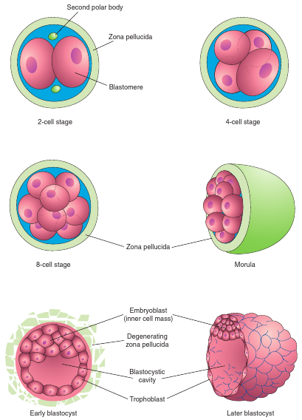

Figure 01. Blastocyst formation, and implantation in the endometrial epithelium (Moore, Persaud, and Torchia, 2016)
About 4 days after fertilization, blastogenesis begins. During this process, the morula enters the uterus, and uterine fluid forms a fluid-filled space inside the morula called the blastocystic cavity, and blastomeres divide into two parts: trophoblast and embryoblast. Trophoblast forms the blastocyst wall, and embryonic parts of the placenta, while embryoblast (inner cell mass or ICM) becomes the primordium of the embryo. After blastocyst floats in the uterine tube for about 2 days, the zona pellucida degenerates and it helps the blastocyst to increase its size while it uses the secretions of uterine glands. About 6 days after fertilization, the blastocyst attaches to the endometrial epithelium and the trophoblasts start to proliferate rapidly and produce two layers: Cytotrophoblast and Syncytiotrophoblast. The cytotrophoblast is the inner layer of cells, and The syncytiotrophoblast which is the outer layer extends and invades through the tissue of the endometrial epithelium. At the end of the first week, the blastocyst is implanted in the endometrium and feeds from the maternal tissues (Moore, Persaud, and Torchia, 2016).
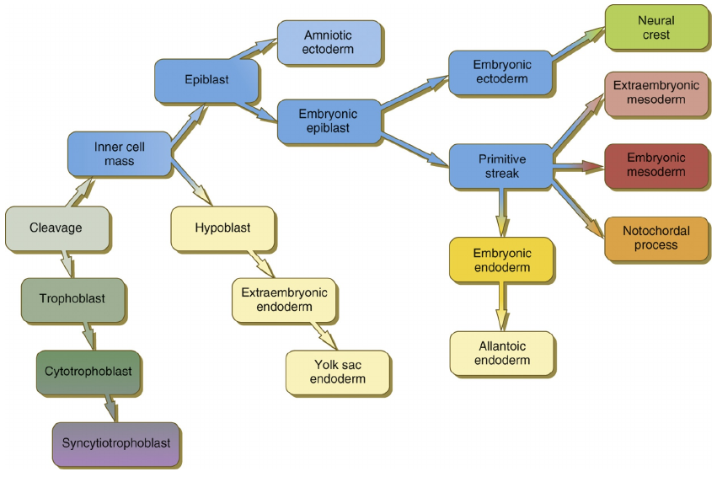
In the second week, blastocyst implantation is completed and the embryoblast differentiates into two layers of cells (which is called bilaminar disc): Epiblast and Hypoblast. Epiblast cells are related to the amniotic cavity and will form germ layers, and Hypoblast contains cuboidal cells adjacent to the exocoelomic cavity. Then, during gastrulation which is the conversion of the bilaminar disc into trilaminar disc (ectoderm, mesoderm, and endoderm) morphogenesis begins (Moore, Persaud, and Torchia, 2016) [Figure 02].

Figure 02. Tissue and Cell formation in the early human embryo (Carlson, 2015)
Mesoderm Formation
During gastrulation, axial mesoderm (AM) or chordamesoderm (CM) firstly forms notochord, then mesoderm lies along the notochord and produces paraxial mesoderm (PM), intermediate mesoderm (IM), and lateral plate mesoderm (LPM). It is known that these subtypes form depending on the activity of BMPs (Tani, Chung, Ohba, and Hojo, 2020).
The CM forms the notochord which induces and patterns the neural tube and determines the anterior-posterior body axis (Gilbert and Barresi, 2016). It is known that Brachyury is expressed in AM and is required for the specification of both posterior AM and PM. In addition to Brachyury, knockout of other T-box genes including EOMES and VegT results in lacking axial and paraxial mesoderm in all anterior and posterior levels, and neural fate is further induced (Bruce and Winklbauer, 2020). There is not much information about the role of TBX6 in AM development.
Development of PM consists of the specification of presomitic mesoderm, somitogenesis, and specification of the somites. Mature somites form two groups: sclerotome, and dermomyotome. Sclerotome is derived into vertebrae and its associated ribs, tendons, dorsal aorta vascular cells, blood vessels of invertebrates, and meninges. Dermomyotome forms myotome and dermatome. Myotome forms the back musculature, rib cage, ventral body wall, and limb, while the dermatome forms the dermis of the back. There are many factors involved in the development of the PM. TBX6 expression is restricted to presomitic mesoderm and its expression decreases when somites form. Although Brachyury is expressed at an earlier point in the PS, TBX6 expression overlaps Brachyury expression and its knockout results in the conversion of presomitic mesoderm into neural tissues. TBX6 represses SOX2 expression and promotes presomitic mesoderm development (Tani, Chung, Ohba, and Hojo, 2020).
In Xenopus, the T-box gene zVegT (zygotic VegT) is critical for PM and its knockout disrupts the formation of somites and is essential for PM formation. In vitro, FOXH1 and EOMES are trans-acting factors that are required for zVegT expression. Nodal signaling induces the expression of EOMES, and both EOMES and Nodal can activate the expression of zVegT (Fukuda et al., 2010). Another factor involved in PM development is MSGN1. MSGN1 or basic-helix-loop-helix (bHLH) is expressed from gastrulation to somite formation. Over-expression of this gene increases the TBX6-expressing and presomitic mesoderm region into the anterior. The lack of MSGN1 decreases the expression of TBX6 in the presomitic mesoderm and the complete failure of somite formation (Tani, Chung, Ohba, and Hojo, 2020).
The IM gives rise to the urogenital system, such as kidneys and gonads (Tani, Chung, Ohba, and Hojo, 2020). There is not much information about the role of TBX6, EOMES, and Brachyury on IM development, but it is known that specific signals of PM are required for the development of IM. For example, observations showed that in embryos with TBX6 null mutation, the formation of IM was severely compromised. Some genes that are known to be essential for the development of IM are PAX8, PAX2, LHX1 (Chapman, 2019).
The LPM develops into splanchnic mesoderm, somatic mesoderm, and extraembryonic membranes. The splanchnic mesoderm forms circulatory system components like the heart, and blood vessels, and cells. The somatic mesoderm forms the skeleton of the pelvis and limbs components except for its muscles which are derived from the dermomyotome (Tani, Chung, Ohba, and Hojo, 2020). BMP signaling cascade and Nodal pathway both influence the formation of LPM. Although Brachyury is commonly used as a reference for mesodermal lineage in mammals, it is dispensable for LPM formation. Conversely, LPM formation is universally controlled by eomesodermin A, FOXH1, and MIXL1 (Prummel, Nieuwenhuize, and Mosimann, 2020).

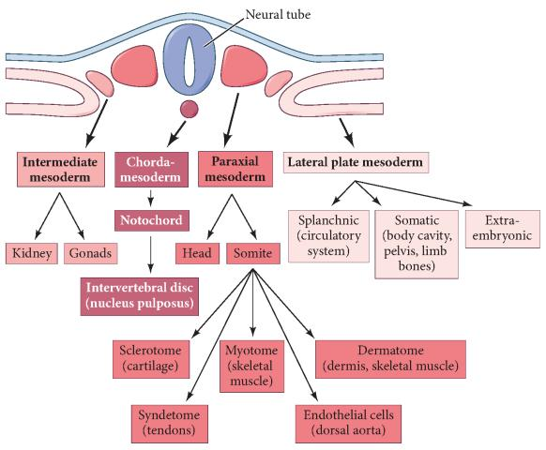

Figure 03. Major lineages of the mesoderm (Gilbert and Barresi, 2016)
Mesodermal genes
Here, five genes of the mesoderm layer are explained. These genes include Brachyury (T), TBX6, EOMES, MESP1, and NKX2-5. EOMES, Brachyury, and TBX6 are all members of T-box transcription factors. Transcription factors of the T-box have an important role in the formation of mesoderm. EOMES (Eomesodermin) is involved in the primary steps of the recruitment of prospective mesodermal cells near the primitive streak. The Brachyury gene is expressed in nascent mesodermal cells and afterward, mesodermal cells migrate from blastopore or primitive streak and start expressing PM genes such as TBX6 (Yano, Iimura, Kojima and Uchiyama, 2016). In mice, TBX6 is expressed at primitive streak and paraxial presomitic mesoderm from 7.5 dpc and when somite segregation begins, its expression decreases (Chapman et al., 1996). In two days of differentiation of ESC, Brachyury which is a marker of the primitive streak is expressed and peaks, and after the onset of Brachyury, expression of MESP1 begins (Bondue and Blanpain, 2010). Another cardiac marker, NKX2-5, was not observable on day 4 of differentiation, but its expression is strong 30 days after differentiation. Brachyury, Eomes, and Mesp1 play an important role in cardiomyocyte differentiation and NKX2-5 is cardiomyocyte progenitor (Liu et al., 2017).

Brachyury (T)
During the development of an embryo, the Brachyury gene is expressed only in the caudal end of the embryo which is the place of new mesodermal cell generation and the notochord (Beisaw et al., 2017). This gene is known to be expressed in progenitor cells of mesoderm (Fehling et al., 2003; Huber et al., 2004). Its transcription factors are essential for mesoderm differentiation (Papaioannou, 2014; Showell, Binder, and Conlon, 2003). Additionally, the Brachyury gene has a lot of common targets with Eomes (Faial et al., 2015), regulates MESP1 directly by binding and activating its promoter (Loh and Lim, 2011), and can be repressed by TBX6 (Koch et al., 2017).
Embryos with a deficiency in Brachyury will fail in the extension of the posterior axis and formation of midline mesoderm (Herrmann et al., 1990). The absence of mesoderm and definitive endoderm will cause neural differentiation (Muñoz-Sanjuán and Brivanlou, 2002; Hemmati-Brivanlou and Melton, 1994; Tropepe et al., 2001). The reason is that activation of any mesodermal genes depends on the Eomes and Brachyury. These two genes bind directly to neural ectoderm enhancers and promoters to repress them, and deficient cells in both genes fail to differentiate into mesoderm and eventually differentiate into neural ectoderm. Furthermore, the knockout of Brachyury and Eomes decreases the expression of MESP1, Mixl1, and Hand1 (Tosic et al., 2019).

EOMES
Eomesodermin is the first T-box transcription factor that is expressed during mouse embryo development (Russ et al., 2000). It is known that its expression affects the transcription of almost all mesodermal genes. In Xenopus, this gene is activated in midblastula transition (Stage 8), its strongest peak is in stage 10.5, and in about stage 18, it finally will be decayed. In lower vertebrates, EOMES can regulate the development of mesoderm and endoderm (Arnold, Hofmann, Bikoff and Robertson, 2008). Brachyury and EOMES expression overlap in epiblast and primitive streak. The EOMES loss results in more expression of Brachyury and vice versa. They are essential for repressing neural ectoderm genes, pluripotency, and activation of all mesoderm and definitive endoderm genes. Both of these genes are critical effectors of TGF-β and Wnt and their knockout results in a decrease in the expression of Brachyury, EOMES, and MESP1 (Tosic et al., 2019). In addition, blockage of the Eomes can cause a deficiency in mesoderm-dependent gene activation (Ryan et al., 1996). In embryos with EOMES deficiency, cells can’t migrate away and accumulate on the posterior side (Arnold, Hofmann, Bikoff and Robertson, 2008).

TBX6
TBX6 is a gene that is involved in mesoderm development, presomitic mesoderm specification in early embryonic development, and is responsible for the fate decision of mesoderm (Chapman and Papaioannou, 1998). Metameric structures in presomitic mesoderm show the fact that this gene is responsible for mesodermal differentiation and mesoderm vs neural fate decision (Yano, Iimura, Kojima and Uchiyama, 2016). Mesoderm lineage development is determined by TBX6-dependent regulation of Sox2. At a molecular level, TBX6 has been shown to inactivate the N1 enhancer of the Sox2 gene in the caudal lateral epiblast (CLE) and lead mesodermal differentiation in mice (Takemoto et al., 2011). The TBX6 is strongly expressed in the paraxial mesoderm, and it has an important role in somite formation and specification via its temporal expression. However, prolonged expression of the TBX6 (longer than 3 days) suppresses cardiac differentiation and induces somite lineage including skeletal muscle and chondrocytes. The TBX6 is expressed on day 2, one day after initiation of Brachyury and EOMES expression. Similar to the MESP1, its expression sharply decreases on day 4, and its knockout resulted in down-regulation of Brachyury, MESP1, and EOMES mRNA expressions. TBX6 specifies cardiovascular differentiation via direct upregulation of MESP1, repression of Sox2, and activation of BMP/Nodal/Wnt signaling (Sadahiro et al., 2018). Deletion of Tbx6 causes excessive growth of neural tissue at the PM (Chapman and Papaioannou, 1998; Takemoto et al., 2011), and in Tbx6 mutations, mesoderm formation initiates, but fail to maintain paraxial mesoderm fate and its KO causes somites to change to neural tube-like structures (Chapman and Papaioannou, 1998).

MESP1
MESP1 is the master regulator of cardiac differentiation (Kotoku et al., 2016). It is a T-box factor-induced transcription factor (Lescroart et al., 2018) which is expressed firstly in the primitive streak in E6.5. During early embryogenesis (Saga et al., 1996). Many different lineages of mesoderm are stimulated by the presence of the MESP1 domain and its induction in day E2.25-3.25 promotes patterning of mesoderm. This transcription factor induces the differentiation of pluripotent cells into mesodermal lineages like hematopoietic, cardiac, and skeletal myogenic cells (Chan, Chan, and Kyba, 2016). For all cardiogenic regions and some vasculogenic regions specification, which give rise to cranial vessels, and dorsal aorta, cells of lateral plate mesoderm express MESP1 which is highly specific for cardiogenic and some vasculogenic regions (Kitajima, Takagi, Inoue, and Saga, 2000; Saga, Kitajima and Miyagawa-Tomita, 2000; Saga et al., 1999) Then, they can form all required components of the heart (David et al., 2011). It is believed that MESP1 is not only present during cardiogenesis, but also is an important regulator for inducing cardiovasculogenesis in pluripotent cells in vertebrate embryos (David et al., 2008; Lindsley et al., 2008; Bondue et al., 2008). The EOMES is the first activator of MESP1/2 and TBX6 is the second activator of MESP1/2 in cardiac specification during the formation of vertebrate’s heart from splanchnic mesoderm (Costello et al., 2011; van den Ameele et al., 2012). In murine embryos, MESP1 and Brachyury are co-expressed in mesodermal cells at the primitive streak, and Brachyury suppression results in MESP1 reduction. As a result, for functional cardiovascular progenitor cells development and differentiation, MESP1 expression requires the presence of Brachyury activity in embryonic stem cells (Kattman, Huber, and Keller, 2006).

NKX2-5
NKX2-5 is another transcription factor that is required for the development of the heart. Mutations in NKX2-5 result in cardiac malformation like septal defects and abnormal conduction system. This gene is known to be a cardiac regulator and it is very important for cardiogenesis. This gene is known to affect many cardiac genes like HAND1, GATA4, MEF2D, SIRT1, and Jarid2. Yet, Their mechanisms are not fully understood (Liang et al., 2019). The gene MESP1 can positively regulate cardiac specification by regulating cardiac progenitor’s markers (NKX2-5) (Bondue et al., 2008; Bondue et al., 2011).

Phylogenetic Profiling
Identifying interactions between proteins is difficult. Recognizing protein-protein interactions in a small range might be successful. However, it is challenging to determine protein-protein interactions on a large scale. Phylogenetic profiling is a solution to this problem. This method is based on one assumption that the proteins which are related evolve similarly, and it examines and compares the genome sequences in different species to determine whole-proteome protein interaction. Until today, similar methods used phylogenetic profiling to identify novel members of protein complexes, expand known pathways, and analyze non-coding sequences.
Two prediction algorithms have been proposed based on information of protein occurrences across different species. One group used co-occurrence methods like Hamming distance, Pearson correlation coefficient, Jaccard similarity, Fisher's exact test, and mutual information to construct a phylogenetic profile by direct comparison of paired proteins. The second group uses model-based methods like collapsing of sub-tree, tree-kernel, maximum likelihood, and parsimony. The first group uses normalization methods like SVD (singular value decomposition), and NPP (normalized phylogenetic profile) to reduce the false positive rate of predictions. Although these methods are sometimes incorrect due to phylogenetic bias or non-independence of profile values, they are still popular for predicting functional linkages due to their time efficiency. The second group uses the evolutionary tree because of the non-independence of the profile values to calculate the correlations for evolutionary processes. These models strongly depend on the reliability of phylogeny and require much higher computational time. They are not user-friendly and have low efficiency because of the high false-positive rate.
PrePhyloPro (PPP) method and online tool uses a combination of multiple co-occurrence methods and use their top rank thresholds to compute the potential linkages. 972 different species were used for constructing a comprehensive phylogenetic profile and identifying human whole proteome functional linkages. Evaluation of PPP was examined using positive and negative reference datasets and PPP results had higher sensitivity and specificity in ROC curves. This online tool is available at http://prephylopro.org/phyloprofile/ (Niu et al., 2017).
Inputs of this tool are linkages number, BLAST E-value, organism, and a file with candidate genes list. Linkages number is the threshold for linkages number of each gene. It can be a random integer or float between 1 and 500. Choosing a smaller value of linkages number results in less but more reliable linkages and leads to a more precise threshold of predicted linkages. However, choosing a smaller value may lead to missing potential and novel linkages due to a lack of strong evidence. The default value for linkages number is 20. There are three values available for the BLAST E-value threshold including 0.001, 0.0005, and 0.0001. The chosen threshold is used for picking homologous proteins. For each pair of referenced protein and test protein, if their blast E-value is smaller than the chosen threshold, the homologs are thought to be present and set as 1; otherwise, the homologs are considered to be absent and set as 0. By today, the supported organisms are homo sapiens (human) and Arabidopsis thaliana (thale cress). The candidate genes list file can have txt format with “tab” separator or csv format with “,” separator. Due to the reliability of the results, at least two genes of a cluster, a complex, or a biological pathway should be entered. The structure of the file should be like Figure 05. In the first column, the “hsa” or “ath” id of each gene should be entered. You can use the “GeneID” column of whole Homo sapiens or Arabidopsis thaliana genes available at http://173.255.208.244/phyloprofile/AnnoData/hsa_wholeGenomeAnno.csv and http://173.255.208.244/phyloprofile/AnnoData/ath_wholeGenomeAnno.csv respectively to find the ID of your input genes. In the second column, you can choose a color for each gene. This tool supports both hex triplet mode and color name mode. You can use “white” or “#FFFFFF” if you don’t want to show the color of a gene. The third column is used for specifying linkage colors. This column uses the same format for colors as the second column, however, you can use “NA” to hide the linkage for certain genes. The colors of this column are used in the circos plot and D3 interactive network. In the fourth column, predefined gene names can be used. This column is optional and if this column is not specified, gene IDs are used as names of genes. These pre-defined genes will be used in phylogenetic profiles and correlation figures.
The results are shown in two ways. The returned web page contains all figures and tables including Phylogenetic profile, correlation matrix, circos plot, D3 interactive network, and predicted linkages list. In addition, a gray block is used to indicate the negative correlation in the correlation matrix plot. Another way is a link at the bottom of the returned page to download the results. This file will be kept on the site’s server for two hours. This downloaded folder contains phylogenetic profile and correlation matrix figures with high quality in both “pdf” and “jpg” formats. In addition, there are input genes listed in “txt” or “csv” format, along with two other “csv” files containing correlation matrix and predicted linkages that can be used for other analysis and validation experiments. Finally, the web page that was returned was saved in “html” format as an overview of the results (Niu, 2018).

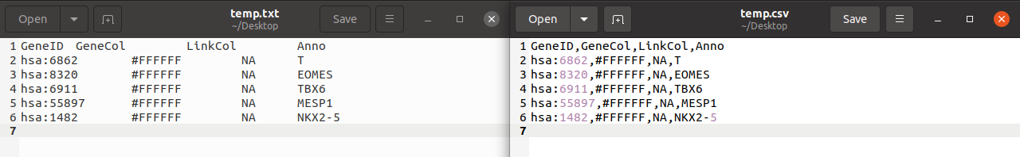
Figure 05. Template of candidate genes list file
Overall Hypothesis and Aim:

Due to their shared developmental function, we hypothesize that the five genes involved in the development of mesoderm (Eomes, Tbx6, Brachyury, Mesp1, and Nkx2-5) must share a similar evolutionary pattern. In this work, we will examine this hypothesis and will utilize the profile of each gene to identify novel molecular players and pathways involved in the development of mesoderm, or other processes - beyond early development - shared by these five genes.

Material and Methods
To have more knowledge about these genes, a correlation plot was created using pluripotent genes (OCT4, NANOG, SALL4, REX1, and KLF4), ectodermal genes (HESX1, OTX2, GBX2, SIX3, and SOX1), endodermal genes (SOX17, GATA6, FOXA2, CTNNB1, and HHEX), and mesodermal genes (T, EOMES, TBX6, MESP1, and NKX2-5) with parameters set as Linkages Number=30, BLAST E-value=0.0001, and Organism=Homo sapiens.

To construct the phylogenetic profile, desired mesodermal genes should be selected first. For this reason, PPP was used for five mesodermal genes (Eomes, Tbx6, T, Mesp1, and Nkx2-5) with the parameters mentioned above. In the next step, only three mesodermal genes (Eomes, Tbx6, and T) were used in the PPP using mentioned parameters. This time, the correlation matrix plot and the ‘predicted_linkages.csv’ file were used. In the predicted linkages file, genes that correlate with all three selected mesodermal genes were examined and 29 genes were found that PPP predicted to correlate with all three of them. These 29 genes were then used as the positive group for the next step. Afterward, three mesodermal genes (Eomes, Tbx6, and T) and the positive group were used to create a correlation matrix plot with mentioned algorithm parameters.

Afterward, a negative group is needed that should be picked randomly from the whole genome, so with the whole human genome available at http://173.255.208.244/phyloprofile/AnnoData/hsa_wholeGenomeAnno.csv, and with the use of Python programming language, Pandas, and NumPy libraries, first, 100 random genes were chosen from 20,127 genes of the human genome. PPP was then used with mentioned parameters to study the correlation matrix plot of 100 random genes. After that, PPP was used the last time with the parameters to study the correlation matrix plot of three mesodermal genes (Eomes, Tbx6, and T) and the negative group. Finally, the expression of three mesodermal genes (Eomes, Tbx6, T) and positive control group were studied using PubMed of NCBI.

Results
PrePhyloPro is an online method we have developed to determine linkages of human genes, based on proteome-wide phylogenetic profiles. It’s based on the fact that functionally related proteins have evolved in a correlated manner. In this experiment, different genes were used as inputs of PPP for examining their correlations. If the correlation between them is high, they most likely have evolved from a common ancestor and are functionally related.

This correlation matrix plot shows that four genes of mesoderm (Brachyury, EOMES, TBX6, and MESP1) have very high correlations with each other, and no strong correlation was observed between these 4 genes and NKX2-5, pluripotent, ectodermal, and endodermal genes. However, pluripotent, ectoderm, and endoderm genes have medium to high correlations with each other [Figure 06]. When five mesodermal genes were used in PPP, the correlation matrix plot showed very high correlations between three T-box transcription factors (Eomes, Tbx6, and T), high correlations between Mesp1 and three T-box transcription factors, and lower correlations between Nkx2-5 and other four genes. [Figure 07] illustrates the results explained. Additionally, evolutionary pattern prediction grouped Eomes, Tbx6, and T in one group, then grouped Mesp1 with these three genes, and finally grouped Nkx2-5 with the four genes mentioned. For more accurate results, three mesodermal genes (Eomes, Tbx6, and T) were eventually chosen for the next steps [Figure 08].

Besides the plot, a predicted linkages file was given by the tool. In the “predicted_linkages.csv” file, genes that have linkage with each of the three mesodermal genes were shown. 29 genes correlate with all three mesodermal genes and they were used as the positive group. These genes are CASP10, CCKAR, CCR1, CNR1, CYSLTR2, DRD1, ELF2, ERF, ETV4, F2RL3, FERD3L, GPR176, HTR6, LDLRAD1, LPAR6, NR2E3, NR2F6, NR4A2, PRLHR, RORB, RORC, S1PR2, SEMA3D, SIGLEC8, SMAD7, TBX3, WNT4, WNT7A, WNT9B [Figure 09]. The correlation matrix for linkage between these 29 genes and three mesodermal genes has been created which you can observe in [Figure 10]. To test the accuracy of PPP, 100 random genes (the negative group) as explained in the material and methods section were examined [Figure 11].

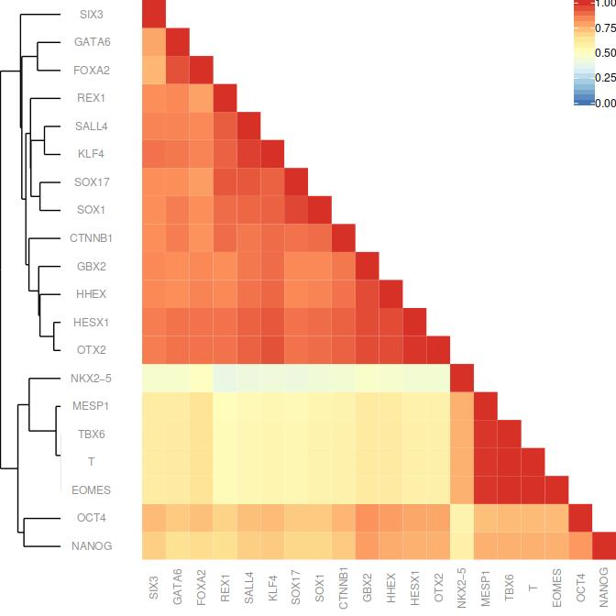
Figure 06. Correlation matrix plot of Pluripotent, Ectodermal, Mesodermal, and Endodermal genes (Niu et al., 2017)

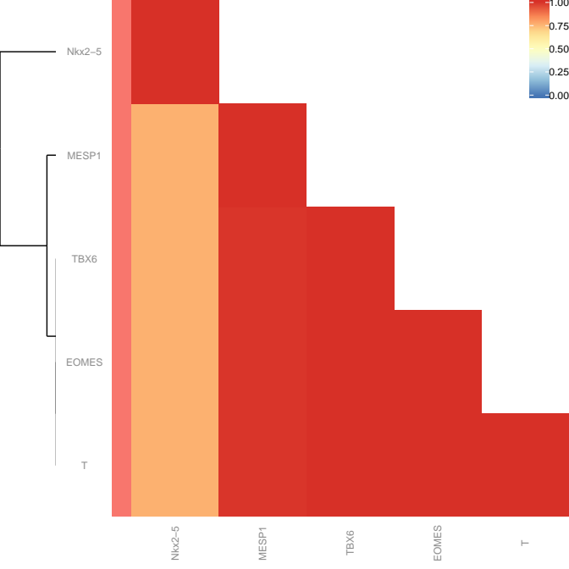

Figure 07. Correlation matrix plot of five mesodermal genes (Eomes, Tbx6, T, Mesp1, and Nkx2-5) (Niu et al., 2017)

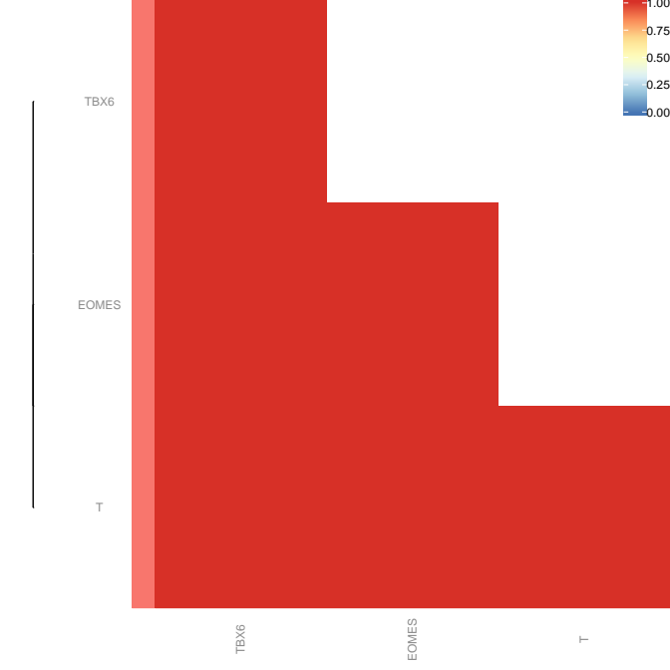

Figure 08. Correlation matrix plot of three mesodermal genes (Eomes, Tbx6, T) (Niu et al., 2017)

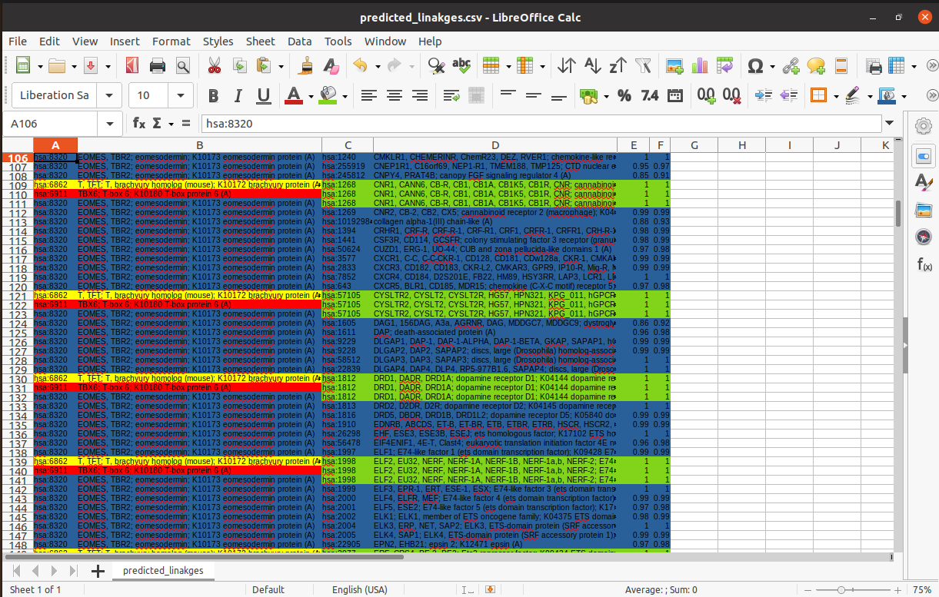

Figure 09. A section of the “predicted_linkages.csv” file. Blue rows indicate genes that are linked to EOMES, yellow rows indicate genes that are linked to Brachyury (T), red rows indicate genes that are linked to TBX6, and lime rows indicate genes that are linked to all three mesodermal genes (Niu et al., 2017).

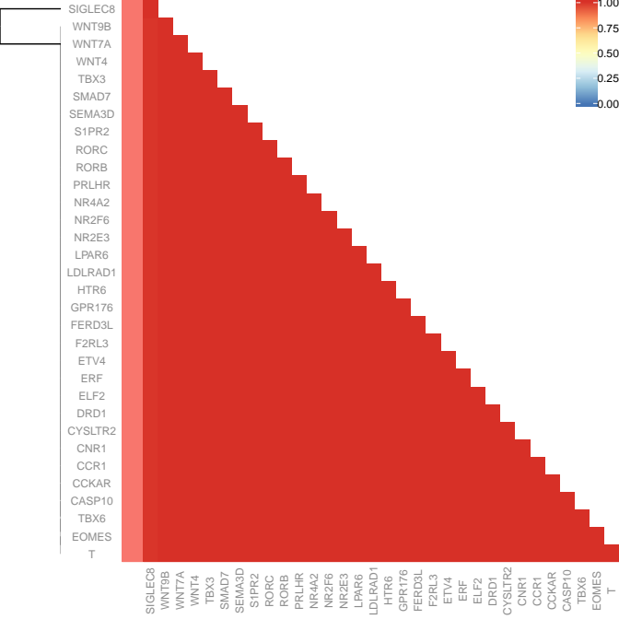

Figure 10. Correlation matrix of three mesoderm genes and the positive group (Niu et al., 2017)

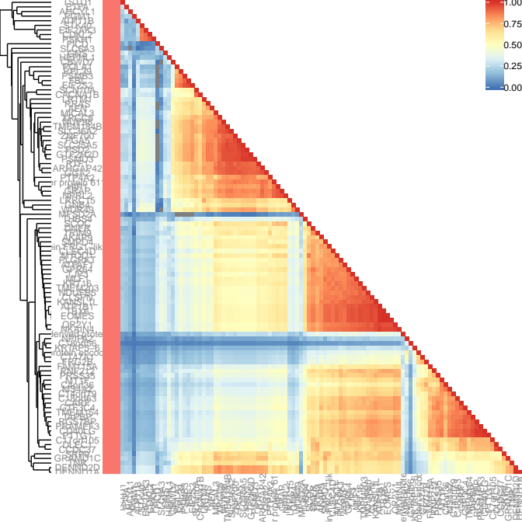

Figure 11. Correlation matrix plot of 100 genes of the negative group and three mesodermal genes (Niu et al., 2017)

Discussion
The mesoderm is one of the most important germ layers in embryo development. This germ layer is known to form the heart and other organs and tissue, e.g. smooth muscle and skeletal muscle. There is little information available about mesoderm and there are many factors involved in the development of mesodermal derivatives, and many of those mechanisms and processes are unclear or unknown for scientists. Nowadays, with the development of computation powers and algorithms, we can use applications like PrePhyloPro that can predict correlations between genes based on known data. This application assumes that proteins having a related functionality are likely to have a similar evolving pattern. These approaches are beneficial because they help scientists to gain a better understanding of gene correlations and reduce the number of errors and amount of costs in their experiments. For this experiment, PPP was used and its accuracy was computed by comparing the results with actual data on NCBI [National Center for Biotechnology Information website which is the most popular place for sharing biology and medical articles]. The correlation matrix plot of PPP shows all kinds of correlations from dark blue (no correlation) to dark red (high correlation), and gray (negative correlation).

We used 5 known mesodermal genes (TBX6, EOMES, Brachyury, MESP1, and Nkx2-5). Although there is little information about them, as you can see in the dendrogram of [Figure 07], these 5 genes are grouped into:
- Brachyury, TBX6, Eomes
- MESP1
- NKX2-5
This grouping suggests that there is an evolution and expression correlation between members of each group. Brachyury, Eomes, and Tbx6 are all members of T-box transcription factors which are critical for mesoderm development.
Although MESP1 is a more specific marker for cardiac mesoderm and is grouped separately, it is predicted to be highly correlated with those 3 genes in the correlation matrix (Figure 07). The information about MESP1 as mentioned before confirms this result.
NKX2-5 is another marker for cardiac mesoderm which is predicted to not have a high correlation with the previous 4 genes in the correlation matrix [Figure 07]. It might be related to the finding that NKX2-5 expression is strong in 30 days after differentiation (later than the other 4 genes), and it is a cardiomyocyte progenitor, while Brachyury, Eomes, and Mesp1 play important role in cardiomyocyte differentiation (Liu et al., 2017).
The positive group (29 genes) can be divided into these categories:
1) G-Protein Coupled Receptors:
CYSLTR2 (G-Protein Coupled Receptor 21): The cysteinyl leukotriene receptor 2 (CYSLTR2) is a gene located on chromosome 13 at position 13q14. This gene encodes a protein receptor for cysteinyl leukotriene (Park et al., 2005). Cysteinyl leukotriene has an inflammatory effect on the body. It causes the smooth muscles of blood vessels to contract and mucus secretion in the respiratory tract (Bisgaard, 2008). Therefore, the CYSLTR2 gene contributes to asthma by coding receptors for cysteinyl leukotriene.

GPR176 (G-Protein Coupled Receptor 176): This gene encodes G–protein-coupled receptor 176 (GPR176) which is from the GPCR protein family and regulates the pace of the circadian clock (Nakagawa et al., 2020).

LPAR6 (G-Protein Coupled Purinergic Receptor P2Y5): LPAR6 is lysophosphatidic acid receptor 6 which is identified as an orphan G protein-coupled receptor and it was subsequently named P2Y5, in the purinergic receptor (P2Y) subgroup because of its homology to nucleotide receptors. In Xenopus, LPAR6 expression is enriched in mesoderm and dorsal ectoderm from late blastulae. Its expression on gastrula is an early response to FGF signaling. Also, its expression is induced by Activin which is a TGF-β family mesoderm-inducing factor, but surprisingly they couldn’t detect any effect of inhibiting LPAR6 on mesoderm. They suggest that maybe this gene is not an effector of FGF signaling, or other LPA receptors making up for defective signaling of LPAR6 (Geach et al., 2014). It seems that this gene is involved in mesodermal/mesoderm derivatives development but the complete mechanism, its inhibition, and activation are not clear.

PRLHR (G-Protein Coupled Receptor 10): The prolactin-releasing hormone receptor (PRLHR) gene encodes prolactin-releasing hormone receptor or G-protein-coupled receptor 10. This protein is a receptor for prolactin-releasing peptides (Su et al., 2015).

S1PR2 (G-Protein Coupled Receptor 13): Sphingosine 1-phosphate (S1P) receptor 2 or S1PR2 is involved in cell proliferation, survival, migration, and differentiation. In zebrafish, mutations in the S1pr2 gene inhibit precursor cells of the heart to migrate towards the mid-line which results in the development of two separate hearts (Mendelson, Lan, Hla, and Evans, 2015). The reason is that the development of the heart depends on the coordination of the endoderm and adjacent cardiac mesoderm, and movement of the endoderm promoting the migration of myocardial cells. Endoderm movement is controlled by S1pr2/GNA13 signaling pathway (Ye, Xie, Hu, and Lin, 2015). This gene is involved in cardiac mesoderm development by having a key role in cell migration.

CCR1: C-C motif chemokine receptor 1 or CCR1 is a member of chemokine receptors which is a member of G-protein coupled receptors (Anam and Davis, 2013). Although no information was found about the role of CCR1 on mesoderm development, CCR1 mRNA expressions were detected on human placenta multipotent mesenchymal stem cells and intracellular CCR1 proteins were found on both human bone marrow multipotent mesenchymal stem cells and human placenta multipotent mesenchymal stem cells (Brooke, Tong, Levesque, and Atkinson, 2008). Expressions of this gene were also found on E12.5 in tissues that are concordant with definitive hematopoiesis both related to timing and space (McGrath et al., 1999), and it was found that its expression was 96-folds higher in hematopoietic stem/progenitor cells than in bone marrow mesenchymal stromal cells which have a high potential of multilineage differentiation capacity to become adipogenic, osteogenic, and chondrogenic cell lineages (Anam and Davis, 2013). No clear information was found about the role of CCR1 on mesoderm development.

2) T-box Transcription Factors:
TBX3 (T-Box Transcription Factor 3): TBX3 is a T-box transcription factor that is important for development, stem cell, nuclear reprogramming, and cancer. This gene is expressed in ESCs and in vivo during the formation of PS. It is regulated by Wnt signaling in mESCs. TBX3 represses Wnt pathway members that are important in differentiation and inhibits mesoderm formation. Knock out of TBX3 induces differentiation in mESCs, upregulation of mesoderm genes (T, FLK1, MIXL1), and ectoderm genes (NES), while endoderm gene (SOX17) was down-regulated (Waghray et al., 2015). Therefore, this gene is negatively correlated with mesodermal development.

3) Nuclear Receptors:
NR2E3 (Nuclear Receptor Subfamily 2 Group E Member 3): NR2E3 (photoreceptor-specific Nuclear Receptor) is believed to affect the development, differentiation, and survival of photoreceptors, especially retina (Webber et al., 2008). In vertebrates, the development of the eye consists of very complex interactions between mesoderm, ectoderm, and endoderm. For instance, AM is required for the separation of eye fields into two retinal primordia (Jayakody, Gonzalez-Cordero, Ali and Pearson, 2015). Mesp1 is one of the NR2E3-dependent genes in the transient decrease group which involves in development and differentiation based on information from GO (Ashburner et al., 2000), Proteome (Biobase GmbH, Wolfenbuettel, Germany), and Swissprot (Bairoch, Boeckmann, Ferro and Gasteiger, 2004) and upregulation of rod genes and repression of cone genes is caused by the interaction of NR2E3 and CRX (Peng et al., 2005). Hence, This gene has correlations with AM, eye formation, and the MESP1 gene.

NR2F6 (Nuclear Receptor Subfamily 2 Group F Member 6): NR2F6 or EAR2 is an orphan nuclear receptor subfamily 2, group F, member 6 (Hermann-Kleiter et al., 2008). Although there is no known relationship between NR2F6 and mesoderm development, it is known that NR2F6 is encoded by human embryonic stem cell (hESC)-specific genes (Hnisz et al., 2013). It is highly expressed in hematopoietic stem cells, but its expression decreases during the differentiation of hematopoietic cells (Hermann-Kleiter and Baier, 2014). This information shows that the correlation between NR2F6 and mesoderm development is not significantly clear.

NR4A2 (Nuclear Receptor Subfamily 4 Group A Member 2): NR4A2 or Nurr1 is an orphan nuclear receptor known as an early response for the development of neurons, and recently it is known to regulate CD4⁺ T cells too. Th17 cells express NR4A2 which is important for the development of acute experimental autoimmune encephalomyelitis (EAE) and the development of this disease depends on the expression of Eomes transcription factors from CD4⁺ T cells. As a result, they proposed that acute EAE depends on NR4A2-dependent Th17 cells, and chronic EAE depends on Eomes, mediated by T cells. This indicates that both NR4A2 and Eomes are critical for the development of acute and chronic EAE, and these two genes have reciprocal involvement in acute and chronic phases of EAE (Raveney et al., 2015). It seems that this gene correlates with EOMES, but no known evidence shows the correlation between this gene and mesodermal development.

RORB (Nuclear Receptor Subfamily 1 Group F Member 2): Retinoid related orphan receptor B gene encodes Retinoid related orphan receptor B. this protein is a transcription factor from the nuclear receptor family which is involved in retinal neurogenesis (Chow et al., 1998). RORB seems not to have a role in mesodermal development.

RORC (Nuclear Receptor Subfamily 1 Group F Member 3): RORC is a retinoic acid receptor (RAR)-related orphan receptor C and is a master transcription factor of Th17 cells. Eomes transcription factors can bind directly to promoters of RORC and IL17a and suppress the development and differentiation of Th17 cells via a smad-independent pathway (Chen et al., 2021). Suppression of Eomes by TGF-β is important for the development and differentiation of Th17 cells (Ichiyama et al., 2011). No known role has been found for this gene and the development of mesoderm.

4) ETS Related Genes:
ELF2 (E74 Like ETS Transcription Factor 2): Eph ligand family 2 (ELF2) is a member of Eph receptors that has important expression patterns in early vertebrate development. In mice, this gene is expressed during organogenesis and organizing somites. Soon after organogenesis on day E8.5, ELF2 expression is observed on the boundary between somites and presomitic mesoderm. At E9.5, the expression is more clear and additional bands forms in more anterior somites of the segmented mesoderm. Finally, on day E10.5, ELF2 expression was mostly strong at organogenesis regions (Bergemann et al., 1995). Consequently, this gene seems to be involved in the development of mesoderm.

ERF (ETS2 Repression Factor): ERF is a subfamily of ETS proteins that is a nuclear target of the Ras/MAPK pathway which is necessary for FGF-induced mesoderm development in Xenopus. ERF is an ETS2 repressor factor, and ETS2 is required for mesoderm patterning and induction of Xbra and posterior mesoderm. Inhibition of ETS2 causes posterior defects in the mesoderm (Kawachi, Masuyama, and Nishida, 2003). This gene also seems to involve in the development of mesoderm.

ETV4 (ETS Variant Transcription Factor 4): ETV4 (PEA3 in mammals) is an ETS transcription factor whose expression is maximal during embryonic development stages of E11-16 (Lamballe et al., 2011), and regulates embryogenesis (Xin, Cowie, Lachance, and Hassell, 1992). In zebrafish, ETV4 is known to be expressed in posterior mesoderm during somitogenesis which includes somite mesoderm, tailbud mesoderm, trunk mesoderm, and paraxial mesoderm (Marra and Wingert, 2016), and mesoderm differentiation on mouse P19 cells by dimethyl sulfoxide (DMSO). Although the effect of ETV4 on mesodermal differentiation is unknown, it is known that it affects the expression of mesodermal gene T and enhances its expression (Yamaguchi, Tanaka, Kitagawa, and Miki, 1999). This factor is also involved in intermediate mesoderm derivatives. For example, ETV4 has many effects on the urogenital system by regulating ureteric bud development (Kuure, Chi, Lu, and Costantini, 2010) which is essential for kidney (Song et al., 2017), collecting duct, pelvis, ureter (Al-Awqati and Gao, 2011; Costantini and Kopan, 2010), and nephrons development (Brown et al., 2013).

5) WNT Family Members:
WNT4 (Wnt Family Member 4): WNT4 is a member of WNT signaling pathway molecules that are known to regulate the formation of mesoderm in mammalian embryos. Especially, WNT1, WNT3A, and WNT4 are known to regulate the brachyury-mediated formation of mesoderm. WNT4 is expressed during stages 0/1, 2, 3, and in embryoblast and whole WNT signaling is essential for the development of the normal heart (Thieme et al., 2012). WNT4 is involved in the development of mesoderm.

WNT7A (Wnt Family Member 7A): WNT7A a member of the WNT family is known to be required for complete dorsalization of limb mesoderm, and its loss results in changing of dorsal limb structures to a ventral fate (Riddle et al., 1995).

WNT9B (Wnt Family Member 9B): WNT9B is another member of the WNT family, which is mostly known to be important in the development of the urogenital system, which is derived from IM. WNT4 acts downstream of WNT9B (Carroll et al., 2005).

7) Others:
CASP10: CASP10 or Caspase-10 is a member of initiator caspases class and a close homolog of caspase-8. It is known that CASP10 can regulate cellular processes like metabolic and extrinsic apoptosis pathways. Deletion of CASP10 results in numerous metastatic nodules in the liver, higher circulating tumor cells (CTCs) in mice. It was confirmed by the downregulation of epithelial marker E-cadherin in primary orthotopic tumors and upregulation of mesenchymal markers vimentin and fibronectin, which suggests the ability to metastasize in these tumors have been increased (Kumari, Deshmukh, and Das, 2019). There was no information about the effect of CASP10 on the development of mesoderm.

CCKAR: CCK or Cholecystokinin is a pleiotropic hormone in the gut that affects central and peripheral regions. CCKAR or CCK-1R’s function in the body includes the release of pancreatic lipase, inhibition of gastric emptying, and short-term satiety. Cholecystokinin receptors (CCKAR and CCKBR) can activate the protein kinase B pathway, which results in pre-adipogenesis, especially in subcutaneous white adipose tissue (Sc-WAT). They both can regulate Akt activity by phosphorylation, and Akt proteins are known to have a relevant role in adipocyte differentiation (Plaza et al., 2018). This gene seems to not affect the development of mesoderm.

CNR1: CNR1 or CB1 is a Cannabinoid receptor that functions from the early stages of development and it regulates the differentiation of stem cells and trophoblast cells. These receptors are known to regulate the fate decision of ectoderm-derived neural progenitor/stem cells and mesoderm-derived hematopoietic progenitor/stem cells. CB1 is known to regulate the differentiation of hematopoietic, immune cells, adipocytes, osteoblasts, and epidermis (Galve-Roperh et al., 2013). Hence, it has a role in mesoderm differentiation.

DRD1: DRD1 gene is located on chromosome 5 at position 5q35. It encodes dopamine receptor D1 which is the most abundant form of dopamine receptor in the central nervous system. DRD1 protein regulates neuron growth and differentiation and several behavioral responses (Grandy et al., 1990).

F2RL3: F2RL3 or Coagulation Factor II Receptor-like 3 codes Protease-activated receptor 4 (PAR4) and is known to be involved in activation of platelets and cardiovascular function, and smoking-related diseases (Cao et al., 2018).

FERD3L: FERD3L or NTWIST is a member of basic-Helix-Loop-Helix (bHLH) transcription factors. These transcription factors are important for developmental processes including myogenesis, hematopoiesis, and neurogenesis. This gene is expressed from 8.5 dpc (Verzi et al., 2002). Since this gene is involved in myogenesis and hematopoiesis, it must have a role in mesodermal derivatives development.

HTR6: This gene encodes Serotonin receptor 5-hydroxytryptamine receptor 6 (HTR6) which is involved in the regulation of neuronal migration and also differentiation during development. It has been shown that it is also related to some mental disorders, such as anxiety and depression (Teng et al., 2019).

LDLRAD1: LDLRAD1 or Low-density lipoprotein receptor class A domain 1 is a member of the low-density lipoprotein receptor family which is known to be involved in the binding site for low-density lipoprotein and calcium (Beecham et al., 2015). There is little information about this gene, but it is known that LDLRAD1 is significantly associated with coronary heart diseases (Hahn et al., 2020).

SEMA3D: Semaphorin-3D (SEMA3D) is important for retinal axon guidance and the correct formation of early axon pathways. This gene is known to be expressed in neural crest and neural development in zebrafish, and it was reported that SEMA3D is important for the development of cardiomyocytes that are derived from the neural crest. It recently is known to be the second source of cardiomyocytes in zebrafish. Knock out of SEMA3D alters the cardiac neural crest development and not lateral plate cardiac development (Sato, Tsai, and Yost, 2006). Therefore, it does not seem to have a relationship with the development of mesoderm.

SIGLEC8: Sialic acid-binding immunoglobulin-like lectin-8 (SIGLEC-8) gene is a member of the immunoglobulin gene family (Kiwamoto et al., 2012). It encodes a transmembrane protein which is only expressed in eosinophils, basophils, and mast cells. This transmembrane protein is a member of the CD33 family (Gao et al., 2010). The expression of Siglec-8 induces apoptosis in eosinophils and prevents degranulation of mast cells. Siglec-8 is therefore related to asthma (Sajay-asbaghi et al., 2020).

SMAD7: SMAD7 is known to inhibit the signaling of ALK-4, about the gastrula stage, which mediates TGF-β, and BMP-4 signaling and induce mesoderm. Low levels of SMAD7 inhibit the dorsal mesoderm genes and higher levels block expression of all mesoderm genes, like Xbra and Wnt8 in Xenopus. This indicates the negative regulatory role of SMAD7 in gene expression and the development of mesoderm (Bhushan, Chen, and Vale, 1998). Surprisingly over-expression of SMAD7 in the ventral epidermis of Xenopus is known to induce dorsal mesodermal markers expression such as Chordin and Brachyury (de Almeida et al., 2008).

Results showed that ELF2, ETV4, WNT4, WNT7A, CNR1, and SMAD7 have a role in the development of mesoderm, but the complete understanding of these mechanisms needs more research. In addition, TBX3 and ERF seem to have a negative correlation with the development of mesoderm, and the correlation matrix should show the correlation of these 2 genes and 3 mesodermal genes as gray. My opinion is that it might be an error. Some genes including S1PR2, CCR1, NR2E3, NR2F6, WNT9B, CCKAR, and FERD3L were shown to correlate with the development of derivatives of mesoderm germ layer e.g. cardiac mesoderm, mesenchymal stem cells, hematopoiesis, differentiation of adipocytes, and urogenital system.
In addition, these results suggest more investigation is needed for finding out if these three mesodermal genes are involved in the biological pathways of the positive group. For instance, the interaction of NR4A2-EOMES, RORC-EOMES, and NR2E3-MESP1 in other biological pathways requires more research.
Furthermore, the correlation matrix between three mesodermal genes and the negative group confirms that the correlation matrix of three mesodermal genes and the positive group did not happen randomly.

References:
Al-Awqati, Q. and Gao, X., 2011. Differentiation of Intercalated Cells in the Kidney. Physiology, 26(4), pp.266-272.

Anam, K. and Davis, T., 2013. Comparative analysis of gene transcripts for cell signaling receptors in bone marrow-derived hematopoietic stem/progenitor cell and mesenchymal stromal cell populations. Stem Cell Research & Therapy, 4(5), p.112.

Arnold, S., Hofmann, U., Bikoff, E. and Robertson, E., 2008. Pivotal roles for eomesodermin during axis formation, epithelium-to-mesenchyme transition and endoderm specification in the mouse. Development, 135(3), pp.501-511.
Ashburner, M., Ball, C., Blake, J., Botstein, D., Butler, H., Cherry, J., Davis, A., Dolinski, K., Dwight, S., Eppig, J., Harris, M., Hill, D., Issel-Tarver, L., Kasarskis, A., Lewis, S., Matese, J., Richardson, J., Ringwald, M., Rubin, G. and Sherlock, G., 2000. Gene Ontology: tool for the unification of biology. Nature Genetics, 25(1), pp.25-29.

Bairoch, A., Boeckmann, B., Ferro, S. and Gasteiger, E., 2004. Swiss-Prot: Juggling between evolution and stability. Briefings in Bioinformatics, 5(1), pp.39-55.

Beecham, G., Dickson, D., Scott, W., Martin, E., Schellenberg, G., Nuytemans, K., Larson, E., Buxbaum, J., Trojanowski, J., Van Deerlin, V., Hurtig, H., Mash, D., Beach, T., Troncoso, J., Pletnikova, O., Frosch, M., Ghetti, B., Foroud, T., Honig, L., Marder, K., Vonsattel, J., Goldman, S., Vinters, H., Ross, O., Wszolek, Z., Wang, L., Dykxhoorn, D., Pericak-Vance, M., Montine, T., Leverenz, J., Dawson, T. and Vance, J., 2015. PARK10 is a major locus for sporadic neuropathologically confirmed Parkinson disease. Neurology, 84(10), pp.972-980.

Beisaw, A., Tsaytler, P., Koch, F., Schmitz, S., Melissari, M., Senft, A., Wittler, L., Pennimpede, T., Macura, K., Herrmann, B. and Grote, P., 2017. BRACHYURY directs histone acetylation to target loci during mesoderm development. EMBO reports, 19(1), pp.118-134.

Bergemann, A., Cheng, H., Brambilla, R., Klein, R. and Flanagan, J., 1995. ELF-2, a new member of the Eph ligand family, is segmentally expressed in mouse embryos in the region of the hindbrain and newly forming somites. Molecular and Cellular Biology, 15(9), pp.4921-4929.

Bhushan, A., Chen, Y. and Vale, W., 1998. Smad7 Inhibits Mesoderm Formation and Promotes Neural Cell Fate inXenopusEmbryos. Developmental Biology, 200(2), pp.260-268.

Bisgaard, H., 2008. Pathophysiology of the cysteinyl leukotrienes and effects of leukotriene receptor antagonists in asthma. Allergy, 56, pp.7-11.

Bondue, A. and Blanpain, C., 2010. Mesp1. Circulation Research, 107(12), pp.1414-1427.

Bondue, A., Lapouge, G., Paulissen, C., Semeraro, C., Iacovino, M., Kyba, M. and Blanpain, C., 2008. Mesp1 Acts as a Master Regulator of Multipotent Cardiovascular Progenitor Specification. Cell Stem Cell, 3(1), pp.69-84.

Bondue, A., Tännler, S., Chiapparo, G., Chabab, S., Ramialison, M., Paulissen, C., Beck, B., Harvey, R. and Blanpain, C., 2011. Defining the earliest step of cardiovascular progenitor specification during embryonic stem cell differentiation. The Journal of Cell Biology, 192(5), pp.751-765.

Brooke, G., Tong, H., Levesque, J. and Atkinson, K., 2008. Molecular Trafficking Mechanisms of Multipotent Mesenchymal Stem Cells Derived from Human Bone Marrow and Placenta. Stem Cells and Development, 17(5), pp.929-940.

Brown, A., Muthukrishnan, S., Guay, J., Adams, D., Schafer, D., Fetting, J. and Oxburgh, L., 2013. Role for compartmentalization in nephron progenitor differentiation. Proceedings of the National Academy of Sciences, 110(12), pp.4640-4645.

Bruce, A. and Winklbauer, R., 2020. Brachyury in the gastrula of basal vertebrates. Mechanisms of Development, 163, p.103625.

Callery, E., Thomsen, G. and Smith, J., 2010. A divergent Tbx6-related gene and Tbx6 are both required for neural crest and intermediate mesoderm development in Xenopus. Developmental Biology, 340(1), pp.75-87.

Cao, D., Qu, Y., Zhang, X., Xu, F., Zhou, S., Zhang, G., Dai, B., Zhu, Y., Shi, G., Shen, Y., Zhu, Y., Zhang, H., Ye, D. and Zhao, J., 2018. High expression of F2RL3 correlates with aggressive features and poor survival in clear cell renal cell carcinoma. Journal of Cancer, 9(18), pp.3400-3406.

Carlson, B., 2015. Gastrulation and Germ Layer Formation. Reference Module in Biomedical Sciences,.

Carroll, T., Park, J., Hayashi, S., Majumdar, A. and McMahon, A., 2005. Wnt9b Plays a Central Role in the Regulation of Mesenchymal to Epithelial Transitions Underlying Organogenesis of the Mammalian Urogenital System. Developmental Cell, 9(2), pp.283-292.

Chan, S., Chan, H. and Kyba, M., 2016. Heterogeneity of Mesp1+ mesoderm revealed by single-cell RNA-seq. Biochemical and Biophysical Research Communications, 474(3), pp.469-475.

Chapman, D. and Papaioannou, V., 1998. Three neural tubes in mouse embryos with mutations in the T-box gene Tbx6. Nature, 391(6668), pp.695-697.

Chapman, D., 2019. Impaired intermediate formation in mouse embryos expressing reduced levels of Tbx6. genesis, 57(3), p.e23270.

Chapman, D., Agulnik, I., Hancock, S., Silver, L. and Papaioannou, V., 1996. Tbx6, a Mouse T-Box Gene Implicated in Paraxial Mesoderm Formation at Gastrulation. Developmental Biology, 180(2), pp.534-542.

Chen, S., Zhang, J., Yu, W., Zhuang, J., Xiao, W., Wu, Z. and Xiao, B., 2021. Eomesodermin in CD4+T cells is essential for Ginkgolide K ameliorating disease progression in experimental autoimmune encephalomyelitis. International Journal of Biological Sciences, 17(1), pp.50-61.

Chow, L., Levine, E.M. & Reh, T.A., 1998. The nuclear receptor transcription factor, retinoid-related orphan receptor β, regulates retinal progenitor proliferation. Mechanisms of Development, 77(2), pp.149–164.

Concepcion, D., 2013. The roles of T and Tbx6 during gastrulation and determination of left/right asymmetry.

Costello, I., Pimeisl, I., Dräger, S., Bikoff, E., Robertson, E. and Arnold, S., 2011. The T-box transcription factor Eomesodermin acts upstream of Mesp1 to specify cardiac mesoderm during mouse gastrulation. Nature Cell Biology, 13(9), pp.1084-1091.

David, R., Brenner, C., Stieber, J., Schwarz, F., Brunner, S., Vollmer, M., Mentele, E., Müller-Höcker, J., Kitajima, S., Lickert, H., Rupp, R. and Franz, W., 2008. MesP1 drives vertebrate cardiovascular differentiation through Dkk-1-mediated blockade of Wnt-signalling. Nature Cell Biology, 10(3), pp.338-345.

David, R., Jarsch, V., Schwarz, F., Nathan, P., Gegg, M., Lickert, H. and Franz, W., 2011. Induction of MesP1 by Brachyury(T) generates the common multipotent cardiovascular stem cell. Cardiovascular Research, 92(1), pp.115-122.

David, R., Stieber, J., Fischer, E., Brunner, S., Brenner, C., Pfeiler, S., Schwarz, F. and Franz, W., 2009. Forward programming of pluripotent stem cells towards distinct cardiovascular cell types. Cardiovascular Research, 84(2), pp.263-272.

de Almeida, I., Rolo, A., Batut, J., Hill, C., Stern, C. and Linker, C., 2008. Unexpected activities of Smad7 in Xenopus mesodermal and neural induction. Mechanisms of Development, 125(5-6), pp.421-431.

Faial, T., Bernardo, A., Mendjan, S., Diamanti, E., Ortmann, D., Gentsch, G., Mascetti, V., Trotter, M., Smith, J. and Pedersen, R., 2015. Brachyury and SMAD signalling collaboratively orchestrate distinct mesoderm and endoderm gene regulatory networks in differentiating human embryonic stem cells. Development, 142(12), pp.2121-2135.

Fehling, HJ., Lacaud, G., Kubo, A., Kennedy, M., Robertson, S., Keller, G., Kouskoff, V., 2003. Tracking mesoderm induction and its specification to the hemangioblast during embryonic stem cell differentiation. Development, 130(17), pp.4217-4227.

Fukuda, M., Takahashi, S., Haramoto, Y., Onuma, Y., Kim, Y., Yeo, C., Ishiura, S. and Asashima, M., 2010. Zygotic VegT is required for Xenopus paraxial mesoderm formation and is regulated by Nodal signaling and Eomesodermin. The International Journal of Developmental Biology, 54(1), pp.81-92.

Galve-Roperh, I., Chiurchiù, V., Díaz-Alonso, J., Bari, M., Guzmán, M. and Maccarrone, M., 2013. Cannabinoid receptor signaling in progenitor/stem cell proliferation and differentiation. Progress in Lipid Research, 52(4), pp.633-650.

Gao, P.-S. et al., 2010. Polymorphisms in the sialic acid-binding immunoglobulin-like lectin-8 (Siglec-8) gene are associated with susceptibility to asthma. European Journal of Human Genetics, 18(6), pp.713–719.

Geach, T., Faas, L., Devader, C., Gonzalez-Cordero, A., Tabler, J., Brunsdon, H., Isaacs, H. and Dale, L., 2014. An essential role for LPA signalling in telencephalon development. Development, 141(4), pp.940-949.

Gilbert, S. and Barresi, M., 2016. Developmental biology. 11th ed. Sunderland, Massachusetts: Sinauer Associates, Inc, p.540.

Grandy, D., Zhou, Q., Allen, L., Litt, R., Magenis, R., Civelli, O. and Litt, M., 1990. A human D1 dopamine receptor gene is located on chromosome 5 at q35.1 and identifies an EcoRI RFLP. American Journal of Human Genetics, 47(5), pp.828-834.

Hahn, J., Fu, Y., Brown, M., Bis, J., de Vries, P., Feitosa, M., Yanek, L., Weiss, S., Giulianini, F., Smith, A., Guo, X., Bartz, T., Becker, D., Becker, L., Boerwinkle, E., Brody, J., Chen, Y., Franco, O., Grove, M., Harris, T., Hofman, A., Hwang, S., Kral, B., Launer, L., Markus, M., Rice, K., Rich, S., Ridker, P., Rivadeneira, F., Rotter, J., Sotoodehnia, N., Taylor, K., Uitterlinden, A., Völker, U., Völzke, H., Yao, J., Chasman, D., Dörr, M., Gudnason, V., Mathias, R., Post, W., Psaty, B., Dehghan, A., O’Donnell, C. and Morrison, A., 2020. Genetic loci associated with prevalent and incident myocardial infarction and coronary heart disease in the Cohorts for Heart and Aging Research in Genomic Epidemiology (CHARGE) Consortium. PLOS ONE, 15(11), p.e0230035.

Hemmati-Brivanlou, A. and Melton, D., 1994. Inhibition of activin receptor signaling promotes neuralization in Xenopus. Cell, 77(2), pp.273-281.

Hermann-Kleiter, N. and Baier, G., 2014. Orphan nuclear receptor NR2F6 acts as an essential gatekeeper of Th17 CD4+ T cell effector functions. Cell Communication and Signaling, 12(1), p.38.

Hermann-Kleiter, N., Gruber, T., Lutz-Nicoladoni, C., Thuille, N., Fresser, F., Labi, V., Schiefermeier, N., Warnecke, M., Huber, L., Villunger, A., Eichele, G., Kaminski, S. and Baier, G., 2008. The Nuclear Orphan Receptor NR2F6 Suppresses Lymphocyte Activation and T Helper 17-Dependent Autoimmunity. Immunity, 29(2), pp.205-216.

Herrmann, B., Labeit, S., Poustka, A., King, T. and Lehrach, H., 1990. Cloning of the T gene required in mesoderm formation in the mouse. Nature, 343(6259), pp.617-622.

Hnisz, D., Abraham, B., Lee, T., Lau, A., Saint-André, V., Sigova, A., Hoke, H. and Young, R., 2013. Super-Enhancers in the Control of Cell Identity and Disease. Cell, 155(4), pp.934-947.

Huber, T., Kouskoff, V., Joerg Fehling, H., Palis, J. and Keller, G., 2004. Haemangioblast commitment is initiated in the primitive streak of the mouse embryo. Nature, 432(7017), pp.625-630.

Ichiyama, K., Sekiya, T., Inoue, N., Tamiya, T., Kashiwagi, I., Kimura, A., Morita, R., Muto, G., Shichita, T., Takahashi, R. and Yoshimura, A., 2011. Transcription Factor Smad-Independent T Helper 17 Cell Induction by Transforming-Growth Factor-β Is Mediated by Suppression of Eomesodermin. Immunity, 34(5), pp.741-754.

Jayakody, S., Gonzalez-Cordero, A., Ali, R. and Pearson, R., 2015. Cellular strategies for retinal repair by photoreceptor replacement. Progress in Retinal and Eye Research, 46, pp.31-66.

Kattman, S., Huber, T. and Keller, G., 2006. Multipotent Flk-1+ Cardiovascular Progenitor Cells Give Rise to the Cardiomyocyte, Endothelial, and Vascular Smooth Muscle Lineages. Developmental Cell, 11(5), pp.723-732.

Kawachi, K., Masuyama, N. and Nishida, E., 2003. Essential Role of the Transcription Factor Ets-2 inXenopus Early Development. Journal of Biological Chemistry, 278(7), pp.5473-5477.

Kitajima, S., Takagi, A., Inoue, T. and Saga, Y., 2000. MesP1 and MesP2 are essential for the development of cardiac mesoderm. Development, 127, pp.3215-3226.

Kiwamoto, T. et al., 2012. Siglec-8 as a drugable target to treat eosinophil and mast cell-associated conditions. Pharmacology & Therapeutics, 135(3), pp.327–336.

Koch, F., Scholze, M., Wittler, L., Schifferl, D., Sudheer, S., Grote, P., Timmermann, B., Macura, K. and Herrmann, B., 2017. Antagonistic Activities of Sox2 and Brachyury Control the Fate Choice of Neuro-Mesodermal Progenitors. Developmental Cell, 42(5), pp.514-526.e7.

Kotoku, T., Kosaka, K., Nishio, M., Ishida, Y., Kawaichi, M. and Matsuda, E., 2016. CIBZ Regulates Mesodermal and Cardiac Differentiation of by Suppressing T and Mesp1 Expression in Mouse Embryonic Stem Cells. Scientific Reports, 6(1).

Kumari, R., Deshmukh, R. and Das, S., 2019. Caspase-10 inhibits ATP-citrate lyase-mediated metabolic and epigenetic reprogramming to suppress tumorigenesis. Nature Communications, 10(1).

Kuure, S., Chi, X., Lu, B. and Costantini, F., 2010. The transcription factors Etv4 and Etv5 mediate formation of the ureteric bud tip domain during kidney development. Development, 137(12), pp.1975-1979.

Lamballe, F., Genestine, M., Caruso, N., Arce, V., Richelme, S., Helmbacher, F. and Maina, F., 2011. Pool-Specific Regulation of Motor Neuron Survival by Neurotrophic Support. Journal of Neuroscience, 31(31), pp.11144-11158.

Lescroart, F., Wang, X., Lin, X., Swedlund, B., Gargouri, S., Sànchez-Dànes, A., Moignard, V., Dubois, C., Paulissen, C., Kinston, S., Göttgens, B. and Blanpain, C., 2018. Defining the earliest step of cardiovascular lineage segregation by single-cell RNA-seq. Science, 359(6380), pp.1177-1181.

Liang, X., Chu, G., Wang, L., Lai, G. and Zhao, Y., 2019. Role of Nkx2.5 in H2O2-induced Nsd1 suppression. Cell Stress and Chaperones, 24(4), pp.697-707.

Lindsley, R., Gill, J., Murphy, T., Langer, E., Cai, M., Mashayekhi, M., Wang, W., Niwa, N., Nerbonne, J., Kyba, M. and Murphy, K., 2008. Mesp1 Coordinately Regulates Cardiovascular Fate Restriction and Epithelial-Mesenchymal Transition in Differentiating ESCs. Cell Stem Cell, 3(1), pp.55-68.

Liu, Q., Jiang, C., Xu, J., Zhao, M., Van Bortle, K., Cheng, X., Wang, G., Chang, H., Wu, J. and Snyder, M., 2017. Genome-Wide Temporal Profiling of Transcriptome and Open Chromatin of Early Cardiomyocyte Differentiation Derived From hiPSCs and hESCs. Circulation Research, 121(4), pp.376-391.

Loh, K. and Lim, B., 2011. A Precarious Balance: Pluripotency Factors as Lineage Specifiers. Cell Stem Cell, 8(4), pp.363-369.

Marra, A. and Wingert, R., 2016. Epithelial cell fate in the nephron tubule is mediated by the ETS transcription factors etv5a and etv4 during zebrafish kidney development. Developmental Biology, 411(2), pp.231-245.

McGrath, K., Koniski, A., Maltby, K., McGann, J. and Palis, J., 1999. Embryonic Expression and Function of the Chemokine SDF-1 and Its Receptor, CXCR4. Developmental Biology, 213(2), pp.442-456.

Mendelson, K., Lan, Y., Hla, T. and Evans, T., 2015. Maternal or zygotic sphingosine kinase is required to regulate zebrafish cardiogenesis. Developmental Dynamics, 244(8), pp.948-954.

Moore, K., Persaud, T. and Torchia, M., 2016. Before We Are Born. 9th ed. Philadelphia: ELSEVIER, pp.21-36.

Muñoz-Sanjuán, I. and Brivanlou, A., 2002. Neural induction, the default model and embryonic stem cells. Nature Reviews Neuroscience, 3(4), pp.271-280.

Nakagawa, S. et al., 2020. Time-Restricted G-Protein Signaling Pathways via GPR176, Gz, and RGS16 Set the Pace of the Master Circadian Clock in the Suprachiasmatic Nucleus. International Journal of Molecular Sciences, 21(14), p.5055.

Niu, Y., 2018. PhyloProfileWeb/readme.md at master · YulongNiu/PhyloProfileWeb. [online] GitHub. Available at: <https://github.com/YulongNiu/PhyloProfileWeb/blob/master/readme.md> [Accessed 22 August 2021].

Niu, Y., Liu, C., Moghimyfiroozabad, S., Yang, Y. and Alavian, K., 2017. PrePhyloPro: phylogenetic profile-based prediction of whole proteome linkages. PeerJ, 5, p.e3712.

Papaioannou, V., 2014. The T-box gene family: emerging roles in development, stem cells and cancer. Development, 141(20), pp.3819-3833.

Park, J., Chang, H., Park, C., Lee, J., Lee, Y., Choi, J., Park, H., Kim, L., Park, B., Choi, Y. and Shin, H., 2005. Association analysis of cysteinyl-leukotriene receptor 2 (CYSLTR2) polymorphisms with aspirin intolerance in asthmatics. Pharmacogenetics and Genomics, 15(7), pp.483-492.

Peng, G., Ahmad, O., Ahmad, F., Liu, J. and Chen, S., 2005. The photoreceptor-specific nuclear receptor Nr2e3 interacts with Crx and exerts opposing effects on the transcription of rod versus cone genes. Human Molecular Genetics, 14(6), pp.747-764.

Plaza, A., Merino, B., Sánchez-Pernaute, A., Torres-García, A., Rubio-Herrera, M. and Ruiz-Gayo, M., 2018. Expression analysis of a cholecystokinin system in human and rat white adipose tissue. Life Sciences, 206, pp.98-105.
Prummel, K., Nieuwenhuize, S. and Mosimann, C., 2020. The lateral plate mesoderm. Development, 147(12), p.dev175059.

Raveney, B., Oki, S., Hohjoh, H., Nakamura, M., Sato, W., Murata, M. and Yamamura, T., 2015. Eomesodermin-expressing T-helper cells are essential for chronic neuroinflammation. Nature Communications, 6(1).

Riddle, R., Ensini, M., Nelson, C., Tsuchida, T., Jessell, T. and Tabin, C., 1995. Induction of the LIM homeobox gene Lmx1 by WNT6a establishes dorsoventral pattern in the vertebrate limb. Cell, 83(4), pp.631-640.

Russ, A., Wattler, S., Colledge, W., Aparicio, S., Carlton, M., Pearce, J., Barton, S., Surani, M., Ryan, K., Nehls, M., Wilson, V. and Evans, M., 2000. Eomesodermin is required for mouse trophoblast development and mesoderm formation. Nature, 404(6773), pp.95-99.

Ryan, K., Garrett, N., Mitchell, A. and Gurdon, J., 1996. Eomesodermin, a Key Early Gene in Xenopus Mesoderm Differentiation. Cell, 87(6), pp.989-1000.

Sadahiro, T., Isomi, M., Muraoka, N., Kojima, H., Haginiwa, S., Kurotsu, S., Tamura, F., Tani, H., Tohyama, S., Fujita, J., Miyoshi, H., Kawamura, Y., Goshima, N., Iwasaki, Y., Murano, K., Saito, K., Oda, M., Andersen, P., Kwon, C., Uosaki, H., Nishizono, H., Fukuda, K. and Ieda, M., 2018. Tbx6 Induces Nascent Mesoderm from Pluripotent Stem Cells and Temporally Controls Cardiac versus Somite Lineage Diversification. Cell Stem Cell, 23(3), pp.382-395.e5.

Saga, H., Hata, N., Kobayashi, S., Magnuson, T., Seldin, M. and Taketo, M., 1996. MesP1: a novel basic helix-loop-helix protein expressed in the nascent mesodermal cells during mouse gastrulation. Development, 122(9), pp.2769-78.

Saga, Y., Kitajima, S. and Miyagawa-Tomita, S., 2000. Mesp1 Expression Is the Earliest Sign of Cardiovascular Development. Trends in Cardiovascular Medicine, 10(8), pp.345-352.

Sajay-asbaghi, M. et al., 2020. Promoter region single nucleotide polymorphism of siglec-8 gene associates with susceptibility to allergic asthma. Personalized Medicine, 17(3), pp.195–201.

Sato, M., Tsai, H. and Yost, H., 2006. Semaphorin3D regulates invasion of cardiac neural crest cells into the primary heart field. Developmental Biology, 298(1), pp.12-21.

Showell, C., Binder, O. and Conlon, F., 2003. T-box genes in early embryogenesis. Developmental Dynamics, 229(1), pp.201-218.

Song, R., Janssen, A., Li, Y., El-Dahr, S. and Yosypiv, I., 2017. Prorenin receptor controls renal branching morphogenesis via Wnt/β-catenin signaling. American Journal of Physiology-Renal Physiology, 312(3), pp.F407-F417.

Su, Q. et al., 2015. Polymorphisms of PRLHR and HSPA12A and risk of gastric and colorectal cancer in the Chinese Han population. BMC Gastroenterology, 15(1).

Takemoto, T., Uchikawa, M., Yoshida, M., Bell, D., Lovell-Badge, R., Papaioannou, V. and Kondoh, H., 2011. Tbx6-dependent Sox2 regulation determines neural or mesodermal fate in axial stem cells. Nature, 470(7334), pp.394-398.

Tani, S., Chung, U., Ohba, S. and Hojo, H., 2020. Understanding paraxial mesoderm development and sclerotome specification for skeletal repair. Experimental & Molecular Medicine, 52(8), pp.1166-1177.
Teng, L.-L. et al., 2019. Serotonin receptor HTR6-mediated mTORC1 signaling regulates dietary restriction–induced memory enhancement. PLOS Biology, 17(3).

Thieme, R., Ramin, N., Fischer, S., Püschel, B., Fischer, B. and Navarrete Santos, A., 2012. Gastrulation in rabbit blastocysts depends on insulin and insulin-like-growth-factor 1. Molecular and Cellular Endocrinology, 348(1), pp.112-119.

Tosic, J., Kim, G., Pavlovic, M., Schröder, C., Mersiowsky, S., Barg, M., Hofherr, A., Probst, S., Köttgen, M., Hein, L. and Arnold, S., 2019. Eomes and Brachyury control pluripotency exit and germ-layer segregation by changing the chromatin state. Nature Cell Biology, 21(12), pp.1518-1531.

Tropepe, V., Hitoshi, S., Sirard, C., Mak, T., Rossant, J. and van der Kooy, D., 2001. Direct Neural Fate Specification from Embryonic Stem Cells. Neuron, 30(1), pp.65-78.

van den Ameele, J., Tiberi, L., Bondue, A., Paulissen, C., Herpoel, A., Iacovino, M., Kyba, M., Blanpain, C. and Vanderhaeghen, P., 2012. Eomesodermin induces Mesp1 expression and cardiac differentiation from embryonic stem cells in the absence of Activin. EMBO reports, 13(4), pp.355-362.

Verzi, M., Anderson, J., Dodou, E., Kelly, K., Greene, S., North, B., Cripps, R. and Black, B., 2002. N-Twist, an Evolutionarily Conserved bHLH Protein Expressed in the Developing CNS, Functions as a Transcriptional Inhibitor. Developmental Biology, 249(1), pp.174-190.

Waghray, A., Saiz, N., Jayaprakash, A., Freire, A., Papatsenko, D., Pereira, C., Lee, D., Brosh, R., Chang, B., Darr, H., Gingold, J., Kelley, K., Schaniel, C., Hadjantonakis, A. and Lemischka, I., 2015. Tbx3 Controls Dppa3 Levels and Exit from Pluripotency toward Mesoderm. Stem Cell Reports, 5(1), pp.97-110.

Webber, A., Hodor, P., Thut, C., Vogt, T., Zhang, T., Holder, D. and Petrukhin, K., 2008. Dual role of Nr2e3 in photoreceptor development and maintenance. Experimental Eye Research, 87(1), pp.35-48.

Xin, J., Cowie, A., Lachance, P. and Hassell, J., 1992. Molecular cloning and characterization of PEA3, a new member of the Ets oncogene family that is differentially expressed in mouse embryonic cells. Genes & Development, 6(3), pp.481-496.

Yamaguchi, H., Tanaka, K., Kitagawa, Y. and Miki, K., 1999. A PEA3 Site Flanked by SP1, SP4, and GATA Sites Positively Regulates the Differentiation-Dependent Expression ofBrachyuryin Embryonal Carcinoma P19 Cells. Biochemical and Biophysical Research Communications, 254(3), pp.542-547.

Yano, Y., Iimura, N., Kojima, N. and Uchiyama, H., 2016. Non-neural and cardiac differentiating properties of Tbx6-expressing mouse embryonic stem cells. Regenerative Therapy, 3, pp.1-6.

Ye, D., Xie, H., Hu, B. and Lin, F., 2015. Endoderm convergence controls subduction of the myocardial precursors during heart-tube formation. Development, 142(17), pp.2928-2940.

