Baha'i Institute for Higher Education
(BIHE)
Biology Department

Comparing drying and vermicompost methods to reduce food waste in apartment space; move toward the reduction of environmental crisis by food waste management at sources.

  - By: Maede Andakhs
  - Email: Maedeandakhs@gmail.com

  - Supervisor:
  - Dr. Hamid Farabi

  - This proposal is submitted to the Department of Biology (BIHE) as partial fulfillment of the BSc Program in Biology

  - Submitted on:
  - May 2022
  - Acknowledgment
At the very outset of this report, I would like to extend my sincere and heartfelt obligation toward all the person who has helped me in this endeavor. Without their active guidance, help, cooperation, and encouragement, I would not have made headway in the project.
I express my heartfelt gratitude to Dr. Hamid Farabi, for his patience in instructing and teaching me how to do or conduct this study.
I am extremely thankful and pay my gratitude to my factually guiding Ms. Maral Amirkhani for her valuable guidance and support for the completion of this project.
Also, my thanks go to my teacher assistant, Ms. Ramona Kaviani for conscientious guidance and encouragement to accomplish this study.
Last, but not least gratitude goes to my family who directly or indirectly helped me to complete this project report.

Contents
ABSTRACT-----------------------------------------------------------------------------------4
- INTRODUCTION--------------------------------------------------------------------------5
- LITERATURE REVIEW
2.1 Vermicompost------------------------------------------------------------------ 7
2.1.1 Effect of Environmental Factors on Vermicomposting--------8
2.1.2 Global Warming Potential of Vermicompost--------------------9
2.1.3 The Application of Vermicompost--------------------------------9

  - DRYING----------------------------------------------------------------------------10
    - External Environmental Factors Effect on Drying Process--11
2.2.2 The Application of Dried Biowaste -------------------------------12
  - PREVIOUS RESEARCH--------------------------------------------------------13
- RESEARCH REVIEW---------------------------------------------------------------------14
- MATERIAL & METHOD-----------------------------------------------------------------15
- RESULT--------------------------------------------------------------------------------------19
- DISCUSSION & CONCLUSSION-------------------------------------------------------22
- REFERENCES-------------------------------------------------------------------------------26
APPENDIX-----------------------------------------------------------------------------------34

Abstract
Today, much food is lost by population increase and the expansion of consumerism. Food waste is one of the major environmental problems, which introduces a large number of greenhouse gases and leachate into the environment. Food wastes in Iran are deposited without the necessary control management. Numerous studies have shown that often foods are lost at the level of consumption. Managing food waste at the source has many social and economic benefits, and it is an important step in reducing climate change and global warming. It seems that vermicomposting and drying are two methods that can be used for food waste management. In the vermicomposting method, earthworms decompose organic materials and turn them into earthworm casting. In the drying method, food wastes completely lose their moisture, volume, and weight.
In this study, vermicompost and drying methods were compared to find out which method is easier and more practical to manage food waste in an apartment space. A vermicomposting box containing 300 Eisenia fetida earthworms was used for the vermicomposting method, and perforated baskets were used to dehydrate food waste in the open space, exposed to sunlight and airflow for the traditional drying method. The results were shown that external factors such as the amount and type of food waste, initial moisture content, and temperature had a direct effect on the performance of earthworms and the speed of decomposition of food waste. When the initial moisture in vermicompost was controlled, it did not produce a lot of leachates and bad smells. This process took three months, it is usually long. Vermicompost fertilizer was produced as a final product, which is full of nutrients for plant growth. The drying method took a short time, between two to three days. When the temperature and airflow were high and the initial moisture and thickness were low, the food waste dried faster and in a short time. Traditional drying methods attracted many insects which were troublesome. Dried food waste completely lost its moisture. Their volume and weight were significantly reduced and it was easy to keep them at home for a long time. Dried wastes were used for feeding livestock. Traditional drying costs much less than vermicomposting but occupied more space than vermicomposting. Both methods were easy and practical for the apartment space. According to the conditions, households can use either of these methods or both methods to manage and reduce food waste at home.

- Introduction:
The population is increasing at lightning speed. It is estimated that the human population will reach 9.7 billion by 2050.¹ The increasing population increases food and food production demands. More food production means producing more food waste, greenhouse gas emissions, and climate change.²
European Commission & Report (2010) defined “food waste” as raw and cooked organic materials produced at the consumer level.³ Food waste consists of both edible and inedible and they are high moisture content with low heat and high calorific value. Food waste can easily decompose and back into the environment.
Food wastage is produced in different parts of the food chain.⁴ Njie (2012) stated that food in low-income countries is lost in storage, transportation, processing, cooling facilities, infrastructure, packaging, and marketing systems because of the lack of knowledge in mechanical and managerial sections. While in medium and high-income countries, most food wastes belong to the consumption part.⁵ For example, the largest fraction (42%) of European food waste is produced by households, it is more than the manufacturing part.⁶ There is a direct relationship between income and food waste production. In all regions, the families with the highest expenditure have a high carbon footprint resulting in food consumption.³
According to recent UNEP research, more than half of the food waste is deposited in landfills.⁷ Expanding food waste landfills cause a lot of environmental problems such as; increasing methane, releasing other unnecessary greenhouse gases, and the use of water and land around the globe.³ It is estimated that 14.18 Gg per year of methane emissions from waste landfills. The methane produced by food waste is 86 times more harmful than other carbon dioxide.^{8, 9} Methane improves global warming by trapping radiant heat from the earth which causes temperature changes through the atmosphere, increases in ocean heat content, increases in atmospheric moisture, sea level rises, and increased melting of land and sea ice.¹⁰ In addition, food waste leaches cause the eutrophication and acidification of local ecosystems, and contaminant the underground fresh water.¹¹ The environment pressure calculations show that 27% of GHG emissions and 15% energy of are related to household food waste, and 90% of the water footprint of food chains is embedded in the individual’s consumption.^{6, 12}
According to COMMUNITIES COTE (2006) in developed countries, efforts are being made to reduce waste production by reducing waste production, recycling, and reuse.¹³ Food waste management is critical in achieving Goal 12.3 of the United Nations Environment Programme.¹⁴ The main reason for reducing food waste production is to decrease environmental problems. Food waste management is a set of activities to control and manage waste from the agricultural production stage to consumption and the final disposal.¹⁵ According to Project Drawdown, a research organization, (2020) changing household behavior to reduce food waste by any actions can reduce emissions by 2.1 billion tonnes by 2050.¹⁶ These problems can stop by converting food waste to useful products such as human food, animal feed, fertilizers, and other beneficial materials.¹⁷ Home waste management has both financial and environmental benefits due to energy saving, reduction in transportation, and elimination of GHG emissions.¹⁸ There are various developing methods to convert food waste to valuable products at the source, such as composting, anaerobic digestion, drying, incineration, and vermicomposting.¹⁹
Research shows that 69.51% of organic waste, which is 46% higher than the world average, is generated in Iran.²⁰ The biggest parts of the Iranian food waste consist of fruits, vegetables, bread, and rice. Unfortunately, 25% of food waste is recycled and 75% of the waste is deposited without any monitoring and management.²¹ The financial value of food waste in Iran is estimated at 15 billion dollars, which is equal to 60% of their oil income in the trash with food waste.²²
Eghtesadonline (2020) reported the average percentage of waste separation at the source in Tehran is only 16% in 2012.²² Mehrnews (2018) stated that 8 thousand tonnes of waste are produced daily in Tehran, but only 5-10% of them are separated at the source. Due to the disorderly situation of the recycling industry in Iran, especially in the field of waste management, there are no accurate statistics on the amount of recycling of food waste in Iran.²³ The lack of a monitoring system for the separation process, lack of necessary education for families and inappropriate culturalization, and the lack of laws prohibiting the disposal of waste are the main factors of the failure to separate waste at the source in Iran.²¹ Today, Tehran and Mazandaran, are involved with environmental problems caused by waste. The waste has not only caused the destruction of the environment but also plagued the people of those areas.²² Identifying an easy way that household can manage their food waste in their home is one of the important steps to reducing the waste environmental problem in Iran.
This study aims to compare two approaches, vermicomposting and drying (dehydration), to select the suitable one for converting food waste to valuable materials in apartment spaces to control climate change due to food waste generation. This research wants to answer this question, which one is a better approach for waste management in the apartment space?
Vermicomposting and drying are two easy and eco-friendly approaches by which households can reduce their food waste at the source. Many research and study indicated that these two methods can be used on the house scale. Vermicomposting is one of the composting methods which decompose bio-organic materials into valuable fertilizer and drying helps to reduce the mass and weight of bridgeable waste by losing its moisture.

2. Literature Review
2.1 Vermicompost
Vermicomposting is an approach in which earthworms convert bio waste to high-rich nutrient manure. Earthworms decompose the organic materials and come out after passing through the gut of the worms as casting, called “earthworms casting” or “vermicompost”.²⁴ For many years, earthworms are the friends of farmers to improve the soil quality and features. Today, vermicompost is converting to a valuable and large market worldwide. The estimations show that the global vermicompost market price is around USD 63.55 million in 2019. Canada, Italy, Japan, India, Malaysia, the Philippines, and the United States are the world’s top use of vermicompost.²⁵
The earthworms and microorganisms are two key factors in the vermicomposting process. When the earthworms consume the organic waste, the aerobic and anaerobic microorganisms in the intestine, digest and absorb the nutrient of organic waste and produced peat-like materials.²⁶ The earthworms have both physical (substrate aerations, mixing, and actual grinding) and chemical actions (digestion of organic waste) on the vermicompost system.²⁷ In the end, their cast has high microbial and enzymic activity, high porosity, water holding capacity, and low C:N ratios.²⁸
The vermicomposting process is different from composting. There is a cooperative relationship between the earthworms and microorganisms in the vermicompost system, while in the composting, the organic waste is decomposed in the aerobic condition.³¹ One of the biggest challenges of the vermicompost process is the optimum temperature. The earthworms cannot survive above 35 ° C. Temperatures below 35 °C are not enough to kill pathogens by providing biofertilizers.³² While the composting process can be reached up the temperature to 70 ° C. Frederickson et al. (1997) in their research explained that sometimes a thermophilic stage is used to kill pathogens before vermicomposting method.³³
The type of earthworms is so important in the vermicompost process. Generally, there are three ecological categorized earthworms: epigeic, anecic, and endogeic. Epigeic species are litter dwellers and litter transformer earthworms that live in the organic soil horizons, the top layer of soil. Epigeic shows incredible potential in decomposing biowaste, great tolerance to a wide range of environmental factors; feeds a high range of biowaste, short life cycle, and best reproduction capacity. Among them, only five have all suitable characteristics for vermicomposting; Eisenia andrei (Savigny), Eisenia fetida (Bouché), Dendrobaena veneta (Savigny), Perionyx excavatus (Perrier), and Eudrilus eugeniae (Kinberg).³⁴

2.1.1 Effect of Environmental Factors on Vermicomposting
Many factors have an influence on the growth of earthworms and the maintenance of their healthy culture, which include temperature, moisture, Feeding, and PH.
- Temperature:
The range of temperature for growth and reproduction of the various vermicompost worms is different (Neuhauser et al, 1988).³⁵ According to Rostami and Eslami’s (2018) research, the appropriate temperature for the vermicompost process is between 15-25 $℃$.³⁶ Edward (1988) explained that E.fetida worms can tolerate temperatures from 0-35 $℃$, but the optimum temperature is 25 $℃.$³⁷
- Moisture:
Another important factor in biomass vermicompost is moisture. Jamieson and Edwards (1973) discovered that the best range of moisture for E.fetida is between 60% to 90%. The reduction of moisture causes a delay in the growth and reproduction of earthworms.³⁸
- PH
Vermicompost earthworms prefer to live at a neutral PH. Vermicompost culture has neutral PH (7.47) in the beginning, but it shifts to acidic PH by reduction of volatile solids and growths of earthworm biomass.³⁹ Haimi and Huhta (1986) explained that the acidic PH of vermicompost at final levels is caused by carbon dioxide production and organic acids by microbial activity during bioconversion of organic materials.⁴⁰
- Food
Food is the most important factor in the vermicompost system, The earthworms show different potential for different food types. They can grow and have good functions when feeding more organic sources, but their functionalities are reduced by consuming industrial products.²⁹ Suthar (2007) observed increases in the rate of organic C, total N and phosphorus, and potassium after vermicomposting when they add biodegradable waste with animal manure.³⁰ Many factors influence the feeding rate such as moisture, particle size, and substrate organic content.⁴¹
2.1.2 Global Warming Potential of Vermicompost
The vermicomposting process also produces heat, water, and carbon dioxide as end-product.⁴² Komakech et al. (2016) did an experiment about the effect of vermicompost on global warming potential (GWP). They observed that the small-scale vermicompost system emission of 10.8 g/mg methane, 62.3 g/mg nitrous oxide, and 12.8 g/mg ammonia; which is a much smaller GWP compared that other fertilizer systems.⁴³
2.1.3 The Application of Vermicompost
Different experiments confirm the positive effect of vermicompost on plant growth. Vermicompost has, directly and indirectly, effects on improving soil quality and plant growth. Earthworms regulate plant growth by improving microbial and enzymatic activity, holding capacity, providing good moisture, and containing both plant growth hormones and humic acid.⁴⁴
Younas et al. (2021) did an experiment on the effects of P.cineraria vermicomposting on the activity and growth of maize crops. The result showed an increase in the plant height, stem diameters, cobe length, number of grains, and grain weight. They understood P.cineraria vermicomposting helps the plant to uptake more macronutrients such as; N, P, K, and micronutrients such as Fe, Zn, and phenolic contents, and the plant photosynthesis process increases too much. P.cineraria vermicomposting has both effects on plant growth and soil quality.⁴⁵
Blouin et al. (2019) explained that vermicompost promotes 26% in commercial yield, 13% in total biomass, 78% in shoot biomass, and 57% in root biomass of plants. p et al. (2017) studied the effect of vermicompost and plant growth enhancers (GA and IAA) on the growth of capsicum annum (Linn.) Hepper. From the comparison of these two methods, they found that 50% vermicompost shows an increase in plant growth than GA and IAA growth enhancers.⁴⁶
Manivannan et al. (2009) compared the effect of vermicompost and inorganic fertilizers-NPK on the physio-chemical and biological features of soils. They observed that vermicompost increases the organic carbon and macro and micro nutrients both in clay loam soil (CLS) and sandy loam soil (SLS). It improves the water holding capacity, cation exchange capacity, and pore space increasingly, and it reduces the PH, bulk density, and electrical conductivity of soils.⁴⁷
Zhao et al. (2020) explained that vermicompost increases the abundances of 41%- 103% bacteria and 8.59%- 16.36% actinomycetes in soil and reduces the abundance of fungi. Vermicompost enhances the microbial activity of soil by increasing available P, catalase activity, polyphenol oxidase activity, and acid phosphatase activity.⁴⁸
2.2 Drying
Moist contents lose their moisture during the drying process. The water and moisture evaporate from the surface of the material as gas. Drying technology helps to reduce the moisture of food waste to produce valuable materials. Moisture reduction of food waste happens during two main steps: 1) water molecules are changed from the liquid phase to gas and evaporate into the surrounding air 2) the water vapor is removed from the inside to the surface by the airflow. Water reduction of food waste reduces the weight and volume of materials and increases their heating value.⁴⁹ Today, there is different drying technology for dewatering the moisture solid waste, such as; Biodrying, Biostabilization, Solar drying, Thermal drying.⁵⁰
- Biodrying
Biodrying is a popular drying method that is used in developed countries. Biodrying technique dries organic waste by the heat generated by microbial degradation with forced aeration.⁵¹ Research shows that organic waste with high water content lost its water by using internal energy by organic waste decomposition in the biodrying process.⁵² The proper temperature for the biodrying process is 40-70 $℃$.⁵³
- Biostabilization
In the biostabilization method, the organic waste is degraded and stabilized by microorganisms that reduce the volume, weight, and leaches of waste.⁵⁴ Biostabilization method is the same as biodrying technique, while they are different in the procedure and time period. biostabilization takes a long time compared that biodrying.⁵³ Research shows that biostabilization drying has a positive effect on the reduction of greenhouse gases in landfills.⁵⁴
- Solar drying
In the solar drying process, the organic waste is dried in the modular solar dryer with forced aeration.⁵⁵ The temperature range of the solar drying system is 50-60℃.⁵⁶ This technique is so eco-friendly due to using renewable energy sources.⁵⁷
- Natural drying
Natural drying is a type of solar drying that is a traditional method used over the years. In this method, food and agricultural materials are exposed to direct sunlight and airflow. This method needs a large space and long drying time and the quality of drying is very dependent on external environmental factors. Many research shows that drying under direct sunlight compare with shade drying reduces the calorific and chemical composition contents such as essential oil, isobutyrate, pinene, Heptanol, and mineral content of agriculture materials.⁵⁸
- Thermal drying
The solid waste lost its moisture with the external energy soil in thermal drying.⁵⁹ Thermal drying is not cost-effective and not eco-friendly, because it needs a large amount of non-renewable energy to evaporate the water of municipal solid waste.⁶⁰ While we can see a 100% reduction of moisture content in a short time (160-260 min) in this method.⁶¹
    - External Environmental Factors Effect on Drying Process:
Many factors influence the quality and the time range of the drying process, which include temperature, airflow, porosity and permeability of biowaste, and size of waste materials.
- Temperature
The temperature has positive effects on the drying process. Nzioka et al. (2016) observed that there is a direct relationship between temperature and drying rate, when the temperature is rising the drying rate is increased. The temperature reduces the time of drying process. ⁶²
- Airflow
Velis et al. (2009) explained that aeration provides a mass and energy flow media that helps water content remove from the matrix. Airflow regulates the heat and temperature of the matrix by transfer of heat redistribution and removal of excessive heat. Airflow provides more O2 for waste that contributes to aerobic decomposition.⁶³
- Size
According to Mohseni and peters (2016) study, increasing the surface area from case 1 with a homogeneous particle size of 20 mm to case 6 with the size of 4 m and 20 mm, enhances the drying rate from 0.00024 kg water/s to 0.00052 kg water/s.⁶⁴ Sadin, R et al (2013) compared three sample tomato slices with three different thicknesses (3 mm, 5 mm, and 7 mm) and they investigated that when the thickness of samples decreases the drying time reduces.⁶⁵
- Initial moisture content
High initial moisture content decreases the drying rate.⁶⁴ Chandramohan (2018) explained that drying moisture content has three stages. In the first step, the sensible heat is transferred to the moisture object and free water and moisture are removed. In the second, and third steps the drying rate gradually reduced, because the interior moisture needs to migrate from the interior to the surface of the product.⁶⁷ Huilinir (2015) found that the low initial moisture improves the drying performance.⁶⁶
2.2.2 The Application of Dried Biowaste
Renewable energy
Sotiropoulos et al. (2015) found that dried biowaste has incredible potential for the production of renewable energy which can be used as; 1) a primary energy source for direct combustion, 2) as a substrate for the production of biogas and 3) as substrate in bioconversion process for the production of second-generation bioethanol. Dried biowaste has a high calorific value that is equal to 4,100 to 3,400 Kcal Kg⁻¹ which is a similar amount of energy released from dry wood, lignite, and coal.⁶⁸
Biobased products
Biobased products can be produced from dried food and agriculture waste; because they have high starch cellulose and hemicellulose content.⁶⁹
Dried food waste for plant growth
Researches show that dried biowaste is not suitable fertilizer for plant growth, because it has low PH, low C/N ratio compare to other fertilizers, and high-rate EC values.^{70,71} In addition, Schoreder et al. (2020) stated that too low moisture of dried food waste limits the microbial activity of the soil. ⁷⁴ According to Conner et al. (2021) observation using direct dried food waste can reduce plant growth and delay the germination of plants, while it can be used as feedstock compost or soil amendment for a long duration prior to planting.⁷⁰
Animal feedstock
Noori et al. (2022) analyzed the number of nutrients in the dried food waste and observed it has a sufficient combination of nutrients, such as protein (51.75 g/kg), fat (45.25$∓$ 0.9 g/kg), ash (39.90 $∓$ 0.4 g/kg), carbohydrate (781.19 gr/kg).⁷³ Schoreder et al. (2020) point out that dried biowaste provide well the nutrient needed for fish feed and the required macronutrients of cattle feed.⁷⁴
2.3 Previous Research
Several studies evaluated the vermicompost process at domestic levels. Pirsaheb et al. (2013) studied vermicomposting methods on a home scale in Iran. Their experiment lasted 30-90 days. They used Eisenia fetida species earthworms in their experiment. They measured the percentage of organic matter, phosphorus, total carbon, total nitrogen, moisture content, ash, electrical conductivity, and pH and compare them with WHO standards. They observed that the percentage of total carbon, C/N ratio, and PH have good quality with a confidence level of 95%. produce high levels of nutrients such as C/N ratio, nitrogen and phosphorus, and high physiochemical quality fertilizers. The result shows that home domestic vermicompost is great management to reduce the household biowaste at the source. It can help to eliminate the cost of municipal waste management systems such as collection and transportation.
Lieo, et al. (2012) did an experiment in the Department of Chemical Engineering of the Universitat Autònoma de Barcelona to compare home composting and vermicomposting. They observed that vermicompost treats more biowaste (50 gr) rather than other aerobic home compost (16 gr) biowaste. Home vermicomposting produces fewer greenhouse gases emission compared to home composting and industrial composting. Both vermicomposting and home composting did not produce odor. The result is shown that both composting and vermicomposting are suitable methods for self-management of biowaste.^{75,76}
Only one article is found about the dehydration of domestic food waste at the source. Sotiropoulos et al. (2015) studied the effect and results of drying food waste at home to mitigate climate change in Papagos-Cholargos in the Attica Region, Greece. Twenty-five households used domestic food waste dryers to dry their food waste for 8 months in this experiment. Observation showed that drying food waste reduces the volume and weight by about 70% w/w by the removal of moisture content of food waste. Dried food has low moisture and water content, preventing growing pathogens, contaminants, odor, and leaches. Dried food waste is monitored and transported very easily. They investigated that dried biowaste has a high potential to produce bioethanol, biogas, thermal energy, and compost by analyzing the Physio-chemical characteristics of dried waste.⁶⁸

- Research review
Today, food waste become one of the main environmental problems in the world. According to the literature review, food waste does not have any problems inherently. When they are placed in landfills, they produce leachate and greenhouse gases, especially methane which is so harmful. Wasting food not only has costs, but also leads to waste of energy and water during production, transportation, storage process, and improper use of raw materials. The importance of recycling waste becomes more apparent every day. The goal of food waste management is the conservation of the earth's resources and ecosystem, conservation of human health, and reduction the environmental pollution and climate change.
In Iran, the rapid increase in the population of cities and the expansion of urbanization in recent decades. The increase in demand for housing, the lack of land, and its high price, lead Iranian people to live in apartments.⁸⁸ There are no studies on the effect of apartment living on the amount of food waste production. While observations are shown a large amount of waste is deposited in landfills around the cities every day in Iran due to the lack of necessary management of the production cycle of agricultural products from cultivation to consumption, which brings a lot of economic and environmental costs. In order to apply proper waste management, the government should establish complete and comprehensive laws, and taxes for industrial and domestic waste. While the basic step are cultivation and education in the field of waste management, consumption pattern, correct separation of waste, and recycling at the source. Education in universities and schools, media, and social media increases public awareness and attracts thoughts on these issues.
But what is important is that, along with the actions of the organizations related to the environment, people and society should also actively participate in reducing waste. Individuals, institutions, and societies are the three main participants to achieve a sustainable society. Multiple studies show that one of the main actions in reducing food waste is that each person separates and recycles their food waste at the source.⁶⁸
Unfortunately, the government does not have any executive plan and accurate planning in this field in Iran. So, people should spontaneously and actively seek solutions to reduce, control and recycle their food waste. Vermicomposting and drying food waste are two effective ways to reduce food waste in the home. This research is trying to compare these two methods to find out which one is more suitable for apartment spaces in the current conditions of Iran.

- Methods & Materials
The experiment was done from June to August in Bojnourd, Iran. For this study two methods were used; vermicomposting and drying.
The food waste produced was weighed every day. The weight of food waste and temperature were recorded each day. The food wastes were divided equally; one part of them was dried in baskets and another part was given to earthworms.
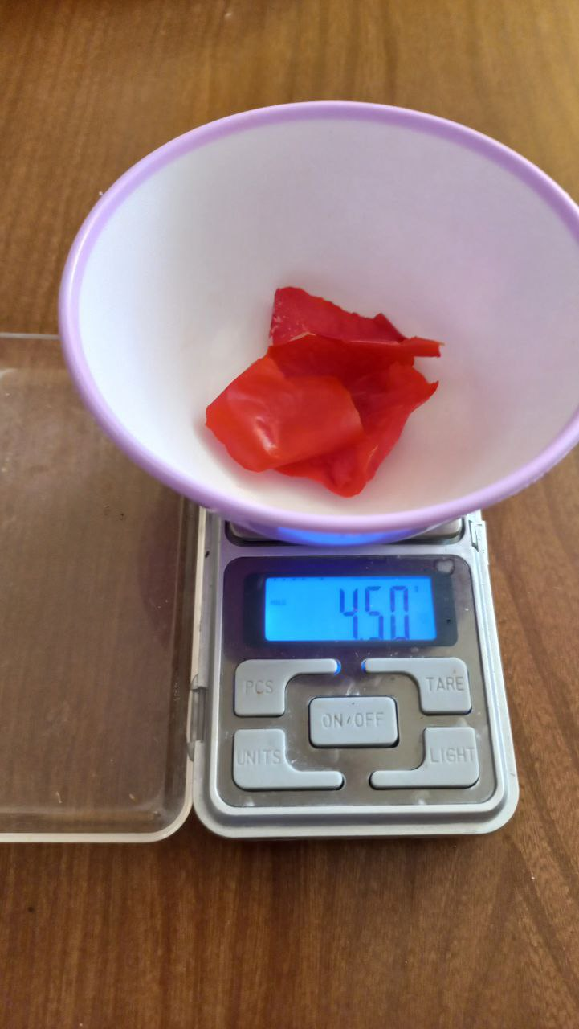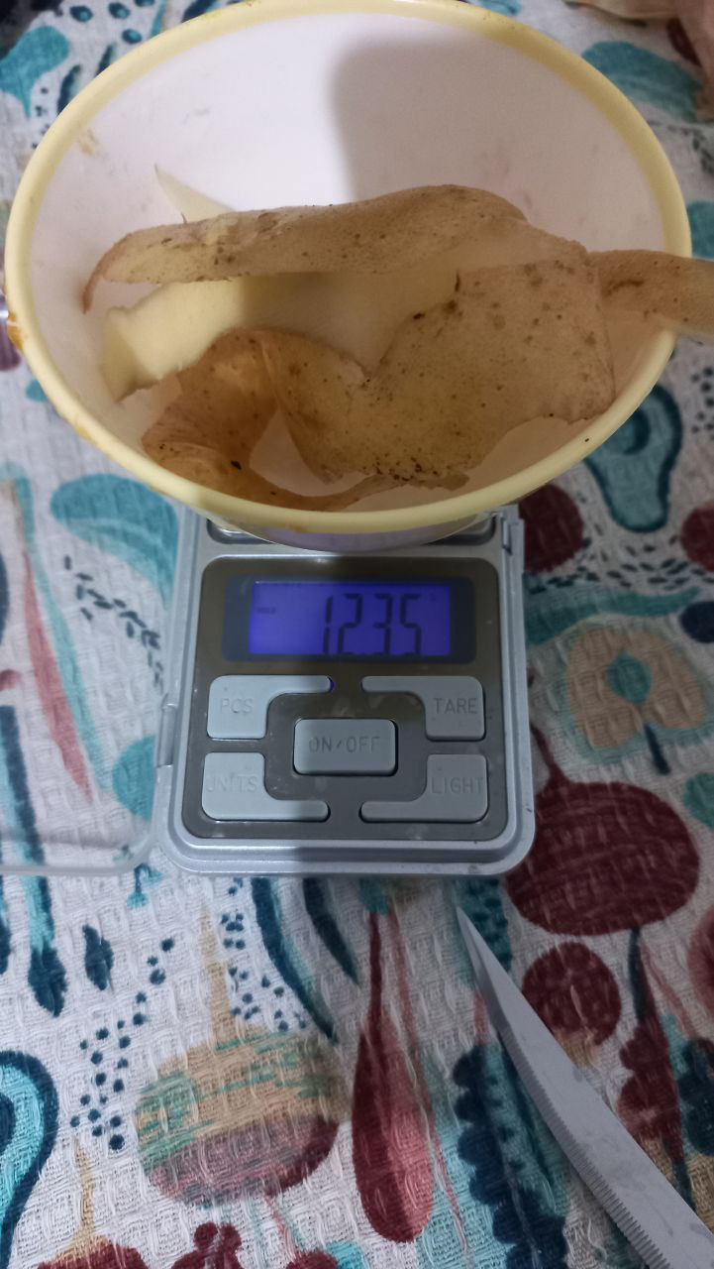
Figure (1): The picture taken by the author of the thesis is the food waste weight recorded every day.
Vermicompost Box
Pre-prepared vermicompost box is bought for 6 million Rials from Vermicomposting Group company in Tehran. The vermicompost box content included; 1) a bin with 6 to 7 kg substrate soil with high quality 2) 250 to 300 Eisenia fetida (Bouché) earthworms 3) some cocoons and earthworm babies. The box had some holes on its body that the air flowed into the box to prepare the oxygen for earthworms. It was placed in the dark place of home. A plastic plate was placed under the box for leachate. The soil substrate was turned upside down every day; because more oxygen and food particles are accessible to the earthworms and it improves the function of earthworms. Approximately 300 ml of water was added to the vermicompost environment every two or three days. While watering is so dependent on the initial moisture content of the food waste. Some food wastes had too much moisture and water content, which moistened the vermicompost substrate enough. So, it was not watered for several days. Sometimes, it was watered once a week.

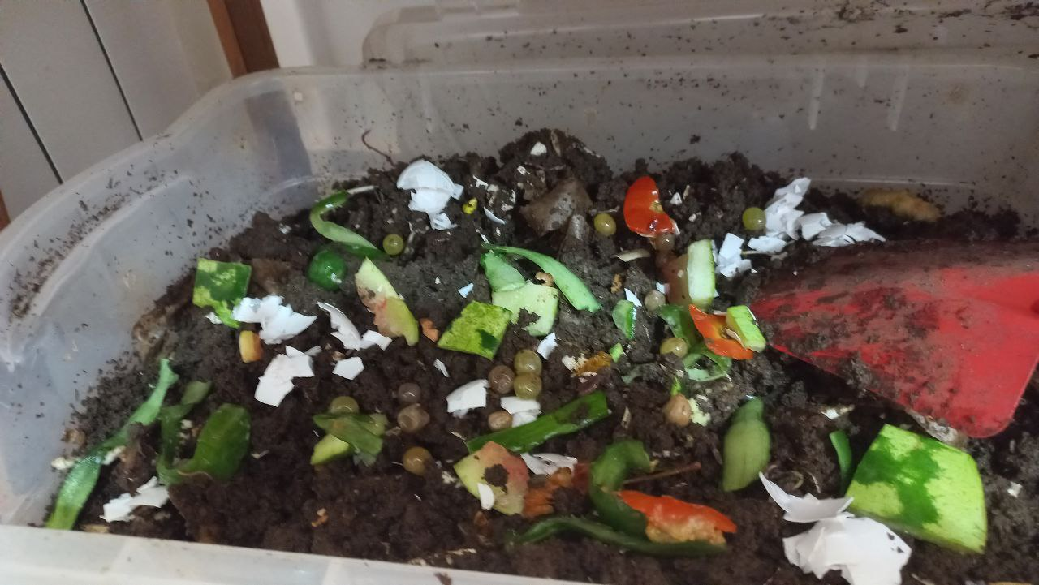
Figure (2): The picture taken by the author of the thesis is the food waste added to the vermicompost box.
After three months, the vermicompost fertilizer was separated from the earthworms. The box was exposed to the sunlight for some minutes and the earthworms moved to lower layers and the top soil was taken up. This was done 2 and 3 times. Figure (3)
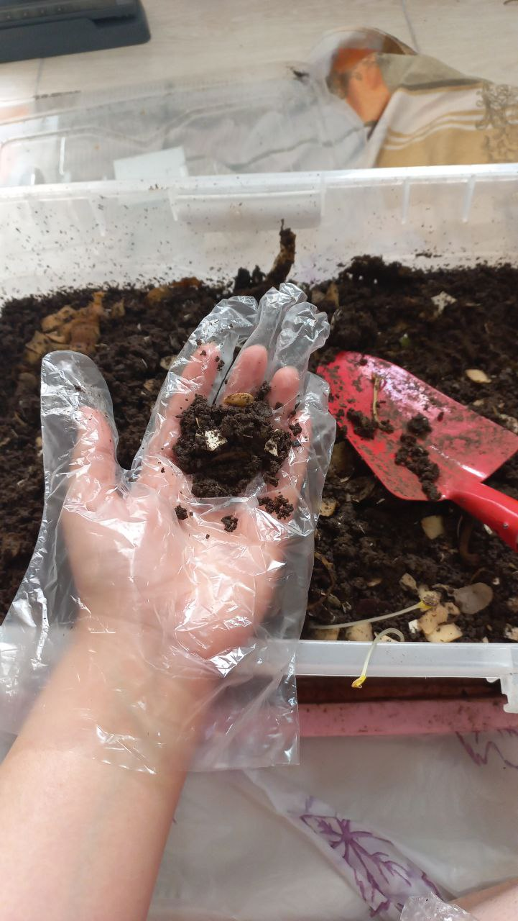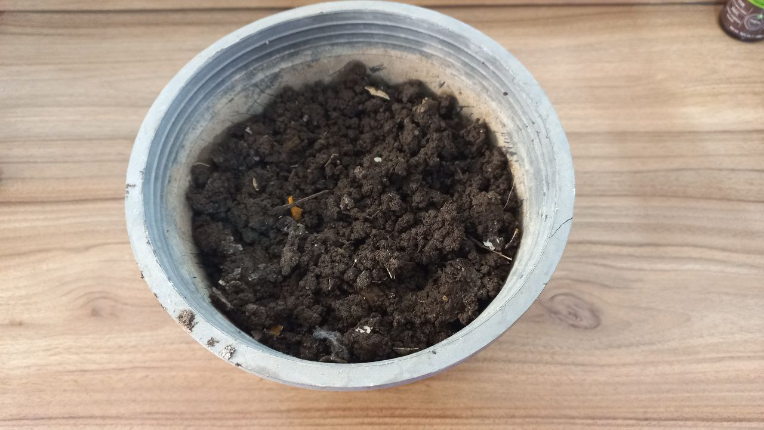
Figure (3): The picture taken by the author of the thesis is the separation stage of vermicompost fertilizer from earthworms.

Drying baskets
Some porous baskets were prepared and put on the balcony of the house, exposed to fresh air and sunlight. The paper in baskets helped the food waste not come out of the pores. The food wastes were cut into small sizes and they were arranged in baskets. When they dried completely, they were collected in a bag.

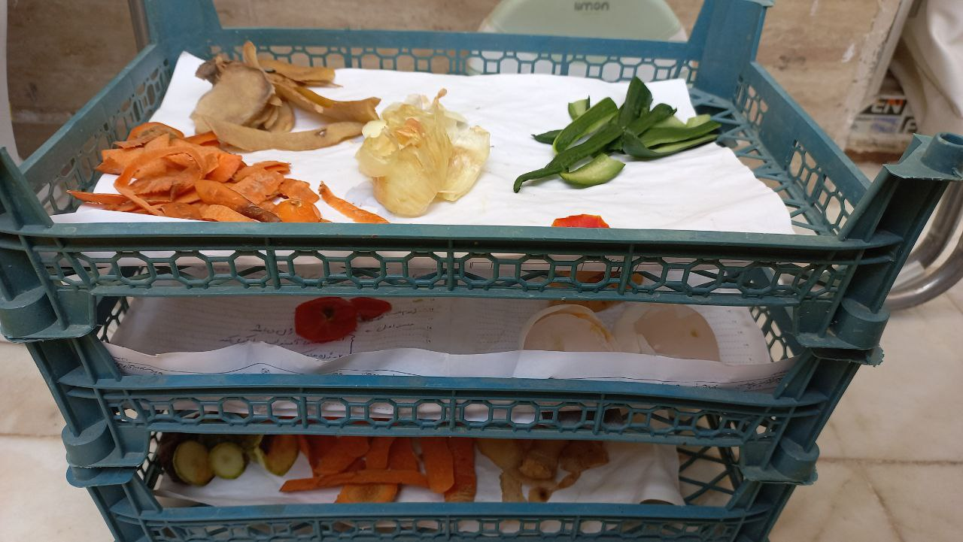
Figure (4): The picture taken by the author of the thesis is the food waste that is put in the baskets
After the food waste was dried completely, they were weighed and recorded the new weights.
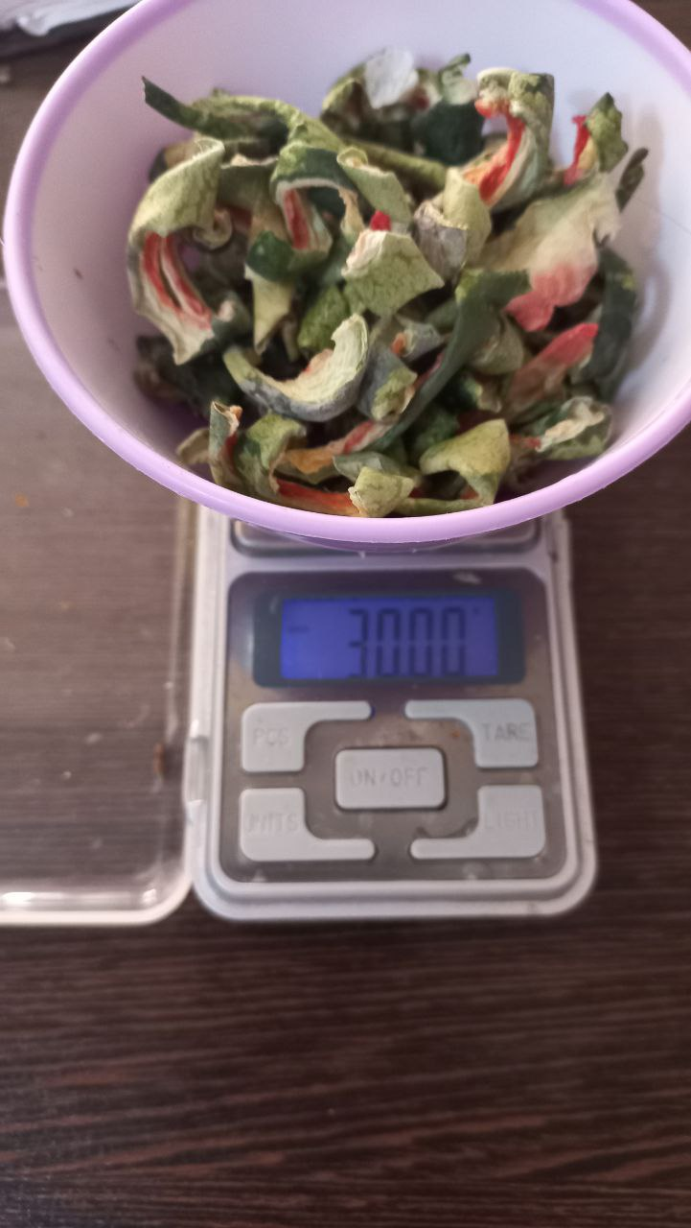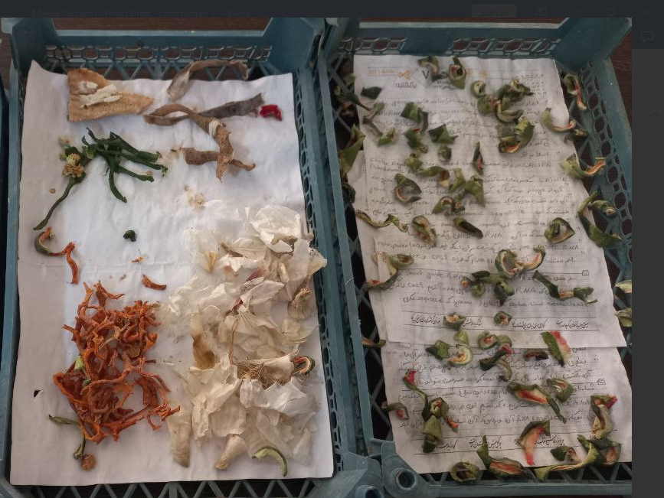
Figure (4): The picture taken by the author of the thesis is the dried food waste after 2 days.

- Result
the qualitative analyses were performed to compare the vermicompost and drying methods to reduce food waste in apartment spaces. This experiment lasted from June to August. The recorded weight of food waste is shown in appendix 1. The initial and the final weight of food waste are shown in the table.
Vermicompost methods
The vermicompost box occupied a small space of the home. It only needed to be put in a dark place without light. Environmental factors were so important in earthworms’ functions.
Food waste was one of the main factors in vermicompost. A large volume of food waste with high initial moisture contents (water lemon) was added to the box from 5 Jun to 7 June. The food waste became moldy and produced a very bad odor, it was like rotten fish odor. Mold causes contamination and grows microorganisms in earthworms’ environment that endanger their life. As a result, about 1 kg and 300 grams of food waste were removed from the box. After that, the amount of food waste was controlled. The food waste was not given to worms for several days when a large amount of food waste was produced. The type of food waste is another important factor. During the experiment, some food types could not give to the earthworms such as; onions and garlic, meat, fats, grease, bones, or oils, acidic foods, bread, salt, pepper, and other spicy foods.

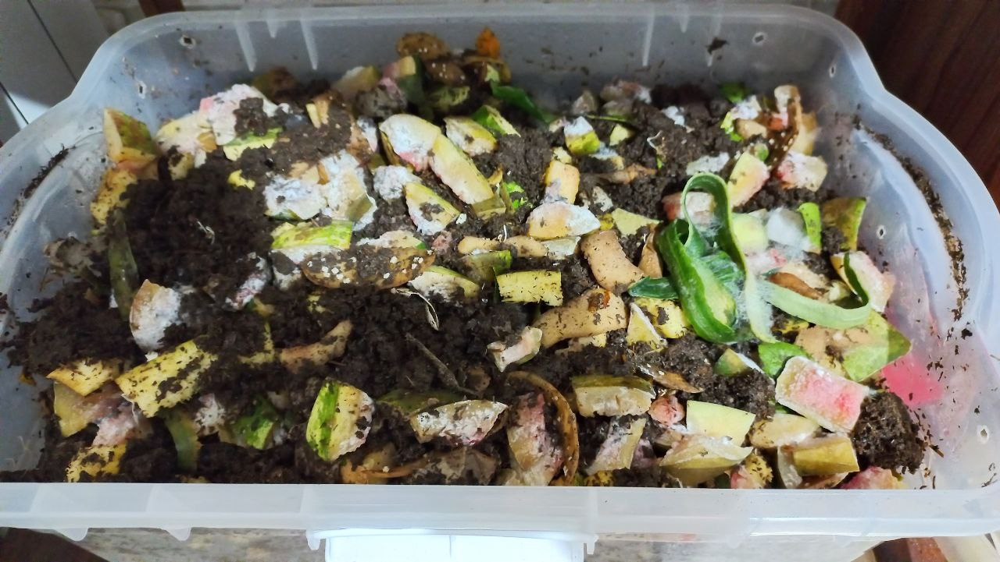
Figure (5): The picture taken by the author of the thesis is the food waste mold that occurs due to adding a large amount of food waste with high moisture content to vermiculture.
The vermicompost method produced leachate, but it had not a bad smell. The volume of leachate so depends on the rate of moisture content of food waste. the moisture was over the limit on 17-20 July, which produced a large volume of leachate and the earthworms came to the surface of the soil and moved to the wall of the box. The leachate, which is called vermicompost tea, was used for plants in the home. Vermicompost tea has many nutrients for the growth of plants.
The summer hot weather was a challenge for the earthworms. On most days the temperature was above 30 $℃$in Bojnourd. The temperature was above 40 degrees at the end of June (25-28). The soil lost moisture very soon. The heat wave reduced the performance of the earthworms. The earthworms decomposed the food waste more slowly than on other days.
Drying methods
Drying food waste needed more space because food waste should be spread in the baskets, till the fresh air and oxygen reach all parts of the food waste particles. Some food waste, such as lemon and water lemon, occupied a large space.
There was no limitation in drying any type of food waste. While the observation was shown that food waste with high moisture and water content decreases the drying rate. Some food waste such as lemon and water lemon, plum, cherry, and green cherry needed more time to dry. When drying took a long time, the food waste became moldy and more insects were gathered.
The hot summer weather had positive effects on the drying rate. The food waste dried in a short time. On the days when the airflow and wind speed were high, the food waste dried in a shorter period of time. One of the main problems of the drying process was gathering insects around food waste. The food waste attracted insects to the home, which was annoying. Sometimes, the insects were observed in the vermicompost boxes. It was so hard to keep the earthworms away from these insects.
Dried food waste produced any leachate. They lost their water and moisture completely They were so clean and had a good smell. The data shows that volume and weight reduced food waste increasingly by drying methods. Only the skin of melons and cantaloupes got moldy on July 22, because they were not sliced properly. When the thickness of food waste was reduced the waste dried very well.
The end product
- Vermicompost
At first the soil of the vermicompost box was dark brown. After addition of food waste to the box, soil volume increased. When the waste was decomposed by the earthworms after two days, soil volume decreased. This soil was so nutrient-rich, that sometimes food waste germinated in it (figure 6). The vermicompost end-product was dark and moist soil (figure 3). The vermicompost fertilizer was used for planting vegetables.
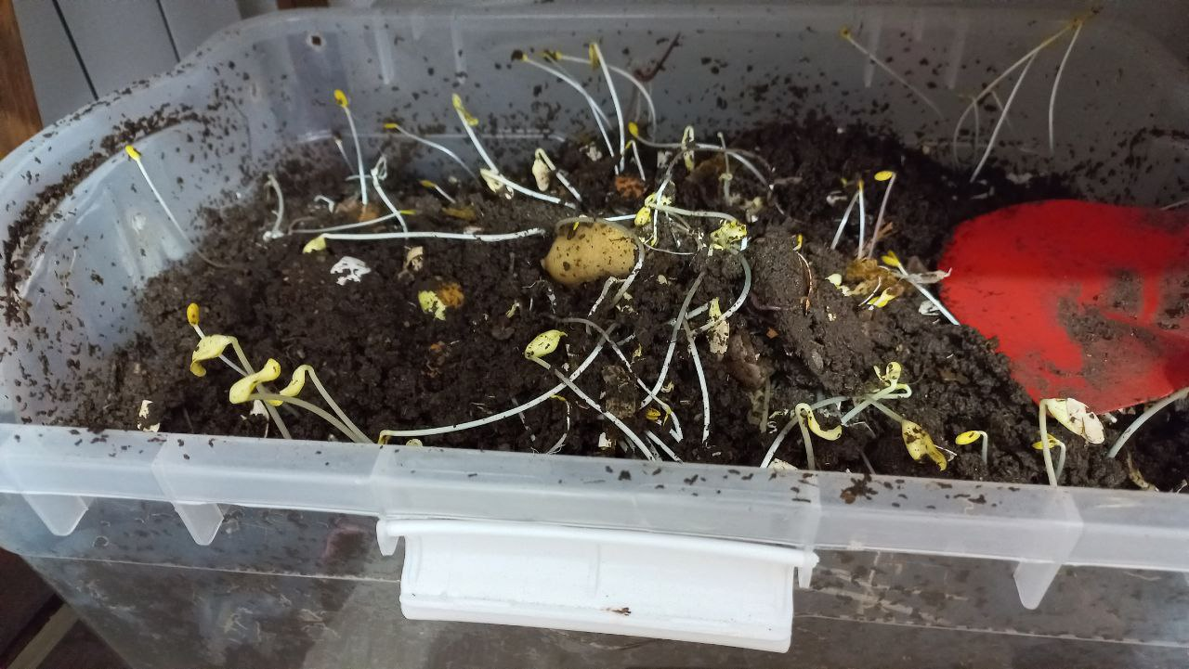
Figure (6): The picture taken by the author of the thesis is the germination of food waste in the vermicompost box.
- Dried Food waste
Food waste dried after 1- 2 days; the high moisture food waste needed more time to dry (3-4 days). The dried food waste lost around 70%-80% of its water. They became so light and they could be carried very easily. Dried food did not mold and did not produce any leachate. So dried food waste can be kept at home for a long time. In the end, the dried food waste was given to a local rancher to use as food for his animals.
Expense
Finding and receiving pre-prepared vermicompost took 4 days. There was no company in Bojnourd to produce the domestic vermicompost box. So, the vermicompost box was prepared by Vermicomposting company from Tehran. The vermicompost box cost about 6 million Rials, but drying methods did not have any cost. Some fruit baskets were prepared from the local fruit store. The vermicompost method is more expensive compared to drying methods.

- Discussion and Conclusion
According to most studies, a large volume of food waste is deposited in landfills every day. Billions of tons of food are lost every year in Iran due to a lack of accurate management and planning. The food waste in landfill is so harmful and produces greenhouse and leachates. Vermicompost and drying are two methods, that each person can manage their food waste in the apartments. The aim of this research is the comparison of these two methods for managing food waste at the source, to explore which one is a suitable and efficient method in apartment space.
Vermicompost methods
The result obtained is shown environmental factors seriously affect the vermicompost process, such as food, moisture, temperature, and oxygen.^{77,78} The data support the Edwards and Bohlen (1996) studies that the type and rate of food waste have an important effect on the vermicomposting process.⁷⁹ According to Figure. 5, the high amount of food waste and initial moisture content produced mold in the vermicompost box. Earthworms could not decompose high amounts of food waste. Riggle and Holmes (1994) observed that each worm can eat equal to its own weight in twenty-four hours.⁸⁰ Additional materials become a suitable substrate for the growth of microorganisms and mold.³⁹ The type of food waste should be controlled. Some food waste is toxic and put in danger the life of earthworms. So, earthworms could not eat any type of food waste and they only had to be dried during the experiment.
The results show that food waste’s initial moisture should be controlled. Some food waste had high water content such as lemon and water lemon which produced high amounts of leachate and the worms came out from the soil. The observation supports Appellof (1997) research that excessive water and moisture can cause the oxygen reduction of vermiculture and lead to the suffocation of earthworms.⁸¹ Reinecke and Venter (1985) noted the optimum moisture content of vermiculture for Eisenia fetida is 70%.⁸²
The temperature was one of the biggest challenges for vermicomposting methods. The speed of decomposition of food waste on hot days by earthworms reduced increasingly. A study conducted by Dominguez and Edwards (2004) to assess the population of earthworms at temperatures above 30 $℃$ showed that the oxygen level of vermiculture was reduced by the enhancement of chemical and microbial activities and disrupted the earthworm’s functions.⁸³
Drying methods
Drying is a very easy method. Every type and amount of food waste can be dried. The rate of drying was depending on different factors such as temperature, initial moisture, and thickness. The hot summer weather increased the drying rate. Sadin et al. (2013) observed that by increasing the temperature on drying of the thin layer of tomatoes, vapor pressure increased and crop drying fast and their tomato slices dried effectively.⁸⁴ Also reducing the thickness of the food waste enhanced the drying rates. Once, when the food waste was not sliced well, it got moldy and did not dry. Ross (2020) stated that water molecules can migrate to the surface easily when the thickness/densities reduce and the surface area increases.⁸⁵ Sairam et al. (2017) explained more thickness increases the activation energy values and reduces the drying efficiency.⁸⁶ Rasing Airflow was another parameter that assist the food waste dried efficiency. Chandramohan (2018) realized that by increasing the airflow the drying rate is increased. They observed that the rate of convection and the diffusion rate increase by increasing the airflow velocity at a particular temperature (60 $℃)$. The moisture content of biowaste decreases by increasing the airflow velocity.⁸⁸
The dried food waste lost its moisture completely. The rate of moisture reduction is dependent on the initial moisture content and composition of food waste. Sotiropoulos (2015) explained that food waste reduces 70-90% of its moisture by drying and it can be kept and transferred very easily because its volume is reduced scientifically.⁶⁸
The two main challenge of drying methods was space and insects. Traditional drying techniques occupied a large space in the apartment. The Observation was shown in the hot summer season, food waste attracted insects to themselves. Sotiropoulos (2015) used a dryer device to study households' dehydration of domestic food waste. Using new technologies instead of traditional methods can be easier for the household to dry their food waste better at home.⁶⁸
Limitation
The amount of food waste produced was very small every day by the household. This small amount of food waste had to be halved, half of it was dried and the other part was given to worms. Some days, the amount obtained was not enough for the worms. So, the food waste of another household was also used to prepare enough food for the worms.
Comparison of drying and vermicompost methods
According to the result of this study, both drying and vermicompost are easy and practical methods for managing food waste in the apartment space. Each of these methods had its special advantages and challenges. Depending on the household condition one of these methods or both can be used. For example, traditional drying is a much cheaper method than vermicompost in the current conditions of Iran, and preparing earthworms and the vermicompost box is not easy in every city of Iran. While drying occupied more space and attract insects which may be a problem in a small apartment. Vermicomposting produces valuable products, vermicompost fertilizer, for households, whereas dried food waste only can be used for animal feed and there is no necessary technology to convert dried food waste into bio-fuels in Iran. Keeping and maintaining the necessary conditions for the survival of worms and even using worms is not pleasant for everyone, drying does not require special control.
Suggestions for future study
Today, there are many discussions in Iran regarding the management of dry waste such as plastic, glass, and metals. People are looking for a way to recycle or reuse them. However, there is not enough knowledge and awareness about food waste management. So, a large amount of waste is thrown away every day by people. But this experiment has shown that vermicomposting and drying are two efficient methods to reduce the amount of household food waste. People can easily reduce their carbon footprint by using these two methods and prevent the production of greenhouse gases and leachates in nature which are caused by food waste.
The next experiment and research can focus on increasing social awareness about the management of food waste in society, especially the age of children and teenagers who play a significant role in the formation of their societies in the future. Also, it can be conducted similar experiments to find effective methods for food waste management in schools, universities, and other administrative institutions.

7. References:
1. United Nations. Growing at a slower pace, world population is expected to reach 9.7 billion in 2050 and could peak at nearly 11 billion around 2100. https://www.un.org/development/desa/en/news/population/world-population-prospects-2019.html. (2019)
2. Wri.org. How to Sustainably Feed 10 Billion People by 2050, in 21 Charts. https://www.wri.org/insights/how-sustainably-feed-10-billion-people-2050-21-charts?_ga=2.112236039.2059916650.1656231377-806633133.1649247518. (2018)
3. European Commission & Report, T. Preparatory Study on Food Waste Across Eu 27. October 33, 17 (2010).
4. Reisch, L. A. et al. Mitigating climate change via food consumption and food waste: A systematic map of behavioral interventions. Journal of Cleaner Production 279, (2021).
5. Njie, D. Global Initiative on Food losses and Waste Reduction. Food And Agriculture Organization of the United Nations (2012).
6. Hertwich, E. G. The Life Cycle Environmental Impacts Of Consumption. Economic Systems Research 23, 27–47 (2011).
7. UNEP. The Environmental Food Crisis: A UNEP Rapid Response Assessment. (2009)
8. To, S., Coughenour, C. & Pharr, J. The environmental impact and formation of meals from the pilot year of a Las Vegas convention food rescue program. International Journal of Environmental Research and Public Health 16, (2019).
9. (Intergovernmental Panel on Climate Change. “Climate Change 2013: The Physical Science Basis.” Fifth Assessment Report, Table 8.7. Cambridge University Press, 2013. Retrieved March 7, 2019, from https://www.climatechange2013.org/images/report/WG1AR5_ALL_FINAL.pdf )
10. In Genetically Modified Plants 283–296 (Elsevier, 2021). doi:10.1016/b978-0-12-818564-3.09991-1
11. Ranganathan, S., Dutta, S., Moses, J. A. & Anandharamakrishnan, C. Utilization of food waste streams for the production of biopolymers. Heliyon 6, (2020).
12. Allan, J. A. in The Water We Eat: Combining Virtual Water and Water Footprints 17–34 (Springer International Publishing, 2015). doi:10.1007/978-3-319-16393-2_2
13. COMMUNITIES COTE. Commission of the European on implementation of the community waste legislation. (2006)
14. FAO. Sustainable Development Goals. https://www.fao.org/sustainable-development-goals/indicators/1231/en/#:~:text=A%20proposal%20for%20measuring%20Food%20Waste%2C%20which%20comprises,along%20production%20and%20supply%20chains%2C%20including%20post-harvest%20losses. (2022)
15.Di Donato, M. & Carpintero, Ó. Household food metabolism: Losses, waste and environmental pressures of food consumption at the regional level in spain. Foods 10, (2021).
16. Oakes, K. How cutting your food waste can help the climate. https://www.bbc.com/future/article/20200224-how-cutting-your-food-waste-can-help-the-climate.(2020)
17. Ojha, S., Bußler, S. & Schlüter, O. K. Food waste valorisation and circular economy concepts in insect production and processing. Waste Management 118, 600–609 (2020).
18. Sulewski, P. et al. Home bio-waste composting for the circular economy. Energies 14, (2021).
19. Salihoglu, G., Salihoglu, N. K., Ucaroglu, S. & Banar, M. Food loss and waste management in Turkey. Bioresource Technology 248, 88–99 (2018).
20. Sadeghpour, A. H. Shariatmadari, N. Dogmehchi, F. Karam Dad, A.H. The assessment of effect of inert materials on the behavior and shear strength of fresh and aged municipal solid wastes. Sharif Civil Engineering, (2019).
21.Alidoust, P. Keramati, M. Shariatmadari, N. Amlashi, A. T. Comparison of municipal solid waste management in Tehran and industrialized developed countries in accordance with the concept of sustainable development. The International Conference on Sustainable development & Urban Construction،Isfahan. (2016)
22. Eghtesadonline. Food waste in Iran is equivalent to 10 European countries. https://www.eghtesadonline.com/%D8%A8%D8%AE%D8%B4%D8%B9%D9%85%D9%88%D9%85%DB%8C-30/144869-%D8%B2%D8%A8%D8%A7%D9%84%D9%87 %D9%87%D8%A7%DB%8C-%D8%BA%D8%B0%D8%A7-%D8%AF%D8%B1-%D8%A7%DB%8C%D8%B1%D8%A7%D9%86%D9%85%D8%B9%D8%A7%D8%AF%D9%84-%DA%A9%D8%B4%D9%88%D8%B1 %D8%A7%D8%B1%D9%88%D9%BE%D8%A7%DB%8C%DB%8C. (2020).
23. Mehrnews. 30% of food in Iran becomes waste. https://www.mehrnews.com/news/3912977/%DB%B3%DB%B0-%D8%AF%D8%B1%D8%B5%D8%AF-%D9%85%D9%88%D8%A7%D8%AF-%D8%BA%D8%B0%D8%A7%DB%8C%DB%8C-%D8%AF%D8%B1-%D8%A7%DB%8C%D8%B1%D8%A7%D9%86-%D8%A8%D9%87-%D8%B2%D8%A8%D8%A7%D9%84%D9%87-%D8%AA%D8%A8%D8%AF%DB%8C%D9%84-%D9%85%DB%8C-%D8%B4%D9%88%D8%AF. (2018).
24. Gajalakshmi, S. & Abbasi, S. A. Earthworms and vermicomposting. Indian Journal of Biotechnology 3, 486–494 (2004).
25. Verified market research. Global Vermicompost Market Size By Product (Lumbricus Rebellus Vermicomposting, Africa Night Crawlers Vermicomposting, And Others), By Application (Home Gardening, Horticulture, Golf Courses, And Landscaping), By Geography Scope And Forecast. https://www.verifiedmarketresearch.com/product/vermicompost-market/. (2021)
26. Benitez, E., Nogales, R., Elvira, C., Masciandaro, G. & Ceccanti, B. Enzyme activities as indicators of the stabilization of sewage sludges composting with Eisenia foetida. Bioresource Technology 67, 297–303 (1999).
27. Ali, U. et al. A review on vermicomposting of organic wastes. Environmental Progress and Sustainable Energy 34, 1050–1062 (2015).
28. Edwards, C. A. in Earthworm Ecology 333–360 (CRC Press, 2020). doi:10.1201/9781482285246-27
29. Garg, V. K., Chand, S., Chhillar, A. & Yadav, A. Growth and reproduction of Eisenia foetida in various animal wastes during vermicomposting. Applied Ecology and Environmental Research 3, 51–59 (2005).
30. Suthar, S. & Singh, S. Vermicomposting of domestic waste by using two epigeic earthworms (Perionyx excavatus and Perionyx sansibaricus). International Journal of Environmental Science and Technology 5, 99–106 (2008).
31. Singh, R. P., Embrandiri, A., Ibrahim, M. H. & Esa, N. Management of biomass residues generated from palm oil mill: Vermicomposting a sustainable option. Resources, Conservation and Recycling 55, 423–434 (2011).
32. Edwards, C.A. Breakdown of Animal, Vegetable and Industrial Organic Wastes by Earthworms. In: Edwards, C.A. and Neuhauser, E.F., Eds., Earthworms in Waste and Environmental Management, SPB Academic Publishing, The Hague, 21-31. (1988)
33. Reinecke, A. J. & Kriel, J. R. Influence of temperature on the reproduction of the earthworm Eisenia foetida (Oligochaeta). South African Journal of Zoology 16, 96–100 (1981).
34. Sherman, R. L. in Vermiculture Technology: Earthworms, Organic Wastes, and Environmental Management 391–408 (CRC Press, 2010). doi:10.1201/b10453
35. Neuhauser, E. F., Loehr, R. C., and Malecki, M. R. The potential of earthworms for managing sewage sludge. In Earthworms in Waste and Environmental Management, ed. C. A. Edwards and E. F. Neuhauser, 9–20. SPB Academic Publishing, the Hague, the Netherlands. (1988)
36. Rostami R, Nabaei A, Eslami A. Survey of optimal temperature and moisture for worms' growth and operating vermicompost production of food wastes. Health and environment, 1(2): 105-112. (2009)
37. Edwards, C.A. Breakdown of Animal, Vegetable and Industrial Organic Wastes by Earthworms. In: Edwards, C.A. and Neuhauser, E.F., Eds., Earthworms in Waste and Environmental Management, SPB Academic Publishing, The Hague, 21-31. (1988)
38. Jamieson, B. G. M., Edwards, C. A. & Lofty, J. R. Biology of Earthworms. The Journal of Animal Ecology 42, 821 (1973).
39. Ndegwa, P. M., Thompson, S. A. & Das, K. C. Effects of stocking density and feeding rate on vermicomposting of biosolids. Bioresource Technology 71, 5–12 (2000).
40. Haimi, J. & Huhta, V. Capacity of various organic residues to support adequate earthworm biomass for vermicomposting. Biology and Fertility of Soils 2, 23–27 (1986).
41. Neuhauser, E. F., Kaplan, D. L., Malecki, M. R. & Hartenstein, R. Materials supporting weight gain by the earthworm Eisenia foetida in waste conversion systems. Agricultural Wastes 2, 43–60 (1980).
42. Ali, M. QUALITY ENHANCEMENT OF COMPOST USING VERMICOMPOSTING AND AIR SEPARATION Thesis submitted for the degree of Doctor of Philosophy By September 2007 Institute of Sustainability , Energy and Environmental Management Cardiff School of Engineering. (2007).
43. Komakech, A. J., Zurbrügg, C., Miito, G. J., Wanyama, J. & Vinnerås, B. Environmental impact from vermicomposting of organic waste in Kampala, Uganda. Journal of Environmental Management 181, 395–402 (2016).
44. Edwards, C. & Arancon, N. The science of vermiculture: the use of earthworms in organic waste management. Vermi Technologies for … 1–25 (2005).
45. Younas, M. et al. The influence of vermicomposting on photosynthetic activity and productivity of maize (Zea mays L.) crop under semi-arid climate. PLoS ONE 16, (2021).
46. Blouin, M. et al. Vermicompost significantly affects plant growth. A meta-analysis. Agronomy for Sustainable Development 39, (2019).
47. Manivannan, S., Balamurugan, M., Parthasarathi, K., Gunasekaran, G. & Ranganathan, L. S. Effect of vermicompost on soil fertility and crop productivity - Beans (Phaseolus vulgaris). Journal of Environmental Biology 30, 275–281 (2009).
48. Zhao, F. et al. Vermicompost improves microbial functions of soil with continuous tomato cropping in a greenhouse. Journal of Soils and Sediments 20, 380–391 (2020).
49. Velis, C. A., Longhurst, P. J., Drew, G. H., Smith, R. & Pollard, S. J. T. Biodrying for mechanical-biological treatment of wastes: A review of process science and engineering. Bioresource Technology 100, 2747–2761 (2009).
50.Tun, M. M. & Juchelková, D. Drying methods for municipal solid waste quality improvement in the developed and developing countries: A review. Environmental Engineering Research 24, 529–542 (2019).
51. Robles-Martínez, F. Biodrying under Greenhouse Conditions as Pretreatment for Horticultural Waste. Journal of Environmental Protection 03, 298–303 (2012).
52. Choi, H. L., Richard, T. L. & Ahn, H. K. Composting high moisture materials: Biodrying poultry manure in a sequentially fed reactor. Compost Science and Utilization 9, 303–311 (2001).
53. Negoi, R. M., Ragazzi, M., Apostol, T., Rada, E. C. & Mǎrculescu, C. Bio-drying of romanian municipal solid waste: An analysis of its viability. UPB Scientific Bulletin, Series C: Electrical Engineering 71, 193–204 (2009).
54. Pin-jing, He, Zheng-Hao Shao, Dongqing Zhang and Li-ming Shao. “Bio-stabilization of municipal solid waste prior to landfill : Environmental and economic assessment.” (2009).
55.Yoo, J. Y., Kim, H. J., Woo, E. J. & Park, C. J. On Solar Energy Utilization for Drying Technology. International Journal of Environmental Science and Development 8, 305–311 (2017).
56. Toshniwal, U. and Karale, S. R. A review paper on Solar Dryer. International Journal of Engineering Research and Applications 3, 896–902 (2013).
57. Ferreira, A. G., Gonçalves, L. M. & Maia, C. B. Solar drying of a solid waste from steel wire industry. Applied Thermal Engineering 73, 102–108 (2014).
58. Deng, Z. et al. A literature research on the drying quality of agricultural products with using solar drying technologies. Solar Energy 229, 69–83 (2021).
59. Ragazzi, M., Rada, E. C., Panaitescu, V. & Aposto, T. Municipal solid waste pre-treatment: A comparison between two dewatering options. WIT Transactions on Ecology and the Environment 102, 943–949 (2007).
60. Water Environment Federation. Residuals and Biosolids Committee Bioenergy Technology Subcommittee. Fact Sheet: Drying of wastewater solids. January 2014 [Internet]. Water Environment Federation; c2018 (2018).
61. Bukhmirov, V. V., Kolibaba, O. B. & Gabitov, R. N. Experimental research of solid waste drying in the process of thermal processing. in IOP Conference Series: Materials Science and Engineering 93, (Institute of Physics Publishing, 2015).
62. Experimental Investigation of drying process for Mixed Municipal Solid Waste: Case Study of Wastes Generated in Nairobi, Kenya. International Journal of Advances in Agricultural and Environmental Engineering 3, (2016).
63. Velis, C. A., Longhurst, P. J., Drew, G. H., Smith, R. & Pollard, S. J. T. Biodrying for mechanical-biological treatment of wastes: A review of process science and engineering. Bioresource Technology 100, 2747–2761 (2009).
64. Mohseni, M., & Peters, B. (2016). Effects of particle size distribution on drying characteristics in a drum by XDEM: A case study. Chemical Engineering Science, 152, 689–698. https://doi.org/10.1016/j.ces.2016.07.004
65. Sadin, R., Chegini, G. R. & Sadin, H. The effect of temperature and slice thickness on drying kinetics tomato in the infrared dryer. Heat and Mass Transfer/Waerme- und Stoffuebertragung 50, 501–507 (2014).
66. Huiliñir, C. & Villegas, M. Simultaneous effect of initial moisture content and airflow rate on biodrying of sewage sludge. Water Research 82, 118–128 (2015).
67. Chandramohan, V. P. Influence of air flow velocity and temperature on drying parameters: An experimental analysis with drying correlations. in IOP Conference Series: Materials Science and Engineering 377, (Institute of Physics Publishing, 2018).
68. Sotiropoulos, A., Malamis, D. & Loizidou, M. Dehydration of Domestic Food Waste at Source as an Alternative Approach for Food Waste Management. Waste and Biomass Valorization 6, 167–176 (2015).
69. Mahmood, A., Iguchi, R. & Kataoka, R. Multifunctional food waste fertilizer having the capability of Fusarium-growth inhibition and phosphate solubility: A new horizon of food waste recycle using microorganisms. Waste Management 94, 77–84 (2019).
70. O’Connor, J. et al. Value of dehydrated food waste fertiliser products in increasing soil health and crop productivity. Environmental Research 204, (2022).
71. Machado, R. M. A. & Serralheiro, R. P. Soil salinity: Effect on vegetable crop growth. Management practices to prevent and mitigate soil salinization. Horticulturae 3, (2017).
72. Murphy, B. W. Impact of soil organic matter on soil properties - A review with emphasis on Australian soils. in Soil Research 53, 605–635 (CSIRO, 2015).
73. Noori, A.W.; Royen, M.J.; Medved’ová, A.; Haydary, J. Drying of Food Waste for Potential Use as Animal Feed. Sustainability, 14, 5849, (2022).
74. Schroeder, J. T., Labuzetta, A. L. & Trabold, T. A. Assessment of dehydration as a commercial-scale food waste valorization strategy. Sustainability (Switzerland) 12, (2020).
75. . Pirsaheb, M., Khosravi, T. & Sharafi, K. Domestic scale vermicomposting for solid waste management. International Journal of Recycling of Organic Waste in Agriculture 2, (2013).
76. Lleó, T. et al. Home and vermicomposting as sustainable options for biowaste management. Journal of Cleaner Production 47, 70–76 (2013).
77 .Amaravathi, G. & Mallikarjuna, R. R. Environmental factors affecting vermicomposting of Municipal Solid Waste. International Journal of Pharmacy … 5, (2015).
78. Singh, J., Singh, S., Vig, A. P. & Kaur, A. in Earthworms - The Ecological Engineers of Soil (InTech, 2018). doi:10.5772/intechopen.75127
79. Edwards, C. A. & Bohlen, P. J. Biology and ecology of earthworms. Third edition. Biology and ecology of earthworms. Third edition (1996).
80. Riggle et al. Earthworms and Composting. Biocycle: Journal of Composting and Recycling. Vol. 35, No. 10 (1994).
81. Appelhof, M. Worms eat my garbage. Second edition. Flower press, Kalamazoo, Michigan. (1997).
82. REINECKE, AJ. & VENTER.l.M. The influence of moisture on the growth and reproduction of the compost worm Eiseniafelida (Oligochaeta). Rev. Ecol. Bioi. Sol. 22(4): 473-481 (1985).
83. Domínguez, J. in Earthworm Ecology, Second Edition 401–424 (CRC Press, 2004). doi:10.1201/9781420039719
84. Sadin, R., Chegini, G. R. & Sadin, H. The effect of temperature and slice thickness on drying kinetics tomato in the infrared dryer. Heat and Mass Transfer/Waerme- und Stoffuebertragung 50, 501–507 (2014).
85. Ross, K. A., DeLury, N., Fukumoto, L. & Diarra, M. S. Dried berry pomace as a source of high value-added bioproduct: drying kinetics and bioactive quality indices. International Journal of Food Properties 23, 2123–2143 (2020).
86. Sairam, N. N. H., Kumar, M. N., Edukondalu, L. & Kumar, G. Y. Effect of Slice Thickness on Drying Kinetics of Papaya using Food Dehydrator. International Journal of Agriculture, Environment and Biotechnology 10, 749 (2017).
87. Chandramohan, V. P. Influence of air flow velocity and temperature on drying parameters: An experimental analysis with drying correlations. in IOP Conference Series: Materials Science and Engineering 377, (Institute of Physics Publishing, 2018).
88. Ahadanjadroshti, M. Gholamhosseini, R. Zadoli Khajeh, S. Apartment living in Iranian-Islamic cities and the social and cultural problems caused by it, a case study: Tabriz city. International conference on civil engineering, architecture and sustainable urban development, Tabriz. (2013). https://civilica.com/doc/273944/
89. Salamatnews. Waste production in Iran is three times the world standard. (2017). https://www.salamatnews.com/news/209850/%D8%AA%D9%88%D9%84%DB%8C%D8%AF-%D9%BE%D8%B3%D9%85%D8%A7%D9%86%D8%AF-%D8%AF%D8%B1-%D8%A7%DB%8C%D8%B1%D8%A7%D9%86-%D8%B3%D9%87-%D8%A8%D8%B1%D8%A7%D8%A8%D8%B1-%D8%A7%D8%B3%D8%AA%D8%A7%D9%86%D8%AF%D8%A7%D8%B1%D8%AF-%D8%AC%D9%87%D8%A7%D9%86%DB%8C-%D8%A7%D8%B3%D8%AA
90. Eghtesadonline. 35 million tons of Iranian food waste per year. (2020). https://www.eghtesadonline.com/%D8%A8%D8%AE%D8%B4-%D8%A7%D9%82%D8%AA%D8%B5%D8%A7%D8%AF-%DA%A9%D9%84%D8%A7%D9%86-3/443571-%D9%85%DB%8C%D9%84%DB%8C%D9%88%D9%86-%D8%AA%D9%86-%D8%AF%D9%88%D8%B1%D8%B1%DB%8C%D8%B2-%D9%85%D9%88%D8%A7%D8%AF-%D8%BA%D8%B0%D8%A7%DB%8C%DB%8C-%D8%A7%DB%8C%D8%B1%D8%A7%D9%86-%D8%AF%D8%B1-%D8%B3%D8%A7%D9%84

Appendix 1

Wednesday (2022/Jun/1)  T= 30$℃$ |  | First Weight (gr) | Second weight (gr)
Egg Shell | Vermicompost | 9.95
Egg Shell | Drying | 8.97 | 7.62
Date palm | Vermicompost | 13.50
Date palm | Drying | 13.20 | 12.90
Cucumber peel | Vermicompost | 21.16
Cucumber peel | Drying | 21.30 | 1.04
Tomato peel | Vermicompost | 13.00
Tomato peel | Drying | 13.40 | 3.90
Tee waste | Vermicompost | 11.50
Tee waste | Drying | 11.50 | 1.04
cabbage | Vermicompost | 32.03
cabbage | Drying | 32.40 | 5/16
Potato peel | Vermicompost | 16.50
Potato peel | Drying | 16.50 | 2.81

Thursday (2022/Jun/2)  T=31$℃$ |  | First Weight (gr) | Second weight (gr)
Egg Shell | Vermicompost | 9.50
Egg Shell | Drying | 9.42 | 8.90
Watermelon shell | Vermicompost | 62.50
Watermelon shell | Drying | 62.50 | 7.94
Cucumber peel | Vermicompost | 23.50
Cucumber peel | Drying | 23.50 | 1.43
Pomato peel | Vermicompost | 107.10
Pomato peel | Drying | 106.80 | 22.23
Tee waste | Vermicompost | 12.78
 | Drying | 12.40 | 1.21

Friday (2022/Jun/3)  T=31$℃$ |  | First Weight (gr) | Second weight (gr)
Egg Shell | Vermicompost | 6.52
Egg Shell | Drying | 6.53 | 6.40
Watermelon shell | Vermicompost | 1100.00
Watermelon shell | Drying | 1150.00 | 86.06
Cucumber peel | Vermicompost | 2.62
Cucumber peel | Drying | 2.43 | 0.33
Banana peel | Vermicompost | 13.00
Banana peel | Drying | 10.34 | 0.98
Tee waste | Vermicompost | 20.11
 | Drying | 20.32 | 2.32
Apple peel | Vermicompost | 18.67
 | Drying | 18.21 | 1.70
Tomato peel | Vermicompost | 7.80
 | Drying | 7.30 | 1.70

Saturday (2022/Jun/4)  T=31$℃$ |  | First Weight (gr) | Second weight (gr)
Watermelon peel | Vermicompost | 2100.00
Watermelon peel | Drying | 2200.00 | 240.07
Tea waste | Vermicompost | 29.04
Tea waste | Drying | 28.64 | 5.33

Sunday (2022/Jun/5)  T=31$℃$ |  | First Weight (gr) | Second weight (gr)
Egg Shell | Vermicompost | 6.19
Egg Shell | Drying | 6.73 | 5.53
Cucumber peel | Vermicompost | 13.12
Cucumber peel | Drying | 13.17 | 1.02
onion peel | Vermicompost
onion peel | Drying | 1.97 | 1.07
Tee waste | Vermicompost | 17.41
 | Drying | 17.50 | 1.87
potato peel | Vermicompost | 17.20
 | Drying | 17.30 | 5.14
Tomato peel | Vermicompost | 2.42
 | Drying | 7.66 | 0.32

Monday (2022/Jun/6)  T=34$℃$ |  | First Weight (gr) | Second weight (gr)
onion peel | Vermicompost
onion peel | Drying | 20.47 | 5.45
Tee waste | Vermicompost | 20.10
 | Drying | 20.15 | 1.96
potato peel | Vermicompost | 8.30
 | Drying | 8.99 | 1.67

Tuesday (2022/Jun/7)  T=35 $℃$ |  | First Weight (gr) | Second weight (gr)
watermelon peel | Vermicompost | 310.00
watermelon peel | Drying | 320.00 | 24.49
onion peel | Vermicompost
onion peel | Drying | 1.35 | 0.94
Tee waste | Vermicompost | 10.26
 | Drying | 10.23 | 0.30
potato peel | Vermicompost | 10.28
 | Drying | 10.31 | 2.42
banana peel | Vermicompost | 17.00
 | Drying | 7.66 | 0.32

Wednesday (2022/Jun/8)  T=35$℃$ |  | First Weight (gr) | Second weight (gr)
Egg Shell | Vermicompost | 5.78
Egg Shell | Drying | 5.49 | 4.93
Cucumber peel | Vermicompost | 17.37
Cucumber peel | Drying | 17.51 | 2.08
peach | Vermicompost | 1.50
peach | Drying | 1.50 | 0.64
potato peel | Vermicompost | 12.67
 | Drying | 12.12 | 3.31
Tomato peel | Vermicompost | 1.25
 | Drying | 1.37 | 0.22

Thursday (2022/Jun/9)  T=30$℃$ |  | First Weight (gr) | Second weight (gr)
Cabbage | Vermicompost | 16.06
Cabbage | Drying | 26.80 | 2.18
Cucumber peel | Vermicompost | 14.32
Cucumber peel | Drying | 14.30 | 1.71
Onion peel | Vermicompost
Onion peel | Drying | 2.63 | 2.01
potato peel | Vermicompost | 8.45
 | Drying | 8.62 | 1.55
Tomato peel | Vermicompost | 2.10
 | Drying | 2.20 | 0.15

Friday (2022/Jun/10)  T=30$℃$ |  | First Weight (gr) | Second weight (gr)
Strawberry leaves | Vermicompost | 50.00
Strawberry leaves | Drying | 50.00 | 24.27
Water lemon peel | Vermicompost | 400.00
Water lemon peel | Drying | 400.00 | 34.21
Tea waste | Vermicompost | 8.78
Tea waste | Drying | 8.56 | 0.23

Saturday (2022/Jun/11)  T=27$℃$ |  | First Weight (gr) | Second weight (gr)
Tomato | Vermicompost | 2.95
Tomato | Drying | 2.67 | 0.24
Cucumber peel | Vermicompost | 16.65
Cucumber peel | Drying | 16.35 | 1.97
Egg shell | Vermicompost | 45.94
Egg shell | Drying | 45.65 | 42.10
potato peel | Vermicompost | 28.32
 | Drying | 28.31 | 5.09
Tea waste | Vermicompost | 10.23
 | Drying | 10.29 | 0.98

Sunday (2022/Jun/12)  T= 27$℃$ |  | First Weight (gr) | Second weight (gr)
watermelon | Vermicompost
watermelon | Drying | 600.00 | 46.94
Vegetable | Vermicompost | 200.00
Vegetable | Drying | 200.00 | 27.77
Cucumber peel | Vermicompost
Cucumber peel | Drying | 18/88 | 1/24
Tomato peel | Vermicompost
Tomato peel | Drying | 3.01 | 1.22
Tee waste | Vermicompost
Tee waste | Drying | 29.43 | 4/21
Onion peel | Vermicompost
Onion peel | Drying | 10.59 | 2.75
Cabbage | Vermicompost
Cabbage | Drying | 1.22 | 0.21

Monday (2022/Jun/13)  T= 35$℃$ |  | First Weight (gr) | Second weight (gr)
Zucchini | Vermicompost | 12.17
Zucchini | Drying | 12.59 | 3.11
Egg shell | Vermicompost | 7.78
Egg shell | Drying | 7.28 | 5.19
Cucumber peel | Vermicompost | 9.10
Cucumber peel | Drying | 9.58 | 0.57
Tomato peel | Vermicompost | 3.55
Tomato peel | Drying | 3.38 | 0.35
Tee waste | Vermicompost | 9.43
Tee waste | Drying | 9.10 | 0.76

Thursday (2022/Jun/14)  T=37$℃$ |  | First Weight (gr) | Second weight (gr)
Cabbage | Vermicompost | 33.76
Cabbage | Drying | 33.23 | 2.54
Cucumber peel | Vermicompost | 6.36
Cucumber peel | Drying | 6.24 | 0.36
Eggplant peel | Vermicompost | 29.20
Eggplant peel | Drying | 29.99 | 4.10
potato peel | Vermicompost | 8.45
 | Drying | 8.62 | 1.55
Tea waste | Vermicompost | 11.11
 | Drying | 11.45 | 1.08

Wednesday (2022/Jun/15)  T=32$℃$ |  | First Weight (gr) | Second weight (gr)
banana | Vermicompost | 34.55
banana | Drying | 34.64 | 3.30
sour cherry | Vermicompost | 6.03
sour cherry | Drying | 6.10 | 1.62
Green plum | Vermicompost | 19.07
Green plum | Drying | 19.14 | 2.96
potato peel | Vermicompost | 9.88
 | Drying | 9.65 | 2.29
Tea waste | Vermicompost | 11.54
 | Drying | 11.98 | 1.11
Watermelon peel |  | 400
 |  | 400 | 29.31

Saturday (2022/Jun/18)  T=31$℃$ |  | First Weight (gr) | Second weight (gr)
Carrot peel | Vermicompost
Carrot peel | Drying | 33.04 | 5.60
Onion peel | Vermicompost
Onion peel | Drying | 4.10 | 2.25
Cucumber peel | Vermicompost | 13.10
Cucumber peel | Drying | 13.40 | 0.74
potato peel | Vermicompost | 17.50
 | Drying | 17.65 | 6.48
Tomato peel | Vermicompost | 8.22
 | Drying | 8.70 | 0.70

Sunday(2022/Jun/19)  T=28$℃$ |  | First Weight (gr) | Second weight (gr)
Eggplant peel | Vermicompost | 29.98
Eggplant peel | Drying | 29.40 | 4.02
watermelon peel | Vermicompost | 1000.00
watermelon peel | Drying | 1000.00 | 78.73
Cucumber peel | Vermicompost | 33.96
Cucumber peel | Drying | 33.64 | 2.26
Bell pepper | Vermicompost | 4.98
 | Drying | 4.93 | 0/40
Banana peel | Vermicompost | 17.32
 | Drying | 17.34 | 1.99

Monday (2022/Jun/20)  T=29$℃$ |  | First Weight (gr) | Second weight (gr)
tomato peel | Vermicompost
tomato peel | Drying | 20.64 | 1.45
Egg shell | Vermicompost
Egg shell | Drying | 12.52 | 11.21
Cucumber peel | Vermicompost
Cucumber peel | Drying | 64.33 | 3.93
Tea waste | Vermicompost
 | Drying | 22.73 | 4.77
Banana peel | Vermicompost
 | Drying | 22.98 | 4.47
Sour cherry | Vermicompost
 | Drying | 131.90 | 35.54

Tuesday (2022/Jun/21)  T=31$℃$ |  | First Weight (gr) | Second weight (gr)
Bell pepper | Vermicompost
Bell pepper | Drying | 18.03 | 1.70
Onion peel | Vermicompost
Onion peel | Drying | 11.2 | 2.51
Cucumber peel | Vermicompost
Cucumber peel | Drying | 35.24 | 2.05
Banana peel | Vermicompost
 | Drying | 34.38 | 6.30
Tomato peel | Vermicompost
 | Drying | 26.57 | 2.00
Mushroom | Vermicompost
 | Drying | 42.92 | 2.42
Apricot | Vermicompost
 | Drying | 106.45 | 21.33

Wednesday (2022/Jun/22)  T=3$6 ℃$ |  | First Weight (gr) | Second weight (gr)
Potato peel | Vermicompost | 63.78
Potato peel | Drying | 63.45 | 11.38
Egg shell | Vermicompost | 22.98
Egg shell | Drying | 22.87 | 8.61
Cucumber peel | Vermicompost | 59.00
Cucumber peel | Drying | 59.17 | 3.96
Tomato peel | Vermicompost | 4.74
 | Drying | 4.49 | 0.90

Thursday (2022/Jun/23)  T=3$6 ℃$ |  | First Weight (gr) | Second weight (gr)
Eggplant peel | Vermicompost | 26.58
Eggplant peel | Drying | 26.88 | 4.78
onion peel | Vermicompost | 2.26
onion peel | Drying | 2.52 | 0.28
Cucumber peel | Vermicompost | 14.08
Cucumber peel | Drying | 14.10 | 0.97
Tomato peel | Vermicompost | 2.00
 | Drying | 2.00 | 0.19

Friday (2022/Jun/24)  T=34$℃$ |  | First Weight (gr) | Second weight (gr)
Egg shell | Vermicompost | 10.26
Egg shell | Drying | 10.59 | 8.20
Potato peel | Vermicompost | 7.29
Potato peel | Drying | 7.23 | 2.26
Carrot peel | Vermicompost
Carrot peel | Drying | 39.45 | 2.76
Tomato peel | Vermicompost | 2.3
 | Drying | 2.3 | 0.21

Saturday (2022/Jun/25)  T=37$℃$ |  | First Weight (gr) | Second weight (gr)
pepper | Vermicompost
pepper | Drying | 15.19 | 2.90
Basil | Vermicompost
Basil | Drying | 1.39 | 0.32
Onion peel | Vermicompost
Onion peel | Drying | 27.88 | 3.75
Cabbage | Vermicompost
 | Drying | 16.05 | 1.75

Sunday (2022/Jun/26)  T=39$℃$ |  | First Weight (gr) | Second weight (gr)
Tomato peel | Vermicompost | 2.29
Tomato peel | Drying | 2.21 | 0.19
Potato peel | Vermicompost | 9.37
Potato peel | Drying | 9.21 | 2.39
Onion peel | Vermicompost
Onion peel | Drying | 2.85 | 1.20
Cucumber peel | Vermicompost | 29.80
 | Drying | 29.88 | 1.99
Watermelon peel | Vermicompost | 96.7
 | Drying | 96.95 | 15.00

Monday (2022/Jun/27)  T=40$℃$ |  | First Weight (gr) | Second weight (gr)
Tomato peel | Vermicompost | 2.29
Tomato peel | Drying | 2.21 | 0.19
Potato peel | Vermicompost | 9.37
Potato peel | Drying | 9.21 | 2.39
Onion peel | Vermicompost
Onion peel | Drying | 2.85 | 1.20
Cucumber peel | Vermicompost | 29.80
 | Drying | 29.88 | 1.99
Watermelon peel | Vermicompost | 96.7
 | Drying | 96.95 | 15.00

Tuesday (2022/Jun/28)  T=41$℃$ |  | First Weight (gr) | Second weight (gr)
Tomato peel | Vermicompost | 1.62
Tomato peel | Drying | 1.59 | 0.15
Potato peel | Vermicompost | 3.21
Potato peel | Drying | 3.10 | 1.37
Onion peel | Vermicompost
Onion peel | Drying | 30.15 | 5.35
Cucumber peel | Vermicompost | 28.16
 | Drying | 28.57 | 1.46
Watermelon peel | Vermicompost | 105.56
 | Drying | 105.80 | 1.08
Eggplant peel | Vermicompost | 64.86
 | Drying | 64.75 | 7.90

Wendsday (2022/Jun/29)  T=34$℃$ |  | First Weight (gr) | Second weight (gr)
Carrot peel | Vermicompost
Carrot peel | Drying | 50.15 | 7.30
Potato peel | Vermicompost | 126.13
Potato peel | Drying | 126.08 | 31.15
Tea waste | Vermicompost | 21.45
Tea waste | Drying | 22.05 | 1.87
Cucumber peel | Vermicompost | 39.10
 | Drying | 39.19 | 2.02
Watermelon peel | Vermicompost | 77.15
 | Drying | 77.45 | 6.18

Thursday (2022/Jun/30)  T=32$℃$ |  | First Weight (gr) | Second weight (gr)
Tomato peel | Vermicompost | 15.43
Tomato peel | Drying | 15.60 | 2.99
Cucumber peel | Vermicompost | 22.74
 | Drying | 22.35 | 1.01
Watermelon peel | Vermicompost | 231.50
 | Drying | 231.90 | 14.52

Friday (2022/July/1)  T=37 $℃$ |  | First Weight (gr) | Second weight (gr)
potato peel | Vermicompost
potato peel | Drying | 12.64 | 3.72
carrot peel | Vermicompost
 | Drying | 22 | 2.22
Watermelon peel | Vermicompost | 83.80
 | Drying | 83.97 | 4.20
Lettuce | Vermicompost | 13.47
 | Drying | 13.79 | 1.33
Egg shell | Vermicompost | 7.33
 | Drying | 7.10 | 6.61
Tomato peel | Vermicompost | 3.6
 | Drying | 3.6 | 0.32
Tea waste | Vermicompost
 | Drying | 14.40 | 1.97
Sunday (2022/July/3)  T=29 $℃$ |  | First Weight (gr) | Second weight (gr)
peas | Vermicompost | 82.43
peas | Drying | 82.45 | 20.71
Tea waste | Vermicompost | 14.83
 | Drying | 14.90 | 2.65
Tomato peel | Vermicompost | 2.81
 | Drying | 2.64 | 0.17
peach | Vermicompost | 5.07
 | Drying | 5.01 | 0.91
Egg shell | Vermicompost | 6.72
 | Drying | 6.75 | 7.00
Onion peel | Vermicompost
 | Drying | 1.76 | 0.60
Saturday (2022/July/2)  T=36 $℃$ |  | First Weight (gr) | Second weight (gr)
potato peel | Vermicompost
potato peel | Drying | 12.66 | 3.72
Tea waste | Vermicompost
 | Drying | 28.10 | 3.62
Watermelon peel | Vermicompost
 | Drying | 325.96 | 29.98
Lettuce | Vermicompost
 | Drying | 6.50 | 0.66
Eggplant peel | Vermicompost
 | Drying | 46.57 | 7.00
Tomato peel | Vermicompost
 | Drying | 36.68 | 3.00
Pumkin | Vermicompost
 | Drying | 3.84 | 0.92

Monday (2022/July/4)  T=29 $℃$ |  | First Weight (gr) | Second weight (gr)
Potato peel | Vermicompost | 2.95
Potato peel | Drying | 2.82 | 0.72
Tea waste | Vermicompost | 10.67
 | Drying | 10.36 | 1.24
Tomato peel | Vermicompost | 1.91
 | Drying | 1.90 | 0.29
Cucumber peel | Vermicompost | 9.92
 | Drying | 9.8 | 0.56
Egg shell | Vermicompost | 10.36
 | Drying | 10.47 | 8.37

Tuesday (2022/July/5)  T=27 $℃$ |  | First Weight (gr) | Second weight (gr)
Potato peel | Vermicompost
Potato peel | Drying | 21.00 | 4.86
watermelon | Vermicompost
 | Drying | 1000.00 | 79.55
Onion peel | Vermicompost
 | Drying | 15.41 | 3.64
Cucumber peel | Vermicompost
 | Drying | 15.86 | 1.99
mushroom | Vermicompost
 | Drying | 9.10 | 1.17
Tea waste | Vermicompost
 | Drying | 18.46 | 3.42

Wednesday (2022/July/6)  T=28 $℃$ |  | First Weight (gr) | Second weight (gr)
Maize | Vermicompost | 110.00
Maize | Drying | 110.00 | 101.00
Egg shell | Vermicompost | 11.23
 | Drying | 11.50 | 10.2

Saturday (2022/July/9)  T=34 $℃$ |  | First Weight (gr) | Second weight (gr)
Carrot peel | Vermicompost
Carrot peel | Drying | 23.78 | 4.08
Watermelon peel | Vermicompost | 300.00
 | Drying | 300.00 | 21.70
Egg shell | Vermicompost | 6.71
 | Drying | 6.91 | 5.73
Lettuce | Vermicompost | 6.02
 | Drying | 6.11 | 4.86
Tea waste | Vermicompost | 9.67
 | Drying | 9.89 | 0.97

Sunday (2022/July/10)  T=36 $℃$ |  | First Weight (gr) | Second weight (gr)
Melon peel | Vermicompost | 200.00
 | Drying | 200.00 | 18.51
Egg shell | Vermicompost | 8.87
 | Drying | 8.65 | 7.54
Tea waste | Vermicompost | 9.67
 | Drying | 9.89 | 0.97

Monday (2022/July/11)  T=36 $℃$ |  | First Weight (gr) | Second weight (gr)
Potato peel | Vermicompost | 4.47
Potato peel | Drying | 4.79 | 1.08
Tomato peel | Vermicompost | 1.00
Tomato peel | Drying | 0.90 | 0.001
lettuce | Vermicompost | 27.65
 | Drying | 27.23 | 2.01
Onion peel | Vermicompost
 | Drying | 10.91 | 2.43
Cucumber peel | Vermicompost | 12.00
 | Drying | 12.00 | 0.82
Egg shell | Vermicompost | 3.20
 | Drying | 3.10 | 2.59
Tea waste | Vermicompost | 10.46
 | Drying | 10.26 | 1.03

Tuesday (2022/July/12)  T=34 $℃$ |  | First Weight (gr) | Second weight (gr)
Potato peel | Vermicompost | 6.50
Potato peel | Drying | 6.50 | 1.21
Tomato peel | Vermicompost | 2.26
Tomato peel | Drying | 2.02 | 0.19
Pepper bell | Vermicompost | 5.61
 | Drying | 5.23 | 0.64
Onion peel | Vermicompost
 | Drying | 7.30 | 1.37
Cucumber peel | Vermicompost | 23.80
 | Drying | 23.50 | 1.50
Eggplant peel | Vermicompost | 39.40
 | Drying | 39.50 | 4.35
Mushroom | Vermicompost | 6.40
 | Drying | 6.53 | 0.44

Wednesday (2022/July/13)  T=34 $℃$ |  | First Weight (gr) | Second weight (gr)
potato peel | Vermicompost | 10.62
potato peel | Drying | 10.87 | 1.97
Tomato peel | Vermicompost | 2.20
Tomato peel | Drying | 2.24 | 0.17
Tea waste | Vermicompost | 20.45
 | Drying | 20.34 | 2.76
Watermelon peel | Vermicompost | 400.00
 | Drying | 400.00 | 29.90
Cucumber peel | Vermicompost | 18.24
 | Drying | 18.15 | 1.75

Thursday (2022/July/14)  T=34 $℃$ |  | First Weight (gr) | Second weight (gr)
potato peel | Vermicompost | 10.62
potato peel | Drying | 10.87 | 1.97
Tomato peel | Vermicompost | 2.20
Tomato peel | Drying | 2.24 | 0.17
Tea waste | Vermicompost | 20.45
 | Drying | 20.34 | 2.76
Watermelon peel | Vermicompost | 400.00
 | Drying | 400.00 | 29.90
Cucumber peel | Vermicompost | 18.24
 | Drying | 18.15 | 1.75

Friday (2022/July/15)  T=34 $℃$ |  | First Weight (gr) | Second weight (gr)
potato peel | Vermicompost | 18.19
potato peel | Drying | 18.07 | 2.20
Tomato peel | Vermicompost | 3.49
Tomato peel | Drying | 3.75 | 0.27
Onion peel | Vermicompost
Onion peel | Drying | 6.86 | 1.47
Tea waste | Vermicompost | 6.50
 | Drying | 6.24 | 0.68
Cucumber peel | Vermicompost | 16.10
 | Drying | 16.15 | 1.59

Saturday (2022/July/16)  T=37 $℃$ |  | First Weight (gr) | Second weight (gr)
Potato peel | Vermicompost | 4.50
Potato peel | Drying | 4.73 | 1.05
Tomato peel | Vermicompost | 2.18
Tomato peel | Drying | 2.33 | 0.15
Tea waste | Vermicompost | 10.20
 | Drying | 10.34 | 1.13
Onion peel | Vermicompost
 | Drying | 10.11 | 2.24
Cucumber peel | Vermicompost | 13.50
 | Drying | 13.45 | 1.01
Cabbage | Vermicompost | 9.00
 | Drying | 9.07 | 1.18
peach | Vermicompost | 3.92
 | Drying | 3.66 | 1.06

Sunday (2022/July/17)  T=37 $℃$ |  | First Weight (gr) | Second weight (gr)
Potato peel | Vermicompost | 8.68
Potato peel | Drying | 8.63 | 1.17
Tomato peel | Vermicompost | 3.75
Tomato peel | Drying | 3.65 | 0.27
Tea waste | Vermicompost | 13.09
 | Drying | 13.19 | 1.24
Onion peel | Vermicompost
 | Drying | 7.76 | 1.17
Cucumber peel | Vermicompost | 21.83
 | Drying | 21.54 | 1.23
mushroom | Vermicompost | 439
 | Drying | 4.10 | 0.22
Watermelon peel | Vermicompost | 200.00
 | Drying | 200.00 | 18.10
Egg shell | Vermicompost | 6.90
 | Drying | 6.82 | 6.01

Monday (2022/July/18)  T=38 $℃$ |  | First Weight (gr) | Second weight (gr)
potato peel | Vermicompost | 32.34
potato peel | Drying | 32.56 | 4.50
Tomato peel | Vermicompost | 7.21
Tomato peel | Drying | 7.05 | 0.78
Onion peel | Vermicompost
Onion peel | Drying | 9.30 | 2.03
Watermelon peel | Vermicompost | 325.00
 | Drying | 325.00 | 22.75
Cucumber peel | Vermicompost | 30.29
 | Drying | 30.64 | 1.98

Tuesday (2022/July/19)  T=38 $℃$ |  | First Weight (gr) | Second weight (gr)
potato peel | Vermicompost
potato peel | Drying | 18.73 | 3.50
Tomato peel | Vermicompost
Tomato peel | Drying | 4.96 | 0.37
Onion peel | Vermicompost
Onion peel | Drying | 6.38 | 1.15
cabbage | Vermicompost
 | Drying | 12.79 | 1.49
Cucumber peel | Vermicompost
 | Drying | 28.15 | 2.00

Wednesday (2022/July/20)  T=35 $℃$ |  | First Weight (gr) | Second weight (gr)
potato peel | Vermicompost
potato peel | Drying | 20.34 | 3.97
watermelon peel | Vermicompost
watermelon peel | Drying | 2000.00 | 185.00
Onion peel | Vermicompost
Onion peel | Drying | 6.98 | 1.32
Egg shell | Vermicompost | 18.76
 | Drying | 18.67 | 17.90
Tea waste | Vermicompost | 10.87
 | Drying | 10.50 | 1.21

Thursday (2022/July/21)  T=35 $℃$ |  | First Weight (gr) | Second weight (gr)
potato peel | Vermicompost
potato peel | Drying | 250.00 | 63.83
watermelon peel | Vermicompost
watermelon peel | Drying | 625.00 | 48.09
Lemon peel | Vermicompost
Lemon peel | Drying | 256.00 | 36.24
Onion peel | Vermicompost
Onion peel | Drying | 7.02 | 2.42
apple shell | Vermicompost
 | Drying | 450.00 | 158.57
Tea waste | Vermicompost
 | Drying | 12.17 | 1.31

Friday (2022/July/22)  T=36 $℃$ |  | First Weight (gr) | Second weight (gr)
Egg shell | Vermicompost | 6.77
Egg shell | Drying | 6.99 | 6.21
Tomato peel | Vermicompost | 2.10
Tomato peel | Drying | 2.37 | 0.29
carrot peel | Vermicompost
 | Drying | 9.26 | 2.27
Green cherry | Vermicompost
 | Drying | 71.88 | 22.50
Cucumber peel | Vermicompost | 10.20
 | Drying | 10.53 | 0.78
Eggplant peel | Vermicompost | 61.29
 | Drying | 61.96 | 5.67
lemon | Vermicompost | 350.00
 | Drying | 350.00 | They got moldy
cantaloupe | Vermicompost | 200.00
 | Drying | 200.00 | They got moldy

Saturday (2022/July/23)  T=31 $℃$ |  | First Weight (gr) | Second weight (gr)
Potato peel | Vermicompost | 10.82
Potato peel | Drying | 10.82 | 2.67
Tomato peel | Vermicompost | 3.56
Tomato peel | Drying | 3.34 | 0.45
Carrot peel | Vermicompost
 | Drying | 19.32 | 4.09
Cabbage | Vermicompost | 16.80
 | Drying | 16.86 | 2.23
Tea waste | Vermicompost | 18.93
 | Drying | 18.64 | 2.54
Lemon peel | Vermicompost | 36.84
 | Drying | 36.21 | 5.07

Sunday (2022/July/24)  T=34 $℃$ |  | First Weight (gr) | Second weight (gr)
Potato peel | Vermicompost | 8.50
Potato peel | Drying | 8.50 | 1.57
onion peel | Vermicompost
onion peel | Drying | 4.95 | 1.19
Carrot peel | Vermicompost
 | Drying | 35.11 | 6.31
Cabbage | Vermicompost | 14.10
 | Drying | 14.50 | 1.79
Tea waste | Vermicompost | 13.76
 | Drying | 13.62 | 1.89
Zucchini | Vermicompost | 19.27
 | Drying | 19.56 | 6.39
Tomato peel | Vermicompost | 12.43
 | Drying | 12.47 | 0.90

Monday (2022/July/25)  T=36 $℃$ |  | First Weight (gr) | Second weight (gr)
Potato peel | Vermicompost | 11.34
Potato peel | Drying | 11.66 | 1.45
Tomato peel | Vermicompost | 5.75
Tomato peel | Drying | 5.27 | 0.81
mushroom | Vermicompost | 2.47
 | Drying | 2.69 | 0.25
Egg shell | Vermicompost | 14.01
 | Drying | 14.32 | 13.56
Tea waste | Vermicompost | 10.23
 | Drying | 10.41 | 1.24

Tuesday (2022/July/26)  T=34 $℃$ |  | First Weight (gr) | Second weight (gr)
Potato peel | Vermicompost | 22.21
Potato peel | Drying | 22.31 | 4.43
Tomato peel | Vermicompost | 0.88
Tomato peel | Drying | 0.90 | 0.02
Carrot peel | Vermicompost
 | Drying | 60.08 | 3.91
Onion peel | Vermicompost
 | Drying | 9.32 | 1.52
Cucumber peel | Vermicompost | 14.63
 | Drying | 14.76 | 1.05

Wednesday (2022/July/27)  T=38 $℃$ |  | First Weight (gr) | Second weight (gr)
Potato peel | Vermicompost | 14.16
Potato peel | Drying | 14.10 | 3.42
Tomato peel | Vermicompost | 22.26
Tomato peel | Drying | 22.40 | 2.26
Onion peel | Vermicompost
 | Drying | 5.84 | 1.21
Egg shell | Vermicompost | 10/.40
 | Drying | 10.36 | 9.21
Tea waste | Vermicompost | 21.10
 | Drying | 21.34 | 2.95

Thuesday (2022/July/28)  T=37$℃$ |  | First Weight (gr) | Second weight (gr)
Potato peel | Vermicompost | 22.54
Potato peel | Drying | 22.56 | 1.47
Tomato peel | Vermicompost | 0.44
Tomato peel | Drying | 0.45 | 0.02
Onion peel | Vermicompost
 | Drying | 11.46 | 2.61
cabbage | Vermicompost | 22.51
 | Drying | 22.74 | 3.03
mushroom | Vermicompost | 6.32
mushroom | Drying | 6.41 | 0.34
Tea waste | Vermicompost | 11.98
 | Drying | 11.65 | 1.15

Friday (2022/July/29)  T=29$℃$ |  | First Weight (gr) | Second weight (gr)
Potato peel | Vermicompost | 8.25
Potato peel | Drying | 8.48 | 1.12
Tomato peel | Vermicompost | 3.80
Tomato peel | Drying | 3.48 | 0.20
Onion peel | Vermicompost
 | Drying | 10.19 | 2.29
Cucumber peel | Vermicompost | 14.12
 | Drying | 14.12 | 1.09
plum | Vermicompost
plum | Drying | 85.86 | 22.84
Eggplant shell | Vermicompost | 39.82
 | Drying | 39.90 | 4.7

Saturday (2022/July/30)  T=28$℃$ |  | First Weight (gr) | Second weight (gr)
Potato peel | Vermicompost | 12.18
Potato peel | Drying | 12.23 | 1.69
Tomato peel | Vermicompost | 3.91
Tomato peel | Drying | 3.78 | 0.47
Onion peel | Vermicompost
 | Drying | 5.72 | 0.97
Cucumber peel | Vermicompost | 27.71
 | Drying | 27.98 | 2.68
plum | Vermicompost
plum | Drying | 5.00 | 1.50
Eggplant shell | Vermicompost | 34.84
 | Drying | 34.97 | 4.18

Sunday (2022/July/31)  T=32$℃$ |  | First Weight (gr) | Second weight (gr)
Potato peel | Vermicompost
Potato peel | Drying | 33.17 | 4.22
Tomato peel | Vermicompost
Tomato peel | Drying | 8.19 | 0.32
watermelon peel | Vermicompost
 | Drying | 800.00 | 55.70
Cucumber peel | Vermicompost
 | Drying | 44.71 | 2.30
Nectar | Vermicompost
Nectar | Drying | 29.90 | 4.22
Tea waste | Vermicompost | 9.73
 | Drying | 9.98 | 1.07

Monday (2022/August /1)  T=30$℃$ |  | First Weight (gr) | Second weight (gr)
Potato peel | Vermicompost | 5.26
Potato peel | Drying | 5.17 | 0.78
Tomato peel | Vermicompost | 1.95
Tomato peel | Drying | 1.80 | 0.09
watermelon peel | Vermicompost | 400.00
 | Drying | 400.00 | 28.00
Cucumber peel | Vermicompost | 26.40
 | Drying | 26.40 | 2.30
Egg shell | Vermicompost | 16.90
Egg shell | Drying | 16.74 | 15.20
Tea waste | Vermicompost | 10.36
 | Drying | 10.87 | 1.29

Tuesday (2022/August/2)  T=32$℃$ |  | First Weight (gr) | Second weight (gr)
Potato peel | Vermicompost | 5.26
Potato peel | Drying | 5.17 | 0.78
Tomato peel | Vermicompost | 1.95
Tomato peel | Drying | 1.80 | 0.09
watermelon peel | Vermicompost | 400.00
 | Drying | 400.00 | 28.00
Cucumber peel | Vermicompost | 26.40
 | Drying | 26.40 | 2.30
Egg shell | Vermicompost | 16.90
Egg shell | Drying | 16.74 | 15.20
Tea waste | Vermicompost | 10.36
 | Drying | 10.87 | 1.29

Wednesday (2022/August /3)  T=31$℃$ |  | First Weight (gr) | Second weight (gr)
Potato peel | Vermicompost | 16.80
Potato peel | Drying | 16.87 | 2.92
Tomato peel | Vermicompost | 1.72
Tomato peel | Drying | 1.70 | 0.14
onion peel | Vermicompost
 | Drying | 52.35 | 3.66
Cucumber peel | Vermicompost | 13.74
 | Drying | 13.80 | 1.37
fig shell | Vermicompost | 18.57
fig shell | Drying | 18.77 | 3.83
Tea waste | Vermicompost | 13.63
 | Drying | 13.98 | 1.42

Thursday (2022/August /4)  T=32$℃$ |  | First Weight (gr) | Second weight (gr)
watermelon peel | Vermicompost | 143.49
watermelon peel | Drying | 143.51 | 9.19
Tomato peel | Vermicompost | 2.80
Tomato peel | Drying | 2.84 | 0.15
Cucumber peel | Vermicompost | 67.80
 | Drying | 67.54 | 5.09
Tea waste | Vermicompost | 11.83
 | Drying | 11.79 | 1.38

Monday (2022/August /1)  T=30$℃$ |  | First Weight (gr) | Second weight (gr)
Potato peel | Vermicompost | 5.26
Potato peel | Drying | 5.17 | 0.78
Tomato peel | Vermicompost | 1.95
Tomato peel | Drying | 1.80 | 0.09
watermelon peel | Vermicompost | 400.00
 | Drying | 400.00 | 28.00
Cucumber peel | Vermicompost | 26.40
 | Drying | 26.40 | 2.30
Egg shell | Vermicompost | 16.90
Egg shell | Drying | 16.74 | 15.20
Tea waste | Vermicompost | 10.36
 | Drying | 10.87 | 1.29

Friday (2022/August /5)  T=32$℃$ |  | First Weight (gr) | Second weight (gr)
Potato peel | Vermicompost | 10.56
Potato peel | Drying | 10.40 | 1.85
Tomato peel | Vermicompost | 0.90
Tomato peel | Drying | 0.95 | 0.07
Onion peel | Vermicompost
Onion peel | Drying | 6.46 | 1.52
watermelon peel | Vermicompost | 137.12
 | Drying | 137.29 | 9.25
Cucumber peel | Vermicompost | 7.45
 | Drying | 7.41 | 0.62
Egg shell | Vermicompost | 6.94
Egg shell | Drying | 6.85 | 6.59
fig | Vermicompost | 12.59
fig | Drying | 12.55 | 3.15
Cabbage | Vermicompost | 50.22
Cabbage | Drying | 50.27 | 6.01
Tea waste | Vermicompost | 15.61
 | Drying | 15.54 | 1.46

Saturday (2022/August /6)  T=30$℃$ |  | First Weight (gr) | Second weight (gr)
Apple peel | Vermicompost | 2.00
Apple peel | Drying | 2.00 | 0.57
onion peel | Vermicompost
onion peel | Drying | 2.71 | 0.71
watermelon peel | Vermicompost | 90.73
 | Drying | 90.24 | 7.84
Cucumber peel | Vermicompost | 11.61
 | Drying | 11.24 | 0.50
Egg shell | Vermicompost | 13.52
Egg shell | Drying | 13.90 | 11.52
plum | Vermicompost
plum | Drying | 44.53 | 14.31
Tea waste | Vermicompost | 18.45
 | Drying | 18.34 | 1.69

Sunday (2022/August /7)  T=33$℃$ |  | First Weight (gr) | Second weight (gr)
Potato peel | Vermicompost | 13.12
Potato peel | Drying | 13.38 | 2.38
Tomato peel | Vermicompost | 3.05
Tomato peel | Drying | 3.11 | 0.12
Onion peel | Vermicompost
Onion peel | Drying | 5.83 | 4.20
watermelon peel | Vermicompost | 63.61
 | Drying | 63.55 | 5.34
Cucumber peel | Vermicompost | 20.16
 | Drying | 20.13 | 2.38
grape | Vermicompost | 15.40
grape | Drying | 15.20 | 5.74
fig | Vermicompost | 22.62
fig | Drying | 22.40 | 4.12
Cabbage | Vermicompost | 0.92
Cabbage | Drying | 0.90 | 0.05
Tea waste | Vermicompost | 11.10
 | Drying | 11.08 | 1.11

Monday (2022/August /8)  T=34$℃$ |  | First Weight (gr) | Second weight (gr)
Potato peel | Vermicompost
Potato peel | Drying | 12.19 | 2.05
onion peel | Vermicompost
onion peel | Drying | 64.74 | 6.79
watermelon peel | Vermicompost
 | Drying | 400.00 | 39.06
Egg shell | Vermicompost
Egg shell | Drying | 13.90 | 12.16
Tea waste | Vermicompost
 | Drying | 21.24 | 2.03

Tuesday (2022/August /9)  T=34$℃$ |  | First Weight (gr) | Second weight (gr)
Potato peel | Vermicompost | 9.40
Potato peel | Drying | 9.12 | 2.28
Tomato peel | Vermicompost | 3.37
Tomato peel | Drying | 3.82 | 0.37
Onion peel | Vermicompost
Onion peel | Drying | 9.64 | 3.62
cabbage peel | Vermicompost | 37.59
 | Drying | 37.76 | 4.56
Cucumber peel | Vermicompost | 10.27
 | Drying | 10.80 | 0.88
Tea waste | Vermicompost | 9.91
Tea waste | Drying | 9.21 | 0.89

Wednesday (2022/August /10)  T=33$℃$ |  | First Weight (gr) | Second weight (gr)
Potato peel | Vermicompost | 7.36
Potato peel | Drying | 7.10 | 2.07
Tomato peel | Vermicompost | 5.10
Tomato peel | Drying | 5.08 | 0.59
Onion peel | Vermicompost
Onion peel | Drying | 106.95 | 12.97
watermelon peel | Vermicompost | 79.37
 | Drying | 79.37 | 5.70
Cucumber peel | Vermicompost | 16.61
 | Drying | 16.66 | 1.08
Mango peel | Vermicompost | 3.53
Mango peel | Drying | 3.32 | 2.66
Zucchini | Vermicompost | 5.92
Zucchini | Drying | 5.44 | 0.38
Cabbage | Vermicompost | 18.44
Cabbage | Drying | 18.80 | 1.82
Tea waste | Vermicompost | 12.32
 | Drying | 12.51 | 1.18

Thursday (2022/August /11)  T=32$℃$ |  | First Weight (gr) | Second weight (gr)
Potato peel | Vermicompost | 3.75
Potato peel | Drying | 3.50 | 0.53
Tomato peel | Vermicompost | 4.40
Tomato peel | Drying | 4.78 | 1.04
Onion peel | Vermicompost
Onion peel | Drying | 10.43 | 1.65
watermelon peel | Vermicompost | 74.49
 | Drying | 74.35 | 5.1
Cucumber peel | Vermicompost | 6.55
 | Drying | 6.78 | 0.72
Mango peel | Vermicompost | 24.50
Mango peel | Drying | 24.92 | 8.13

Friday (2022/August /12)  T=32$℃$ |  | First Weight (gr) | Second weight (gr)
Potato peel | Vermicompost
Potato peel | Drying | 33.85 | 4.92
Tea waste | Vermicompost
Tea waste | Drying | 24.30 | 2.74
Onion peel | Vermicompost
Onion peel | Drying | 35.07 | 22.08
Egg shell | Vermicompost
 | Drying | 19.88 | 18.36
Zucchini | Vermicompost
 | Drying | 24.11 | 1.64
Mushroom | Vermicompost
Mushroom | Drying | 6.90 | 0.57

Saturday (2022/August /13)  T=33$℃$ |  | First Weight (gr) | Second weight (gr)
Egg shell | Vermicompost
Egg shell | Drying | 9.10 | 8.75
Tomato peel | Vermicompost
Tomato peel | Drying | 0.80 | 0.02
Onion peel | Vermicompost
Onion peel | Drying | 2.50 | 0.95
Cucumber peel | Vermicompost
 | Drying | 16.00 | 1.34
Tea waste | Vermicompost
 | Drying | 20.11 | 1.32

Sunday (2022/August /14)  T=33$℃$ |  | First Weight (gr) | Second weight (gr)
Potato peel | Vermicompost | 12.07
Potato peel | Drying | 12.05 | 2.89
Tomato peel | Vermicompost | 1.88
Tomato peel | Drying | 1.79 | 0.38
Onion peel | Vermicompost
Onion peel | Drying | 11.66 | 3.27
carrot peel | Vermicompost
 | Drying | 44.37 | 5.02
Cucumber peel | Vermicompost | 12.66
 | Drying | 12.79 | 0.67
Bread | Vermicompost | 24.50
Bread | Drying | 24.92 | 8.13

Monday (2022/August /15)  T=34$℃$ |  | First Weight (gr) | Second weight (gr)
Potato peel | Vermicompost | 14.77
Potato peel | Drying | 14.70 | 1.83
Pepper bell | Vermicompost | 1.76
Pepper bell | Drying | 1.88 | 0.59
Onion peel | Vermicompost
Onion peel | Drying | 12.53 | 2.09
carrot peel | Vermicompost
 | Drying | 21.00 | 1.50
Tea waste | Vermicompost | 14.65
Tea waste | Drying | 14.21 | 1.29
watermelon peel | Vermicompost | 400.00
 | Drying | 400.00 | 31.50
lavender | Vermicompost | 5.67
lavender | Drying | 5.63 | 1.57

Tuesday (2022/August /16)  T=34$℃$ |  | First Weight (gr) | Second weight (gr)
Potato peel | Vermicompost | 12.50
Potato peel | Drying | 12.35 | 1.65
Pepper bell | Vermicompost | 2.09
Pepper bell | Drying | 2.11 | 0.66
Onion peel | Vermicompost
Onion peel | Drying | 21.55 | 3.98
mushroom | Vermicompost | 1.84
 | Drying | 1.37 | 0.08
Tea waste | Vermicompost | 10.54
Tea waste | Drying | 10.21 | 0.99
Tomato peel | Vermicompost | 1.33
 | Drying | 1.60 | 0.34

Wednesday (2022/August /17)  T=33$℃$ |  | First Weight (gr) | Second weight (gr)
Potato peel | Vermicompost | 10.80
Potato peel | Drying | 10.95 | 2.35
Eggplant peel | Vermicompost | 28.46
Eggplant peel | Drying | 28.90 | 3.47
Onion peel | Vermicompost
Onion peel | Drying | 4.60 | 1.72
Tomato peel | Vermicompost | 1.96
 | Drying | 1.80 | 0.41
Tea waste | Vermicompost | 8.39
Tea waste | Drying | 8.45 | 0.87
cucumber peel | Vermicompost | 21.87
 | Drying | 21.90 | 1.76

Thursday (2022/August /18)  T=32$℃$ |  | First Weight (gr) | Second weight (gr)
Potato peel | Vermicompost | 14.60
Potato peel | Drying | 14.43 | 3.09
Carrot peel | Vermicompost
Carrot peel | Drying | 47.60 | 3.46
Onion peel | Vermicompost
Onion peel | Drying | 9.58 | 4.01
Tomato peel | Vermicompost
 | Drying | 1.80 | 0.41
Tea waste | Vermicompost | 10.65
Tea waste | Drying | 10.91 | 1.72
cucumber peel | Vermicompost | 13.31
 | Drying | 13.45 | 0.79
plum | Vermicompost
 | Drying | 7.56 | 2.31

Friday (2022/August /19)  T=33$℃$ |  | First Weight (gr) | Second weight (gr)
Potato peel | Vermicompost | 8.65
Potato peel | Drying | 8.91 | 2.76
Eggplant peel | Vermicompost | 24.43
Eggplant peel | Drying | 24.70 | 4.17
Cabbage | Vermicompost | 35.75
Cabbage | Drying | 35.41 | 4.12
Tomato peel | Vermicompost | 2.12
 | Drying | 2.37 | 0.42
Tea waste | Vermicompost | 15.87
Tea waste | Drying | 15.98 | 2.07
cucumber peel | Vermicompost | 12.87
 | Drying | 12.83 | 0.96
Mushroom | Vermicompost | 9.76
 | Drying | 9.71 | 1.23

Saturday (2022/August /20)  T=32$℃$ |  | First Weight (gr) | Second weight (gr)
Zucchini | Vermicompost | 6.87
Zucchini | Drying | 6.91 | 0.49
Egg shell | Vermicompost | 11.65
Egg shell | Drying | 11.47 | 10.78
cabbage | Vermicompost | 15.43
cabbage | Drying | 15.20 | 1.06
Carrot peel | Vermicompost | 29.32
Carrot peel | Drying | 29.15 | 2.10
watermelon peel | Vermicompost | 400.00
 | Drying | 400.00 | 26.70
Tea waste | Vermicompost | 10.07
Tea waste | Drying | 10.18 | 1.11

