Vaccine Development Strategies against SARS-CoV-2

By: Dorna Rouhipour
Supervisor: Dr. Eric Frost

This thesis is submitted to the Department of Biology (BIHE) as a partial fulfillment of the BSc Program in Biology

June 2023
Department of Biology
Faculty of Science
Bahá’í Institute for Higher Education (BIHE)



©Dorna Rouhipour, Tehran, Iran, 2023
Contents

List of Abbreviations 5
Table of Figures: 11
Chapter One: Virology of SARS-CoV-2 1
Coronavirus Introduction 1
Coronavirus Taxonomy 1
Coronavirus Structure 3
Coronavirus Genome 6
Coronavirus Proteins 7
1. Structural Proteins 8
2. Non-structural Proteins 8
3. Accessory Proteins 12
4. Coronavirus Lifecycle 14
5. COVID-19 Symptoms 17
6. COVID-19 Diagnosis 18
7. COVID-19 Therapeutics 18
Chapter Two: Immunology of SARS-CoV-2 20
Immunology Introduction 20
Recognition of SARS-CoV-2 20
Evasion strategies of SARS-CoV-2 24
Innate immunity against SARS-CoV-2 26
1. Dendritic cells (DCs) and macrophages 27
2. Neutrophils 28
3. Innate Lymphoid Cells (ILCs) and Natural killer cells (NKs) 28
4. Inflammation by early virus replication 29
5. Complement and SARS-CoV-2 29
6. Interferons 30
Generation of cytokine storm and acute respiratory distress syndrome 31
Adaptive immunity against SARS-CoV-2 34
1. B cells and T cell production and activation 35
1. Antibodies 38
2. Cell-mediated immune response 41
Chapter three: SARS-CoV-2 vaccines 47
Vaccines introduction 47
History of SARS-CoV-1 and MERS-CoV vaccines 48
Types of vaccines 57
1. Live attenuated viral vaccines: 57
2. Inactivated viral vaccines: 59
3. Recombinant viral-vectored vaccines: 62
4. Protein subunit vaccines: 69
5. Virus-like particles (VLPs) vaccines 72
6. Nucleic acid-based (DNA or mRNA) vaccines 76
Conclusion: 83

Abstract

In December 2019, a virus detected in China caused Coronavirus disease 2019 (COVID-19). This virus, called severe acute respiratory syndrome coronavirus 2 (SARS-CoV-2), rapidly spread worldwide, leading to the implementation of quarantine measures in various parts of the world for several months. By affecting the lung cells, this virus has caused acute respiratory problems and numerous deaths. In response, scientists focused on developing vaccines to prevent the disease and reduce the rates of death and hospitalization. Despite the numerous challenges in vaccine production, scientists successfully developed and released different vaccines with acceptable effectiveness in 2020 and subsequent years. This review examines the various strategies used for vaccine production for COVID-19 disease and provides examples of vaccines associated with each strategy.

Keywords: SARS-CoV-2, coronavirus, coronavirus vaccines, COVID-19, coronavirus disease-19, DNA Vaccines, RNA Vaccines, protein-subunit vaccines, inactivated vaccines, virus-like particle vaccines, recombinant viral vaccines

List of Abbreviations

3CLpro: 3-Chymotrypsin-like cysteine protease
AAV: Adeno-associated virus
ACE2: Angiotensin-converting enzyme 2
Ad: Adenovirus
Ad41: Adenovirus type 41
Ad5: Adenovirus type 5
ADCC: Antibody-mediated cellular cytotoxicity
ADCP: Antibody-dependent cellular phagocytosis
ADE: Antibody-dependent enhancing
Ang II: Angiotensin II
ANPEP: amino peptidase N
APCs: Antigen-presenting cells
ARDS: Acute respiratory distress syndrome
BCR: B cell receptor
b: Base
CCL2: CC chemokine Ligand 2
CD: Cluster of differentiation
CD: Connector domain
CD: Cytoplasmic domain
cGas: Cyclic GMP-AMP synthase
CH: Central helix
ChAd: Chimpanzee adenovirus
CMs: Convoluted membranes (
COVID-19: Coronavirus Disease of 2019
CoVs: Coronaviruses
CpG: Cytosine–phosphate–guanosine
CTD: C terminal domain
CTLs: Cytotoxic T lymphocytes
CTSB: Cathepsin B
CTSL: Cathepsin L
CXCL10: C-X-C motif ligand 10
DAMPs: Damage-associated molecular patterns
DCs: Dendritic cells
DC-SIGN: Dendritic Cell-Specific Intercellular adhesion molecule-3-Grabbing Non-integrin
DMSs: Double-membrane spherules
DMVs: Double-membrane vesicles
DNA: Deoxyribonucleic acid
E: Envelope
ECD: Extracellular domain
EMMPRIN: Extracellular matrix metalloproteinase inducer
ER: Endoplasmic reticulum
ERGIC: Endoplasmic reticulum-Golgi intermediate compartment
eVLPs: Enveloped VLPs
ExoN: Exoribonuclease
Fc: Fragment crystallizable region
FcRs: Fragment crystallizable region receptors
FP: Fusion peptide
G-CSF: Granulocyte-colony stimulating factor
HE: Hemagglutinin-esterase
HR: Heptad repeat
ICU: Intensive care unit
IDLVs: Integrase-defective lentiviral vectors
IFI16: IFN-inducible 16
IFIT: Interferon-induced protein with tetratricopeptide repeats
IFITM: Interferon-inducible transmembrane
IFN: Interferon
IFNAR: IFN receptor
Ig: Immunoglobulin
IKK: Inhibitor of NF-kB kinase-ε
IKKs: Inhibitor-κB kinases
IKKε: I-kappa-B kinase ε
IL-1b: Interleukin-1-beta
IL-6: Interleukin-6
ILC: Innate lymphoid cells
IP10: Interferon gamma-induced protein 10
IRF3: Interferon regulatory factor 3
ISGF3: IFN-stimulated gene factor 3
ISGs: IFN-stimulated genes
ISREs: IFN-stimulated response elements
JAK1: Janus kinases
Kb: kilo base
M: Membrane
MASP: Mannose-associated serine protease
MAVS: Mitochondria antiviral signaling protein
MBL: Mannose-binding lectin
MCP1: Merozoite surface protein 1
MDA5: Melanoma differentiation-associated protein 5
MERS-CoV: Middle East Respiratory Syndrome coronavirus
MHCI: Histocompatibility Complex class 1
MHCII: Histocompatibility class 2
MIP: Macrophage inflammatory protein-1
Mpro: Main protease
mRNA: Messenger RNA
MVA: Modified vaccinia virus Ankara
MVA-EBO-Z: MVA vector expressing the same antigen
MyD88: Myeloid differentiation primary response 88),
N: Nucleocapsid
N7-MTase: N7-methyltransferase activity
NETS: Neutrophil extracellular traps
neVLPs: Nonenveloped VLPs
NFIS: Needle Free Injection System
NF-KB: Nuclear factor kappa B
NK: Natural killer
NLRP3: NLR family pyrin domain containing 3
NLRP3: NOD-like receptor protein 3
Nsp: Non-structural protein
NTD: N-terminal domain
ORF: Open reading frames
PAMPs: Pathogen-associated molecular patterns
PHB1: Prohibitin 1
PHB2: Prohibitin 2
PKR: Protein kinase dsRNA-activated
PLpro: Papain-like protease
PRRs: Pattern recognition receptors
PS: Protein subunit
PUN: 5′-polyuridine rich region
RANTES: Regulated on activation, normal T expressed and secreted
RAS: Renin–angiotensin system
RBD: Receptor-binding domain
RBM: Receptor-binding motif
RdRp: RNA-dependent RNA polymerase
RIG-I: Retinoic acid-inducible gene I
RLRs: RIG-I-like receptors
RNA: Ribonucleic acid
ROS: Reactive oxygen species
RTC: Replication-transcription complex
S: Spike
SARS: Severe Acute Respiratory Syndrome
SARS-CoV-2: Serve Acute Respiratory Syndrome 2
SARSr- CoVs: SARS-related coronaviruses
SD1/2: Subdomains 1 and 2
sgRNAs: Subgenomic RNA
SP: Signal peptide
STAT: Signal transducer and activator of transcription
STING: stimulator of IFN genes
SYND1: Syndecan-1 ()
TBK1: TANK- binding kinase 1
TBK1: TRAF family member associated NFκB activator (TANK) - binding kinase 1
Tc cells: Tc cells cytotoxic T cells
TCR: T cell receptors
Tfh: T follicular helper cells
TH cells: Helper T cells
TLRs: Toll-like receptors
TM: Transmembrane region
TMPRS2: Transmembrane serine protease 2
TNF: Tumor necrosis factor
TNF-α: Tumor necrosis factor-α
tPA: Tissue plasminogen activator gene
TRAF3: Necrosis Factor Receptor-associated Factor 3
TRIF: TIR-domain-containing adapter-inducing interferon-β
TRS: Transcriptional regulatory sequence
TYK231: Tyrosine kinase
UTR: Untranslated region
VE: Vaccine efficacy
VOCs: Variants of concern
ZAP: Zinc-finger antiviral protein

Table of Figures:
Figure 1: SARS-CoV-2 classification. The figure displays the SARS-CoV-2-related lineage, which clusters with closely related viruses in bats and pangolins. Sarbecoviruses include the SARS-CoV-2-related lineage SARS-CoV and bat SARS-related coronaviruses (SARSr-CoVs). This figure is taken from (Hu et al., 2021). 3
Figure 2: SARS-CoV-2 structure of the virus.The figure displasy the structural proteins and the genome. This figure is taken from (Bergmann and Silverman, 2020). 4
Figure 3: simple schematic of S protein. This figure is taken from (Satarker and Nampoothiri, 2020) 5
Figure 4: Genome of SARS-CoV-2. Figure is taken from (Hemarajata, 2020) 7
Figure 5: Nsps function and location in the genom of SARS-CoV-2. Figure adopted from (V’kovski et al., 2020). 9
Figure 6: Structure of RTC. Figure adopted from (Hartenian et al., 2020) 11
Figure 7: A schematic of DMSs formation and viral RNA transcription. Figure is taken from (V’kovski et al., 2020) 12
Figure 8: Attachment of SARS-CoV-2 to ACE2. Figure adopted form (Hartenian et al., 2020) 15
Figure 9: Receptors of SARS-CoV-2. Figure adopted form (Sokolowska et al., 2020) 16
Figure 10: Brief lifecycle of SARS-CoV-2. Figure adopted form (Bergmann and Silverman, 2020) 17
Figure 11: TLR activation and related singnaling pathway. Figure adopted from (Amor, Fernández Blanco and Baker, 2020). 21
Figure 12: RLRs activation. Figure adopted form( Kasuga et al., 2021). 22
Figure 13: Antiviral and inflammatory response pathway, Figure adopted from (Schultze and Aschenbrenner, 2021) 23
Figure 14: Bloking IFN production. Figure adopted from (Amor, Fernández Blanco and Baker, 2020) 25
Figure 15: SARS-Cov-2 make changes in the cell. Figure is taken from (Asrani and Hassan, 2021) 32
Figure 16: Angiotensin 2 function. Figure adopted from (Lumbers et al., 2020) 33
Figure 17: T-Cell Dependent Activation of B-Cells. Figure adopted from (Supriya, 2022) 36
Figure 18: B cell activation, figure adopted from (Zheng et al., 2021) 37
Figure 19: APCs interact with CD4 cells. Figure is taken from (Lakna, 2018). 42
Figure 20: Role of CD4 + T cells in SARS-CoV-2 infection (Sette and Crotty, 2020). 43
Figure 21: Naïve T cell activation. Figure adopted from (Libretexts, 2021). 44
Figure 22: CTL killing the target cell. Figure adopted from (Punt et al., 2019). 44
Figure 23: CD8 T cell release perforin. Figure adopted from (Ibrahim and Menkovska, 2022). 45
Figure 24: spike protein of diffrenet strian of sars-co-2. Fiqure is adopted from (Prates-syed et al., 2021). 55
Figure 25: N-terminal domain (NTD), N terminus of RBD or HR (HR1/HR2), Human tissue plasminogen activator gene (tpa), Central helix (CH), Transmembrane domain (TM), Connector domain (CD), Subdomains 1 and 2 (SD1/2), Furin cleavage site (S1/S2, arrow), Receptor-binding domain (RBD, Receptor-binding motif (RBM), Protein subunit (PS). A: Schematic representation of the composition and arrangement of S protein. B: Janssen Pharmaceuticalsand Novavax full S protein. C: AstraZeneca full S protein. D: Pfizer-BioNTech s full Sprotein (Mart et al., 2021). 57
Figure 26: Recombinant viral vector vaccine repsonse. Figure adopted from (Deng et al., 2022). 61
Figure 27: What SpikoGen do in human body. Figure adopted from (Chavda, Vora and Vihol, 2020). 72
Figure 28: Summery level of VLP vaccines production. Figure is taken from (Ruocco and Strasser, 2022). 73
Figure 29: VLP categories. Figure is taken from (Prates-syed et al., 2021). 74
Figure 30: Different VLP vaccines. Figure is taken from (Prates-syed et al., 2021). 75
Figure 31: the side effects of BNT162b2 vaccine. Figure is taken from (Patel et al., 2022). 79
Figure 32: How BNT162b2 work in human body. Figure is taken from (Nance and Meier, 2021).. 80

Chapter One: Virology of SARS-CoV-2

Coronavirus Introduction

Over 6 million individuals have died because of Serve Acute Respiratory Syndrome 2, or SARS-CoV-2 (Worldometer, May 23, 2023). The virus responsible for this pandemic, which first emerged in late 2019 in China and then spread worldwide, was named SARS-CoV-2. The disease caused by this virus is called coronavirus disease-19 (COVID-19) because it first appeared in 2019. COVID-19 presents with a range of symptoms, from asymptomatic to fatal, that typically appear 2 to 14 days after infection. These symptoms often include cough, fever, shortness of breath, weakness, muscle aches, sore throat, and loss of taste (Esakandari et al., 2020). The transmission rate of SARS-CoV-2 is high, leading to approximately 689 million confirmed cases of infection worldwide (Worldometer, May 23, 2023). Due to its high mortality rate, significant efforts have been made to develop effective drugs and vaccines to combat COVID-19 infection (Esakandari et al., 2020). Therefore, understanding the virology, molecular and cellular characteristics of the coronavirus, and how the human body can protect itself from the virus are crucial.
Coronavirus Taxonomy

This section provides a brief overview of the origin and taxonomy of SARS-CoV-2. SARS-CoV-2 belongs to the Coronaviridae family and the Nidovirales order. Viruses in the Nidovirales order share four common characteristics:
1. Unfragmented positive strand RNA (ribonucleic acid)
2. Encoding structural proteins distinct from nonstructural functional proteins
3. Attachment to the host cell by receptors on the cell surface.
4. Mediating the fusion of the viral and cellular membranes by one of the viral surface glycoproteins (Yassine Kasmi and Ennaji, 2020).
The Coronaviridae family consists of large, enveloped, single-stranded RNA viruses. These spherical viruses have the largest known RNA, ranging from 25,000 to 32,000 base (bp). The RNA is positive sense, capped, and polyadenylated. The family comprises two subfamilies: Coronavirinae and Torovirinae (Payne, 2017).
Coronavirinae subfamilies are widespread among mammals. Bats often host Coronaviruses (CoVs), which are considered minor pathogens of humans. However, in 2002, humans were infected by CoVs, leading to an epidemic of severe acute respiratory syndrome (SARS). Another coronavirus, the Middle East Respiratory Syndrome coronavirus (MERS-CoV), caused severe respiratory illness in the Middle East in 2012 (Payne, 2017). Furthermore, in 2019, a new coronavirus named Severe Acute Respiratory Syndrome Coronavirus 2 (SARS-CoV-2) emerged.
Coronaviruses are classified into four subgroups: alpha (α) coronaviruses, beta (β) coronaviruses, gamma (γ) coronaviruses, and delta (δ) coronaviruses (Shereen et al., 2020). Phylogenetic analysis of the SARS-CoV-2 genome shows that beta SARS-CoV-2 shares 88% identity with two bat-derived SARS-like coronaviruses (bat-SL-CoVZC45 and bat-SL-CoVZXC21), 79% similarity to SARS-CoV, and 50% with MERS-CoV (Yadav et al., 2021). Additionally, the SARS-CoV-2 genome demonstrates 96.2% nucleotide similarity to RaTG13, a bat coronavirus (V’kovski et al., 2020).
Based on this evidence, SARS-CoV-2 has been classified in the subgenus Sarbecovirus and the Beta coronavirus genus. Moreover, SARS-CoV-2 clusters with SARS-CoV (figure 1). Within this clade, SARS-CoV-2 forms a distinct lineage with RaTG13, RmYN02, ZC45, and ZXC21. These findings suggest that bats might be the original host of this virus (Hu et al., 2021).
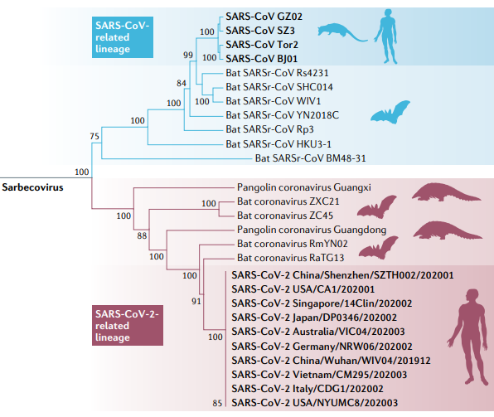
Figure 1: SARS-CoV-2 classification. The figure displays the SARS-CoV-2-related lineage, which clusters with closely related viruses in bats and pangolins. Sarbecoviruses include the SARS-CoV-2-related lineage SARS-CoV and bat SARS-related coronaviruses (SARSr-CoVs). This figure is taken from (Hu et al., 2021).
Coronavirus Structure

Coronavirus exhibit a crown-like structure on their surface because of their spikes. The name Corona is because of its solar corona structure on the surface (Yassine Kasmi and Ennaji, 2020). Coronaviruses are enveloped, with their viral positive single-stranded RNA being covered with nucleocapsid proteins and then surrounded by a lipid bilayer membrane (Hartenian et al., 2020). Five structural proteins play a role in the structure of the virus: spike (S), membrane (M), envelope (E), nucleocapsid (N), and Hemagglutinin-esterase (HE) (Kannan et al., 2020). The structure of SARS-CoV-2 is illustrated in Figure 2.
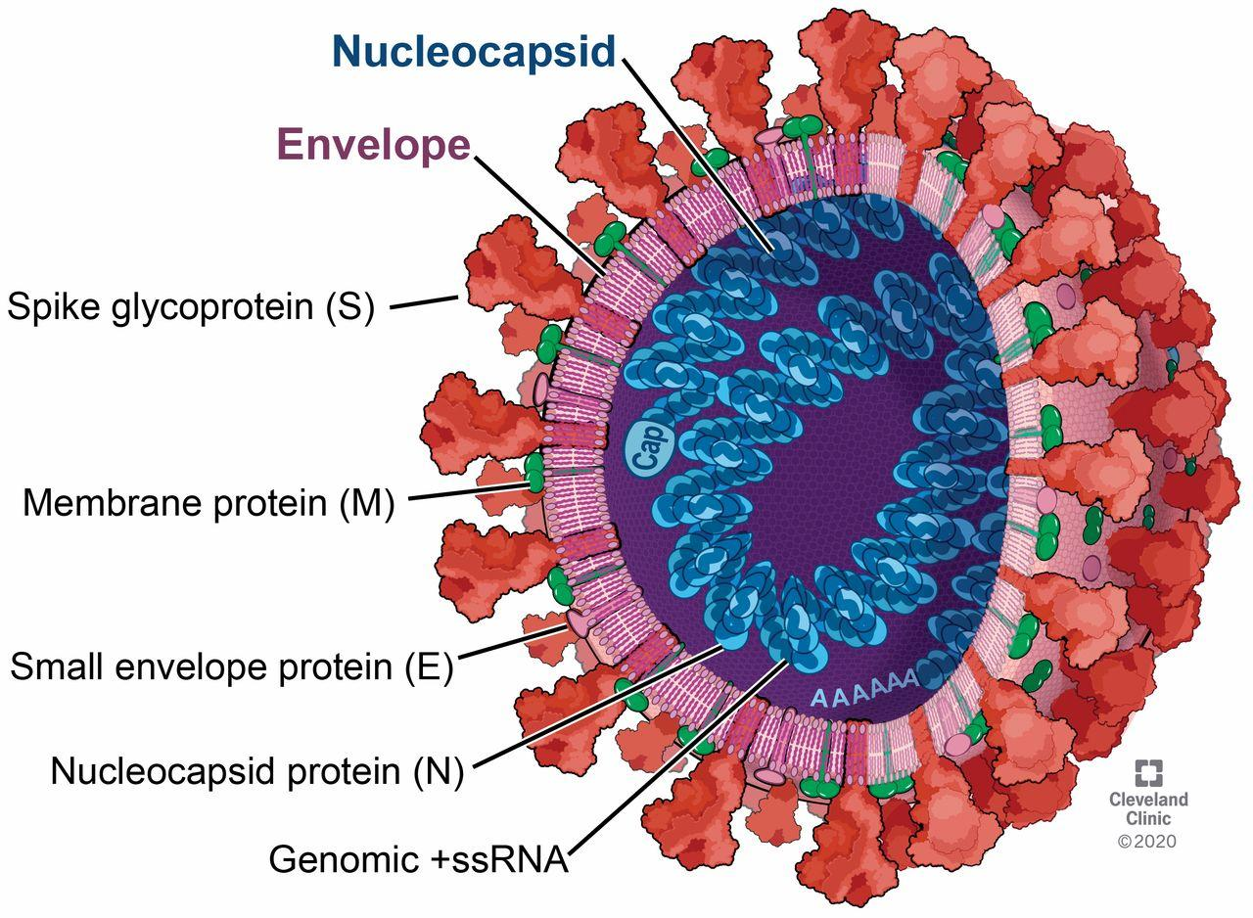
Figure 2: SARS-CoV-2 structure of the virus. The figure displasy the structural proteins and the genome. This figure is taken from (Bergmann and Silverman, 2020).

Structural proteins are crucial the virus’s life cycle. Spike glycoproteins bind to receptors on host cells, facilitating the fusion between the virus and the host cells (Bosch et al., 2003). The S protein has a large ectodomain with a small endodomain. As depicted in figure 3, the spike protein consists of two subunits: S1 and S2 (Wang, Grunewald, and Perlman, 2020). The S1 domain, located at the N-terminus of the spike protein, binds to the angiotensin-converting enzyme 2 (ACE2) receptor, whereas the S2 domain, at the C-terminal, mediates the fusion between the viral and cellular membrane (Shi et al., 2020). The receptor-binding domain (RBD) is part of the S1 subunit. The S2 subunit contains a fusion peptide (FP) region and two heptad repeat (HR) regions: HR1 and HR2 (Tay et al., 2020).
The two subunits of the spike protein work in conjunction. The S1 subunit cleaves within the endosome, exposing the fusion peptide. The fusion peptide then inserts into the host membrane. The S2 subunit folds to bring the HR1 and HR2 regions together, causing membrane fusion and releasing the viral package into the cell cytoplasm of the host (Tay et al., 2020).

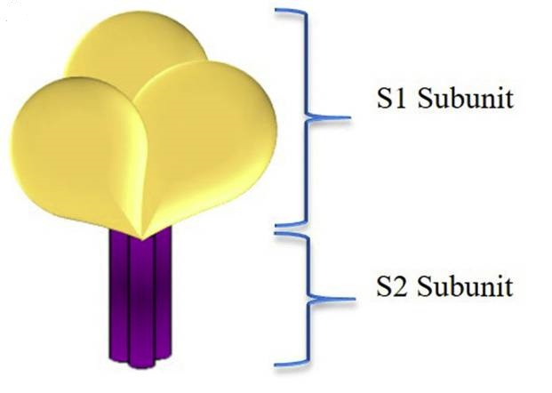
Figure 3: simple schematic of S protein. This figure is taken from (Satarker and Nampoothiri, 2020).

M proteins are the most abundant structural proteins responsible for shaping the virus. They consist of three transmembrane domains that promote the virion’s shape and maintain curvature (R. Fehr and Perlman, 2015; Liang et al., 2020).
The E proteins, although small in size, have different functions depending on the type of coronavirus. However, the general role of E proteins is to facilitate the assembly and release of the virion and forming of ion channels. They also play a role in pathogenesis (Wang, Grunewald, and Perlman, 2020). The E protein contains three domains: a short hydrophilic amino-terminal domain, a large hydrophobic transmembrane domain, and a c-terminal domain (Liang et al., 2020).
The N proteins consist of two domains: the N-terminal (NTD) and C-terminal (CTD). The NTD binds to 3` end of the viral RNA. This protein has two RNA substrates: the transcriptional regulatory sequence (TRS) and the genome packaging signal. Additionally, the N protein can bind to the M protein and a non-structural protein (nsp), facilitating the encapsulation of the viral genome into viral particles (Liang et al., 2020; Wang, Grunewald, and Perlman, 2020). The structural proteins are illustrated in Figure 2.
Hemagglutinin-esterase (HE), found in β-CoVs such as SARS-CoV-2, binds to the sialic acids of the S protein and mediates cell entry via its acetyl-esterase activity (Wang, Grunewald, and Perlman, 2020).
In addition to these structural proteins (S, N, M, E, and HE), the coronavirus gene also encodes other proteins that contribute to the virus’s rapid spread.
Coronavirus Genome

As mentioned in the previous sections, CoVs have the most significant known RNA genome, about 30 kilo base (Kb), which encodes about 22-29 proteins. Their RNA genome has a 5′ cap and 3′ poly-A tail. These structures help the viral RNA to act as an mRNA (messenger RNA) and encode viral proteins. The viral RNA genome translates directly into the host cell cytoplasm (Chen, Liu and Guo, 2020; Hartenian et al., 2020).
The SARS-CoV-2 genome consists of structural and non-structural genes that encode nsps. Around two-thirds of the SARS-CoV-2 genome encodes non-structural proteins necessary for the transcription and replication of the genome. As shown in figure 4, Nsp are encoded in two open reading frames (ORF1a and ORF1b). ORF1a and ORF1b are in the 5` section of the RNA. Translation of ORF1a/b produces one of the two polyproteins. One is a shorter polyprotein (nsps 1-11), while the other is longer (nsps 1-16). To liberate these nsps, polyproteins must undergo proteolytic cleavage by two viral proteases. These viral proteases are encoded by nsp3 and nsp5. Nsp3 encodes a papain-like protease (PLpro1 and PLpro2), and nsp5 encodes chymotrypsin-like cysteine protease (3CLpro), which is the target of the novel antiviral Paxlovid (Ziebuhr, Snijder and Gorbalenya, 2000; Hartenian et al., 2020; Wu et al., 2022).
The structural proteins are produced from structural genes in the 3` section of the genome. Besides, seven ORFs encode accessory proteins which are interspersed between structural genes (Payne, 2017). The accessory proteins include ORF3a, 3d, 6, 7a, 7b, 8, 9b, 14, and 10, which are produced from at least five ORFs encoding accessory genes: ORF3a, ORF6, ORF7a, ORF7b, and ORF8. These accessory proteins are necessary for pathogenesis and replication in the host cell. For example, they can inhibit the immune response of host cells (Yadav et al., 2021).
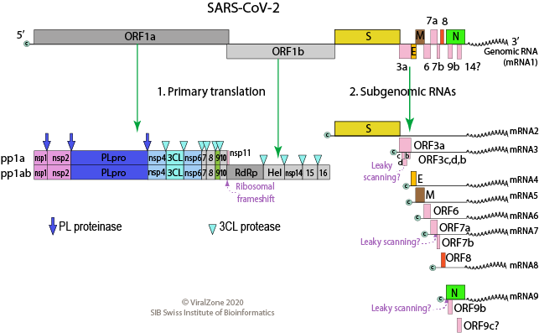
Figure 4: Genome of SARS-CoV-2. Figure is taken from (Hemarajata, 2020).
RNA viruses need sequences as regulatory or leader sequences to help RNA replication, transcription, and gene expression. As an example, Cis-acting regulatory elements are primary RNA sequences that are often folded into a distinctive secondary structure. These elements regulate the activity of RNA through interactions with other RNA molecules, DNA, or RNA-binding proteins. They play a role in the regulation of replication, transcription, and genome packaging. These regulatory elements are present from the 5` untranslated region (UTR) to the coding region of rep1a and 3` UTR. 5′ UTR contains multiple stem-loop structures that control RNA synthesis (RNA replication and transcription) by conformational changes. Another cis-acting sequence is near the end of the rep1a gene, which directs ribosomal frameshifting (Payne, 2017). At the 5′ ends of the genome, there is a leader sequence and an UTR. Also, there are transcriptional regulatory sequences (TRSs) at the beginning of each gene (structural or accessory) in the 5` region. TRSs are needed for gene expression. The 3′ UTR is necessary for viral RNA replication and synthesis (Wang, Grunewald and Perlman, 2020). TRSs are located between ORFs required for terminate the transcription and further acquisition of a leader RNA (Chen, Liu and Guo, 2020).
Coronavirus Proteins

There are three types of Proteins for SARS-CoV-2. 1. Structural proteins that participate in the structure of the virus. 2. Non-structural proteins which play a role in virus replication. 3. Accessory proteins cooperating with NSPs are crucial in viral replication, pathogenesis, and virus evasion (Yadav et al., 2021).
- Structural Proteins

There are four significant proteins for coronavirus structure. The spike (S), membrane (M), envelope (E), and nucleocapsid (N) proteins. The primary functions of each protein and how their role in the structure of the virus has been presented in the “Coronavirus Structure” section.
Structural proteins also help the virus escape the immune system and form the virus's structure. For example, the N is involved in suppressing interferon (IFN) production. This protein targets STAT1 and STAT2 in the interferon production signaling pathway, disrupting interferon production and the antiviral response. Another structural protein is the M. This protein suppresses the production of type I and III interferons. On the other hand, the M can bind to cytosolic molecules that sense viral RNA and disrupt the viral RNA sensing pathway, such as retinoic acid-inducible gene I (RIG-I), melanoma differentiation-associated gene (MDA5), mitochondria antiviral signaling protein (MAVS), and TRAF family member associated NFκB activator- binding kinase 1 (TBK1) (Kasuga et al., 2021).
- Non-structural Proteins

Sixteen nsp are encoded by the SARS-CoV-2 genome. These proteins are necessary for virus replication. The role of each nsp has been summarized below.
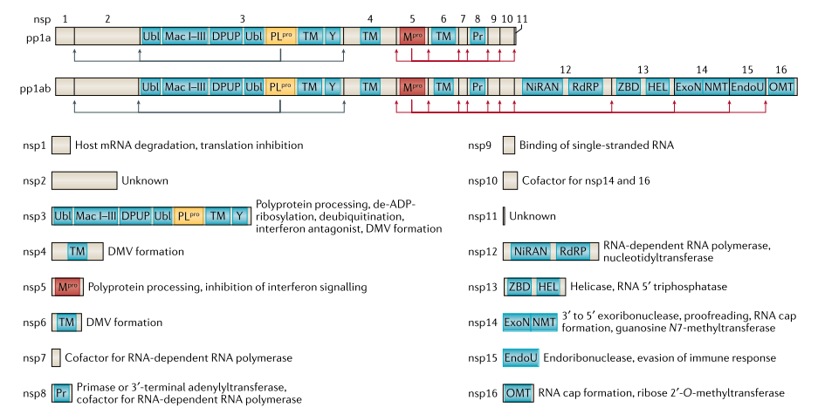
Figure 5: Nsps function and location in the genom of SARS-CoV-2. Figure adopted from (V’kovski et al., 2020).
NSP1: The complete name of this protein is ‘’N-terminal product of the viral replicas’’. This leader protein acts as a host translation inhibitor and degrades host mRNAs by cleaving 5`-capped mRNA. It inhibits type I interferon by blocking the IFN signaling pathway by suppressing the promoter activities of IFN-stimulated response elements (ISREs) (Thoms et al., 2020).
NSP2: The full name is ‘’N-terminal product’’. This protein binds to host proteins, Prohibitin 1 and Prohibitin 2 (PHB1 and PHB2). Cornillez-Ty (2009) data suggest this protein disrupts host cellular signaling (Cornillez-Ty et al., 2009).
NSP3: Papain-like proteinase, or nsp3, is essential in viral replication. It releases NSP1, NSP2, and NSP3 from the N-terminal regions of pp1a and pp1ab. The pp1a includes NSP1 to NSP11, and pp1ab has NSP12 to NSP16 (Yadav et al., 2021). Nsp3 cleaves viral polyproteins and blocks the host's innate immune response. It also acts as a deubiquitinase and promotes cytokine expression (R. Fehr and Perlman, 2015). Nsp3 can suppress the IFN signaling pathway by binding to interferon regulatory factor 3 (IRF3) and preventing the phosphorylation, dimerization, and nuclear translocation of IRF3. Moreover, Nsp3 can inhibit the NF-κB signaling pathway (Frieman et al., 2009).
Nsp5: Nsp5 with nsp2 is responsible for processing viral polyproteins through its 3C-like protease activity. NSP5 inhibits interferon signaling. Of course, the inhibitory properties of NSP5 depend on its protease activity. Therefore, by inhibiting protease, the inhibitory properties of NSP5 can be prevented, so interferon signaling is not inhibited (Zhu et al., 2017). Indeed, it is the target of the novel antiviral Paxlovid (Wu et al., 2022).
Nsp8: Nsp8 and Nsp7 are components of the viral RNA-dependent RNA polymerase (RdRp) complex and play a role in facilitating RdRp activity. In addition, SARS-CoV-2 Nsp8 also plays an inhibitory role in host innate immunity (Hartenian et al., 2020). It was shown that Nsp8 could suppress the MDA5-derived IFN signaling pathway (Yang et al., 2020).
Nsp16: Nsp16 mediates methylation of the cap of viral mRNA and prevents coronavirus recognition by MDA5 (Hartenian et al., 2020).
Other NSPs functions are explained in Table 1 (Hartenian et al., 2020; Yadav et al., 2021).
NSP4: | The NSP4 protein has a role in double-membrane vesicle formation.
NSP5: | Nsp5 is a proteinase and is responsible for polyprotein processing. It also has a role in inhibiting interferon signaling.
NSP6: | The function of Nsp6 is DMV formation.
NSP7: | This protein is a cofactor for RNA-dependent RNA polymerase.
NSP8: | Nsp8 is a processivity factor for RdRp and a cofactor with nsp7 and nsp12.
NSP9: | Nsp9 is a single-strand binding protein.
NSP10: | Nsp10 is a Cofactor for nsp14 and 16 nsp11.
NSP11: | The activity is unknown.
NSP12: | Act as RDRP and nucleotidyltransferase.
NSP13: | Act as helicase, and RNA 5′ triphosphatase.
NSP14: | Exoribonuclease activity acting in a 3`-5` direction is one function of nsp14. It also has N7-guanine methyltransferase activity. It has a role in RNA cap formation and has RNA proofreading Properties.
NSP15: | Nsp15 has endoribonuclease activity. It has a role in the evasion of the immune response.
NSP16: | This protein is a 2`-O-Methyltransferase and down-regulates the activities of RIG-I and MDA5.

Nsps 2-16 assemble to form a replication-transcription complex (RTC) for synthesizing proteins (transcription and translation of the viral genome). RTC-translated subgenomic RNA (sgRNAs) make up a nested set. SgRNAs are negative strands and templates for producing subgenomic mRNAs, which possess common 5′‐leader and 3′‐terminal sequences. Translation of these sgRNAs produces structural and accessory proteins (Chen, Liu and Guo, 2020).
Coronavirus uses a multi-protein complex including the RdRp (nsp12), processivity factors (nsp7-8), a helicase (nsp13), single-strand binding protein (nsp9), a proofreading exonuclease (nsp14), other cofactors (e. g. nsp10), and capping enzymes (e.g., nsp16) for replication (Hartenian et al., 2020).
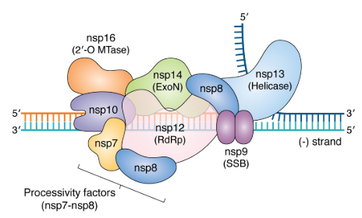
Figure 6: Structure of RTC. Figure adopted from (Hartenian et al., 2020).

Nsp3, Nsp4, and Nsp6 are involved in generating double-membrane vesicles (DMVs). DMVs with convoluted membranes (CMs) and tiny open double-membrane spherules (DMSs) make a protective microenvironment for the replication of viral genomic RNA and transcription of subgenomic mRNAs (V’kovski et al., 2020).
Nsp10 (cofactor), Nsp13 (RNA 5′ triphosphates activity), Nsp14 (N7-methyltransferase activity), and Nsp16 (2′-O-methyltransferase activity) make up the RNA capping machinery during the viral life cycle (Kasuga et al., 2021).
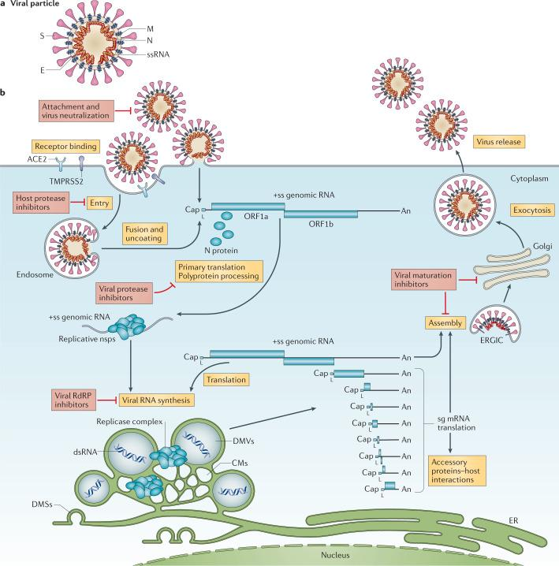
Figure 7: A schematic of DMSs formation and viral RNA transcription. Figure is taken from (V’kovski et al., 2020).
- Accessory Proteins

Accessory gene sets of coronavirus genes encode neither the non-structural proteins 1–16 nor the canonical coronavirus structural proteins (Yadav et al., 2021). These accessory genes encode accessory proteins. The function of each is described below.
ORF3: the largest accessory protein for SARS-CoV-2 is ORF3a. This protein promotes virus release by functioning as an ion channel. Different motifs of this protein are involved in its distribution within the cell, its internalization into separate subcellular compartments, or in pathogenesis and immune evasion. SARS-CoV ORF3a has been shown to cause necrotic cell death and lysosomal damage. ORF3a can activate pro-IL-1b gene expression and interleukin-1-beta (IL-1b) secretion, nuclear factor kappa B (NF-kB) signaling, and NLR family pyrin domain containing 3 (NLRP3) inflammasomes to cytokine storm generation. The ORF3b protein is an interferon antagonist. This protein suppresses the induction of IFN type-I. The function of ORF3C is unknown (Redondo et al., 2021).
ORF6: ORF6 protein is an IFN antagonist and suppresses the IFN responses. This protein blocks IFN activation by blocking transcription factor STAT (signal transducer and activator of transcription) transportation to the nucleus. ORF6 binds to Rae1 and Nup98, thus forming a complex that inhibits trafficking between the cytoplasm and nucleus (Redondo et al., 2021).
ORF7: ORF7a is another SARS-CoV-2 protein that can antagonize the IFN-I response. SARS-CoV-2 neutralizes the host ubiquitin system to enhance ORF7a’s ability to antagonize IFN-I responses (Redondo et al., 2021). ORF7a binds to cluster of differentiation ${14}^{+}$ (CD${14}^{+}$) monocytes in the blood. This attachment causes a decrease in antigen-presenting ability and expression of pro-inflammatory cytokines (Zhou, Xiao and Chen, 2021). ORF7a also inhibits the IFN-I response via the blocking of STAT2. ORF7b can disrupt some cellular processes that are involved in some of the symptoms of SARS-CoV-2 infection (Fogeron et al., 2021).
ORF8: ORF8 is a secreted protein. This protein is detected in the sera of COVID-19 because they have the most potent and specific antibody response among the SARS-CoV-2 antigens. In SARS-CoV-2 infections, deletions in ORF8 result in milder disease, decreased hypoxia, and decreased release of inflammatory cytokines. ORF8 can down-regulate the surface expression of major histocompatibility complex class 1 (MHCI) in various types of cells. ORF8 is a type I IFN antagonist that targets the PRRs-mediated pathway of the IFN-b promoter and the downstream signal transduction. This signal transduction leads to interaction between IFN-b and autocrine and paracrine type I IFN receptor (IFNAR) of INF-stimulated genes. SARS-CoV-2 ORF8 contributes to the cytokine storm during infection by activating the IL-17 signaling pathway and promoting the expression of proinflammatory factors (Redondo et al., 2021).
ORF9: ORF9b suppresses innate immunity by targeting the MAVS signalosome, with subsequent loss of Tumor Necrosis Factor Receptor-associated Factor 3 (TRAF3) and TRAF6, limiting host interferon response. ORF9 overexpression induced autophagy in host cells. ORF9b manipulates this organelle in various ways. ACE2 overexpression is one of the manipulations. Overexpression of the ACE2 receptor improves cell binding to the S protein allowing virus entry. ORF9b-mediated activation of the inflammasome to evade immune responses facilitates viral replication. ORF9c of SARS-CoV-2 suppresses antiviral response by impairing interferon signaling, antigen processing and presentation, complement signaling, and induced IL-6 signaling (Redondo et al., 2021).
ORF10: Deletion of ORF10 does not change the replication ability of SARS-CoV-2. It has been understood ORF10 is not essential in SARS-CoV-2 infection (Redondo et al., 2021).
ORF14: ORF14 function is not clearly understood.

- Coronavirus Lifecycle

Viruses can only reproduce in infected host cells. The first step of the coronavirus life cycle begins with attachment. Limitations for receptor attachment determine host species range and tissue tropism (Hartenian et al., 2020). S proteins of CoVs attaches to a specific receptor on host cells. SARS-CoV-2 spike binds to ACE2 as a host cell receptor. S protein is homotrimeric, which requires the assembly of 3 identical S proteins. Each of these proteins consists of two subunits, S1 and S2. Proteolytic cleavage at two sites of S proteins activates this protein for fusion (M. Y. Wang et al., 2020). The S1 subunit binds to the receptor, and the S2 subunit undergoes conformational changes that cause fusion between the virion and cell membranes (Bergmann and Silverman, 2020). The first cleavage occurs at the S1/S2 boundary, provoking an S2 pre-fusion conformation. The second cleavage in S2 causes the fusion of two membranes and releases the viral RNA genome into the cytoplasm. Transmembrane serine protease 2 (TMPRS2) is a cell surface serine protease that cleaves proteolytically the S protein. By cleaving at S2, the peptide causes the fusion of the viral and cellular membranes. The viral genome is then released into the host cell cytoplasm. It seems that SARS-CoV-2 uses endosomal protease and endocytosis as an alternate way of cell entry. Other proteases like furin and cathepsin also participate in the cleavage of the S protein (Hartenian et al., 2020).
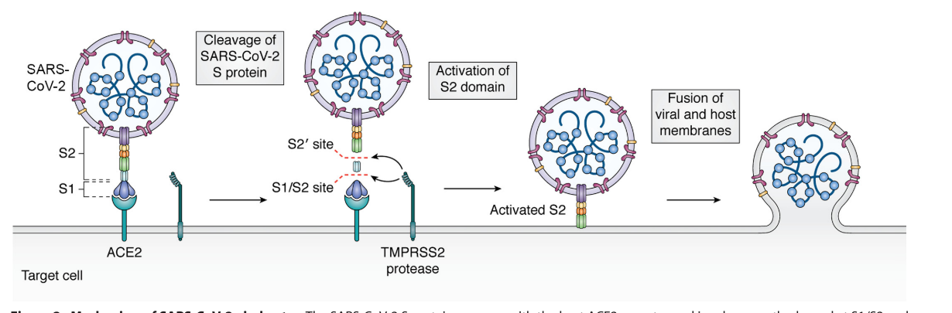
Figure 8: Attachment of SARS-CoV-2 to ACE2. Figure adopted form (Hartenian et al., 2020).
Spikes of SARS-CoV-2 bind to ACE2 10–20 times stronger than SARS-CoV Spikes, so SARS-CoV-2 is more transmissible than SARS-CoV. There is also a salt-bridge interaction between the ACE2 receptor and S protein, which could improve the interaction. Data suggest a furin cleavage site at the S1/S2 junction on SARS-CoV-2. The stretch of polybasic residues contains a furin recognition motif present in S1/S2 on SARS-CoV-2. So, a cleavage event at the S1/S2 site implies that SARS-CoV-2 S may only require cleavage at the S2 site on the target cell surface, which would potentiate the membrane fusion process (Hartenian et al., 2020).
SARS-CoV-2 can use other receptors for entry like CD147 (extracellular matrix metalloproteinase inducer (EMMPRIN)), which cooperates with syndecan-1 (SYND1), CD26, an important T cell and also epithelial cell receptor, amino peptidase N (ANPEP; a receptor for human and porcine coronaviruses), ENPEP and a glutamyl-aminopeptidase as well as (DC-SIGN (Dendritic Cell-Specific Intercellular adhesion molecule-3-Grabbing Non-integrin). In addition to TMPRSS2, other proteins such as furin or human endosomal cysteine proteases are potentially capable of cleaving S, such as cathepsin L (CTSL) and cathepsin B (CTSB) (Sokolowska et al., 2020).
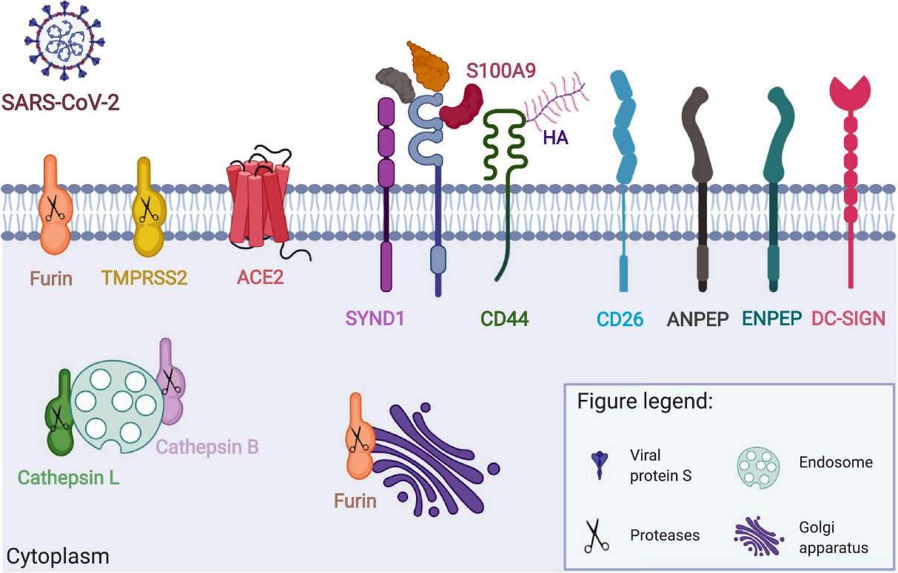
Figure 9: Receptors of SARS-CoV-2. Figure adopted form (Sokolowska et al., 2020).
Transcription and translation of the virus genome are the next steps in the virus lifecycle. Translation by host ribosomes starts with the replicase gene on the viral RNA genome. Rep1a and Rep1b, two ORFS encoded by the replicase gene, express two polyproteins, pp1a, and pp1ab. For expressing both polyproteins, ribosomal frameshifting must occur. Ribosomal frameshifting from the rep1a reading frame to the rep1b ORF was caused by a slippery sequence (5′-UUUAAAC-3′) before an RNA pseudoknot structure. An RNA pseudoknot makes the ribosome pause (stop ribosome elongation) in a slippery sequence and moves back one nucleotide (-1 frameshift). It causes a change in the reading frame and subsequent translation of Rep1b resulting in pp1ab production (Hartenian et al., 2020). Pp1ab is processed into 16 nsps by 3CLpro or main protease (Mpro) and papain‐like protease. These proteases are virally encoded (Chen, Liu and Guo, 2020). After protease activity, these nsps form RTC. RTC syntheses the negative RNA strand. These negative strands are then used to produce positive RNA strands. The new positive strands are then translated to produce more nsp and RTC.
The replication of the viral genome produces genomic RNA and subgenomic RNA. Subgenomic RNAs are positive-sense and have the 3′ co-terminal of the full-length viral genome to form a set of nested RNAs that serve as mRNA to produce viral proteins. The order Nidovirales can develop a series of nested RNAs. Structural proteins are also translated and inserted into the endoplasmic reticulum (ER); in other words, they go into the secretory pathway (endoplasmic reticulum-Golgi intermediate compartment (ERGIC)). In ERGRC, viral RNA is surrounded by N proteins to form a nucleocapsid that is part of the mature virion. These virions bud into membranes of the ERGIC. M proteins bind to the nucleocapsid and promote the completion of virion assembly. Vesicles that contain viruses are transported to the cell surface and released by exocytosis (Wang, Grunewald, and Perlman, 2020). Figure 10 illustrates the entry of the virus into the cell and the transcription of the viral genome until the formation of virions.
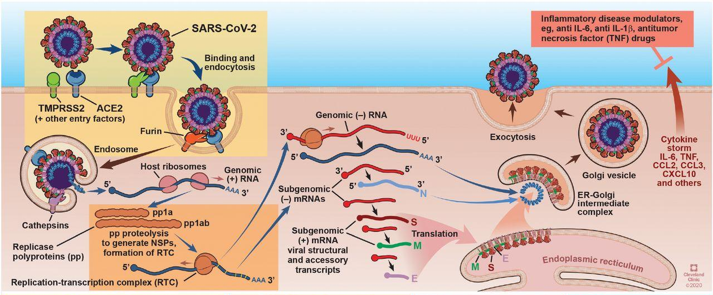
Figure 10: Brief lifecycle of SARS-CoV-2. Figure adopted form (Bergmann and Silverman, 2020).
DMVs are membrane structures formed by positive-sense RNA viruses such as coronaviruses. They anchor the RTC and support viral replication and RNA synthesis (Amor, Fernández Blanco and Baker, 2020).
- COVID-19 Symptoms

The symptoms that the coronavirus causes are very much related to the immune reactions that occur in the body, which we will discuss in Chapter Two. COVID-19 disease can have different symptoms, from mild to intense. Common symptoms include fever (higher than 38°C), sore throat, cough, muscle pain, dyspnea, headaches, and diarrhea. Anosmia means loss of sense of smell and dysgeusia meaning loss of taste are symptoms that are more specific to COVID-19 (Mehraeen et al., 2021). Expectoration and hemoptysis are also seen in some patients (Sun et al., 2020).
Given that the target receptor of the SARS-CoV-2 is the ACE2 receptor, symptoms can be found wherever the number of these receptors is high. ACE2 receptors exist in the lungs, small intestine, kidneys, heart, and other human tissues. All of them can be infected by SARS-CoV-2 and cause various symptoms (Vellas et al., 2020).
- COVID-19 Diagnosis

Early disease diagnosis is essential for its treatment. This is undoubtedly true for COVID-19, which is easier to treat if diagnosed early. The purpose of this paper is not related to study diagnostic methods, so we will only mention the methods. The four most common ways to diagnose COVID-19 in patients are 1. Nucleic Acid tests that use RT-PCR 2. Antigenic testing with immunochromatography with colloidal gold. 3. Imaging Technology by Chest radiograph or CT (Yuefei Jin, Haiyan Yang , Wangquan Ji , Weidong Wu and Duan, 2020; Kevadiya et al., 2021).

- COVID-19 Therapeutics

By knowing the lifecycle of the virus and its effect on the body, drugs can be designed for treatment. There are four major strategies. 1. Drugs that inhibit virus entry. 2. Drugs that inhibit virus replication. 3. Plasma therapy or monoclonal antibody therapy (Hu et al., 2021). Vaccines are also a preventative solution.
Drugs that inhibit virus entry: These drugs disturb virus and cell membrane fusion by targeting S proteins and ACE2. These drugs prevent viruses from entering the host cells. Drugs that Inhibit virus replication are another category of drugs.
One of the factors that cause death in COVID-19 patients is cytokine storm syndrome, which occurs because of the immune response. Some medicines that modulate the excessive inflammatory response are called Immunomodulatory agents. Plasma therapy or monoclonal antibody therapy are other methods categorized in immunoglobulin therapy (Uddin et al., 2020).
The best and most effective prevention method is the vaccine. The vaccine can control and prevent the spread of the virus in the long term. There are different types of strategies for designing vaccines for SARS-CoV-2. Some include recombinant vectors, DNA, mRNA in lipid nanoparticles, inactivated viruses, live attenuated viruses, and protein subunits (Hu et al., 2021).
In Chapter One, we addressed the virology of SARS-CoV-2; the taxonomy of this virus was discussed in part. The virus's structure, genome, and proteins were described. The symptoms and how to diagnose and treat this disease are also summarized.

Chapter Two: Immunology of SARS-CoV-2

Immunology Introduction

The previous chapter gives a brief overview of SARS-CoV-2 virology. The virus lifecycle is studied, but questions about how the virus life cycle induces an immune response and how the immune system defends against SARS-CoV-2 still remain. This part focuses on answering these questions.
The immune system employs different mechanisms to protect bodies against foreign entities, such as viruses. It consists of innate immunity and adaptive immunity, which work together to combat viruses like SARS-CoV-2. Before adaptive immunity is developed, biological barriers like skin and mucous membranes serve as the first line of defense against pathogens as part of innate immunity.
Recognition of pathogens is a prerequisite for the immune system to initiate an immune response. Innate immunity often possesses mechanisms to identify pathogens and activate signaling pathways upon their activation. The activation of innate immunity has implications for the activation of adaptive immunity. This section commences by discussing how innate immunity recognizes pathogens.
Recognition of SARS-CoV-2

It is vital to detect pathogens in the body. Initial recognition of microbes is done by detecting pathogen-associated molecular patterns (PAMPs) and damage-associated molecular patterns (DAMPs). The receptor-recognizing PAMPs and DAMPs are called pattern recognition receptors (PRRs). Activation of PRRS, in addition to identifying pathogens, triggers host defense like producing chemokines and co-stimulatory molecules, IFNs, and pro-inflammatory cytokines against pathogens (S. Chakraborty, B.M. Veeregowda, R. Deb, 2013; Kasuga et al., 2021).
There are two types of PRRs: Toll-like receptors (TLRs) and RIG-I-like receptors (RLRs), responsible for sensing RNA viruses (like SARS-CoV-2). These receptors trigger antiviral IFN synthesis. There are multiple TLRs; each recognizes different PAMPs. PAMPs can be a part of microbes like nucleic acids, lipoproteins, or lipids. For example, TLRs 7 and 8 can detect single-stranded RNA in endosomal compartments and recognize RNA viruses that enter through endocytosis. RLRs are cytoplasmic viral sensors that detect intracellular non-self RNAs with different secondary structure patterns. RLRs can recognize RNAs with an un-methylated 5′-end nucleotide. These properties are generated during the replication of RNA viruses such as coronaviruses. After attaching RNA viruses to these receptors, antiviral defense is initiated. Adaptor proteins activate and start downstream signal cascades (Vabret et al., 2020; Kasuga et al., 2021).
PRRs affect downstream signaling via TANK-binding kinase 1 (TBK1) and inhibitor-κB kinases (IKKs). The effect of PRRs leads to the activation of the transcription factors IRF3 and IRF7 and NF-κB (nuclear factor kappa-light-chain-enhancer of activated B cells). Subsequently, these transcription factors induce the expression of potent antiviral activity molecules. Examples of these molecules are type I IFNs (IFN-α/β) and IFN-stimulated genes (ISGs). Also, cytokines, chemokines, and antimicrobial peptides can be produced as a result of this signaling. These molecules are essential to initiate the host's innate and adaptive immune response (Amor, Fernández Blanco and Baker, 2020).
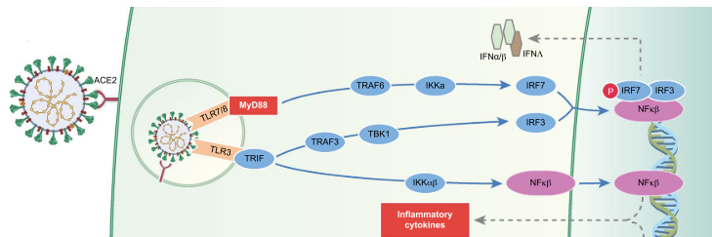
Figure 11: TLR activation and related singnaling pathway. Figure adopted from (Amor, Fernández Blanco and Baker, 2020).
The cyclic GMP-AMP synthase (cGas) is another type of PRR. The sGas/STING (stimulator of IFN genes) pathway is activated by binding enveloped viruses (like SARS-CoV-2) to host cells and cytosolic viral RNA. Similar to TLRs and RLR, STING engages TBK1 downstream to activate IRF3 and NF-κB inducing type I IFN and proinflammatory cytokines (Punt et al., 2019; Amor, Fernández Blanco and Baker, 2020).
When RLRs are activated, RLRs proteins undergo a conformational change from an inactive to an active form. RLRs release caspase-activating recruitment domains (CARDs) in their activated state. CARDS bind to the MAVS signaling adapter. Then MAVS affects downstream signaling pathways and recruits TRAF3 and TRAF6 (ubiquitin ligases). TRAF3 and TRAF6 associate with TBK1, I-kappa-B kinase ε (IKKε), and the IKKα/β/γ complex. These antiviral kinases, TBK1, IKKε, and the IKKα/β/γ activate transcription factors like IRF3 and IRF7, and NF-κB. After that, type I IFN and pro-inflammatory cytokines are produced (Kasuga et al., 2021).
Melanoma differentiation-associated protein 5 (MDA5) is a cytoplasmic sensor for Coronavirus RNA. MDA5 triggers the downstream adaptor MAVS on mitochondria by activating TRAF3. TRAF3 and TRAF6, TBK1, together with an IKK, phosphorylate the ‘‘master regulators’’ IRF3 and IRF7. Following this, transcription of type I IFNs, and numerous ISGs are induced. This sensor also contributes to pro-inflammatory responses (Loo and Gale, 2011; Punt et al., 2019).

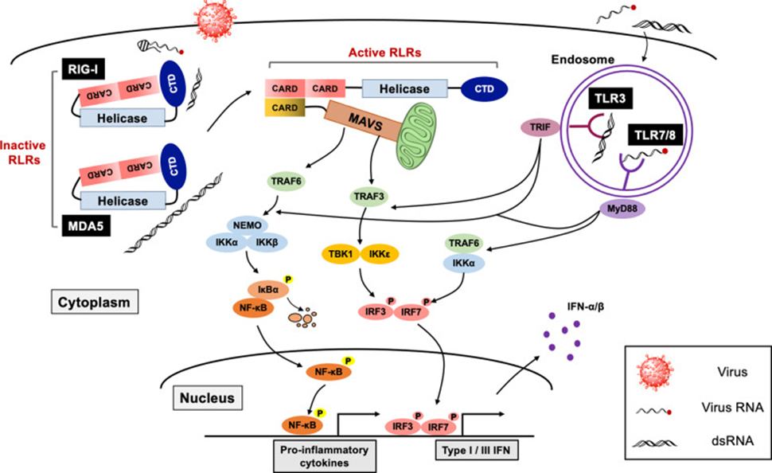
Figure 12: RLRs activation. Figure adopted form(Kasuga et al., 2021).
Viral detection prompts the production of IFNs, which in turn triggers the expression of hundreds of ISGs to aid antiviral responses for early immune response. Type I and III IFNs bind to their receptors to start downstream signaling cascades. These signaling cascades are activated by tyrosine kinases JAK1 (Janus kinases) and TYK231 (Tyrosine kinase), then STAT1 and STAT2 induce the formation of the IFN-stimulated gene factor 3 (ISGF3) complex, which then acts as a transcription factor to drive the expression of ISGs (Kasuga et al., 2021).
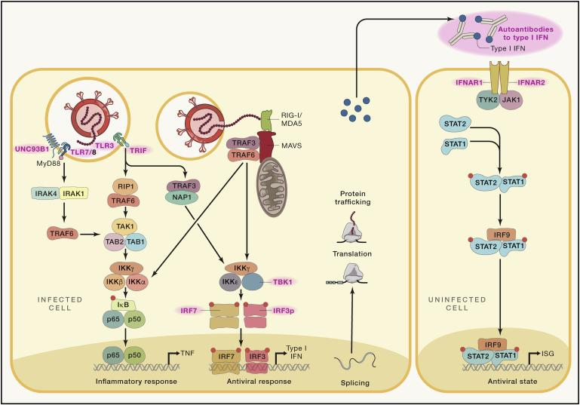
Figure 13: Antiviral and inflammatory response pathway, Figure adopted from (Schultze and Aschenbrenner, 2021).

ISGs encode proteins that have a role in the antiviral response, for example, interferon-inducible transmembrane (IFITM) proteins. IFITM proteins have been shown to inhibit viral entry by blocking viral envelope fusion or suppressing the intracellular trafficking of incoming viral particles. The IFN-inducible 16 (IFI16) protein, an innate immune sensor of intracellular DNA, can downregulate viral mRNA synthesis. Protein kinase dsRNA-activated (PKR), a sensor of dsRNA, plays a role in the antiviral response. PKR inhibits protein translation and induces cell apoptosis. Human IFIT (Interferon-induced protein with tetratricopeptide repeats) family proteins have also been reported to inhibit viral protein production by binding to subunits of the eukaryotic initiation factor 3 translation complex by recognizing RNAs lacking 2′-O methylation (Kasuga et al., 2021). Proinflammatory cytokines such as interleukin-6 (IL-6) and tumor necrosis factor (TNF) are also secreted due to signaling cascades. TNF is a proinflammatory cytokine involved in systemic inflammation, which plays a key role in the acute phase reaction (Lee, Channappanavar and Kanneganti, 2020).
Evasion strategies of SARS-CoV-2

As the immune system has mechanisms to kill the virus, the virus has mechanisms to escape the immune system. Effective escape methods dictate viral host range as a virus can only develop in a host if it can escape the host's immune system. Indeed, each host has specific immune system proteins and signals. Coronaviruses have evolved strategies to escape innate immune recognition, allowing widespread replication. Most viruses use proteins to antagonize the host's immune system by targeting viral sensors or blocking downstream antiviral signaling molecules. Like other viruses, SARS-CoV-2 uses different strategies. Virus evasion methods include the evolution of low genomic cytosine–phosphate–guanosine (CpG), RNA shielding, masking of potential key antigenic epitopes as well as inhibition of steps in the IFN type I/III pathways (Amor, Fernández Blanco and Baker, 2020).
Generally, the zinc-finger antiviral protein (ZAP) specifically binds to and degrades CpG motifs in the genomes of RNA viruses. Compared to other viruses, SARS-CoV-2 has evolved the most extreme CpG deficiency of all beta coronaviruses. So, ZAP does not easily degrade it (Amor, Fernández Blanco and Baker, 2020; Xia, 2020).
Another strategy to protect mRNA the host and many viruses’ uses is processing the 5′ end cap. RNA with a cap does not undergo degradation. A 5` cap blocks recognition by cytosolic PPRs. During replication, SARS-CoV-2 has applied several mechanisms to protect the 5′ ends with a cap structure. SARS-CoV Nsp14 plays a needed role in the 5′-capping of viral mRNA. The guanine-N7-methyltransferase activity (N7-MTase) of nsp14 caps the 5` end. Thereby activation of antiviral sensors such as MDA5 and IFIT family proteins are blocked (Hartenian et al., 2020).
However, another strategy used by SARS-CoV-2 to protect the viral RNA and proteins generated during replication depends on using the RTC or replication organelle, formed with double-membrane vesicles (Fu, Cheng and Wu, 2020). The RTCs link with the ERGIC and Golgi apparatus shielding the virus during maturation. Coronaviruses are similarly protected from detection by cytosolic PRRs due to the sequestration of viral dsRNA within DMVs. (Amor, Fernández Blanco and Baker, 2020) Nsp3, Nsp4, and Nsp6 produce DMV formation during virus replication. Coronaviruses form a double-membrane compartment by stealing the host ER membrane to make a shelter. In this shelter, the viral components can escape cytosolic PRR sensing (Kasuga et al., 2021).
So far, the identification of the immune system and the stimulation of interferon production have been reviewed. Coronavirus, with its non-structural proteins, disrupts in the same mechanism of inhibition of IRF3 and IRF7 or inhibition of STAT1 signaling, which prevents the production of interferon. (Sokolowska et al., 2020). For blocking STING/TBK1/IKKε-induced type I IFN production, IFN antagonism interferes with the stimulator of IFN genes (STING)–TRAF3–TBK1 complex. Moreover, the translocation of STAT1 and STAT2 to the nucleus, and IRF3, NF-κB signaling, including IFITs, were interfered with. As examples, nsp1, 4, and 6 and ORF6 disturbed STAT-1/2 signaling. Nsp 10, 13, and 16 interfered with the viral RNA, preventing recognition by RIG-I, MDA-5, and IFITs (Amor, Fernández Blanco and Baker, 2020).
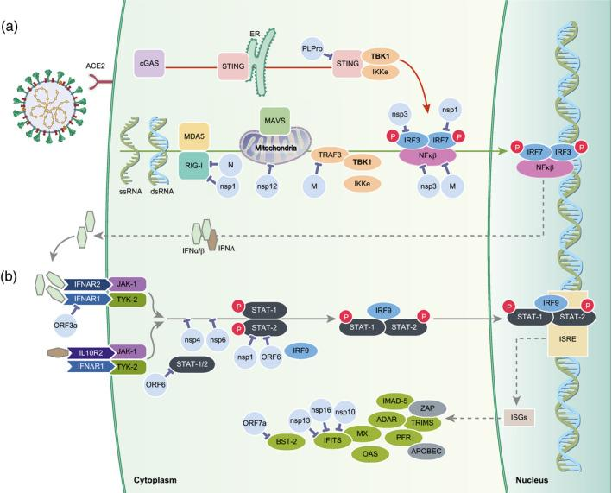
Figure 14: Bloking IFN production. Figure adopted from (Amor, Fernández Blanco and Baker, 2020).
Coronavirus genomes encode different RNA-modifying enzymes. These enzymes alter the biochemical properties of both host and viral RNAs. Via these enzymes, coronaviruses have means of modifying their RNAs to avoid being sensed by antiviral receptors. The viral RNA is modified by viral endoribonuclease. Nsp13, Nsp14, and Nsp16 help in RNA modification. For example, Nsp13 removes the 5′-PPP moiety from viral RNAs. 5`-PPP is a molecular signature for the RIG-I ligand. Nsp15 also can eliminate the 5′-polyuridine region from the virus (PUN) RNA to prevent being sensed by cytosolic dsRNA sensors, including MDA5, PKR, and OAS/RNase L (Kasuga et al., 2021).
As mentioned above, the virus has many strategies to escape the immune system. These strategies help the virus to spread and cause acute infections, which has led to many deaths. In this section, we have discovered how different parts of the SARS-CoV-2 genome contribute to its functioning. In the following sections, we will review other functions of the innate immune system.
Innate immunity against SARS-CoV-2

Although coronaviruses use many strategies for immune evasion, SARS-CoV-2 effectively initiates immune signaling pathways. Increasing viral loads and producing viral proteins, RNA, and DAMPS are the cause of triggering innate immune pathways. The receptor used by SARS-CoV-2 to enter cells can also play an important role in activating the immune response. In this section, we briefly review the function of each part of the innate immune system, including different types of white blood cells, the inflammation response, the complement system, and interferons.
- Dendritic cells (DCs) and macrophages

Monocytes/macrophages and DCs play a crucial role in antiviral responses by linking innate and adaptive immunity. The macrophages and DCs express PRRs that can detect PAMPs or DAMPs. Macrophages and the DCs start antiviral responses by developing a substantial type I interferon. Furthermore, respiratory epithelial cells and macrophages located in the lung are able to secrete chemokines like IL-8, macrophage inflammatory protein-1 (MIP-1), regulated on activation normal T expressed and secreted (RANTES), and other cytokines. In response to acute viral infection, these cytokines attract immune cells to the area. These responses start after recognition by PRRs (Ahmed-Hassan et al., 2020).
The epithelium cells of the airway are the first line of defense that provides a mechanical barrier that brings out particles or pathogens via cilia, mucus, and coughing. This barrier also includes pulmonary epithelial cells, DCs, and tissue-resident macrophages (Ahmed-Hassan et al., 2020). Peripheral activation and accumulation of activated pro-inflammatory monocytes/macrophages in the lung characterize symptomatic SARS-CoV-2 infection. SARS-CoV-2 is characterized by inflammasome activation of monocytes/macrophages and production of high levels of IL-6, granulocyte-macrophage colony-stimulating factor (GM-CSF), IL-1β, TNF-α, chemokines (C-X-C –Motif), ligand 8 (CXCL-8), CC chemokine ligand 3 (CCL-3), and cell death. This is followed by a cytokine storm, cytokine release syndrome (CRS). Macrophages primarily secrete some cytokines (namely IL-6), and evidence for macrophage activation syndrome has been reported. Thus, the positive effect of anti-IL-6R therapy on COVID-19 outcomes suggests that therapies targeting macrophage-associated activity are a promising means of suppressing the inflammatory storm during COVID-19. (Sokolowska et al., 2020).
As a result, the function of these two types of immune cells against the coronavirus is important because DCs and macrophages can activate IFN-1 and inflammatory responses, thereby activating the immune system. (Taefehshokr et al., 2020)
- Neutrophils

The neutrophil count increases in the nasopharyngeal epithelium and lung after SARS-CoV-2 infection (Reusch et al., 2021). When neutrophils are activated, neutrophil extracellular traps (NETS) are released. The NET formation occurs during systematic inflammation and is the way to trap pathogens. The NET structure is also related to acute respiratory distress syndrome (ARDS), which we see in COVID-19 patients (Hazeldine and Lord, 2021). The NETs contain extracellular DNA fibers, histones, antimicrobial proteins, and proteases which are released. If this neutrophil response is not regulated, it can lead to thrombosis and inflammation. (Taefehshokr et al., 2020)
COVID-19 patient samples show the penetration of neutrophils in pulmonary capillaries and alveolar space. In patients with severe covid-19, uncontrollable progressive inflammation induces substantial crosstalk between neutrophils releasing NETs, and IL-1β secretion from macrophages, which is thought to be the driving force behind additional problems. (Sokolowska et al., 2020)
- Innate Lymphoid Cells (ILCs) and Natural killer cells (NKs)

The ILCs are a type of effector cells that regulate immune response by responding to cytokines and inducing IFN-γ production and NKs cells. (Sokolowska et al., 2020) NK cells have receptors to regulate their cytotoxicity. NK receptors recognize the fragment crystallizable (Fc) region of antibodies bound to surface antigens. These antigens are expressed on infected cells or extracellular virions as immune complexes. When NK cells are activated, they can induce lysis of cells infected by the virus through antibody-mediated cellular cytotoxicity (ADCC) and upregulate viral proteins. NK cell activation also leads to cytokine production (Vabret et al., 2020).
- Inflammation by early virus replication

Inflammation is one of the immune system's responses to harmful stimuli like pathogens, damaged cells, and toxic compounds. There are cellular and molecular events and interactions for minimizing infection via inflammation. If acute inflammation is not controlled, however, it may become chronic (Chen et al., 2017). When the virus enters cells and begins replicating and dividing, epithelial and endothelial cells become apoptotic and release proinflammatory chemokines. Activation of viral 3a protein due to virus replication activates NOD-like receptor protein 3 (NLRP3). This receptor increases the synthesis of IL-1β in macrophages. Elevated IL-1β causes pyroptosis and the release of proinflammatory cytokines (Asrani and Hassan, 2021).
The inflammatory response activates macrophages and monocytes to clear the virus; like cytokines, it releases and activates B and T cells. Activating all these factors helps eliminate the infection, but sometimes this response is exaggerated or dysfunctional, leading to systemic and tissue damage. As seen in COVID-19 patients, the lungs, airways, and cells infected with the virus die and become pyroptotic. Another event is vascular leakage, which leads to tissue cell death. All of this leads to the release of more chemokines and cytokines, which signal the T cell to start working and can activate cytotoxic T cells as well as interferons (Tay et al., 2020).

Inflammation by downregulation of ACE2 receptors
SARS-Cov-2 causes inflammation in two ways. The first way for the virus to cause inflammation is to enter the body. The second way is related to ACE2. ACE2 converts angiotensin II to angiotensin. This function lowers blood pressure. ACE2 is a receptor for SARS-CoV-2, too. ACE2 regulates the renin–angiotensin system (RAS), also. The attachment of SARS-CoV-2 to ACE2 downregulates its function. Loss of RAS enhances vascular permeability, accumulation of neutrophils, lung edema, inflammation, and acute lung injuries, and releasing inflammatory cytokines such as IL-1β and TNF-α (Duan, 2020; Tay et al., 2020; Asrani and Hassan, 2021).

- Complement and SARS-CoV-2

Complement systems is an important component of innate immunity because, in addition to defending the body against invaders, they also enhance hemorrhagic immunity. The complement system uses receptors to detect microbes and respond to them. The responses of the complement system are very diverse and include inflammation, opsonization, and cell lysis (Shibabaw et al., 2020).
There are three ways to activate the complement system. The first pathway is activated by antibodies attached to the pathogen, or the classical pathway. The second pathway is the lectin pathway, where mannose-binding lectin (MBL) can detect the surface glycan domain on pathogens, or mannose. The third path is the alternative path (Shibabaw et al., 2020).
In the first pathway, C1q binds to the antibody-antigen complex, which eventually activates its subunits and breaks down C4 into C4a and C4b and C2 into C2a and C2b. Now the products of these cleavages, C2a and C4b, together break C3 into C3a and C3b. The C3b generated by the C3 convertase (C4bC2a) breaks C5. In the lectin pathway, Mannose-associated serine protease (MASP) breaks C2 and C4 to form the C3 convertase. In the alternative pathway, C3 undergoes spontaneous hydrolysis by binding with the pathogen’s cell surface components. C3a plays a role in inflammation. C3b helps in opsonization in addition to the lysis of C5. C5a and C5b have roles in lysis and inflammation. C5a is a chemoattractant that has a role in inflammatory cell recruitment, phagocytic cell activation, and the production of granular enzymes and free radicals. (Shibabaw et al., 2020)
The complement system is involved in both coagulation and inflammatory pathways. The typical pulmonary findings for ARDS were accompanied by significant deposits of terminal complement components C5b-9 (membrane attack complex), C4d, and MASP2, in the microvasculature. The scientists conclude that some severe COVID-19 patients may experience a type of catastrophic microvascular injury syndrome mediated by the activation of complement pathways and an associated pro-coagulant state (Sokolowska et al., 2020).
- Interferons

Interferons' role is tied to identifying non-self-patterns, as discussed earlier. Interferons can perform various activities, such as interfering with virus replication, stimulating cytotoxic T cells and NK cells, and having antiviral activity. Interferons are usually released when TLRs are detected and stimulated by external agents. As mentioned, TLRs are stimulated by double-stranded or single-stranded DNA or RNA, especially double-stranded RNA associated with RNA virus replication. Some are even sensitive to and recognize bacterial lipopolysaccharide. After TLRs bind to foreign particles, genes encoding inflammatory cytokines and specific IFNs are stimulated and begin to make interferons and inflammatory cytokines. IFN signaling cascades are initiated by connecting them to their receptors. The name of the receptors is IFRAR1 /2. This binding activates JAK-1 and TYK kinases and phosphorylates STAT1 and STAT2 (Shibabaw et al., 2020).
Generation of cytokine storm and acute respiratory distress syndrome

Viral infection can lead to an overactive immune system and excessive release of inflammatory cytokines. This is called a cytokine storm, which begins with a local inflammatory response and then spreads systemically. Cytokines are helpful in relieving infection, but when secreted in large quantities, they cause insufficiency and ARDS, also seen in patients with severe COVID-19 (Ricci et al., 2021).
Cells, including B cells, T cells, NK cells, macrophages, DC, neutrophils, monocytes, and tissue-resident cells as epithelial and endothelial cells, are involved in developing cytokine storms. Substances that cause cytokine storms have been reported in the blood of people with coronavirus. These substances include IL-1β, granulocyte-colony stimulating factor (G-CSF), GM-CSF, merozoite surface protein 1 (MCP1), IFNγ, Interferon gamma-induced protein 10 (IP10), MIP1A, MIP1B, TNFα, IL-2, IL-7, IL-8, IL-9, IL-10, IL-17, fibroblast growth factor, platelet-derived growth factor (PDGF), vascular endothelial growth factor, CC chemokine Ligand 2 (CCL2), CCL3, CCL4, chemokine (C-X-C motif) ligand 10 (CXCL10), CCL8, CXCL2, CXCL8, CXCL9, and CXCL16 (Ricci et al., 2021).
Individuals in an intensive care unit (ICU) have higher levels of IP10, IL-2, IL-7, IL-10, G-CSF, MIP1A, MCP1, and TNFα. IL-1β and TNFα are involved in increasing TH17 activity. TH17 causes permeability and vascular leakage. This triggers the release of other cytokines, such as IL-17, IL-21, IL-22, and GM-CSF. Each of these cytokines plays a vital role in the inflammatory response. For example, IL-17 plays a role: It synthesizes G-CSF. G-CSF itself is involved in innate immunity and inflammatory response and helps neutrophils. IL-17 causes fever by inducing the secretion of IL-1β, TNFα, and IL-6. It is also involved in the regeneration of damaged tissues. IL-17 even affects chemokines (Asrani and Hassan, 2021).
The increasing level of some cytokines like IL-6 and IL-23 influence the differentiation of TH17 cells. A high level of IL-6 and IL-13 turn on JAK2-STAT3 pathways, and differentiation of TH17 cells starts. Th17 has a proinflammatory effect. These are cytokines released due to the cytokine storm, but how does the coronavirus cause the cytokine storm?
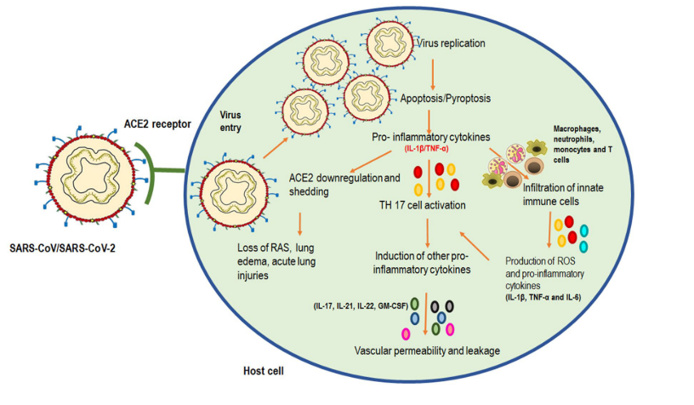
Figure 15: SARS-Cov-2 make changes in the cell. Figure is taken from (Asrani and Hassan, 2021).

SARS‐CoV‐2 uses ACE2 as a cell receptor, expressed on epithelia in renal, cardiovascular, gastrointestinal tract tissue, and vascular endothelial but most abundantly expressed in epithelial cells of type I and II in alveolar, nasal, and buccal sites. Hence, ACE2 receptors are present mainly in the respiratory system. ACE2 is responsible for maintaining blood pressure homeostasis and controlling inflammation (Ahmed-Hassan et al., 2020). ACE2 regulates the RAS by balancing the conversion of angiotensin I to angiotensin 1–9 and angiotensin II to angiotensin 1–7. Angiotensin II (Ang II) affects fibrosis, inflammation, proliferation, angiogenesis, and vasoconstriction. Converting Ang II to other molecules neutralizes Ang II's effects (Lumbers et al., 2020).
ACE2 and ACE compete to hydrolyze inactive decapeptide Ang I. Ang I is converted to Ang II by ACE, and ACE2 converts Ang I to nonapeptide Ang (1–9). In this way, the amount of Ang I available for ACE to form ANG II is reduced. ACE2 also hydrolyzes Ang II and Ang (1–9) to Ang (1–7). Unlike Ang II, Ang (1–7) has anti-inflammatory properties. As a result, ACE2 acts as a negative regulator. The ACE2 receptor is enslaved by SARS-CoV-2, which prevents it from performing its normal function and breaks the Ang I and Ang II peptides (Esakandari et al., 2020).

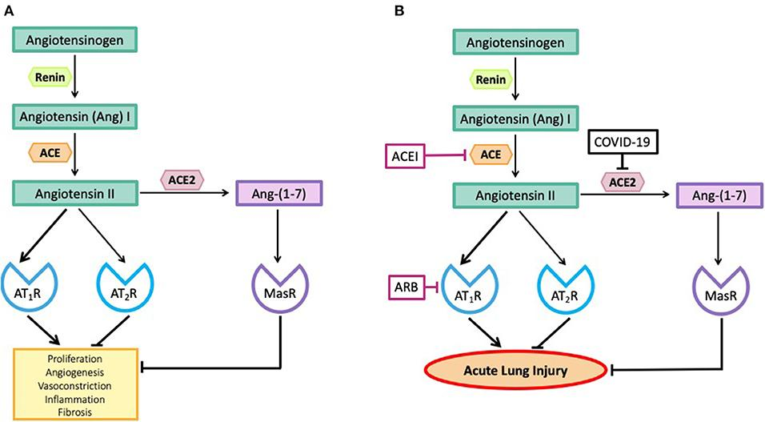
Figure 16: Angiotensin 2 function. Figure adopted from (Lumbers et al., 2020)

The binding of SARS-CoV-2 to ACE2 triggers endosome formation and reduces ACE2 expression on the cell surface, putting the RAS system into a pro-inflammatory mode and inducing reactive oxygen species (ROS) production, fibrosis, collagen deposition, and IL-2 is triggered. IL-6 and IL-8 production by recruitment of macrophages and neutrophils. Therefore, ACE2-mediated binding and entry of SARS-CoV-2 can be associated with the first step in a series of enhanced and detrimental immune responses in coronavirus infection, including complement activation, PAMPS- and DAMPS-mediated activation of the innate immune system, inflammasome activation, pyroptosis, activation of NK cells, hyperactivation of macrophages, neutrophils, innate T cells, induction of cytokine storm (Amor, Fernández Blanco and Baker, 2020).
As a result, pathobiological changes in the lungs include the appearance of type II pneumocytes, damage to the alveolar epithelial cells, and diffuse alveolar damage. Thrombotic microangiopathy, significant accumulations of CD4+ mononuclear cells around small thrombotic vessels, and hemorrhage appear to be important causes of death. The described process involves activated local megakaryocytes in the lung, platelet aggregation, fibrin deposition, and clot formation. Furthermore, certain degenerated neutrophils and the concentration of viral RNA in neutrophils within the alveoli suggest viral infection in these cells. Multiple hepatic necrosis, mild lymphocytic infiltration, sinus dilatation, and steatosis are pathological changes observed in the liver of COVID-19 patients with moderate to severe disease. Mild myocardial hypertrophy and focal fibrosis alterations are tissue changes observed in cardiac biopsies of deceased COVID-19 patients (Esakandari et al., 2020)
So far, we have learned how these cytokines can help us kill viruses, but they can also make our condition worse. The link between acute COVID-19, and its symptoms to the immune system also has been studied. In the next section, we will look at how the body's adaptive system works against coronavirus.
Adaptive immunity against SARS-CoV-2

In addition to innate immunity, we have another type of immunity called adaptive immunity. Unlike innate immunity, which responds equally to all pathogens, adaptive immunity must first identify and respond to a foreign antigen. For this reason, it takes longer to activate adaptive immunity. The innate immune system can activate adaptive immunity. Macrophages and dendritic cells are innate immune components that can also activate adaptive immune cells. Another advantage of an adaptive immune system is that it has memory cells that can detect and respond to antigens from a few weeks to a few months later. This characteristic is used to produce vaccines.
When a virus or microbe enters the body, innate immunity is activated first. As a result of activating innate immunity, three activities are performed. 1. Restricting the replication of the virus. 2. Creating an antiviral state in the tissues. 3. Activation of adaptive immunity. The first two innate immunity tasks help to reduce virus replication and limit viral load, but the third is crucial to eliminating the virus. It takes several days for adaptive immunity to work against a virus. At this time, adaptive immunity against viruses must build cells with the right receptors, and naïve cells must become effector cells. (Sette and Crotty, 2020)
As mentioned earlier, adaptive immunity is divided into humoral and cellular immunity. Antibodies and B lymphocytes play a role in humoral immunity with the help of T lymphocytes, while T lymphocytes are involved in cellular immunity. More specifically, three significant cells in the adaptive immune system are B cells, T cells, including CD$4^{+}$ T cells, and CD$8^{+}$T cells. B cells are involved in producing antibodies, CD$4^{+}$ T cells have helper and effector functions, and CD$8^{+}$T cells kill microbial and infected cells. Therefore, adaptive immunity is important for viral infections and their elimination. On the other hand, we can design a vaccine due to memory cells in adaptive immunity (Sette and Crotty, 2020) In other words, the human body makes specific antibodies and CD$4^{+}$ and CD$8^{+}$ cells against COVID-19 (Grifoni, et al. 2020).
- B cells and T cell production and activation

T and B lymphocytes are made in the bone marrow and mature and become active in different parts of the body. For example, naïve B cells are produced in the red bone marrow and then migrate to the lymphatic system. When naïve B cells in the lymph are exposed to a specific antigen, they are activated, and the maturation process begins. We must know that B cells have surface antigen-specific receptors against a specific antigen. When the antigen detects a match with the receptor on the cell, the cell becomes active with the help of CD$4^{+}$ T cells. After activation, the naïve B cell begins to divide and forms two types of cells: memory B cells and effector B cells or plasma cells. Plasma B cells produce the same surface receptors as B cells that were able to detect the antigen. After reinfection with the SARS-CoV-2 virus, memory B cells can be quickly converted into plasma cells to generate specific antibodies. These receptors are the same as antibodies. These antibodies then circulate throughout the body to detect and respond to antigens. Memory B cells also produce these antibodies, which are attached to the surface of B cells. Now B cells have immunoglobulin molecules attached to the membrane of the B cell called the B cell receptor (BCR). Once the antigen is detected, the receptor can bring the antigen into the cell and process it. Through this process, cellular signaling is activated, resulting in the release of cytokines. The release of cytokines is important for the connection of immune cells (Punt et al., 2019).
In addition to B cells, adaptive immunity requires T cells. T lymphocytes, after being made in the red bone marrow, progenitor T cells go to the thymus and mature there. In the thymus, T cells express T cell receptors (TCR). In addition, T cells must express CD4 or CD8 receptors. Unlike antibodies or B cells, T cell receptors cannot detect free antigens. In the same way, the part of the antigen that we call the epitope must be presented on the MHCI or class 2 (MHCII). MHCII is present only on antigen-presenting cells such as macrophages or dendritic cells, whereas MHCI is present on all cells (Punt et al., 2019)
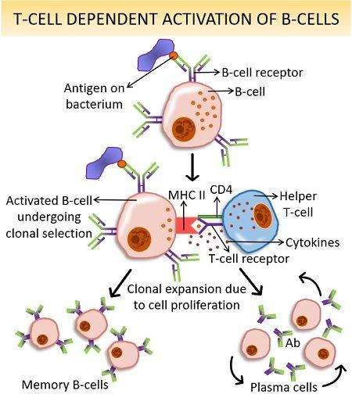
Figure 17: T-Cell Dependent Activation of B-Cells. Figure adopted from (Supriya, 2022).
Three types of T cells can be created: Helper T cells ($T_{H}cells)$, Cytotoxic T cells ($T_{C} cells)$, and T regulatory cells ($T_{reg} cells)$. Each of these T cells has its own role. Helper T cells carry the CD4 receptor on them and can bind to MHCII. These cells help activate B cells, cytotoxic T cells, and other cells of the immune system. Cytotoxic T cells have a CD8 receptor and bind to MHCI. These cells remove pathogens that infect host cells. T regulators have a regulatory function to reduce the risk of autoimmune disease by stopping the synthesis of specific cells (Punt et al., 2019)
Activation of B lymphocytes with T cells is necessary for the production of memory B cells. Macrophages that ingest antigens present small pieces of antigens on their surface on MHCII. A T-helper cell with a receptor against the same antigen can detect and attach to the macrophage epitope. If the B lymphocyte has already captured a protein and presents its epitopes on its MHCII, including the same antigen, it will attach to the T-helper cell. These connections activate B cells and differentiate them into effector and plasma cells. Antibodies are produced in large quantities, and these antibodies eliminate the pathogen in different ways (Willey, Sherwood and Woolverton, 2011)
Each T and B cell responds to a specific antigen and has a receptor for a specific epitope. So, if the immune system wants to be efficient, it has to build up against many receptor antigens on the B and T cell. Mammalians make extensive B and T cell repertoires by randomly joining different coding segments in the antibody or receptor gene to produce proteins with different N-terminal domains and constant sequences elsewhere. In this way, the gene from which the T cell receptor is expressed makes new sequences that bind to multiple epitopes. The point is that these new receptors should not react with the body's proteins. The process in which TCRs are eliminated and those that are efficient remain is called positive and negative selection (Punt et al., 2019)
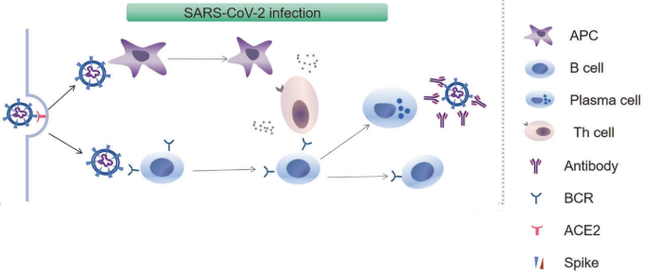
Figure 18: B cell activation, figure adopted from (Zheng et al., 2021).
- Antibodies

B cells and plasma cells will produce one of five types of antibodies or immunoglobulin (Ig), depending on the kind of T-cell assistance they got during activation and the cytokines to which they were exposed. The five types of antibodies include IgM, IgG, IgA, IgE, and IgD. Each has its own set of characteristics and functions in the fight against infection. Two long chains, known as heavy chains, and two shorter chains, known as light chains, make up an antibody. The sequences of the variable part are different for each antigen. The heavy-chain constant sections define the antibody isotype or class. Each antibody has its own set of features and functions in the fight against infection (Punt et al., 2019).
During an initial immune response, IgM antibodies are the first to be produced. This kind of antibody activates the complement system and effectively causes microorganisms to lyse. They excel at agglutinating antigens including those that form part of bacteria or viruses. The agglutinated bacteria or viruses can then be phagocytosed more efficiently by macrophages. This class has ten antigen-binding sites for pathogen binding (Punt et al., 2019).
IgG is the most common antibody class in the serum. IgG has several subclasses (like IgG1 and IgG3) which bind to fragment crystallizable region receptors (FcRs) and can enhance phagocytosis by macrophages or opsonization. IgG1 and IgG3 are particularly good at activating complement (Punt et al., 2019).
IgA is a significant antibody class in secretions, including mucus in the gut and respiratory tracts. IgA can stimulate phagocytosis, mediate ADCC by binding FcRs on NK cells, and trigger the degranulation of granulocytes (Punt et al., 2019).
IgE's role is in allergy and asthma. IgE induces the degranulation of eosinophils and basophils and the release of molecules such as histamine and proteases that damage pathogens. IgD binds to basophils and mast cells, and after the antigen binds to the IgD antibodies, these cells are activated to release antimicrobial peptides, which attack the pathogens. The activated cells also release cytokines (including IL-4, TNF, and IL-1), and chemokines (Punt et al., 2019).
The Fc region of an antibody is the part of the antibody that interacts with Fc receptors (FcRs) on cell surfaces. The cell-surface receptor is specific for the Fc portion of certain classes of immunoglobulin. FcRs are present in lymphocytes, mast cells, macrophages, and other accessory cells. FcRs allow nonspecific immune cells to take advantage of the exquisite specificity of antibodies to focus their cellular functions on specific antigens and pathogens. They also provide a physical bridge between the humoral and cell-mediated immune systems. Cross-linking by multiple antibody-antigen complexes, FcRs initiate effector responses (Punt et al., 2019).
Antibodies secreted by B cells must react with specific antigens exposed to a pathogenic virus or bacteria. Antibodies have different ways of defending against these organisms. This section reviews the most effective methods that can be operated. Antibodies generated by activated B cells protect the body against pathogens through six antibody-mediated effector functions.
- Degranulation: Granulocytes such as neutrophils, mast cells, basophils, and eosinophils express Fc receptors for various immunoglobulin classes. When antibodies are bound by granulocyte Fc receptors and then are cross-linked by some pathogens, the fusion of the secretory granules with the plasma membrane can be triggered, releasing a variety of soluble mediators, some of which can be harmful to the pathogen (Willey, Sherwood and Woolverton, 2011).

- Neutralization: Neutralization is one of the main activities of antibodies. During this deactivation process, the virus can no longer attach to its receptor on the host body (Lee and Oh, 2021). Most viruses and some bacteria enter a cell or tissue by binding, specifically, to cell-surface proteins, stimulating endocytosis. Antibodies that bind pathogen proteins and block them from binding to cells are potent effector molecules because they can prevent a pathogen from initiating an infection. (Willey, Sherwood and Woolverton, 2011) IgA antibodies play an important role as neutralizers (Lee and Oh, 2021).

- Agglutination: Each antibody molecule can bind and cross-link multiple pathogens, resulting in agglutination. In this case, the pathogen cannot easily attach to cellular receptors and infect cells. On the other hand, pathogens are cleared more effectively because they are grouped together (Willey, Sherwood and Woolverton, 2011).

- Opsonization: In this method, antibodies bind to antigens and tag them. In this way, the engulfment of antigens is promoted and enhanced by phagocytoses. Opsonizing antibodies bind antigens via their antigen-binding sites and are then bound by Fc receptors expressed on phagocytic cells, triggering phagocytosis. If the antigen is a cellular antigen like a virus-infected or tumor cell, the process is often referred to as antibody-dependent cellular phagocytosis (ADCP) (Willey, Sherwood and Woolverton, 2011).

- Complement Activation: Antigen-antibody complexes can activate the classical complement pathway; specifically, when antibodies that associate with complement bind to the surface of bacteria and some viruses, they can initiate a cascade of reactions that results in the generation of the membrane attack complex, creating pores in pathogen membranes and killing the microbe. This capacity to stimulate complement-mediated membrane damage is a property of specific antibody classes, including IgM and some IgG subclasses (Willey, Sherwood and Woolverton, 2011).

- Antibody-Dependent Cell-Mediated Cytotoxicity: Antibodies bound to foreign antigens on the surface of the body’s cells, such as tumor antigens or virus proteins on an infected cell, can activate the killing activity of several types of cytotoxic cells (e.g., NK cells and granulocytes). Unlike cytotoxic T lymphocytes, NK cells do not express antigen-specific T-cell receptors. However, they express receptors for IgG Fc and can use these to bind the antibodies already bound to antigens on infected cells, triggering the release of cytotoxic proteins, referring to ADCC (Willey, Sherwood and Woolverton, 2011). This process will prevent an infected cell from producing and releasing many virus particles.
Like all other types, the humoral response to the coronavirus begins with the production of IgG and IgM antibodies. The level of antibodies is related to the severity of the disease and the number of viral particles produced (viral load). SARS-CoV-2 antigens can stimulate B cells to proliferate and differentiate into plasma cells, and then plasma cells produce specific antibodies against the coronavirus (Zheng et al., 2021). Although both types of antibodies (IgG and IgM) must be produced, the IgG type is more persistent, and the IgM type decreases after three months. At the onset of the first infection, antibodies are produced against the N protein because this protein is highly immunogenic. After 4-8 days from the initial symptoms, antibodies are made against the spikes (Shah et al., 2020). Spikes are the main target of neutralizing antibodies. B lymphocytes and the humoral immune system produce these neutralizing antibodies. These antibodies can also kill cells infected with the virus (Vabret et al., 2020).
- Cell-mediated immune response

All immune defenses mentioned earlier are called antibody-mediated (humoral), but there are cell-mediated immune responses that directly rid the organism of pathogens and abnormal cells. Eliminating infected cells by cytotoxic T cells or eradicating intracellular pathogens by macrophages are examples of cell-mediated immune responses. Cytotoxic effector cells include the CD8 cytotoxic T lymphocytes (CTLs) of the adaptive immune system, NKT lymphocytes, which bridge the innate and adaptive immune systems, and NK cells. All of the cytotoxic effector cells induce cell death by triggering apoptosis in their target cells.
Helper T cells (TH cells) are found in the blood. TH cells have CD4 receptors, which are a kind of T cell receptor. These receptors can recognize antigens in the form of short peptides presented on MHC class II molecules. Antigen-presenting cells (APCs), such as macrophages, neutrophils, and dendritic cells, present antigens to helper T cells together on their MHC class II molecules. CD$4^{+}$T cells are an important member in activating the cell-mediated immune response. CD$4^{+}$T cells play a critical role in mediating immunological responses by secreting particular cytokines after being activated and differentiated into diverse effector subtypes. CD$4^{+}$ T cells have a variety of activities, including activation of innate immunity cells, B-lymphocytes, cytotoxic T cells, and nonimmune cells, as well as inhibition of immune responses (Punt et al., 2019). Antigenic stimulation, mediated by the interaction of TCR and CD4 as co-receptors with the antigen-MHC II complex presented by professional APCs, is the first stage in the differentiation of naïve cells. As a result, a network of downstream signaling pathways is activated, leading to the proliferation and differentiation of naïve cells into specialized effector cells (Luckheeram et al., 2012).
Figure 19: APCs interact with CD4 cells. Figure is taken from (Lakna, 2018).

CD$4^{+}$T cells can differentiate into different cells and thus help the immune system. They help CD$8^{+}$T cells respond better, initiate antiviral activity, repair tissues, absorb innate immune system cells, and help B cells. Virus-specific CD$4^{+}$T cells can differentiate into Th1 and T follicular helper cells (Tfh). Th1 produces IFNγ and cytokines. The Tfh helps with the humoral system, the production of neutralizing antibodies, and the creation of memory cells (Crotty et al., 2020).
The response of T cells to SARS-CoV-2 has been determined in all patients. In general, CD$4^{+}$ T cells respond more prominently than CD$8^{+}$, to SARS-CoV-2. CD$4^{+}$ T cells control early infection. T cells can respond to any viral protein, but this response is higher against viral spikes, which is why this protein is used in candidate vaccines. In addition, antibodies to viral spikes can neutralize viral infectivity, whereas antibodies to other proteins will not usually neutralize the virus. Spike-specific CD$4^{+}$ T cells are required to initiate the anti-spike antibody response. Structural proteins S, M, and N are good targets for CD4+. In addition, T cells have a high response to ORF3a and nsp3 (Krammer, 2020; Sette and Crotty, 2020).
Figure 20: Role of CD4 + T cells in SARS-CoV-2 infection (Sette and Crotty, 2020).

CD$8^{+}$ T cells are a group of T cells that can kill infected cells, so they are important for clearing viruses from the body (Sette and Crotty, 2020). Cytotoxic T lymphocytes or cytotoxic T cells (Tc cells) are involved in the destruction of virus-infected cells and tumor cells. The CD8 receptor is a type of TCR found on cytotoxic T cells. These receptors recognize antigens presented with MHC class I molecules. Tc cells recognize and kill infected cells by activating T cell receptors. Naïve Tc cells are activated in secondary lymphoid tissues and differentiate into functional effector CTLs. Differentiation of naive CD$8^{+}$T cells into effector CTL involves recognition of MHC class I peptide complexes on activated dendritic cells and the assistance of TH1 effector CD$4^{+}$ T cells. Effector CTLs recognize MHC class I peptide-antigen complexes on specific target cells in the periphery, such as virus-infected cells and tumor cells, and induce apoptosis in target cells (Punt et al., 2019). CD$8^{+ }$T cells can detect spike, nucleocapsid, M, and ORF3a SARS-CoV-2 as antigens, but they only react to linear peptide epitopes on these proteins, which can be presented on MHC type I or type II molecules. The antigens do not need to be exposed on the viral surface, as in the case of antibodies, but since cells present linear epitopes of all the proteins they are synthesizing, these epitopes can result in cell killing by CD$8^{+}$T cells. These cells can work with IFNγ, granzyme B, and perforin (Sette and Crotty, 2020).

;.
Figure 21 : Naïve T cell activation. Figure adopted from (Libretexts, 2021).

CTL-target cell complex development occurs when T-cell receptors on CTL associate with processed antigen (linear peptide)-MHC class I complexes on appropriate target cells. After the connection between the two cells is established, the centrosome becomes polarized at the point of contact, causing the Golgi stack and granules to migrate to the point of contact with the target cell, where the contents of the granules are released onto the surface of the target cell through exocytosis. Causes apoptosis in target cells. CTLs are recycled when the complex dissociates, and the target cell dies by apoptosis (Punt et al., 2019)
Figure 22: CTL killing the target cell. Figure adopted from (Punt et al., 2019).
Granules released from Tc cells contain molecules that have pro-apoptotic properties, perforin, which causes holes in the target cell membrane, and proteases called granzymes. Perforin and granzyme are released into the space between the two cells at the junction. In addition to killing the infected cell, granzyme B can kill and fragment the viral DNA (Punt et al., 2019). Studies have shown that a decrease in CD$4^{+}$ T and CD$8^{+}$ T cells is directly related to the severity of COVID-19 disease (Zhang et al., 2020).
Figure 23: CD8 T cell release perforin. Figure adopted from (Ibrahim and Menkovska, 2022).
Due to the escape strategies of the coronavirus, in some people, the adaptive immune system is activated later, and eventually, the disease becomes severe. Especially in the elderly, because T cells cannot start to detect and differentiate rapidly (due to a more limited naive T cell repertoire), the response of neutralizing antibodies will begin later, leading to more severe coronavirus symptoms in the elderly (Moderbacher et al., 2020)
In the second chapter, we summarized the immune system's role in suppressing the virus and how it can protect us from viral disease. This information helps us to make the vaccines to protect against SARS-CoV-2. Vaccines against the virus can be made using the mechanism of antibodies and cytotoxic T cells. There are advantages of antibodies and advantages of T cells. T cell titers decrease gradually, but the antibodies remain in the patient's body (Lee and Oh, 2021). On the other hand, with SARS Cov-1, memory T cells persisted longer than memory B cells and antibodies (Tnag et al., 2011). With antibodies, neutralization requires a very specific epitope that changes with mutation, while T-cells can target any peptide epitope synthesized by the infected cell and presented with MHC. Antibodies may also inactivate the virus by agglutinating it and allowing macrophages to ingest and digest the clump of the virus, also favored by opsonization. This may also reduce the viral titer in the body as a clump of viruses, rather than a single virion, will "infect" a cell. Antibodies inactivate viruses’ one particle at a time, whereas T-cells prevent the synthesis of hundreds of virions by killing the infected cell. It is much more difficult in the laboratory to titrate effective T-cells than to measure neutralization and agglutination.
Chapter three: SARS-CoV-2 vaccines

Vaccines introduction

Vaccines are a crucial tool in reducing death and infection caused by the virus. Therefore, scientists worldwide are actively involved in finding the most effective vaccine against SARS-CoV-2. Scientists are developing vaccines using the adaptive immunity, as described in the previous chapter. The production and manufacture of vaccines is a precise and time-consuming process. After initial experimentation on animals, three phases of clinical trials are performed to demonstrate the effectiveness and safety of the vaccine for humans. If the vaccine passes each stage with positive results, it will be approved. This process typically takes an average of 10 to 15 years, with a significant amount of time dedicated to antigen selection and initial experiments on animals. However, clinical trials may extend to 5 to 10 years or longer. However, the COVID-19 pandemic did not give us 15 years to conduct research (Rathore and Ghosh, 2020). Additionally, there is phase 4 of vaccine development, referred to as the post-approval phase, where the vaccine is continuously monitored for safety and effectiveness in the general population to detect any rare or long-term side effects that were not identified in earlier clinical trials. Phase 4 studies may also examine the vaccine's effectiveness against new variants of the virus, as well as different age groups or populations. In addition, phase 4 studies may investigate the optimal timing and frequency of vaccine booster doses (Zarreen, Dibyangshee and Ramneet, 2022). Researchers are working rapidly to study and produce vaccines.
Developing a universal vaccine against coronavirus is a critical issue to prevent the spread of the disease. A suitable vaccine should not endanger people's health and should be available to protect a wide range of ages. On the other hand, this vaccine should provide long-term and short-term immunity.
In general, we have six categories of vaccines.
- live attenuated virus vaccines
- Inactivated or killed virus vaccines
- Recombinant viral-vectored vaccines
- Protein subunit vaccines
- Virus-like particles (VLPs) vaccines
- Nucleic acid-based (DNA or mRNA) vaccines
Vaccines require two components to effectively function. The first component is an antigen from the target pathogen, which is either inserted into the vaccine recipient or produced by their cells. The second component is an infectious signal that activates the host's immune system. Not all antigens can efficiently activate the host's immune receptors, necessitating the use of adjuvants in such vaccines. Adjuvants are biochemical components that enhance immune recognition and activate innate immune cells to elicit an adaptive immune response. These biochemical components are added to non-live vaccines, such as inactivated viruses, protein subunits, and nucleic acid-based vaccines (Jeyanathan et al., 2020).
Vaccines induce an immune response similar to what the host would develop from natural infection. If natural infection leads to lifelong immunity, as seen with measles, mumps, or hepatitis A or B, vaccines can be developed to confer lifelong immunity as well. However, for infections where lifelong immunity is not naturally induced, such as with influenza, repeated vaccination cycles are likely required. Vaccines against viruses that do not induce natural immunity, such as HIV or Hepatitis C, present challenges in development, although scientists continue their efforts to improve in this area.
History of SARS-CoV-1 and MERS-CoV vaccines

Research conducted during SARS-CoV and MERS-CoV helped develop a vaccine that could prevent SARS-CoV-2. At first, they targeted protein S to make a vaccine because protein S is necessary for coronaviruses to enter the host cell. Studies have shown that antibodies produced against protein S in recovered SARS patients will neutralize virus and are long-lasting. In addition, several studies have shown that anti-S antibodies can neutralize SARS-CoV and MERS-CoV and exert protective effects in animals and humans. Other structural proteins were also tested for vaccine production, but they were unsuccessful. For example, anti-protein N vaccines usually cannot induce neutralizing antibodies because protein N is not shown on the surface of the virus. On the other hand, because the N protein mutates less than the S protein, it is a suitable target for CoV vaccines that produce cellular immunity. Another study showed that a viral vaccine vector expressing the N protein is capable of stimulating CD$8^{+}$T cell-dependent immunity to SARSCoV and MERS-CoV (N. Wang et al., 2020; Zhao et al., 2020). Finally, a protein or proteins should be selected to make a vaccine that ensures a definite response from the body.
The process of making a vaccine is very complicated, and scientists may face new problems at each stage before or after injecting the vaccine. For example, one of the problems of vaccines for MERS-CoV and SARS-CoV was the emergence of the Antibody-dependent enhancing (ADE) effect. This effect was caused by suboptimal antibodies induced by the vaccine, which made it easier for the virus to enter the host cell. For this reason, studies showed that the SARS-CoV vaccine based on full-length S protein increases SARS-CoV infection of human cell lines in vitro. This effect caused concern for the development of vaccines against protein S. Of course, to solve the problem, it was suggested to make a vaccine against epitopes of protein S. One of these epitopes could be the S1 subunit or the RBD domain of protein S. This strategy could reduce the induction of non-neutralizing antibodies by CoV vaccines and thus reduce the effect of ADE (Yong et al., 2019; Y. Der Li et al., 2020).
Developing a vaccine against SARS-CoV started with producing vaccines against the full-length S protein. However, the focus of the research was shifted to producing vaccines against the S protein RBD. The results of the studies showed that the extracellular domain of the S protein and trimeric S proteins (triSpike) could both protect against SARS-CoV infection. It is very important to use a spike protein stabilized in its pre-fusion conformation because the immune system must respond to the virus at the pre-fusion stage (Xia, 2021). As a result, the SARS-CoV pre-fusion spike has become the main target of SARS vaccines (Pallesen et al., 2017; Tay et al., 2020). SARS-CoV subunit vaccines were also tested based on the S2, N, and M subunit structural proteins. However, no evidence exists that they can induce neutralizing antibodies (Y. Der Li et al., 2020).
To make a vaccine against MERS-CoV, Scientists tried to use previous experience. Most MERS-CoV protein subunit vaccines have focused on RBD-based vaccines. RBD-based MERS-CoV vaccines are generally highly immunogenic and induce strong neutralizing antibodies, cellular immunity, and a protective effect against MERS-CoV infection. Trimeric RBD protein vaccines can induce long-lasting neutralizing antibodies for six months. These results suggest that the MERS-CoV RBD is a promising vaccine target that can induce long-lasting and broad-spectrum neutralizing antibodies against infection (Tai et al., 2016; Y. Der Li et al., 2020).
Of course, in addition to choosing the target for the vaccine, several other factors are important in the effectiveness of the vaccine. A system in which the protein is correctly expressed in good quantity, or adjuvants to be added in vaccines. Several adjuvants (Freund, aluminum, lipid monophosphoryl A, montanide, ISA51, and MF59) were investigated in combination with MERS-CoV RBD, and data showed MF59 best enhanced the protein to elicit neutralizing antibodies and protective effects. This data provided a good starting point for optimizing adjuvants for SARS-CoV-2 subunit vaccines (Y. Der Li et al., 2020).
The number of viral like particle vaccines or SARS-CoV and MERS-CoV is low. In the research, SARS-CoV S protein and influenza virus M1 protein were prepared, which showed that they induce neutralizing antibody in mice. In another study, the SARS-CoV S protein was used with mouse hepatitis virus E, M, and N proteins to induce antibody responses and reduce SARS-CoV virus titer in the lungs of mice after the viral challenge. For MERS-CoV, VLPs containing MERS-CoV S, E, and M proteins can cause specific induction, Antibody response, and Th1-mediated cellular immunity in rhesus macaque. Finally, it is clear that using this strategy allows researchers to make useful vaccines for the coronavirus (Y. Der Li et al., 2020).
Other virus vectors are used in making viral vaccines, the most popular of which is an adenovirus. In one of the studies, an adenovirus containing the S1 fragment was used, and when tested on monkeys and mice, it was shown to induce neutralizing antibodies. One of the research projects conducted on this vaccine compared it with the inactive SARS-CoV vaccine; the results showed that both are protective and produce neutralizing antibodies. A viral vector vaccine was tested for MERS-Co V. Human adenovirus type 5 (Ad5) and type 41 (Ad41), which express MERS-CoV S or S1, was used against MERS-CoV. These vaccines induced neutralizing antibodies in mice. Chimpanzee adenovirus has been used to make a vaccine against MERS-CoV, which expresses the MERS-CoV S protein. The results have shown that this vaccine (ChAdOx1) induces high levels of neutralizing antibodies and cellular immunity in mice. ChAdOx1-MERS vaccine has entered the clinical trial phase, and the result showed that all doses of ChAdOx1-MERS are safe and one dose can induce cellular and humoral immunity. The research team used the same ChAdOx1 platform to develop a vaccine against SARS-CoV-2, resulting in the AZD1222 (or ChAdOx1-nCoV-19) vaccine (Y. Der Li et al., 2020; Kandeel et al., 2023).
Another strategy for making vaccines is to create inactivated viruses. The virions in the vaccine were chemically, or radiation inactivated. In general, this type of vaccine does not have a pathogenic risk. However, during the process of inactivating the epitopes, it is possible to change the shape of the epitopes in an unwanted way. The research found that SARS-CoV inactivated by UV and formaldehyde can induce a neutralizing antibody response. However, on the other hand, another study about inactivated vaccines against SARS-CoV and MERS-CoV showed it caused eosinophil-related lung pathology. Because of this, this type of vaccine against SARS-CoV was less prevalent among scientists (Y. Der Li et al., 2020).
Live attenuated vaccines contain viruses in which the genes responsible for pathogenicity have been modified or deleted, resulting in weakened viruses. Because this type of vaccine has all viral components, it is considered an effective vaccine with high immunity. On the other hand, if these changes do not occur on the right sequences of genome or if the virus turns into a virulent state, the risk of this type of vaccine is high. One of the structural proteins, the E protein, plays a significant role in inflammasome activation. By activating the inflammasome, the inflammation in the lung is intensified, and by removing the E protein, the severity of the coronavirus can be reduced. Another gene that can change is the gene encoding nsp16. Nsp16 encodes a ribose 2'-O-methyltransferase required for 5' capping of viral RNA. This methylation prevents the activation of the innate immune response dependent on type I interferon by viral RNA and thus helps the coronavirus. Hence, the deletion of nsp16 causes the activation of interferon I. In addition to the two mentioned proteins, nsp14, which encodes exoribonuclease (ExoN) that is involved in RNA correction during replication, can also be a good target for this type of vaccine. The loss of ExoN causes a lack of correct and accurate viral gene replication and leads to the weakening of the pathogenesis of the coronavirus. Studies by Graham et al. Deletion of ExoN has been shown to reduce the pathogenicity of SARS-CoV in young, aged, and immunocompromised mice. All three of these methods can be suitable for SARS-CoV-2 (Graham et al., 2012; Y. Der Li et al., 2020).
Variants of Concern
VOCs stands for "variants of concern." VOCs are mutated versions of a virus of particular concern because they may have increased transmissibility, virulence, or the potential to evade immunity generated by previous infection or vaccination. Diverse variants result from several modifications like recombination, single-point mutation, insertion, and deletion.
First, it is important to understand the definitions of lineage and variants. Lineage refers to a group of related viruses that share a common ancestor, while variants are characterized by genetic code mutations. A lineage or a group of the lineage may exhibit similar genetic changes (CDC, 2023).
In the context of the COVID-19 pandemic, several VOCs of the SARS-CoV-2 virus have been identified, including the B.1.1.7 variant first identified in the UK, the B.1.351 variant first identified in South Africa, and the P.1 variant first identified in Brazil. These variants have caused concern because they may be more transmissible and can partially evade immunity generated by previous infection or vaccination. The vaccines that have been designed and injected so far have been made against the original variants of SARS-CoV-2, and their effect on new variants should be checked. On the other hand, VOCs are worrisome because they interact more with the receptor and cause increased mortality (Vaziri et al., 2022).
The alpha variant of the coronavirus was detected in London in September 2020, research on this strain has shown that sore throat, cough and fatigue were more common in patients with the alpha variant, while common symptoms such as loss of taste and smell were less (Mahase, 2021). After examining the protein S gene, scientists noticed a mutation in the RBD part, which causes a change in the affinity of this strain to the receptor inside the human body, as well as a better escape of this agent from the immune system. Of course, changes and mutations in the protein N gene have also been observed, the effects of which are not known (Vaziri et al., 2022). In study conducted by Graham et al, it has been determined that ChAdOx1 nCoV-19 vaccine has about 75% effectiveness for the alpha variant (Graham et al., 2021; Vaziri et al., 2022). The vaccine efficacy (VE) of AZD1222 is 70%, and two doses of BNT162b2 vaccine were estimated to be 89% effective (Nasreen et al., 2022).
The beta strain emerged in South Africa in October 2020. The name of this strain is 501Y.V2, which we refer to as B.1.351 lineage. The mutations we see in this strain are also in the spike, which makes this strain more inclined to connect to the receptor. On the other hand, this strain can escape neutralizing antibodies (Vaziri et al., 2022). Two doses of Pfizer vaccine cause 86% protection against severe infection with Beta (Polack et al., 2020).
The gamma type of this virus from the P.1 lineage was discovered in Brazil in January 2021, which showed greater transmissibility in young patients. This variant also has 10 mutations in the spike, and two of them are similar to the alpha and beta strains, which causes a firm connection to the receptor. Other mutations are good for escaping antibodies. However, several mutations have also been reported in NTDs. According to Vaziri et al, two doses of Pfizer vaccine have 84% effectiveness (Vaziri et al., 2022).
Delta type (B.1.617 lineage) which is very famous May 10, 2021 was identified in India. There are two important identified mutations in this species, one is at L452R in the RBD region and the other is at P681R in the furin cleavage site between S1 and S2. According to article “The ins and outs of SARS-CoV-2 variants of concern (VOCs)“ by Vaziri et al, two doses of the Pfizer vaccine have an effectiveness of 87%. However, different studies produce varying results. For instance, research in Norway shows that the effectiveness of the Pfizer vaccine against the Delta variant is 64.6% (Vaziri et al., 2022). The transmissibility of the Delta variant is estimated to be 60% higher than the alpha variant (Zarreen, Dibyangshee and Ramneet, 2022).
Omicron strain (B.1.1.529 lineage) was identified in 2021 in South Africa. Omicron strain itself contains different lineages including BA.1, BA.2, and BA.3. For example, BA1 has 60 mutations on S proteins, E protein, M protein, N protein has occurred. A.2 is not small and has 57 mutations, most of which are on s and RBD. These mutations make this strain bind better to the receptor and escape from the antibodies induced by the vaccines. Some of these mutations are the same as those observed in the gamma and beta strains, which lead to adverse results such as faster transmission and antibody escape. According to different studies, the binding affinity of Omicron to the host cell receptor is 1.5-2.8 times higher than the wild strain, but it is weaker than the delta strain (Fan et al., 2022).
Spike modifications
Protein S plays an essential role in vaccine production as it is present on the surface of the virus, facilitating its entry into host cells. Therefore, we will examine this part further. Protein S consists of 1273 amino acids in the form of a transmembrane glycosylated homotrimer. This protein comprises two significant parts and a signal peptide (SP). SP consists of amino acids 1-12, the S1 subunit (13–685), and the S2 subunit (686–1273). The transmembrane region (TM) (1214–1234) and cytoplasmic domain (CD) (1235–1273) are in the S2 subunit. The receptor-binding motif (RBM; 437-508) is located in the receptor-binding domain (RBD; 319-541), part of the S1 subunit (Mercurio et al., 2021; Prates-syed et al., 2021).
The fusion machinery is composed of two fusion peptides (816–837 and 835–855) and two heptad regions (920–970 and 1163–1202). Host proteases targeted to cleave the S1/S2 interface (685–686). Removing the S1/S2 site causes the second cleavage site at S2 (815–816). This promotes the projection of needle-shaped fusion peptides into the host membrane, leading to cell fusion in 60–120 s. When there are higher numbers of RBDs expressed on the surface, the virus can better connect to the receptor, and hence the virus becomes more transmissible (Prates-syed et al., 2021).
Knowing all the S protein mutations helps us know the virus better and make better vaccines. On the other hand, these mutations help to identify the virus which is increasingly producing VOCs. Below are the VOCs (Variants of Concern) associated with the coronavirus, along with the mutations that have occurred in each of them. The Alpha variant (B.1.1.7; main mutations in RBD: N501Y, P681H, 69/70 ∆) increased transmissibility to 43–90% higher than the original strain. In addition, alpha variants were associated with increased disease severity in younger patients. However, this VOC did not significantly affect the efficacy of available vaccines. Beta variants (B.1.351; main mutation in RBD: E484K, K417N, N501Y) are associated with reduced vaccine efficacy and increased immune evasion than alpha variants. Gamma variants (P.1; main mutation in RBD: K417T, E484K, N501Y, D614G) have 1.7-2.4 times more transfer potential than Alpha variants. Interestingly, the gamma and alpha mutants have similar binding affinities between RBD and ACE2, slightly more potent than the original strain. However, the emerging mutant (delta) has been shown to affect immune responses and be 55% more contagious than the alpha mutant, thus posing the most significant global health concern. Delta variant (B.1.617.2) (main mutation: T19R, G142D, E156G, F157Δ, R158Δ, L452R, T478K, D614G, P681R, and D950N) was first identified in India in December 2020 and quickly became major local VOCs. One study showed the people who receiving the first dose of Pfizer-BioNTech and Oxford-AstraZeneca vaccines were not as protected against the Delta variant than who received the second dose (Prates-syed et al., 2021).
Figure 24: spike protein of diffrenet strian of sars-co-2. Fiqure is adopted from (Prates-syed et al., 2021).
The spike protein is a crucial target for COVID-19 vaccines. Several changes have been made to the spike protein to increase vaccine effectiveness. These changes are in line with greater immunity, better recognition by the human body and its stability. Some of the changes include:
1. Stabilizing mutations: The spike protein is prone to changing shape, making it harder for the immune system to recognize. Stabilizing mutations help keep the spike protein in a shape that the immune system can recognize (Vzorov, Samokhvalov and Chebanenko, 2021).
2. Deletion of the furin cleavage site: The furin cleavage site is a part of the spike protein that allows it to be readily cleaved by a human enzyme called furin. This cleavage can make the virus more infectious. Removing the furin cleavage site from the spike protein can make the virus less infectious and more recognizable to the immune system (Xia, 2021). In designing a vaccine with S glycoproteins in a stable pre-fusion state, it is necessary to modification to the furin cleavage site. In this modification, arginine amino acid residues (R), substituted by amino acids such as glutamine (Q), serine (S), or glycine (G), inhibit cleavage processing, thus keeping the S glycoprotein in a more stable pre-fusion state (Mart et al., 2021).
3. Introduction of proline substitutions: Proline substitutions are amino acid changes that help stabilize the spike protein in the pre-fusion form. This is the shape that the immune system must recognize to prevent the virus from infecting cells (Xia, 2021).
4. Insertion of additional mutations: Some COVID-19 vaccines have additional mutations in the spike protein that make it more recognizable to the immune system (Xia, 2021).
Additionally, as previously mentioned, different companies may utilize specific parts of protein S when making the coronavirus, since this protein comprises different segments. For example, AstraZeneca has developed a non-replicating viral vector derived from a simian adenovirus ChAdOx-1. Ad5-nCOV is based on the non-replicating viral vector Ad5. To improve humoral and cellular immune responses, scientists designed vaccine to produce full-length S glycoprotein containing the human tissue plasminogen activator gene (tPA) signal peptide at the N-terminus (Mart et al., 2021).
Pfizer-BioNTech has developed the BNT162b2 vaccine, which consists of a complete S-glycoprotein with the mutation sites K986P and V987P. The Ad26.COV2.S vaccine contains a full-length S glycoprotein which is stabilized by proline substitutions (K986P/V987P), and amino acid changes R682S and R685G to remove the furin cleavage site (proteolytic cleavage). The S protein was fixed in its pre-fusion state. The vaccine NVX-COV2373 from the Novavax company also used these modifications to substitute three arginines for glutamines (R682Q, R683Q, and R685Q) (Mart et al., 2021). Of course, protein S is a good target for vaccines, but type o vaccines design to use only a part of protein S, which not greatly stimulates the immune system. This part is the RBD. This part contains RBM, which directly interacts with the ACE2 receptor in the human body. One of the vaccines that have benefited from this strategy is BNT162b1 which not approved for mass production (Mulligan et al., 2020).
Figure 25: N-terminal domain (NTD), N terminus of RBD or HR (HR1/HR2), Human tissue plasminogen activator gene (tpa), Central helix (CH), Transmembrane domain (TM), Connector domain (CD), Subdomains 1 and 2 (SD1/2), Furin cleavage site (S1/S2, arrow), Receptor-binding domain (RBD, Receptor-binding motif (RBM), Protein subunit (PS). A: Schematic representation of the composition and arrangement of S protein. B: Janssen Pharmaceuticalsand Novavax full S protein. C: AstraZeneca full S protein. D: Pfizer-BioNTech full S protein (Mart et al., 2021).
Types of vaccines

- Live attenuated viral vaccines:

Of course, the first vaccine in history was an attenuated viral vaccine for smallpox that used a similar, relatively harmless virus from cows called cowpox (Brisse et al., 2020). Other attenuated viral vaccines (rabies) were developed long ago before immunity was well understood. The first polio vaccines, as well as measles vaccine are also live attenuated vaccines. The advantages of these vaccines are low cost, strong immunity, and long duration of immunity (Y. Der Li et al., 2020).
Live attenuated vaccines are produced, in vivo, by manipulating and deleting pathogenic genes. By injecting live attenuated vaccines, the weakened virus enters the body and replicates in the cells, but it does not cause severe illness. The coronavirus also has pathogenic genes that are not necessary for virus replication. Therefore, by removing these types of genes, we can make a weakened vaccine. For example, if we delete the 2D-O-methylase gene, the virus cannot hide its RNA from MDA5. Eventually, one of the mechanisms of escape from the virus was obtained, and the antiviral response was activated against the virus (Jeyanathan et al., 2020).
Another way to weaken a virus is to change its codons (codon deoptimization). It is crucial to exercise caution during this process to ensure the manipulation of the correct codons, thereby avoiding any alteration of the nucleic acid sequence that could lead to the encoding of pathogenic proteins. In this method, care must be taken that the new type of attenuated virus is not pathogenic to the body and cannot revert genetically. Sometimes an attenuated virus recombines with a wild-type virus strain to produce a pathogenic strain (Jeyanathan et al., 2020).
Attenuated vaccines can be given intranasally to better protect the upper respiratory tract. But it is time-consuming and technically challenging to test and use these viruses clinically because the injection system is not as reproducible as an intradermal injection. (Krammer, 2020) COVI-VAC is one of the attenuated vaccines that is injected in one dose. This vaccine was developed in the United Kingdom by Codagenix and the Serum Institute of India. The viral spike protein gene in this vaccine contains 283 silent mutations that Codagenix introduced. Because the COVI-VAC vaccine is a live attenuated, it creates immunity against other viral proteins and even strains of the same virus (Khoshnood et al., 2022).
Immunity caused by this vaccine is robust. In the first week of January 2021, COVI-VAC began the phase 1 clinical trial. For the phase 1 clinical trial, a randomized, double-blind, placebo-controlled, dose-escalation experiment was designed. In this trial, 48 subjects participated. The subjects were men and women between the ages of 18 and 30, with a negative COVID-19 Clear test, not pregnant, having no history of or current symptoms of coronary heart disease, chronic obstructive pulmonary disease, hypertension, diabetes, or any other underlying illnesses. The data showed that COVI-VAC was well tolerated (Tolerability is defined as local and immediate reactions and systemic adverse effects in individuals.), with 48 patients reporting no severe side effects. This study found that COVI-VAC enhances mucosal and serum antibody immunological responses (Khoshnood et al., 2022). COVI-VAC was approved for use in Russia.
In the human body, when Live attenuated virus is taken up by Antigen-Presenting Cells (APCs), the antigen fragments derived from the virus are presented on the surface of the APCs. Upon detection of these antigen fragments by helper T cells, the immune system is triggered. B cells, which also possess various surface proteins, can capture viral proteins if they react to the virus antigen. The helper T cell can bind to antigens displayed on B cells, leading to the activation, proliferation, and secretion of antiviral antibodies by B lymphocytes. These antibodies persist in the body and can rapidly neutralize and block the invading virus by binding to the specific coronavirus proteins. It is worth noting that inactivated vaccines do not efficiently stimulate cellular immunity (Punt et al., 2019).
- Inactivated viral vaccines:

One of the vaccine strategies is an inactivated vaccine. The archetypal inactivated vaccine, the influenza vaccine, was first approved by the FDA in 1945 (Kim et al., 2022).
In this method, the virus is produced in cell culture and then inactivated by chemical and physical substances like formaldehyde, glutaraldehyde, ultraviolet, and gamma rays (Khoshnood et al., 2022). These vaccines need adjuvant to induce the immune system (Haque and Pant, 2020). Vaccines that contain the entire virus can elicit an immune response against proteins other than the spike protein (Krammer, 2020). It is easy to produce an inactivated vaccine, but it is more dangerous since you must grow the live virus in large amounts. Also, growth of the virus in cell culture can cause mutation and further reduction of effectiveness (Khoshnood et al., 2022).
Examples of these types of vaccines for COVID-19 are CoronaVac (PiCoVacc), produced in China. The Bharat vaccine in India is made with the same technology (Krammer, 2020). In Iran, two vaccines have been produced in the same way: FAKHRAVAC and COVIran Barekat. Another famous vaccine made in China but administered in Iran and other countries is Sinopharm. Sinopharm is an FDA-approved vaccine. It is easy to produce an inactivated vaccine, but it is more dangerous since you must grow the live virus in large amounts (Khoshnood et al., 2022).
The Sinofarm vaccine is BBIBP-CorV. This vaccine is manufactured by Sinopharm (Beijing, China). The Sinofarm vaccine induces the immune system to secrete antibodies, use memory immunity against the wild virus, and have a stronger response to the virus. To produce the vaccine, scientists first identified various variants of the coronavirus in patients. The scientists then assessed which variants were more suitable for cloning and producing the vaccine. They then cloned the HB02 strain. HB02 strain was chosen because it had optimal replication in Vero cells. One of the challenges is maintaining pure strain during vaccine production. To ensure that the strain was not modified by growth in cultured cells, the genetic sequences from samples from mass production were evaluated, and their homology similarity was shown to be more than 99.95% (H. Wang et al., 2020) The virus was then inactivated with a substance called beta-propiolactone. It can inactivate the virus and prevent multiplication, but the viral proteins remain intact, and the immune system can detect them and make antibodies against them. Scientists isolated inactive viruses and combined them with aluminum-based compounds. This aluminum material works as an adjuvant (Khoshnood et al., 2022).
In the human body, the inactivated virus is phagocytosed by APCs. After being ingested by APC, antigen fragments are displayed on the surface of APC. If these antigen fragments are detected by the helper T cell, the immune system is activated. B cells also have different surface proteins; if one is reactive to the virus antigen, it can capture the viral protein on its surface. The helper T cell can also attach to antigens in B cells, eventually activating B lymphocytes and proliferating and secreting antiviral antibodies. These antibodies remain in the body and can rapidly block and neutralize the infecting virus. These antibodies are made against coronavirus proteins so they can bind to them. Unfortunately, inactivated vaccines do not efficiently stimulate cellular immunity (Punt et al., 2019).
Figure 26: Recombinant viral vector vaccine repsonse. Figure adopted from (Deng et al., 2022).
The WHO finally authorized the Chinese COVID-19 vaccine for emergency use after the vaccine candidate completed phase 3 clinical testing. In a phase 1/2 double-blind, randomized, and placebo-controlled experiment, 192 participants took part in phase 1. They were randomly assigned to receive either a placebo or the vaccination at doses of 2, 4, or 8 µg (for age groups of 18 to 59 years and 60 years). Phase 2 involved the random administration of the vaccine or a placebo to 448 participants. These studies showed that BBIBP-CorV is safe and well-tolerated at all dosages evaluated in two age groups. Additionally, research indicates that two 4-g doses of the vaccine on days 0 and 21 or 0 and 28 led to stronger neutralizing antibody titers (Khoshnood et al., 2022).
The clinical trials indicate that the Sinopharm vaccine is satisfactory in preventing new infections and death caused by SARS-CoV-2. The protective effect of this vaccine was estimated at 78.89%, and its effectiveness was 78.07% by considering the person-years. The antibody response decreases three months after Sinopharm administration, but the T cell response continues. The immunogenicity of this vaccine against Beta and Delta types of SARS-Cov-2 is nearly 60%, while it is not immunogenic against Omicron 180 days after the second dose. Concerning the Sinopharm BBIBP efficacy, CorV's the WHO reported on a test-negative design carried out in Bahrain, where the vaccine's effectiveness for adults by primary analysis was over 90% 14 days after the second dosage. The percentages of fully immunized people who the BBIBP-CorV protected against hospitalization, severe illnesses, and mortality were 80%, 92%, and 97%. The first dose of the vaccine is good for stimulating the immune system. Still, the boosts cause an immune response, so the second dose is critical to maintaining the vaccine's effectiveness. Studies in Peru also showed 93.9% effectiveness in preventing deaths from COVID-19. Efficacy in preventing SARS-CoV-2 infection was reported to be 49.2% to 54.7% for all participants and those over 60, respectively (Wang, Chen and Lu, 2022).
In a study with 1080 participants, it was found that 24.4% of the participants had no side effects after the first dose. 42.2% is the most common side effects were pain at the injection site, fatigue (12.2%), and headache (9.6%). In the second dose, more side effects were seen. In the double dose, 14% had no side effects, but 32.6% experienced pain at the injection site, 16.3% experienced fatigue, 13.7% lethargy, 10% had headaches, and 10% had tenderness. Finally, the side effects of this vaccine are very few and mild, and this patient does not need to be hospitalized. The result of the vaccine's effectiveness in the United Arab Emirates, which conducted the phase 3 clinical trial of the vaccine, was 86% (Qubais et al., 2020).
A study comparing Sinopharm and Pfizer-BioNTech vaccines found that the level of anti-SARS-CoV-2 antibody secretion was higher in people who received Pfizer-BioNTech than Sinopharm. By testing the blood of the two groups, scientists have determined that both groups' anti-S1/S2 IgG levels are present, but the dose is lower in the group vaccinated with the Sinopharm vaccine. The number of IFNγ-secreting, virus-specific T cells is almost similar for both groups. Interestingly, BNT162b2 could only induce anti-spike T lymphocyte responses, but BBIBP-CorV could also induce T cell responses against the nucleocapsid and membrane proteins. Finally, it can be said that two doses of BBIBP-CorV can induce anti-SARS-CoV-2 antibody in all healthy adults (Vályi et al., 2021).
- Recombinant viral-vectored vaccines:

Recombinant viral vector vaccines use a viral vector to transfer a gene to the host cell and turn on the immune response. Viral vectors are vehicles that deliver genetic material into cells for various purposes, including gene therapy, vaccine development, and basic research. They are modified viruses that can infect cells and deliver their genetic material without causing the disease associated with the original virus (Wold, William. Toth, 2015). Some examples of viral vectors include:
Adenovirus (Ad): Adenoviruses are commonly used as vectors in vaccine development. They are relatively easy to manipulate to carry specific genes or antigens in the lab. Ad are a family of DNA viruses that include Adenovirus type 5 (Ad5) and Adenovirus type 26 (Ad26), even Adenoviral vectors based on a chimpanzee adenovirus (ChAd) (Travieso et al., 2022). Ads are an excellent choice for use in the vaccine because Adenoviruses are generally well-tolerated by the immune system and have a low risk of causing severe disease or other adverse effects, and can be produced in large quantities relatively easily and quickly, making them a practical choice for vaccine production, can infect a wide range of cell types and tissues, the lack of integration in the host genome, and genetic safety making them useful for various applications. Disadvantages include that some people may have pre-existing immunity to adenoviruses, which can also reduce the effectiveness of the gene therapy or vaccine (This is not the case regarding ChAd) (Wold, William. Toth, 2015; Travieso et al., 2022).
Adeno-associated virus (AAV): AAV, a small, non-pathogenic virus, is commonly used as a vector in gene therapy due to its ability to integrate genetic material into the host cell's DNA with a minimal risk of causing an immune response. However, AAV has limitations such as its limited cargo capacity due to its relatively small genome, which restricts the amount of genetic material it can carry. Additionally, while AAV is generally well-tolerated by the immune system, it can elicit an immune response in certain patients, hampering the effectiveness of gene therapy. Moreover, pre-existing antibodies to AAV in some individuals can also diminish the efficacy of gene therapy. On the other hand, AAV offers several advantages such as its safety profile, as it is non-pathogenic and poses a low risk of triggering an immune response or other adverse effects (Lee et al., 2017; Travieso et al., 2022).
Poxviruses: Poxviruses are a family of large DNA viruses that include smallpox, monkeypox, and vaccinia virus, among others. POXVIRUS vector vaccines have been used to develop vaccines for various diseases, including HIV, influenza, and Ebola. One advantage of these vaccines is that they can induce cellular and humoral immune responses, providing long-lasting protection against the pathogen. Additionally, because poxviruses are relatively stable and easy to manipulate in the lab, they can produce large quantities of vaccines quickly and efficiently. However, POXVIRUS vector vaccines have some limitations and potential side effects like all vaccines. These include local reactions at the injection site, fever, and rare cases of serious adverse events, especially in patients with immunosuppression (Travieso et al., 2022).
Lentivirus: Lentiviruses can integrate genetic material into the host cell's DNA as a type of retrovirus. Integrase-defective lentiviral vectors (IDLVs) are used in vaccine platforms due to their capacity to generate potent and long-lasting immune responses. Two advantages of this viral vector are Low to no pre-existing immunity and High immunogenicity without any adjuvant (Travieso et al., 2022).
To make a viral vector vaccine, a viral protein is first targeted. The entire genome of several SARS-CoV-2 isolates was sequenced. From work with SARS1 and MERS vaccines, the spike protein was presumed to be the best antigenic target, so this viral protein or cDNA gene was identified and cloned. Numerous changes were made in the sequence to make it a better vaccine, according to research done on SARS-CoV-1. Eventually, the gene was inserted into a harmless vector, such as a bacterium or other viruses, and injected into the human body (Haque and Pant, 2020). Antigenic proteins, usually originating from the vector's genes, are expressed on the surface of the vector. When the vaccine containing these antigens and the desired vaccine genes is injected into the body, it activates the immune system. To make a vector with the desired antigen from a different virus or bacteria, you may need to remove some of the vector genes themselves to insert the antigen gene into the vector (Travieso et al., 2022). Indeed, this strategy has been advantageously employed with adenoviral vectors.
After the vaccine is injected, adenoviruses enter the cell. This entry is in the form of creating a bubble. It then sends its DNA to the nucleus. The cell reads the spike gene, and then the mRNA is synthesized into a protein. These spikes are subsequently produces on the cell’s surface. When these spikes are detected on the surface of cells by immune cells, a cellular immune response is generated. On the other hand, when a vaccinated cell is killed, the remnants of the spike protein are picked up by APCs in the blood and generate a humoral response. APCs present the fragments on their surface, and helper T cells identify them and activate the immune system.
These vaccines are typically made with the adenovirus vector, which can effectively stimulate the cells of the adaptive system, providing robust immunization. The adenovirus system used for the SARS-Cov2 vaccine is called a "non-replicating vector." It will not replicate when injected into a human host. The vaccine will only induce the synthesis of a minimal number of viral genes, in addition to the SARS-Cov2 Spike gene inserted in the place of adenoviral genes that are expressed early in viral infection and are essential for viral replication. Without these genes, the virus is unable to replicate. The virus will only replicate in cells transformed by these genes and continuously expressing them. The problem with this vaccine is that the vectors may be neutralized by pre-existing vector immunity and may not effectively stimulate the immune system. This is particularly problematic with adenovirus vectors derived from common adenovirus serotypes like Adenovirus 5, but less likely with rare human serotypes or chimpanzee adenoviruses. However, a positive aspect of this vaccine is that it activates both cellular and humoral immunity, which are essential for eliminating pathogen-infected cells (Travieso et al., 2022). Another advantage of this vaccine is its ability to be engineered for targeted delivery to specific tissues or cells.
Several vaccines were formulated against SARS-CoV-2 using this approach. This paper specifically focuses on the AstraZeneca vaccine from Oxford. This vaccine utilizes a chimpanzee adenovirus as a vector. Adenoviruses typically cause infections in respiratory, ocular, and gastrointestinal epithelium. Their linear, double-stranded genomes range in size from 26 to 45 kb. Adenovirus-based vectors might be replication-competent or replication-defective depending on whether they fully or partially include the early 1 (E1) region. Many viral vectors have been genetically modified to become replication-deficient, thus enhancing safety and minimizing reactogenicity (Travieso et al., 2022).
A vaccine with similar properties was made by Janssen pharmaceuticals using adenovirus type 26, and the similar Sputnik V vaccine has two doses, one with an adenovirus type 26 vector and a second with an adenovirus 5 vector (Jones and Roy, 2020). A replication-deficient Ad5 vector expressing the SARS-CoV-2 spike gene was tested in a randomized, double-blind, placebo-controlled phase 2 trial, and preliminary immunogenicity data showed that one dose was sufficient to induce a significant antibody and cytotoxic T-cell response and that the vaccine was generally safe (Zhu et al., 2021). Adenoviral vectors based on a chimpanzee adenovirus (ChAd) serotypes have been developed and tested against SARS-CoV-2. SARS-CoV-2 vaccines that used the ChAd vector entered a phase III clinical trial in 2020, rapidly (Travieso et al., 2022).
AstraZeneca vaccine (AZD1222) is approved for use in 180 countries. The second and third phases of the vaccine's clinical trial yielded good results. These trials showed that two doses of the AstraZeneca vaccine for adults over 18 years of age have safety, tolerability, immunogenicity, and efficacy. In addition, the statistics show that this vaccine prevents 91% of hospitalizations and 67% of the symptoms of delta infection. It prevents 74% of symptomatic infections by the alpha variant (Li et al., 2022).
A phase 2 single-blind randomized and controlled trial was conducted to determine whether this vaccine suits children aged 6-17. There were 262 participants in this experiment; 150 were 12-17 years old, and 112 were 6-11 years old. These participants received two doses of the ChAdOx1 nCoV-19 vaccine. 80% of participants experienced side effects after the first dose and 76% experienced side effects after the second dose. One of the side effects of this vaccine was fever. 16% of the participants experienced fever after the first dose in 12 to 17-year-old children, similar to the research that happened in the adult trial after the injection of this vaccine, in which 18% of the participants had fever. A study conducted after two doses of the Sinopharm vaccine showed that 13% of the participants experienced fever. The fever experience for participants aged 6-11 years was 47%, although this research was consistent with the phase 2/3 study of BNT162b2 on participants aged 5-11 years with 100% fever. Anti-spike IgG response after 8-12-week intervals was similar to that seen in adults. However, participants aged 6–11 years produced higher anti-spike IgG titers and neutralizing antibody concentrations than participants aged 12–17 years after the first and second doses of the vaccine 112 days apart (Li et al., 2022).
Although AZD1222 vaccine has received the necessary approvals, one of the side effects confirmed after its injection in adults is the possibility of thrombosis with thrombocytopenia syndrome. Its incidence rate is 8·1 per million. This complication has been reported following the administration of Ad26.COV2.S (Janssen), as well as after SARS-CoV-2 infection. Studies showed that AZD1222 vaccine could be used in two immunogenic doses for children and teenagers. Spike-specific cellular immune response was observed after the injection of the first dose. Humoral immunity was also observed, although the level of humoral immunity differed in age groups and the intervals between the first and second vaccinations (Li et al., 2022). Another research in four trials conducted on three continents showed 70.4% efficacy after two vaccine doses and 64.1% protection after one dose (Voysey et al., 2021). AZD1222 is an effective vaccine for Covid-19. In a study with 32,000 participants, two doses of this vaccine, one month apart, were 74% effective in preventing symptomatic illness 15 days or more after the second dose. Another important finding was that this vaccine could be used for adults over 65. Even after the first dose, it has a good effect and prevents the exacerbation of the disease and hospitalization (Falsey et al., 2021).
Prior knowledge and research on vaccine development have expedited the creation of a vaccine for sars-cov-2. As an example, Ebola vaccine. According to Travieso et al., ''Heterologous viral vector vaccines (HVVV) consist of a combination of two or more vectors encoding either the same or different antigens that can be administered together or in prime/boost regimens.'' HVVV can induce stronger and longer-lasting immune responses. This new strategy has been used to produce an Ebola vaccine, in which replication-deficient adenovirus chimpanzee serotype 3 (ChAd3) used as a vector to express wild-type Ebola glycoprotein as a prime and for the boost a modified vaccinia virus Ankara (MVA) vector expressing the same antigen (MVA-EBO-Z). A study was conducted on 40 British and 40 Senegalese adults. One group received MVA-EBO-Z alone, and the second group received ChAd3-EBO Z, followed by MVA-EBO-Z. The results were that the humoral response of the Senegalese volunteers was significantly lower than the British group. The antibody titer and cellular immune responses were higher in the volunteers receiving both vaccines compared to those receiving only the MVA vaccine in both the Senegalese and British groups. The reason for the inadequate humoral response in the Senegalese can also be generalized to one of the reasons for the increase in pathogen exposure, genetic differences, microflora composition, and nutritional status. Finally, the result obtained is that we can use HVVV to develop more effective vaccines. We can also use this strategy for the corona vaccine. After seeing side effects in the ChAdOx1 vaccine, people who received it in the first dose had to use the Pfizer BNT162b2 mRNA vaccine or the Moderna mRNA-1273 vaccine for their first booster dose. After studying these people, it was observed that this group of people who used heterologous vaccination with ChAdOx1 and mRNA had better immunity than those vaccinated with homologous ChAdOx1. A study by Barros-Martins et al. showed that the ChAd/BNT regimen induces a higher level of anti-spike IgG and IgA compared to the ChAd/ChAd regimen. On the other hand, in the ChAd/BNT group, the titer of neutralizing antibodies against the concerned types of SARS-CoV-2 such as B.1.1.7, B.1.351, P.1 was 20 to 60 times higher. Another study was conducted, which showed that ChAd/mRNA vaccination produces more anti-spike and anti-receptor binding domain IgG antibodies and spike-specific CD8+ T cells than ChAd/ChAd. (Barros-martins et al., 2021; Travieso et al., 2022)
The AstraZeneca COVID-19 vaccine, based on an adenovirus vector, has been shown to induce a strong cellular immune response against the spike protein of SARS-CoV-2. Specifically, the vaccine has been shown to stimulate the production of both CD4+ T cells, which help to activate other cells in the immune system, and CD8+ T cells, which can directly kill virus-infected cells (Ewer et al., 2021). AZD1222 induces a strong Th1 response and a significant expansion of CD8+ T cell responses. In addition, the pattern of cytokine production was significantly different between CD4+ and CD8+ T cells, where IFN is primarily produced by CD8+ T cells than TNF and IL2. Contrary to CD4+ Th1 response, at 28 days and 56 days after vaccination, it was revealed that there were significantly reduced concentrations of spike specific CD8+ T cells in vaccinated individuals (Dutta, 2021).
Early data suggests that the vaccine provides high protection against COVID-19 for at least several months after vaccination. For example, a study conducted in the UK found that the AstraZeneca vaccine was 76% effective at preventing symptomatic COVID-19 for up to 3 months after the second dose. Another study conducted in Brazil found that the vaccine was 67% effective at preventing symptomatic COVID-19 for up to 4 months after the double dose. In addition to these studies, real-world data from countries such as the UK and Israel have shown that the AstraZeneca vaccine is highly effective at preventing severe disease, hospitalization, and death from COVID-19 (Hung and Poland, 2021).
In a 4-stage clinical trial with 17178 participants, it has been shown that the efficacy of vaccine for people who received two standard doses of the AstraZeneca were 63.1%, and people who received a low dose with one standard dose were 80.7%. The vaccine's effectiveness after a single standard dose from day 22 to 90 was 76%. From another strategy, when the dose of the vaccine was injected after six weeks, its effectiveness was 55.1%, and when it was injected after 12 weeks, its effectiveness was 81.3%. Another result of this strategy was that the IgG antibody responses to the anti-SARS-CoV-2 spike were more than twice as high in those with a two-dose interval of at least 12 weeks. The interval between two doses of the vaccine was six weeks (Hung and Poland, 2021). It's important to note that the duration of protection depends on factors such as age, underlying health conditions, and exposure to new virus variants.
- Protein subunit vaccines:

To elicit a robust immune response, it is unnecessary to use the entire pathogen in the vaccine formulation; instead, specific parts can be utilized. This concept has been applied in the development of subunit vaccines, such as protein subunit vaccine. In these vaccines, protein subunits are produced through recombinant synthesis of protein antigens or through protein isolation and purification methods after cultivating large amounts of pathogens (Kyriakidis et al., 2021).
In subunit vaccines, part of the antigen is inserted into the vaccine to activate the immune response. In subunit vaccines developed for the coronavirus, the S protein was selected as a subunit to induce the production of neutralizing antibodies. These vaccines can also stimulate the primary cell response. One of the challenges of these vaccines is that they are weak. These vaccines require adjuvants and should be injected at repeated doses (Jeyanathan et al., 2020). There are several vaccine candidates for this strategy. COVAX-19 (or SpikoGen), Novavax Vaccine, and even RAZI Cov Pars, the Iranian vaccine, are three examples of this strategy (Heidary et al., 2022). This paper is going to concentrate on SpikoGen which is used in Iran, but that there are other protein subunit vaccines that have similar properties. Like Novavax which is approved by WHO.
COVAX-19 is based on recombinant spike proteins developed by Vaxine Pty Ltd., a South Australian biotech firm. In this vaccine, an anti-inflammatory Advax-SM, Advax-CpG adjuvant are used. The spike extracellular domain (ECD) expressed in baculovirus insect cell lines is used in this vaccine. In June 2020, Phase 1 of the clinical trial started in Australia with 40 adults who were randomly selected. 30 participants were given active vaccine and 10 participant’s placebo. Findings of this Phase showed COVAX-19 was safe, well-tolerated, and immunogenic. Phases 2 and 3 clinical trials with CinnaGen Company in Iran have been conducted. The Phase 2 conducted with 400 Iranian participants who received two doses of either the active vaccine or placebo with 21 days interval in a 3:1 ratio. CinnaGen also claimed SpikoGen was well tolerated and immunogenic. In 2021, a Phase 3 clinical began in Iran. A randomized, double-blind, placebo-controlled trial was held. 16,876 adult volunteers participated in the phase 3. They received either two doses of SpikoGen vaccine (25 µg) with Advax-SM adjuvant (15 mg) or placebo with 21-day intervals in 3:1 ratio. Iran has approved the vaccine for emergency use because CinnaGen claimed SpikoGen induce immune response in 87% of participants (Heidary et al., 2022; Bayani et al., 2023). A parallel randomized and double‐blind placebo‐controlled trial was performed on COVID‐19 vaccinated participants. The vaccine is SpikoGen with Advax-CpG adjuvant. In this trial, a follow‐up duration of 6 months after the booster dose showed the spikes showed neutralization activity against the prevailing Delta or Omicron variants (Tabarsi et al., 2022). An interesting study defined broad cross-neutralization against VOCs, including Delta and Omicron, when SpikoGen as a booster for people who were primarily vaccinated with different types of the vaccine (Bayani et al., 2023).
Another essential vaccine consideration is whether they induce a humoral or cellular responses. A study shows COVAX-19 generates neutralizing antibodies and T cells, which prevent the virus from attaching to human receptors (Chavda, Vora and Vihol, 2020). Another study in mice showed the Advax-CpG55.2 adjuvant in the vaccine produced a balanced Th1/Th2 response, strong cellular response defined polyfunctional T cells, and robust in vivo cytotoxic T lymphocyte activity against spike-labeled target cells and also increased the breadth of serum neutralizing antibody to cover the alpha variant of concern (L. Li et al., 2020). A randomized, placebo-controlled, double-blind phase 2 trial showed two intramuscular injections of 25 μg of SpikoGen with three weeks intervals induced robust humoral and T cell responses against SARS-CoV-2. There is not much data for SpikoGen vaccines. However, initial data suggests that the vaccine protects against COVID-19 for at least 6 months after the second dose. Results from a randomized, placebo-controlled, double-blind phase 2 trial showed production of Spike-stimulated interferon gamma increased 35 days after injection in the SpikoGen group. By day 35, in the SpikoGen group, CD4+ and CD8+ T cell percentages increased to 1.7% and 0.9% (Tabarsi et al., 2020).
Vaccine efficacy for SpikoGen was calculated as 44% against any symptomatic COVID-19 and 77.51% against severe COVID-19 (Tabarsi et al., 2020). Unfortunately, there was not much data for efficacy of this vaccine (Tabarsi et al., 2022). Iran approved this vaccine for emergence use but the WHO organization has not approved this vaccine yet.
As with all vaccines, SpikoGen also has side effects. In www.cinnagen.com, the most common side effects of SpikoGen are described as pain, swelling at the injection site, tiredness, headache, and muscle ache, pain in joints, nausea, fever, and sore throat that are much like other vaccines. Other side effects are shivering, dizziness, rhinorrhea, and diarrhea. However, the side effects disappeared 72 hours after injection without medical intervention (CinnaGen, 2021). These side effects are mild and moderate. Interestingly, anti-inflammatory adjuvant reduces the vaccine administration side effect like high fevers, fatigue, and muscle aches (Chavda, Vora and Vihol, 2020).
Figure 27: What SpikoGen do in human body. Covax-19 cause secretion of nABs that cause nuetrlizing virus and the virus entry is failed. Figure adopted from (Chavda, Vora and Vihol, 2020).
A vaccine made in Iran by RAzi Co. is RAzi Cov Pars. This vaccine is a protein subunit vaccine that contains coronavirus-like spike proteins. The vaccine is given to a person in three stages, the first two stages are administered as a vaccine injection at an interval of 21 days, and then the third dose is administered as a nasal spray after 51 days. The first clinical trial of RAzi-CoV vaccine was double-blind, randomized, and placebo-controlled and was conducted in January 2021 in Iran. In this experiment, there were 133 participants aged 18-55 who were divided into four random groups, one of which was the control group. The result of this trial showed that the vaccine is safe and has mild symptoms. The second clinical trial was conducted in April 2021 in Iran with 500 participants aged 18-70. This randomized placebo-controlled trial was conducted in which the participants were divided into two groups. A vaccine group and a placebo group. The first group received the vaccine and the second group received adjuvant. The immunogenicity and efficacy of the vaccine were confirmed in this study (Heidary et al., 2022). Razi-Cov Pars received emergency use authorization in Iran.
- Virus-like particles (VLPs) vaccines

How are VLP vaccines made? First, we must select the proteins of the viruses that we want to use as antigens. We must then clone these genes. The genes are then placed in eukaryotic or prokaryotic cells to use their gene expression system and produce them in a way that they can self-assemble. In the final stage, the cells are removed, and the pseudo-viral particles are isolated. Care must be taken to eliminate the nucleic acid and the rest of the host cell in which the viral particles are expressed (Nooraei et al., 2021).
Figure 28: Summery level of VLP vaccines production. Figure is taken from (Ruocco and Strasser, 2022).
VLP vaccines contain virus proteins that are put together like the original structure of the virus but do not have the virus genome. Coronavirus vaccines contain structural proteins S, M, and E, with or without N. Because they bud from the VLP-producing cell, they are similar in structure to the original virus but do not have a genome, so they are not pathogenic. These vaccines require adjuvants (Jeyanathan et al., 2020).
VLPs are classified in two ways. The first classification into two categories is based on the absence or presence of an envelope: nonenveloped (neVLPs) or enveloped VLPs (eVLPs), and the other type of classification is based on the origin of the genes, which is divided into two kinds, homologous or heterologous. Homologous VLPs are made only from genes of the pathogen itself, and heterologous VLPs are made from the combination of proteins from several sources. To make coated VLPs, scientists use a more complex expression system, and production should be obtained using insect, mammalian or plant cells. Structural proteins must be expressed so that the virus can be assembled to make SARS-CoV-2 VLP, although most of these proteins are for the immunogenicity of S and N proteins. The construction of heterologous VLP vaccines using proteins that can be used as alternative VLP scaffolds has also been investigated (Prates-syed et al., 2021).
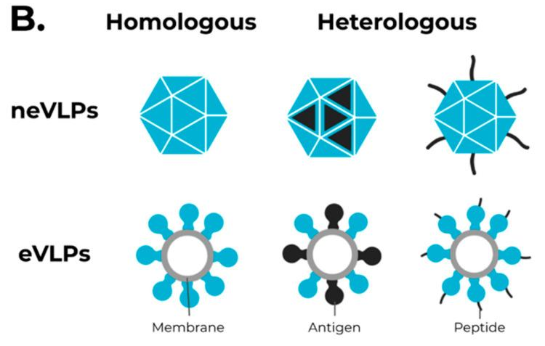
Figure 29: VLP categories. Figure is taken from (Prates-syed et al., 2021).
For example, NDVLP-S2P is a heterologous chimeric eVLP in which the Newcastle disease virus is used. In this vaccine, the transmembrane domain of the NDV fusion protein was fused to SARS-CoV-2 S2P, which caused the S2P proteins to have the correct conformation and to be more immunogenic than the trimeric S protein. CoVLP from Medicago/GSK is another vaccine that uses mutated S2P protein. This vaccine is administered in two doses. In this vaccine, a GSAS plant peptide is used at the S1/S2 subunit location, and TM/CD regions of the Influenza H5 A/Indonesia/5/2005 are used. This vaccine candidate is currently in phase 3 clinical trials (NCT04636697). As shown in Figure 30.D, VBI-2902a is an MLV-based eVLP vaccine candidate containing a prefusion S protein fused to the VSV-G cytoplasmic transmembrane domain (VSV-GTC). This vaccine is in clinical trials 1/2 (NCT04773665) (Prates-syed et al., 2021).
Figure 30: Different VLP vaccines. Figure is taken from (Prates-syed et al., 2021).

Recently, a plant-based vaccine has received more attention. One of the vaccines against the covi19 disease is made from the plant Nicotiana benthamiana. M, N, and E genes of the virus inside the vector are injected into the plant. This method of using the plant is also used by Medicago Inc to make the CoVLPs vaccine. The commercial name is Covifenz. In this vaccine, modified full-length S protein is expressed in plant cells, then they assemble and go to the plasma membrane and germinate in the form of a virus-like structure from plant cells. Experiments that have not been completed in macaques show that these VLPs can induce a strong IgG response (Maharjan and Choe, 2021; Mohsen and Bachmann, 2022).
This vaccine made by Medicago Company, has passed the 3 clinical phases and is approved in Canada. As we mentioned, these types of vaccines usually need an adjuvant. The CoVlp vaccine also has an AS03 adjuvant. In the first clinical phase, the results have shown that by injecting this vaccine with adjuvant, it brings better humoral and cytokine production responses. All subjects in the study had neutralizing antibody responses after injection with two doses. There were mild side effects after the injection (Ward et al., 2021). These reasons were enough for this vaccine to enter the next phase of research, and in phases 2 and 3, a randomized, observer-blind, placebo-controlled study was designed for people aged 18 to 65 (Maharjan and Choe, 2021). In this experiment, two doses of 3.75 µg of this vaccine caused a humoral response, and interferon-gamma (IFN-γ) and IL-4 responses were also observed. The side effects of this vaccine were minor, like other vaccines, such as injection site pain, muscle pain, and fatigue for 1 to 3 days (Gobeil et al., 2021).
In a phase 3 study, the results show that this vaccine is 70% effective against any symptomatic infection in the young adult population and 78.8% effective against moderate to severe disease. The effectiveness of this vaccine against different types of coronaviruses is as follows. 75.3% for the delta variant and 88.6% for the gamma variant, and it varies from 72 to 92.5% for the other variants, although there is no information for Omicron (Gobeil et al., 2022; Makarkov et al., 2022). The Covifenz COVID-19 vaccine was authorized in Canada under the Food and Drug Regulations.
Some of the advantages of the VLP vaccine are 1. They are safer than inactivated or attenuated virus vaccines because reversion of the virus is avoided. 2. 20 to 200 nm size of VLPs and their structure is easily recognized and absorbed by antigen-presenting cells 3. The manufacturing has flexibility because it can be produced in a range of production systems (Dai, Wang and Deng, 2018).
- Nucleic acid-based (DNA or mRNA) vaccines

Nucleic acid-based vaccines use the genetic material of the virus to make the cells of the recipient produce viral proteins and activate the immune response. Depending on the pathogen, the genetic material can be DNA or RNA. Once nucleic acid enters the host cells, it can translate the genes into proteins and eventually make antigens that activate the immune system. Since the antigens are made in non-antigen presenting cells, they stimulate cellular immunity much better than proteins that are injected into the body and will be captured and presented by APCs. For the coronavirus vaccine, the mRNA encoding the viral antigen is complexed with a carrier such as lipid nanoparticles so that the injected mRNA can enter cells. When virus mRNA goes into the cytoplasm of the host cell, it can make proteins and activate the immune response (Jackson and Kester, 2020).
- mRNA Vaccines:

mRNA vaccines did not exist in the 20th century, and this technology is very new. Two mRNA vaccines for COVID-19 developed by Pfizer–BioNTech and Moderna have become famous. To make an mRNA vaccine, we must first identify the appropriate pathogen antigen, in this case the S protein is the preferred target. With the known gene sequence of this antigen, it can then be cloned into a plasmid DNA. This DNA is then transcribed into RNA by T7-RNA polymerase. To increase the translation rate, 1-methyl-pseudouridine rather than uridine is used for transcription. Then, we can inject vaccine into the body for clinical phases. When this vaccine is injected into the body, this piece of mRNA can be converted to a protein (the same antigen) using a host translation device. The advantage of this vaccine is that it stimulates both humoral and cellular immunity (Khandker et al., 2021). On the other hand, innate immunity also plays a role by secreting chemokines at the injection site. The advantages of this type of vaccine are stability, high production speed, and cost-effectiveness. Moreover, they no longer require adjuvants (Dong et al., 2020). They work better than DNA vaccines because they express the antigen in the cytoplasm. Pfizer and Moderna are two COVID vaccines that were developed and approved by the WHO for Covid19.
One of the challenges of making RNA vaccines is to prevent RNA degradation by host cells. There is an enzyme in the host cell called ribonuclease. This enzyme can destroy RNAs and detect foreign RNAs and destroy them. Another problem is that negatively charged mRNA cannot cross the negatively charged cell membrane. This problem prevents mRNA from reaching the host cells translational machinery. To solve these challenges, scientists designed lipid nanoparticles to carry mRNA (Khandker et al., 2021). These lipid nanoparticles can protect mRNA from ribonucleases and also prevent early activation of interferon-related genes. Lipid nanoparticles can cross cell membranes and can be specifically designed for specific target cells (Patel et al., 2022). One of the reasons that mRNA vaccines must be kept very cold is that the mRNA will be degraded by ribonucleases at room temperature. After injection, mRNA enters the host cells. Cells' ribosomes translate mRNA, and spike proteins are made. The spikes go on the surface of the cells and are recognized by the immune system.
BNT162b2 and BNT162b1 are two vaccines developed by BioNTech and Pfizer. In BNT162b2, the complete genome of the S protein is encoded, with two mutations that keep the protein in its pre-fusion conformation. In BNT162b1, the RBD portion of the S protein is encoded. In both cases, the immune system is stimulated, but BNT162b2 is in mass production because BNT162b1 did not work as well in early trials. In a phase 2/3 trial, different doses of the vaccine were injected into adults and then tested for antibody titers and immunogenicity. Doses between 10 µg and 30 are suitable for first and second injections. Phase 2/3 was performed for BNT162b2, and the results showed 95% efficacy to prevent coronavirus infection in participants over 16 years old. These best results used 30 µg for two doses (Polack et al., 2020). A phase 3 trial was also designed for 12- to 15-year-olds, showing that using three doses of 30 µg of BNT162b2 was 100% effective 7 days after second dose (Gurtman et al., 2021). A single dose of this vaccine can increase IgG antibody to the spike protein, and thus prevent the virus from attaching to the cellular receptor (Khandker et al., 2021). If we want to give more details about the effectiveness of the Pfizer vaccine, we should mention that two doses of the Pfizer vaccine for adults above 16 years of age have an effectiveness of 96.7% to prevent death and 97.2% to prevent hospitalization. Against the delta variant, 64.2% 14 days after the first injection and 53.5% 14 days after the second injection are effective against hospitalization and death (Patel et al., 2022). The efficacy of the Pfizer vaccine after 2 doses against the alpha variant is 93.7% (Zarreen, Dibyangshee and Ramneet, 2022).
Regarding the symptoms after the injection of the vaccine, pain at the site of injection is one of the common symptoms that lasts up to a week. Systemic reactions include fatigue, headaches, and fever also were more common in the younger recipients and after the second dose. Myocarditis has been reported after administration, especially after the second dose in adults, the prevalence of myocarditis was 3.5 cases per 1 million doses. The benefits of vaccination in preventing hospitalization and mortality offset the increased risk of myocarditis (Patel et al., 2022).
Figure 31: the side effects of BNT162b2 vaccine. Figure is taken from (Patel et al., 2022).
When infected cells were killed, antigenic particles were detected by the antigen-presenting cells. These cells also show these proteins on their surface. When helper T cells detect these antigenic components, the cells call for immunity to fight. B cells can directly identify infected cells or spike fragments. When these B cells are activated by helper T cells, they proliferate and make antibodies. These antibodies are made against the spike protein. Antibodies prevent spikes from attaching to receptor cells and signal them for elimination. APCs, on the other hand, can activate killer T cells. T killer cells can kill any cells which have spike proteins on their surface. As a result, this type of vaccine activates the response of T cells well.
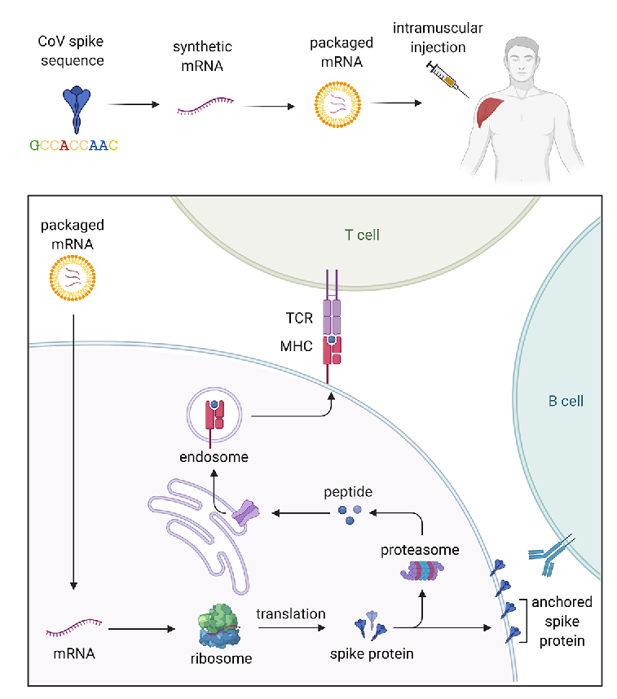
Figure 32: How BNT162b2 work in human body. Figure is taken from (Nance and Meier, 2021).

- DNA Vaccines:

DNA vaccine is another type of nucleic acid-based vaccine. After injection with this type of vaccine, the gene is transcribed into mRNA and translated into the protein which serves as an antigen in the cells. Indeed, scientists engineer plasmid containing the DNA sequence encoding the antigens. This antigen is recognized by the immune system as a foreign body. All DNA vaccines being tested in clinical trials for COVID-19 use the S protein as the antigen.
There are four different DNA vaccines against Covid19. One vaccine is in a phase 3 trial, the nCoV vaccine by Zydus Cadila (Zy-CoV-D). INO-4800 and the AG0301-COVID19 vaccine are two Vaccines at the phase 2/3 trial stage. Another DNA-based vaccine is the GX-19 vaccine under the phase 1/2 trial (Brisse et al., 2020). This paper discusses the Zydus Cadila: ZyCoV-D vaccine which has been approved by the Drugs Controller General of India (DCGI).
A randomized, double-blind, placebo-controlled study of a DNA vaccine, ZyCoV-D, has been conducted and its results have been reported by Akash Khobragade and colleagues. This vaccine contains a 2 mg dose of a DNA plasmid (pVAX-1) carrying the gene encoding the S protein, expressing the Wuhan-Hu-1 spike antigen and IgE signal peptide. This vaccine is administered intradermally. The participants were injected at 28-day intervals. When 158 people had a positive RT-PCR test 28 days after the third administration, results were analysed. The results showed that this vaccine prevents severe disease and death and is safe. Its efficacy was 66.6%. This vaccine is licensed for emergency use in India. One of the challenges of DNA vaccines is their delivery in the body. Because mRNA vaccines only pass through the cell membrane, but DNA vaccines, in addition to the cell membrane, must pass through the nuclear and cytoplasmic membranes in order to enter the nucleus. For this reason, nanoparticles used for mRNA delivery do not work well for DNA delivery. In the above study, the device was small and portable (<50 grams) and consisted of an injector, syringe and filling adapter (Needle Free Injection System (NFIS)). But the use of this device is a limiting factor, because in addition to producing a vaccine for its injection, there must be an injection device. If we overcome this limiting factor, DNA vaccines can be a suitable option for global use due to their cheapness and effectiveness. To test the immunogenic potential of the DNA plasmid in this vaccine, this vaccine was injected in three doses of 25, 100, and 500 micrograms in mice, guinea pigs, and rabbits. This test showed that the DNA vaccine elicited an antibody response, including neutralizing antibodies against SARS-CoV-2 and also induces a Th-1 response. ZyCoV-D also elicited balanced humoral and cellular immune responses in participants who demonstrated either or both antibody or T-cell responses 70 days after three vaccine doses (khobragade, akash. bhate, suresh. ramaiah, 2020; Kansagra et al., 2021).
The side effects reported for this vaccine were mild and resolved completely. Most of the side effects were related to the injection site, which included redness and swelling, pain, itching at the injection site. Other side effects were headache, fever, and fatigue. ZyCoV-D is stored at 2–8°C, but is stable at 25°C for at least 3 months. (khobragade, akash. bhate, suresh. ramaiah, 2020)
The ZyCoV-D vaccine is effective against the delta variant was found to be 100% effective against severe and moderate COVID-19 cases and 64·9% effective against mild COVID-19 cases (khobragade, akash. bhate, suresh. ramaiah, 2020).
It has been said that mRNA vaccines are easier to deliver, but the many advantages of DNA vaccines make scientists eager to find them. These advantages include the facts that DNA vaccines induce cellular and humoral immunity while not inducing an anti-carrier immune response. DNA vaccines are effective even in newborns, they are safe, stable and in production. The technology itself is simple, fast and cheap (Wang et al., 2022). This vaccine can be stored at a temperature of 4 degrees, which is much more feasible compared to mRNA technology, especially for developing countries. These vaccines do not have live vectors, so the possibility of causing infection in people's bodies is less, as is the case with viral vector vaccines. Scientists are always concerned however that DNA vaccines could integrate into the host DNA causing mutations that could lead to cancer.

Conclusion:

In order to prevent fatalities and curb the spread, vaccines against the SARS-CoV-2 virus had to be developed. Scientists have drawn upon their experience with SARS-CoV-1 and MERS-CoV, as well as their understanding of the human immune responses, to produce these vaccines. This article reviewed the progress made in developing vaccines against SARS-CoV-2. It has been determined that the spike protein is the ideal target for eliciting a response within the body, and various strategies have been employed to create vaccines based on it.
The quest to develop a vaccine for this virus has led to the rapid advancement of mRNA vaccine technology and viral vector vaccine technology, two strategies that had not previously been employed for human vaccines. Utilizing these two strategies along with other conventional strategies, scientists have developed and administered numerous vaccines globally. This article explored the different strategies employed and the progress achieved in this field.
In conclusion, due to the limitations of delivering the vaccine to different countries, it is important for everyone to choose the best available in their country and receive it to prevent severe infections for themselves and those they come into contact with. For optimal effectiveness, it is crucial not to forget to receive the second and third doses.

References:
Ahmed-Hassan, H. et al. (2020) ‘Innate Immune Responses to Highly Pathogenic Coronaviruses and Other Significant Respiratory Viral Infections’, Frontiers in Immunology, 11(August). doi: 10.3389/fimmu.2020.01979.
Alba Grifoni, Daniela Weiskopf, et al. (2020) ‘Targets of T Cell Responses to SARS-CoV-2 Coronavirus in Humans with COVID-19 Disease and Unexposed Individuals’, CellPress, (January). doi: 10.1016/j.cell.2020.05.015 SUMMARY.
Amor, S., Fernández Blanco, L. and Baker, D. (2020) ‘Innate immunity during SARS-CoV-2: evasion strategies and activation trigger hypoxia and vascular damage’, Clinical and Experimental Immunology, 202(2), p. 17. doi: 10.1111/cei.13523.
Asrani, P. and Hassan, I. (2021) ‘SARS‑CoV‑2 mediated lung inflammatory responses in host: targeting the cytokine storm for therapeutic interventions’, Molecular and Cellular Biochemistry, 476(2), pp. 675–687. doi: 10.1007/s11010-020-03935-z.
Barros-martins, J. et al. (2021) ‘Immune responses against SARS-CoV-2 variants after heterologous and homologous ChAdOx1 nCoV-19 / BNT162b2 vaccination’, Nature Medicine, 27(September). doi: 10.1038/s41591-021-01449-9.
Bayani, F. et al. (2023) ‘An overview of the vaccine platforms to combat COVID-19 with a focus on the subunit vaccines’, 178(September 2022), pp. 32–49. doi: 10.1016/j.pbiomolbio.2023.02.004.
Bergmann, C. C. and Silverman, R. H. (2020) ‘COVID-19: Coronavirus replication, pathogenesis, and therapeutic strategies’, Cleveland Clinic Journal of Medicine, 87(5), pp. 1–7. doi: 10.3949/CCJM.87A.20047.
Bosch, B. J. et al. (2003) ‘The Coronavirus Spike Protein Is a Class I Virus Fusion Protein: Structural and Functional Characterization of the Fusion Core Complex’, 77(16), pp. 8801–8811. doi: 10.1128/JVI.77.16.8801.
Brisse, M. et al. (2020) ‘Emerging Concepts and Technologies in Vaccine Development’, Frontiers in Immunology, 11(September), pp. 1–22. doi: 10.3389/fimmu.2020.58307.
CDC (2023) SARS-CoV-2 Variant Classifications and Definitions, Center for disease control and Prevention (CDC). Available at: https://www.cdc.gov/coronavirus/2019-ncov/variants/variant-classifications.html#:~:text=Variants of concern might require, masking%2C testing or physical distancing.
Chavda, V. P., Vora, L. K. and Vihol, D. R. (2020) ‘covax-19 Vaccine: Completely blocks virus transmission to non-immune individuals’, clinical complementrary medicine and pharmacology, (January). doi: 10.1016/j.ccmp.2021.100004.
Chen, L. et al. (2018) ‘Inflammatory responses and inflammation-associated diseases in organs’, Oncotarget, 9(6), p. 15. doi: 10.18632/oncotarget.23208.
Chen, Y., Liu, Q. and Guo, D. (2020) ‘Emerging coronaviruses: Genome structure, replication, and pathogenesis’, Journal of Medical Virology, 92(4), pp. 418–423. doi: 10.1002/jmv.25681.
CinnaGen (2021) SpikoGen (Recombinant COVID-19 Vaccine) Long Live Immunity, CinnaGen. Available at: https://www.cinnagen.com/Product.aspx?t=2&l=1&Id=607.
Cornillez-Ty, C. T. et al. (2009) ‘Severe Acute Respiratory Syndrome Coronavirus Nonstructural Protein 2 Interacts with a Host Protein Complex Involved in Mitochondrial Biogenesis and Intracellular Signaling’, Journal of Virology, 83(19), pp. 10314–10318. doi: 10.1128/jvi.00842-09.
Crotty, S. et al. (2020) ‘T follicular helper cell biology: A decade of discovery and diseases’, Immunity, 50(5), pp. 1132–1148. doi: 10.1016/j.immuni.2019.04.011.T.
Dai, S., Wang, H. and Deng, F. (2018) ‘Advances and challenges in enveloped virus-like particle (VLP ) -based vaccines’, journal of immunological sciences, 2, pp. 36–41. doi: 10.29245/2578-3009/2018/2.1118.
Deng, S. et al. (2022) ‘Viral Vector Vaccine Development and Application during the COVID-19 Pandemic’, MDPI. doi: 10.3390/ microorganisms10071450.
Dong, Y. et al. (2020) ‘A systematic review of SARS-CoV-2 vaccine candidates’, Signal Transduction and Targeted Therapy, 5(1). doi: 10.1038/s41392-020-00352-y.
Duan, G. (2020) ‘Virology, Epidemiology, Pathogenesis, and Control of COVID-19’, MDPI, pp. 1–17.
Dutta, S. S. (2021) Oxford-AstraZeneca COVID-19 vaccine induces robust T cell-based immunity, News Medical Life Science. Available at: https://www.news-medical.net/news/20210628/Oxford-AstraZeneca-COVID-19-vaccine-induces-robust-T-cell-based-immunity.aspx.
Esakandari, H. et al. (2020) ‘A comprehensive review of COVID-19 characteristics’, Biological procedures online, 2, pp. 1–10. doi: 10.1186/s12575-020-00128-2.
Ewer, K. J. et al. (2021) ‘T cell and antibody responses induced by a single dose of ChAdOx1 nCoV-19 (AZD1222) vaccine in a phase 1 / 2 clinical trial’, Nature Medicine, 27(February). doi: 10.1038/s41591-020-01194-5.
Falsey, A. R. et al. (2021) ‘Phase 3 Safety and Efficacy of AZD1222 (ChAdOx1 nCoV-19) Covid-19 Vaccine’, the new england journal of medicine. doi: 10.1056/NEJMoa2105290.
Fan, Y. et al. (2022) ‘SARS-CoV-2 Omicron variant: recent progress and future perspectives’, Nature, (March). doi: 10.1038/s41392-022-00997-x.
Fogeron, M. et al. (2021) ‘SARS-CoV-2 ORF7b: is a bat virus protein homologue a major cause of COVID-19 symptoms?’, bioRxiv, pp. 1–19. doi: 10.1101/2021.02.05.428650.
Frieman, M. et al. (2009) ‘Severe Acute Respiratory Syndrome Coronavirus Papain-Like Protease Ubiquitin-Like Domain and Catalytic Domain Regulate Antagonism of IRF3 and NF-κB Signaling’, Journal of Virology, 83(13), pp. 6689–6705. doi: 10.1128/jvi.02220-08.
Fu, Y., Cheng, Y. and Wu, Y. (2020) ‘Understanding SARS-CoV-2-Mediated Inflammatory Responses: From Mechanisms to Potential Therapeutic Tools’, Virologica Sinica, 35(3), pp. 266–271. doi: 10.1007/s12250-020-00207-4.
Gobeil, P. et al. (2021) ‘Phase 2 Randomized Trial of an AS03 Adjuvanted Plant-Based Virus-Like Particle Vaccine for Covid-19 in Healthy Adults, Older Adults and Adults with Comorbidities’, medrxiv, pp. 1–35. doi: 10.1101/2021.05.14.21257248.
Gobeil, P. et al. (2022) ‘Durability and cross-reactivity of immune responses induced by a plant-based virus-like particle vaccine for COVID-19’, Nature Communications, pp. 1–10. doi: 10.1038/s41467-022-34728-1.
Gower, C. et al. (2019) ‘Effectiveness of Covid-19 Vaccines against the B.1.617.2 (Delta) Variant’, the new england journal of medicine, pp. 1–10. doi: 10.1056/NEJMoa2108891.
Graham, M. S. et al. (2021) ‘Changes in symptomatology, reinfection , and transmissibility associated with the SARS-CoV-2 variant B . 1. 1. 7: an ecological study’, The Lancet. doi: 10.1016/S2468-2667(21)00055-4.
Graham, R. L. et al. (2012) ‘A live, impaired-fidelity coronavirus vaccine protects in an aged , immunocompromised mouse model of lethal disease’, Nature Medicine, 18(12). doi: 10.1038/nm.2972.
Gurtman, A. et al. (2021) ‘Safety, Immunogenicity, and Efficacy of the BNT162b2 Covid-19 Vaccine in Adolescents’, the new england journal of medicine, pp. 1–12. doi: 10.1056/NEJMoa2107456.
Haque, A. and Pant, A. B. (2020) ‘Efforts at COVID-19 Vaccine Development: Challenges and Successes’, MDPI, (December), pp. 1–16. doi: 10.3390/vaccines8040739.
Hartenian, E. et al. (2020) ‘The molecular virology of coronaviruses’, Journal of Biological Chemistry, 295(37), pp. 12910–12934. doi: 10.1074/jbc.REV120.013930.
Hazeldine, J. and Lord, J. M. (2021) ‘Neutrophils and COVID-19: Active Participants and Rational Therapeutic Targets’, Frontiers in Immunology, 12(June), pp. 1–21. doi: 10.3389/fimmu.2021.680134.
Heidary, M. et al. (2022) ‘A Comprehensive Review of the Protein Subunit Vaccines Against’, Frontiers in Microbiologyi, 13(July). doi: 10.3389/fmicb.2022.927306.
Hemarajata, P. (2020) SARS-CoV-2 Sequencing Data: The Devil Is in the Genomic Detail, American Society for Microbiology. Available at: https://asm.org/Articles/2020/October/SARS-CoV-2-Sequencing-Data-The-Devil-Is-in-the-Gen (Accessed: 25 May 2023).
Hu, B. et al. (2021) ‘Characteristics of SARS-CoV-2 and COVID-19’, Nature Reviews Microbiology, (March 2021), pp. 141–154. doi: 10.1038/s41579-020-00459-7.
Hung, I. F. N. and Poland, G. A. (2021) ‘Single-dose Oxford – AstraZeneca COVID-19 vaccine followed by a 12-week booster Pirtobrutinib shows evidence to inaugurate a third generation of BTK inhibitors’, The Lancet, 397(10277), pp. 854–855. doi: 10.1016/S0140-6736(21)00528-6.
Ibrahim, O. and Menkovska, M. (2022) ‘Dietary Fibers-Classification, Properties , Analysis and Function : A Review’, Advances in Bios-cience and Biotechnology, (December). doi: 10.4236/abb.2022.1312036.
Jackson, N. A. C. and Kester, K. E. (2020) ‘The promise of mRNA vaccines: a biotech and industrial perspective’, npj Vaccines, pp. 3–8. doi: 10.1038/s41541-020-0159-8.
Jeyanathan, M. et al. (2020) ‘Immunological considerations for COVID-19 vaccine strategies’, Nature Reviews Immunology, 20(10), pp. 615–632. doi: 10.1038/s41577-020-00434-6.
Jones, I. and Roy, P. (2020) ‘Sputnik V COVID-19 vaccine candidate appears safe and effective’, The Lancet, (January), pp. 2020–2022. doi: 10.1016/ S0140-6736(21)00191-4.
Kandeel, M. et al. (2023) ‘Safety and immunogenicity of the ChAdOx1, MVA-MERS-S , and GLS-5300 DNA MERS-CoV vaccines’, International Immunipharmacology, 118(December 2022), pp. 1–9. doi: 10.1016/j.intimp.2023.109998.
Kannan, S. et al. (2020) ‘COVID-19 (Novel Coronavirus 2019) - recent trends’, European Review for Medical and Pharmacological Sciences, 24(4), pp. 2006–2011. doi: 10.26355/eurrev_202002_20378.
Kansagra, K. et al. (2021) ‘Safety and Immunogenicity of a DNA SARS-CoV-2 vaccine (ZyCoV-D ): Results of an open-label , non-randomized phase I part of phase I / II clinical study by intradermal route in healthy subjects in India’, EClincalMedicine, 38. doi: 10.1016/j.eclinm.2021.101020.
Kasuga, Y. et al. (2021) ‘Innate immune sensing of coronavirus and viral evasion strategies’, Experimental and Molecular Medicine, 53(5), pp. 723–736. doi: 10.1038/s12276-021-00602-1.
Kevadiya, B. D. et al. (2021) ‘Diagnostics for SARS-CoV-2 infections’, Nature Materials, 20(May). doi: 10.1038/s41563-020-00906-z.
Khandker, S. S. et al. (2021) ‘A Systematic Review on COVID-19 Vaccine Strategies, Their Effectiveness , and Issues’, MDPI, 19, pp. 1–37. doi: 10.3390/vaccines9121387.
khobragade, akash. bhate, suresh. ramaiah, vijendra et al. (2020) ‘Efficacy, safety , and immunogenicity of the DNA SARS-CoV-2 vaccine ( ZyCoV-D ): the interim efficacy results of a phase 3 , randomised , double-blind , placebo-controlled study in India’, Lancet, (January). doi: 10.1016/S0140-6736(22)00151-9.
Khoshnood, S. et al. (2022) ‘An overview on inactivated and live- ­ attenuated SARS- ­ vaccines’, Journal of Clinical Laboratory Analysis published by Wiley Periodicals LLC, (March), pp. 1–12. doi: 10.1002/jcla.24418.
Kim, Y. H. et al. (2022) ‘Influenza vaccines: Past, present, and future’, WILEY, (April 2021). doi: 10.1002/rmv.2243.
Krammer, F. (2020) ‘SARS-CoV-2 vaccines in development’, Nature, 586(October). doi: 10.1038/s41586-020-2798-3.
Kyriakidis, N. C. et al. (2021) ‘SARS-CoV-2 vaccines strategies: a comprehensive review of phase 3 candidates’, npj Vaccines. doi: 10.1038/s41541-021-00292-w.
Lakna (2018) What is the Difference Between Cytotoxic T Cells and Helper T Cells, Pediaa.com. Available at: https://pediaa.com/what-is-the-difference-between-cytotoxic-t-cells-and-helper-t-cells/.
Lee, C. S. et al. (2017) ‘Adenovirus-mediated gene delivery: Potential applications for gene and cell-based therapies in the new era of personalized medicine’, Genes and diseases. doi: 10.1016/j.gendis.2017.04.001.
Lee, E. and Oh, J. E. (2021) ‘Humoral Immunity against SARS-CoV-2 and the Impact on COVID-19 Pathogenesis’, Molecules and Cells, 44(6), pp. 392–400. doi: 10.14348/molcells.2021.0075.
Lee, S., Channappanavar, R. and Kanneganti, T. (2020) ‘Coronaviruses: Innate Immunity , In fl ammasome Activation , In fl ammatory Cell Death , and Cytokines’, (January).
Li, G. et al. (2022) ‘Safety and immunogenicity of the ChAdOx1 nCoV-19 (AZD1222 ) vaccine in children aged 6 – 17 years : a preliminary report of COV006 , a phase 2 single-blind , randomised , controlled trial’, 399. doi: 10.1016/S0140-6736(22)00770-X.
Li, L. et al. (2020) ‘Covax-19/Spikogen vaccine based on recombinant spike protein extracellular domain with Advax-CpG55.2 adjuvant provides single dose protection against SARS-CoV-2 infection in hamsters’, vaccine, (January). doi: 10.1016/j.vaccine.2022.04.041.
Li, Y. Der et al. (2020) ‘Coronavirus vaccine development: from SARS and MERS to COVID‑19’, Biomedical sciencecience, pp. 1–23. doi: 10.1186/s12929-020-00695-2.
Liang, Y. et al. (2020) ‘Highlight of Immune Pathogenic Response and Hematopathologic Effect in SARS-CoV, MERS-CoV, and SARS-Cov-2 Infection’, Frontiers in Immunology, 11(May), pp. 1–11. doi: 10.3389/fimmu.2020.01022.
Libretexts (2021) 14.2.3: T Lymphocytes, Libretexts. Available at : https://bio.libretexts.org/Courses/Mansfield_University_of_Pennsylvania/BSC_3271%3A_Microbiology_for_Health_Sciences_Sp21_%28Kagle%29/14%3A_Immunology/14.02%3A_Specific_Adaptive_Host_Defenses/14.2.03%3A_T_Lymphocytes.
Loo, Y. M. and Gale, M. (2011) ‘Immune Signaling by RIG-I-like Receptors’, Immunity, 34(5), pp. 680–692. doi: 10.1016/j.immuni.2011.05.003.
Luckheeram, R. V. et al. (2012) ‘CD4 + T Cells: Differentiation and Functions’, Clinical and Developmental Immunology, 2012. doi: 10.1155/2012/925135.
Lumbers, E. R. et al. (2020) ‘The Lung, the Heart, the Novel Coronavirus, and the Renin-Angiotensin System; The Need for Clinical Trials’, Frontiers in Medicine, 7(May), pp. 1–7. doi: 10.3389/fmed.2020.00248.
Maharjan, P. M. and Choe, S. (2021) ‘Plant-Based COVID-19 Vaccines: Current Status , Design , and Development Strategies of Candidate Vaccines’, MDPI, pp. 1–21. doi: 10.3390/ vaccines9090992 Academic.
Mahase, E. (2021) ‘Covid-19: Sore throat , fatigue , and myalgia are more common with new UK variant’, BMJ (Online), (January), p. 2021. doi: 10.1136/bmj.n230.
Makarkov, A. I. et al. (2022) ‘Efficacy and Safety of a Recombinant Plant-Based Adjuvanted Covid-19 Vaccine’, the new england journal of medicine, pp. 1–13. doi: 10.1056/NEJMoa2201300.
Mart, D. et al. (2021) ‘SARS-CoV-2 Vaccines Based on the Spike Glycoprotein and Implications of New Viral Variants’, Frontiers in Immunology, 12(July). doi: 10.3389/fimmu.2021.701501.
Mehraeen, E. et al. (2021) ‘Olfactory and gustatory dysfunctions due to the coronavirus disease (COVID ‑ 19): a review of current evidence’, European Archives of Oto-Rhino-Laryngology, 278(2), pp. 307–312. doi: 10.1007/s00405-020-06120-6.
Mercurio, I. et al. (2021) ‘Protein structure analysis of the interactions between SARS ‑ CoV ‑ 2 spike protein and the human ACE2 receptor: from conformational changes to novel neutralizing antibodies’, Cellular and Molecular Life Sciences, 78(4), pp. 1501–1522. doi: 10.1007/s00018-020-03580-1.
Moderbacher, C. R. et al. (2020) ‘Antigen-Specific Adaptive Immunity to SARS-CoV-2 in Acute COVID-19 and Associations with Age and Disease Severity ll Antigen-Specific Adaptive Immunity to SARS-CoV-2 in Acute COVID-19 and Associations with Age and Disease Severity’, Cell, 183(4), pp. 996-1012.e19. doi: 10.1016/j.cell.2020.09.038.
Mohsen, M. O. and Bachmann, M. F. (2022) ‘Virus-like particle vaccinology, from bench to bedside’, CMI (clinical microbiology and infection), (April). doi: 10.1038/s41423-022-00897-8.
Nance, K. D. and Meier, J. L. (2021) ‘Modifications in an Emergency: The Role of N1-Methylpseudouridine in COVID-19 Vaccines’. doi: 10.1021/acscentsci.1c00197.
Nasreen, S. et al. (2022) ‘Effectiveness of COVID-19 vaccines against symptomatic SARS-CoV-2 infection and severe outcomes with variants of concern in Ontario’, nature microbiology, 7(March). doi: 10.1038/s41564-021-01053-0.
Nooraei, S. et al. (2021) ‘Virus ‑ like particles: preparation, immunogenicity, and their roles as nanovaccines and drug nanocarriers’, Journal of Nanobiotechnology, pp. 1–27. doi: 10.1186/s12951-021-00806-7.
Pallesen, J. et al. (2017) ‘Immunogenicity and structures of a rationally designed prefusion MERS-CoV spike antigen’, PNAS. doi: 10.1073/pnas.1707304114.
Patel, R. et al. (2022) ‘A comprehensive review of SARS-CoV-2 vaccines: Pfizer, Moderna & Johnson & ABSTRACT’, Human Vaccines & Immunotherapeutics, 18(1), pp. 1–12. doi: 10.1080/21645515.2021.2002083.
Payne, S. (2017) ‘Chapter 17 - Family Coronaviridae’, 21(1), pp. 149–158. doi: http://dx.doi.org/10.1016/B978-0-12-803109-4.00017-9.
Polack, F. P. et al. (2020) ‘Safety and Efficacy of the BNT162b2 mRNA Covid-19 Vaccine’, the new england journal of medicine, pp. 1–13. doi: 10.1056/NEJMoa2034577.
Prates-syed, W. A. et al. (2021) ‘VLP-Based COVID-19 Vaccines: An Adaptable Technology against the Threat of New Variants’, MDPI, pp. 1–17. doi: 10.3390/ vaccines9121409 Academic.
Punt, J. et al. (2019) Kuby Immunilogy. eighth. Edited by E. Champion, Erica. Pantages Frost. new york: W.H.freeman macmillan learning.
Qubais, B. et al. (2020) ‘Side effects and perceptions following Sinopharm COVID-19 vaccination’, Internation journal of infectious diseases, (January). doi: 10.1016/j.ijid.2021.08.013.
R.Fehr, A. and Perlman, S. (2015) ‘Coronaviruses: An Overview of Their Replication and Pathogenesis’, Coronaviruses: Methods and Protocols, 1282(1), pp. 1–282. doi: 10.1007/978-1-4939-2438-7.
Rathore, J. S. and Ghosh, C. (2020) ‘severe acute respiratory syndrome coronavirus-2 (SARS-CoV-2), a newly emerged pathogen: an overview’, Pathogens and Disease, 78(6), pp. 1–9. doi: 10.1093/femspd/ftaa042.
Redondo, N. et al. (2021) ‘SARS-CoV-2 Accessory Proteins in Viral Pathogenesis: Knowns and Unknowns’, Frontiers in Immunology, 12(July), pp. 1–8. doi: 10.3389/fimmu.2021.708264.
Reusch, N. et al. (2021) ‘Neutrophils in COVID-19’, Frontiers in Immunology, 12(March), pp. 1–9. doi: 10.3389/fimmu.2021.652470.
Ricci, D. et al. (2021) ‘Innate Immune Response to SARS-CoV-2 Infection: From Cells to Soluble Mediators’, International Journal of Molecular scineces, (M), pp. 1–20. doi: 10.3390/ijms22137017.
Ruocco, V. and Strasser, R. (2022) ‘Transient Expression of Glycosylated SARS-CoV-2 Antigens in Nicotiana benthamiana’, MDPI. doi: 10.3390/ plants11081093 Academic.
S. Chakraborty, B.M. Veeregowda, R. Deb, and B. M. C. N. (2013) ‘An Overview of the Immune Evasion Strategies Adopted by Different Viruses with Special Reference to Classical Swine Fever Virus’, Intech, 32(July), p. 21. doi: http://dx.doi.org/10.5772/55435.
Satarker, S. and Nampoothiri, M. (2020) ‘Structural Proteins in Severe Acute Respiratory Syndrome Coronavirus-2’, Archives of Medical Research, 51(January), pp. 482–491. doi: 10.1016/j.arcmed.2020.05.012.
Schultze, J. L. and Aschenbrenner, A. C. (2021) ‘COVID-19 and the human innate immune system’, Cell, 184(7), p. 22. doi: 10.1016/j.cell.2021.02.029.
Sette, A. and Crotty, S. (2020) ‘Adaptive immunity to SARS-CoV-2 and COVID-19 Alessandro’, CellPress, (January). doi: 10.1016/j.cell.2021.01.007.
Shah, V. K. et al. (2020) ‘Overview of Immune Response During SARS-CoV-2 Infection: Lessons from the Past’, Frontiers in Immunology, 11(August), pp. 1–17. doi: 10.3389/fimmu.2020.01949.
Shereen, M. A. et al. (2020) ‘COVID-19 infection: Origin, transmission, and characteristics of human coronaviruses’, Journal of Advanced Research, 24, pp. 91–98. doi: 10.1016/j.jare.2020.03.005.
Shi, Y. et al. (2020) ‘An overview of COVID-19’, Zhejiang University-SCIENCE B, 21(5), pp. 343–360. doi: doi.org/10.1631/jzus.B2000083.
Shibabaw, T. et al. (2020) ‘Role of ifn and complements system: Innate immunity in sars-cov-2’, Journal of Inflammation Research, 13, p. 12. doi: 10.2147/JIR.S267280.
Sokolowska, M. et al. (2020) ‘Immunology of COVID-19: Mechanisms , clinical outcome , diagnostics , and perspectives — A report of the European Academy of Allergy and Clinical Immunology ( EAACI )’, (May), p. 32. doi: 10.1111/all.14462.
Sun, P. et al. (2020) ‘Understanding of COVID-19 based on current evidence’, Journal of Medical Virology, pp. 548–551. doi: 10.1002/jmv.25722.
Supriya, N. (2022) Thymus Dependent Antigens, Biology Reader. Available at: https://biologyreader.com/thymus-dependent-antigens.html (Accessed: 1 June 2023).
Tabarsi, P. et al. (2020) ‘Evaluating the ef fi cacy and safety of SpikoGen ®, an Advax- CpG55 . 2 e adjuvanted severe acute respiratory syndrome coronavirus 2 spike protein vaccine: a phase 3 randomized placebo-controlled trial’, CMI (clinical microbiology and infection), (January). doi: 10.1016/j.cmi.2022.09.001.
Tabarsi, P. et al. (2022) ‘Immunogenicity and safety of SpikoGen ®, an adjuvanted recombinant SARS-CoV-2 spike protein vaccine as a homologous and heterologous booster vaccination : A randomized placebo-controlled trial’, immunology, (April), pp. 1–14. doi: 10.1111/imm.13540.
Taefehshokr, N. et al. (2020) ‘Covid-19: Perspectives on Innate Immune Evasion’, Frontiers in Immunology, 11(September), pp. 1–12. doi: 10.3389/fimmu.2020.580641.
Tai, W. et al. (2016) ‘A recombinant receptor-binding domain of MERS-CoV in trimeric form protects human dipeptidyl peptidase 4 (hDPP4) transgenic mice from MERS-CoV infection’, Virology, (January). doi: 10.1016/j.virol.2016.10.005.
Tay, M. Z. et al. (2020) ‘The trinity of COVID-19: immunity, inflammation and intervention’, Nature Reviews Immunology, 20(6), pp. 363–374. doi: 10.1038/s41577-020-0311-8.
Thoms, M. et al. (2020) ‘Structural basis for translational shutdown and immune evasion by the Nsp1 protein of SARS-CoV-2’, Science, 369(6508), pp. 1249–1256. doi: 10.1126/SCIENCE.ABC8665.
Tnag, F. et al. (2011) ‘Lack of Peripheral Memory B Cell Responses in Recovered Patients with Severe Acute Respiratory Syndrome: A Six-Year Follow-Up Study’, The journal of immunology. doi: 10.4049/jimmunol.0903490.
Travieso, T. et al. (2022) ‘The use of viral vectors in vaccine development’, npj Vaccines, pp. 1–10. doi: 10.1038/s41541-022-00503-y.
Uddin, M. et al. (2020) ‘SARS-CoV-2/COVID-19: Viral Genomics, Epidemiology, Vaccines, and Therapeutic Interventions’, Listening to Women After Childbirth, (January), pp. 81–88. doi: 10.4324/9781351118422-5.
V’kovski, P. et al. (2020) ‘Coronavirus biology and replication: implications for SARS-CoV-2’, Nature Reviews Microbiology, pp. 155–170. doi: 10.1038/s41579-020-00468-6.
Vabret, N. et al. (2020) ‘Review Immunology of COVID-19: Current State of the Science’, CellPress, 1, p. 32. doi: 10.1016/j.immuni.2020.05.002.
Vályi, I. et al. (2021) ‘Comparison of antibody and T cell responses elicited by BBIBP‑CorV (Sinopharm) and BNT162b2 (Pfizer ‑ BioNTech) vaccines against SARS‑CoV‑2 in healthy adult humans’, GeroScience, 2, pp. 2321–2331. doi: 10.1007/s11357-021-00471-6.
Vaziri, M. S. et al. (2022) ‘The ins and outs of SARS-CoV-2 variants of concern (VOCs)’, Archives of Virology, 167(2), pp. 327–344. doi: 10.1007/s00705-022-05365-2.
Vellas, C. et al. (2020) ‘COVID-19, Virology and Geroscience: A Perspective’, Journal of Nutrition, Health and Aging, 24(7), pp. 685–691. doi: 10.1007/s12603-020-1416-2.
Voysey, M. et al. (2021) ‘Safety and efficacy of the ChAdOx1 nCoV-19 vaccine (AZD1222 ) against SARS-CoV-2 : an interim analysis of four randomised controlled trials in Brazil , South Africa , and the UK’, Lancet, pp. 99–111. doi: 10.1016/S0140-6736(20)32661-1.
Vzorov, A. N., Samokhvalov, E. I. and Chebanenko, V. V (2021) ‘Modification of the Spike Protein for Vaccines against Enveloped RNA Viruses’, Molecular Biology, 55(4), pp. 538–547. doi: 10.1134/S0026893321030158.
Wang, C., Chen, L. and Lu, Q. (2022) ‘Vaccination with the Inactivated Vaccine (Sinopharm BBIBP-CorV ) Ensures Protection against SARS-CoV-2 Related Disease’, MDPI, pp. 1–7. doi: 10.3390/vaccines10060920 Academic.
Wang, H. et al. (2020) ‘Development of an Inactivated Vaccine Candidate, BBIBP-CorV , with Potent Protection against SARS- CoV-2’, CellPress, (January). doi: 10.1016/j.cell.2020.06.008.
Wang, M. Y. et al. (2020) ‘SARS-CoV-2: Structure, Biology, and Structure-Based Therapeutics Development’, Frontiers in Cellular and Infection Microbiology, 10(November), pp. 1–17. doi: 10.3389/fcimb.2020.587269.
Wang, N. et al. (2020) ‘Subunit Vaccines Against Emerging Pathogenic Human Coronaviruses’, Frontiers in Immunology, 11(February). doi: 10.3389/fmicb.2020.00298.
Wang, X. et al. (2022) ‘Development of DNA Vaccine Candidate against SARS-CoV-2’, MDPI. doi: 10.3390/v14051049.
Wang, Y., Grunewald, M. and Perlman, S. (2020) ‘Coronaviruses: An Updated Overview of Their Replication and Pathogenesis’, in Methods in Molecular Biology, pp. 1–29. doi: 10.1007/978-1-0716-0900-2_1.
Ward, B. J. et al. (2021) ‘Phase 1 randomized trial of a plant-derived virus-like particle vaccine for COVID-19’, Nature Medicine, 27(June). doi: 10.1038/s41591-021-01370-1.
Willey, J. M., Sherwood, L. M. and Woolverton, C. J. (2011) Prescott`s Microbiology. ninth. Edited by K. Timp and A. FitzPatrick. McGraw-Hill. doi: DOI:10.1128/jmbe.v11i1.154.
Wold, William. Toth, K. (2015) ‘Adenovirus Vectors for Gene Therapy, Vaccination and Cancer Gene Therapy William’, Curr Gene Ther, 13(6), pp. 421–433. doi: 10.2174/1566523213666131125095046.
Worldometer (2023) COVID-19 CORONAVIRUS PANDEMIC. Available at: https://www.worldometers.info/coronavirus/ (Accessed: 23 May 2023).
Wu, C. et al. (2022) ‘Structure genomics of SARS-CoV-2 and its Omicron variant: drug design templates for COVID-19’, Acta Pharmacologica Sinica, (October 2021), pp. 1–13. doi: 10.1038/s41401-021-00851-w.
Xia, X. (2020) ‘Extreme Genomic CpG Deficiency in SARS-CoV-2 and Evasion of Host Antiviral Defense’, 37(9), pp. 2699–2705. doi: 10.1093/molbev/msaa094.
Xia, X. (2021) ‘Domains and Functions of Spike Protein in SARS-Cov-2 in the Context of Vaccine Design’, MDPI, 2, pp. 1–16. doi: 10.3390/v13010109.
Yadav, R. et al. (2021) ‘Role of Structural and Non-Structural Proteins and Therapeutic Targets of SARS-CoV-2 for COVID-19’, Cells, 10(4), pp. 1–16. doi: 10.3390/cells10040821.
Yang, Z. et al. (2020) ‘Suppression of MDA5-mediated antiviral immune responses by NSP8 of SARS-CoV-2 (preprint)’, bioRxiv, p. 2020.08.12.247767. Available at: http://biorxiv.org/content/early/2020/08/12/2020.08.12.247767.abstract.
Yassine Kasmi, K. K. and Ennaji, A. S. and M. M. (2020) ‘Coronaviridae: 100,000 Years of Emergence and Reemergence’, Malaysian Palm Oil Council (MPOC), 21(1), pp. 1–9. doi: 10.1016/B978-0-12-819400-3.00007-7 127.
Yong, C. Y. et al. (2019) ‘Recent Advances in the Vaccine Development Against Middle East Respiratory Syndrome-Coronavirus’, Frontiers in Microbiologyicrobiology, 10(August), pp. 1–18. doi: 10.3389/fmicb.2019.01781.
Yuefei Jin , Haiyan Yang , Wangquan Ji , Weidong Wu, S. C. and Duan, and G. (2020) ‘virology, epidemiology, pathogenesis, and control of COVID-19’, Novel Research in Microbiology Journal, 4(5), pp. 955–967. doi: 10.21608/nrmj.2020.118446.
Zarreen, F., Dibyangshee, S. and Ramneet, S. (2022) ‘COVID ‑ 19 phase 4 vaccine candidates , effectiveness on SARS ‑ CoV ‑ 2 variants , neutralizing antibody , rare side effects , traditional and nano ‑ based vaccine platforms : a review’, 3 Biotech, 12(1), pp. 1–30. doi: 10.1007/s13205-021-03076-0.
Zhang, Y. et al. (2020) ‘The Comparative Immunological Characteristics of SARS-CoV , Coronavirus Infections’, Frontiers in Immunology, 11(August), p. 21. doi: 10.3389/fimmu.2020.02033.
Zhao, Jincun et al. (2020) ‘Airway Memory CD4 + T Cells Mediate Protective Immunity against Emerging Respiratory Coronaviruses’, Immunity, (January). doi: http://dx.doi.org/10.1016/j.immuni.2016.05.006 SUMMARY.
Zheng, J. et al. (2021) ‘Characterization of SARS-CoV-2-specific humoral immunity and its potential applications and therapeutic prospects’, Cellular & Molecular Immunology, (August), pp. 1–8. doi: 10.1038/s41423-021-00774-w.
Zhou, Z., Xiao, F. and Chen, J. (2021) ‘Structural insight reveals SARS-CoV-2 ORF7a as an immunomodulating factor for human CD14+ monocytes’, iScience, 24(3), p. 102187. doi: 10.1016/j.isci.2021.102187.
Zhu, F. et al. (2021) ‘Safety and immunogenicity of a recombinant adenovirus type-5-vectored COVID-19 vaccine with a homologous prime-boost regimen in healthy participants aged 6 years and above: a randomised, double-blind, placebo-controlled, phase 2b trial’, Clinical Infectious Diseases. doi: 10.1093/cid/ciab845.
Zhu, X. et al. (2017) ‘Porcine Deltacoronavirus nsp5 Antagonizes Type I Interferon Signaling by Cleaving STAT2’, Journal of Virology, 91(10). doi: 10.1128/jvi.00003-17.
Ziebuhr, J., Snijder, E. J. and Gorbalenya, A. E. (2000) ‘Virus-encoded proteinases and proteolytic processing in the Nidovirales’, General virology, pp. 853–879. doi: 10.1099/0022-1317-81-4-853.

