Afsaneh Asghari
----------------------------------------------------------------------------------------------------------------
AUTHOR OF THESIS

Bachelor of Science (Biology)
----------------------------------------------------------------------------------------------------------------
DEGREE

Circadian rhythm and its role in human disease
TITLE OF THESIS

Dr Keyvan Sedaghat
----------------------------------------------------------------------------------------------------------------
THESIS SUPERVISOR

Circadian disruption and its role in human disease

Afsaneh Asghari

Thesis submitted to the Biology Department of BIHE, in order to fulfill the BS.C of science

Department of Biology
Faculty of Science
BIHE

© Afsaneh. Asghari, Tehran, Iran, 2013
Abstract
Are you an early riser or a night vigilant? It happens for each of us that we may awake before the alarm clock rings. This is a function of biological clock. In this article we want to know if disruption in circadian clock that occurs for shift workers or in jet lags has any effect on appearance of diseases such as cancer, diabetes or obesity? In fact, we must study if there is any link between this disruption and over weighted ness or cancer or diabetes.
Biological rhythms exist in all organisms from cyanobacteria to human. Organisms use this rhythm to coordinate their physiology. Biological clock has nine genes and the productions of these genes regulate circadian rhythm. There is more than one circadian clock in each organism. As it is proven disruption of cell cycle causes cancer. Transition from different phases of cell cycle that is done by CDKs, CKIs and expression of CDKs, CKIs Tumor suppressor genes are controlled by clock genes and show circadian rhythmicity in their expression thus disruption in circadian rhythm causes cancer. In this study we survey the effects of disruption of circadian rhythm in some cancers such as colon cancer, colorectal cancer, skin cancer, liver cancer and breast cancer then we check if this disruption has any effects on obesity and diabetes as well?
Lack of sleep is associated with obesity and also, the increase of abdominal fats elevates the risk of diabetes. However we cannot suggest that disruption of circadian rhythm will definitely increase the risk of diabetes. Disruption may make the person susuptible for the mentioned diseases but has not shown to have direct effect on these diseases.
[Biological clock, circadian rhythm, cancer, diabetes, hypertension and melatonin]
Table of contents
Abstract …………………………………………………………………………………
Table of contents ……………………………………………………………………….
List of figures ……………………………………………………………………………
List of tables ……………………………………………………………………………..
List of abbreviations …………………………………………………………………….
Acknowledgment ………………………………………………………………………..

Chapter 1: Introduction ……………………………………………………………….. 1
General concept …………………………………………………………………………… 1
Properties of circadian rhythm …………………………………………………………… 3
Circadian rhythm in plants ……………………………………………………………….. 4
Mechanism of circadian clock in Arabidopsis ………………………………………… 6
Anatomy ………………………………………………………………………………… 10
The main circadian pacemaker is SCN ……………………………………………….. 12
Exogenous and endogenous drives of circadian rhythm ……………………………. 15
Entrainment ……………………………………………………………………………….. 15
Circadian rhythm control different function in human body ……………………… 16
Circadian clock mechanism at molecular level ……………………………………… 17
Post translational modification ………………………………………………………… 19
Protein phosphorylation in negative feedback loop …………………………………. 20
Transcriptional regulation of circadian clock ………………………………………….. 23
Clock gene expression …………………………………………………………………… 26
Component of clock ……………………………………………………………………… 28
Life style and circadian rhythm ………………………………………………………… 29
Clock controlled genes (CCGs) ………………………………………………………….. 30
Pathway of photic signal ………………………………………………………………… 32
Photoreception of retina …………………………………………………………………. 33
Brain and circadian rhythm …………………………………………………………… 35
Disruption of circadian rhythm and appearance of disease ………………………. 36
Gene expression in hematopoietic cells ……………………………………………….. 37
Organization of circadian clock in and out of network ………………………………. 38
Physiology of circadian rhythm ………………………………………………………… 39
Neuropeptid in SCN …………………………………………………………………… 39
Neurotransmitters that have role in circadian rhythm …………………………… 40
Chapter 2: methodology ……………………………………………………………… 46
Chapter 3: is there any connection between circadian rhythm and disease? …… 47
Role of bHLH- PAS transcription factor of circadian clock in cancer ……………… 52
Role of period transcription factor in cancer ………………………………………… 52
Role of cryptochrome gene in cancer …………………………………………………... 53
Role of other clock genes in cancer …………………………………………………… 53
Shift work ………………………………………………………………………………… 55
Melatonin …………………………………………………………………………………. 58
Mechanism of action of melatonin ……………………………………………………… 61
Sleep deprivation have many effect on different event ………………………………. 66
Disruption of circadian rhythm cause creating of many cancers ……………………. 69
Obesity …………………………………………………………………………………… 78
Diabetes ……………………………………………………………………………………. 80
Hypertension ……………………………………………………………………………… 81
Immune response ………………………………………………………………………… 83
Chapter 4: Chronobiology……………………………………………………………… 84
Chronopharmacodynamics …………………………………………………………… 92
Chronopharmacokinetics ……………………………………………………………… 93
Chapter 5: result ……………………………………………………………………….. 95
Study1 ……………………………………………………………………………. 95
Study 2 ……………………………………………………………………………. 96
Study3 …………………………………………………………………………….. 98
Study 4 …………………………………………………………………………….. 99
Study 5 ……………………………………………………………………………. 100
Study 6 ……………………………………………………………………………. 101
Study7 …………………………………………………………………………….. 104
Study 8 …………………………………………………………………………… 105
Study 9 ……………………………………………………………………………. 106
Study 10 …………………………………………………………………………… 107
Study11 …………………………………………………………………………… 107
Study12 …………………………………………………………………………… 113
Study 13 …………………………………………………………………………… 116
Study 14 …………………………………………………………………………… 117
Chapter 5: Discussion …………………………………………………………… 120
The role of circadian clock gene in cancer ………………………………………. 121
Circadian rhythm in cancer genetics …………………………………………….. 122
Cell proliferation and cancer cell growth are under clock regulation ………… 123
Chapter 6: References ………………………………………………………………. 126
List of figures:
Figure 1: simple scheme of circadian rhythm ………………………………………… 3
Figure 2: model of circadian clock in Arabidopsis ……………………………………. 8
Figure 3: schematic diagram that show three stage integrator of circadian rhythm ..14
Figure 4: schematic representation that show post translational modification in mammalian circadian clock …………………………………………………………… 22
Figure 5: model for circadian oscillator in mammals ……………………………….. 25
Figure 6: metabolic consequence in disruption of circadian rhythm ………………. 31
Figure 7: link between regulator of mammalian circadian clock and cell cycle regulatory pathway ………………………………………………………………………..51
Figure 8: role of clock and BMAL1………………………………………………………58
Figure 9: physiology of secretion of melatonin …………………………………………60
Figure 10: mechanism of action of melatonin in cellular level ………………………. 62
Figure 11: a pathway that show link between sleep loss and increase risk of diabetes and obesity…………………………………………………………………………………67
Figure 12: pathway of biologic signal from retina to mammary tissue ……………..78
Figure 13: schematic representation of circadian timing system …………………….85
Figure 14: hypothetical circadian clock of mammals…………………………………..86
Figure 15: main cellular determinants of cancer chronotherapeutics ………………89
Figure 16: a pathway that shows links between sleep loss and diabetes ……………99
Figure 17: Mutation in circadian genes cause mices become cancer prone ……… 103
Figure 18: Effect of sleep restriction on metabolism of glucose………………………116
List of tables:
Table 1: Genes that have role in circadian rhythm in plants ……………………………5
Table 2: Genes that have role in circadian rhythm in plants and have role in the morning (early shift) ……………………………………………………………………….5
Table 3: Genes that have role in circadian rhythm in plants and are active from early daytime till midnight ……………………………………………………………………….6
Table 4: Genes that have role in circadian rhythm in plants that act during the night.6
Table 5: Mean age adjusted weight by sleep duration in the nurse health study……80
Table 6: Anticancer drugs and its role in circadian timing for tolerability, pharmacokinetics and its antitumor effect in laboratory rodents……………………..87
Table 7: Sociodemographic and health characteristic in case and control participants………………………………………………………………………………109
Table 8: Relationship between endometrosis and life time in shift worker and between endometrosis and change in sleep time on persons who are not night shift worker ……………………………………………………………………………………110
Table 9: Relationship between endometrosis and duration of shift worker……….111
Table 10: Relationship between endometrosis and working more than one type as shift working in 4 week…………………………………………………………………..112
Table 11: Risk of endometrosis and hCLOCK T3111 C polymorphism ……………113
Table 12: "Mean age adjusted weight by sleep duration in the Nurse Health study"……………………………………………………………………………………117
Table 13: Genes that have role in colon cancer ………………………………………119

List of abbreviations

A
A1 Angiotensin 1
Ach Acetylcholine
ACS1 Acetyl -COA synthetase
ACTH Adrenocorticotropic hormone
Adrp Adipocyte differentiation related protein
AMP Adenosine mono phosphate
ANGII Angiotensin II
APC Adenomatous polyposis coli
AR Androgen receptor
ARC Arcuate nucleus
Asps Advanced sleep phase syndrome
AVP Arginine vasopressin
B
bHLH basic helix loop helix
Bmal1 Brain muscle Arnt- like protein1
βTrCP1 Betatransducin repeat protein 1
βTrCP2 Betatransducin repeat protein2
BTX Bungarotoxin
C
CAB chlorophyll a/b
cAMP Cyclic adenosine monophosphate
calB Calbindin
CALR Calretinin
CCA1 Circadian clock associated 1
CCG Clock controlled gene
CDC Cell division cycle
CDK Cyclin dependent kinase
CGH Comparative genomic hybridization
cGMP Cyclic guanosin mono phosphate
CHE Circadian hiking expedition
CIPC Clock-interacting circadian protein
CKB Casein kinase β
CKI Cyclin dependent kinase inhibitor
CKIε Clock casein kinase I ε
CLC Cardiotrophin – like cytokine
CLOCK Circadian Locomoter output cycles Kaput
CLs Confidence intervals
CRY1 Cryptochrome 1
CRY2 Cryptochrome 2
CRY3 Cryptochrome 3
CREB Cyclin AMP response element binding
CRH Corticotrophin releasing hormone
CTS Circadian timing system
D
DBP D element binding protein
DDR DNA damage response pathway
DMH Dorsomedial hypothalamus
dmSCN Dorsomedial SCN
DMV Dorsomedial nucleus of vagus
DR Dorsal and median raphe nuclei
DSPS Delayed sleep phase syndrome
DsPZ Dorsal subparaventricular zone
E
EAA Excitatory amino acid
EGFR Epidermal growth factor receptor
ELF3 Early flowering 3
ENK Enkephalin
ERK Extracellular signal regulated kinase
F
Faat P1 Fatty acid transport protein1
FBX13 F box13
FBXL21 F box and leucin rich repeat protein 21
FIO1 Fiona 1
FKF Flavin binding
FSH Follicle stimulating hormone
G
G1 Gigantea 1
GABA Gamma amino butyric acid
GAD Glutamic acid decarboxylase
G- CSF Granulocyte- colony stimulating factor
GH Growth hormone
GHT Geniculohypothalamic tract
GM-CSF Granulocyte- monocytes colony stimulating factor
GRP Gastrine releasing peptide
GSK3β Glycogen synthase kinase 3β
H
HAT Histon acetyl transferase
Hmgb1 High mobility group box 1
Hmgcr 3 hydroxyl 3 methyl glutaryl CoA reductase
HNSCC Head and neck squamous cell carcinoma
HPAaxis Hypothalamic –pituitary adrenal axis
HSF1 Heat shock factor 1
I
IEGs Immediately early genes
IGL Intergeniculate leaflets
INF-β Interferon β
IVGTT Intervenous glucose tolerance test
J
JMJD Jumonji domain containing histon demethylases
L
LA Linoleic acid
LAN Light at night
LC Locus coerulus
LH Luteinizing hormone
LHA Lateral hypothalamic area
LHY Late elongated hypocotyls
LKP light, oxygen, voltage kelch protein
LUX Luxarrythmo
LWD Light regulated WD

M Mitosis
MAPK Mitogen activated protein kinase
MaSigPro microarray significant profiles
m- ENK Met enkephalin
ML1 High affinity receptor
ML2 low affinity receptor
MPO Medial projection area
mRNA Messenger RNA
MrOS Osteoporotic Fractures in Men Study
MYBBP1
MYB3R2
N
NADP Nicotinamid Adenine Dinucleotid phosphate
NAD (p) H Nicotinamid Adenine Dinucleotid phosphate hydrogen
NAT N- acetyl transferase
NER Nucleotide excision repair
NF-KB Nuclear factor Kappa B
NHR Nuclear hormone receptor
NK Natural killer cell
NMD N methyl- D aspartate
NMS Neuromedin S
Nnmt Nicotinamid N methyl transferase
NO Nitric oxide
NONO
NPAS2 Neuronal PAS domain protein 2
NPCL
NPY Neuropeptid Y
NR Nuclear receptor
NPY/AgRP Neuropeptid Y/agouti- related protein
NT Neurotensin
NTS receptor Neurotensin receptor
O
Ors Odds ratio
OX Optic chiasma
P
PACAP Pituitary Adenylate cyclase activating polypeptide
PCR Polymerase chain reaction
PDGF Platelet – derived growth factor
PDF Pigment dispersing factor
PER 1 Period 1
PER 2 Period 2
PER 3 Period 3
PHI Peptide histidin isoleucin
Phy Phytochrome
PIF3 Phytochrome- Interacting factor 3
PK2 Prokineticin 2
POMC/CART Pro opimelanocortin/ cocaine and amphetamine regulated transcript
PPP family
PRMT5 Protein Arginine methyl transferase 5
PRRs Pseudo- response regulators
PTM Post translational modification
PUFA Omega- 6 poly unsaturated fatty acid
PVH paraventricular nucleus
PVN Paraventricular nucleus
R
REV-ERBα
RGC Retinal ganglion cells
RHT Retino hypothalamic tract
RNA Ribonucleic acid
RORα
ROS
RZR Retinoid Z receptor
S
S Synthesis
SAD Seasonal affective disorder
SCN suprachiasmatic nucleus
SIRT1 Sirtain 1
SOF Osteoporotic fractures
SS Somatostatin
T
TEJ
TGFα Transforming growth factor α
3V third ventricle
TIC Time for coffee
TIM
TMN histaminergic tuberomammilary neurons
TNFα Tumor necrosis factor
TOC 1 Timing of Cab expression
U
UV Ultraviolet light
V
WEE 1
VEGF Vascular endothelial cell growth factor
VIP Vasoactive intestinal polypeptide
VLPO Ventrolateral preoptic nucleus of the hypothalamus
VLSCN Ventrolateral SCN
VPAC2R receptor of VIP
VSPZ Ventral subparaventricular zone
VTA Ventral tegmental area
W
WBC White blood cell
WHO World health organization
X
XPA Xeroderma pigmentosum a
Z
ZTL Zeitlupe

Acknowledgment
There are many people who supported me throughout my studies and their patience and love lit my way and warmed my heart. Firstly to follow the study I should thank Dr Keyvan Sedaghat whose supervision and wisdom was a beacom light through this. Also I should thank to my family specially my parents and my beloved husband who has been and will be my greatest support.
Introduction:
General concept
Biological rhythms are a ubiquitous phenomenon that is present in all organisms from cyanobacteria to human. At the end of each day some biological function decline but when human starts a new day some functions increase like heart rate, blood pressure and temperature and the body prepares itself for new tasks. this rhythm that occurs periodically about 24 hours is called circadian rhythm^{[57]}. The word circadian is derived from two Greek words: ‘’circa’’ that means about and ‘’dian’’ that means day. Circadian rhythms take 24 hours. In the past scientists thought that circadian rhythm exists only in Eukaryotic organism but now they know that circadian rhythm exists in prokaryotic organism such as cyanobacteria as well^{[65]}. Circadian rhythm exists in both unicellular and multicellular organisms. It has been found in plants and animals^{[3]}. . So we understand that all organisms use circadian rhythm to coordinate their physiology^{[65]}.
"Rhythm can be defined as statistically validated physiologic changes recurring with a reproducible waveform."^{[24]} We can explain it as macroscopically or microscopically. In macroscopically term rhythm shows periodic aspect of data that displayed as a function of time. In microscopically term^{[24]}. Biorhythm is periodic changes in living organism that is described by period, amplitude, mesor and acrophase^{[3]}. These parameters are considered as follows:
Period: Biorhythms are "periodic changes in living organism". Biorhythms have a wide spectrum of period time from fraction of 1HZ (circasemicentennial) to 10 years (circadecennial) cycle^{[3]}. This classification is dependent on the length of the period in each rhythm. The rhythm that has 24 hours period is called circadian. The rhythm that has more than a day is called infradian and the rhythm that has less than a day is called ultradian¹. So period ‘’corresponds to the length of a given rhythm"^{[11]}.
Amplitude: " is the measure of the amount of a rhythmic event."^{[11]} High amplitude in human has high clinical significance and the data of these characteristics are related to central measure at the same time. Small amplitude is not important clinically. However it is important to know that amplitude and mesor of circadian rhythm decrease during the old age^{[3]}.
Mesor: "Mesor is the adjusted mean"of"amplitude which is the extent of an oscillation which measures one half of the extent of rhythmic change in a cycle."^{[3]}
Acrophase: ‘’ consists of the timing of a given rhythm with respect to a stimulus."^{[11]} Measuring of time is called acrophase which is different from measured peak. We can find similar cases of acrophase in diurnal species but circadian rhythm in nocturnal species is visa versa^{[3]}.
Angular frequency is the frequency of a periodic process usually expressed in degrees per unit of time. The angular frequency of circadian rhythm is 15º/hr^{[3]}.
A circadian system is a system that consists of coupled oscillators that generate 24h time and coupling means circadian signal that is sent from one oscillator to another and changes the rhythm of recipient directly or indirectly^{[11][27]}.
Circadian rhythm has five properties that include:
1)"They are ubiquitous, endogenous and innate" 2)"Their period (tau) is about 24 h and is usually but not always independent
3)"They are precise and robust" 4)The tau is plastic and temperature compensated" 5) They are entrainable and can be phase shifted, despite their compensation to some zeitgeber and general resistance to noise^{[50]}.

Fig1. Simple scheme of circadian rhythm. Light of sun and moon are important zeitgeber for human. Input pathway sends signal to central oscillator and output pathway directs oscillations.^{[50]}

Circadian rhythm in plants

"Most eukaryotes and some prokaryotes have a circadian clock"^{[75]}. A wide range of organisms from cyanobacteria to mammals have circadian rhythm that is controlled by the circadian clock. " The circadian clock in Arabidopsis plants regulate a number of biological processes such as rhythmic leaf movement, petal opening, the elongation rate of stem, hypocotyls and roots, circumnutation of stems, central and secondary metabolit, biosynthesis, hormone biosynthesis and responses, water stress responses, stomatal opening, Ca²⁺ concentration in certain cellular compartment, water uptake, seed dormancy and defense against pathogens^{[51]}.

There are 25 genes that are associated with the function of circadian clock. Here is a list of genes that have role in circadian rhythm of Arabidopsis:
Clock gene | Molecular function
CKB3 | β subunit of CK2
CKB4 | β subunit of CK2
PRR3 | interact with TOC1
CHE | Transcription factor
ZTL | Blue light receptor
LKP2 | Blue light receptor
FKF1 | Blue light receptor
PRMT5 | Methyl transferase
G1 | Interact with ZTL family
TEJ | Poly (ADD-ribose) Glycohydrolase
LWD1 | Associate with PRR9 promoter
LWD2 | Unknown
FIO1 | Unknown
TIC | Unknown
JMJD5(JMJ30) | Probable histon demethylases
MYB3R2 | Transcription factor
bHLH69 | Transcription factor

Table 1.Genes that have role in circadian rhythm in plants^{[51]}.
Clock gene | Molecular function
CCA1 | Transcription factor
LHY | Transcription factor

Table 2. Genes that have role in circadian rhythm in plants in the morning (early shift)^{[51]}.
Clock gene | Molecular function
PRR9 | Transcription factor
PRR7 | Transcription factor
PRR5 | Transcription factor and interact with TOC1

Table 3: Genes that have role in circadian rhythm in plants and are active from early daytime till midnight^{[51]}.

Clock gene | Molecular function
TOC1 | Transcription factor
LUX(PCL1) | Transcription factor
ELF4 | Transcription factor
ELF3 | Transcription factor
Table4. Genes that have role in circadian rhythm in plants that act during the night^{[51]}.

LHY and CCA encode single –MYB transcription factors signal that is expressed in high amount and create disruption for normal function of the clock^{[1]}.
Mechanism of circadian clock in Arabidopsis:
The input pathway: blue light is absorbed by CRYPTOCHROME1 (CRY), CRY2 and PHYTOCHROME A (Phy A) but red light is absorbed by Phya, PhyB, PhyD and Phy E. A circadian oscillator that is composed of LATE ELONGATED HYPOCOTYLE (LHY) and CIRCADIAN CLOCK ASSOCIATED (CCA1) regulate the expression of Phy B. Another gene that its expression is rhythmic and is important in photoreception is EARLY FLOWERING 3( ELF3) that modulates light input of the clock^{[75]}.
The core oscillator: Three components of this oscillator include: CCA1, LHY and TIMING OF CAB EXPRESSION (TOC1). LHY and CCA1 repress expression of TOC1 that causes reduction in activation of LHY/CCA1 and TOC1 promoting the expression of LHY/CCA1^{[75]}.
Light activates the expression of LHY /CCA at dawn. The accumulation of proteins of LHY/CCA1 at dawn regulates the expression of TOC1. During the day the expression of LHY/CCA1 decreases. This decrease causes increase in TOC1 transcript level. Increases in TOC1 transcript level reaches maximum level at the end of the day when amounts of LHY/CCA1 are at their lowest level. TOC1 promotes the expression of LHY/CCA1 and causes expression of LHY/CCA1 to reach a peak and begin the cycle again^{[75]}.
TOC1 with interaction with PHYTOCHROME- INTERACTING FACTOR 3 (PIF3) activates the expression of LHY/CCA1. Also ELF4 activates the expression of CCA1. LHY/CCA1 which activate genes that relate to morning phase and repress genes that relate to evening phase^{[75]}.
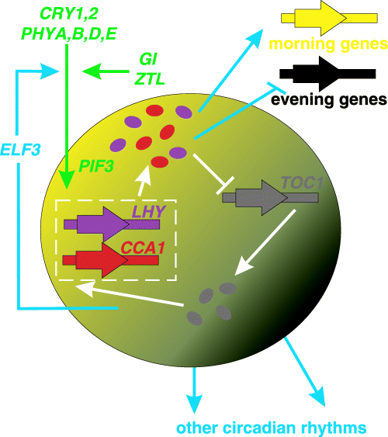
Figure 2. Model of circadian clock in Arabidopsis^{[75]}.
The output pathway is a pathway from core oscillator to regulate physiological processes. Such as transcription, biochemistry, physiology and development. The mechanism of circadian output pathway is unknown but some genes such as CCA1 have role in this pathway that activates chlorophyll a/b(CAB) expression^{[49]}.
Circadian clock of Arabidopsis is comprised of 3 interlocked feedback loops with two single MYb domain transcription factors. CCA1 and LHY have role in each loop. TOC1 member of family of pseudo- response regulators (PRRs) are related to one loop but three TOC1 paralogs PRR5, PRR7 and PRR9 are related to second loop. And the third loop is MYb transcription factor LUX ARRHYTHMO (LUX)^{[49]}.
Three parameters define circadian rhythms that include: periodicity, entrainment ability and temperature compensation. Circadian system divides into three parts. Input pathway, central oscillator and output pathways. The most important stimulus in plants is light. Temperature also has an important role in circadian rhythm and is one stimulus for circadian rhythm. There are many oscillators in multicellular plants^{[48]}.
In generation of circadian rhythm in human three systems are involved: 1) Anatomic like suprachiasmatic nuclei 2) neuronal- like retinohypothalamic tract and 3) neuroendocrine like melatonin^{[65]}.
There is an endogenous clock that controls circadian rhythm. In fact, circadian clock is composed of three components that include: 1) central circadian oscillator that produces autonomously rhythmic signal 2) input pathway 3) output pathway^{[57]}. The central oscillator that is called master clock is located in anterior part of hypothalamus in mammals and is called suprachiasmatic nucleus (SCN)^{[65]}. Input means environmental timing information from sensory pathway that goes to network of oscillators and output that is from network of oscillator that act on target structure and create rhythm in behavior^{[27]}. Environmental signal has effect on circadian rhythm. For example, temperature fluctuation has effect on rhythm because circadian rhythm is temperature compensated. Input pathway transmits environmental signal such as light to the clock because it consists of photoreceptors and output pathway transmits signal away from the clock and the consequence is an overt rhythm such as sleep- wake cycle^{[65]}.
Anatomy:
clock that is in SCN is composed of neurons that are located in "either side of midline above optic chiasma about 3 cm behind the eyes." Clock genes encode proteins and these proteins are component of negative feedback loop that create oscillation in timing system. Synchronization of internal time is due to light in mammals. Pineal gland secrets melatonin and this secretion mechanism is controlled by SCN. " a prolongation of melatonin signal from night to night indicates the season is moving through autumn to winter while progressive shortening means the worst of winter may soon be over" these are seasonal changes in human such as change in mood ,for example, depression in winter and increase of appetite^{[25]}.
Inhibitors of protein synthesis cause phase shift in the free- running rhythm. In fact, protein synthesis can regulate rhythmicity. Serotonin is a neurotransmitter that exists in Aplysia eye and cause phase shift. The effect of phase shift of serotonin is regulated by cyclic adenosine mono phosphate (AMP), which is the inhibitor of phosphodiesterase and activators of adenylate cyclase which causes phase shift that is similar to phase shift that is caused by serotonin. We can conclude that AMP may be a component of input pathway that serotonin entrain the pacemaker or part of circadian pacemaking mechanism^{[70]}.
Each organism contains more than one circadian clock because with the complexity of physiological function each organ/tissue system needs a specific clock but there is a master clock or central clock that is located in the SCN. Multiple clocks are called peripheral oscillators to distinguish them from central clock. This central clock controls the function of peripheral oscillators. The master clock and oscillators are intracellular and the clock tissue is composed of cluster of cells. The important point is the uniformity of the mechanism of this clock from cyanobacteria to mammals^{[65]}.
As said above circadian rhythms are controlled by central clock. The clock exists in another part of the brain and peripheral clocks. The central clock is located in SCN and neurons of SCN show circadian rhythm. This point shows that timekeeping mechanism is intracellular^{[10]}.
Recent studies show that oscillator exists in non- SCN brain region such as hypothalamic nuclei, forebrain, olfactory bulb and pineal gland and in non- neuronal tissue such as liver, kidney, muscle, adipose tissue and blood cells. The role of clocks that are found in SCN differ from those that exist in peripheral tissue. In fact, clock of each tissue has particular function. The signals mediating communication of SCN and peripheral clocks are molecules like glucocorticoid, retinoic acid, prostaglandin E2, and systemic signal such as food dependent processes and body temperature and neuronal signals. Central clock and peripheral clock have different synchronizer ,for example, main synchronizer of SCN clock is light but peripheral clocks, synchronizer is feeding rhythm^{[10]}.
Central and peripheral clocks regulate many physiological functions such as insulin sensitivity, endocrine regulation, energy homeostasis, satiery signaling, cellular proliferation and cardiovascular function^{[5]}.
The main circadian pacemaker is SCN for 4 reasons as follows: 1) Entrainment pathway ends in SCN
2) Lesion of SCN can disrupt temporal pattern of sleep/wake cycle and temperature of core body
3)" if the SCN is isolated it may not interfere with the SCN rhythmicity although it certainly abolishes the sleep-wake cycle"
4) " isolated SCN neurons preserve the circadian control of their firing rate"^{[11]}.
SCN stimulate some parts of the brain most of which are located in thalamus and hypothalamus. SCN has projections that via dorsomedial hypothalamus (DMH) they go to ventrolateral preoptic nucleus of the hypothalamus (VLPO) and then to arousal promoting cell groups. VLPO with wake- maintaining posterior lateral hypothalamus generate sleep- wake control. Monoaminergic nuclei such as histaminergic tuberomammilary neurons (TMN), locus coerulus (LC) and serotonergic dorsal and median raphe nuclei (DR) promote wakefulness because they have excitatory effects on cortex and inhibit sleep promoting neurons of VLPO. Sleep- wake cycle is controlled by circadian rhythm and homeostatic processes^{[11]}.
This picture shows three stages of integrator for circadian rhythm. SCN that is master clock is located in hypothalamus which sends a few outputs into light brown region. These outputs are sleeping regulatory system. The light brown system includes ventral subparaventricular zone (VSPZ) and dorsal subparaventricular zone (dSPZ) and dorsomedial nucleus of the hypothalamus (DMH). Neurons in vSPZ send information that is necessary to organize the daily cycle of wake-sleep but neurons of dSPZ send information that is necessary for rhythms of body temperature. Outputs of SPZ integrate into DMH with other input and neurons of DMH drive circadian cycle of sleep, activity, feeding and corticosteroid secretion. " Cycles of body temperature are maintained by dSPZ projections going back to the medial projection area (MPO)" but DMN is the origin of projections of VLPO for sleep cycle, corticotrophin releasing hormone (CRH), neurons of paraventricular nucleus (PVH) for corticosteroid cycles and lateral hypothalamic (LHA) orexin and melatonin concentrating hormone. "Integrative steps in the SPZ and DMH allow circadian rhythm to adapt to environmental stimuli such as food availability" ^{[62]}.
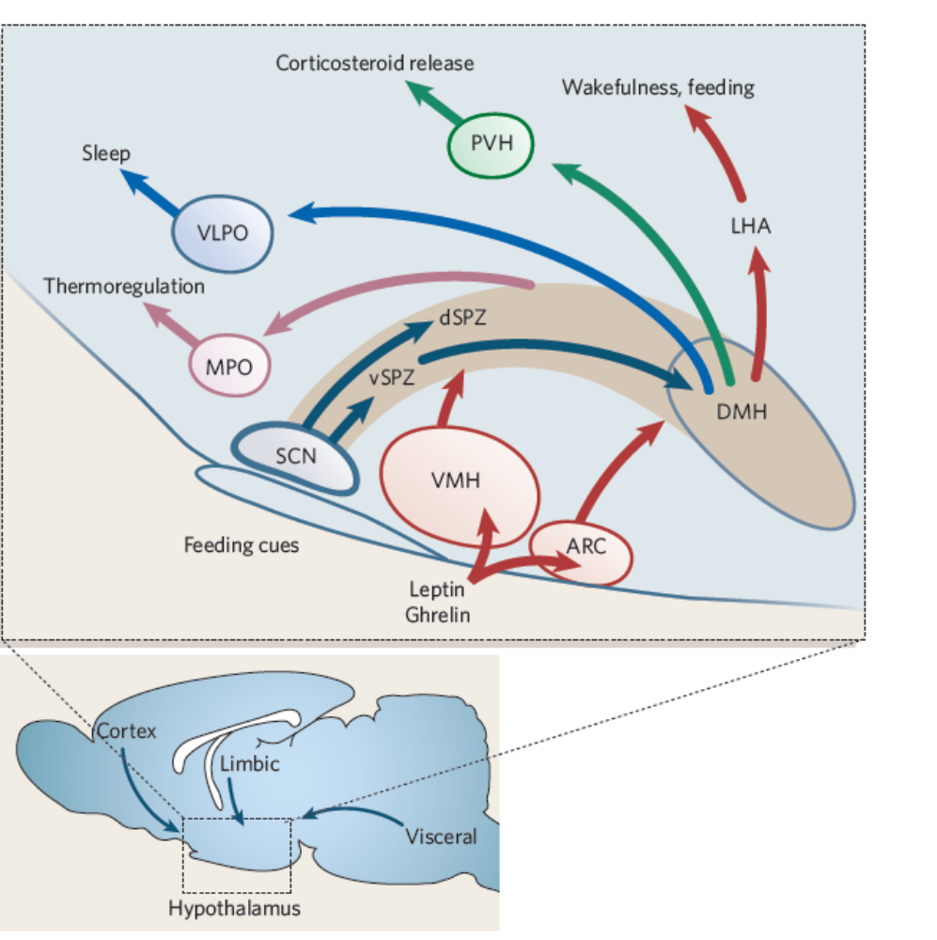
Figure 3. Schematic diagram that is shown three stages of integrator of circadian rhythm ^{[62]}.
Signals that emanate from SCN have important role in coordination of rest activity cycle. There are three SCN derived signaling polypeptides that include: transforming growth factor alpha (TGFα), prokineticin -2 (PK-2) and cardiotrophin like cytokine (CLC).^{[44]} These factors inhibit Locomoter activity so factors that are secreted from SCN " are able to alternate between inhibition and stimulation of different behavioral outputs"^{[33]}.

Clock genes/ proteins exist in peripheral tissue and clock controlled gene (CCGs) control rhythmic expression of clock gene/ proteins^{[53]}.
Exogenous and endogenous derivatives of circadian rhythm.
There are exogenous and endogenous derivatives of circadian rhythm. Exogenous derivative is like this example that during the day your body receives food. This event occurs during the day not at night so the stomach is more active during the day and creates a circadian rhythm in gastrointestinal function. If body gains no food, the circadian rhythm disappears so secretion of gastric acid after exposing of body to food is exogenous factor. In addition to exogenous stimuli there are endogenous stimuli both of which affect circadian rhythm ,for example, secretion of melatonin from pineal gland that has a 24 hour pattern and is independent of change that occur in environment therefore, it is endogenous stimuli^{[65]}.
Entrainment:
External periodic signal that emerges from the rotation of the earth regulate biological rhythm. This concept is called entrainment^{[13]}.
Circadian entrainment shows the compatibility of organism with its environment^{[23]}. There are many factors that act as entrainment agent for circadian rhythm that include: light, temperature, noise, electromagnetism, availability of food, social interaction¹, dependence on habitat, tides and moonlight^{[23]}. The most important circadian entrainment agent for human is light-dark cycle. Scientists believe that bright light can entrain circadian rhythm but now they know that indoor lights have some effect on circadian rhythm as well^{[65]}. Light is the major factor that regulates the activity of SCN⁴. The peripheral oscillators do not respond to light/dark cycle. They are stimulated by none- photic stimuli ,for example, feeding is the most important zeitgeber ( stimuli) for peripheral clock^{[57]}. Many physiological processes in the body show rhythmicity that includes: body temperature, sleep –wake cycle, feeding behavior, endocrine function, hepatic metabolism, and renal function^{[65]}.
Circadian rhythm controls different functions in human body.
Circadian rhythm controls different functions in human body such as sleep and wakefulness, body temperature, blood pressure, hormone production, digestive secretion, immune activity.^{[40]}, rest and activity, heart rate, liver and renal plasma flows, bile and urine production, intestinal peristalsis, secretion of digestive enzymes into the gastrointestinal tract, major endocrine functions and metabolism,^{[44]} cognitive and motor performance, serum hormone level and urinary excretion. These functions vary rhythmically in human. Many sensory and regulatory processes are under control of circadian rhythm such as photoreception, synaptic excitability and receptor mediated events^{[70]} .
There are nine circadian genes whose protein products are necessary for generation and regulation of circadian rhythm in the cells of individual. These core clock genes include: clock, casein kinase Iε (CKIε), cryptochrome 1(Cry 1), cryptochrome 2 (Cry 2), period 1 (Per 1), period 2 (Per2), period 3(Per3),brain muscle Arnt-like protein 1(Bmal1) and neuronal PAS domain protein 2 (NPAS2)^{[57]}.Three Per genes do not bind to DNA directly but Per genes from clock genes encode PER-ARNT-SIM (Pas) domain nuclear proteins^{[40]}.
Circadian clock mechanism at molecular level:
Circadian clock consists of two transcriptions at feedback loop that are interdependent. 1) The first loop controls the expression of per and also controls the expression of (d) CLK 2) The second feedback loop that is not necessary for molecular and behavioral rhythm but is necessary for
a) High amplitude rhythm that is necessary for survival in the natural environment but it is not necessary in constant condition.
b)"transcription of various environmental signals to the first feedback loop"
c) Controlling the expression of time specific circadian outputs^{[3]}
The mechanism of central clock in SCN and peripheral oscillators is similar at molecular level^{[57]}. The mechanism of clock is autoregulatory feedback loop and the products of oscillator in specific genes regulate the expression of these genes. These genes are called clock genes. Proteins negatively regulate synthesis of messenger RNA (mRNA) and these proteins are component of auto regulation. Each loop needs 24 hours to complete and results in oscillation level of Ribo nucleic acid (RNA) and protein and circadian oscillation. "Rhythmic expression of the proteins ensures that the negative feedback on transcription is rhythmic which in turn ensures rhythmic expression of the mRNA"^{[65]}. The molecular clock of circadian clock is a network of transcriptional- translational feedback loops. Genes are component of core clock that can produce proteins. Existence of these proteins is necessary for generation and regulation of rhythm. There are two gene families called period and cryptochrome. In mammals, there are three Per genes and two Cry genes. The expression of these genes is activated by dimer of protein clock (Circadian Locomoter Output Cycles Kaput) and BMAL1 (Brain- Muscle Arnt- Like protein 1). Clock and BMAL1 are transcription factors which form heterodimer. They bind to their promoter at E box "direct interaction of bHLH motif with a CACGTG response element on the DNA is called E box" and activate transcription. Because clock has intrinsic histone acetyltransferase (HAT) activity it can induce chromatin remodeling and create a state that gene expression is activated. PER and CRY are two proteins that are synthesized in cytoplasm and they must enter the nucleus. In the nucleus activity of clock and BMAL1 is repressed by Cry protein and this inhibits the formation of clock/BMAL1 complex so they use negative feedback for the expression of per and Cry genes. The enzymatic activity of clock acetylates non histon substrate. Therefore, acetylation of BMAL1 by clock is a regulatory switch because it facilitates Cry dependent repression^{[57]}
Histon deacetylase that is called Sirtain 1(SIRT1) is another modulator of circadian clock. SIRT1 regulates circadian rhythm because it counteracts with HAT activity of the clock. SIRT1 binds to clock/BMAL1 complex and promote deacetylation and deregulation of PER2. The second regulatory loop which is done by clock/ BMAL1 complex activates the transcription of retinoic acid and related orphan nuclear receptors Rev-erba and Rora.( Rev- erbα is a gene that encode orphan nuclear receptor that expression of Rev-erb α is activated by clock/ BMAL1 heterodimer and repress by PER and Cry proteins). Both proteins are transcription factors that bind to promoter of Bmal1 at REV-ERBα and RORα response elements. Function of these two proteins is apposite to each other. RORα activates the transcription of BMAL1 and REV-ERBα represses transcription of BMAL1^{[57]}.
Another gene in circadian clock is NPAS2 that heterodimerize with BMAL1 and creates a complex then this complex bind to E box motif and with help of transcription it can activate the circadian genes^{[57]}.
Post translational modifications (PTM)
Circadian rhythm that is regulated by autoregulatory loop and is composed of transcription activator such as clock: NPAS2/BMAL1. This transcription activators induces expression of repressors like Per1-3/Cry1-2 that this feedback inhibit forward limb. Clock/BMAL1 cause induction in the expression of orphan nuclear receptor (NHRs) RORα and REV-ERBα that activate and repress transcription of BMAL1^{[30]}.
To maintain circadian rhythm post translational modification (PTM) must take place in core clock proteins. The modifications in PTM are protein phosphorylation, acetylation, and ubiquitionation but are not limited to this modification^{[73]}.

Protein phosphorylation in negative feedback loop:
Protein phosphorylation of PTM is essential for Eukaryotic cells including proteasomal degredation, subcellular localization, complex formation and protein activity. More than 500 protein kinases exist in human that they catalyze reversible phosphorylation of proteins. Phosphtases have reversible effect on protein phosphorylation process. Protein phosphorylation regulates proteasomal degredation of clock proteins that is very important for negative feedback loop^{[73]}.
Casein kinase 1ε/δ is an essential regulator of the negative feedback loop CKI family that has 7 isoform that include: α, β, χ, δ, ƹ, ɸ and Y has an important role in regulation of cellular process such as tumor suppression, Wnt signal, cell cycle progression and apoptosis^{[73]}.
CKIε and CKIδ have role in mammalian circadian oscillator. The roles of CKIε/δ include: 1) promotion from proteasomal degredation of PER proteins by activation of β-TRCP1/2recognition site and β-TRCP1/2 is part of E3 ubiquitin ligase complex 2) CKIε/δ regulates nuclear localization of PER/CRY complex. In temporal and spatial coordination of PER proteins CKIε/δ has a role and this role influences the negative feedback loop.
A brief explanation for the function of different kinase in circadian oscillator^{[73]}.
Casein kinase 2: is a tetrameric kinase and is composed of two regulatory and two catalytic subunits. When subunit of CK2 is down- regulated or is blocked pharmacologically there are disruptions in period length of circadian oscillator, for example, over expression of CK2 causes shortening of the period.
Gsk3β: glycogen synthase kinase 3β (GSK3β) has role in transduction pathway and many cellular processes. Inhibition of GSK3β or down regulation of GSK3β causes period shortening in circadian rhythm^{[73]}.
Phosphatase: serine/ thereonin belong to PPP family have important role in circadian rhythm regulation. Phosphatase regulates function of Kinase and with the help of phosphorylation they activate or inhibit kinase activity. Phosphatase dephosphorylate PER destabilizing phosphorylation site so it counteracts with CKIε/δ mediate destabilization PER protein^{[73]}.
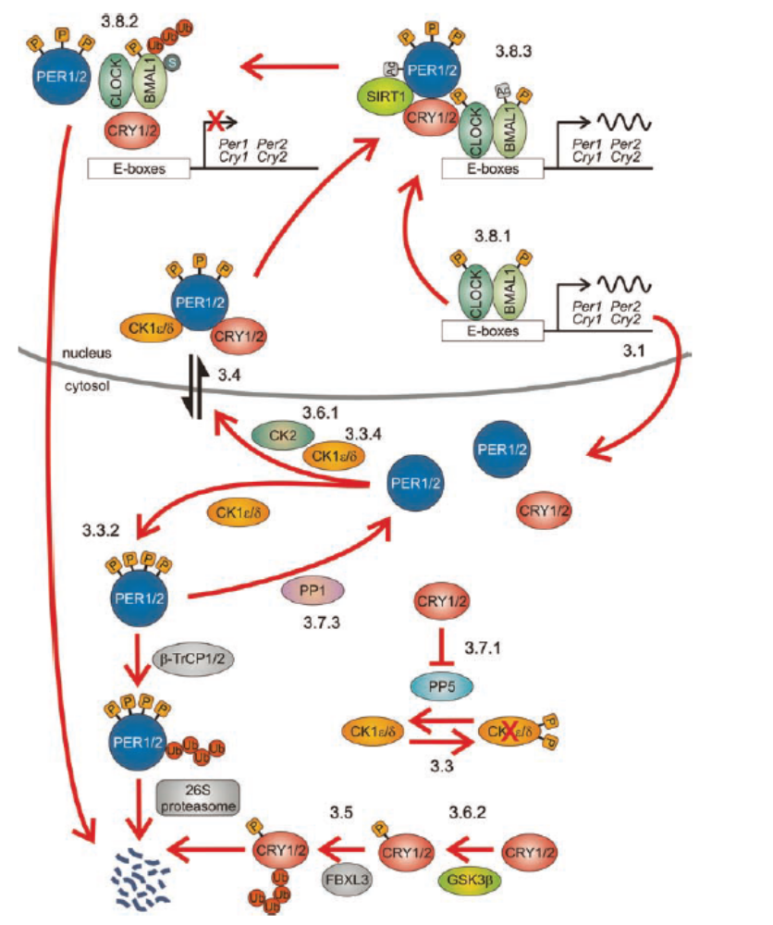Figure 4 schematic representations that is shown PTM in mammalian circadian clock. After mediation of transcription by CLOCK/BMAL1, PER1/2 proteins is accumulated in cytoplasm. CKIε/δ phosphorylates PER1/2 in addition it ubiquitionation and proteasomal degredation. Β- TrCP1/2 that is an F-box protein of the E3 ubiquitin ligase complex ubiquitinated PER1/2. "PP1 dephosphorylates and stabilizes PER2"CK2 has role in controlling the nuclear localization of PER1/2.CKIε/δ has inhibitory autophosphorylation activity that counteract with PP5.CRY1/2 bind to PP5 and this binding inhibit phosphorylation of CKIε/δ so activity of CKIε/δ reduced. CRY1/2 phosphorylate by GSK3β that lead to ubiquitionation and proteasomal degredation. FBXL3 that is F-box protein has important role for ubiquitionation of CRY1/2dimerization of CLOCK and BMAL1 and their phosphorylation cause highest transcriptional activity. BMAL1 become ubiquitinated that facilitate proteasomal degredation. In addition BMAL1 and PER2 acetylated that increase their stability. BMAL1 acetylation done by histon acetyltransferase activity of CRY. SIRT1 that is histon deacetylase bind to CLOCK, BMAL1 and PER2 and deacetylase PER and BMAL1
Transcriptional regulation of circadian clock.
Transcription is necessary to exploit genetic information that is stored in the genome of organism. With transcription process the genetic information converts to mRNA and mRNAs are used as templates for synthesis of products of genes. Two processes regulate transcription that includes: transcription activation or repression^{[60]}.
Clock associated gene 1: kinases and phosphatase
There are numbers of kinases and phosphtases that modify clock proteins that include: casein kinase 1 ε, casein kinase 1δ, casein kinase 2, glycogen synthase kinase 3, protein phosphatase, protein phosphatase 2A and protein phosphatase 5. The family of casein kinase phosphorylates Per and Cry proteins and protein phosphatase family dephosphorylate these groups^{[60]}.
Clock associated gene2: chaperons.

If proteins and RNAs of circadian oscillator are too long circadian oscillators will not be functional. Therefore many circadian proteins are target for proteasomic degredation and this is occurring immediately after phosphorylation by kinase. Chaperons recognize proteins that must be degraded. These chaperons contain F- box motif "that recruit an ubiquition ligase complex" so the clock proteins is ubiquitioned and destroyed by chaperons. Chaperons that have role in this process include: SLIMB targets PER, JETLAG TIM, FBX13, FBXL21 and β-TrCP1. Second classes of chaperons that have role in circadian clock are heat shock proteins. When heat shock factor 1 (HSF1) binds to its target gene it activates the transcription of a wide number of chaperon loci and this occurs at night^{[60]}.
Clock associated gene3: chromatin modifying proteins.
Histon acetylation and histon methylation activate and repress clock gene and clock controlled genes. There are many chromatin – modifying proteins that have role in circadian oscillator such as histon methylases and demethylases, acethylases and deacethylases and various classes of ATP dependent chromatin recognition mechanism^{[60]}.
Clock associated gene4: coactivator and corepressor.
The action of this group is critical for transcriptional repression or transcriptional activation of clock genes. Such as 1) CIPC gene in mammals that has repressive role " by antagonizing the clock –BMAL mediated activation independent of the cryptochrome" The consequence of this depletion is shortening of circadian period length or 2) MYBBP1a protein that can immunoprecipitate the promoter of PER regulated genes that help repression of transcription 3) NONO protein depletion of whom in mammals cause rhythmicity^{[60]}.
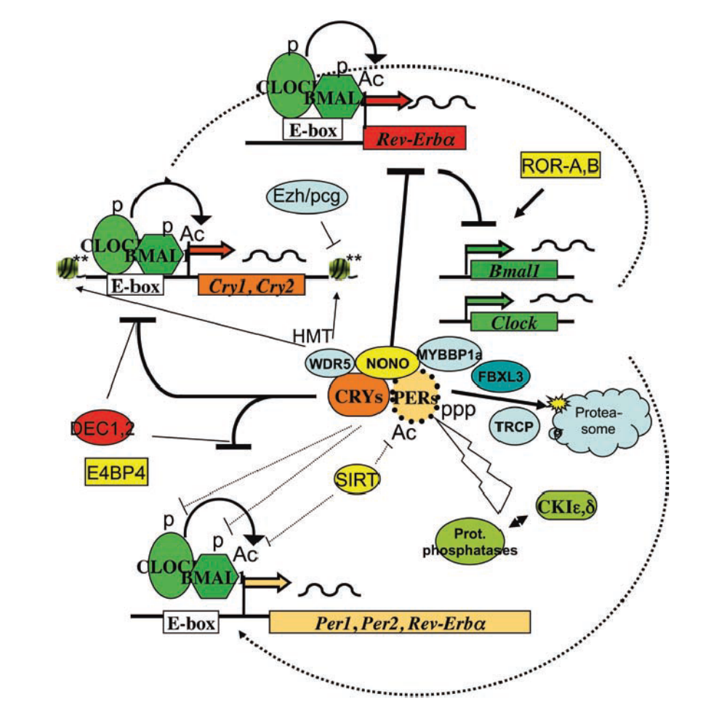
Figure5 : model for circadian oscillator in mammals. BMAL1 and CLOCK activate transcription by "E-box motifs of two classes of repressors" in stabilizing loop REV-ERBα repress transcription of BMAL1 and CLOCK genes. RORα and RORβ that is transcription activator compete with action of REV-ERBα to fine- tune expression of circadian genes. In core loop BMAL1 and CLOCK activate transcription of per and Cry genes. " upon reaching a certain thresholds concentrations these factors counteract the positive factors to repress the per, cry and REV-ERBα genes that generate two interlocked feedback loops that their phase separate by about 12 h post translational modifications regulate activity of different proteins. P show phosphorylation like CKIε, δ and AC show acetylation. SIRT has effect on activity of BMAL1 or half life of PER2. FBXL3 influence on half life of CRY proteins and TRCP that determines half life of PER proteins by proteasom – dependent degredation pathway and various factors such as WDR5, Ezh/Pcg may regulate structure of local chromatin. Factors such as NONO and MYBBP1α interact with PER or CRY "that have yet to precise functions" Dec1 and Dec2 genes and E4BP4 are factors that have role in regulation of circadian genes ⁶⁰
Clock gene expression
Clock genes transmit output signals to the rest of the organism" by driving rhythms of gene expression" and a direct mechanism that clock can drive rhythms in gene expression by regulating the activity of promoter. Transcription factors can recognize the promoter. The promoters are part of the clock rhythmic activity of transcription factors which cause the rhythmic expression of clock genes that are located in downstream of the clock. The downstream genes encode proteins or transcription factors that affect the property of cells or function^{[65]}.
We can see the rhythmic expression of clock genes in numerous structures of brain ,for example, the rhythmic expression of mRNA of Per1,Per2 and Bmal1 is in forebrain structure such as olfactory bulbs, piriform, cerebral cortices, hippocampus, hypothalamic nuclei, pituitary, pineal gland, cerebellum and nucleus of the solitary tract^{[17]}.
To define a clock rhythmic the expression of clock genes and clock proteins are not sufficient. In addition, clock needs 1) candidate structure that creates oscillation within the circadian range 2) oscillation must be temperature compensated which means oscillation does not change with variation in temperature 3) the structure must communicate with environment clock to receive input from the environment^{[17]}.
SCN divide in to two parts 1) dorsomedial part that is called shell that expresses arginine vasopressin (AVP) and 2) ventrolateral part that is called core and expresses vasoactive intestinal peptides (VIP). Gastrine releasing peptide (GRP) that expresses neurons is in central core of SCN. This VIP or core neuron receive 3 nervous projections from different tissues. 1) Retina: a photo pigment that is called melanopsin receives light that are expressed in specific ganglion cell in retina. Rethynohypothalamic tract transfer light information to SCN and other areas of the brain such as intergeniculate leaflets (IGL). Projection release glutamate and PACAP and are synchronized to light 2) the intergeniculate leaflets (IGL) an indirect pathway of transfer of light to the SCN is through IGL with the help of geniculohypothalamic tract. This pathway secret neuropeptid Y, enkephalin and GABA in the core of SCN. Function of this pathway is the regulation of photic information. 3) Raphe nuclei: serotonergic projection is the third entry to the SCN^{[17]}.
Circadian control is a complex function. For example, rest- activity behavior is oscillation in clock genes that causes oscillation in cellular (neuronal) property. This oscillation is derived by rhythmic expression of an output (perhaps a hormone) from the cell" and then output mechanism act rhythmically on cells to control rest – activity rhythm^{[65]}.
Circadian rhythm is controlled by endogenous biochemical pacemaker which has three properties:
1)" persisting oscillations in constant condition with exquisite precision"
2) Temperature compensation
3) "entrainment of the endogenous pacemaker to the environmental cycle of light and dark."^{[31]}
Components of clock include:
1) State variable that is a molecule that exposes the time of day through rhythmic change that occur in its level or activity
2) state parameter that in itself is not a cycle but is necessary for the regulation of state variable^{[65]}.
We can observe human circadian rhythm in a wide range of variables that include: aspect of behavior, physiology, endocrinology, neurology and metabolism^{[65]}.
The interaction of circadian clock with metabolic function is in three different anatomical levels that include:
1)’’ The regulation of feeding behavior by the SCN" 2)"The regulation of metabolic control centers within the hypothalamus"
3)"The regulation of physiological process in metabolically active tissue"
Lifestyle and circadian rhythm
Our current lifestyles in which people are awake almost until morning has affected metabolic processes and homeostasis. Light condition control many rhythmic processes of hormones such as prolactin, glucocorticoid, adrenocorticotropic hormone (ACTH), corticotrophin releasing hormone (CRH) serotonin and melatonin^{[53]}.
Control of rhythmic genes in tissue is not only by circadian oscillators. In addition to circadian oscillators, external factors such as hormones or variation in temperature that ultimately are controled by SCN regulate clock genes^{[53]}.
Circadian clock interacts with metabolic process in 4 different ways:
1) Peripheral clock that control transcriptional control of clock control genes (CCGs) that regulate the concentration of enzyme that should be available for metabolic pathway.
2) With the help of rhythmic release of humoral factors they synchronize metabolic state and have effect on physiology of target tissue.
3)" neural regulation of target organs" such as activating or deactivating sympathetic and parasympathetic synapses
4) those routes that interact with external environment regulate the behavior of organism^{[53]}.

Clock controlled genes (CCGs)

The CCGs in liver include:
1) Genes that have role in nutrient metabolism such as glutamate transporter Glat2, Pyruvate kinase and lipin.
2) Genes that have role in cholesterol synthesis such as Hmgcr and NPCI.
3) Genes that have role in xenobiotic metabolism and detoxification such as methyl transferase Nnmt^{[53]}.
CCGs in adipocyte include gene that regulate metabolism of fatty acids such as Faatp1 (fatty acid transport protein 1), fatty acid –Co A synthetase (Acs1), adipocyte differentiation related protein (Adrp) and adipokine such as adipsin which resist in deregulation of circadian rhythm and have effect on metabolic function. Deregulation of circadian rhythm cause metabolic syndrome, obesity and cardiovascular events. We can see these diseases in shift workers. "The capacity to defend long- term energy homeostasis is related both to the time of day when food is consumed and to the phase relationship between meal time and the sleep/wake cycle."This finding shows that consumption of food during rest period causes obesity but this does not occur when food is eaten during the active period. Metabolic network are under control of circadian in levels such as transcription, translation and metabolic cycle. Many circadian clock genes have role in metabolism^{[53]}.
The disruption of clock genes has metabolic consequences. Clock and BMAL1 activate E-box regulated gene such as Per1, Per2, Cry1, Cry2, Rev-erbα and RORα. Each of these E-box regulated genes control different metabolism that are shown in fig 5-3^{[53]}.
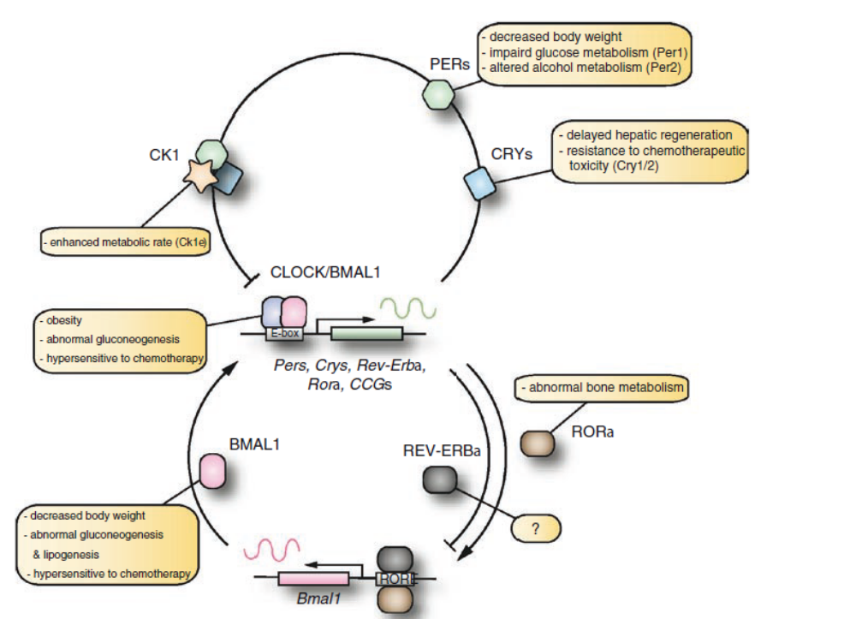
Figure 6.metabolic consequence in disruption of circadian rhythm. Picture shows two main feedback loop of mammalian circadian timing system. Clock/BMAL1 activates E-box genes that include Pers, Crys, Rev- Erb α and RORα. Proteins of PER and CRY create complex with kasein Kinase 1 (CK1) that relocate back to the nucleus. In the nucleus they inhibit from activity of Clock/BMAL1.Rev-Erb α and RORα compete with each other for elements of RORE on promoter of BMAL1 so they regulate transcriptional activity of Bmal1^{[53]}.
Per and Cry and casein kinase 1 (CK1) create a complex which is sent to nucleus and the function of this complex is that it inhibits the activity of clock/ BMAL1. REV-ERBα and RORα compete with each other for ROR element that exist in promoter of BMAL1 and regulate transcription activity of Bmal1^{[53]}.
Metabolism can affect the function of circadian clock oxidative state in cells as in NAD(p)H/ NAD(p) ratio regulate activity of clock /BMAL1 and the regulation take place by binding to DNA. Therefore we can see the fluctuation in cellular metabolism has effect on transcriptional activity of clock genes^{[53]}.
Pathway of photic signal
Circadian system of human is regulated by three organs that have cooperation with each other. These three organs include:1) retina (light receptor in the eyes that receive input light) 2) suprachiasmatic nucleus in the hypothalamus(clock gene) 3) pineal gland (melatonin synthesis)^{[3]}.
Perception of light takes place in the eye then photic signal with help of cyclic AMP response element binding (CREB) protein is transmitted to SCN^{[45]}. Retina cells receive information during the day light or stimulation by artificial illumination^{[3]}. In fact photic input from retina is transmitted to ventral SCN. "SCN is located in the hypothalamus immediately above the optic chiasma (OX) on either side of the third ventricle (3V)"^{[45]}. In the retina there is a special light sensitive ganglion cell that acts as lighting receptor and sends information that is useful for the regulation of circadian rhythm. Retina sends this input to SCN that is located in hypothalamus with the help of retinohypothalamic tract (RHT)^{[3]}. A little population of retinal ganglion cells (RGC) form retinohypothalamic tract (RHT) in the optic chiasma that project to neuron that is in ventral SCN^{[45]}. Photoreceptors provide light input to circadian system. Light enters through eyes. There are photoreceptors that are called rod and cone in the outer retina that detect input light. Photoreceptors send input light to bipolar cells that synapse with retinal ganglion cells (RGC). The axon of RGC form optic nerve that project to visual center of the brain^{[55]}.
Photic information is transmitted from retina to pineal gland with the help of SCN and sympathetic nervous system. Norepinephrin that is neural input to pineal gland secret melatonin as output. During the days retinal photoreceptor cells are hyperpolarized that inhibit release of norepinephrine. In the darkness Photoreceptors release norepinephrine and numbers of α and β adrenergic receptors increase in gland arylalkalamine N- acetyltransferase and are activated which causes secretion of melatonin. When secretion of melatonin increases through passive diffusion it enters bloodstream^{[6]}.
Photoreception of retina:
Melanopsin which contain RGC are photosensitive and iPRGC receive light input from the rods and cones of retina with the help of bipolar and amacrine cells. The axons of these cells form RHT and project to SCN^{[45]}.
"Photic transmition to the SCN and intracellular signal transduction": two main neurotransmitters that are released from presynaptic RGC are glutamate and PACAP. During the processes of light at night glutamate and PACAP bind to respective receptors that causes depolarization of membrane and influx of Ca²⁺ in targeted SCN neurons. In post synaptic SCN neurons change in level of intracellular Ca²⁺ and cAMP triggers the activation of multiple kinases and at last phosphorylation of CREB. Phosphor- CREB causes activation of immediately early genes (IEGs) such as Per1 with the help of CRE that causes establishment of new circadian phase^{[45]}.
There is no circadian photoreception in peripheral tissue but "SCN provides rhythmic timing cues for light entrainment to the peripheral tissues" Information of circadian timing from SCN are first transmitted to other brain regions such as locus coeruleus and dorsal hypothalamus by direct neuronal projections. These regions regulate sleep and peripheral organs such as pineal gland and liver by intermediate neurons mainly PVN. Regulation of peripheral tissues is done by cyclic diffusible factors from the SCN and its targeted brain region. Transforming growth factor α (TGFα), prokineticin 2(PK2) and cardiotrophin- like cytokine (CLC) are diffusible timing signal in circadian regulation of Locomoter activity. Diffusible factors that are secreted from SCN and their function is inhibition of Locomoter activity during the day^{[45]}In regulation of circadian rhythm SCN are very important. SCN is composed of oscillators. These oscillators generate circadian output that regulates rhythms. Mitogen activated protein kinase (MAPK) is regulated by signal that is generated by light in SCN. MAPK is an enzyme that phosphorylate maximally during the day. Therefore, light pulse at night causes rapid phosphorylation of this enzyme. BMAL1 is positive regulator of autoregulatory feedback loop in circadian oscillation and MAPK phosphorylate the transcription factor BMAL1. Location of light responsive cells have overlap with non rhythmic cells in SCN central core compartment. Cells of core region of SCN express light induced gene while the shell region of SCN have cells with rhythmic expression of clock genes. Cells of SCN release humoral factors that modulate the activity of other cells like cells of pineal gland and immune system. Expression of clock genes in SCN are modulated by humoral factor^{[3]}.
Brain and circadian rhythm
Many parts of brain generate circadian rhythm. These parts of hypothalamus that include arcuate nucleus(ARC), paraventricular nucleus (PVN), lateral hypothalamic area(LHA) and dorsomedial hypothalamus (DMH) and these parts of brain stem that include ventral tegmental area (VTA), dorsomedial nucleus of vagus (DMV), medial preoptic area (MPO)have relationship with SCN and this relationship create a neural circuit that generate circadian rhythm within ARC, Orexigenic neuropeptid Y/agouti- related protein (NPY/AgRP) and aneroxigenic pro-opimelanocortin/cocaine and amphetamine regulated transcript (POMC/CART). Peptides connect with cell body that is located in the SCN and expressed by neurons. NPY/AgRP and POMC/CART are expressed and neurons of SCN propose to cell bodies that are in PVN and LHA to modulate autonomic sleep wakefulness behavior^{[30]}.

Disruption of circadian rhythm and appearance of disease
Disruption of circadian rhythm causes appearance of some disorders like metabolic syndrome, inflammatory diseases, obesity, diabetes and cancer^{[57]}. Disruption of circadian rhythm promotes the growth of tumor and this is done by WNT10A- dependent angio/stromagenesis that causes enhancing in oxidative stress level. Tumor necrosis factor α (TNFα) or oxidative stress activates NF-KB that is transcription factor. The target gene of NF-KB is WNT10A that is expressed by TNFα because in promoter region of WNT10A there is one NF-KB site so WNT10A may be regulated by NF-KB pathway. Endothelial cell and stromal cell are activated by WNT signal of cancer cells or WNT signal from nontumor cells.WNT signal is divided in to canonical pathway or non canonical pathway. Canonical WNT signaling pathway stabilizes β catenin. β catenin is expressed by endothelial cells that tumor vessels have formed recently so we can say that Wnt/β- catenin signal has a role in tumor angiogenesis^{[78]}.
Evolution selects a system that is composed of two interwined cell cycle 1) the cell division cycle (CDC) 2) circadian biological clock. When these two cycles do not work well we can see that susceptibility to some kind of cancer increases. Cell division that is one biological process is controlled by circadian rhythm. Rhythm defines the time of cell division so disruption of circadian rhythm is associated with some kind of cancer^{[31]}.
Expression profiling studies show that up to 15% of transcripts in the tissue are clock controlled gene. For example clock/BmaL1 complex controls the expression of some clock genes directly^{[21]}.
Gene express in hematopoietic cells.
Clock genes are expressed in hematopoietic cells. Circadian genes that are expressed in human hematopoietic lineage include stem/progenitor cells and circulating levels of hematopoietic growth factors display daily oscillations. These growth factors are several including granulocyte- colony stimulating factor ( G- CSF) granulocyte- monocytes colony stimulating factor (GM-CSF) tumor necrosis factor (TNF) and interleukins 2,6 and 10 to cellular level. Circadian apparatus and proteins of clock regulate cell cycle and apoptotic pathway in hematopoietic cells^{[21]}.
Circadian neurons secret neuropeptid such as pigment dispersing factor (PDF), NPLP1 that can be found in fly, vasoactive intestinal polypeptide (VIP), prokineticin 2 and vasopressin (AVP)^{[27]}.
Neuropeptides have important role in synchronizing of circadian cells. For example, loss of VIP or the receptor of VIP that is called VPAC2R causes two important changes in SCN that include: 1) percentage of rhythmic neurons will decrease 2) " loss of synchrony among the circadian neurons"^{[27]}.
How VIP regulate this synchrony?
VIP stimulates secretion of GABA that acts as a circadian coupling factor. Blocking of GABA causes decrease in rate at dorsal SCN that has role in regulation of large shift changes in the light cycle. GABA is not necessary for synchronous daily rhythms in gene expression and daily applications of VIP agonist which causes restoring of synchrony of VIP deficient SCN in presence of GABA antagonist^{[27]}.
Organization of circadian clock in and out of the network:
Input: The clock is useful because it is set to the local time. The network of oscillator of circadian reacts to daily cues such as light, food and temperature. Light sensing organs such as retina and ecelli send light input pathway to the clock cells. Light from retinal melanopsin cells entrain to circadian rhythm in brain and body. If melanopsin neurons are deleted light cannot synchronize the behavioral rhythm. Melanopsin neurons project to SCN and other areas of brain. This input acts on ventral SCN which then sends signal to dorsal SCN and changes circadian rhythms to local time. Temperature of the brain and availability of food is an input to SCN^{[27]}.
Output: VIP neurons of SCN control different output. VIP neurons of SCN project to preoptic area and regulate secretion of gonadotropin releasing hormone. Prolactin and glucocorticoid so loss of VIP causes disruption in circadian rhythm in body. It is not worthy that some output regulate input pathway that is called zeitnhmers^{[27]}.

Physiology of circadian rhythm:
Clock controlled gene include:
Argininevasopressin (AVP): that is neuropeptid. There is an E-box in promoter region that means positive transcription control with the help of clock/ BMAL1 heterodimer^{[17]}.
Albumin D- element binding protein (DBP): is related to transcription factor family. E-box activates DBP neurotransmitter^{[17]}.
Neuropeptides in SCN:
SCN sub divides in to two regions: 1) dorsomedial SCN (dm SCN) that express AVP and 2) ventrolateral SCN (VL SCN) that express VIP and GRP.
Other neuropeptid include: dm SCN: AVP –synthethizing neuron which limit dm SCN and send project to VL SCN^{[17]}.
VL SCN:
The main hormone in this area is VIP, Gastrine- releasing peptide (GRP) and peptide hisidin isoleucin (PHI). Daily rhythm of VIP increases during the night in SCN. Existence of VIP is necessary to create oscillation in SCN. GRP that carries photic information to other areas of brain. Between these regions there are some neurons that synthesize somatostatin whose function is still unknown^{[17]}.
Peptides can control activity of Locomoter
Transforming growth factor (TGF):
TGFα is inhibiting activity of Locomoter. TGFα is expressed during the day. Infusion of TGFα in third ventricle inhibits the activity of Locomoter and this event take place by EGF receptor that is located in subparaventricular zone of the hypothalamus^{[17]}.
Prokineticin 2 (PK2):
Function of PK2 is the same as TGFα. Its expression occurs at the beginning of the day. Intracerebroventricular administration of PK2 during the night inhibits the activity of Locomoter^{[17]}.
Cardiotrophin- like cytokine (CLC):
Inhibits Locomoter activity. It is expressed at the end of the day^{[17]}.
Neurotransmitters that have role in circadian rhythm:
Two methods are used to analyze the effects of neurotransmitters in the circadian system.
1) Manipulation of neurochemical system.
2) The effect of pharmacological manipulation on cellular activity in SCN. With the analysis of neurochemical effect on rhythm we find that neurotransmitters are important components of SCN that have important function in SCN^{[61]}.
Acetylcholine (Ach) with the help of nicotinic binding site regulates the effect of light. Injection of putative nicotinic antagonist α- bungarotoxin (BTX) near the SCN causes prevention from the effect of light on daily rhythm of pineal N-acetyltransferase (NAT) activity so it decreases the effect of light. Therefore, the concentration of Ach increases after exposure to light^{[61]}.
Carbachol is a drug that influences circadian rhythm that cause phase dependent phase shift in circadian rhythm. It binds to acetylcholine receptor and activates it. Carbachol is classified as cholinergic agonist "These effects mimic the action of light in entraining the circadian pacemaker and suggest that acetylcholine may play a role in photo entrainment"^{[80]}.
Mecamylamin is a drug that has role in circadian rhythms. It blocks phase advancing and phase delaying effect of light so we can conclude that acetylcholine regulate phase shifting effect of light in circadian rhythm^{[35]}.
Glutamate or related excitatory amino acid (EAA) is the transmitter of retinal projection to SCN. Glutamate and aspartate have excitatory effects on neurons of SCN. After optic nerve is stimulated EAA released in SCN. EAA is blocked by kynurenate and other antagonist and if these blockages occur neural responses to optic nerve will be suppressed^{[35]}.
The inhibitory amino acid gamma amino butyric acid (GABA) have role in regulation of circadian rhythm^{[35]}.
Neurotransmitters can control circadian rhythm in cerebral cortex, pineal gland and peripheral tissue. Neurotransmitters have two aspects that include: 1) neurotransmitters have more than one function so the prediction of function is too complex.
2) Input of neurotransmitters in different pathway and influence of this input can vary by itself and by way of modification on functions of SCN^{[59]}.
Neurotransmitters are including: acetylcholine, glutamate, neuropeptid Y (NPY), serotonin, vasoactive intestinal peptide (VIP), peptide histidin isoleucin (PHI), arginine vasopressin (AVP), etc^{[59]}.
Three pathways that are identified in SCN include: retinohypothalamic tract (RHT), geniculohypothalamic tract (GHT) and projection from raphe nuclei^{[59]}.
RHT and its neurotransmitters: glutamate and PACAP are transmitters that transfer photic information to the SCN. Light stimulation of retina induces RHT to secret glutamate into ventral VIP- containing part of the SCN. Glutamate has important role in RHT/SCN synaptic connection because it regulates photic regulation of circadian rhythm. PACAP which contains retinal ganglion cells are located on RHT. After stimulation PACAP is released and affect cells of SCN^{[59]}.
Nitric oxide (NO): NO has important function on SCN. Production of NO is linked to N- methyl- D- aspartate (NMD) and NMD induces the production of cyclic guanosin monophosphate (cGMP) and administration of cGMP produces phase shift in circadian rhythm. The blocking of NO production causes disruption in conveying of light to SCN. Other effects of blocking of NO action is intracellular increase of CA, activation of nNOS, augmented production of cyclic guanosin monophosphate (cGMP), activation of protein kinase C, phosphorylation of cyclic adenosine monophosphate (cAMP), response element binding protein (CREB)^{[59]}.
Histamine: Histamine acts as a final neurotransmitter induce phase shift in circadian rhythm. Excitatory effect of histamine on neuronal firing is regulated by H1 receptor and inhibitory effect by H2 receptor^{[59]}.
Neurotensin (NT): cell bodies of SCN have NT and two NT receptors that are called NTS1 and NTS2. NT can regulate circadian pacemaker with the help of NTS1 and NTS2 receptors. NT regulates the effect of neurons of SCN by the activation of NTS1 and NTS2 receptors rather than glutamate or GABA receptor or modulation of synaptic release of glutamate or GABA^{[59]}.
Neuromedin S (NMS): NMS is another neurotransmitter of SCN. NMS is expressed in core part of SCN and has diurnal peak in light/ dark cycle. NMS with VIP have role in the maintenance of circadian rhythmicity^{[59]}.
Gastrine releasing peptide (GRP):
GRP and its receptor that are called BB2 are synthesized by neurons of SCN. GRP has role in photic entrainment. Its role in regulation of circadian rhythm is not well known^{[59]}.
GHT is the second photic projection from intergeniculate leaflet (IGL) to SCN. IGL receives input from retina by a separate branch of RHT. GHT has NPY, GABA and enkephalin (ENK) neurotransmitters^{[59]}.
NPY: RHT and GHT have overlap in the SCN. NPY that is transmitter of GHT acts as a pacemaker of neurons in SCN. NPY inhibits GABA mediated synaptic transmition by inhibition of Ca current^{[59]}.
Serotonin:
Serotonin causes phase shift in SCN although light does not cause phase shift^{[59]}.
GABA: GABA is an important neurotransmitter that regulates SCN function. Neurons of GABA express neurotransmitter of GABA so they are GABAergic. Glutamic acid decarboxylase (GAD) is an enzyme that synthesizes GABA and exists in all neurons of SCN^{[59]}.
Intra SCN communication's neurotransmitter:
VIP: VIP is a neurotransmitter of SCN neurons which exist in core of SCN. Light can activateVIP. VIP is synthesized from prepro VIP and "further cleavage of molecules from VIP and peptide histidin isoleucin (PHI). VIP and PHI are related to PACAP. VIP receptor that is called Vipr2 is expressed in SCN neurons. VIP with GRP and AVP show circadian variation in the level of mRNA. In fact, change in peptide content that is caused by light causes change in synthesis and release of peptide. Secretion of this peptide causes circadian variation^{[59]}.
AVP: AVP are in dorsomedial part of SCN. It is secreted by SCN with circadian patterns. V1 receptor regulates excitatory action of AVP. Decrease in AVP cause decrease amplitude activity rhythms, increased rhythm fragmentation and disruption of normal sleep/wake cycle. Therefore,AVP not only has role in circadian timing but also has role in circadian mammary^{[59]}.
Melatonin: mechanism of melatonin will be clarified later.
Neurotransmitters that have role in efferent projection:
Somatostatin (SS): is located in core and shell of SCN. It has role in phase shifting and resets the clock phase^{[59]}.
Calbindin (calB): are exist in core and shell of SCN. It is stimulated by light. CalB is necessary for circadian Locomoter activity rhythm^{[59]}.
Calretinin (CALR): CALR is another neuron in ventral part of SCN that is a calcium binding protein^{[59]}.
Angiotensin II (ANGII): ANGII is octapeptid in SCN and has role in circadian rhythm. ANCII acts as neuromodulator or neurotransmitter that is regulated by angiotensir 1 (A1) receptors^{[59]}.
Met-Enkephalin (mENK): which is locates in the shell of SCN has neurotransmitter activity. Prokineticin 2 (PK2) has role in circadian clock. Molecular rhythm of PK2 is regulated by circadian clock and light^{[59]}.
Chapter 2: Methodology
I search in pubmed website and read about 80 articles to understand circadian rhythm. These articles were review article and research articles that I use for this paper. After reading and understanding these article I wrote my thesis that is a summary of information about circadian rhythm and its role in human disease such as malignancies, diabetes and obesity.

Chapter 3: is there any connection between circadian rhythm and disease?
We know that SCN control various rhythms such as body temperature, activity and hormone levels. SCN regulates this rhythm via projection to other nuclei of hypothalamus and brain region^{[59]}.
Many physiological events are under the control of circadian system. Mutation in clock genes has profound effect on clock genes and causes creation of rhythm related syndrome^{[9]}.
1) morningness-eveningness preference:
There are individual differences between preferred time of activity and rest among human and "subjects can be described on a scale of morningness-eveningness". There are differences in time of circadian phase between morning and evening that is a consequence of change in sleep schedules. There are differences between young morning type and evening. Type subject is the relationship between endogenous circadian pacemaker and sleep –wake cycle. " Young evening type subjects wake up early in their circadian cycle which implies that a larger advance portion of the phase – response curve is exposed to morning light. This phase relationship is such that evening type subjects wake up closer to their maximal circadian drive for sleep"^{[9]}.
2) Advanced sleep phase syndrome (Asps):
Asps exist in older people. Asps do not exist in younger people unless they have depression. The characteristic of Asps is evening sleepiness and waking early in the morning. Patients sleep around 18-21h and wake up early about at 01:00-04:00 a.m. Younger people that have Asps reported that they have genetic predisposition. This disorder occurs because of mutation in PER2 gene. Replacement of Serine by glycine causes inability of CKIε; therefore, CKIε cannot phosphorylate PER2 protein. This event causes faster accumulation of PER2 and accelerate feedback loop of clock and shorter circadian period^{[9]}.
3) Delayed sleep phase syndrome (Dsps):
The characteristic of DSBS is inability to fall sleep or to wake up at appointed time by a "phase delay in the main sleep episode". This disorder occurs because G647polymorphism of H4 haplotype of the PER3 increased. The polymorphism causes alteration CKIε phosphorylation of hPER3. And it affects on interaction with PER1/2 or affect on output pathway of SCN^{[9]}.
4) Non 24h sleep- wake syndrome:
It is uncommon syndrome in seeing subjects. This syndrome is observed in blind people, astronauts and submariner that live under artificial light dark cycle. This syndrome is associated with psychiatric condition such as schizoid or avoidant personality disorder^{[9]}.
5) Seasonal affective disorder (SAD):
SAD is a disorder that occurs with change in seasons. Patients have depressions in months during fall and winter compared to months during spring and summer. This disorder has a typical symptom such as increase in carbohydrate curve, increase in weight, and increase in sleepiness and reduction in energy level. The cause of SAD is that secretion of melatonin is increased during winter and summer^{[9]}.
The disruption of cell cycle causes cancer. Cell cycle has 4 four phases that include G1, S, M and G2. When cells exit from cell cycle they enter the phase that is called G0 or cell cycle arrest. Transition between these phases is controlled by cyclin dependent kinase (CDK) and cyclin dependent kinase inhibitor (CKI). For example cyclin B1 and their associate kinase control transition from G2 to M phase and cyclin A, D, E and their associated kinase control transition from G1 to S phase. Studies demonstrate that DNA synthesis, DNA repair process, cyclin, CDKs, CKIs, tumor suppressor gene, oncogen are controlled by core clock gene and all of them show circadian rhythm in their expression so disruption of circadian rhythm cause disruption in these processes and cause cancer^{[69]}.
There are connections between circadian clock and division cycle. Many genes in cell cycle regulation are controlled by circadian rhythm such as cyclin D1, cyclin A, Mdm2, Gadd45α and C-Myc. Cyclin D1 and Cyclin A are core regulators of cell division cycle. Mdm2 and Gadd45α have important roles in regulation of P53 in DNA damage response pathway (DDR). Mdm2 is an E3 ubiquitin ligase which regulates P53 at 2 levels and negative regulation of these two levels include: 1) inhibition from transcription activation of P53 2) Mdm2 targeting P53 for degredation. Gadd45α is a P53 target gene and we can see its function on G2/M checkpoint. Deletion in Gadd45α cause centrosome amplification and eventually causes anneploidy and genomic instability. C-Myce is a protoancogen and overexpression of it causes abnormal proliferation in various human tumors. NPAS2/BMAL1 complex controls the expression of C-Myc by E-box motif that exists in promoter. Per2 cause suppression in expression of C-Myce. Defective Per2 cause deregulation of regulators of cell cycle. Overexpression of Per2 suppresses expression of protoancogens such as C-Myce so over expression of Per2 in cancer cell inhibits cell proliferation and promotes from apoptosis of cells and overexpression of PER2 in non cancerous cell do not enhance the apoptotic rate so if overexpression of Per2 takes place phenomena such as inhibition of proliferation, cell cycle arrest, apoptosis and loss of clonogenic ability will occur^{[81]}.
In addition to Per2, Per1 has role in tumorigenesis because it interacts with checkpoint and overexpression of Per1 cause increase in sensitivity of cells to DNA damage and induced apoptosis. If Per1 is inhibited then apoptosis is suppressed^{[81]}.
The link between regulator of circadian clock and cell cycle regulatory pathway:
At the top there are some destructive agents that cause damage to genomic DNA such as ROS, IR, UV and hydroxy urea. Black boxes show damage that trigger check points of cell cycle. After that we can see several DDR pathways and at last checkpoints and regulators in cell cycle are shown. Arrow line show activation of interactions and blocked line show inhibitory interactions and the red circle with a sin- like drawing show the genes whose expression is under control of circadian clock^{[81]}
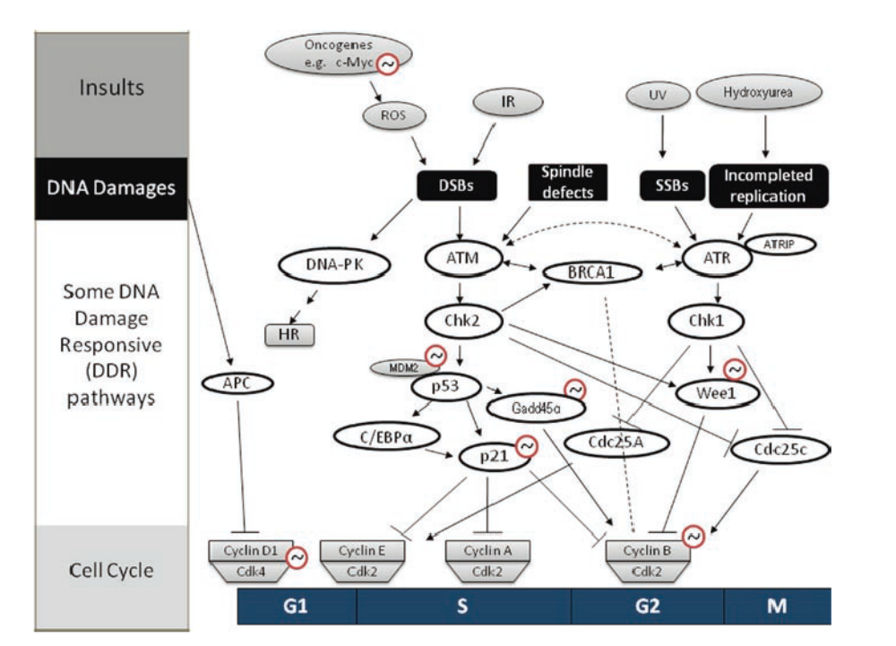
Figure 7.Link between regulator of mammalian circadian clock and cell cycle regulatory pathway. Top of picture show agents that damage to genomic DNA. Block boxes show damages that trigger cell cycle checkpoint. Middle portion of picture show several DNA damage responsive pathway and their regulators. The bottom of picture show key checkpoint and its regulator in cell cycle. Lines show flows of pathway arrow line shows activate interaction and block line shows inhibitory interaction." The red circles with sine – like drawing mark the gens whose expression has been identified to be under the circadian clock control"^{[81]}.

Role of bHLH-PAS transcription factor of circadian clock in cancer:
WEE1 is a transcription factor that inactivates cyclin B1-CDK1 complex. WEE1 inactivate it by phosphorylating CDK1 so WEE1 can regulate transition from G2 to M phase. Circadian expression of WEE1 is regulated by clock/BMAL1 and CLOCK/NPAS2 heterodimer and this regulation is done by three E-box elements that are in promoter region of the gene. BMAL1 can regulate expression of P21 and P53. P21 negatively regulate transition of G1 to S phase by inhibiting the activity of cyclin – CDK2/4 complex. P53 is tumor suppressor protein that regulates many processes including cell cycle checkpoints, DNA damage and repair. Epigenetic inactivation of BMAL1 causes incidence of some hematologic malignancy such as acute lymphocytic and myeloid leukemia. In the cells of patients with hematologic malignancy the promoter CPG islands of BMAL1 gene was hypermethylated so transcriptional silencing occurs in genes. Experiment show that if in hypermethylated cells the expression of BMAL1 is restored the growth of tumor is reduced but knockdown expression of BMAL1 in unmetylated cells cause increase in the growth of tumor so BMAL1 plays a key role in the regulation of cell cycle and disruption in expression of BMAL1 which can cause cancer^{[69]}.
Role of period transcription factors in cancer:
PER that is a transcription factor can act as tumor suppressor genes. Expression of per1 and per2 is deregulated in many cancers such as breast cancer, lung cell carcinoma, prostate cancer etc. Overexpression of per1 induce apoptosis of cells and this is done by inducing the expression of C-Myc and suppressing in expression of P21 in cancer cells so PER regulates expression of cyclin B and CDK1 with help of P53 dependent mechanism and expression of WEE1 is suppressed by circadian control^{[69]}.
Role of cryptochrome gene in cancer:
Loss of Cry causes reduction in risk of developing cancer. UV creates genotoxic stress whenever P53 is induced by UV and "triple knockout skin fibroblast cells” This event shows that "triple mutant cells are much more susceptible to UV apoptosis" This event causes lower incidence of cancer. In addition, antimitotic expression of Wee1 is higher in mutant Cry that causes reduction in inactivity of CDK1 that causes diminished cell division and the activity of proliferation so down regulation of Cry gene expression has important role that can be used for the treatment of some kinds of cancer^{[69]}.
Role of other clock gene in cancer:
REV-ERB, RORα, ROR gamma and CKI1ε are clock genes that regulate cell cycle process and distribution in their expression cause incidence of cancer. Nuclear receptor REV-ERBα regulate the expression of P21 negatively but RORα regulate expression of P21 positively so both of them control transition from G1 to S phase of cell cycle. RORα is down regulated in many cancers such as breast, lung and gastric cancer. This is done because of epigenetic factor like methylation mediate gene silencing. CK1ε phosphorylate PER for deregulation and has an important role in regulating cellular differentiation, proliferation, apoptosis and chromosomal segregation. CK1ε is dysregulated in some cancer such as breast, leukemia, pancreatic ductal adenocarcinoma, mammary ductal carcinoma, etc. Disruption of CK1ε causes cancer because it has two property: 1) it is anti apoptotic 2) it has growth stimulatory property but cK1ε exerts its oncogenic property by reducing PER stability whose function is like tumor suppressor protein and regulates AKt pathway positively which has role in cell proliferation. Inhibition of CK1ε by using inhibitor in tumor cell causes increase in sensitivity of cancer cells to CD95 that causes apoptosis and inhibits tumor growth^{[69]}.
Circadian gene works like a tumor suppressor gene so it retards the development of cancer and aging. Circadian gene has a role in biological pathway such as cell proliferation and apoptosis. By the control of expression of tumor suppressor genes such as cell cycle gene and transcription factor circadian genes control cancer^{[79]}.
In peripheral tissue with regulation of genes such as C-MYC, MDM2, P53, cyclin D1 and GADD45a circadian clock controls cell proliferation and apoptosis. BMAL1 has the most important role in circadian clock and BMAL1 is a member of helix loop helix PAS domain that has transcription factor^{[71]}.
Underlying pathophysiological mechanism is that exposure to light at unusual times causes disruption of sleep- wake rhythm and causes development of cancer." Light during the biological night disturbs the circadian system, alters sleep- activity patterns, suppresses melatonin production and deregulates circadian genes of cancer related pathway" Now we know that disturbance of the internal physiological clock by trans – meridian flight- night work, shift work and rotating shift work elevates the risk of cancers specially breast and prostate cancer^{[15]}.
Shift work:
Jet lag, sleep disorder and shift work sleep disorder occur because of dyssynchrony between internal clock and external light- dark cycle^{[38]}.
Jet lag that is the result of air travel across time zones^{[38]} Shift work includes those who work at night like nurses. Shift work is carcinogenic for human because it disrupts circadian rhythm^{[26]}. Night shift work has two consequences: 1) disruption of the circadian system of human so it provides jet lag 2) exposure to light at night that suppressed nocturnal secretion of melatonin. Both of these consequences cause increase in many kinds of cancer such as breast cancer and colorectal cancer¹¹⁰. Four pillars are necessary to consider the risk of assessment: 1) hazard identification 2) dose – response assessment 3) exposure assessment 4) risk characterization
IARC answered that shift working with chronodisruption increase the risk of cancer. Shift works that cause disruption of circadian rhythm promote development of cancer^{[15]}.
"In 2007, the world health organization (WHO) even classified shift work as a probable carcinogen due to accumulating evidence that disruptions to the circadian rhythm increased the risk of developing certain cancers"^{[46]}.
Restricting sleep causes reduction in insulin sensitivity and increase the risk of diabetes. Decrease in insulin sensitivity causes increase in glucose level. Sleep deprivation and disruption of circadian rhythm exert their effect on metabolism of body via separate mechanisms. Lack of sleep cause decrease in insulin sensitivity but disruption of circadian rhythm and sleeping untimely causes decrease in production of insulin both of which are too bad^{[46]}.
Shift work causes increase in prostate cancer in men. Melatonin a hormone that is closely related to circadian rhythm is implicated in increase of incidence of tumor among shift worker. 1) melatonin suppresses the growth of tumor by down regulation of transcription, secretion or activity of growth factor 2) stimulates immune system by increase in production of interleukin 2 and interleukin 4 by T helper cell 3) it protects DNA from oxidative damage by scavenging free radicals. Suppression of melatonin causes increase in level of sex hormones and in breast cancer causes increase in level of stradiol and in prostate cancer causes increase in level of testosterone^{[39]}.
Exposure to light at night increases the risk of breast cancer because light at night suppresses normal production of melatonin at night by the pineal gland that leads to increase in secretion of estrogen by ovaries^{[14]}.
Night shift work is a risk factor for breast cancer" and the breast cancer risk increases with the number of years or number of hours per week that individuals spent working at night"^{[74]}.
Day/ night cycle controls secretion of endocrine and metabolic hormones. In addition, circulating of hormones in the body influences circadian rhythm. Overnight shift workers have more susceptible to type of breast and prostate cancer that depends and are related to hormones. Disruption of circadian rhythm causes increased risk of breast cancer. Repression of Per1 and Per2 is decreased in breast tumor when we compare it with normal breast tissue. Expression of per genes correlates with expression of other genes that have role in breast cancer such as Her2, BRCA1 and estrogen receptors. If Per gene is deregulated this deregulation cause methylation of region of per gene promoter. Per gene links circadian system to estrogen and androgen signaling. Estrogen and androgen are two gonadal steroid hormones whose existence of is necessary in normal physiology and has role in breast and prostate cancer. These two hormones have estrogen and androgen receptors and they are members of nuclear receptor (NR) ER and AR that mediate their effects¹⁷.There are relationships between NR and peripheral circadian clocks. "Per2 interacts with ERα and suppresses estrogen mediated transcription of ER target gene in breast cancer." Per2 creates feedback mechanism that couples the circadian clock to estrogen pathway.Per1 binds to AR. Expression of Per1 in prostate cancer inhibit transcriptional activity of AR but silencing expression of Per1 causes increase in transcription of Per1. In fact, Per1 acts as an AR co- repressor that couples circadian rhythms to AR signaling. We know that per1/2 are estrogen and androgen responsive gene. This finding provides a link between core component of circadian and ER/AR pathway. Per couples circadian cycle to androgen response. Clock/BMAL1 complex activates transcription of core clock genes like per, Cry and tissue specific rhythmic genes such as AR. When per and Cry are heterodimerized they inhibit clock/BMAL1 complex. AR regulates the expression of core clock genes. Binding of per to AR causes inhibition of AR transcriptional activity". Metabolic and chromatin remodeling cycles further integrate in to the circadian control of normal cellular function"^{[21]}.
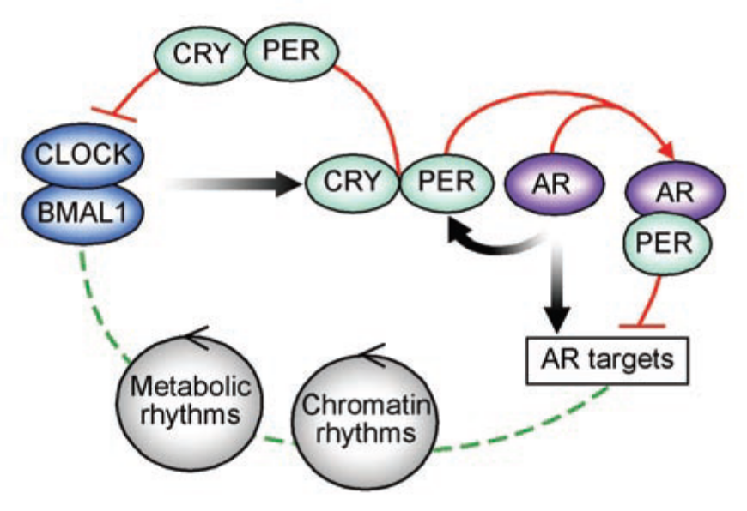
Figure 8. Role of CLOCK and BMAL1..Picture show that CLOCK and BMAL1 activate core clock genes such as per and Cry in addition they activate tissue specific rhythmic genes such as AR. Per and Cry heterodimerize and inhibit from formation of clock/BMAL1 complex. Tissue specific transcription factors such as AR regulate expression of core clock genes. Per bind to AR and inhibits AR transcriptional activity. "Metabolic and chromatin remodeling cycle further integrate in to the circadian control of normal cellular function^{[21]}.
Melatonin:
Melatonin is an important hormone that has role in circadian rhythm. It is the main hormone that relates circadian rhythm to peripheral organs. Melatonin has anti tumor activity in different kinds of human cancers. This reduction takes place because of exposure to light at night and physiologically because of aging. As mentioned above secretion of melatonin inhibits breast and prostate cancer but it interacts with estrogen and androgen signaling pathway. For example, in breast cancer melatonin reduces the expression and activity of aromatase that is an enzyme that has role in biosynthesis of estrogen. In human prostate cancer melatonin induce nuclear exclusion of AR^{[21]}.
Melatonin plays an important role in events such as biological regulation of circadian rhythm, sleep, mood, reproduction, tumor growth and aging. Pineal gland that is located in center of brain behind the third ventricle. Pineal gland is highly vascular and consists of two different kinds of cells: 1) pinealocytes that secret indolamines mostly melatonin and peptides such as arginine vasotocin and 2) Neuroglial cells secret melatonin with the help of post ganglionic retinal nerve fibers that pass from retinohypothalamic tract to suprachiasmatic nucleus and then go to superior cervical ganglion and at last to pineal gland^{[6]}.
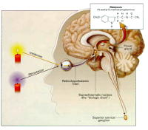
Figure 9.Physiology of secretion of melatonin.Pineal gland secret melatonin. Secretion of melatonin are done by postganglionic retinal nerve fiber that pass through retinohypothalamic tract to suprachiasmatic nucleus then go to superior cervical ganglion and finally to pineal gland. This neural system activate by darkness. Activation of α and β adrenergic receptors in the pineal gland cause increase in cyclic AMP and increase concentration of calcium that activate arylalkylamin N- acetyltransferase that initiate synthesis of melatonin^{[6]}.
Receptors of melatonin are in the SCN. Melatonin can inhibit metabolic activity of SCN of specific circadian phase. In addition, melatonin can create change in electrical activity of SCN and this is the effect of melatonin on the SCN^{[2]}.
Neurological system will be active in darkness and light works as a suppressor. When α and β adrenergic receptor in pineal gland is activated, this activation causes increase in cyclic AMP and calcium concentration that activates arylalkylamin N acetyltransferase and causes the secretion of melatonin. Secretion of melatonin is controlled by endogenous free- running pacemaker that is located in SCN^{[6]}.pineal gland secrets melatonin at high levels at nights so it is called hormone of darkness. Level of this hormone has important role in cooperation of various oscillations especially in endocrine organs. If alteration takes place in secretion of this hormone psychiatric disorder occurs. Melatonin acts as an antioxidant and an immunodulator and has antitumor activity. We can find it in different organisms from bacteria to human^{[3]}.
Melatonin is produced by bone marrow cells and circulating lymphocytes. Production of melatonin by pineal gland can be modified by immunological factors such as antigen stimulation, inflammation, cytokines, histamine, prostaglandin and opioids. Melatonin regulates function of cells that have melatonin receptor. Receptors of melatonin belong to G-protein coupled receptor family (receptor mt1 and mt2) and quinine reductase family (receptor mt3). Receptor of melatonin exists in SCN cells and many other organs^{[3]}.
In biosynthesis of melatonin at first tryptophan is converted to 5- hydroxytriptophan with the help of tryptophan hydroxylase. 5 hydroxytriptophan decarboxylates to serotonin. Melatonin synthesized from serotonin with the help of two enzymes that catalyze this reaction that include: 1) arylalkylamin N acetyltransferase and 2) hydroxy indole o- methyltransferase^{[6]}.
Mechanism of action of melatonin:
There are two membrane bound melatonin receptors that include ML1 (high affinity receptor) and ML2 (low affinity receptor). ML1 subdivides to Mel1a and Mel1b. Melatonin changes the conformation of α subunit of intracellular G protein by binding to its membrane bound receptors and then binds to adenylate cyclase and activates it. Melatonin can act as intracellular site by binding to systolic calmudulin. Melatonin has effect on calcium signaling through interaction with target enzymes such as adenylate cyclase and phosphodiesterase and structural protein. Nuclear binding are α and β retinoid Z receptor (RZR) ^{[6]}.
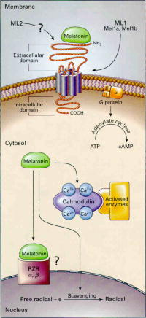
Figure10.mechanism of action of melatonin in cellular level^{[6]}.
Melatonin is scavenger of toxic hydroxyl radical and other oxygen centered radicals so melatonin protects macromolecules especially DNA from degenerative diseases. Melatonin can inhibit growth of tumor. Melatonin stimulate secretion of interleukin 4 in bone marrow T helper cells and stimulate secretion of granulocyte macrophage colony stimulating factor in stromal cells and protect bone marrow from apoptosis^{[6]}.
Endogenous secretion of melatonin will change in passengers who fly across time zone, and in night shift workers and patients with delayed sleep phase syndrome. Melatonin has effect on the growth of tumor. Pinealectomy increases growth of tumor and administration of melatonin causes decrease in the growth of tumor. Concentration of melatonin is low in serum and urinary excretion of melatonin is low in breast cancer and prostate cancer. The mechanism in which melatonin inhibits the growth of tumor is that melatonin has antimitotic activity. Physiologic and pharmacologic concentration of this hormone prevent from the proliferation of cultured epithelial breast cancer cell line and malignant melanoma cell lines and this effect is the result of intranuclear down regulation of gene expression or inhibition from "release and activity of stimulatory growth factors" Activity of receptors in tumor cells are regulated by melatonin, for example, melatonin decreases estrogen binding activity and expression of estrogen receptor that depend on dose and time in breast cancer cells^{[6]}.
Melatonin has immunomudulatory activity. Melatonin increases immune response because production of cytokine that are derived from T helper cells are increased by melatonin. Melatonin protects bone marrow cells from apoptosis because melatonin increases the production of colony- stimulating factors with the help of granulocytes and macrophages. Melatonin has protective effect against tumor growth by shielding molecules and protects DNA from oxidative damage^{[6]}.
Environmental factor especially light controls the time of circadian rhythm. Other factors such as stress and fear can alter ability of light to modify melatonin level^{[68]}.
Cell cycle is controlled by circadian rhythm so circadian rhythm is a tumor suppressor. Melatonin acts as a differentiating agent in some cancers. Melatonin after changing the adhesion of molecules decreases the invasive character of cancer cells and causes programmed cell death or act as cyctostatic drug. It can do this by modulation of expression of estrogen receptor, activity of protein kinase C, activity of calcium (calmudulin), and intracellular redox status and so changes the cytoskeletal structure. These effects adhere with suppression of tumor linoleic acid uptake cause conversion to 13-hydroxy octadecadienoic acid that can activate EGFR/MAPK mitogenic signaling^{[3]}.
There is one important matter that is "shift work is detrimental for health". Melatonin is a hormone that links night shift work and the development of cancer. Secretion of melatonin is under control of circadian clock and circadian clock controls it at night. Light suppresses the secretion of melatonin and melatonin acts as a scavenger of oxygen radicals that cause DNA damage and it is known that DNA damage causes cancer. With this background regarding the new life style in which people are awake till dawn and use baby- light- TV, computer, street light, moon light, emergency light or any other light pollution that comes with urban development cancer expands with the mechanism of light at night (LAN) hypothesis. It is noteworthy that synthesis of melatonin is not decreased when people are exposed to common light sources such as baby- light, TV, computer, etc. therefore, "under these circumstances it is unlikely that light pollution can be linked to health consequence via the LAN hypothesis in healthy, sighted people" The possibility of this matter is higher than before that weak zeitgeber during darker days and brighter nights have great effect on circadian rhythm^{[34]}.
Sleeping as little as possible is an admirable behavior in contemporary society. There are many hormones that have effect on regulation of glucose and control of appetite and sleep has influence on these hormones. For example, leptin and ghrelin that depend on time of sleep, duration and quality of sleep and sleep propensity and sleep architecture are controlled by two mechanisms in CNS that is under the control of circadian rhythm^{[42]}.
Cell to cell interaction do not create circadian signal in nuclei of SCN but single SCN cells create circadian neural signals. Circadian timing transmits to other parts of brain and periphery with
1) Direct neuronal connections with other parts of hypothalamus
2) With control of activity of sympathetic nervous system
3) with hormonal signal such as melatonin^{[42]}.
The major mechanism that controls circadian rhythmicity and sleep-wake homeostasis on peripheral physiological system is the modulation of hypothalamic activation and inhibiting factors that control release of pituitary hormones and regulation of sympathetic and parasympathetic nervous activity^{[42]}.
GH: Is a hormone that is necessary to control sleep-wake homeostasis. Shortly after onset of sleep, reproducible pulse of GH happen so GH is released during the night but when sleep period is displaced the amount of GH that is released during the night is minimum or absent. This reduction in GH exists in men but is not detected in women^{[42]}.
Cortisol: Release of cortisol is maximum early in the morning. The level of cortisol is reduced during the day time so manipulation of sleep- wake cycle affects the release of cortisol⁴³. Cortisol is a strong oscillator and is an important marker for circadian rhythm in men. There are many diseases that are related to cortisol such as endocrine diseases in which circadian rhythm of cortisol is disruptted^{[72]}.
Leptin: that is secretted by adipocytes and ghrelin that is secretted by stomach cells influence sleep. The amount of leptin is dependent on food intake so the amount of leptin is minimum during the morning and increases during the day time so it depends on sleep-wake cycle.
Ghrelin: that is decreased during and after the ingestion of meals. The concentrations of both hormones are higher during nocturnal sleep than during wakefulness so we can understand that sleep has an important role on endocrine function^{[42]}.
Sleep deprivation has many effects on different events that include: 1) sleep deprivation cause increase in the activity of sympathetic nervous system.
2) loss of sleep causes increase in level of growth hormone(GH)during these two events that are because of effect of loss of sleep cause increase in insulin sensitivity and glucose tolerance that raises the risk of diabetes.
3) loss of sleep has effect on hormones that have a role in appetite regulation, for example, the level of leptin that is satiery factor (appetite inhibiting hormone) is lower and level of ghrelin that is stimulant of appetite (appetite stimulatory hormone) is higher, therefore,the food intake of food is higher which causes obesity. 4) With loss of sleep there is more time to eat so it causes increase in appetite and increase in intake of foods that will cause obesity.
5) Sleep loss reduces energy expenditure by decrease in physical exercise that in turn causes obesity. Obesity is a risk factor for type 2 diabetes^{[37]}.
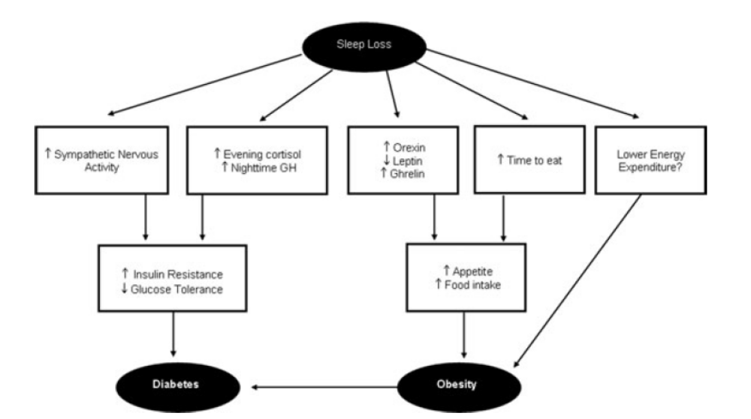
Figure11.schematic pathway that explain how sleep loss lead to increase risk of diabetes and obesity ^{[37].}
There are many life processes that are coordinated by biological clock such as eating, seasonal migration and cell proliferation^{[22]}.
People who sleep too little or travel across time zones impair the function of circadian. " Prolonged, simultaneous disruption of our normal sleep and circadian rhythms affects the working of our insulin- secreting pancreatic cells creating a prediabetic state" Under this condition we can see a decrease in resting metabolic rate that causes yearly increase in weight more than 10 pounds and this is the reason why it is so important to go to bed on time^{[7]}.
Short sleep duration and disordered sleep causes metabolic change such as dysregulation of many hormone, reduction in sensitivity of insulin,, insulin resistance and glucose intolerance, increased risk of chronic diseases such as obesity and type 2 diabetes^{[7]}.
As mentioned before loss of sleep increases the incidence of diabetes. The glucose metabolism is impaired for two reasons:
1) when there is a change in secretion of insulin because "pancreatic β cells do not secret enough insulin in response to a glucose stimulus"^{[7]}.
2) change in insulin sensitivity that causes peripheral tissue not to be able to respond to insulin signal as a result of increase in their glucose uptake^{[7]}.
Acute circadian misalignment occurs as a result of "sleeping during the biological day and eating during the biological night" and this event occurs because of jet lag and shift work. These events have effect on glucose metabolism which cause increase in postprandial glucose and increase in circulating insulin levels. " suggesting a reduced insulin sensitivity coupled with an inability of the pancreas to sufficiently increase insulin secretion"^{[7]}.
Disruption of circadian rhythm causes creating of many cancers.
Colon cancer: Gastrointestinal tract show circadian rhythms. For example, secretion of gastric acid, emptying of gastric, expression and activity of digestive enzyme along with the crypt-villus axis and responses to certain drugs that are used for patients with colon cancer vary with time of day. In gastrointestinal tract clock genes are expressed in epithelial cells and myenteric plexus. Disruption of circadian rhythm because of shift work, time zone travelling, and space flights causes gastrointestinal symptoms such as abdominal discomfort, constipation or diarrhea. Shift workers and passengers with jet lag are susceptible to irritable bowel syndrome. Gastrointestinal clock plays an important role in colon cancer. Clock genes such as clock, per2, Per3 and Cry are expressed in peripheral tissue such as heart, liver, adipose tissue and gastrointestinal tract. The maximum expressions of genes that are associated with colon cancer occur in dark cycle. Bcl2 gene that is co transcribed with Per2 "suggests potential direct control of transcriptional regulation by the clock/BMAL1 dimer. Bcl2 has E- box in its promoter region that allows for direct clock –controlled transcriptional regulation. Bcl2 increases oncogenesis because it prevents from apoptosis. A group of genes that are expressed rhythmically in distal colon are associated with inflammation. From those genes are CFTR that has an important role in regulation of intestinal electrolyte homeostasis and the expression of CFTR is regulated by colonic inflammation and kB kinase β. Expression of CFTR is higher at the beginning of light cycle in anti phase with expression of Per gene and it suggests it must be controlled by clock genes. Inhibitor of kB kinase phosphorylates residues of serine in IkB proteins that are destroyed by ubiquitionation pathway so it allows the activation of nuclear factor kB complex. Chronic inflammation alter the function of clock genes that regulate immune function because clock genes are expressed in epithelial cells of colon so they play an important role in regulation of host immune defense^{[28]}.
Colorectal cancer: risk of colorectal cancer is increased in shift workers. Circadian clock coordinates physiologic processes in peripheral tissue by tissue specific clock controlled gene such as thymidylate synthase, P21 and Wee1 that targets of the DNA replication, mitosis and other growth regulator such as vascular endothelial cell growth factor. Per2 is a circadian clock gene that acts as a negative growth regulator and tumor suppressor. Disruption of circadian rhythm increase cell proliferation and increases the risk of cancer. Disruption causes increase in the incidence of epithelial cancer. Circadian disruption that exists in shift workers causes some cancers such as breast cancer, colorectal cancer, and endometrial cancer.Per2 modulates β catenin signaling in colon cancer. Down regulation of PER2 increases the levels of β catenin protein and target of β catenin that is cyclin D and accelerates cancer cell proliferation. Decrease in level of PER2 RNA has been reported in some acute leukemia. Over expression of Per2 in cancer cells cause cell cycle arrest, increased apoptosis and decreased clonogenecity. Mutation in per2 affects the expression of other clock genes such as Per1, Cry1 and BMAl1. Decrease in level of Per1 RNA causes colorectal cancer. Expression of these clock genes depend on rhythm so it can be seen that product of Per2 suppresses intestinal and colonic tumorigenesis by down regulation of β catenin and β catenin signaling pathway so the products of Per2 are target for prevention of colon cancer and it’s control ^{[76]}.
In colorectal cancer the amount of expression of β catenin is increased which activates Wnt signaling pathway such as C-Myc, Cyclin D and VEGF that are promoted from proliferation of cells. "In the absence of Wnt signaling β catenin is associated with adenomatous polyposis coli (APC) protein" APC phosphorylates by glycogen synthase kinase 3β (GSK-3β) phosphorylated. β catenin ubiquitinated by ubiquitin E3 ligase SCF^{β_TrCP} and 26 S proteasom degrades it.β- TrCP that is a F- box protein "determines the substrate speaficity of SCF ligase targeting a variety of proteins modulating proliferation, apoptosis and DNA damage response pathway.’’ Β- TrCP regulates circadian clock because it is target of PER1 and PER2 for their ubiquitin mediated degredation. Recent study shows that β-TrCP is upregulated in colon cancer so β catenin causes increase in the amount of degredation of PER2 in colon cancer^{[77]}.In colon cancer one of circadian genes that is Per1 provide a link between circadian clock and DNA damage and causes apoptosis and cancer^{[81]}.
Skin cancer: in human skin there is less DNA replication and more repairs in the morning and more replication and fewer repairs in the evening. We know that UV is the main cause of skin cancer "because UV induced skin cancers arise from mutagenic replication of epidermal keratinocyte DNA. The same UV dose is more carcinogenic in early morning hours than when given in the early evening hours" Humans have powerful circadian clock in their skin. Circadian rhythm in human has different chrorotypes. By restricting exposure to UV radiation in the early morning hours the probability of skin cancer in human is reduced^{[19]}.
Liver cancer: the circadian timing system controls main pathways that are responsible for drug pharmacokinetic, drug metabolism and detoxification and cellular proliferation so if there is a disruption in circadian rhythm it increases the risk of liver cancer^{[18]}.
There is a relationship between LAN and incidence of prostate and colon cancer in men. Light at night is a risk factor for some types of cancers because it causes circadian disruption. A circadian is disrupted by a variety of mechanisms such as 1) suppression of secretion of melatonin by pineal gland increase the growth of tumors. 2) Depression of functions of immune system and thermoregulatory 3) direct disruption of the function of clock genes in SCN that alters the regulation of cell cycle^{[36]}.
Head and neck squamous cell carcinoma (HNSCC):HNSCC is malignancy of oral cavity, pharynx, and larynx. PER1, PER2, PER3, CRY1, CRY2, CKIε and BMAL1 are down regulated in HNSCC that is not in non cancerous tissue. CRY2 is the most down regulated gene and it is decreased in HNSCC about nine fold in comparison with normal tissue. Mutation in Cry2 activates P53 apoptosis pathway (NF-KB signaling pathway) that eliminates premalignant and malignant cells. Clock genes such as Cry that they are tumor suppressor genes which increase apoptosis. Down regulation of clock genes in HNSCC causes clock genes to lose their function to eliminate premalignant and malignant cells so this will brings about the development of tumor^{[29]}.
Breast cancer: The disruption of circadian rhythm is an important risk factor in breast cancer. Gene silencing occurs whenever DNA methylation takes place in CPG rich region that is called CPG Island. CPG is located in promoter region. DNA methylation in CPG Island causes gene silencing. Aberrant methylation or hypermethylation takes place in genes that are related to cancer in cancer cells. Breast cancer occurs because of change in methylation of promoter. Promoter of PER1 and CRY1 genes are methylated in cancerous tissue. There is correlation between methylation of PER1 promoter and repression estrogen receptor. Methylation of PER1 promoter causes the expression of estrogen receptor not to take place the result of which is development of aggressive tumor so inactivation of PER1 has an important role in the development of breast cancer^{[40]}.
PER1, PER2, BMAL1 and CRY1 are genes that regulate circadian clock. When these genes become inactive which causes the deregulation of breast cancer cells from the control of the central pacemaker. PER1, PER2 and CRY are inactive in breast cancer and this inactivation causes the deregulation of control of cell cycle that lead to proliferation of breast cancer tissue. Methylation of promoter inactivates the expression of circadian genes and disrupts circadian rhythm of breast cancer cells^{[40]}.
Omega –6 polyunsaturated fatty acid (PUFA) and linoleic acid (LA) are two pathways that mediate melatonin cancer inhibitory action on tumor growth. There are many PUFA in western diet that cause increase in the level of LA more than the amount that is required to prevent essential FA deficiency . LA can upregulate the expression of genes and proteins induced in estrogen receptor (ERα) expression. Cell cycle progression, G protein signaling, extracellular signal regulated kinase (ERK) 1/2 and PI3 Kinase/ AKt/mTOR growth cascade, while down regulating intracellular communication. Therefore, secretions of melatonin at night sends a signal from central circadian system that inhibits human breast cancer signal transduction activity, mitogenic LA metabolism and proliferation/ growth. This is done by oncostatic property^{[4]}.
1P36 is a chromosomal region and it is commonly a deleted region in human cancers. Deletion in 1P36 is the cause of breast tumor and metastasis of lymph node, poor prognosis, higher rate of recurrence; large tumor size and DNA aneuploidy.CHD5 and KIF1B are two tumor suppressor genes that do not have a specific role in the development of breast cancer. PER3 gene that is located within CHD5 controls the circadian rhythm of members of period family of circadian rhythm, and the genes which control cell cycle, DNA damage responses and tumor progression. Deletion of PER3 gene on 1P36 is associated with breast cancer. PER2 is estrogen inducible corepressor of PER3 which prevents from molecular import and causes accumulation of PER2 in cytoplasm^{[12]}.
Phosphorylation regulates stability and nuclear translocation of Per3 protein. Phosphorylation occurs by another circadian protein that is called Casein Kinase I. If amino acid residues are decreased in shorter variant of Per3 protein it has a functional impact on phosphorylation-dependent activity. In delayed sleep phase syndrome and diurnal preference there are functionality of Per3 length variation in circadian rhythm. This Per3 length variation is associated with breast cancer more in young women compared to old women because 1) estimate of relative risk is attenuated in old women 2) cumulative exposures to environmental factors are higher and longer in old women. Occurrence of breast cancer is related to inherited risk among young women but it is related to environmental exposure in old women^{[82]}.
When pineal gland loses its function it causes a decrease in secretion of melatonin that causes increase in the level of reproductive hormone specially stradiol level, in turn, that causes increase in the growth and proliferation of hormone- sensitive cell in breast. In addition, melatonin has antimitotic activity that affect hormone- dependent proliferation by interaction with nuclear receptor. Expressions of P53 that is a tumor suppressor gene is increased by melatonin cells which do not have P53 are unstable genetically and are more susceptible to tumors. As we know, light is a powerful stimulus that regulates secretion of melatonin by pineal gland. Light causes the suppression in secretion of melatonin. Melatonin causes increase in expression of P53. Interaction of a receptor with retinoid Z receptor (RZR) which is a nuclear melatonin receptor causes an arrest of MCF-7 cells in G0/G1 phase of cell cycle which is controlled by P53 pathway. By shielding DNA from oxidative damage melatonin protects the cells against cancer. Therefore work on rotating night shift is associated with breast cancer^{[64]}.
Another reason that the circadian disruption causes breast cancer is that nocturnal illumination has an effect on menstrual cycle. Length of illumination at night causes shortening of menstrual cycle. The length of menstrual cycle is very important because short menstrual cycle increases the risk of breast cancer. In contrast, long menstrual cycle decreases the risk of breast cancer^{[68]}.
The main factor of risk for breast cancer is oscillation in estrogen^{[67]}.Stimulation of growth of endometriosis is done by synthesis of estrogen and metabolism. Serum estrogen has a circadian secretion pattern in premenopausal women and after the adjustment of the monthly ovarian rhythm. It tells us that estrogen is vulnerable to circadian disruption. Night shift work affects the secretion of estrogen and metabolism and increases the risk of several estrogen influenced conditions such as menstrual cycle change, breast cancer and adverse coronary events. Sensitivity to circadian disruption has genetic components in human^{[47]}.
Circadian rhythm has a role in breast cancer and causes circadian gene hypothesis which states that there are genes that are responsible to maintain circadian rhythm. These genes act as a panel of candidates that suppress breast cancer. Neuronal PAS domain protein 2 (NPAS2) is the largest circadian gene that is expressed in forebrain and encode basic helix loop helix PAS class of transcription factor. It does it by binding to E-box element that is in promoter region of its target genes. NPAS2 with BMAL2 form heterodimer then transcriptionally activate the expression of PER and CRY that are necessary to maintain biological rhythm. Loss of NPAS2 causes defect in circadian system such as disorders in sleep and behavior. NPAS2 regulate PER2 that is a tumor suppressor so it has a role in tumorigenesis. In addition, it regulates oncogen C-myce, therefore, it suppresses the transcription. Thus, NPAS2 is a tumor suppressor and "has an important role in DNA damage response, cell cycle control by activating different downstream genes"^{[74]}.
"Genetic variation in NPAS2 might be candidate biomarkers for breast cancer risk"^{[74]}.
This figure shows and explains signaling pathway cascade from retinal light to its effect on mammary tissue. From retina, neuronal signaling transmits to suprachiasmatic nuclei. From suprachiasmatic nuclei there is neuroendocrine transduction that affects hormones that are related to breast cancer or directly affect master clock of suprachiasmatic nuclei in genes that regulate cell cycle in mammary tissue^{[66]}.
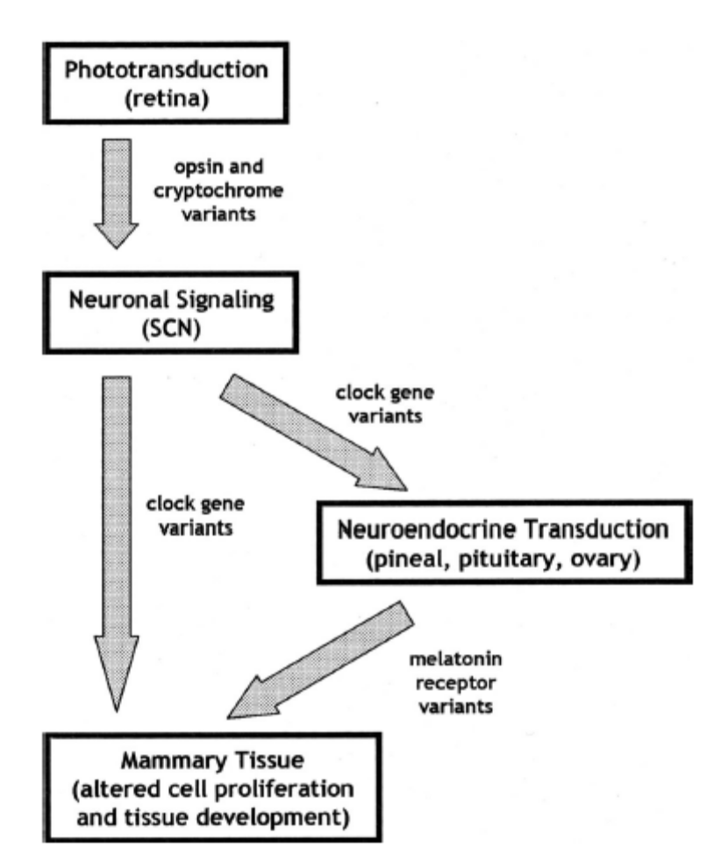
Figure 12. Pathway of biologic signal from retina to mammary tissue^{[66]}.
There are many mechanisms that disrupt circadian rhythm and increase incidence of breast cancer that include;
1) Light at night causes decrease in amount of melatonin that, in turn, causes increase in level of estrogen.
2) Melatonin disrupts the signaling of estrogen but does not have any effect on its production.
3) Melatonin is oncostatic. It does not depend on the effect of estrogen or interaction with estrogen.
4) Melatonin has an effect on immune system and free radical may have a role in breast cancer.
5) Exposure to ill- timed artificial light disrupts the function of circadian gene in SCN that alters the regulation of cell cycle in mammary tissue^{[66]}.
Disruption of circadian rhythm causes the appearance of other disease such as obesity, diabetes and hypertension^{[20]}.
Obesity:
Circadian clock exists in all tissues and it exists even in immortalized cell lines. There is a relationship between circadian rhythm and adipose biology. "Indeed multiple aspects of adipose-related physiology display daily variation”, for example, circulating blood borne concentration of leptin and adiponectin have circadian rhythm. Leptin and adiponectin are members of fat derived hormone family that are called adipokines. There is a molecular link between circadian rhythm and adipose physiology. Clock genes have a role in differentiation of adipocyte^{[32]}.
Sleep deprivation increases the weight of body. Lack of sleep causes decrease in level of leptin and increase in level of ghrelin and increase hunger and apetit behavior. Short sleep durations cause decrease in expenditure of energy by the effect of non-exercise activity, thermogenesis and dropping off of temperature in core body. Sleep deprivation cause decrease in glucose tolerance and decreased insulin sensitivity. It cause obesity by increasing the time that is available for eating and maintenance of healthy life style is very difficult. Another aspect that is created by the lack of sleep is fatigue, stress and tension. Short sleep duration and increase in body weight are powerful in children. Aging weakens this associationit does not eliminate it.^{[20]}.
Reduction in sleep is associated with obesity and obesity is a risk factor for some diseases such as sleep apnoea, arthritis, asthma and depression. This point is important that increase in weight causes decrease in sleep that results in increase in the amount of fats not muscles. Increase in abdominal fat increases the risk of diabetes and heart disease^{[54]}.
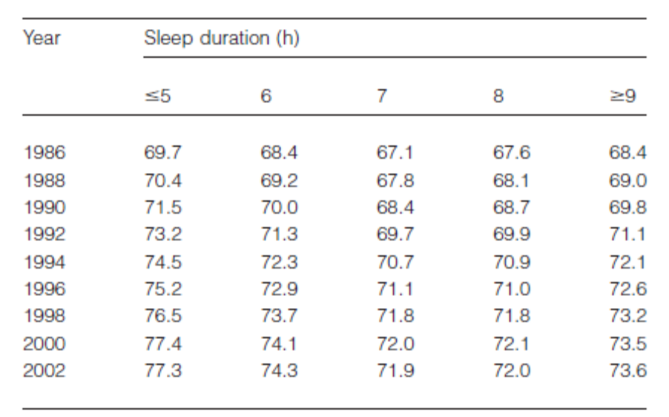
Table 5. "Mean age adjusted weight by sleep duration in the nurse health study"^{[54]}.
Diabetes:
1) Sleep deprivation causes the activity of sympathetic nervous system
2) Sleep deprivation causes decrease in cerebra glucose utilization in positron emsission tomography scan. Sleep deprivation also causes decrease in uptake of glucose of brain that causes development of insulin resistance.
3) Acute sleep deprivation increases evening level of cortisol which is an antagonist of insulin that in sleep deprivation conditions it creates insulin sensitivity in peripheral site. Increase in insulin resistance compromise function of B cells and causes type 2 diabetes. Short sleep duration increases the incidence of diabetes in men and long sleep duration increases incidence of diabetes only in women. ,so, in shift work where there is disruption in sleep- wake cycle the incidence of diabetes is very high^{[20]}.

Hypertension:
Short sleep duration causes maintenance of hypertension. Lack of sleep causes increase in blood pressure and increase in activity of sympathetic nervous system. Blood pressure and heart rate have diurnal pattern both of which will decrease during the sleep. Short sleep duration causes increase in blood pressure and heart rate. There is an association between short sleep duration and hypertension prevalence in middle-age people but there is no relationship between short sleep duration and hypertension in the elderly. Short sleep duration causes increase in hypertension and elevated blood pressure which lead to other cardiovascular diseases. Short sleep duration increases the incidence of myocardial infarction and fatal cardiovascular disease in women all of which are results of increase in blood pressure^{[20]}.
Concentration of glucose in plasma is very important because it uses glucose as a primary energy source as it cannot oxidize amino acids to fatty acids. Function of some organs such as liver, muscle, adipose, pancreas and brain is that they prepare homeostasis in blood glucose. When animals feed the level of glucose in blood increases and the increase in level of blood glucose stimulates pancreas to secret insulin. Insulin promotes peripheral tissue to uptake glucose. Liver and muscles synthesis glycogen that inhibits the production of glucose via gluconeogenesis in the liver and kidney. Glycogen stimulates liver to produce fatty acid and lipid. Excess glucose is saved in adipose tissue and is used for lipogenesis not glycogenesis^{[69]}.
Disruption of circadian rhythm or disruption in normal sleep affects on insulin-secreting pancreatic cells that create diabetes and obesity. Short sleep duration and disordered sleep cause metabolic change such as deregulation of multiple hormone axes, reduction in insulin sensitivity, and resistance to insulin and glucose intolerance. Circadian pacemaker in SCN controls circadian rhythm and this rhythm synchronize molecular circadian clock in peripheral tissue. Peripheral clock control physiological function to match with daily pattern of behavior such as feeding activity and sleep. But there is a disruption in this control in circadian rhythm in many people who perform shift work and this disruption causes fatigue, poor sleep, gastrointestinal complaints, and detrimental metabolic change and increased risk of developing obesity and diabetes. Acute misalignment of circadian rhythm causes decrease in production of insulin and this decrease in production of insulin causes increase in blood glucose after eating meals. Prolonged circadian disruption causes changes in the 1) brain that cause dendritic recognition and loss2) change in behavior that is responsible for novel environment and 3) change in glucose metabolism causes increase in concentration of insulin and weight gain so according to these three changes we can conclude that risk of diabetes increases in shift workers^{[7]}.
Appropriate concentration of blood glucose is maintained by the breakdown of glycogen in the liver through glucogenesis in the liver and kidney so there is constant supply of glucose for the brain. The lipid that is stored in adipose tissue is used by other tissue as energy fuel. Any imbalance in time of coordination of these organs affects on glucose and disrupts in homeostasis and cause the appearance of some disorders such as metabolic syndrome, obesity and diabetes. These metabolic processes are under control of circadian rhythm because genes that control metabolic process show circadian rhythm and all reactions that occur in this pathway such as glycolysis, gluconeogenesis, lipid biosynthesis, metabolism, oxidative phosphorylation are under control of core clock genes^{[69]}.
Immune response:
Immune response and inflammatory process are two important processes that protect the body from invasion of pathogens. These processes are regulated by a plethora of cells in different organs and protein mediators that are secreted from these cells: for example, white blood cell in arculation, macrophages in adipose and lungs, kupffer cell in liver, mast cells in muscles and microglial cell in the brain. Core clock genes are expressed in cells that regulate immune response and inflammatory processes. Inflammatory mediators cytokines such as IL-6, IL-2, IL-12, TNF-α, and interferon gamma show circadian rhythm. For example, concentration of TNF-α and IL-6 both of which are cytokines peak early in the morning in human. (At the beginning of active cycle) The number of monocytes and T and B lymphocytes peak during inactive period of organism but neutrophil and NK cells peak in active period of organism. Secretion of hormones such as melatonin, glucocorticoid, prolactin that regulate immune responses process show circadian rhythm^{[69]}.
Circadian rhythm has a role in immune activity such as natural killer (NK) cells which are essential components of innate immune system. Expression of NK cell is in the highest level in the morning. Other components of immune system such as T helper, T suppressor and splenic B cells also show circadian rhythm^{[83]}.
Sleep disorder that is influenced by alteration in circadian rhythm affects the expression of the hypothalamic- pituitary adrenal (HPA) axis. HPA axis is an important component of neuroendocrine system that controls the reaction of body to stress and has an important role in the regulation of immune system^{[83]}.
Chapter 4: Chronobiology:
There are three main questions in Chronobiology that include: 1)"Where is the clock located and how does it work?" 2)"How does it interact with the environment?" 3)" How does the clock tell time to the rest of the body?"^{[23]}.
Circadian timing system (CTS) is a molecular event that rhythmically controls drug metabolism and detoxification, cell cycle, molecular target, DNA repair, apoptosis and angiogenesis. CTS is composed of 1) a hypothalamic pacemaker the suprachiasmatic nuclei SCN 2) an array of SCN that generate circadian physiology output 3) molecular clock in the cells of all peripheral tissue^{[43]}.
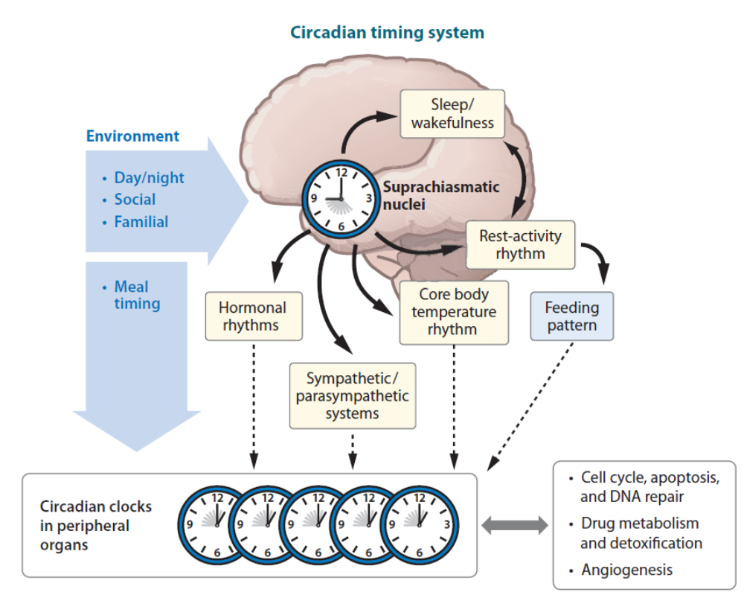
Figure 13.Schematic representation of circadian timing system^{[43]}
SCN creates circadian physiology by diffusible signals such as transforming growth factor α, epidermal growth factor, prokineticin-2 (PK-2), cardiotrophin-like- cytokine, neuroanatomic sympathetic and parasympathetic pathway. These signals that emanate from SCN coordinate molecular clock in each cell and molecular clock controls cellular function that is related to cancer treatment such as metabolism of drugs and detoxification and cellular proliferation, DNA damage, etc^{[43]}.
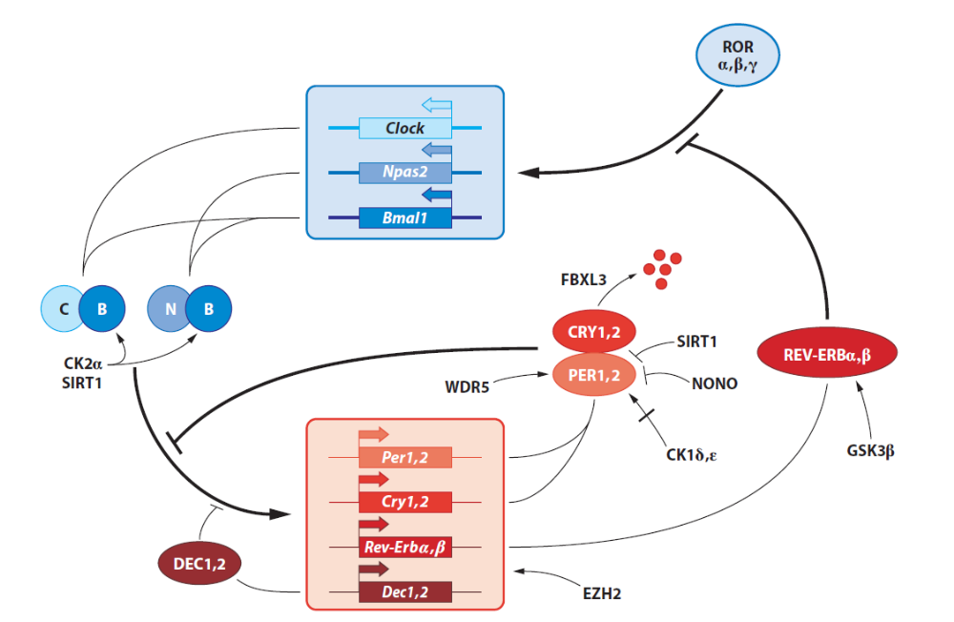
Figure14. Hypothetical circadian clock of mammals. Molecular oscillator is based on molecular feedback loops within a positive limb (CLOCK, NPAS2, BMAL1) and negative limb (PER and CRY) that connect to each other via nuclear orphan receptor REV-ERBα. Heterodimerization between BMAL1 and CLOCK or NPAS2 cause activation of transcription of per and Cry genes. The polycomb EZH2 and kasein kinase 2 (CK2) and silencing information regulator (SIRT1) interact with this heterodimer and facilitate their action. The accumulation and activity of PER and CRY is influence by phosphorylation by protein kinase (CK1δ.ε), by with help of ubiquitionation by a complex that contain F-box protein (FBXL3) that is specific for CRYs, with help of histon methyl transferase binding protein WDR5 and with help of NONO an RNA and DNA binding protein. DEC1 and DEC2 compete with BMAL1- CLOCK/NPAS2 heterodimer for binding to E-box so reduce E-box mediated transactivation. Nuclear orphan receptor RORα, RORβ and RORγ are activators in accessory feedback loop and REV-ERBα and REV-ERBβ are repressor and regulate circadian transcription of Bmal1^{[43]}.
CTS can modify the ability of toxicity of 40 anticancer drugs that are listed below:^{[43]}
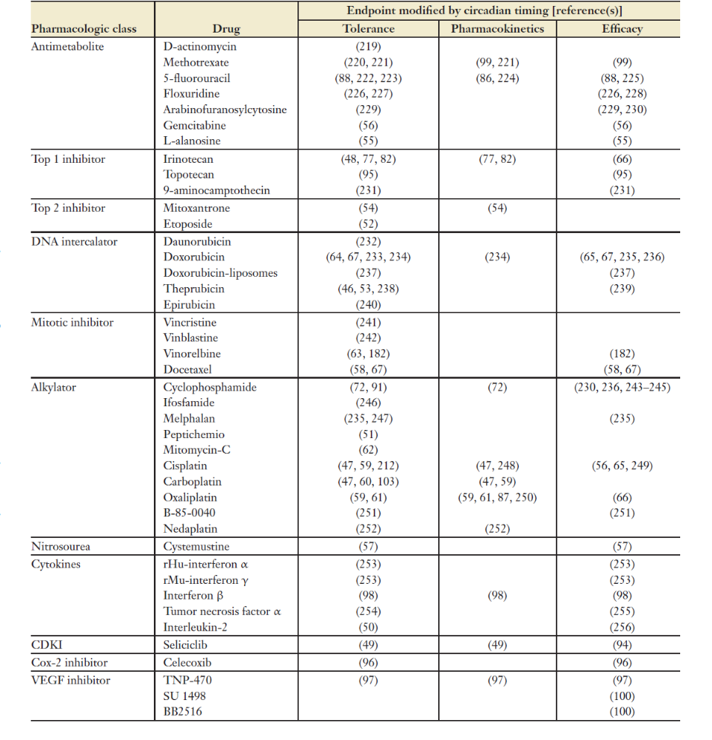
table 6.Anticancer drugs and its role in circadian timing for tolerability, pharmacokinetics and its antitumor effect in laboratory rodents^{[43]}.
" A potentially lethal dose of any of these agents result in 2 fold to more than 10 fold changes in the incidence of toxic deaths and /or maximum body weight loss as a function of circadian timing of drug administration"^{[43]}.
Anticancer agents that have circadian tolerability undergo oxidation, reduction or hydrolysis. They do it in liver and in intestine. CTS controls both phase I metabolism and phase II drug detoxification and elimination that are done by redundant processes such as rhythmic physiology and circadian clock signaling^{[43]}.
Activity of microsomal oxidase will be several folds during dark span and their activity is reduced during exposure to light span. The CTS determines circadian timing of anticancer medication. CTS can control transport of drug, bioactivation, detoxification, metabolism, targets and elimination that is part of chronopharmacology of anticancer agent in different levels such as cellular, tissue and whole organism level. CTS can regulate cell cycle related events such as transition of G1/S or G2/M, DNA repair and apoptosis that is part of chronopharmacodynamics of anticancer drug. "The relations between chronopharmacokinetics and chronopharmacodynamics help construct optimal chronomodulated drug delivery schedules with proper parameters^{[43]}.
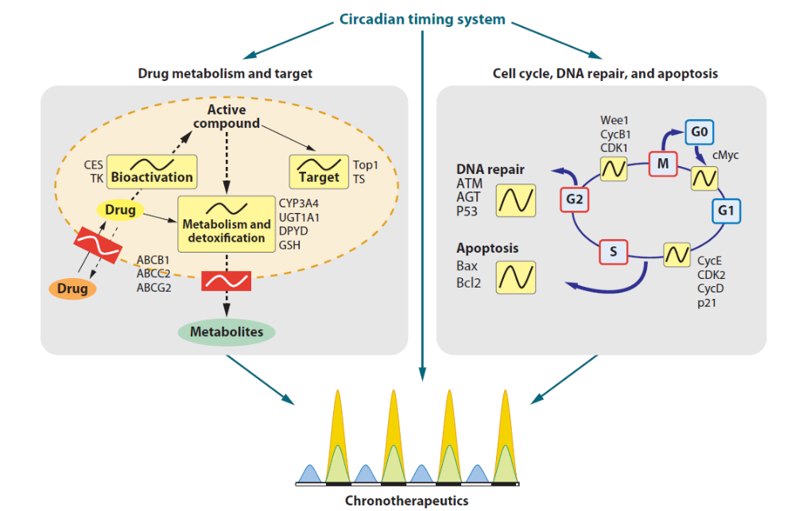
Figure 15. "Main cellular determinants of cancer chronotherapeutics"^{[43]}.
Pharmacotherapy that is done by monitoring concentration of drugs by Pharmacogenetic approach such as genetic diagnosis is very interesting because of rapid progress of molecular biology. "Consequently, dosage adjustment has been based on the inter individual differences in drug pharmacokinetics". Chronopharmacology is an investigative science that explain dependencies of drugs to biological rhythm. Effectiveness or toxicity of drugs depend on dosing time that are relate to biological rhythm. Chronopharmacological phenomenon is influenced by pharmacodynamics and pharmacokinetic usage of medications. From the viewpoint of pharmaceutics the usage of biological rhythm to pharmacotherapy is done by usage of formulated tablets and capsules in appropriate time and special delivery systems that synchronize concentration of drugs to rhythm in disease activity. Drugs for several diseases do not depend on the time of day because Chronopharmacological findings are not summarized systematically " in an applicable format for clinical practice and a reference rhythm for circadian timing of medications has not been clarified"^{[52]}
Chronobiological approaches show the important role of 24h rhythms in physiological function and disease.
1) the rhythms of serum cortisol, aldestrone, testosterone, platelet, adhesiveness, blood viscosity and NK- cell activity is in the highest level during the beginning hours of day time.
2) The level of insulin, cholesterol, triglycerides, platelet number and uric acid are the highest during the day and in the evening.
3) The peak of gastric acid secretion, white blood cell (WBC), lymphocytes, prolactin, melatonin, eosinophil, adrenal corticotrophic hormone (ACTH), follicle stimulating hormone (FSH) and luteinizing hormone (LH) is during night time^{[52]}.
24h rhythm causes prominent day-night pattern in manifestation of many medical conditions in pathophysiological diseases for example:
1) Sneezing, runny nose and stuffy nose in allergic and infectious rhinitis is in worst condition during the morning when we get out of bed.
2) Onset of migraine headache occur more during the morning when patient awakes. 3) The worst symptoms of rheumatoid arthritis occur during the morning but the worst symptoms of osteoarthritis occur during later time of day.
4) The peak of morbidity and mortality that depend on myocardial infarction is during initial hours of day time. 5) The probability of hemorrhagic stroke is the highest in the morning when diurnal activity start. 6) Ischematic events, chest pain and ST- segment depression of angina is the highest during the day time hours. 7) Pain and gastric distress that is because of peptic ulcer disease and its acute exacerbation is the highest in late evening and early morning. 8) Seizures of epilepsy that is common during sleeping and offset in the morning^{[52]}.
The efficiency of pharmacotherapy depends on the administration of drugs at a time at which they are most effective. Chronotherapy of a drug is done by the usage of formulated tablets and capsules at appropriate time and also by a special drug delivery system that synchronize concentration of drugs to rhythms in disease activity. Chronotherapy is associated with the following: risk and intensity of symptom of disease vary overtime such as allergic rhinitis, arthritis, asthma, myocardial infarction, congestive heart failure, stroke and peptic ulcer disease. Biological rhythm has a role in pharmacokinetic and pharmacodynamics. The therapeutic toxicity ratio of drugs varies according to Chronobiological factors of antitumor medications^{[52]}.
Examples for chronopharmacotherapy: 1) Usage of theophylline tablets once a day for the treatment of nocturnal asthma. 2) Usage of verapamile HCL before bedtime for the treatment of patients with ischemic heart disease or essential hypertension.
3) Usage of HZ receptor antagonist tablet once a day in the evening or usage of proton pomp antagonist once a day in the morning for treatment of peptic ulcer disease.
4) Usage of hypontics before bed time for sleep induction and maintenance.
5) Infusion of antitumor drug- delivery patches system in the morning for physiologic androgen- replacement therapy.
6) Infusion of antitumor drugs in time according to biological rhythm " to moderate toxicity and enhance dose- intensity in cancer treatment"
7) Usage of tocolytic drug in time according to biological rhythm in contracting of uterine to avert preterm labor and birth^{[52]}.
Chronopharmacodynamics:
"Biological rhythms at the cellular and subcellular levels can give rise to significant dosing- time differences in the pharmacodynamics of medications that are unrelated to their pharmacokinetics. This phenomenon is called chronesthesy. Rhythm in numbers of receptors, conformation of receptor, second messengers, metabolic pathway, is free to bound fraction of drugs which explains chronesthesy. For example, antitumor effect of interferon β ( INF-β) is more efficient during rest phase^{[52]}.
Chronopharmacokinetics:
Physiological factors vary according to time of day, factors such as gastrointestinal, cardiovascular, hepatic and renal change. These changes depend on circadian rhythm for the fate of drugs in the organism. In absorption of drugs there are circadian changes in many drugs ,for example, secretion of Gastric acid and PH, motility, gastric emptying time and gastrointestinal blood flow will change according to time of day. In distribution of drugs there are circadian changes that vary according to time of day ,for example, blood flow that depends on regulatory factors such as sympathetic and parasympathetic system that are coordinated by circadian time dependence. Other examples are albumin, α1 acid glycoprotein, red blood cells and transporters^{[52]}.
In hepatic drug metabolism that depend on activity of enzymes in the liver and hepatic blood flow both of which are coordinated by circadian time- dependent differences. In drug elimination renal physiological function like glomerular filtration, renal blood flow, urinary PH tubular resorption show circadian time dependent differences. Sleep disorder in human is because of genetic mutation that affects circadian clock function^{[52]}.
Most anticancer agents that have circadian rhythm undergo oxidation, reduction and hydrolysis. They do this modification in phase I metabolism that take place in liver and in lesser amount in the intestine. CTS with the help of redundant processes such as rhythmic physiology and circadian clock signaling controls phase I metabolism and phase II detoxification and elimination. The activity of microsomal oxidase is the highest during the darkness and is lowest during the light in rats^{[43]}.
In this part we must fetermine whether there is a balance between toxicity of drugs and therapeutic value? Drugs that are used for cancer also have effect on healthy cells so the dose timing that patient uses drugs has important role in maximizing therapeutic effects and causes reduction in adverse effects. Target of chemotherapeutic drugs show circadian rhythm. Example such as Nucleolin (has role in synthesis and maturation of ribosomes) ELF4A (that is RNA helicase protein and has role in translation initiation) show circadian rhythm in their expression^{[69]}.
Recent study by Lurisci et al 2009 show that Seliciclib that is cyclin dependent kinase inhibitor can disrupt the circadian molecular clock in liver and this occurs because of the time of the administration of the drug^{[69]}.
Chronodisruption (CD) disturb circadian organization of physiology, endocrinology, metabolism and behavior. CD causes increase in incidence of cancer. Chronodisruptores are exogenous and endogenous agents that are active chronobiologically and disturb the time. Chronodisruption is a"putative link between shift work, time zone travel and human cancers"^{[16]}.
Chronopharmacokinetics: There are 24 hours changes in four processes that include: absorption, distribution, metabolism and elimination and these changes determine the disposition of many drugs in human^{[44]}.
Chronopharmacodynamics: "circadian change in the interaction between the active forms of the drug and its molecular target determine the extent of molecular and cellular response" This 24 hours circadian rhythm creates membrane microviscosity or permeability, receptor density, binding enzymatic activity transport and repair protein and ion channel in human tissues^{[44]}.
Results:
In this regard we divide studies into two categories. First category that checks whether there is any linkage between disruption of circadian rhythm and creation of some disease such as cancer, obesity and diabetes and second category that checks whether there is no linkage between disruption of circadian rhythm and creation of these diseases.
In this part we introduce some clinical trial briefly and explain its connection to circadian rhythm.
Study 1. An important factor that has role in circadian rhythm is light and dark patterns. In an experiment that is done on 40 albino female Sprague-dawley rats there are two groups of rats. One group that is exposed to 12L: 12D pattern of light and dark and the other group that is exposed to 12L: 12D pattern that is reversed every 18 hours. They use species light stimulus for rats that is higher than threshold. In addition, scientists use Daysimetere that is a device that records light- dark data and activity- rest data in human simultaneously. They use Daysimetere in group of day shift nurses and rotating shift nurses. There are 32 day shift nurses and 11 rotating shift nurses all of whom are premenopausal female who receive Daysimetere to measure their circadian light stimulus and use this device for seven consecutive days. In addition to wearing Daysimetere scientists obtain urine sample from nurses every four hours for melatonin assay. They found that pattern of circadian disruption is very different in day shift nurses when we compare it with rotating shift nurses but the results are very similar to patterns of parallel group of rodents.
When data of Daysimetere was collected scientists found that in day shift nurses there is "consistent relationship between the activity and transformed CS values over the course of the seven-day measurement session. For the rotating shift nurses, however, this synchrony is much less pronounced" These experiments show that there is relationship between light exposure and markers of circadian rhythm such as rest-activity pattern, core body temperature and melatonin synthesis^{[58]}.
Study 2. Epidemiological studies show that shift working increases the incidence of cancer and tell that there is relationship between circadian rhythm and tumorigenesis but there is no molecular mechanism. In this article authors design an experiment to show tumor progression related to circadian rhythm ^{[78]}.
The aim of this study is profounding the effects of light at night on increasing the risk of cancer and poorer pregnancies. Scientists use mice and divide them to two groups. Hella cell inject to nudmice. One group exposed to 24 hours artificial light and other group exposed to 12 hours light/dark cycle. This experiment shows that light stress in Hella cell causes increase in tumor volume in L/L group when compare it with L/D group. L/L tumors are not larger than L/D but immunohistochemical analysis shows that they are highly vascular.
Microarray analysis of L/L tumors and L/D tumors shows these results:
A) 201 genes were transcriptioally upregulate in L/L tumors when compare it with L/D tumors.
B) Vascular- endothelial cell growth factor (VEGF)-A and VEGF-B are two important molecules in cancer angiogenesis and expression of these two molecules are same in L/D and L/L tumors. But hyper Vascularization occurs in L/L tumor.
C) Semi- quantitative RT-PCR show that human WNT10A and mouse Wnt10a were upregulated in L/L tumor.
D) Immunohistochemical analysis shows that expression of WNT10A occurs around blood vessels and it is higher in L/L tumors when compared it with L/D tumors.
E) Volume of tumor is increased in L/L group when compared it with L/D group.
F) Tumor micro vessel and stroma were increased in L/L group. These results suggest that incidence of cancer in night shift work is higher than day shift work^{[78]}.
This study shows that disruption of circadian rhythm cause progression of malignant tumor by Wnt signaling pathway^{[78]}.
Study 3. Shift working increases the risk of diabetes. In this experiment 21 patients were under control in laboratory for 3 weeks. The results show that sleep deprivation and sleep/wake schedules- that do not coordinate with internal biological clock - cause reduction in secretion of insulin by pancreas. In addition it causes insulin sensitivity of organs and tissues of body.
In another experiment that was done by Buxton in 2010 he studied 20 healthy young men and restrict their sleep to 5 hours a night for 1 week. He found that insulin sensitivity of young men is reduced. This study confirms that restriction of sleep increases the risk of diabetes.
Buxton also studied the relation between circadian disruption and production of insulin. 21 volunteers were used to study on their behavior for 6 week. During first three weeks volunteers must be in bed for 10 hours each night at their home. This ensured Buxton that volunteers rest full and their biological clock was normal. Then Buxton measured the level of glucose and insulin of volunteers after eating healthy breakfast. For second 3 weeks volunteers forced to sleep less than 7 hours a night, Each day they wake up 4 hours later than the previous day the light of room shift according to their schedule. Then glucose and insulin level of patients were measured after eating identical breakfast^{[46]}.
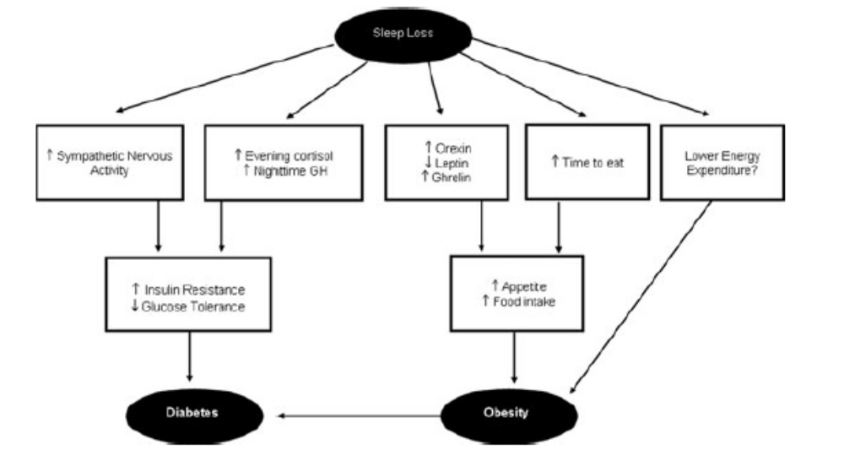
Figure 16. A pathway that shows links between sleep lose and diabetes^{[37]}.

Glucose level is higher in second 3 week and level of glucose stay high for hours. Even some of patients have high glucose level that they clinically classified as a prediabetic. Increase in glucose level cause decrease in production of insulin, this finding proves that lack of sleep causes decrease in insulin sensitivity, however disruption of circadian rhythm causes decrease in production of insulin^{[46]}.
Study 4.In another study Buxton tries to find the effects of changing life styles. In this experiment 21 human participate that 11 of them were young, about 23 and 10 of them were older than 70. They were maintained in a completely controlled environment for 6 weeks. They have constant diet and their activities were scheduled. Sleep and circadian rhythm are related to each other so they designed a protocol that manipulates these variables. At first participant, had enough sleep. Then they have sleep for 5-6 hours per 24 hours for 3 week. In this situation participant want to sleep at unusual times in their circadian cycle. In this 3 week glucose control went haywire and they can not response to high insulin after a meal, so there is too much glucose in their blood. Some of them show prediabetic situation. During 3 weeks, this magnitude of disruption coupled with decrease in resting metabolic rate and set diabetes and obesity. It seems exact process that how this occur need further study^{[7]}.
The result of this study have cautionary message for employers about adverse metabolic effects of shift working^{[7]}.
Study 5. 1P36 is a chromosomal region and is most commonly deleted region in human cancers. Deletion in 1P36 occurring in breast tumors. Scientists analyze frequency of genetic alterations at 1P36 and PER3 gene copy number in 180 lymph node negative breast cancer of patients who treatment with chemotherapy or tamoxifen. They analyzed expression level of PER3 with usage of microarray profiles from more than 400 samples of breast cancer. They tested the effect of loss of Per3 on tumor susceptibility with two mouse models of breast cancer. Scientists use breast cancer data that published before, that includes clinical gene expression and array comparative genomic hybridization (CGH) data. Tumor DNA samples obtained from frozen breast tumors.
Deletion of PER3 is directly related to tumor recurrence in patients with estrogen receptor (ER). Mice with deficiency in per3 show increase in susceptibility to breast cancer. This article shows that disruption in function of PER3 serve as an indicator of probability of tumor recurrence in patients with ER positive tumor. Further studies may show link between deregulation of sleep and breast tumorigenesis^{[12]}.
Study 6. Epidemiological studies show that there is clear link between disruption of circadian rhythm and creation of cancer in human.This idea was tested in an experiment by using mice as models.
Mice that lack Per1, Per2, Cry1 and cry2 or one copy of Bmal1show, development of tumor.When mice kept in 24 hours alternating light dark condition, mice with deficiency in Bmal1, Cry1 and Cry2, Per1 or Per2 alone are cancer prone. Mice that have deficient in Bmla1 show hyperplasia of salivary glands, in addition there is significant reduction in size of other organs because of aggressive aging. Mice that have Bmal1,Cry and Per mutant show increase in risk of ulcerative dermatitis and hyperplasia of salivary gland, liver, uterus, development of liver and ovarian cancer^{[41]}.
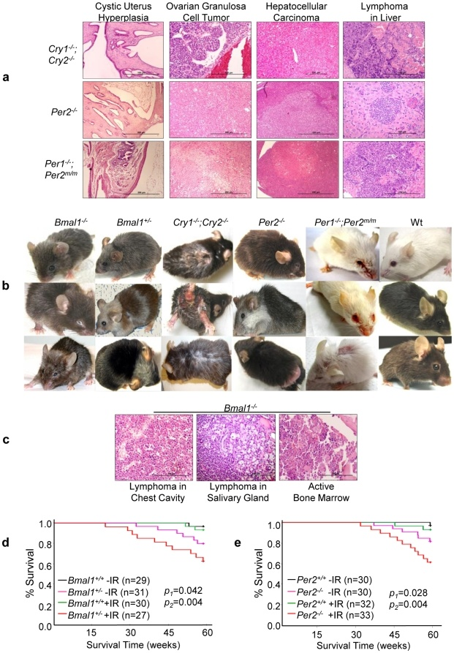
Figure 17. mutation in circadian genes cause mice become cancer prone ^{[41]}.
Then scientists examined effect of central clock on tumor suppression. They studied the effect of jetlag on mice. They found that jetlag increase development of tumor wild type Cry and Per mutant mice. It causes pancreatic and intestinal tumors in mutant mice. "Jetlag also significantly changed tumor spectrum and induced osteosarcoma, liver and ovarian tumors, hyperplasia of the salivary gland, liver and uterus as well as sever seminal vesicle enlargement in Wt mice". In addition female mice with circadian gene mutation showed an earlier onset and a higher tumor incidence compared to male mutant mice, when they kept in 24 hours L/D cycle.¹⁰⁴
They found that tumor suppression controlled by clock. ’’Extracellular mitogenic signals that drive peripheral clock – controlled expression of key cell cycle and tumor suppressor genes to generate a circadian rhythm in cell proliferation. Frequent disruption of circadian rhythm is an important tumor promoting factor"^{[41]}.
Study7.Shift working that involves circadian disruption is probably carcinogenic for humans. There is a point that if LAN increase risk of breast cancer so blind women must be at lower risk of breast cancer because they have not opportunity for light during the night to disarrange their melatonin rhythm. Hahn analyzed more than 100000 records and found that 0.26%of women in primary diagnosis of cardiovascular disease were blind but 0.15 % of women in primary diagnosis of breast cancer are blind. Feychting found that blind persons were at lower risk of different types of cancer, including breast cancer. But Pukkala found that blind women are at lower risk of breast cancer but risk of other cancer is higher. Blask wants to show that light exposure at night can increase risk of breast cancer in women or not. They grew MCF7 cells in nude mice for obtaining human-derived tumor. Then they implant it to nude rats. These tumors directly infused with blood that taken from women in three conditions:
1) During the day
2) During the night that is dark
3) During the night after exposure to bright light.
Blood that is rich of melatonin taken, during the night and growth activity of MCF7 xenograft is slow, but blood depleted from melatonin taken during the day and during the night after exposure to bright light and growth activity of tumor is not slow^{[67]}.
Exposure to light at night cause increase risk of breast cancer. LAN suppresses nocturnal production of melatonin by pineal gland. This experiment show that this exposure associate with increase risk of breast cancer^{[14]}.
Study 8. In experiment women that have breast cancer with 20-74 years from 1992 - 1995 were chosen as case patients. Control group were women with age between 20-74 years that have no history of breast cancer. Information were collected by inpersion interview from 1993-1995. These information clarified known or suspected risk factors for breast cancer such as reproductive history, family history of breast cancer and lifestyle factors. In addition they ask questions to obtain data on pattern of sleep and habits in 10 years before diagnosis. "Odds ratio (Ors) and 95% confidence intervals (CLs) were estimated by using of conditional logistic regression with adjustment for other potential risk factors."^{[14]}
The results show increase risk of breast cancer among people who do not sleep during the period of night when melatonin are at highest level. Risk of breast cancer does not increase with interrupted sleep that occurs by turning on the light. The risk of breast cancer increase among persons who have brightest bedrooms. Therefore shift work associate with increase in risk of breast cancer with increasing years and with more hours per week of graveyard shift work^{[14]}.
It also shows that exposure to light at night may be associate with breast cancer^{[14]}.
Study 9. In this experiment scientists use blood sample that collect from completed breast cancer case control. The age of patients are 30 to 80 years and have no diagnosis of cancer except non melanoma skin cancer. Controls are randomly selected among women who have not breast cancer and this matter prove histological. Scientist taken interview from patient and they ask questions about smoking habits, alcohol consumption, menstrual and reproductive factors, age of menarche, age at first pregnancy, age at menopause and parity life time location history, family history of breast cancer, body mass index and etc. They also use standard method genomic DNA extracted and length polymorphism in Per3, determined by PCR assay^{[82]}.
Increase risk of breast cancer associate with homozygous 5 repeat allele and heterozygous 5 repeat allele among premenopausal women⁶⁹. This experiment shows that circadian genes have role on breast cancer but need further investigation^{[82]}.
Study 10. In a study that was done on nurses, a questionnaire like previous study was used. The aim of this study was finding connection between night shift work and breast cancer.
This experiment show that probability of breast cancer is higher among people who work 1-4 year or 15-29 year as rotating shift work, and probability of breast cancer is increased in people who work more than 30 years as night shift work^{[64]}.
Study11. In this experiment 235 person that their age is between 18-49 with surgically confirmed endometriotic disease were studied. Reference date were month and year that a woman first time visit GH reporting system that lead to diagnosis of endometriosis. Controls were 1016 selected randomly from a list of woman who enrolled in GH in same time. Women who cannot speak English or have hysterectomy or bilateral oophorectomy were not participate. They ask some questions about demographics, employment, prior medical conditions, menstrual history, pregnancy history, contraceptive methods, hormone use, cigarettes and alcohol use and family history of endometrosis^{[47]}.

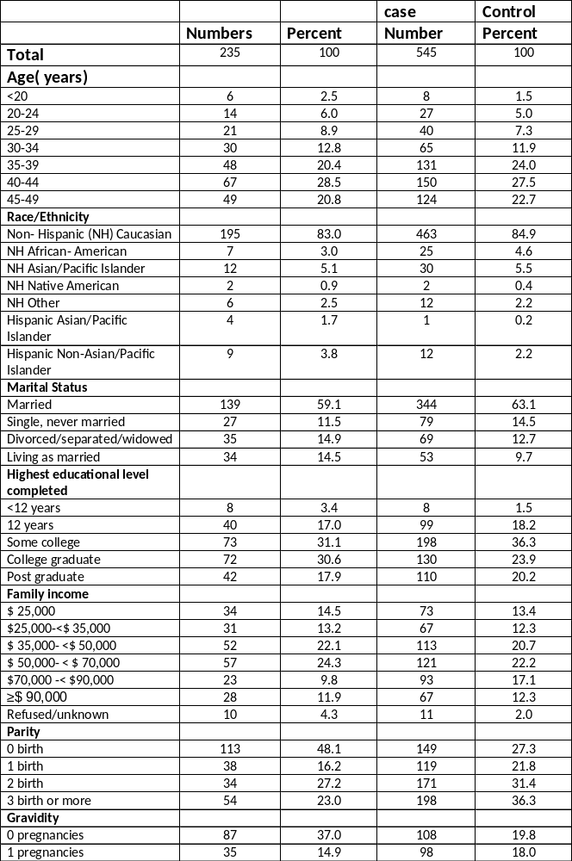Table 7.Sociodemographic and health characteristic in case and control participants^{[47]}.
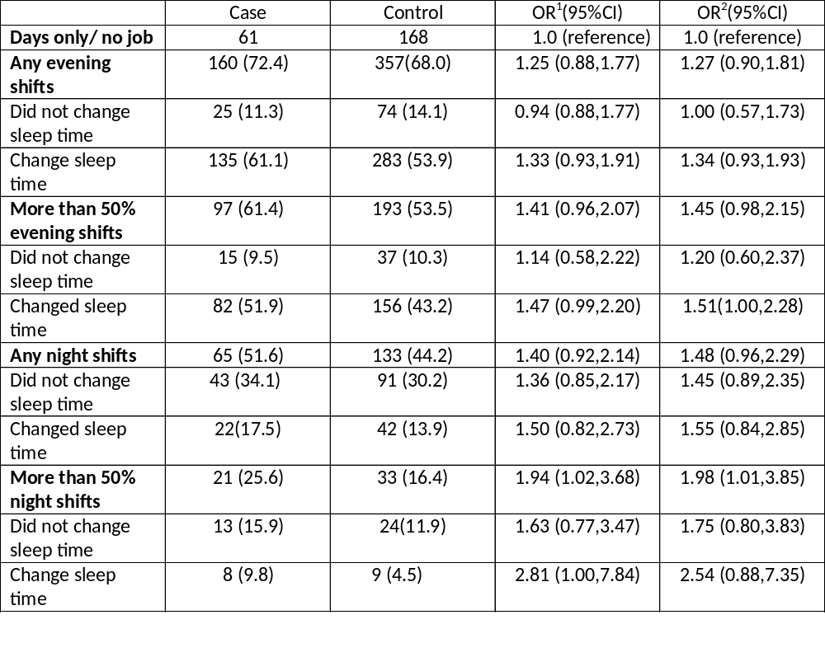
Table 8. relationship between endometrosis and life time in shift worker and between endometrosis and change in sleep time on persons who are not night shift worker^{[47]}.
The Risk of endometrosis increases among women who worked in evening shift work, night shift work or work more than 50% of hours during evening shift. Working more than 50% hours during night shift cause doubling risk of endometrosis^{[47]}.
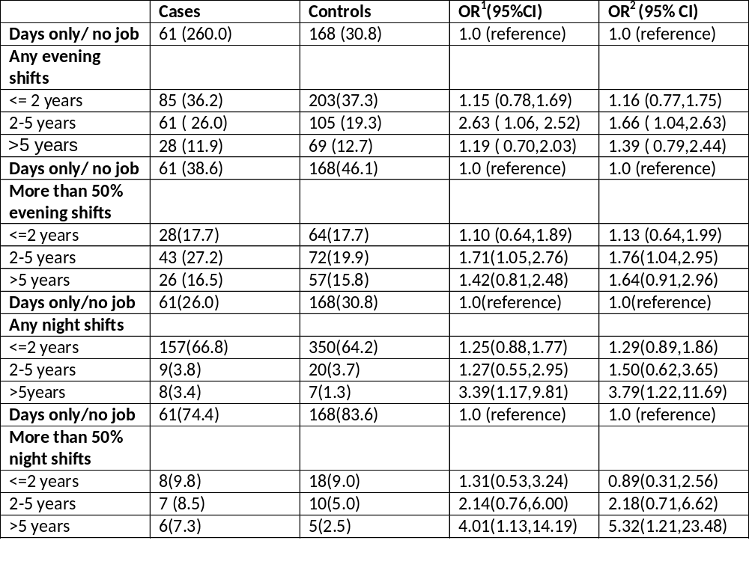
Table 9. Relationship between endometrosis and duration of shift worker^{[47]}.
There is increase in risk of endometrosis among women who working more than one type of shift in a four week period but this increase is slightly higher than that of women who shift did not rotate^{[47]}.
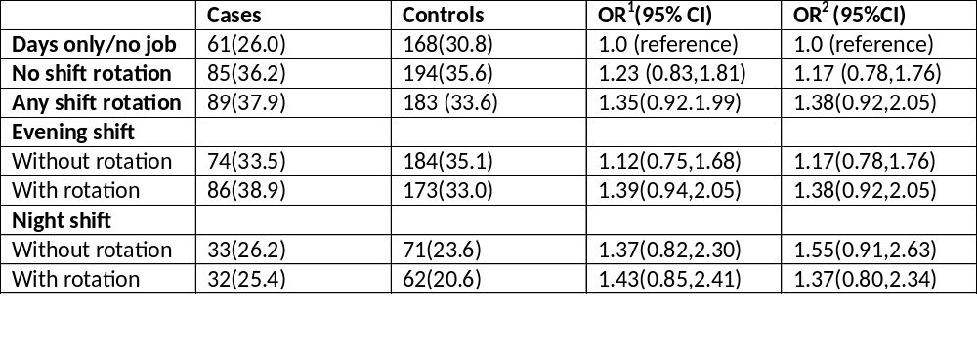Table 10. Relationship between endometrosis and working more than one type as shift working in 4 week^{[47]}.
T3111c polymorphism of h clock does not associate with disease and there is no interaction between polymorphism and shift work^{[47]}.
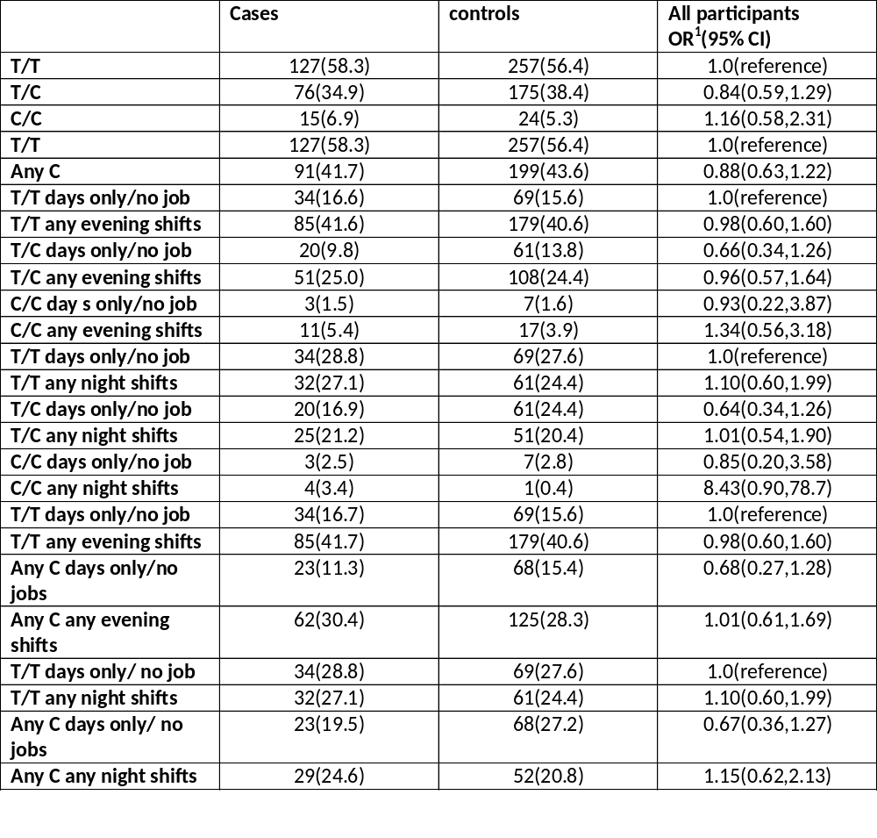Table 11. Risk of endometrosis and hCLOCK T3111 C polymorphism^{[47]}.
This experiment shows that "some aspect of night shift work may influence the development of endometrosis"^{[47]}.
Study 12. In this experiment 20-35 healthy male were recruited and their sleep pattern and medical physiological histories were analyzed.
Participants spent 10 hours in night in bed for more than 8 nights that is sleep replete condition. Then 5 hours in night in bed for 7 nights that is sleep restricted condition. They received 300 mg/day modafinil during sleep restriction. Diet and activity were controlled. On the last 2 days of each condition we assessed glucose metabolism by intervenous glucose tolerance test (IVGTT) and euglycemic –hyperinsulinemic clamp. Scientists bleed and urine samples to ensure that hematology and serum chemistry were in normal situation. Before experiment start, participants slept 10 hours each night for 5 days; they slept from 10 P.M till 8 A.M.
Insulin sensitivity of IVGTT reduced 20+_ 24% after sleep restriction. Insulin sensitivity assessed by clamp reduces 11+_5.5 % after restriction of sleep. Tolerance of glucose and disposition index reduced by sleep restriction^{[8]}.

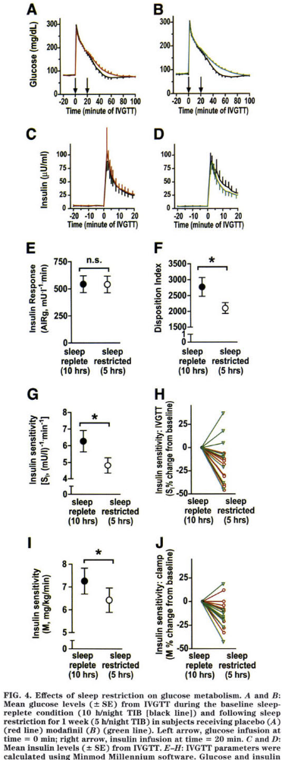
Figure 18. Effect of sleep restriction on metabolism of glucose^{[8]}.
This experiment shows that sleep restriction for 1 week cause reduction in insulin sensitivity therefore insufficient sleep has effect on insulin resistance^{[8]}.
Study 13. An experiment that have done on two groups of older people the osteoportic fractures in Men study (MrOS) and the study of osteoporotic Fractures (SOF) a group of men that were 65 years old or more were enrolled in this experiment from 2000 – 2002 for MrOS . An ancillary study was done on 3135 men from 2003 -2005 to characterize sleep. The SOF began in 1986 that recruit group of women who were 65 years or more and sleep exam was done on those women who participate in the study. In both groups they use wrist actigraphy. Actigraphy with usage of accelerometers detect movement and the presence or absence of motion at the wrist has been used to infer sleep/ wake status. " In normal populations wrist actigraphy assessments of sleep duration, correlate well against the gold standard of polysomnography." Therefore it is easy measure sleep over multiple nights." Sleep was recorded over a mean of 5.2 nights in MrOS and 4.1 nights in SOF so reduction in sleep associate with obesity^{[54]}.
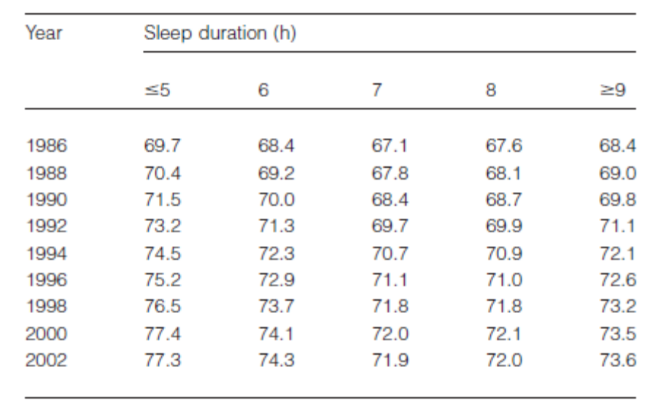
Table 12."mean age adjusted weight by sleep duration in the Nurse health study"^{[54]}.
There is a hypothesis that chronic sleep restriction cause increase or altered dietary intake. In rats reduction in sleep produce hyperphgia but this is paradoxical with weight loss.
In secondary analyzes they found increase were notable for high fats and high carbohydrate foods. These changes corresponded with increase in level of serum ghrelin, and reduction in sleep has effect on peripheral regulator of hunger^{[54]}.
Study 14. There are several clinical studies that suggest clock genes have role in gastrointestinal symptoms and disease. "Data from the nurses' health study showed that women who worked at least 3 nights per month for 15 or more years had a significantly greater risk of developing colorectal cancer when compared with women who never worked rotating night shifts"
In an experiment male mice with ages between 8-12 week were used. Before experiment started mice were maintained on 12 hours light/dark cycle for 2 weeks so light become zeitgeber for these mice. After that RNA isolated with modified guanidinium thiocyanate/ phenol/chlorophorm. RNA sample quantified and qualified. After that DNA synthesized and transcription was done with help of polymerase chain reaction (PCR) expression analyze of specific gene was done. Western blot was done by using Bcl2 as antibody. Microarray significant profiles (maSigPro) was used for identifying genes with statistically significant rhythmic expression^{[28]}.
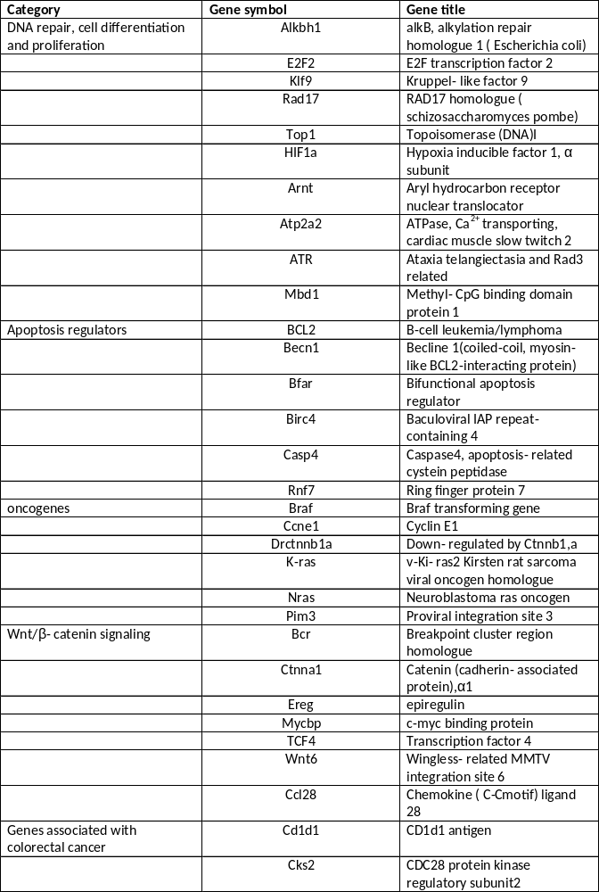Table 13. Genes that have role in colon cancer ^{[28]}.
Circadian gene expression was identified in 3.7% of distal colonic genes that many of these genes have role in cell signaling, differentiation, proliferation and cell death. In all genes that express rhythmically in colon of mouse, 7% of them associate with formation of colorectal cancer^{[28]}.
Discussion:
Circadian rhythm exists in all organisms from cyanobacteria to human.^{[69]} This clock reply to light, in fact is regulates activities of body in days and nights. Regulation of this clock is very important because it regulate many physiological functions such as sensitivity to insulin, endocrine regulation and etc. In addition circadian rhythm control different function in human such as sleep and wakefulness, body temperature, metabolism and etc.
In this study we want to find any relation between effect of circadian rhythm and health. And does circadian rhythm cause creation of some diseases such as diabetes, overweight and cancer or not?
Nowadays life styles of people are changed. People are awake till near the morning and when sun rises; they decide to sleep about near the noon. This deregulation has effect on metabolic process and causes disorder in circadian rhythm. In addition shift work and jet lag that both of them cause deregulation in circadian rhythm and disruption in sleep/wake cycle has bad effects on circadian rhythm.
In this regard we divide studies in to two categories. The First category that checks any linkage between disruption of circadian rhythm and creation of some diseases such as cancer, obesity and diabetes and the second category that checks linkage between disruption of circadian rhythm and creation of these disease.
The role of circadian clock genes in cancer
There is much evidence that support the matter that dysfunction of circadian clock associates with creation of cancer in human. When expression level of Per1 and Per2 genes decreased, sporadic and familiar breast tumor occur. Expression of Per1 gene is lower in familiar forms of breast cancer than sporadic forms that suggest potential deregulation of circadian clock could contribute to the inherited form of the disease^{[63]}.
Methylation of promoters of rer1 and Cry1 genes cause survival of breast cancer cell because methylation inactivate expression of these genes and cause disruption of circadian rhythm.^{[63]}
Disruption of circadian rhythm causes prostate cancer. There are genetic variations that associate with prostate cancer. Clock genes and androgen receptor (AR) are expressed with circadian oscillations in normal prostate, per1 inhibits from transcriptional activity of AR and then down regulation of clock gene cause prostate tumorigenesis.^{[63]}
DNA repair and circadian rhythmicity
"Circadian clock determines the strengths of cellular response to DNA damage including DNA repair" DNA repair pathway protects DNA from exogenous and endogenous stimuli. Many components of DNA repair entrained by circadian oscillation for example:
1) Nucleotide excision repair (NER) that is DNA repair mechanism prevent genome from damage that may be created by factors like ultraviolet light (UV) irradiation and chemical mutagens. “NER in brain of mouse shows circadian periodicity that mediate by xeroderma pigmentosum a (XPA) that is DNA damage recognition protein.
2) Tip60, which is histon acetylase of chromatin, "with DNA damage response and repair completency is over expressed in cisplatin- resistant cells and its silencing sensitizes cells to this cancer chemotherapeutic agent." Expression of Tip60 is regulated by circadian transcription factor and DNA repair through histon acetylation control by circadian rhythm.
3) High mobility group box1 (Hmgb1) protein that has role in mismatch repair mechanism shows circadian rhythmic expression in retina of rats.^{[63]}
“Cell proliferation and cancer cell growth are under clock regulation’’
Proliferation rhythm of tumor cells follows cyclical pattern that differ with normal tissues. Disruption of circadian rhythm causes alteration in proliferation of cancer cells. Down regulation of Per1 and Per2 increases growth of cancer cells at specific times of day. Per1 is a tumor suppressor and inhibits proliferation of cancer cells. Down regulation of per2 causes proliferation of breast cancer cells and tumor growth in a circadian time dependent manner. Clock mutation inhibits cell growth and proliferation by up- regulation of cell cycle inhibitory gene and reduction in ability of mutant cell to respond to mitogenic signal. Disruption of circadian clock, because of clock protein deficiency, do not affect on carcinogenesis. DNA synthesis in tumor cells modulates, by factors such as platelet- derived growth factor (PDGF). PDGF activates when tumor development occur, and it is related with tumor vascularization, adhesion, invasion and aggressiveness of cancer cells.
DNA synthesis and telomerase activity that prevents cells from apoptosis, express with circadian pattern in the hepatic cancer cells. Interferons (IFNs) that are multifunctional cytokines and have antitumor activities and their receptors show a diurnal rhythm of expression in implanted tumor cells. ^{[63]}
With this background we cannot definitely say that disruption of circadian rhythm associates with some diseases such as cancer, obesity and diabetes. Disruption of circadian rhythm may be susceptible people to these diseases but it does not associate with appearance of these diseases completely. Person may have genetic polymorphism so probability of suffering of disease will be increased. Scientists investigate gene expression in diseased person and healthy person some genes were become upregulate or down regulate or were become normal. They investigate how gene expression will change. This disruption occurs because genes down regulate and amount of these genes will decrease then person will be susceptible for cancer. For example expression of protoancogen will increase or expression of some genes, which inhibit from suffering of cancer, will decrease. Human have genetic differences so some enzyme that exist in body that cause anti- oxidant and so production of free radicals is high in one body but this enzyme cause antioxidant is low in another body so protection system became weak therefore some individuals became susceptible to this disease.
With this information we can conclude that disruption of circadian rhythm has no effect on disease such as cancer. It may cause that persons became susceptible for this disease but it does not have bad effect directly.

References

[1] D. Alabadi, T. Oyama, M.J. Yanovsky, F.G. Harmon, P. Mas and S.A. Kay, Reciprocal regulation between TOC1 and LHY/CCA1 within the Arabidopsis circadian clock, Science 293 (2001) 880-883.
[2] J. Arendt and S. Deacon, Treatment of circadian rhythm disorders--melatonin, Chronobiol Int 14 (1997) 185-204.
[3] J. Berger, regulation of circadian rhythms, Applied Biomedicine 2 (2004) 131-140.
[4] D.E. Blask, R.T. Dauchy, G.C. Brainard and J.P. Hanifin, Circadian stage-dependent inhibition of human breast cancer metabolism and growth by the nocturnal melatonin signal: consequences of its disruption by light at night in rats and women, Integr Cancer Ther 8 (2009) 347-353.
[5] M.S. Bray and M.E. Young, The role of cell-specific circadian clocks in metabolism anddisease, Obes Rev 10 Suppl 2 (2009) 6-13.
[6] A. Brzezinski, Mechanism of disease: Melatonin in Humans, The NEW ENGLAND JOURNAL of MEDICINE 336 (1997) 186-195.
[7] O.M. Buxton, S.W. Cain, S.P. O'Connor, J.H. Porter, J.F. Duffy, W. Wang, C.A. Czeisler andS.A. Shea, Adverse metabolic consequences in humans of prolonged sleep restriction combined with circadian disruption, Sci Transl Med 4 (2012) 129ra143.
[8] O.M. Buxton, M. Pavlova, E.W. Reid, W. Wang, D.C. Simonson and G.K. Adler, Sleep restriction for 1 week reduces insulin sensitivity in healthy men, Diabetes 59 (2010) 2126-2133.
[9] N. Cermakian and D.B. Boivin, A molecular perspective of human circadian rhythm disorders, Brain Res Brain Res Rev 42 (2003) 204-220.
[10] N. Cermakian and D.B. Boivin, The regulation of central and peripheral circadian clocks in humans, Obes Rev 10 Suppl 2 (2009) 25-36.
[11] S.L. Chellappa, Cajochen,C, The Circadian Clock and the Homeostatic Hourglass: Two Timepieces Controlling Sleep and Wakefulness. In: U. Albrecht (Ed.), The circadian clock, Vol. 12, Springer, New york, 2010, pp. 195-228.
[12] J. Climent, J. Perez-Losada, D.A. Quigley, I.J. Kim, R. Delrosario, K.Y. Jen, A. Bosch, A. Lluch, J.H. Mao and A. Balmain, Deletion of the PER3 gene on chromosome 1p36 in recurrent ER-positive breast cancer, J Clin Oncol 28 (2010) 3770-3778.
[13] S. Daan, A History of Chronobiological Concepts. In: U. Albrecht (Ed.), The circadian Clock, Vol. 12, Springer, New York, 2010, pp. 1-35.
[14] S. Davis, D.K. Mirick and R.G. Stevens, Night shift work, light at night, and risk of breast cancer, J Natl Cancer Inst 93 (2001) 1557-1562.
[15] T.C. Erren, P. Falaturi, P. Morfeld, P. Knauth, R.J. Reiter and C. Piekarski, Shift work and cancer: the evidence and the challenge, Dtsch Arztebl Int 107 (2010) 657-662.
[16] T.C. Erren and R.J. Reiter, Defining chronodisruption, J Pineal Res 46 (2009) 245-247.
[17] C. Feillet, Albrecht,U, Clocks, Brain Function, and Dysfunction. In: U. Albrecht (Ed.), The Circadian Clock, Vol. 12, Sringer, New York, 2010, pp. 229-282.
[18] E. Filipski, P. Subramanian, J. Carriere, C. Guettier, H. Barbason and F. Levi, Circadian disruption accelerates liver carcinogenesis in mice, Mutat Res 680 (2009) 95-105.
[19] S. Gaddameedhi, C.P. Selby, W.K. Kaufmann, R.C. Smart and A. Sancar, Control of skin cancer by the circadian rhythm, Proc Natl Acad Sci U S A 108 (2011) 18790-18795.
[20] J.E. Gangwisch, Epidemiological evidence for the links between sleep, circadian rhythms and metabolism, Obes Rev 10 Suppl 2 (2009) 37-45.
[21] S. Gery and H.P. Koeffler, Circadian rhythms and cancer, Cell Cycle 9 (2010) 1097-1103.
[22] M.U. Gillette and T.J. Sejnowski, Physiology. Biological clocks coordinately keep life on time, Science 309 (2005) 1196-1198.
[23] D.A. Golombek and R.E. Rosenstein, Physiology of circadian entrainment, Physiol Rev 90 (2010) 1063-1102.
[24] F. Halberg, CHRONOBIOLOGY, Annu. Rev. Physiol 31 (1969) 675-726.
[25] M. Hastings, The brain, circadian rhythms, and clock genes, Bmj 317 (1998) 1704-1707.
[26] E. Haus, Circadian disruption in shiftwork is probably carcinogenic to humans, Chronobiol Int 24 (2007) 1255-1256.
[27] E.D. Herzog, Taghert,P.H, Circadian Neural Networks. In: U. Albrecht (Ed.), The Circadian Clock, Vol. 12, Springer, New York, 2010, pp. 179-194.
[28] W.A. Hoogerwerf, M. Sinha, A. Conesa, B.A. Luxon, V.B. Shahinian, G. Cornelissen, F. Halberg, J. Bostwick, J. Timm and V.M. Cassone, Transcriptional profiling of mRNA expression in the mouse distal colon, Gastroenterology 135 (2008) 2019-2029.
[29] C.M. Hsu, S.F. Lin, C.T. Lu, P.M. Lin and M.Y. Yang, Altered expression of circadian clock genes in head and neck squamous cell carcinoma, Tumour Biol 33 (2012) 149-155.
[30] W. Huang, K.M. Ramsey, B. Marcheva and J. Bass, Circadian rhythms, sleep, and metabolism, J Clin Invest 121 (2011) 2133-2141.
[31] C.H. Johnson, Circadian clocks and cell division: what's the pacemaker?, Cell Cycle 9 (2010) 3864-3873.
[32] J.D. Johnston, G. Frost and D.T. Otway, Adipose tissue, adipocytes and the circadian timing system, Obes Rev 10 Suppl 2 (2009) 52-60.
[33] A. Kalsbeek, I.F. Palm, S.E. La Fleur, F.A. Scheer, S. Perreau-Lenz, M. Ruiter, F. Kreier, C. Cailotto and R.M. Buijs, SCN outputs and the hypothalamic balance of life, J Biol Rhythms 21 (2006) 458-469.
[34] T. Kantermann and T. Roenneberg, Is light-at-night a health risk factor or a health risk predictor?, Chronobiol Int 26 (2009) 1069-1074.
[35] D.L. Keefe, Earnest,D.J,Nelson,D,Takahashi,J.S and Turek,F.W, A cholinergic antagonist, mecamylamine, blocks the phase- shifting effects of light on the circadian rhythm of locomoter activity in the golden hamster, Brain Res 2 (1987) 308-312.
[36] I. Kloog, A. Haim, R.G. Stevens and B.A. Portnov, Global co-distribution of light at night (LAN) and cancers of prostate, colon, and lung in men, Chronobiol Int 26 (2009) 108-125.
[37] K.L. Knutson and E. Van Cauter, Associations between sleep loss and increased risk of obesity and diabetes, Ann N Y Acad Sci 1129 (2008) 287-304.
[38] B.P. Kolla and R.R. Auger, Jet lag and shiftwork sleep disorders: how to help reset the internal clock, Cleve Clin J Med 78 (2011) 675-684.
[39] T. Kubo, K. Ozasa, K. Mikami, K. Wakai, Y. Fujino, Y. Watanabe, T. Miki, M. Nakao, K. Hayashi, K. Suzuki, M. Mori, M. Washio, F. Sakauchi, Y. Ito, T. Yoshimura and A. Tamakoshi, Prospective cohort study of the risk of prostate cancer among rotating-shift workers: findings from the Japan collaborative cohort study, Am J Epidemiol 164 (2006) 549-555.
[40] S.J. Kuo, S.T. Chen, K.T. Yeh, M.F. Hou, Y.S. Chang, N.C. Hsu and J.G. Chang, Disturbance of circadian gene expression in breast cancer, Virchows Arch 454 (2009) 467-474.
[41] S. Lee, L.A. Donehower, A.J. Herron, D.D. Moore and L. Fu, Disrupting circadian homeostasis of sympathetic signaling promotes tumordevelopment in mice, PLoS One 5 (2010) e10995.
[42] R. Leproult and E. Van Cauter, Role of sleep and sleep loss in hormonal release and metabolism, Endocr Dev 17 (2010) 11-21.
[43] F. Levi, A. Okyar, S. Dulong, P.F. Innominato and J. Clairambault, Circadian timing in cancer treatments, Annu Rev Pharmacol Toxicol 50 (2010) 377-421.
[44] F. Levi and U. Schibler, Circadian rhythms: mechanisms and therapeutic implications, Annu Rev Pharmacol Toxicol 47 (2007) 593-628.
[45] A.C. Liu, W.G. Lewis and S.A. Kay, Mammalian circadian signaling networks and therapeutic targets, Nat Chem Biol 3 (2007) 630-639.
[46] C. Luiggi, The Dark Side of Working Nights, (2012).
[47] J.L. Marino, V.L. Holt, C. Chen and S. Davis, Shift work, hCLOCK T3111C polymorphism, and endometriosis risk, Epidemiology 19 (2008) 477-484.
[48] C.R. McClung, Circadian Rhythms in Plants, Annu Rev Plant Physiol Plant Mol Biol 52 (2001) 139-162.
[49] C.R. McClung, Plant circadian rhythms, Plant Cell 18 (2006) 792-803.
[50] M. Merrow, Lenssen,D,Roenneberg,T, Comparative Clocks. In: U. Albrecht (Ed.), The Circadian Clock, Vol. 12, Springer New york, 2010, pp. 157-177.
[51] N. Nakamichi, Molecular mechanisms underlying the Arabidopsis circadian clock, Plant Cell Physiol 52 (2011) 1709-1718.
[52] S. Ohdo, Chronopharmaceutics: pharmaceutics focused on biological rhythm, Biol Pharm Bull 33 (2010) 159-167.
[53] H. Oster, Circadian Clocks and Metabolism. In: U. Albrecht (Ed.), The Circadian Clock, Vol. 12, Springer, New York, 2010, pp. 115-138.
[54] S.R. Patel, Reduced sleep as an obesity risk factor, Obes Rev 10 Suppl 2 (2009) 61-68.
[55] S.N.a.F. Perison, R.G, Non image - Forming Photoreceptors. In: U. Albrecht (Ed.), The Circadian Clock, Vol. 12, Springer, New York, 2010, pp. 105-113.
[56] A. Pronk, B.T. Ji, X.O. Shu, S. Xue, G. Yang, H.L. Li, N. Rothman, Y.T. Gao, W. Zheng and W.H. Chow, Night-shift work and breast cancer risk in a cohort of Chinese women, Am J Epidemiol 171 (2010) 953-959.
[57] S. Rana and S. Mahmood, Circadian rhythm and its role inmalignancy, J Circadian Rhythms 8 (2010) 3.
[58] M.S. Rea, A. Bierman, M.G. Figueiro and J.D. Bullough, A new approach to understanding the impact of circadian disruption on human health, J Circadian Rhythms 6 (2008) 7.
[59] V. Reghunandanan and R. Reghunandanan, Neurotransmitters of the suprachiasmatic nuclei, J Circadian Rhythms 4 (2006) 2.
[60] J.A.a.B. Ripperger, S.A, Transcriptional Regulation of Circadian Clocks. In: U. Albrecht (Ed.), The Circadian Clock, Vol. 12, Springer, New York, 2010, pp. 37-78.
[61] B. Rusak and K.G. Bina, Neurotransmitters in the mammalian circadian system, Annu Rev Neurosci 13 (1990) 387-401.
[62] C.B. Saper, T.E. Scammell and J. Lu, Hypothalamic regulation of sleep and circadian rhythms, Nature 437 (2005) 1257-1263.
[63] C.a.K. Savvidis, M, Circadian rhythm disruption in cancer biology. Mol Med, Vol. 18, 2012, pp. 1249-1260.
[64] E.S. Schernhammer, F. Laden, F.E. Speizer, W.C. Willett, D.J. Hunter, I. Kawachi and G.A. Colditz, Rotating night shifts and risk of breast cancer in women participating in the nurses' health study, J Natl Cancer Inst 93 (2001) 1563-1568.
[65] A. Sehgal (Ed.), molecular biology of circadian rhythm, Canada, 2004.
[66] R.G. Stevens, Circadian disruption and breast cancer: from melatonin to clock genes, Epidemiology 16 (2005) 254-258.
[67] R.G. Stevens, Light-at-night, circadian disruption and breast cancer: assessment of existing evidence, Int J Epidemiol 38 (2009) 963-970.
[68] R.G. Stevens and M.S. Rea, Light in the built environment: potential role of circadian disruption in endocrine disruption and breast cancer, Cancer Causes Control 12 (2001) 279-287.
[69] S. Sukumaran, R.R. Almon, D.C. DuBois and W.J. Jusko, Circadian rhythms in gene expression: Relationship to physiology, disease, drug disposition and drug action, Adv Drug Deliv Rev 62 (2010) 904-917.
[70] J.S. Takahashi and M. Zatz, Regulation of circadian rhythmicity, Science 217 (1982) 1104-1111.
[71] H. Taniguchi, A.F. Fernandez, F. Setien, S. Ropero, E. Ballestar, A. Villanueva, H. Yamamoto, K. Imai, Y. Shinomura and M. Esteller, Epigenetic inactivation of the circadian clock gene BMAL1 in hematologic malignancies, Cancer Res 69 (2009) 8447-8454.
[72] Y. Touitou, A. Bogdan, F. Levi, M. Benavides and A. Auzeby, Disruption of the circadian patterns of serum cortisol in breast and ovarian cancer patients: relationships with tumour marker antigens, Br J Cancer 74 (1996) 1248-1252.
[73] J.T. Vanselow, kramer,A, Posttranslational Regulation of Circadian Clocks. In: U. Albrecht (Ed.), The Circadian Clock, Vol. 12, Springer, New York, 2010, pp. 79-104.
[74] F. Wang, Z. Hu, R. Yang, J. Tang, Y. Liu, K. Hemminki, C. Sutter, B. Wappenschmidt, D. Niederacher, N. Arnold, A. Meindl, C.R. Bartram, R.K. Schmutzler, B. Burwinkel and H. Shen, A variant affecting miRNAs binding in the circadian gene Neuronal PAS domain protein 2 (NPAS2) is not associated with breast cancer risk, Breast Cancer Res Treat 127 (2011) 769-775.
[75] A.A. Webb, The physiology of circadian rhythms in plants, Wiley 160 (2003) 281-303.
[76] P.A. Wood, X. Yang, A. Taber, E.Y. Oh, C. Ansell, S.E. Ayers, Z. Al-Assaad, K. Carnevale, F.G. Berger, M.M. Pena and W.J. Hrushesky, Period 2 mutation accelerates ApcMin/+ tumorigenesis, Mol Cancer Res 6 (2008) 1786-1793.
[77] X. Yang, P.A. Wood, C.M. Ansell, M. Ohmori, E.Y. Oh, Y. Xiong, F.G. Berger, M.M. Pena and W.J. Hrushesky, Beta-catenin induces beta-TrCP-mediated PER2 degradation altering circadian clock gene expression in intestinal mucosa of ApcMin/+ mice, J Biochem 145 (2009) 289-297.
[78] Y. Yasuniwa, H. Izumi, K.Y. Wang, S. Shimajiri, Y. Sasaguri, K. Kawai, H. Kasai, T. Shimada, K. Miyake, E. Kashiwagi, G. Hirano, A. Kidani, M. Akiyama, B. Han, Y. Wu, I. Ieiri, S. Higuchi and K. Kohno, Circadian disruption accelerates tumor growth and angio/stromagenesis through a Wnt signaling pathway, PLoS One 5 (2010) e15330.
[79] E.A. Yu and D.R. Weaver, Disrupting the circadian clock: gene-specific effects on aging, cancer, and other phenotypes, Aging (Albany NY) 3 (2011) 479-493.
[80] M. Zatz and M.A. Herkenham, Intraventricular carbachol mimics the phase-shifting effect of light on the circadian rhythm of wheel-running activity, Brain Res 212 (1981) 234-238.
[81] Z.a.L. Zhao, C.C, Circadian Clock, Cell Cycle and Cancer. In: U. Albrecht (Ed.), The Circadian Clock, Vol. 12, Springer, New York, 2010, pp. 139-156.
[82] Y. Zhu, H.N. Brown, Y. Zhang, R.G. Stevens and T. Zheng, Period3 structural variation: a circadian biomarker associated with breast cancer in young women, Cancer Epidemiol Biomarkers Prev 14 (2005) 268-270.
[83] Y. Zhu and T. Zheng, Clock-cancer connection in non-Hodgkin's lymphoma, Med Hypotheses 70 (2008) 788-792.

