
Final thesis

Subject:
high-throughput screening method for Li-ion batteries cathode material using Machine Learning

Shamim Idelkhani

Supervisor: Dr. Shaghayegh Agah

Table of Contents
Abstract 4
Chapter 1: lithium-ion batteries: Opportunities in new revolution 5
1.1 Introduction 5
1.2 Background 5
1.2 Components 7
1.2 Mechanism 8
1.3 Conclusion 10
Chapter 2: DFT: Revealer of material properties 11
2.1 Introduction 11
2.2 Fundamental of DFT 11
2.3 Conclusion 15
Chapter 3: Machine learning: Imitation in game of learning 16
3.1 Introduction 16
3.2 Fundamental of Machine learning 16
3.2 Supervised model 18
3.2.1 Regression 18
3.2.2 Tree based models 20
3.2.2.1 Decision tree 20
3.2.2.2 Random Forest 21
3.2.2.3 Gradient Boosting 21
3.2.3 Support vector machine 22
3.2.4 K-Nearest Neighbors 23
3.2.5 Artificial Neural network 24
3.2.5 Classification 25
3.3 Clustering 26
3.4 Model’s performance and metrics 27
3.4.1 Regression metrics 27
3.4.1 Classification metrics 28
3.5 Training: Do and Don’t 29
3.6 Conclusion 31
Chapter 4: Combination of DFT and ML: Enhancing DFT for material discovery 30
4.1 Introduction 30
4.2 Organic lithium – ion battery 30
4.3 DFT and ML 35
4.4 Recent researches 38
4.5 Conclusion 41
Chapter 5: Critical review of current approaches to apply ML solutions in the design of LIB cathodes 42
5.1 Introduction 42
5.2 Dataset 43
5.3 Improvement proposals 43
5.4 Methods 45
5.5 Experimental Results and analysis 49
5.6 Conclusion 54
Chapter 6: Developing optimum artificial intelligence for organic compounds to calculate reduction potential 55
6.1 Introduction 55
6.2 Methods 57
6.3 Experimental Results and analysis 61
6.4 Conclusion 69
Chapter 7: Conclusion 70
Supplementary materials 70
References 71

Abstract: Typical metallic cathodes in Lithium-ion batteries contain Cobalt which results in high price, toxicity and high consumption of Cobalt contained materials whereas Cobalt is rare element considering its reserves. For this purpose, it is a great opportunity to explore and discover new materials to be experimented for lithium – ion batteries cathode. Density functional theory (DFT) which has been used in previous studies for material discovery, can contribute as a capable tool in multi-level screening process to select final candidates to be tested experimentally. Due to high computational cost of DFT, Machine learning (ML) can narrow down the space for DFT and experimental studies and play an important role in accelerating screening processes of battery materials. In this study, we want to represent an optimized screening process by developing ML approach. For this study, we used a sample containing more than 26000 datapoint to calculate reduction potential. This property is one of the most critical criteria for cathode selection, will be found for all organic materials based on their functional groups. Several experiments using different statistical and machine learning methodologies such as clustering, principal component analysis and stack learning have been used to optimize model performance. We were able to achieve R²_{Train} =0.78, R²_{Test} =0.74 and mean absolute error (MAE) of MAE_{Test}=0.388 V MAE_{Test}=0.422 V which is suitable for the first stages of the screening. Trained algorithm proves that it is decent to be used to calculate reduction potential for all organic substances.

Chapter 1: lithium-ion batteries: Opportunities in new revolution
Introduction
Lithium-ion batteries are a new generation of batteries that have had an impact on our industrial and personal lives. Lithium-ion batteries have become an integral part of our daily lives, powering the smartphones and laptops that have revolutionized modern society¹. Most rechargeable electronic devices these days work with lithium batteries. Most of today's all-electric vehicles and PHEVs (plug-in hybrid electric vehicles) use lithium-ion batteries, though the exact chemistry often varies from that of consumer electronics batteries². These days we can see them in new-generation cars like Tesla. One of the most important benefits of lithium-ion batteries, is that they are rechargeable which allows us use them in a wide range of applications. Other applications of lithium-ion batteries include portable power packs, electric scooters, solar energy storage, etc. ³. In this chapter, our goal is to review on types of lithium – ion batteries, function, reactions, advantages and disadvantages.
Background
Lithium as main element of lithium-ion battery is the third element on periodic table and has one of the lowest standard reduction potentials with V = -3.04 V vs Standard Hydrogen Electrode (SHE) among other elements^{4,5}. Lithium has a density $ρ=0.534 g/cm^{3}$ at 20 C which makes it even less dense than water⁴. These features allow scientists to design batteries with high electric permittivity and low weight.
In addition to being rechargeable, there are other advantages to lithium-ion batteries. In nickel-metal-hydride batteries, if nickel-metal-hydride batteries are recharged repeatedly after being only partially discharged, they gradually lose a usable capacity due to a reduced working voltage. Lithium-ion batteries, in contrast, are considered to have no memory effect⁶. Another advantage of lithium-ion batteries is their relatively high energy density. Compared with other types of batteries, lithium-ion batteries have a higher energy density which results in lighter weight and smaller size. Estimated values are shown in Figure 1-1:
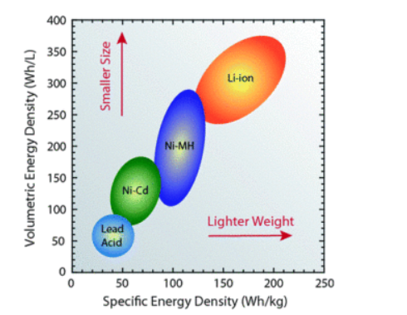
Figure 1-1 – batteries volumetric and specific energy density comparison⁷

Another advantage of lithium-ion batteries is their low wasted energy which leads to high efficiency. For example, lead-acid batteries are less efficient at storing power than lithium-ion batteries. Lithium batteries charge at nearly 100% efficiency, compared to the 85% efficiency of most lead acid batteries⁶. Other advantages of lithium-ion batteries include low maintenance, eco-friendly, extended cycle life, and low self-discharge rate ^{7,8,9}.
Despite having profitable advantages, there are disadvantages to lithium-ion batteries that create challenges for scientists to investigate further. One of the main disadvantages is their low energy density compared to fossil fuels. In their best performance lithium-ion batteries have an energy density of 265 Wh/kg⁷, which is equal to 0.95 MJ/kg. Compared with other fuels in Table 1-1, this energy density is quite low:
Fuel | Energy density (MJ/kg)
Wood | 16
Coal | 24
Ethanol | 26.8
Biodiesel | 38
Crude oil | 44
Diesel | 45
Gasoline | 46
Natural gas | 55
Uranium | 3900000
Table 1-1 – Energy density of different fuels¹⁰
Although lithium-ion batteries do not require special maintenance, safety is one of the issues they are face. One of the most notable events concerning their safety subject was battery explosion in Samsung Galaxy Note7 smartphones¹¹. Although explosions in smartphones usually do not result in significant cost, battery explosions on a larger scale such as cars or industrial uses can lead to disasters with high costs.
Another disadvantage of lithium-ion batteries is their impact on the environment. Lithium–ion batteries contain precious metals such as nickel, cobalt, manganese, iron, and aluminum¹². Extracting or mining these metals from disposed batteries, can result in erosion and pollution¹³.
Components
A lithium–ion battery consists of 4 main parts: cathode, anode, separator, and electrolyte¹⁴. Each part plays its own role in the battery. The cathode is where reduction occurs and it affects the capacity of the battery. There are different types of cathodes for lithium–ion batteries. The earliest lithium–ion batteries used lithium cobalt oxide (LCO) with a capacity of 135 mAhg⁻¹ in the range of 3–4.2 V vs Li+/Li which can be used in low-power application^{15,16}.
Lithium iron phosphate (LFP) is another material that is suitable for lithium–ion battery cathode due to its safety, high cycling performance and being environmentally friendly but it has lower specific energy compared to other types^{15,17}. The last and most common types of lithium-ion battery cathodes are NCM and NCA cathodes which both consist of 3 different metals.
NCM with the formula of LiNi_{x}Co_{y}Mn_{z}O₂ (which x+y+z=1) consists of Nickel, Cobalt, and Manganese. Each metal plays its own role in the battery. Cobalt assists the battery with high kinetics, Nickel helps with high capacity and manganese has the safety role in battery¹⁸. NCM batteries are usually known for their high capacity (>150 mAh/g) and high energy density (200–300 Wh/kg)¹⁹. NCA cathodes are considerably the same as NCM. The difference is using aluminum instead of manganese in the cathode leads to higher specific energy and lifespan¹⁹. Each NCM and NCA cathode usually has an identification number or code which indicates the combination ratio of metals in the cathode. For example, NCM 811 means LiNi_{0.8}Co_{0.1}Mn_{0.1}O₂. Comparing these 4 types of cathode results in Figure 1-2. Also, estimated average value of capacity, voltage and thermal run aways are in Table 1-2:
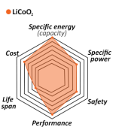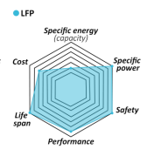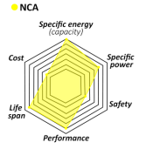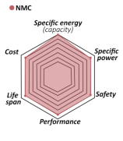
Figure 1-2 – Different type of LIB cathodes operational comparison²⁰
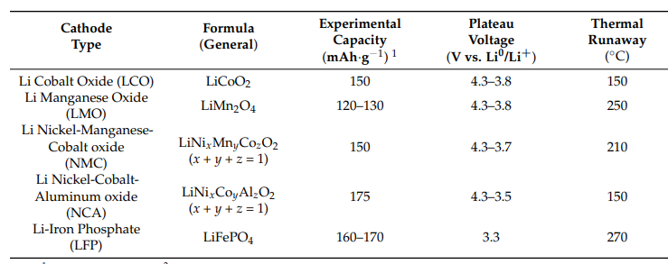
Table 1-2 – LIB cathodes thermal run away, plateau voltage and experimental capacity²⁰
The difference in voltage, capacity and thermal runaway, provides a variety of options for manufacturers to select lithium - Ion batteries for their products like laptops, smartphones, and even electric vehicles. Giving an example for electric vehicles, each company uses a different type of cathode which is shown in Table 1-3 and 1-4. The reason for different choices is related to batteries’ different operation:
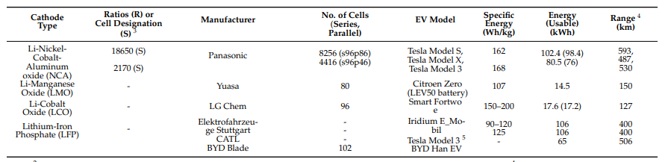
Table 1-3 – electric vehicles LIB’s type²⁰
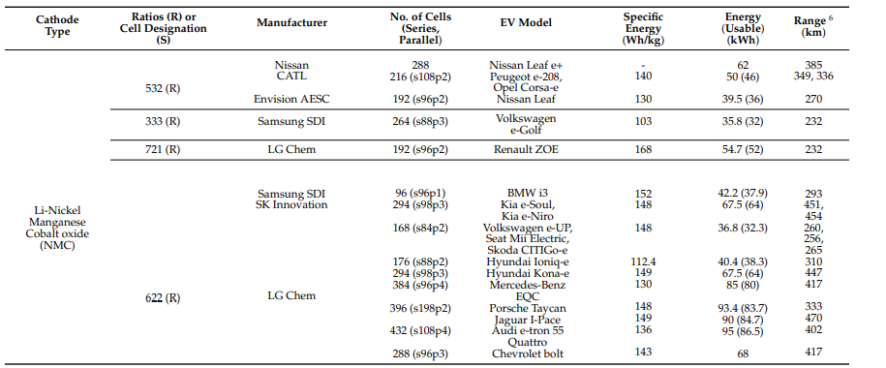
Table 1- 4 – electric vehicles LIB’s type²⁰
For other parts, the anode is made of graphite or amorphous carbon compounds. Anode’s role in the battery is to receive lithium ions and enable electrons to flow in an external circuit^{14,21}. The separator consists of the porous membrane which isolates the anode and cathode electrically and finally electrolyte which selectively allows lithium ions to pass and force electrons to pass from the wire to the other side. Electrolytes in lithium-ion batteries are usually containing a dissociated lithium conducting salt²¹.
Mechanism
The mechanism of lithium–ion batteries is important and consists of multiple redox reactions. As we know, a reduction reaction occurs in the cathode, and an oxidation reaction occurs in the anode. In lithium-ion batteries usually aluminum is the cathode current collector and copper is used for collecting current on the anode side. Brief explanations of the mechanism are shown in Figure 1-3:
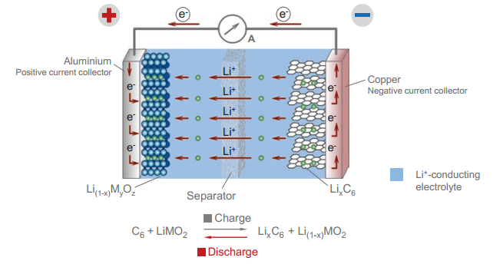
Figure 1-3 – LIBs working mechanism²¹
After plugging battery to electric current, first a fraction of lithium in the lithium complex cathode disassociates due to external electric current and is placed between graphite planes through an electrolyte and separator. This reaction produces electrons that can’t pass from the separator so they are forced to go through the wire to the anode side to join lithium ions on the other side. In this position, the battery is fully charged. This process is a nonspontaneous reaction and won’t happen without external electric current.
On the other hand, after unplugging the charger for normal usage, in discharge in a spontaneous reaction, electrons through the wire and lithium ions through the electrolyte, move to the cathode side, and by this flow of electrons in the circuit, power is delivered to our device. Here, considering the anode is graphite, for all mentioned types of cathodes, reactions are listed in Eq1-1 and Table 1-5,1-6,1-7:
$$LCO=\left\{\begin{aligned}Anode=Li_{n}C_{6}⟺C_{6}+nLi^{+}+ne^{-} \\ Cathode: Li_{m-n}CoO_{2}+nLi^{+}+ne^{-}⟺ LiCoO_{2} \\ Overall: Li_{m-n}CoO_{2}+Li_{n}C_{6}⟺LiCoO_{2}+C_{6}\end{aligned}\right.$$
Eq 1-1 – LCO cathode, anode and overall reaction¹⁹
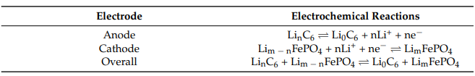
Table 1-5 – LFP LIB cathode, anode and overall reaction¹⁹

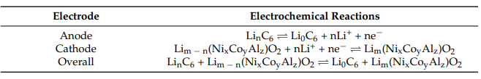
Table 1-6 - NCA LIB cathode, anode and overall reaction¹⁹
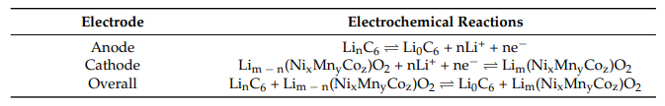
Table 1-7 - NMC LIB cathode, anode and overall reaction¹⁹
Conclusion
Lithium – ion batteries are important part of electronic devices due to their beneficial advantages. Despite of observed disadvantages, abundance of cathodes in lithium – ion batteries create opportunities for designers to produce batteries considering their requirements. Although energy density for lithium – ion batteries are low compared to other energy kind of fuel, considering latest progresses in lithium – batteries material discovery, is promising and might solve this challenge in near future.

Chapter 2: Density Functional Theory: Revealer of material properties
Introduction
Material discovery has been always a hot topic in various industries and research areas including aerospace industries, polymer researches etc. Properties of materials are one of the most important criteria for material selection for different applications. For example, capacity of materials can be considered as criteria for battery cathode selection. Due to factors including high expense of materials, experiments, variety of candidates etc. it can be challenging to measure properties of all interested materials. Density Functional Theory (DFT) which is a numerical solution to Schrodinger equation, is powerful tool for computing electronic, magnetic, vibrational and optic properties, can approximately predict properties of interest. In this chapter, we are going to discuss about fundamentals of DFT and its application in material science.
Fundamental of DFT
One of the most important equations in quantum physics is the Schrodinger equation. Schrodinger independent of time equation is Eq 2-1:
$$Hψ=Eψ Eq 2-1$$
Where H is the Hamiltonian operator that contains kinetic and potential energies information for all particles in a many-body system, $ψ$ is wave function and E is the energy eigenvalue for the system. This equation in quantum physics can be compared with Newton’s law in classical physics²². Schrodinger’s more complicated equation is Eq 2-2:
$$\left[ \frac{h^{2}}{2m}\sum_{i=1}^{N}{∇_{i}^{2}}+\sum_{i=1}^{N}{V\left(r_{i}\right)}+\sum_{i=1}^{N}{\sum_{j<i}^{N}{U\left(r_{i},r_{j}\right)}}\right]ψ=Eψ Eq2-2$$
Where N is the number of electrons, h is the Planck constant, m is the mass of electrons, r is the position of electrons, and the three terms in the brackets represent in order, the kinetic energy of each electron, the interaction energy between each electron and the collection of atomic nuclei, and the interaction energy between different electrons. In Eq2-2, there are 2 additional terms for Hamiltonian operator which has been eliminated due to assumptions. First it can be considered that due to significant mass difference between electrons and nuclei, nuclei are considered to be static and just electrons can move around them. Using this assumption, kinetic energy of nuclei will be ignored in comparison with kinetic energy of electrons. In addition, as nuclei positions are fixed, the interaction between two nuclei considered to be constant. This is called Born-Oppenheimer approximation. We should add that Each position (r) is position of an electron or nuclei in 3 dimensions.
Solving Schrodinger equation for Hydrogen molecule is simple. Hydrogen molecule have just two electrons, considering 3 dimensions for each electron, will form a 6-dimensional function for the wave function and it can be calculated by hand but for large molecules with a large number of electrons, calculations would be complicated. For example, “if we were interested in a nanocluster of 100 Pt atoms, the full wave function requires more than 23,000 dimensions”²³.
By solving this equation and indicating the wave function of the ground state of a compound, we can determine the quantum properties of that compound. These high dimensional molecules which exist in abundance act like an obstacle for solving precise wave function and ground state energy.
One of the ways to solve complicated equations is using Density Functional Theory (DFT). Because of the topic here, we will just discuss the DFT method in detail, not the other methods. DFT introduces electron density as a variable for numerically solving the Schrödinger equation. “The quantity that can (in principle) be measured is the probability that the N electrons are at a particular set the of coordinates, $(r_{1},r_{2},r_{3},r_{4}…,r_{N})$This probability is equal to $ψ^{*}\left(r_{1},r_{2},r_{3},r_{4}…,r_{N}\right)ψ\left(r_{1},r_{2},r_{3},r_{4}…,r_{N}\right)$, where the asterisk indicates a complex conjugate” ²³. Two number also appears in formula in Eq2-3 because of spin of electrons in orbital:
$$n\left(r\right)=2\sum_{i}{{ ψ}_{i}^{*}\left(r\right)ψ_{i}(r)}=2\sum_{i}{{\left|ψ_{i}\left(r\right)\right|}^{2}} Eq2-3$$
“Factor of 2 appears because electrons have spin and the Pauli exclusion principle states that each individual electron wave function can be occupied by two separate electrons provided, they have different spins”²³.
Now with this new variable, it is not important how many electrons participate in the system because for N electrons and 3N dimension, the problem’s dimension will reduce to three! Consider that for the mentioned nanocluster you can reduce a problem with more than 23000 dimensions to only three. The DFT approach introduces a density form of electrons instead of calculating precise amount of their repulsion or attraction demonstrated in Figure 2-1:
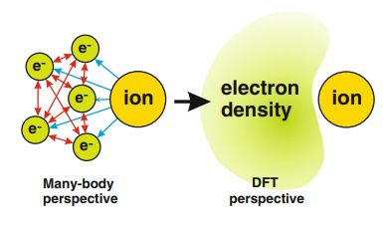
Figure 2-1 – Perspective of DFT vs. perspective of Many-body
Kohn and Hohenberg are two scientists who are famous because of their works in the DFT field and two of the most fundamental theorems in DFT also known as the Kohn-Hohenberg theorem which first states that: “the ground state of any interacting many particle systems with a given fixed interparticle interaction is a unique functional of the electron density n(r)”²⁵. Also, the second Kohn-Hohenberg theorem states that “the electron density that minimizes the energy of the overall functional is the true electron density corresponding to the full solutions of the Schrodinger equation”²⁴.
First Kohn-Hohenberg theorem claims that there is a functional one-to-one relationship between the ground state of electron density and Schrodinger’s equation ground state²³. We need to mention that this theory doesn’t give any information about what the functional actually is.
The second theorem states that by knowing what the functional is, we can minimize it by changing the electron density variable to find the ground state of electron density. After real electron density was found, we can find properties using the ground state of electron density.
There is an important set of equations related to fundamental DFT known as Kohn-Sham equations. Now one of the remarkable tasks was to minimize functional by electron density. The functional in Kohn-Hohenberg theorem can be defined as Eq 2-4 in terms of single electron wave function²⁶:
$$E\left[ψ_{i}[n\left(r\right)]\right]=E_{known}\left[n\left(r\right)\right]+E_{XC}\left[n\left(r\right)\right] Eq2-4$$
Which $E_{known}$can be calculated from analytical but exchange correlation functional ($E_{XC}$) and the whole functional are unknown. Exchange correlation functional is other terms that are not considered in known parts.
For the known part, functional can be calculated from formula in Eq2-5:
$$E_{known}\left[n\left(r\right)\right]=-\frac{h^{2}}{m} \sum_{i}{\int{ψ_{i}^{*}∇^{2}}ψ_{i}}d^{3}r+\int{V\left(r\right)}n\left(r\right)d^{3}r+\frac{e^{2}}{2}\iint{\frac{n\left(r\right) n\left(r^{'}\right)}{\left|r-r^{'}\right|}}d^{3}rd^{3}r^{'}+E_{ion}$$
$$Eq2-5$$
“The terms on the right are, in order, the electron kinetic energies, the Coulomb interactions between the electrons and the nuclei, the Coulomb interactions between pairs of electrons, and the Coulomb interactions between pairs of nuclei”²⁶.
Still our problem is to indicate exchange correlation functional. We will discuss exchange correlation later. Kohn and Sham showed that “right electron density can be expressed in a way that involves solving a set of equations in which each equation only involves a single electron”²³. Here is final form of Kohn-Sham equation in Eq2-6:
$$\left[-\frac{h^{2}}{m}∇^{2}+V\left(r\right)+V_{H}\left(r\right)+V_{XC}\left(r\right)\right] ψ_{i}=ε_{i}ψ_{i} Eq2-6$$
Where: $V_{H}\left(r\right)=e^{2}\int{\frac{ n\left(r^{'}\right)}{\left|r-r^{'}\right|}}d^{3}r^{'} Eq2-7$ And $V_{XC}\left(r\right)=\frac{δE_{xc}(r)}{δn(r)} Eq2-8$
In Eq2-6, second term from left, V(r), is interaction between an electron and nuclei. The third term, $V_{H}\left(r\right)$, which is described in Eq2-7, is called Hartree potential and can be explained by interaction between single considered electron and total electron density of other electrons. Last term in bracket, $V_{XC}\left(r\right)$, is called exchange-correlation potential which can be defined as all other contributions for a single electron.
One of the main challenges of Kohn-Sham equation is to find approximation for V_{XC}. There are several approximations and methods for calculating the approximate exchange correlation. Localized density approximation (LDA), generalized gradient approximation (GGA) and Hybrids are different types of functionals for DFT calculations. A complete list of functionals has been demonstrated in Figure 2-2.
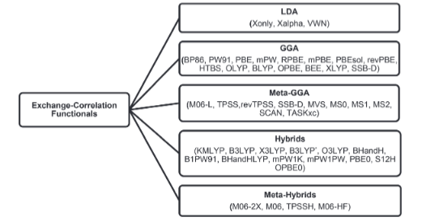
Figure 2-2 – Types of exchange correlations functionals with example²⁷
As we move from LDA to meta-Hybrids, accuracy increases but computational time for property calculation will also increase. There are other non-DFT methods like Hartree-Fock method (HF)and post Hartree-Fock methods including: configuration interaction (CI), coupled cluster (CC), Møller–Plesset perturbation theory (MP), and the quadratic configuration interaction (QCI) approach. Each of these methods has multiple variants with names that describe salient details of the methods. For example, CCSD calculations are coupled-cluster calculations involving excitations of single electrons (S), and pairs of electrons (double—D), while CCSDT calculations further include excitations of three electrons (triples—T)²³
DFT calculations contain advantages compared with other methods and approximations. Brief description of these advantages are high accuracy and low time cost. Here is comparison of 4 methods for estimating C-H bond length and ionization energy for methane in Table 2-1:
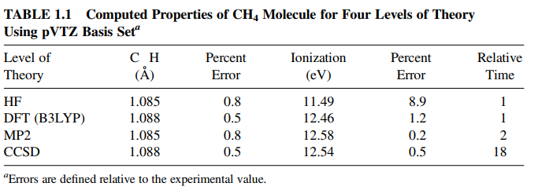
Table 2-1 - computed properties of Methane molecule using DFT and non-DFT methods²³
One of the most famous sets in DFT is Becke-3-Lee Yang Parr (B3LYP) method²⁸ which is more common in DFT calculation:
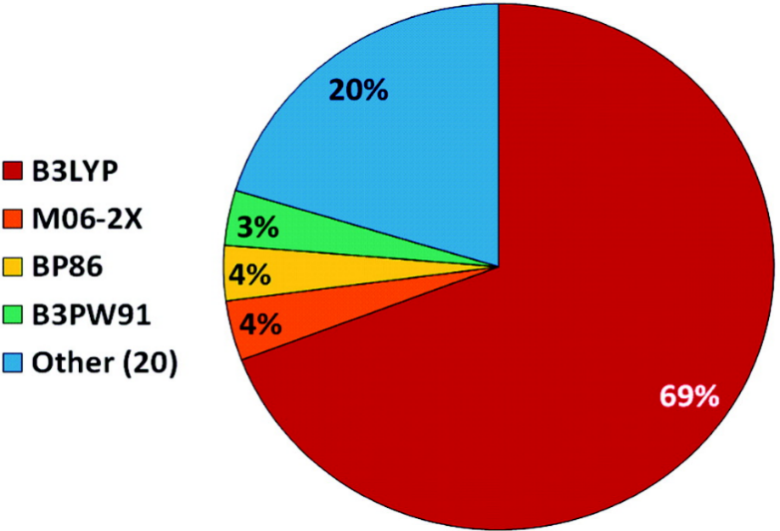
Figure 2-3 – usage of DFT methods in different areas²⁹
Conclusion
As a numerical solution of Schrodinger equation, DFT has proved itself as one of the most accurate and fast tools in predicting electronic properties. DFT also is applicable in optics, magnetics and all other fields which are related to electrons and their energy levels. One of the most important points in for DFT is selecting right package for exchange correlation functional. DFT has opened ways for scientists that will enable them to select best materials in electronic fields in future.

Chapter 3: Machine learning: Imitation in game of learning
Introduction
Current decade (2020-2030) can be coined as artificial intelligence (AI) decade. Several artificial intelligence applications have been released in recent years for different applications (e.g. ChatGPT, Bing, etc.). Machine learning (ML) is subset of AI that refers to technologies and algorithms trained to understand patterns and make decisions. In this chapter, we are going to discuss about fundamental, basic and types of ML.
Fundamental of ML
Machine learning (ML) is part of artificial intelligence (AI) which is used to solve problems by using different algorithms³⁰. Machine learning is not like a program which needs to be coded with formulas or criteria, instead it allows computer to learn and generate any formula or criteria which it needs to learn by given data. ML is one of the strongest tools facing large amounts of data when they need to be processed. These data can be photos, numbers, text or any other kind of data. “The goal of machine learning, closely coupled with the goal of AI, is to achieve a thorough understanding about the nature of the learning process about the computational aspects of learning behaviors, and to implant the learning capability in computer systems”³¹. Here the main difference between classic programming and machine learning is shown in Figure 3-1:
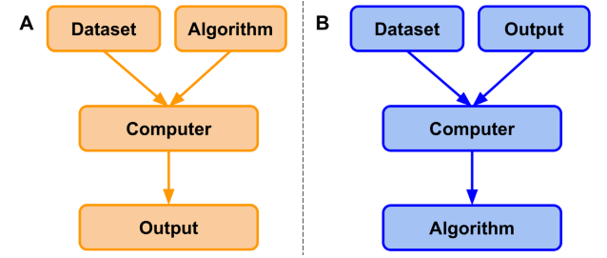
Figure 3-1 – difference between classical programming and ML³²
ML is used in different areas including data analytics, predictions, decision making, business intelligence, recommendation systems, search engines, computer vision and etc. are some examples which ML is useful³³. There are 4 main types of ML algorithms: supervised ML, unsupervised ML, semi-supervised and reinforcement learning.
In supervised ML algorithms, input variables with labeled target variables are given to the computer for training which means correct answers are given to the system. Supervised ML itself is divided into classification and regression³⁴. Later we will talk about classification and regression and explain them with more details.
In unsupervised ML algorithms, there is no labeled data or right answer. Here the computer tries to find answers by creating algorithms for itself without requiring a person as a supervisor³⁵. Clustering is one of the main branches of unsupervised ML.
Semi supervised algorithms usually are not considered as the main part of machine learning but here we will discuss it briefly. Semi-supervised learning is a combination of supervised and unsupervised ML. In semi-supervised ML, we used labeled data and unlabeled data for training to predict about unlabeled data. “The goal of semi-supervised learning is to learn a function that can accurately predict the output variable based on the input variables, similar to supervised learning”³⁶.
The last type of ML is reinforcement learning. Reinforcement learning is a method based on trial and error of an agent’s performance in an environment. Gaming, recommendation systems, marketing and advertising etc. are main branches of reinforcement learning³⁷. Other types of ML which can be found in Figure 3-2:
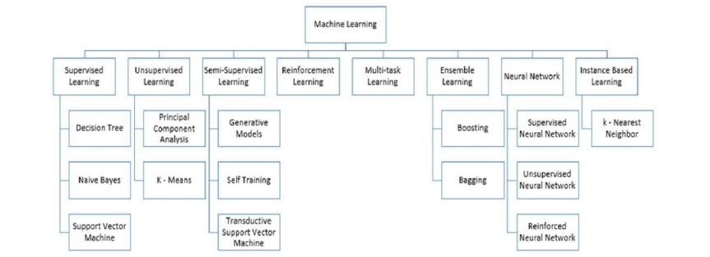
Figure 3-2 – types of learning for ML³⁸
Do we need machine learning in all fields? Well, the answer is it depends. Figure 3-3 can indicate which part of machine learning is appropriate for our system:
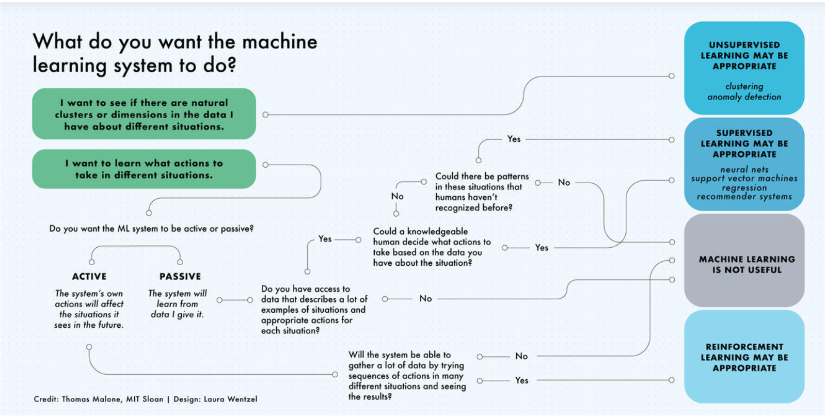
Figure 3-3 – Chart guide for ML application³⁹
Supervised models: Regression
Supervised regression to is used to understand relationship between independent and dependent variables⁴⁰. There are multiple types of regression models: linear regression, polynomial regression, random forest regression, gradient boosting regression, stepwise regression, Lasso regression, Ridge regression, Bayesian linear regression and etc⁴¹. Each of them has their own methods for regression methods. Classification is one the most important types is used for dividing data into multi classes by understanding algorithm of labeled data. Regression algorithms are even applicable in classification in order to obtain boundaries. Here we will discuss some of these methods.
Linear regression (LR) is the simplest form of regression that find a linear relationship between input and target variable⁴². LR can be separated into two main branches: simple linear regression (SLR) and multiple linear regression (MLR). SLR uses linear equation between one input variable for predicting target variable. SLR can mathematically be formulated as Eq3-1 ⁴³:
$$y=β_{0}+β_{1}x Eq3-1$$
Where x and y are input and output variables, $β_{1}$ is slope and $β_{0}$ is the intercept of the equation. Although computers can be used for calculating optimum slope and intercept, for small number of data, this calculation can be done with hands. For set of x and y we have:⁴³
$$\overline{x}=\frac{\sum_{i=1}^{N}{x_{i}}}{N} Eq3-2 \overline{y}=\frac{\sum_{i=1}^{N}{y_{i}}}{N} Eq3-3$$
$$SS_{x}=\sum_{i=1}^{N}{{\left(x_{i}-\overline{x}\right)}^{2}} Eq3-4 SS_{xy}=\sum_{i=1}^{N}{(x_{i}-}\overline{x})\left(y_{i}-\overline{y}\right) Eq3-5$$
$$β_{1}=\frac{SS_{xy}}{SS_{x}} β_{0}=\overline{y}-β_{1}\overline{x} Eq 3-6$$
Which N is number of data, $\overline{x}$ is average of input variables and $\overline{y}$ is average of target variables in Eq3-1,6.
“Multiple linear regression extends simple linear regression to include more than one explanatory variable”⁴⁴. MLR uses multiple input variables but the equation is still linear. MLR equation can be described as Eq3-7:⁴⁵
$$y=β_{0}+β_{1}x_{1}+β_{2}x_{2}+β_{3}x_{3}+…+β_{n}x_{n}+e Eq3-7$$
Where [x1, x2, x3, …, xn] are input variables, y is output variable and [$β_{0},β_{1},β_{2},…, β_{n}]$ are coefficients and $e$ represents error for this equation.
LR is simple, easy to use and doesn’t assume any dependencies of features on each other but one of the major problems of LR is overfitting. Overfitting happens when a model perfectly fit for training data but it’s not efficient while used for testing set⁴⁶. There are multiple ways to prevent overfitting. Most applicable solution in LR is using regularizations like lasso and ridge regressions^{46,47}. Lasso regression (also called L1) is ideal for big datasets with fast answers acquired and Ridge regression (L2) is useful when there are many predictors with no zero coefficient and normal disturbution⁴⁸.

Rewriting MLR equation for p features can be formulated as Eq 3 - 8 :⁴⁹
$$f\left(x_{i}\right)=β_{0}+\sum_{j=1}^{P}{x_{ij}}β_{j}→e_{i}=\sum_{i=1}^{N}{\left(y_{i}-f\left(x_{i}\right)\right)}=\sum_{i=1}^{N}{\left(y_{i}-β_{0}-\sum_{j=1}^{P}{x_{ij}}β_{j}\right)} Eq3-8$$
Which N is number of data points, $e_{i}$ is the error or residual of the system and p is number of input parameters. Both Lasso (least absolute shrinkage and selection operator)⁵⁰ and Ridge regression’s goal is to minimize residual sum of squares using penalty coefficient of $λ$ with different systems as it shown in Eq3-9,10,11:⁵¹
$$e^{2}=\frac{1}{N}\sum{{\left(y_{i}-β_{0}-\sum_{j=1}^{P}{x_{ij}}β_{j}\right)}^{2} Eq3-9}$$
$$Lasso : \frac{1}{2N}\sum{{\left(y_{i}-β_{0}-\sum_{j=1}^{P}{x_{ij}}β_{j}\right)}^{2}}+λ\sum_{j=1}^{P}{β_{j}} Eq3-10$$
$$Ridge: \frac{1}{N}\sum{{\left(y_{i}-β_{0}-\sum_{j=1}^{P}{x_{ij}}β_{j}\right)}^{2}}+λ\sum_{j=1}^{P}{β_{j}^{2}} Eq3-11$$
If the penalty coefficient equals zero for both Lasso and ridge, the residual sum of squares will be the same with LR and if the penalty function tends to infinity, it will make the coefficient zero and the equation will turn to constant function. Right amount of penalty coefficient should be tuned with the cross-validation method.
Another regression algorithm which is based on mathematics is polynomial regression. Polynomial regression with one input variable can be formulated as Eq3-12:⁵²
$$y=β_{0}+β_{1}x+β_{2}x^{2}+β_{3}x^{3}+β_{4}x^{4}+…+β_{n}x^{n} Eq3-12$$
Tree based models
Decision tree
Decision tree-based algorithm are the next type of regression, although they are used for classification too⁵³. “If one defines a node’s predicting value as the constant prediction and the node’s impurity as the sum of squared deviations about its samples’ mean, the decision tree will become a regression model”⁵⁴. Decision trees use criteria for splitting data until they reach answer⁵². Main parts of the decision tree are nodes and branches⁵⁵.
Nodes are possible attributes which are related to an event⁵⁶. There are 3 types of nodes: Root node, internal nodes and leaf nodes⁵⁷. Root node is the first decision point which will lead to subdivision of all results into multiple mutually subsets. Internal nodes represent tests on each attribute which from top is connected to parent node and from bottom is connected child node^{56,58}. Leaf nodes as the final part of the decision tree show result of choices and criteria. In each decision tree, branches show results of internal or root nodes test⁵⁸. Here in Figure 3-4, we can see an example of how decision tree works:⁵⁷
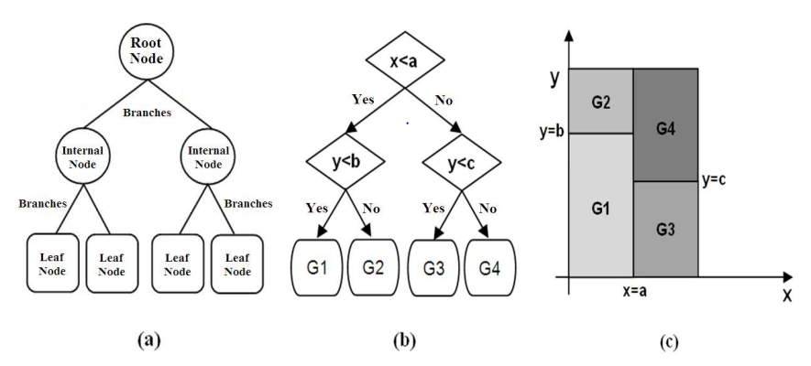
Figure 3-4 – components(a), flow chart (b) and result (c) of a decision tree⁵⁷
Random Forest
There are two important regression algorithms which are based on decision trees: Random Forest (RF) and Gradient Boosting (GB). As these methods are decision tree based, they can be used for classification too⁵⁸. Both RF and GB methods use decision trees but the algorithms are different.
RF uses parallel decision trees for regression and classification. Each tree trains privately from subsets of the main dataset as it is shown in Figure 3-5. In RF, features and samples of data are given to each tree randomly which is called bootstrap⁵⁹. Then after each tree has been trained by data, then each tree will give results individually. Final result will be predicted by aggregation. Aggregation in classification method is done by majority voting but in regression output of system is mean of all outputs:
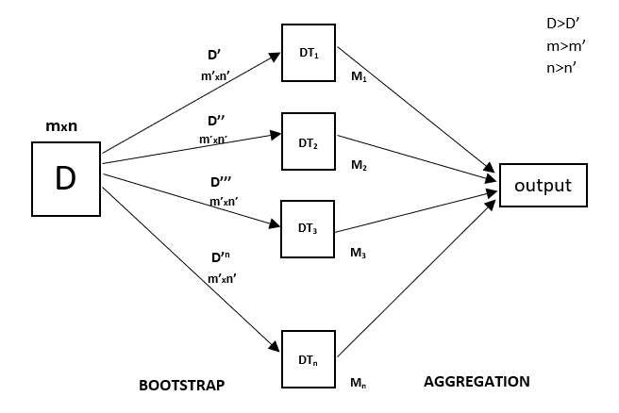
Figure 3-5 – Random Forest general mechanism⁶⁰
RF’s main advantages is being resistance to overfitting in comparison with decision tree., high accuracy specially in big datasets, fewer hyperparameters for tuning compared with other machine learning methods like support vector machine and artificial neural network⁶¹. There are disadvantages and limitations for RF algorithm. One of the most important disadvantages of RF is that it is not able to predict any other class of the same data which it has been trained on. “For example, if the training data for a biomass model contain low and moderate biomass values but no high values it will not be possible to accurately predict high biomass values when the model is applied to the full data set”⁶².
Gradient Boosting
Gradient boosting (GB) is another algorithm which is based on decision trees. As said, a common subject about RF and GB is using decision trees as core of algorithm but their main difference is about how they use decision trees for predicting target variable of machine learning. In RF each tree has been trained separately in parallel using bagging (whole process of bootstrap and aggregation) and final the result is obtained by voting in classification and averaging in regression. GB instead, use trees in series instead of parallel. Goal of GB is minimizing loss function (which we will discuss in next part) by adding a new learner (decision tree which is also known as weak learner) to previous model⁶³. Figure 3-6 shows how GB’s operation system:
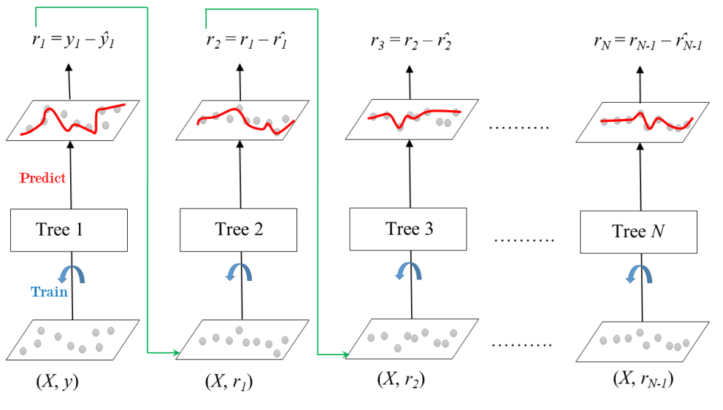
Figure 3-6 – Gradient boosting mechanism with N number of trees ⁶⁴
In Figure 3-6, the first tree trains with X as input values and y as label target values. Prediction of this tree after training and fitting will be $\hat{y}$ which had residue of r with labeled target value. Second tree will be trained by X as input value and r1 as target value and its predictions will be assumed as $\hat{r_{1}}$. Now r2 is residue of residue and this loop will occur till Nth tree. It means that each tree receives the previous tree’s error and minimize the it and pass it to the next tree. This will lead to error decreasing and high performance. GB can be formulated as Eq3-13:
$$\hat{y}=μ+\sum_{m=1}^{N}{v\hat{h_{m}}(x_{i})} Eq3-13$$
Where $μ$ is population mean, v is shrinkage factor which acts like weight for each tree and h is prediction of weak learner⁶⁴.
Support vector machine
Other famous ML algorithms are support vector machine (SVM), k-nearest neighbors (KNN) and neural networks (NN)³⁷. First algorithm, SVM, like RF and GB can be used in both regression and classification and the idea behind it is based on finding the best hyperplane and margin which acts like boundary for system⁶⁵.
For example, in this 2D diagram in Figure 3-7, the middle line is called hyperplane which separates data into two 2 classes. Closest data points to hyperplane are call support vectors and parallel dashed lines which are distance between support vectors and hyperplane is called margin:
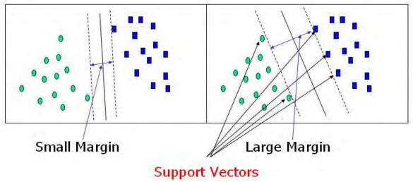
Figure 3-7 – Margin, hyperplane and support vectors for supporting vector machine algorithm (SVM)⁶⁵
One of the main challenges in SVM is selecting optimized hyperplane and margins. Hyperplanes with large margins lead to better separation, stronger classification and lower error in model⁶⁶. For example, there are 2 charts with identical data and 2 different hyperplanes and margins in Figure 3-7. Obviously right hyperplane with bigger margin is more efficient for classification.
Hyperplane function is not exactly linear in every model, especially in high dimensional models. Mathematical function of hyperplane is called kernel which can be linear, polynomial, circle, sigmoid etc., based on the model we are working with⁶⁶.
Mentioned SVM method that contains defining optimized hyperplane, margins and kernels usually is used for classification. For the regression part, support vector regression (SVR) is used which is inspired from SVM using mathematical equations⁶⁷.
SVM algorithms can be used for both semi supervised and supervised learning and there is less probability of overfitting but SVM is sensitive to noise in dataset and as the dataset get larger, efficiency of algorithm will decrease because of more requiring training time and it should be mentioned that finding right kernel is hard in larger datasets⁶⁸.
K-Nearest Neighbors
K-Nearest Neighbors (KNN) is an instance-based ML algorithm also known as lazy learning⁶⁵. KNN is another method which is suitable for both regression and classification^{69,70}. It is called a lazy learning algorithm because there is no math equation or special criteria for this method. In the classification part, KNN trains and analyzes data (instances) and predicts new data based on similarity with stored instances. KNN predicts class of new instances by voting of its near neighbors. In regression, based on feature similarity and how closely it is related to trained data, target value will be predicted by weighted averaging⁶⁹.
Artificial neural network
NN also known as artificial neural network (ANN) is one of most widely used algorithms for learning in data science⁷¹. ANN also can be used in supervised, unsupervised and even reinforcement learning³⁶ which makes it one of the most popular algorithms in ML. ANN algorithm has been inspired by biological neural network⁷¹, which means the network has been built on basic blocks. These blocks are known as artificial neurons:
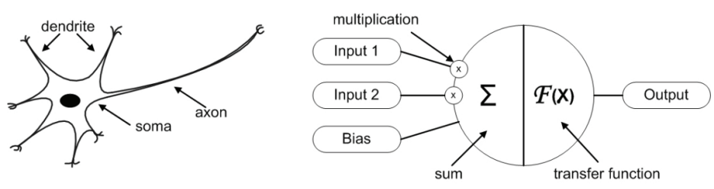
Figure 3-8 – Main parts of biological and artificial neuron⁷²
In Figure 3-8, the left side is a biological neuron and the right side is an artificial neuron. Both of them are basic structures of biological and artificial network. They have other similarities in operation time. In biological neurons, the main structural and functional parts are: axons, dendrite and soma⁷¹. There is also a synapse part in each neuron which is a junction that links dendrites with soma⁷³. Dendrites are input terminals for signals coming from other neurons, Soma or cell nucleus where all the process of signal is occurring there and axon which is the result of processing^{71,72}. After the signal is sent by a neuron, another neuron receives it and this loop will repeat till it reaches the brain.
Compared with biological neural network (BNN), signals are like data inputs (raw data with their weights) for ANN. In a node which acts soma’s role in BNN, all required calculation and process is operating using the transfer function and finally passes the result as an output⁷². Transfer function of ANN can be these functions: step function, linear function and nonlinear (sigmoid) function⁷¹. Equation of ANN in discrete time of k can be formulated as Eq3-14:⁷²
$$y=F\left(\sum_{i=1}^{m}{w_{i}\left(k\right)}x_{i}\left(k\right)+b\right) Eq3-14$$
Where x and y are input and output of system, $w$ is weight, b is bias and F is the transfer function of the system. Totally comparing ANN and BNN we have Table 3-1 results:⁷³
BNN | ANN
Dendrite | Inputs
Cell nucleus or Soma | Nodes
Synapses | Weights
Axon | Output
Table 3-1 – Similarity between artificial neuron and biological neuron⁷³
Simple ANN can be constructed by 3 main parts: input layer which contains input nodes, output layer which will indicate result of learning and hidden layer(s) (it can be more than one) between these 2 layers where the main process is performing⁷⁴. Schematic of ANN model can be described as Figured 3-9:
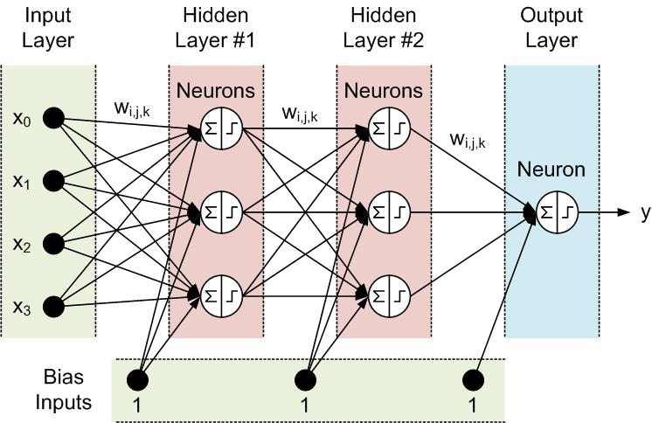
Figure 3-9 – architecture of artificial neural network with 2 hidden layers⁷⁵
Classification
Classification is another branch of supervised learning. In classification, data are labeled with their belonged class and algorithm learns to classify data. In classification similar instances are in same classes. Generally, there are 2 types of classification: Binary classification and multi-class classification⁷⁶. The difference between these two, is number of classes. In binary classification, data is divided into two classes like gender detection whereas in multi-class classification data can be separated into several classes like classification of bank customers into rich, regular and poor customers.
We have covered some classification algorithms like RF, GB, SVM, KNN, ANN etc. while explaining regression. These algorithms as mentioned, can be used for both regression and classification. Also, there are other algorithms for classification like logistic regression and Naive Bayes for classification⁶⁸. Naïve Bayes is algorithm which assumes independence between each feature and it is based on conditional probability of happening. Formula of this algorithm is described in Eq3-15:⁷⁷
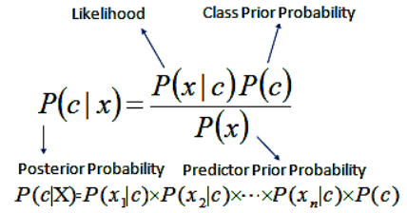 $Eq3-15$
By comparing all these algorithms, we have Table 10 results which is compared relatively:
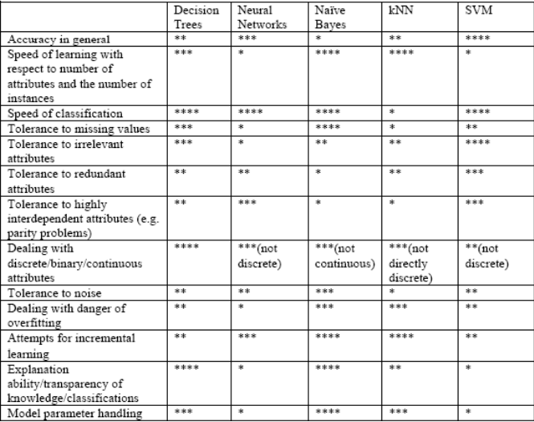
Table 3-2 – comparison between different classification algorithms⁷⁸
In Table 3-2 one star (*) means poor performance and four stars (****) is excellent performance.
Clustering
Clustering is one of main branches of unsupervised learning where data is not labeled and there is no correct answer for each instance. Instead, algorithm learns to find similarity between instances and put them in same cluster. Clustering is efficient when instances in a cluster are similar and there is too difference between pair of clusters to separate them⁷⁹. For evaluating how good clusters are, there are multiple coefficients which can indicate result quality, like: Silhouette coefficient, Dunn indicator, F indicator, Rand indicator etc.⁸⁰. One of the most known clustering algorithms for its celerity and efficiency is K-Means⁸¹. Also, there are other clustering methods like DBSCAN, SNN algorithm and Grid-based algorithms are other clustering algorithms⁸².
Model performance and Metrics
One of the most important subjects in ML is about accuracy of model in all types of algorithms. There are several indicators for measuring accuracy of a model using statistical formulas.
Regression Metrics
Mean absolute error (MAE), mean absolute percentage error (MAPE), mean square error (MSE), root mean square error (RMSE) and R-squared (R²) are some important examples of these metrics for regression models⁸³. In following formulas Eq3-16,21, considering $X_{i}$ is value which is predicted by model and $Y_{i}$ is real value for $i$ instance in total m instances, mentioned metrics will be formulated as:⁸⁴
$$\overline{Y}=\frac{1}{m}\sum_{i=1}^{m}{Y_{i}} Eq3-16$$
$$MAE=\frac{1}{m}\sum_{i=1}^{m}{\left|X_{i}-Y_{i}\right|} \left(best value=0 , worst value=+∞\right) Eq3-17$$
$$MAPE=\frac{1}{m}\sum_{i=1}^{m}{\left|\frac{Y_{i}-X_{i}}{Y_{i}}\right| (best value=0 , worst value=+∞)} Eq3-18$$
$$MSE=\frac{1}{m}\sum_{i=1}^{m}{{\left(X_{i}-Y_{i}\right)}^{2}} \left(best value=0 , worst value=+∞\right) Eq3-19$$
$$RMSE=\sqrt{\frac{1}{m}\sum_{i=1}^{m}{{\left(X_{i}-Y_{i}\right)}^{2}} } \left(best value=0 , worst value=+∞\right) Eq3-20$$
$$R^{2}=1-\frac{\sum_{i=1}^{m}{{\left(X_{i}-Y_{i}\right)}^{2}} }{\sum_{i=1}^{m}{{\left(\overline{Y}-Y_{i}\right)}^{2}}} \left(best value=1 , worst value=-∞\right) Eq3-21$$

Classification Metrics
As regression, classification metrics are important to evaluate algorithms. Classification metrics are based on accuracy or precision of choices. First, it is required to define concepts about classification. If we consider that our classes have divided into two binary classes as True (1) and False (0) while they have predicted Positive (1) and Negative (0) by algorithm; 4 outcomes may happen that we can explain them as confusion matrix:
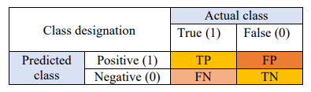
Figure 3 – 10 – Confusion matrix of classification⁸⁵
“TP (True Positive) - The data point in the confusion matrix is True Positive (TP) when a positive outcome is predicted and what happened is the same.
FP (False Positive) - The data point in the confusion matrix is false positive when a positive outcome is predicted, and what happened is a negative outcome. This scenario is known as a Type 1 Error.
FN (False Negative) - The data point in the confusion matrix is false negative when a negative outcome is predicted, and what happened is a positive outcome. This scenario is well known as a Type 2 Error and is considered as dangerous as a Type 1 Error.
TN (True Negative) - The data point in the confusion matrix is True Negative (TN) when a negative outcome is predicted and what happens is the same.”⁸⁵
There are several parameters which evaluates system’s efficiency based on these concepts such as accuracy and precision with the formula of:⁸⁵
$$Accuracy=\frac{TP+TN}{TP+FP+FN+TN} \left(Best=1 Worst=0\right) Eq3-22$$
$$Precision=\frac{TP}{TP+FP} \left(Best=1 Worst=0\right) Eq3-23$$
$$Sensitivity=\frac{TP}{TP+FN} \left(Best=1 Worst=0\right) Eq3-24$$
$$False positive rate=\frac{FP}{TN+FP} \left(Best=0 Worst=1\right) Eq3-25$$

Training: Do and Don’t
After all, there are some important rules in ML. First is about train and test data. It is not recommended to use all your data for ML to fit and find a relation because of overfitting. Actually, it is better to split your data to train and test and check train and test data accuracy to avoid overfitting. Second is data scaling, for some algorithms like KNN, SVM and ANN scaling is required.
Next important chapter in ML is hyperparameters and its tuning process. In ML, there are external parameters which are specified for an algorithm. These parameters which are called hyperparameters should be tuned and learned by input data. One example for hyperparameter is number of estimators (trees) in decision tree-based algorithms like RF and GBDT. Number of trees should be adjusted by input data. Also, input data does not include number of trees and it should by tuned in coding part. Varying number of trees also would affect function and performance of algorithm.
Other example for hyperparameters can be learning rate for GBDT, number of hidden layers and nodes in ANN, number of neighbors in KNN, kernels selection in SVM and penalty coefficient in Ridge and Lasso regression. Most of algorithms have multiple hyperparameters to tune. Some Algorithms like Ridge and Lasso regression have just one hyperparameter (Penalty coefficient) to tune and an algorithm like SLR have not any hyperparameter to tune.
There are many ways to tune hyperparameter of an algorithm. Generally, it can be divided into manual search and auto search. Auto search methods itself can be introduced as:⁸⁶
- Grid search
- Randomized search
- Bayesian optimization
In Grid search all possible conformation of hyperparameters are tested to find optimum results but in random search, best set will be chosen randomly. Bayesian optimization is other technique for hyperparameter tuning. This method is based on Bayes theorem and probability.
These methods usually include cross-validation (CV) to prevent overfitting. In train and test split operation, noised datapoints may disturb learning process in training or accuracy measurement in testing process if they have not been divided uniformly which will lead to overfitting. Main solution is to use CV. Figure 3-11 shows how CV help us to avoid overfitting:
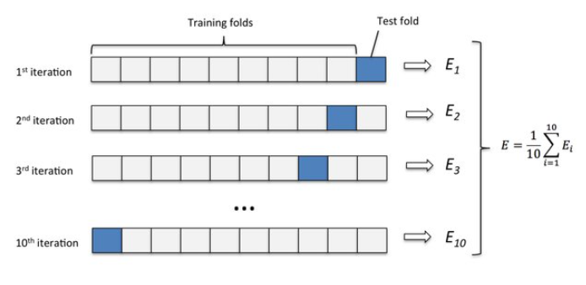
Figure 3-11 – Diagram of CV operation⁸⁷
In Figure 3-10, first data is divided into K parts (here K=10). For preventing problems mentioned in train and test split, in the first iteration K-1 parts will participate in training part and 1 part will participate in testing (validation) process for whole training data. In next iteration, another part will be validated and still K-1 part will be used for training. After K iteration, all parts have been trained and tested. Final score for accuracy of system will be average of all iterations. Combination of hyperparameter tuning and CV will lead to Figure 3-12:
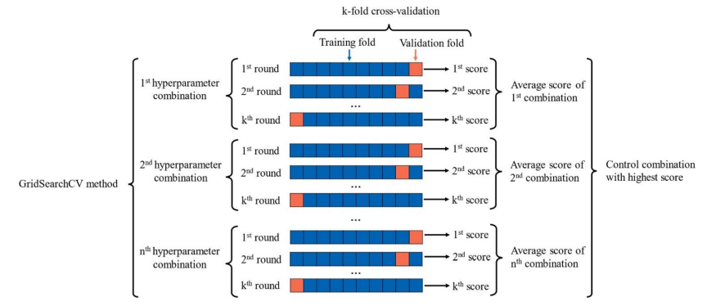
Figure 3-12 – hyperparameter tuning using cross validation⁸⁸
In Figure 3-12, for each set of combination for hyperparameters, cross validation is performed and finally best hyperparameters with highest score of accuracy will be achieved.

Conclusion
ML has established a new approach in solving academic and general problems by its versatile abilities. Supervised, unsupervised and reinforcement learning are being used by data scientists and engineers to analyze their data and build robust models for various applications. Although ML’s fast and accurate answers has high potential to accelerate researches and scientific projects, first it is required to know about how the algorithm works and how it should be tuned to produce a decent result. In future, ML has potential to improve result of any academic work that involves data

Chapter 4: Combination of DFT and ML: Enhancing DFT for material discovery
Introduction
In modern society where there is high demand for electronic rechargeable devices, electric cars etc., lithium-ion batteries (LIB) can play vital role in growth of industry. Unfortunately, there are several challenges with mentioned metallic LIBs in chapter 1. Traditional metallic LIB cathodes like LCO, NCM and NCA are facing problems like toxicity, recycling, capacity limitations, safety and environmental issues. These challenges are most common in the batteries with metallic cathode problems⁸⁹. Therefore, exploring material for enhancing lithium – ion batteries (LIB) abilities has become a cutting-edge research topic recently. One of the board alternative candidates to solving LIB issues are organic cathodes. Density functional theory (DFT) as a property predicter is suitable tool for predicting properties of organic LIBs due to electron transfer. Although predicting accurate properties of materials requires lot of time, machine learning (ML) can accelerate this process by estimating some of those numbers. In this chapter, we are going to review LIB challenges, organic LIBs and how combination of ML and DFT will aid us to find best candidates for batteries.
Organic lithium – ion battery
One of the most important reasons of LIB challenges is the existence of cobalt in the cathode. Cobalt is essential element in LIB’s cathode which is present in LCO, NCM and NCA cathodes. Cobalt is toxic and it can harm eyes, skin, lungs and even it can cause cancer⁹⁰. Raw cobalt’s price is higher than any other element in LIB⁹¹. As 40-50% total cost of LIBs is related to cathode⁹⁰, presence of cobalt can affect total cost of battery more than other components. Figure 4-1 is graph of cobalt’s price compared with nickel and copper which are used in LIB:
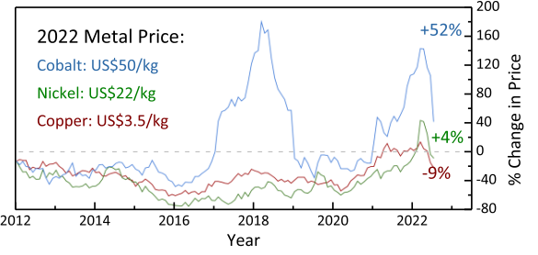
Figure 4-1 – price of metals participates in LIB⁹¹
Another issue which is related to cobalt, is abundance of this element. Cobalt is rare element compared with other metals and one of the main issues with cobalt is its relative low reserves as it is shown in Figure 4-2:
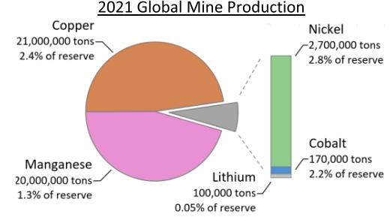
Figure 4-2 – reserves and mine production of metals in LIB⁹¹
Organic lithium-ion batteries (OLIB) can be offered as a general solution to metallic LIB’s problems. OLIBs are not new generation of batteries, in fact first generation of rechargeable lithium batteries used ${\left(CF_{x}\right)}_{n}-Li$ as cathode material in early 1970s⁹². Generally, safety, low cost, high capacity, ease of fabrication, natural abundance, high power densities and environmental friendliness are main advantages of OLIBs^{92,93}. Although having these advantages, yet there are some problems with organic cathodes. Organic cathodes in OLIB suffer from low cycling stability, low energy density and do not meet all requirements in life time and rate capability⁹⁴. Still organic realm seems to be attractive for scientists for exploring to find substances which can be used as cathode in batteries. Figure 4-3 shows number of publications from 1996 to 2018 using “organic electrode material” keyword:
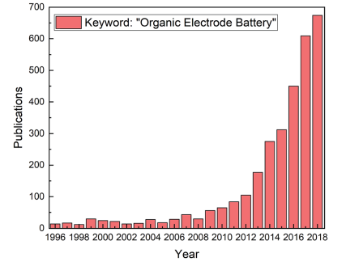
Figure 4-3 - number of publications “organic electrode material” keyword in each year⁹⁵
Figure 4-3 demonstrates that there is a high interest to find suitable organic molecules as electrodes for rechargeable batteries. Generally comparing LIB with OLIB can be summarized in Figure 4-4:
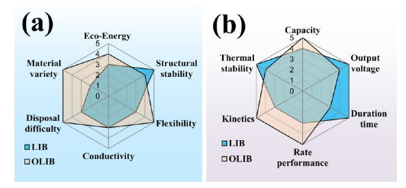
Figure 4-4 – organic and metallic lithium – ion batteries comparison⁹⁶
Several organic materials have been nominated for electrode in OLIB during history. Carbonyl compounds ($C=O),$ nitrile compounds $(C≡N)$ , organosulfur compounds, imine compounds $(C=N)$, azo compounds $(N=N)$, conductive polymers, organic radicals etc., are part of candidates that research demonstrated them suitable for OLIB cathode⁹⁷. Their derivatives like quinones and acid anhydrides can be used as cathode too⁹². Researches for exploring of organic cathodes can be simplified as Figure 4-5:
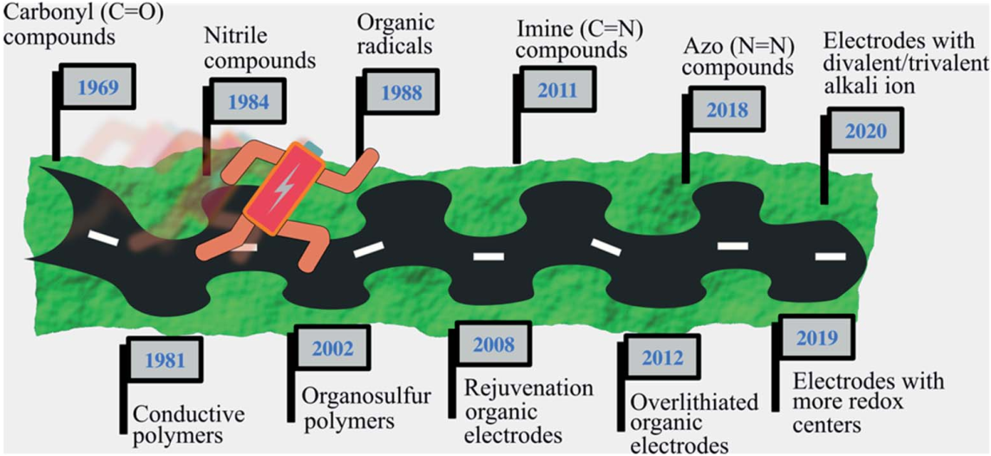
Figure 4-5 – suitable functional groups for organic lithium battery⁹⁷
Obviously, these groups have different characteristics with each other as cathode by physical and electrical properties. Six most important of these groups properties is shown in Figure 4-6:
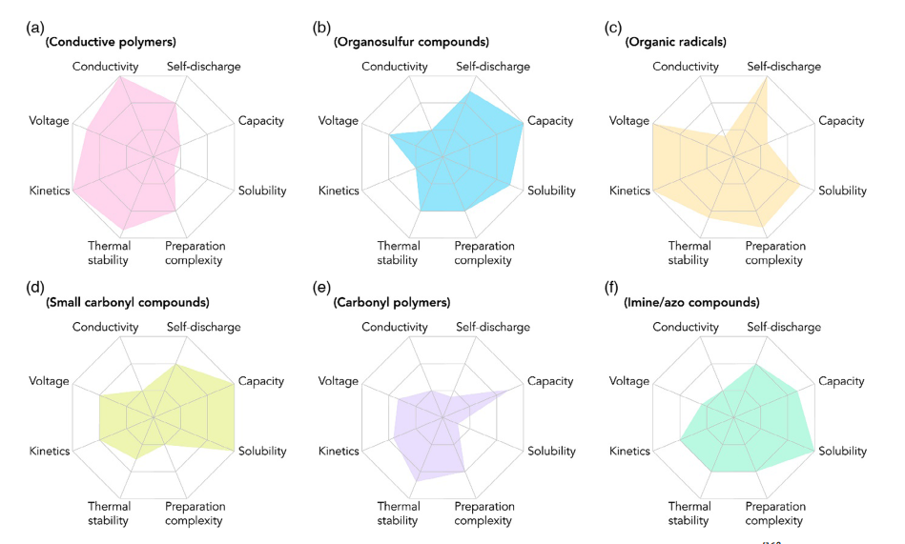
Figure 4-6 – comparison between organic cathode candidates in LIB⁹²
For OLIBs, n-types and p-types organic materials are suggested to be used⁹⁶. “If the organic redox-active group is reduced (oxidized) by accepting (donating) electrons to a negatively (positively) charged state, it is categorized into n-type (p-type) organic materials. Those redox-active groups (bipolar-type) can accept or donate electrons according to different charge potentials”⁹⁶. Mentioned organic groups can be divided into p-type and n-type in Figure 4-7:⁹⁸
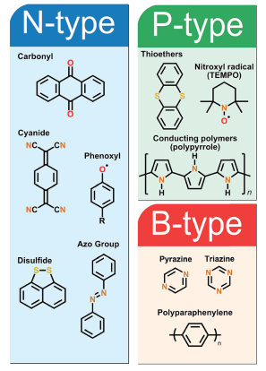
Figure 4-7 – Organic examples for N-type, P-type and B-types⁹⁸
N-type organic cathodes generally used with lithium containing anodes⁹⁶, considering n-type organic component as NT their overall reaction can be written as Eq4-1:⁹⁸
$$NT+xLi^{+}+ne^{-}⟺NT^{-}-Li^{+} (Eq 4-1)$$
In p-type cathodic reaction there is no lithium in anode or cathode. Anode is normal LIB anode which is graphite or amorphous carbon compounds as mentioned in LIB chapter. Here electrolyte plays and important role. As mentioned, electrolyte’s material is usually containing a dissociated lithium conducting salt. Electrolyte’s (e.g.,$Li^{+}PF_{6}^{-})$ role is to support cathode with negative ions to generate electrons and then send electrons to lithium to anode through wire. Lithium ions after dissociation will move toward anode with electrons. This reaction is for charging process and after discharging opposite reactions will regenerate electrolyt⁹⁸. In following reaction in Eq 4-2 which is for charging process, PT is representing p-type and $Li^{+}PF_{6}^{-}$ and $C_{6}$ in order is considered to be as electrolyte and anode material :⁹⁸
$$Eq 4-2=\left\{In cathode: \begin{aligned}Li^{+}PF_{6}^{-}→Li^{+}+PF_{6}^{-} \\ PT+PF_{6}^{-}→PT^{+}-PF_{6}^{-}+e^{-} \\ In anode:Li^{+}+e^{-}+C_{6}→LiC_{6}\end{aligned}\right.$$

DFT and ML
In our framework we use density functional theory (DFT) based data to select appropriate organic cathodes. DFT is powerful tool for predicting thermodynamic properties, reaction mechanisms, electronic structure, material properties and molecular properties^{99,100,101,102,103}.
DFT is used to predict material properties when experimental results can’t be obtained by experiments because of high cost or unreachable materials etc. Also, DFT proves itself with its precise predictions in different fields^{104,105,106,107} but there are limitations such as existence of too many approximations for DFT, being slow for liquid calculation, failing for correlated systems and predicting values with low efficiency of electronic excited systems^{108,109}.
Most important DFT problem is about its high computational cost. In Figure 4-8 orange bars shows how much time is required for predicting bond dissociation energy using different DFT and non-DFT approximations for just one molecule:
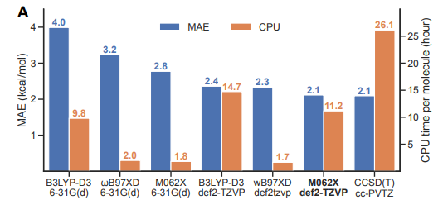
Figure 4-8 – CPU time and MAE per molecule for predicting bond dissociation energy using different DFT and non-DFT approximations¹¹⁰
Although there are other examples which show how much DFT calculations will cost (In next charts some of them will be shown), this one is enough now for us to proceed. The main popular solution in this situation is to combine machine learning (ML) with DFT. In this process, DFT’s data which are extracted from DFT software like Jaguar, Gaussian¹¹¹ etc., are given to ML algorithm for training and after proving that ML algorithm is trained and tested well, it will be able to predict even for unseen material data. In other words, ML will be trained to act as a shortcut for obtaining answers in much less time. In Figure 4-9, the difference in time and cost for same property predictions is obvious between ML and DFT:
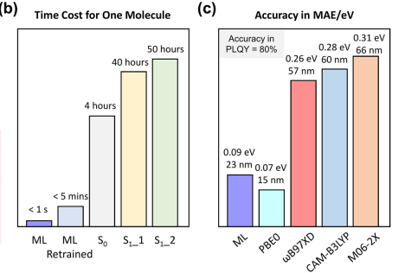
Figure 4-9 – Time cost and accuracy of different DFT methods vs trained ML¹¹²
In this chart S₀ is optimization of molecule for ground state and S₁ 1-2 are different DFT approximations (S₁_1 = CAM-B3LYP/6-31G*/LR-PCM(DCM) and S₁_2 = CAM-B3LYP/6-311+G*/LR-PCM(DCM))¹¹². The most important point in this chart is about that this time cost is just for a molecule. Another important point in this chart is that it shows after training, ML has better accuracy than most of DFT approximations. There are other examples too where ML assists DFT for minimizing computational cost^{94,113,114,115,116}.
Recent researches
As it is shown in Figure 4-3, every year, the number of researches that has conducted about organic lithium – ion batteries have increased. As number of the organic substances are over million compounds, most of articles include ML for narrowing organic candidates for cathode, anode and even electrolyte. Moreover, DFT participates in articles as a versatile tool aiming to predict properties. Most researches, use DFT, ML combination of them in order to predict properties. In this part, we are going to review recent innovative researches about ML and DFT assistance in filtering compounds for lithium-ion batteries.
In first article which has conducted by Andrew F. Zahrt et al ¹¹⁷, ML has been used to predict competency of more than 38000 organic reactions to be applied as electrodes, electrolyte etc. More specific, classification algorithm is performed in order to distinguish between appropriate reaction and unpleasant reaction. In addition, DFT has been used in this article in order to predict natural bond orbital calculations for cathode radicals, anode radicals and neutral form. This research which has high potential to find new organic suitable reactions for lithium-ion batteries. Figure 4-10 demonstrates general framework of this article:
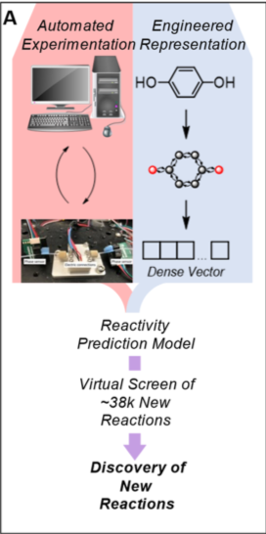
Figure 4-10 – General framework of reaction selection process¹¹⁷
In next article which has been done by Shaorui Sun et al¹¹⁸, dispersion-corrected density functional theory (DFT-D2) was applied to study nine experimentally reported organic electrode materials, and the theoretical method successfully has predicted their potentials. In next step, this method has been used to predict voltage and capacity of 31 organic crystalline compounds which has been selected from CCDC (Cambridge Crystallographic Data Centre) database. Achievement of this process can introduce us options better than regular cathodes like LFP and LCO considering voltage and capacity. This issue can be demonstrated as Figure 4-11:
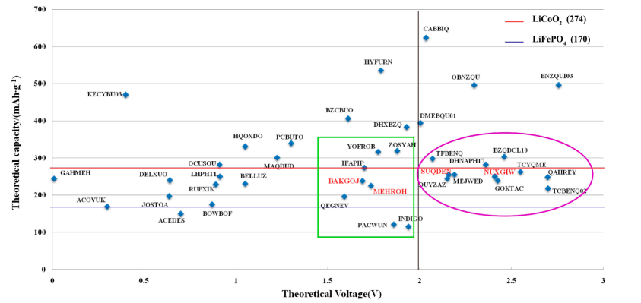
Figure 4-11 – Organic crystalline option Vs LCO and LFP
In Figure 4-11, each datapoint’s name is abbreviation for a compound. For example, Benzocyclobutene-1,2-dione is full name of (C8H4O2, BZCBUO) and also 2,5-dihydroxy-1,4-benzoquinone is full name of (C6H4O4, DHXBZQ). Full list of their names is available in article.
Shaorui et al argue that 2,3-butanedione (C4H6O2, CABBIQ) has a high capacity, it is a liquid at room temperature and cannot be used as the electrode material. The capacities of o-benzoquinone (C6H4O2, OBNZQU) and p-benzoquinone (C6H4O2, BNZQUI) are both 496 mAh/g but they have relatively high band gap which is not suitable for cathode selection. Options exist in purple ellipse, eventually has selected to be final candidates for lithium- ion batteries cathode due to their high voltage, decent capacity and ideal band gap. In purple ellipse in Figure 4-11, has highlight two special materials due to their small band gap which is considered to be ideal candidates to be experimented for lithium-ion batteries: 2-(2-(phenyl)ethenyl)-(1,4)-benzoquinone (C14H10O2, SUQDEN) and 7,9-dithiabicyclo(4.3.0)-nona-1(6),3-diene-2,5-dione-8-thione (C7H2S3O2,NUXGIW)¹¹⁸.
In next step we want to present Rodrigo P. Carvalho et al⁹⁴ article that we found one of the most creative articles in this field. In this work, Natural Language Processing (NLP) based on structure and bonds has been applied to predict reduction potential for more than 26000 organic compounds. In this system, Simplified Molecular-Input Line-Entry System (SMILES) will be given to NLP and NLP will learn to decompose structures into bonds and atoms into coded embedding vectors. This embedding vector will be given into Artificial neural network (ANN) layers to predict reduction potential which is one of the most important criteria for cathode selection. Schematic of this work can be presented in Figure 4-12. Mentioned process with accuracy of R² =0.88 for test, is one of the most accurate works for vast amount of data:
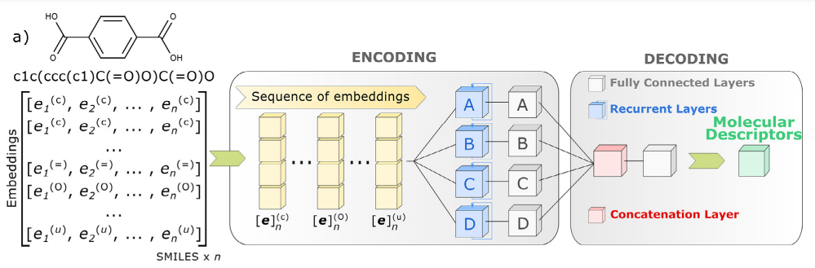
Figure 4-12 – Process of applicated NLP⁹⁴
Moreover, there are other articles regrading application of ML in lithium-ion batteries. Figure 4-13 shows part of ML predictions in Lithium-ion batteries. Full list of articles including achievements is available¹¹⁹:

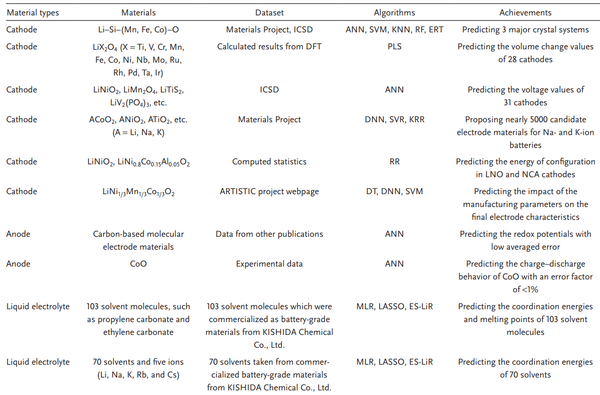
Figure 4-13 – conducted researches for ML application in LIB¹¹⁹
Conclusion
In recent years, several organic groups have been identified as candidate for LIB’s cathode which can be divided into p-type, n-type and b-type. DFT as a versatile tool can play important role in specifying suitable organic molecule. One of the biggest problems related to DFT is computational time which make it not suitable for processes like screening. Trained ML, based on DFT can assist to accelerate processes to select best candidates that worth to be experimented.

Chapter 5: Critical review of current approaches to apply ML solutions in the design of LIB cathodes
Introduction
Although machine learning (ML) can be a great tool for predicting properties, it is not recommended to use single ML algorithms for a problem. The main reason is because not all algorithms work for every problem and wrong algorithm selection can lead to inefficient prediction protocols for properties. If the training process leads to overfitting, the problem of inefficient predictions remains. For example, in an article for finding initial discharge capacity using machine learning, six ML algorithms resulted in different accuracies in Table 5-1 (in Table 5-1, GBM is Gradient boosting algorithm, RF is Random Forest, SVM is Support vector machine, KRR is kernel-ridge regression, KNN is K-nearest neighbors and ANN stands for artificial neural network). In Table 5-1, using algorithms ANN for predicting 50th cycle end discharge is not optimized due to its low accuracy:
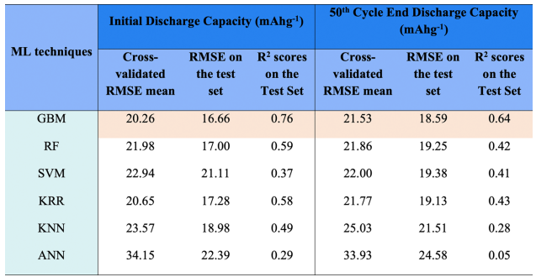
Table 5-1 - Comparisons of the Mean RMSE Values during the 5-Fold Cross-Validation and for Testing against the Holdout Test and the R2 Test Score Computed by Six Nonlinear Models, for the Prediction of Initial Discharge Capacity and the 50th Cycle End Discharge Capacities of Doped NCM Cathode Systems¹²⁰
In this chapter, a review on Omar Allam et al work that has studies on predicting density functional theory (DFT) based redox potential by ANN for 114 cases is presented¹¹³. We also investigate alternative solutions that fit this problem better and are robust and flexible.

Dataset
Articles dataset which is available in supplementary information of article consists of the following features:
- highest occupied molecular orbital (HOMO)
- lowest unoccupied molecular orbital (LUMO)
- electron affinity (EA)
- HOMO-LUMO gap
- Number of aromatic rings
- Number of carbons
- Number of oxygens
- Number of boron
- Number of hydrogens
- Number of lithium
After reviewing the complementary material, it is found out that just 106 data was present in found in dataset but we assume that missing data would not have large effect on evaluation metrics.
First 4 features are all in eV and has been calculated using DFT software. “Jaguar software with PBE0 was used to calculate the exchange correlation interactions and 6-31+G(d,p) basis set. All the organic materials of our interests were geometrically optimized in both neutral and anionic phases followed by vibrational frequency calculations to evaluate the reduction free energies at 298 K in the gas phase”¹¹³. In this article, redox potential (in Volt) is target variable to be predicted by mentioned features. This is an important property for batteries as it shows potential (tendency) of molecule for decomposing electrochemically in cathode or anode¹²¹.
Improvement Proposals
In this chapter, several improvements have been discussed to this study:
- First improvement is addressing algorithm selection. ANN algorithm is used in this study to predict redox potential with low error but it seems that it is not optimized algorithm for this dataset due to size of dataset.
- Second improvement suggestion is about training data. As the article mentioned, 108 datapoint of 114 datapoints were used for training and just 6 data points were used for testing algorithms accuracy. In ML, we use train data for fitting a relation and test data for evaluating and common ratio for test and train is 20-30% to evaluate the model although higher ratios may be used in some models¹²² but here ratio of test to train is about 5.2% which is not even close to 20 %.

The reason why ANN may not be perfect algorithm for this dataset is due low number of datapoints in model and 77 parameters due to structure of model that should be determined. Articles ANN structure is shown in Figure 5-1:
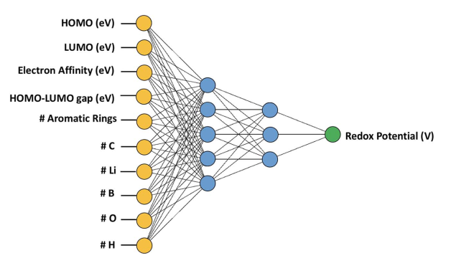
Figure 5-1 – architecture of ANN algorithm in article¹¹³
In Figure 5-1, yellow circles are input layer. As it shown in Figure 3-9 with weights and biases, first hidden layer with 5 nodes (blue circles) and then second hidden layer with 3 nodes can be calculated. In final stage, redox potential as output layer (green circle) can be obtained. Considering Figure 3-9, total number of weights and biases will be:
$$Total weights=n( \sum_{i=1}^{10}{\sum_{j=1}^{5}{W_{ij}}})+n(\sum_{k=1}^{5}{\sum_{l=1}^{3}{W_{kl}})}+n(\sum_{m=1}^{3}{W_{m}})=50+15+3=68$$
$$Eq5-1$$
$$Total biases=5+3+1=9 Eq5-2$$
In Eq5-1, $n()$ is counting operator, and $W_{ij}$ is the weight connected from node $i$ in previous layer to node $j$ to in next layer. For example, considering Figure 5-1, $W_{63}$is weight that connects number of carbons to third (middle) node in first hidden layer. In order from left to right, first summation is total number of weights between input layer and first hidden layer, second summation is number of weights between first and second hidden layer and third summation is number of weights that connects second hidden layer to output layer. Considering one bias for each node except input nodes, total number of biases will be nine.
As mentioned, totally there are 77 parameters to be determined by model in training process. As there are just 108 datapoints in model, loss might not be minimized. We want to explore and search between simpler algorithms to compare them with ANN in this article to find optimized algorithm for this dataset.

Methods
We used python 3.11 with PyCharm (edition 2023.1) program for ML process. All of codes will is shared using GitHub link in the end of this file. As number of features are relatively high, Dr Omar Allam et al has decided to find best feature combination for feature selection process using contribution analysis by investigating of error of neural network by removing input variable. Finally features include HOMO, LUMO, gap of HOMO-LUMO, EA and number of oxygen and lithium atoms and the rest are ignored. As feature contribution (selection) may differ from one algorithm to another, our next step was to select the best features for each algorithm. For simple linear regression (SLR), as Pearson correlation coefficient was in article but for ensuring results, we add new Pearson correlation chart with heat map (Figure 5-3):
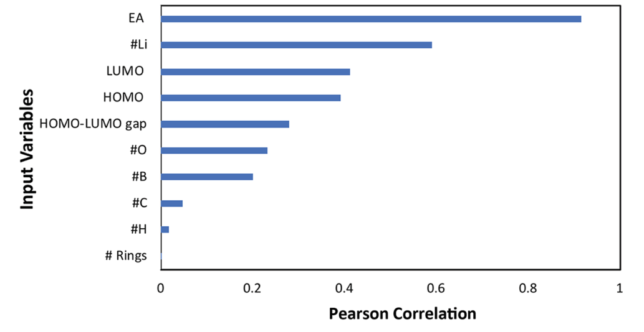
Figure 5-2 – Input variables Pearson correlation against redox potential¹¹³
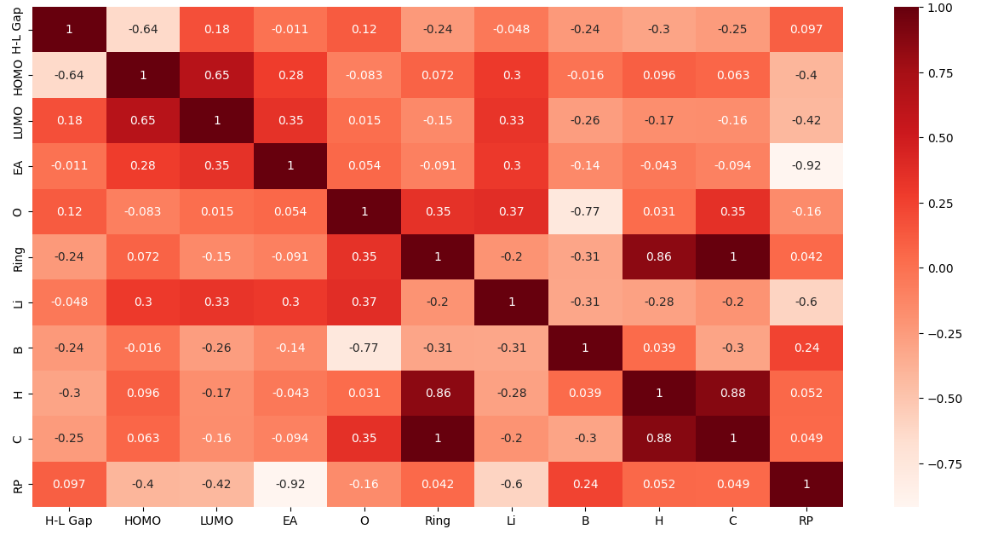
Figure 5-3 – Input variables Pearson correlation against each other
In Figure 5-3, H-L gap, EA, O, Ring, Li, B, H, C and RP in order are representing HOMO-LUMO gap, electron affinity, Number of oxygens, number of aromatic rings, number of lithium, number of boron, number of hydrogens, number of carbons and redox potential.
In our heatmap chart (Figure 5-3) as rectangles color getting darker, two features are more correlated directly and as it gets brighter two features are more correlated reversely. It means that as one of them increase, other one will decrease. Zero number’s color in heatmap bar means there is no correlation between two features. Aromatic ring is also completely correlated with number of carbons. This happens because base structure of aromatic rings is totally based on carbons Our chart’s value is pretty similar to articles result, demonstrating that article’s feature selection was good enough for satisfying results. There are some differences in values like oxygen which can occur because of missing data in system.
Considering for SLR, both Figure 5-2 and Figure 5-3 demonstrate that EA is more correlated with redox potential than other features linearly. By plotting electron affinity versus redox potential, Figure 5-4 will be obtained:
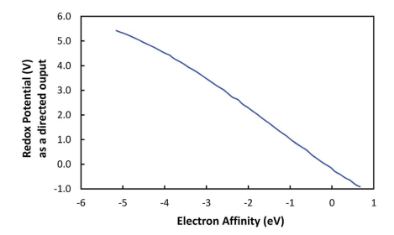
Figure 5-4 – Electron affinity versus redox potential¹¹³
As it is shown in Figure 5-4, diagram is not completely but considerably linear but if we consider it for another pair of features, for example number of oxygens and redox potential with Pearson correlation of -0.16 which means almost there is no correlation between them. Sketching these features versus each other in Figure 5-5 will prove this argument:
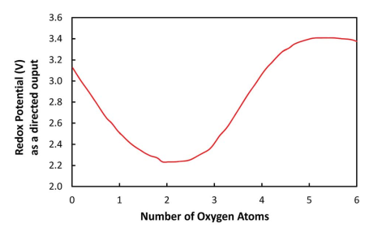
Figure 5-5 – Number of oxygens versus redox potential¹¹³
As expected, Figure 5-5 shows that there is no relation between number of oxygens and redox potential. It should be mentioned that in plotting process for Figure 5-2 and Figure 5-3, other features considered constant.
Here we use simple linear regression (SLR) which we discussed about its feature selection, random forest (RF), gradient boosting decision trees (GBDT) and kernel ridge regression (KRR). KRR can be defined as ridge regression but using other kernels than linear that we reviewed on ridge and lasso regularizations. Kernels in KRR can be exponential, polynomial, sigmoid, radial based functions and etc.
For RF, GBDT and KRR, best features may not be the same features for ANN. We studied feature importance to select optimum features for each algorithm. Trial and error method were also used to find suitable features.
SLR feature importance introduces EA as the best feature considering Pearson correlation charts in Figure 5-2,3,4. For Tree based algorithms, feature importance was done by scikit-learn, machine learning library, decision trees / random forest can be used to assess feature importance. The result of feature importance can be shown as Figure 5-6 and 5-7 for GBDT and RF algorithms:
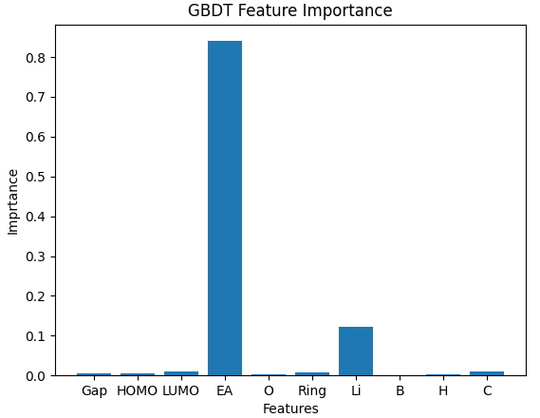
Figure 5-6 – Importance of features for GBDT algorithm
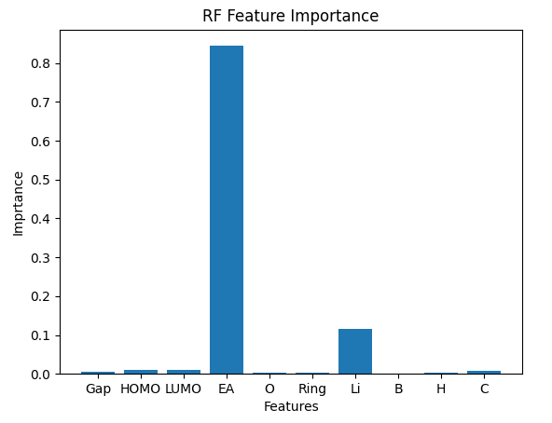
Figure 5-7 – RF feature importance
Except finding feature importance, different combinations were tested to find out which set of features are ideal for each algorithm. Also, hyperparameter tuning is done for all trials to prevent overfitting for judging equally. We used grid search CV method from scikit-learn library for cross validation with CV=5 for all algorithms. Grid search CV combines all possible tuning combinations to find best hyperparameter set for mode. Because number of datapoints are relatively small, higher CVs may be used in order to validating algorithm which is mentioned where it is used. In large dataset, because of high computational cost, low CVs are preferred.
Experimental results and analysis
For each set of features combination R-squared and MAE are calculated as criteria for feature selection. Also, Ridge and Lasso regression (regularizations) performed to prevent SLR overfitting. Also, we should mention that for KRR, input data has been scaled using StandardScaler while there is no need to scale data for decision tree-based methods like RF and GBDT. Here is one of sample of code with explanation. Other algorithms have been defined in same way with different codes related to each algorithm.
About 30 different combinations were tested for each algorithm. Finally, best combination of features selected using R-squared and MAE with train and test split. 25 percent of datapoints kept out for test process. For feature selection part, if two or multiple combinations have same R² and MAE, the feature set with more structural data (non-DFT data) will be selected. For each set, all combinations with their metrics and their related hyperparameters also exists in “Result” excel file which will be in attached. Best features and their hyperparameters for each algorithm are written in Table 5-2 and Table 5-3:
Algorithm | Feature | Hyperparameter
RF | EA-Li-LU-C | 'bootstrap': False, 'max_depth': 8, 'max_features': 'log2', 'min_samples_leaf': 2, 'min_samples_split': 3, 'n_estimators': 200
GBDT | EA-LU- Li-O-C-ring-H-B | {'learning_rate': 0.2, 'max_depth': 2, 'min_samples_split': 3, 'n_estimators': 150}
KRR | EA- Li-O-C-ring-H-B | alpha=0.1, coef0=3, degree=2, gamma=0.1, kernel='poly'
Table 5-2 – best features for each algorithm with its related hyperparameters
And their accuracy is:

Algorithm | R²-Train | R²-Test | MAE_Train (Volt) | MAE_Test (Volt)
RF | 0.999 | 0.931 | 0.077 | 0.185
GBDT | 0.999 | 0.979 | 0.018 | 0.124
KRR | 0.992 | 0.992 | 0.047 | 0.063
Table 5-3 – R² and MAE for train and test for each algorithm
The article used R² to evaluate train accuracy (R²=0.9616) and MAPE for the test accuracy. Article trained 108 datapoints and then has selected 6 datapoints from beginning, that was not touched for test process. Here we first mentioned six test data are separated from main dataset. Then for main dataset, train and test operation were performed considering 25 percent of datapoints for test operation. Then we will predict article’s 6 datapoints using trained ML to compare it with article’s test results. After mentioned processes was done, final results obtained for each algorithm has shown in Table 5-4. In Table 13, yellow column is real values which is predicted by DFT and green column us article’s result. All other white columns are different algorithms which have been used in our framework. R² and MAE for train and test process also has calculated for each algorithm. Here it should be mentioned that for article’s results just R² for train process exists.
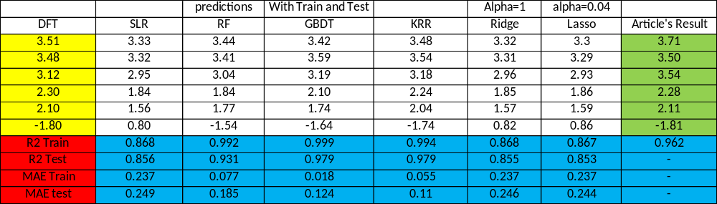
Table 5-4 - Result of six tested data for different ML algorithms and comparing percentage error pf each result vs DFT results
For better visualization of these data, first we start our work with R-squared in Table 5-4. Blue bars indicate training R-squared for training and orange bars are representing test R-squared. In Table 5-4, yellow column is for real DFT values (real output) and other columns are predictions by each algorithm.
Here as there is no test R² for testing ANN (because article has selected MAPE for test criteria) we do not consider and compare for ANN due to low number of datapoints for ANN. Lasso (with alpha =0.04), Ridge (alpha=1) and LR also has nearly same performance. In Figure 5-8, RF, GBDT and KRR has slightly better performance than ANN in training with mentioned features:
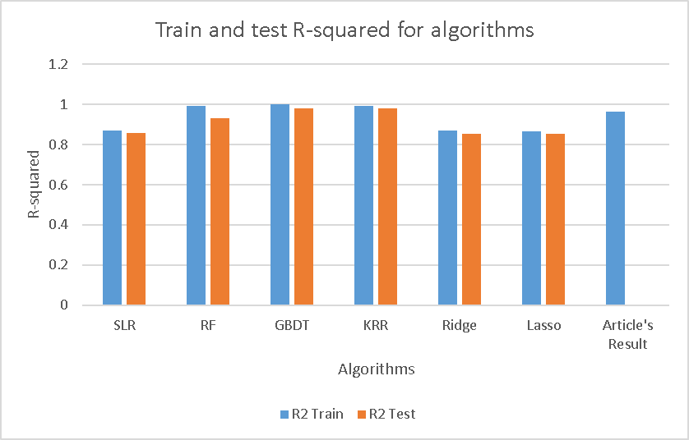
Figure 5-8 – Result of accuracy of trained algorithms
Next, we will discuss about MAE for train and test. Figure 5-9 shows us MAEs for these algorithms. Although hyperparameter selection has been done, RF and GBDT seems to have overfitting. This problem happens because there is not too much data for train and test not because any problem in hyperparameter tuning selection process. Here KRR is optimized algorithm because there is no overfitting and lowest MAE test among other algorithms.

Figure 5-9 – MAE for different algorithms
SLR, Ridge and Lasso prediction values obtained by EA and other algorithms best on their selected features and hyperparameters. Also ridge and lasso performed on this dataset and have same answers with SLR. For calculating error percentage for these 6 datapoints we will use Eq 5-3:
$$error \%=\frac{\left|real amount-predicted amount\right|}{real amount}×100 Eq5-3$$
In final comparison state using article’s criteria for testing using 6 data prediction which is shown in Table 5-5, while Ridge, Lasso and SLR was not suitable algorithm for this dataset, GBDT and RF algorithm’s performance was close to ANN but KRR was even better than ANN. With 75 trained data vs 108 trained data, KRR algorithm has better R-squared and percentage error than ANN and this model should be selected for this dataset. In Table 5-5 green row shows average percentage error for 6 data.
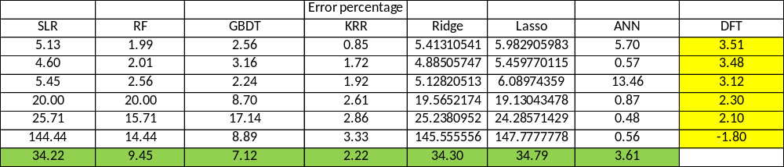
Table 5-5 – Error percentage for algorithms prediction
In this stage also for better visualization we prepare to chart to analyse. First one, which is more general, we have calculated error percentage of all algorithms in Figure 5-10 for mentioned six datapoints which have been used for testing process. Each number of DFT column in Table 5-5 represents one of test datapoints in Figure 5-10:
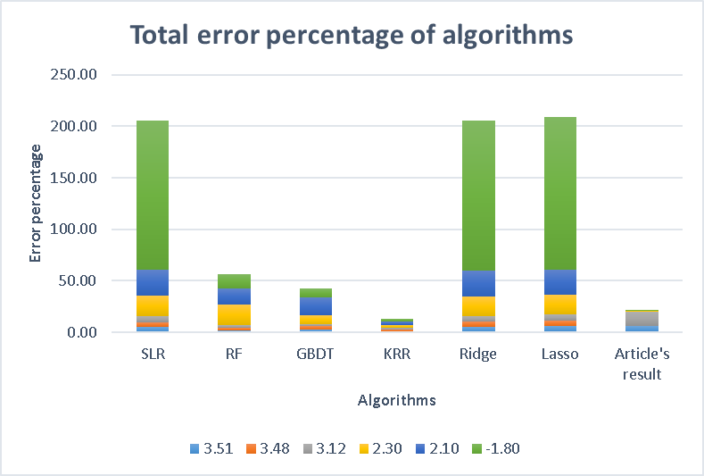
Figure 5-10 – Total error percentage for different algorithms
In Figure 5-10, because of high error percentage of SLR, Ridge and Lasso, it may be hard to give our opinion about how other algorithms are performing. So, we prepare another chart by omitting these three algorithms. Results are better for comparing in Figure 5-11:
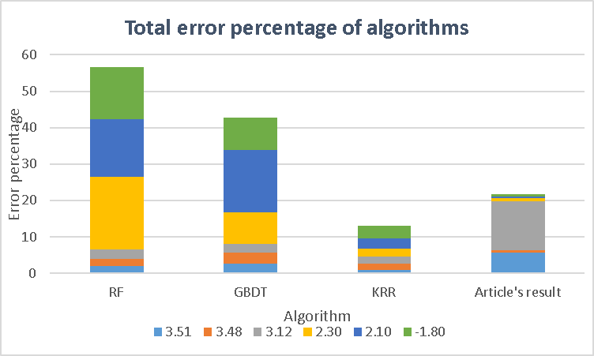
Figure 5-11 – Total error percentage of algorithms
Another reason for this question that why KRR is better is because none of its prediction’s errors are above 5 percent while in ANN it may give answers till 15 % error. Although 6 datapoint are not enough to judge about algorithms, it seems that KRR algorithm has lower fluctuation in predictions.
After selection process, best answers here by accuracy have obtained by KRR among other algorithms. Figure 5-12 shows answers (in console) with parts of code in python:

Figure 5-12 – Results of KRR
Conclusion
Algorithm selection is one of the most important parts in ML. Not all algorithms are suitable for all models. In this study we reviewed an article which uses ANN to predict redox potential to find suitable organic cathode for lithium-ion batteries. Article’s prediction had high accuracy in terms of R² and MAE but as number of datapoints was relatively low, we considered that it may not able to adjust weights and biases perfectly. After searching other algorithm’s results, we demonstrated that KRR algorithm can predict slightly better than ANN.

Chapter 6: Developing economical artificial intelligence for all organic compounds to calculate reduction potential
Introduction
Organic realm with its high variety always has been attracted scientists for material selection. LIB’s electrodes are another project that scientists are referring back to organic materials to find suitable compounds. As number of organic compounds are in order of millions, machine learning can be used for the screening process to select compounds that are worth experimenting with or searching for. In previous chapter a ML model have developed for 114 datapoint for organic structures in order to high throughput screening process but an algorithm which its learning is based on 114 datapoint cannot satisfy all learning aspects for organic structures. In this chapter our goal is to develop artificial intelligence to be used in screening process to predict reduction potential for all organic compounds.
Idea for screening process have been inspired from screening funnel in Figure 6-1. Important subject about Figure 61 is computational cost for screening process. Less accurate algorithms with no DFT data can be used for initial steps in screening process which will decrease cost optimally but their accuracy should satisfy conditions for screening process:
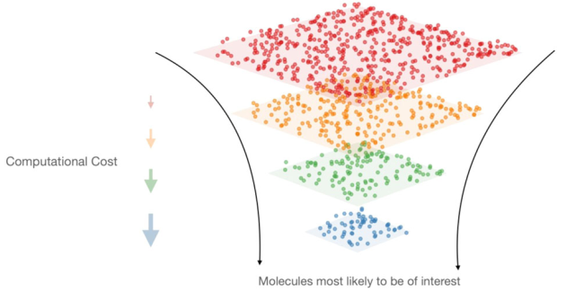
Figure 6-1 – Screening funnel considering computational cost during process¹²³
Parameters which have been calculated based on DFT will increase computational cost and they are suitable for final stage of screening. One example of this method can be demonstrated in previous chapter.
In this study we will train an artificial intelligence for first stage of screening. We developed and trained our algorithm based on more than 26000 datapoints. Organic structures in our model are representing all organic functional groups include alcohols, acids, ethers etc.

The article we are using its dataset, has used ANN as algorithm but with different approach comparing with previous chapter. In this article ANN used as natural language processing (NLP). In this method every structure is considered as a vocabulary. Each structure consists of atoms as each vocabulary consist of alphabets. So, elements here are playing role of alphabets. In language, although two words have same alphabets like “night” and “thing” (both have g-h-i-n-t), they have different meanings. For structures, two molecules can have equal number of carbons, oxygen and hydrogen but because they are built differently like ethers and alcohols functional group, they will have different value (here value can be considered as reduction potential). This is absolute beauty of science when machine tries to learn and tries to find meaning of structure and tries to connect it to a property.
After breaking down of each structure in training process for NLP, all elements (alphabets) will be gathered. In next step all alphabet parts (elements) will be indexed. Then each structure will convert to a vector of numbers to ANN for prediction. For example, a SMILES like Cc1ccccn1, describing 2-methylpyridine, will be separated to: [C, c, 1, c, c, c, c, n, 1], which result in alphabet of [1, C, c, n]⁹⁴. After list of alphabets completed, each alphabet will be indexed with a number. For example, mentioned 2-methylpyridine SMILES would be translated to [2, 3, 1, 3, 3, 3, 3, 4, 1], by using [1, C, c, n] alphabets with index as Eq6-1:
$$\left\{\begin{aligned}'C'=2 \\ 'c^{'}=3 \\ 'n^{'}=4\end{aligned}\right. Eq6-1$$
“Finally, an embedding system is employed to transform each vocabulary element into a new unique n-dimensional vector of scores, named embeddings. These scores represent an unknown characteristic that will be adjusted during the training phase in such a way that the neural network is responsible to learn the meaning of each vocabulary entry and how it is connected to the desirable property”⁹⁴.
Coulomb matrix and many body tensor representation also have been investigated by article for neighbour atoms interaction calculation. If these kinds of methods can be capable for other properties, ML would be a great source for predicting properties of compounds. Dataset of the article can be found in reference number 125 with the name of OMEAD_26218.csv.
Simplified molecular input line entry system (SMILES) of compounds here represents molecule. In SMILES uppercase letters like C and O are atoms in the parent chain and lowercase letter like n and c atoms in rings. Whenever also an atom is in parenthesis, it means that it has been branched from parent chain. It should be mentioned that no hydrogen is shown in SMILES. Reading SMILES for understanding its structure can be easy in small structures for example, structure for SMILES in below is Figure 6-2:
$$SMILES: CCCCCC(=O)OCC$$
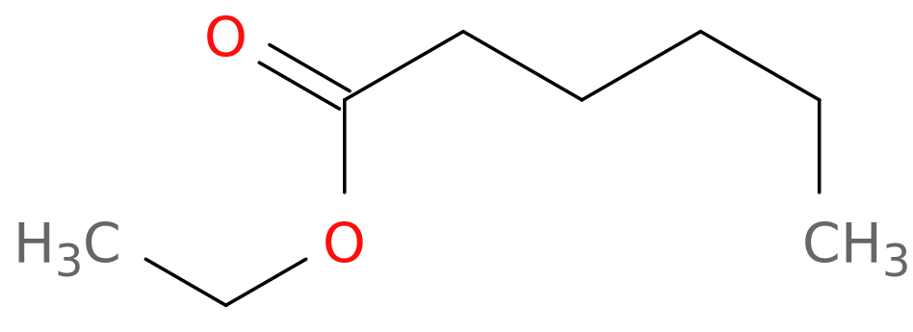
Figure 6-2 – example of simple SMILES and its structure
In reference number 124, there is a website which can covert SMILES to 2D structures. For bigger SMILES, understanding structure can be truly hard. For example, SMILE in below is Figure 6-3:
$SMILES:$N#CC(=C(C(=C(C#N)C#N)c1ccc(cc1)N(c1ccccc1)c1ccccc1)c1ccc(s1)c1n(CC)c(=O)c2c1c(=O)n(c2c1cccs1)CC)C#N
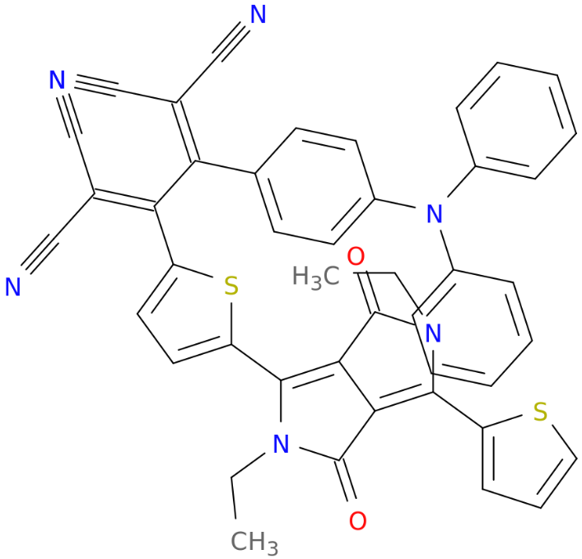
Figure 6-3 – complicated SMILES and its structure
Methods
First for feature part, as we said, all features will be extracted from structure of compounds. Figure 4-5 inspired us to think about how features should be generated. As structure with special functional groups were at the center of attention, we decided to select functional groups as models features. As compounds like alkanes has no special functional groups, we decided to add features that can represent whole structure of compound. These features are number of elements and molecular weight each compound. All of these features have been extracted by coding in python 3.11 with PyCharm 2023.1 from simplified molecular input line entry system (SMILES) of compounds. In this study reduction potential, which plays important role for cathode selection will be predicted for all organic materials.
Here for DFT reduction potential “calculations in this stage were carried out using the Gaussian16 software package with the B3LYP functional and the 6–31G(d)/6–311G(d,p) Pople basis set theory level while keeping molecules in the gas phase”⁹⁴.
Our approach for solving this problem is to add functional groups of SMILES to generate applicable dataset for regression process. The whole idea was based on this theory that most important effect for changes in reduction potentials can be functional groups. Path of project for first step was to find all functional group of a structure but as we saw in previous parts, understanding bigger SMILES can be truly challenging. Obviously, it is not possible to convert more than 26000 SMILES to 2D structures and then find their functional groups one by one. As there are no hydrogen in SMILES, finding organic functional groups using pattern for some groups which contains hydrogen like alcohols, acids, aldehydes, amines etc. can be so hard.
Another challenge for finding functional groups was complicated organic structure that couldn’t be counted as a familiar functional group. There was multiple kind of these structures in SMILES which we will see some instance of these kind of structure like Figure 6-4:
$$SMILES 1:Brc1sc(=O)n2c3c1[nH]c(=O)c3cnoc2=O$$
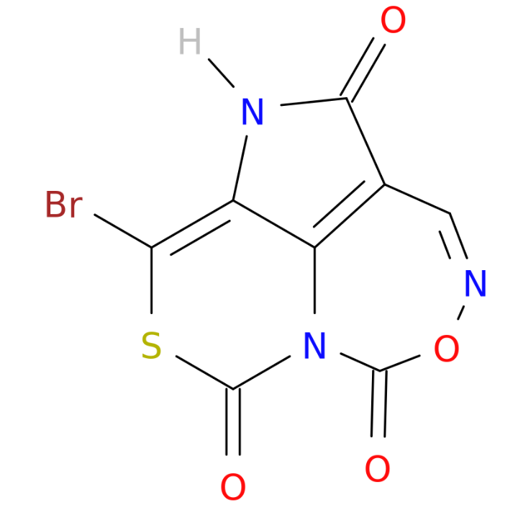
Figure 6-4 – organic structure with complex functional group
This SMILES is even hard to find functional groups based on its structure. These kind of structures acts as an obstacle for finding exact value of functional groups in structures. Although it is hard to find number of functional groups because of mentioned reasons, we decide to find them using python and generate dataset for our prediction. Our dataset contains more than 40 features such as number of atoms, functional groups and molecular weight. List of total known functional groups are: Azo – aromatic rings (benzene) – non aromatic rings – nitrile – alkyne – alkene – ketone – aldehyde – anhydride – carbonate – Imine – amide – ester – ether – alcohol – amine – imide – acid and nitro. Number of carbons, hydrogens, nitrogen, oxygens, sulphur, halogens, lithium and sodium with molecular weight also added to dataset.
This method has some limitations considering natural language processing. First it can not distinguish reduction potential between to structural isomer. For example, in Figure 6-5 there are two structures which have same number of rings, functional groups and atom numbers but different reduction potential:
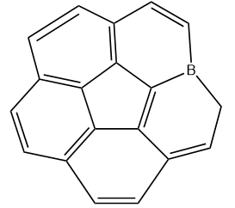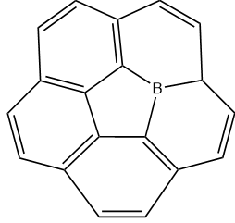
Figure 6-5 – two isomer structure with different redox potential
In Figure 6-5, left structure has redox potential of 3.32 while right structure has redox potential of 2.90. Another limitation of this method is to classifying all kinds of non-aromatic rings in one group which is not correct because some rings have nitrogen, some has oxygen and other may be cyclohexane which all of them has been classified as non-aromatic ring. Third limitation is that all groups may not be extracted from SMILES for upgrading performance.
Existence of strange structures in Figure 6-4 is first problem that should be solved. We have developed an algorithm for identifying these kinds of structures and add them to dataset as a feature. Some name and their related structure of these groups in final dataset are:

- NCONCONCO: 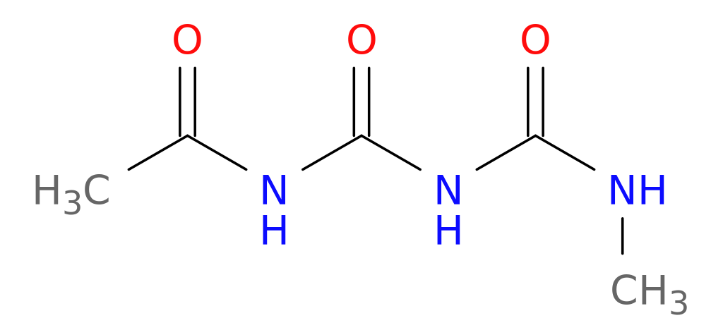
- NCONCON: 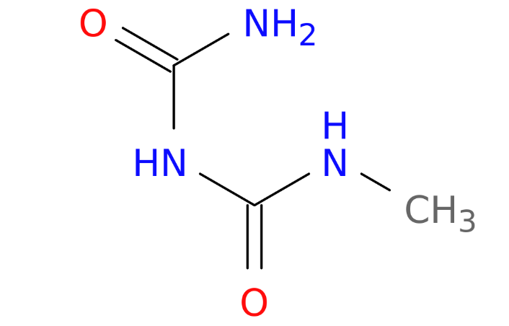
- SCOC: 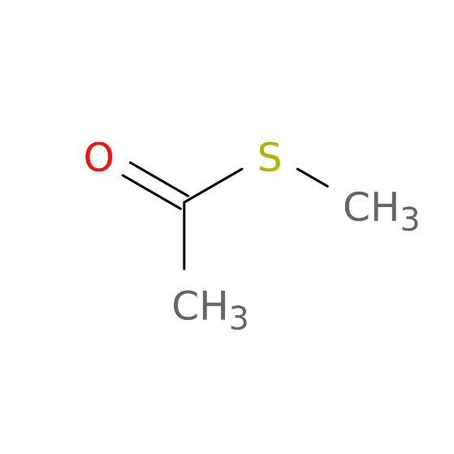
- OCOON: 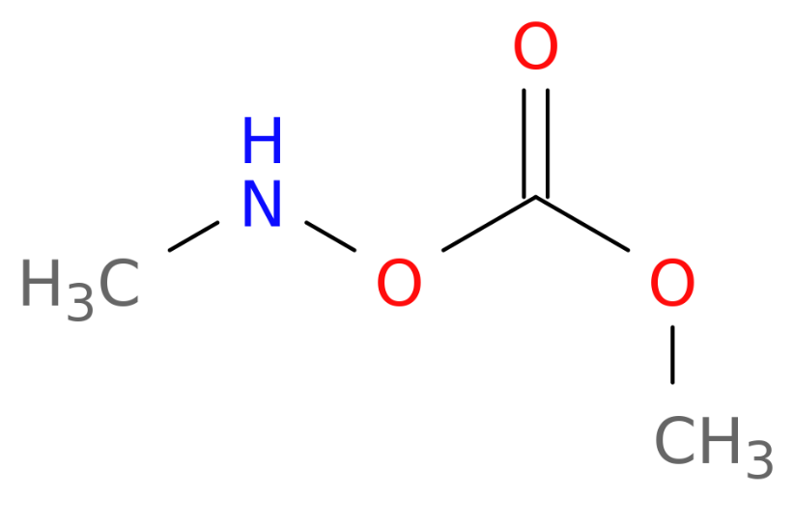
- CON: 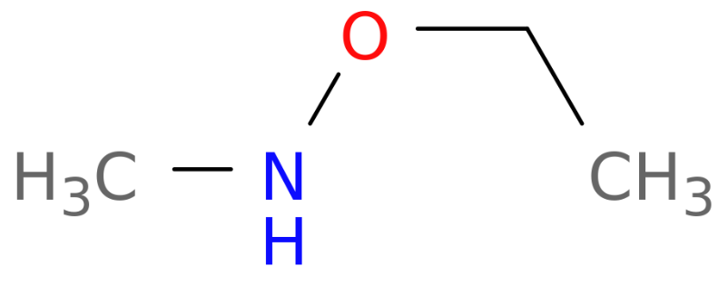
- NOCONCO: 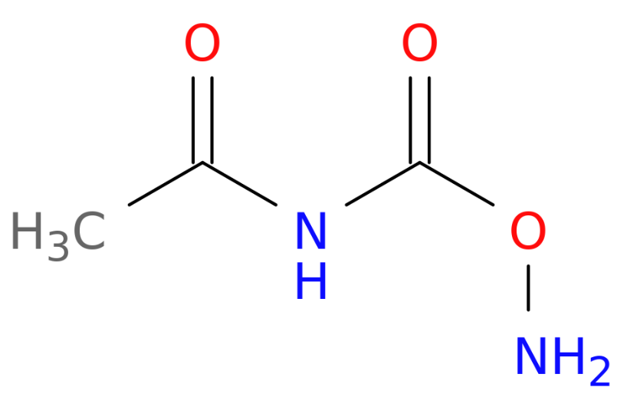
- NCOON: 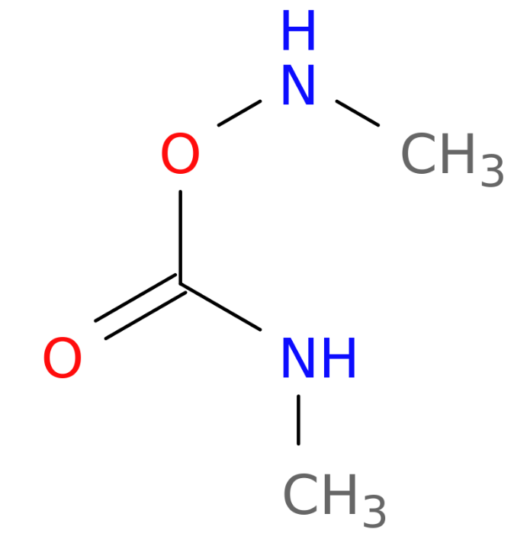
After generating dataset, we filtered features by eliminating features less than one percent (300 datapoint) contribution in whole dataset. Just acid and lithium containing groups passed to final dataset as exception. Then we used principal component analysis method to reduce number of features and time cost.
In next step we decided to cluster datapoint in order to find clusters including functional groups. This work might help us to find more accurate results for each functional group. We used KMeans algorithm for clustering to obtain our results.

Experimental Results and analysis
First as there are 31 features for our model, algorithm may be confused to use features optimally. In this stage, we used principal component analysis (PCA) method to reduce number of features. Figure 6-6 shows us how many components (features) we can select that covers the variance of main dataset.
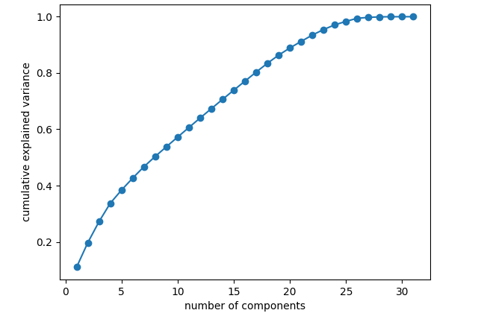
Figure 6-6 – Number of components vs explained variance
Optimal number for component number is 21-24. In this number 90-95 percent of data can be covered by components while number of features will reduce from 31 to 21. We want to test our results with and without PCA.
Using original features, first ML applied on final dataset using RF, GBDT, KNN and KRR algorithms. Just like previous chapter, hyperparameter tuning and scaling performed when it was necessary. In table 15, list of hyperparameters (with CV=3) of each algorithm has been written. Also, their MAE and R² has been listed in Table 6-1 with best hyperparameters:
 | Hyperparameter
RF | bootstrap': True, 'max_depth': 8, 'max_features':auto, 'min_samples_leaf': 5, 'min_samples_split':2 , 'n_estimators':200
GBDT | learning_rate': 0.05, 'max_depth' :6, 'min_samples_split': 3, 'n_estimators':150
KRR | alpha':0.05, coef0: -1, 'degree':2, 'gamma':0.1, 'kernel':'polynomial'
KNN | algorithm: 'ball_tree', metric='manhattan, n_neighbours=23
Table 6-1
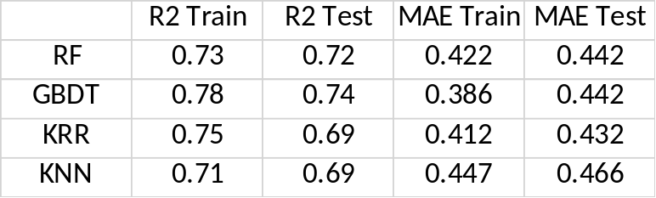
Table 6-2
$$Features :C-O-Li- Ring-B-H$$
 | R² Train | R² Test | MAE Train (V) | MAE Test (V)
GBDT | 0.767 | 0.558 | 0.385 | 0.663
RF | 0.763 | 0.460 | 0.426 | 0.764
KRR | 0.612 | 0.400 | 0.418 | 0.610
Table 6-3
All algorithms approximately give us same results considering R² and MAE but GBDT here is slightly better especially considering R². In previous chapter, result of ML using non-DFT features can be demonstrated as Table 6-3. Considering limitations and comparing R² Test in Table 6-3, result of Table 6-2 seems to be improved.
As answers was approximately same, we decided to use a new ML algorithm. We decided to use stacking ensemble learning which is method using combination of ML algorithms, seeking for higher accuracy. Figure 6-7 shows how stacking ensemble works:
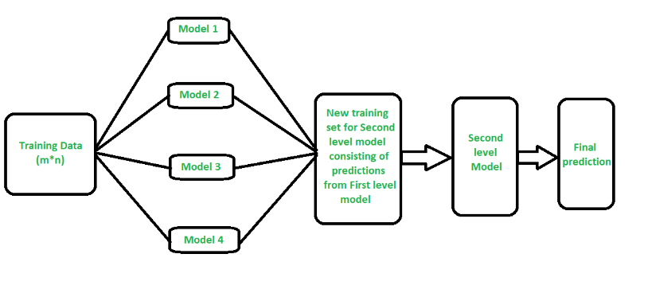
Figure 6-7 – architecture of stack ensemble learning ¹²⁶
In stacking ensemble learning, prediction of each model will be feature to a final algorithm for final prediction. We applied ensemble learning twice for better prediction with combination of 4 tested algorithms. In Figure 6-8 we show the path for this part. We once use LR as final algorithm and once GBDT to optimize predictions.

GBDT
Train Prediction
KRR
Train Prediction
Stack algorithm
Final prediction
RF
Train Prediction
KNN
Train Prediction

Figure 6-8 – diagram of our work
In next step we define RF, KRR, KNN and GBDT with their optimized hyperparameters which had been mentioned in Table 15. For this stage, stack learner is defined with its 4 base models which has been defined with their names. As final algorithm, once GBDT and once LR has been tested. In next lines of the code first we define time system to calculate process time and after data training for each algorithm. This process has been done with MacBook MKGQ3 M1Pro 2021. Then we use R² and MAE for model for checking its accuracy. This process is also done for final stack learner. Answers for LR as final estimator for each part are in Table 6-4: (computation time is in s)
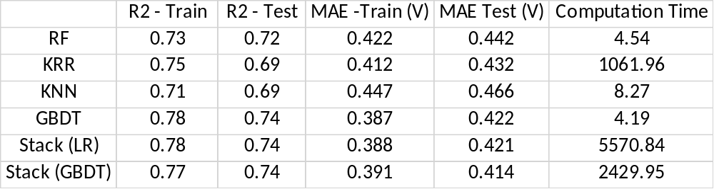
Table 6-4 – accuracy and computation time of each algorithm
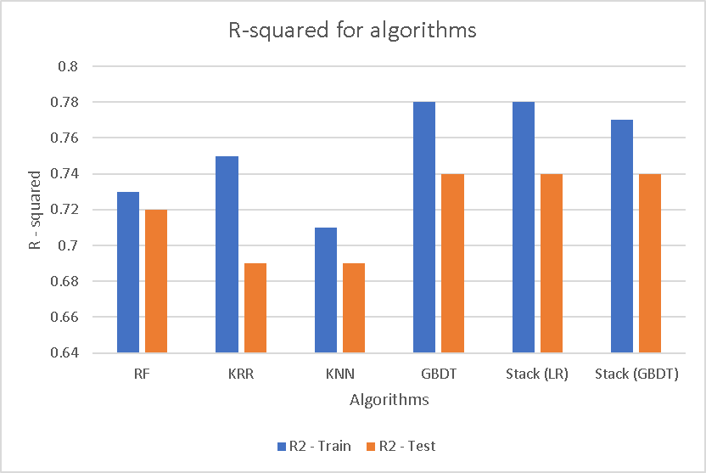
Figure 6-9 – Train and test R-squared for participating algorithms

Figure 6-10 – Train and test MAE for algorithms
Figure 6-9 and Figure 6-10 shows us R-squared and MAE for participating algorithms. Unfortunately, none of stacking methods could help us to improve our model efficiency but due to limitations results are acceptable for this work. Totally considering, GBDT is best method for calculating due to its high accuracy in R² and MAE and low time cost due to Table 18 for this work.
In Figure 6-6 which we mentioned above, 15 components will just explain 74 percent of dataset’s variance. There is no special rule but generally number of component selection in a number that cover between 90-95 percent of variance. Considering that ideal number of components will be between 21 -24 components. Here we have calculated R-squared and MAE for 15-29 components using GBDT algorithm due to its fast and accurate answers which its diagram has shown in Figure 6 - 11 , 12:
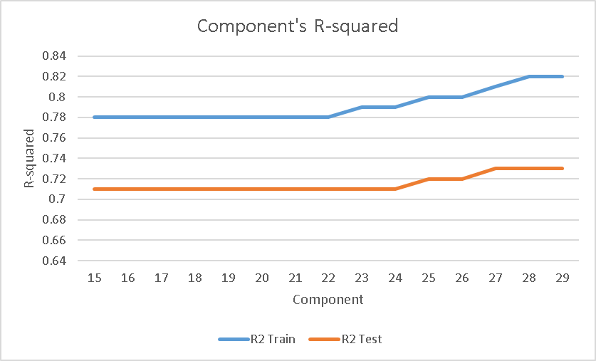
Figure 6-11 – Train and test R-squared for PCA components

Figure 6-12 – Train and Test MAE for PCA components
Unfortunately, PCA does not assist us to improve model accuracy. Figure 6-11,12 results are not better than main results which means that model has not been confused for selecting features. Another reason which why PCA can not assist us is low computation cost of GBDT which disables any help for lowering time cost.
For clustering first challenge is to find number of clusters. For this work we used two methods: Elbow method and Silhouette coefficient for validating each other. First starting with Elbow method, we have:
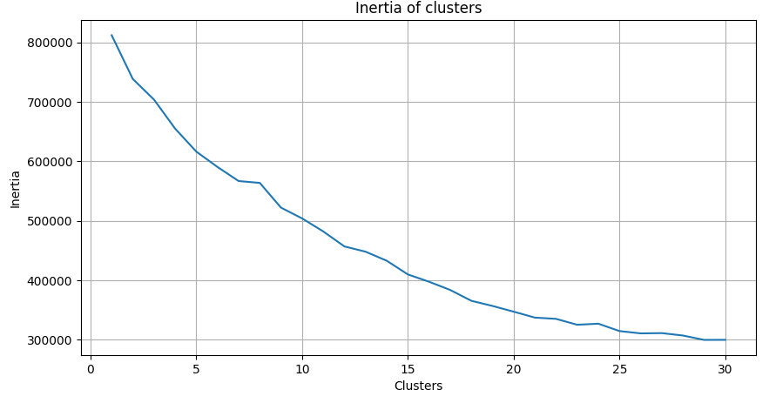
Figure 6-13 – Elbow method for selecting number of clusters
In Elbow method for selecting number of clusters, elbow point or optimum number of clusters, should be a cluster number that after that inertia moves almost parallel with number of clusters. In Figure 6-13, it is hard to say exact number of clusters but it seems 20 number of clusters should be a good choice for our work.
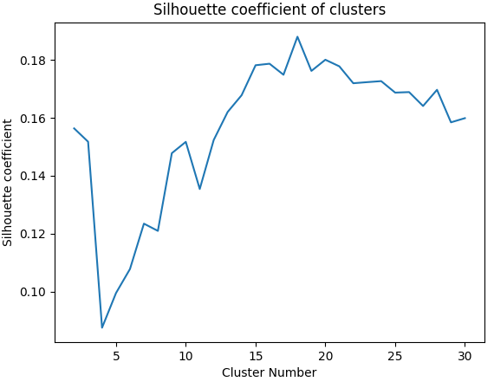
Figure 6-14 – Silhouette coefficient for clusters
Silhouette coefficient of different clusters which have been sketched in Figure 6-14, shows us best number for clustering is 18. In Figure 6-14, best Silhouette coefficient is about 0.18. Silhouette coefficient is a dimensionless coefficient between 1 and -1. If coefficient is 1, it means perfect clustering. If Silhouette coefficient is zero, it means that there is no difference between clustering and using original dataset and if is -1 it means that clustering operation is totally wrong. Our best Silhouette coefficient for clustering ,0.18, is just slightly better than using original dataset.
In this stage we decided to obtain MAE for train and test part for clustering which means for a specific number of clusters, there will be a MAE for train and train for whole dataset. Here 25 % of datapoints kept out for testing process using mentioned GBDT algorithm. Results for this process have been shown in Figure 6-15:
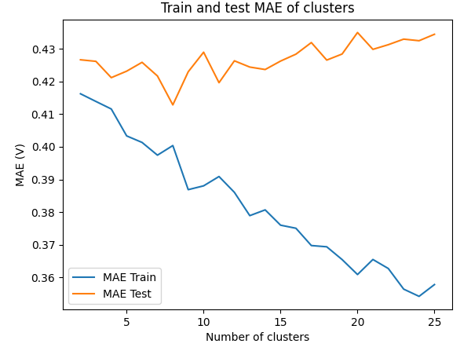
Figure 6-15 – Train and test MAE for clusters using GBDT
In Figure 6-15, MAE for training part is decreasing which means it is getting more accurate by dividing it to more clusters but more important part which is MAE for test, is fluctuating just like silhouette coefficient in Figure 6-14. Unfortunately, like PCA, clustering can’t assist us for getting more accurate results. The main reason about why clustering does not help us, is that organic functional groups are not pure. There are not just alcohols, acids, ethers or etc. Usually, organic compounds have multiple functional groups which will make them hard to cluster. For example, consider a structure with alcohol, ketone and acid. Clustering this structure is too hard.

Conclusion
In this chapter, we developed a model for all organic structure to predict reduction potential based on organic functional groups. After hyperparameter tuning including cross validation we selected GBDT algorithm due its high accuracy and low computational cost. Although we used multiple methods, none of PCA and clustering and stack ensemble learning could help us to improve our results so main results can be presented as our final results. Results are relatively acceptable considering previous chapter’s results and limitation we have faced with this model.

Chapter 7: Conclusion
Organic world due to its high variety of compounds, ease of production and low cost, has attracted scientists for material exploring. Organic compounds can be alternative selection for lithium – ion batteries cathodes but not all of organic compounds are suitable for this operation. We used combination of DFT and ML to screen and extract materials with high value in experimental researches. In this work, first we mentioned problems of main lithium-ion batteries cathodes. Then we had a critical review on one of recent works in this area for small scaled dataset and finally we developed an artificial intelligence to calculate reduction potential for all organic structures based on functional groups. For our main work, developing artificial intelligence for organic structures, although some limitations and challenges exists, results were acceptable. This process with some improvements in order to omit limitations can be applicable to other models for all organic structures to calculate different properties in order to find suitable organic cathodes. Another complicated but highly efficient algorithm which we find it in our researches can be “Natural language processing” which can beneficial in next ML researches.

Supplementary materials

All Python codes associated with chapter 4 and 5 can be found in GitHub link:
https://github.com/shamim1379/Final-project

References
- Arumugam Manthiram. A reflection on lithium-ion battery cathode chemistry
- https://afdc.energy.gov/vehicles/electric_batteries.html
- https://www.theearthawards.org/the-common-uses-of-lithium-ion-batteries/
- https://www.rsc.org/periodic-table/element/3/lithium
- https://www.gov.nl.ca/education/files/k12_evaluation_chem3202_standardreductionpotentials.pdf

- Tsuyoshi Sasaki, Yoshio Ukyo, Petr Novak. Memory Effect in Lithium-Ion Battery

- https://www.cei.washington.edu/education/science-of-solar/battery-technology/
- https://www.powertechsystems.eu/home/tech-corner/lithium-ion-battery-advantages/
- https://nightsearcher.co.uk/en/newses/faq/advantages-of-lithium-ion-batteries_f0e5.html
- https://energyeducation.ca/encyclopedia/Energy_density
- https://www.forbes.com/sites/maribellopez/2017/01/22/samsung-reveals-cause-of-note-7-issue-turns-crisis-into-opportunity/
- https://www.powertechsystems.eu/home/tech-corner/safety-of-lithium-ion-batteries/
- https://ul.org/research/electrochemical-safety/getting-started-electrochemical-safety/environmental-impacts
- https://www.samsungsdi.com/column/technology/detail/55272.html#:~:text=Li%2Dion%20batteries%20consist%20of,of%20the%20components%20is%20missing.
- Florian Schipper, Evan M. Erickson, Christoph Erk, Ji-Yong Shin, Frederick Francois Chesneau, and Doron Aurbacha, Review—Recent Advances and Remaining Challenges for Lithium Ion Battery Cathodes
- https://www.powertechsystems.eu/home/tech-corner/safety-of-lithium-ion-batteries/

Zishan Ahsan,Bo Ding,Zhenfei Cai,Cuie Wen,Weidong Yang,Yangzhou Ma,Shihong Zhang,Guangsheng Song,Muhammad Sufyan Javed. Recent Progress in Capacity Enhancement of LiFePO₄ Cathode for Li-Ion Batteries

Guanyu Wang ,Tom Fearn , Tengyao Wang , Kwang-Leong Choy. Machine-Learning Approach for Predicting the Discharging Capacities of Doped Lithium Nickel–Cobalt–Manganese Cathode Materials in Li-Ion Batteries

Manh-Kien Tran, Andre DaCosta, Anosh Mevawalla, Satyam Panchal ,Michael Fowler. Comparative Study of Equivalent Circuit Models Performance in Four Common Lithium-Ion Batteries: LFP, NMC, LMO, NCA
- The Latest Trends in Electric Vehicles Batteries
- Lithium – ion battery book
- http://hyperphysics.phy-astr.gsu.edu/hbase/quantum/schr.html
- David S. Sholl, Janice A. Steckel. Density Functional Theory

https://link.springer.com/chapter/10.1007/978-3-662-44593-8_5

Arjan J.H. Frijns, Camilo C.M. Rindt, Silvia V. Gaastra-Nedea. Modeling thermochemical reactions in thermal energy storage systems

C.C.M. Rindt, S.V. Gaastra-Nedea. Modeling thermochemical reactions in thermal energy storage systems

https://www.semanticscholar.org/reader/b403dbf59721bf05f01332c0b75a27747abb52a8

- https://www.cup.uni-muenchen.de/ch/compchem/energy/dft1.html
- https://cdnsciencepub.com/doi/10.1139/cjc-2012-0506
- https://www.ibm.com/topics/machine-learning
- https://csc.lsu.edu/~jianhua/csc7333-intro-0.pdf

Rene Y Choi , Aaron S Coyner , Jayashree Kalpathy-Cramer , Michael F Chiang , J Peter Campbell. Introduction to Machine Learning, Neural Networks, and Deep Learning

- https://royalsociety.org/topics-policy/projects/machine-learning/videos-and-background-information/#:~:text=Machine%20learning%20is%20used%20in,phones%20such%20as%20voice%20recognition.
- https://www.geeksforgeeks.org/supervised-unsupervised-learning/
- https://www.ibm.com/topics/unsupervised-learning#:~:text=the%20next%20step-,What%20is%20unsupervised%20learning%3F,the%20need%20for%20human%20intervention.
- Alind Gupta. Semi supervised learning in ML
- https://onlinedegrees.scu.edu/media/blog/9-examples-of-reinforcement-learning

- Beta Mahesh. Machine Learning Algorithms-A review

- https://mitsloan.mit.edu/ideas-made-to-matter/machine-learning-explained
- Dastan Hussen Maulud, Adnan Mohsin Abdulazeez. A Review on Linear Regression Comprehensive in Machine Learning

- Veena Ghorakvi. Types of Regression Technique in ML

- Keith A. Marill. Linear Regression, Part I: Simple Linear Regression

Show-Li Jan, Gwowen Shieh. Sample size calculations for model validation in linear regression analysis
- Mark Tranmer, Jen Murphy, Mark Elliot, Maria Pampaka. Multiple Linear Regression

Gülden Kaya Uyanık, Neşe Güler. A Study on Multiple Linear Regression Analysis

- https://www.ibm.com/topics/overfitting

- AmiyaRanjanRout. ML – Advantages and Disadvantages of Linear Regression

Joseph O Ogutu, Torben Schulz-Streeck, Hans-Peter Piepho. Genomic selection using regularized linear regression models: ridge regression, lasso, elastic net and their extensions

Ganesh Doosa. The Mathematical background of Lasso and Ridge Regression

L.E. Melkumova, S.Ya. Shatskikh. Comparing Ridge and LASSO estimators for data analysis

Luis Alberto Geraldo-Campos, Juan J. Soria Tamara Pando-Ezcurra. Machine Learning for Credit Risk in the Reactive Peru Program: A Comparison of the Lasso and Ridge Regression Models

Eva Ostertagová. Modelling using Polynomial Regression

- Mike Sishi, Arnesh Telukdarie. The Application of Decision Tree Regression to Optimize Business Processes

- Haoran Luo, Fan Cheng, Heng Yu, Yuqi Yi. SDTR: Soft Decision Tree Regressor for Tabular Data
- https://www.ibm.com/docs/en/db2-warehouse?topic=procedures-regression-trees

- Yan-yan Song, Ying Lu. Decision tree methods: applications for classification and prediction

- José Alberto Silva de Sá, Arthur Almeida, Brigida Ramati Pereira da Rocha, Maria Aurora Santos Mota. Lightning Forecast Using Data Mining Techniques On Hourly Evolution Of The Convective Available Potential Energy

- https://www.datasciencecentral.com/decision-tree-vs-random-forest-vs-boosted-trees-explained/

Sunil Kumar. Himani Sharma. A Survey on Decision Tree Algorithms of Classification in Data Mining

https://www.geeksforgeeks.org/random-forest-regression-in-python/

Li'ai Wang, Xudong Zhou, Xinkai Zhu, Zhaodi Dong, Wenshan Guo. Estimation of biomass in wheat using random forest regression algorithm and remote sensing data

- N. Horning. Random Forests: An algorithm for image classification and generation of continuous fields data sets

Samir Touzani, Jessica Granderson, Samuel Fernandes. Gradient boosting machine for modeling the energy consumption of commercial buildings

https://www.geeksforgeeks.org/ml-gradient-boosting/

Taiwo Oladipupo Ayodele. Types of Machine Learning Algorithms

Iqbal H. Sarker. Machine Learning: Algorithms, Real-World Applications and Research Directions

Alex J. Smola, Bernhard Scholkopf. A tutorial on support vector regression

Susmita Ray. A Quick Review of Machine Learning Algorithms
- Srikanta Patnaik Xin-She Yang Ishwar K. Sethi. Advances in Machine Learning and Computational Intelligence
- Gongde Guo, Hui Wang, David A. Bell Yaxin Bi KNN Model-Based Approach in Classification

Jianshi Tang, Fang Yuan, Xinke Shen, Zhongrui Wang. Bridging Biological and Artificial Neural Networks with Emerging Neuromorphic Devices: Fundamentals, Progress, and Challenges

Kenji Suzuki. Artificial Neural Networks - Methodological Advances and Biomedical Applications

Harikiran. Artificial Neural Networks and its Applications

Rene Y. Choi; Aaron S. Coyner; Jayashree Kalpathy-Cramer; Michael F. Chiang; J. Peter Campbell. Introduction to Machine Learning, Neural Networks, and Deep Learning

- https://matlab1.com/artificial-neural-network-design-implementation/
- https://www.geeksforgeeks.org/getting-started-with-classification/

Batta Mahesh. Machine Learning Algorithms -A Review

J E T Akinsola. Supervised Machine Learning Algorithms: Classification and Comparison

Kristina P. Sinaga, Miin-Shen Yang. Unsupervised K-Means Clustering Algorithm

- Dongkuan Xu, Yingjie TianA Comprehensive Survey of Clustering Algorithms

Youguo Li, Haiyan Wu. A Clustering Method Based on K-Means Algorithm
- T. Soni Madhulatha. An Overview On Clustering Methods
- Performance Metrics (Error Measures) in Machine Learning Regression, Forecasting and Prognostics: Properties and Typology
- Davide Chicco, Matthijs J. Warrens, Giuseppe Jurman. The coefficient of determination R-squared is more informative than SMAPE, MAE, MAPE, MSE and RMSE in regression analysis evaluation
- Vujovic Zeljko, Classification Model Evaluation Metrics
- https://towardsdatascience.com/7-hyperparameter-optimization-techniques-every-data-scientist-should-know-12cdebe713da
- https://www.researchgate.net/publication/332370436_Introduction_to_Support_Vector_Machines_and_Kernel_Methods/figures?lo=1
- https://www.researchgate.net/publication/360189662_Shear_Strength_Prediction_of_Slender_Steel_Fiber_Reinforced_Concrete_Beams_Using_a_Gradient_Boosting_Regression_Tree_Method

- Chang Sua , Fang Yangb , Lvlv Jib , Lihuan Xu, and Cheng Zhang. Polytriphenyl-amine derivative with high free radical density as the novel organic cathode for lithium ion batteries
- https://www.cdc.gov/niosh/topics/cobalt/default.html

Arumugam Manthiram. Can Cobalt Be Eliminated from Lithium-Ion Batteries?

Hailong Lyu, Xiao-Guang Sun, Sheng Dai. Organic Cathode Materials for Lithium-Ion Batteries: Past, Present, and Future
- https://www.sciencedirect.com/science/article/abs/pii/S2405829719309298

Rodrigo P. Carvalho, Cleber F.N. Marchiori, Daniel Brandell, C. Moyses Araujo. Artificial intelligence driven in-silico discovery of novel organic lithium-ion battery cathodes
- Juho Heiska, Mikko Nisula and Maarit Karppinen. Organic electrode materials with solid-state battery technology

Danying Xu, Minxia Liang, Shuo Qi, Weiwei Sun. The Progress and Prospect of Tunable Organic Molecules for Organic Lithium-Ion Batteries

Amitava Banerjee, Nabil Khossossi, Wei Luo, Rajeev Ahuja. Promise and reality of organic electrodes from materials design and charge storage perspective
- Juho Heiska, Mikko Nisula and Maarit Karppinen. Organic electrode materials with solid-state battery technology

Ghazaleh Hashemkhani Shahnazari, Masoud Darvish Ganji. Understanding structural and molecular properties of complexes of nucleobases and Au13 golden nanocluster by DFT calculations and DFT-MD simulation

W. Kohn , A. D. Becke ,R. G. Parr. Density Functional Theory of Electronic Structure
- Jorg Neugebauer, Tilmann Hickel. Density functional theory in materials science

Marcela Herrera, Roberto M. Serra, Irene D’Amico. DFT-inspired methods for quantum thermodynamics

Mengmeng Zhang, Donghui Wei, Yang Wang, Suiji Li, Jiefei Liu, Yanyan Zhu, Mingsheng Tang. DFT study on the reaction mechanisms and stereoselectivities of NHC-catalyzed [2 + 2] cycloaddition between arylalkylketenes and electron-deficient benzaldehydes

- Nagaraju Kerru, LalithaGummidi, SandeepV. H. S. Bhaskaruni, Surya Narayana Maddila, Parvesh Singh & Sreekantha B. Jonnalagadda. A comparison between observed and DFT calculations on structure of 5-(4-chlorophenyl)-2-amino1,3,4-thiadiazole

Dipendra Jha , Kamal Choudhary , Francesca Tavazza , Wei-Keng Liao , Alok Choudhary , Carelyn Campbell , Ankit Agrawal. Enhancing materials property prediction by leveraging computational and experimental data using deep transfer learning

Zahra Rostami, Akram Hosseinian, Aazam Monfared. DFT results against experimental data for electronic properties of C₆₀ and C₇₀ fullerene derivatives

A.A. Al-Muntaser, M.M. El-Nahass, Hosam A. Saad. DFT calculation and experimental study on electronic structure and optical properties of 7-Amino-4-oxo-3-(2-(2-thienyl)vinyl)-4H,8H-[1,2,4]triazino[3,4-b][1,3,4]thiadiazine-8-carbonitrile thin films
- Tanja van Mourik, Michael Bühl, Marie-Pierre Gaigeot. Density functional theory across chemistry, physics and biology
- Kieron Burke. Perspective on density functional theory

Peter St. John, Yanfei Guan, Yeonjoon Kim, Seonah Kim. Prediction of Homolytic Bond Dissociation Enthalpies for Organic Molecules at near Chemical Accuracy with Sub-Second Computational Cost
- Kristaps Ermanis, Kevin E. B. Parkes, Tatiana Agbackb, Jonathan M. Goodman. Expanding DP4: application to drug compounds and automation
- Cheng-Wei Ju , Hanzhi Bai, Bo Li , Rizhang Liu. Machine Learning Enables Highly Accurate Predictions of Photophysical Properties of Organic Fluorescent Materials: Emission Wavelengths and Quantum Yields

Omar Allam, Byung Woo Cho, Ki Chul Kim, Seung Soon Jang. Application of DFT-based machine learning for developing molecular electrode materials in Li-ion batteries

Victor T. Barone, Blair R. Tuttle, Sanjay V. Khare. Properties of AgBiI₄ using high through-put DFT and machine learning methods

Anand Chandrasekaran, Deepak Kamal, Rohit Batra, Chiho Kim, Lihua Chen, Rampi Ramprasad. Solving the electronic structure problem with machine learning

Ryo Nagai, Ryosuke Akashi, Osamu Sugino. Completing density functional theory by machine learning hidden messages from molecules

https://pubs.acs.org/doi/epdf/10.1021/jacs.2c08997

https://pubs.acs.org/doi/epdf/10.1021/acs.jpcc.5b08609

https://onlinelibrary.wiley.com/doi/10.1002/adma.202101474

Guanyu Wang, Tom Fearn, Tengyao Wang, and Kwang-Leong Cho, Machine-Learning Approach for Predicting the Discharging Capacities of Doped Lithium Nickel–Cobalt–Manganese Cathode Materials in Li-Ion Batteries, ACS Central Science 2021 7 (9), 1551-1560

https://pubs.acs.org/doi/pdf/10.1021/acsomega.8b00576

https://onlinelibrary.wiley.com/doi/full/10.1002/sam.11583

https://www.nature.com/articles/s41524-022-00947-9

https://novoprolabs.com/tools/smiles2pdb

https://gitlab.com/rpcarvalho/anima/-/tree/master/databases

https://www.geeksforgeeks.org/stacking-in-machine-learning/

